Document Title Urgent Care Centre at Central Middx Hospital
Document Status Draft
Document Version V7 28th June 2017

1. Introduction 4
2. Vision 6
3. Population Needs 8
3.1 National Context 8
3.2 Local Context 8
4. Primary Care Transformation 10
5. Whole Systems 10
6. Accountable Care Partnership/s 11
7. Like Minded – Mental Health Transformation Programme 12
8. NHS Outcomes Framework Domains and Indicators 13
8.1 Local Defined Outcomes 14
9. Future Service Developments 15
10. Information 15
11. Aims and Objectives of Service 17
11.1. Key Components of the Urgent Care Centre 17
11.2 Urgent Care Triage Components 18
11.3 Urgent Care Centre to Have the Ability and Knowledge To: 18
o Aims 18
• Hours of Operation 20
13. Service Description and Care Pathways 20
13.1 Service Model 20
13.2 Treatment 21
13.3 Arrival, Registration and Triage 22
13.4 Clinical Assessment 22
14. Clinical Assessment 23
14.1 Clinical Assessment 23
15. Medical Emergencies 24
• Patient Re-Direction Pathway 24
• Unregistered Patients 26
• Referrals Back to Community Based Services 26
• Communication of Episode to the Patient’s GP 26
• Management of Waiting Times 27
20.1 Management of Non-Attending Appointments for Routine Primary Care: 28
• Care Delivery 28
21.1 Minor Injury 28
21.2 Pathology and Radiology requests in the Urgent Care Centre 28
• Routine Primary Care Appointments 29
23. Paediatrics 30
• Transfer to/ from UCC with A&E 30
• Access to Specialty Advice 31
• Access to Diagnostics and Investigations 31
• Interpretation and Reporting 32
• Discharge from Urgent Care Centre 32
30. Medicines Management 33
30.1 Prescribing and Supply 33
30.2 Formulary 33
30.3 Clinical Governance of Medicines Management 33
30.4 Administering 34
30.5 Monitoring, Reporting and Financial Implications 34
30.6 Reporting and Financial Implications 34
31. Accommodation 34
31.1 Key Space Requirements 34
32. Staffing 35
32.1 Clinical Leadership 35
32.2 Skill Mix 36
33. Training and Development 36
34. Location 37
35. Population Covered 37
36. Acceptance and Exclusion Criteria 37
36.1 Acceptance Criteria 37
36.2 Mental Health 38
36.3 Exclusion Criteria: Adults 38
36.4 Exclusion Criteria: Children 39
37. Interdependencies with Other Services 39
38. Applicable National Standards 41
39. Contract Management 41
40. Clinical Governance 41
40.1 Creation and Regular Review of the Joint Clinical Policy, including: 42
40.2 Service Audit, including: 42
41. Patient Involvement 43
42. Clinical Risk Management and Legal Protection 43
43. Risk Management 43
44. Accountability 43
45. Incident Reporting 43
46. Policies and Procedures 44
47. Safeguarding 44
47.1 Safeguarding Adults 45
47.2 Safeguarding Children 45
48. Key Service Outcomes 47
49. Location of Provider Premises 47
50. Developing the Integrated Urgent Care Model 48
50.1 Clinical Advice and Triage Service 48
51. Mental Health 49
52. Intermediate Care 49
53. Discharge from Integrated Urgent Care Service 50
54. Supporting Infrastructure 50
54.1 Information Technology and Information Governance 51
54.2 Access Patient Records 51
54.3 Clinical Records 51
54.4 Functionality in support of Interoperability expected 52
54.5 Text Message/Email Summaries 52
54.6 Directory of Services 52
55. Training 53
55.1 All Staff 53
55.2 Training of Doctors and Other Healthcare Professionals 54
56. Medicines and Poisons Training 54
57. Service Resilience and Responsiveness 54
57.1 Business Continuity 54
57.2 Risk Management 54
57.3 Response in a Major Incident 55
58. Clinical Governance 57
59. Engagement with Healthcare Professionals and Professional Feedback 59
60. Applicable National Standards (e.g.NICE) 59
61. KPIs and Metrics 60

Introduction

Following a review of Integrated Urgent Care, Brent Clinical Commission Group will be undertaking a process to improve and optimise the stand alone Urgent Care Centre that is based at Central Middlesex hospital; this has resulted in a new service specification being created. It is likely that the new service specification will be subject to an open and competitive procurement process for the CCG to identify a suitable and qualified provider to commission. The Urgent Care Centre will be available to any patients that attend irrespective of the borough the patient resides in; this includes registered and non-registered patients.

This new service specification will reflect a renewed focus of integrated working and will incorporate the integrated urgent care strategies across North West London and the new Commissioning Standards for Integrated Care that take effect from April 2017. The aim is for the patient to be in the right place with the right clinician first time being delivered by a dynamic responsive collaborative provider. The provider should have a flexible approach to the development of the service and the CCG would encourage the provider to bring forward proposals and suggestions to innovate and redesign.

The North West London Collaboration of Clinical Commissioning Groups are currently working together to re-shape the NHS 111, GP Out of Hours and wider urgent care services with the aim of commissioning a functionally Integrated Urgent Care System. This will provide a single entry point for patients with an urgent care need, and through NHS 111 and a Clinical Hub be able to access a networked system of integrated care services where organisations collaborate to deliver, organise and facilitate high quality, clinical triage, advice and treatment.

Patients with an urgent healthcare requirement will predominantly access urgent care services outside of their core GP opening hours. Access to Urgent Integrated Care can be through automatic divert when the GP practice is closed or by calling NHS 111. Access to NHS 111 and Clinical Hub (Clinical Advice and Triage Service) will be available 24 hours per day, 365 days per year.

Central to this approach will be the development of a 'Clinical Advice and Triage Service’ (CATS) which will operate across the Brent, Harrow and Hillingdon Federation of Clinical Commissioning Groups. A model built with the same principles will also apply to the remaining CCGs across North West London. The Clinical Advice and Triage Service will offer patients who require it access to a range of clinicians.
The Clinical Assessment, Advice and Triage Service will provide support directly to patients who access North West London NHS 111 by receiving appropriate calls directly from NHS 111 (non-clinical) health advisers.
The service will also be accessible by health professionals in the community and within the acute sector (if required) so that clinical decisions do not need to be taken in isolation.

Vision

- To ensure right care, in the right place, first time.
- To align and reduce the duplication of unscheduled care services, improve accessibility and the overall patient experience
- To manage patients effectively, reducing unnecessary steps and clinical risk
- To ensure that access to services is coordinated, avoiding the need for patients to navigate a complex and confusing system
- For all services to be technically linked and/or interoperable to an IT infrastructure that facilitates the sharing of patient records, referrals and booking of appointments, including GP practice appointments as part of a whole integrated system
- To create an integrated unscheduled care service that is coordinated between Primary, Planned, Urgent, Intermediate, Mental Health, Social Care, Community and Paediatric care services and other parts of the local healthcare system
- To promote health and wellbeing
- To promote and deliver self-care where appropriate
- To deliver appropriate referrals

A plan for online integration in the future will make it easier for the public to access urgent health advice and care. This will increasingly be in a way that offers a personalised and convenient service that is responsive to people’s health care needs when:

- They need medical help fast, but it is not a 999 emergency
- They do not know whom to contact for medical help
- They think they may need to go to A&E or another NHS urgent care service
- They need to make an appointment with an urgent care service
- They require health information or reassurance about how to care for themselves or what to do next

Figure 1. Diagrammatic representation of a functionally integrated urgent care service:

Population Needs

3.1 National Context

The NHS Five Year Forward View (5YFV) explains the health services in England for people of all ages with physical and mental health problems, and sets out the new models of care needed to deliver this. The 5YFV highlights that the traditional divide between primary care, community services, and hospitals is increasingly a barrier to the personalized and coordinated health services required for patients. The management of long-term conditions is now a central task for the NHS; caring for these needs requires a partnership with patients over the long term rather than providing single, unconnected ‘episodes’ of care. The FYFV sets out a clear programme of change to better connect care across organisational boundaries for these patients, including;

- Delivering care through a system approach using networks of care not just single organisations
- Increasing the focus on out-of-hospital care
- Integrating services around the patient, ensuring health, mental health and social care services are co-ordinated
- Continually evaluate new models of care and develop them to provide the best experience for patients and best value for money

The inclusion of community services is fundamental in delivering this programme of change and provider(s) will deliver against the objectives set out above whilst continually working alongside partners to evolve the model in accordance with the strategic direction of NHS NWL CCGs and our Local Authority Partners

3.2 Local Context

Shaping a Healthier Future

Shaping a Healthier Future (SaHF) is a clinically led programme being delivered across the eight Clinical Commissioning Groups (CCGs) in North West London (NWL) which will create a future healthcare system in NWL to meet the changing demands of the population, improve standards, and provide a sustainable financial future.

The vision for care in NWL is underpinned by four overarching principles detailed below:

- Personalised – Enabling people to manage their own care themselves and to offer the best treatment to them. This ensures care is unique.
- Localised – Localising services where possible, allowing for a wider variety of services closer to home. This ensures care is convenient.
- Integrated – Delivering care that considers all the aspects of a person’s health and is coordinated across all the services involved. This ensures care is timely, efficient and appropriate.
- Specialised – Centralising services where necessary for specific conditions ensuring greater access to specialist support. This ensures care is better.

Delivery of SaHF is directly supported by the North West London Five Year Strategy and a series of transformation programmes have been initiated to deliver SaHF. All of these programmes are relevant to the delivery of the Integrated Urgent Care Service. These transformation programmes are:

- Primary Care Transformation (including out-of-hospital): Placing Primary Care at the heart of whole system working, and improving access to GP services.
- Whole Systems Integrated Care: Coordinating care across commissioning bodies and providers, centred on the patient.
- Acute Reconfiguration: Improving hospitals to deliver better care 7 days a week, and ensuring there are more services accessible and closer to home.
- Mental Health Transformation: Improving mental and physical health through integrated services.

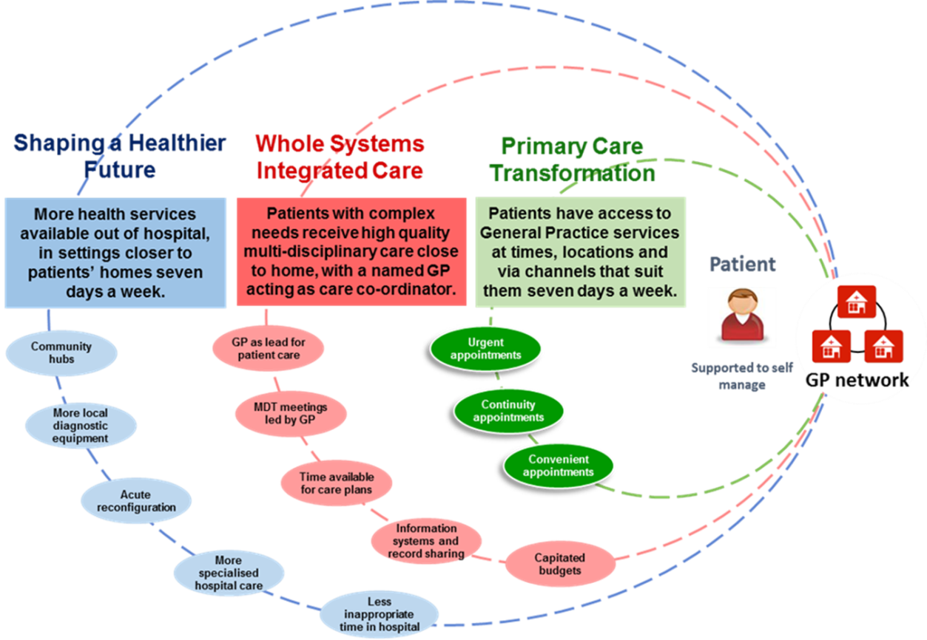

Primary Care Transformation

Primary care in North West London is seeing unprecedented levels of change in terms of transformation of primary care service delivery. Practices are delivering a range of new ‘Out of Hospital’ Services, requiring implementation of new systems, processes, training and development of staff to ensure required competencies can be delivered.

In addition across the CCGs there is an ambitious programme for new models of primary care for different patient groups. New and innovative approaches are being developed to increase access into general practice, support the Integrated Urgent Care model and strengthen the whole systems integrated care.

All models have the aim of ensuring seamless coordinated care across the primary care landscape for patients with more complex needs or vulnerabilities and those requiring urgent access through redirection and a single point of access for bookable GP slots.

The provider will be expected to respond to and support the focus of this transformation programme, working with practices to ensure the needs of the patient population are met through co-design and mutual alignment and give opportunities in developing staff in urgent care across different settings.

The UCC at Central Middlesex Hospital will be co-located with a GP practice held under an Alternative Services Medical Provider (APMS) contract. It is expected that the UCC will work collaboratively with this provider to manage patient care. Examples of collaborative working would include
- ensuring patients from the APMS practice presenting for primary care conditions are re-directed back to the GP practice
- directing unregistered patients to local GP practices and where the patient chooses the APMS provider, agreeing with this provider a process to register patients.
- Working with the GP practice for urgent patient diagnostics to be made available to the APMS provider patients

It is expected the UCC and APMS provider will meet on a regular, at least quarterly, to discuss and agree improvements to patient pathways.
It is also proposed that a GP Access Hub will be located on the Central Middlesex site, subject to patient consultation. The UCC provider will be required to work with the GP Access Hub provider to re-direct patients appropriately, in line with the national direction on Right Care First Time. The UCC provider will provide continued patient education on the most appropriate route for accessing unscheduled care appointments this would include information on the primary care Access Hubs. Provider will provide evidence of education having being undertaken.

Whole Systems

North West London is one of 14 pioneer sites to implement integrated care at scale and pace. Across the 8 boroughs, 31 partner organisations have agreed to work together in pursuit of a shared person-centred vision for integrated care.

While all boroughs are developing their own approach to whole-systems, the principles, which underpin these approaches, are shared.

Community services will work to integrate with and support Whole Systems Integrated Care (WSIC) as Early Adopters and develop a seamless interface during the contract period, this will include responding to the different requirements of each CCGs model, and contributing to service developments as the WSiC programme is embedded across the CCGs.

General practice is central to the Whole Systems Programme and is being embedded into New Models of Care and aligned with the Strategic Commissioning Framework.

Accountable Care Partnership/s

In 2017/18 the CCG will develop a shadow outcome based commissioning model / Accountable Care Partnership (ACP) before implementing an extended range of outcome based commissioning through a formal partnership in April 2018. (Via ACO/MCP)

Any services that are currently commissioned or are procured in future, the outcomes required of those service and associated budgets, might, in future form part of an the ACP model. The CCG will require current and future providers of services to work closely and in an integrated way with any ACP in the delivery of services that provide clinical and financial outcomes that meet the requirements of ACP agreements.

How Accountable Care Models Work

  - Accountable Care models are globally recognised as one of the most effective ways to bring providers together.
  - Shown to advance the joining up of design, management and delivery of care.
  - Providers work under a single contract, with a single pooled budget to take joint responsibility for delivering services.
  - Outcomes based health and care contracts for a defined patient or resident population.
  - Partners are incentivised to continuously improve and to drive delivery out of formal care settings and increasing focus on primary and secondary prevention.
  - Gives greater financial security in order to plan and transform care over the longer term.

The Value of Accountable Care Models
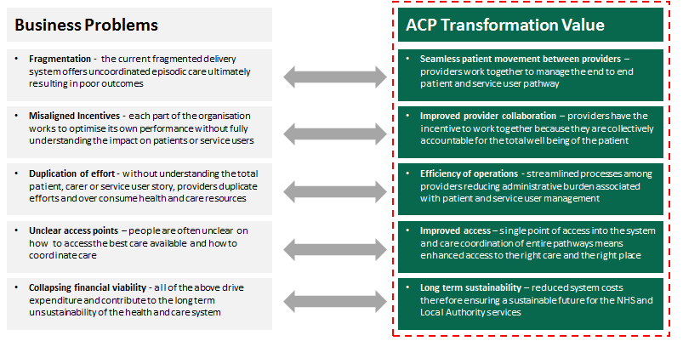

7. Like Minded – Mental Health Transformation Programme

The Collaboration of NWL CCGs and system leaders across North West London endorsed the commencement of a programme to develop a NWL-wide Whole System Mental Health & Wellbeing Strategic Plan. This builds upon the previous NWL Mental Health Strategy (Shaping Healthier Lives) and the Whole Systems approach to involving health and social partners as well as service users and the voluntary sector.

The first phase of the Like Minded programme focused on the development of a ‘Case for Change’, which describes the eight major issues identified across North West London relating to mental health and wellbeing, and the ambitions to improve outcomes and experiences.

The Case for Change is built on a wide range of data, people’s experiences, best practice and a structured approach to prioritisation, to agree a number of shared priority work streams. It has been endorsed by Health & Wellbeing Boards, CCG Governing Bodies, Central North West London NHS Foundation Trust (CNWL) and West London Mental Health Trust (WLMHT).

Commissioners would be looking to work actively with providers to deliver this vision. The provider(s) of the Integrated Urgent Care Service would be a key partner of this vision and would be expected to work with other providers to work towards a single 24/7 clinical Single Point of Access for reactive care management which would act as the focal point for the Integrated Unscheduled Care Services.

8. NHS Outcomes Framework Domains and Indicators

Domain 1  OUTCOME 1  OUTCOME  2 | Preventing people from dying prematurely  People are assessed, provided with advice and/or treatment and discharged from the service within the specified timeframe by appropriately skilled and qualified staff leading to an appropriate clinical outcome  People who use the Urgent Care Centre have access to the right care, in the right, place, by those with the right skills, the first time | X
Domain 2  OUTCOME 3 | Enhancing quality of life for people with long-term conditions  People with long-term conditions are treated in-line with their care records and wishes and are provided with the most appropriate treatment for their needs first time. | X
Domain 3  OUTCOME 4 | Helping people to recover from episodes of ill-health or following injury  People receive a holistic and personalized service which responds to their immediate need in a timely fashion and also arranges for any follow-up care and support required within a single episode of care | X
Domain 4  OUTCOME 5  OUTCOME 6  OUTCOME 7  OUTCOME 8 | Ensuring people have a positive experience of care  People have access to a service 24/7 which supports them in effectively navigating the urgent and emergency care system  People’s perceived urgent care need is dealt with in a personalized way that takes into account their holistic need  People are provided with information and options for self-care and are supported to manage an acute or long-term physical or mental condition  People received improved patient care, experience and outcome by ensuring the early input of the most appropriate senior clinician when required. | X
Domain 5  OUTCOME 9  OUTCOME 10 | Treating and caring for people in safe environment and protecting them from avoidable harm  The service is accessible and provides the same quality of care to all patients who access the service.  People who use the service have their care needs responded to within a single episode of care which minimizes the need for handovers and re-triaging between services. | X

8.1 Local Defined Outcomes

In addition to the outcomes specified above, as a core part of the integrated urgent care system providers are expected to deliver the following outcomes:

- Improved efficiency and productivity of the urgent care system is increased with a reduction in the overlap and duplication across service provision and clinical time.
- Increase opportunities across the urgent care system to reduce non elective hospital admissions, improving the systems impact of NHS 111 and the Clinical Advice and Triage Service
- A single point of access to urgent healthcare services available 24/7
- Patients and/or their family/carers are provided with information and options to support self-care and for the management of acute or long-term physical and mental conditions
- If an onward referral is required, patients experience this seamlessly e.g. through direct booking of appointments at a wider range of urgent or unscheduled care services
- A single clinical telephone triage
- Public satisfaction and confidence in the NHS is increased
- The quality and experience of patient care is measured and acted upon to ensure continuous service improvement

9. Future Service Developments

NHS Brent and Harrow are committed to improving services to patients and responding to the changing landscape of the NHS and the general needs of population, these are aligned with the strategy of the North West London Shaping a Healthier Future programme (SaHF).

The CCG is currently working to redesign the model of unscheduled and urgent Integrated care. The provider will work with the CCG to accommodate service development changes and improvements.

Dependent on the level and type of changes implemented these will be managed via variation to the main contract in keeping with specified notice periods for change. The provider will be required to be receptive and adaptable to change and to manage the change process.

Future anticipated changes may include:

- Additional delivery of Minor Injury services within GP Access Centre environments
- Transport of patients to other services
- The use of a wider and varied clinical and professional skill mix
- The implementation of alternative operational and clinical pathways
- Appointment or blended appointment systems to access all services
- Contribution to the management of long term conditions
- Further development of Virtual Wards and Intermediate Care Step up/down beds

The future model of care will be a whole systems integrated care approach to the delivery of healthcare across the locality with integrated and close working links to NHS 111, other Urgent Care Centres, GP Access Centres, Out of Hours services, Clinical hubs, community, intermediate, primary and secondary care services with pathways to mental health services to form a functionally integrated, effective and networked model.

10. Information

Significant pieces of work and patient engagement has been undertaken by NHS Health London Partnership and this very much underpins the vision and strategy for Integrated Unscheduled and Urgent Care Services across Brent Harrow and Hillingdon CCGs:

The patient experience and their expectations
https://www.myhealth.london.nhs.uk/system/files/Nov%202015%20Event%20-%203%20The%20Patient%20Perspective_0.pdf

Patient Co-design
https://www.myhealth.london.nhs.uk/system/files/Nov%202015%20Event%20-%20A%20Patient%20Co-design%20workshop.pdf

Responding to Patients Expectations
https://www.myhealth.london.nhs.uk/system/files/Nov%202015%20Event%20-%204%20Responding%20to%20Patient%20Expectations%20-%20the%20U%26EC%20Facilities%20Specification.pdf

Redesigning Urgent and Emergency Care Services
https://www.myhealth.london.nhs.uk/system/files/Nov%202015%20Event%20-%202%20Urgent%20and%20Emergency%20care%20-%20the%20new%20offer.pdf

11. Aims and Objectives of Service
The Urgent Care Centre (UCC) will work on the principle that all patients should receive a consistent level of face to face clinical assessment.
All patients attending the UCC will have access to timely and appropriate care according to their healthcare needs.
The Urgent Care Centre will have the ability and knowledge to facilitate access to the provision of the right healthcare, delivered by the most appropriate person or service in the most optimal environment. The model is predicated on the ability to safely identify patients who require:
- Emergency Care
- Urgent Care
- Routine Care
Where appropriate the model of care is to navigate patients who do not have emergency, urgent illness or injury healthcare needs away from the hospital setting so that their care requirements can be delivered outside of the hospital within the community. Working in a joined up and integrated way with the Clinical Advice and Assessment Service (CATS) will enable the UCC to ensure that the most clinically appropriate service is provided to the patient by clinically assessing the need and urgency of the patient and selecting the most appropriate pathway, some of the key alternative pathways are:
- Primary Care - Appointments provided within Primary Care at the GP practice or GP Access Centre.
- Primary Care - Appointment with a clinician at a Primary Care Centre (Currently named GP Access Centre)
- Primary Care - A routine appointment at the Urgent Care Centre
- Primary Care – Supporting patients to self-care
- Community Care – Facilitation or mobilising community services
- Intermediate Care – Facilitation or mobilising home or community bed based services
- Pharmacy – Self-care, pharmacist advice and over the counter medications
- Mental Health – Referral or mobilising specialist care
- Palliative/End of Life – Facilitation or mobilising of services
- Social Care – Referral or mobilising adult and children’s social care services
These pathways are not limited, however are often the desired outcome in facilitating clinically appropriate treatment and services within the community.

11.1. Key Components of the Urgent Care Centre
- Urgent Care Triage
- Urgent Care Centre
- Minor Injury Service
- Navigation

11.2 Urgent Care Triage Components
- Face to face clinical assessment of the patient’s condition
- Assessment of the clinical need of the patient
- Assessment of the clinical urgency of the patient
- Identify red flags
- Select the clinically appropriate pathway for the patient
- Navigate the patient when clinically appropriate
- ‘Blue light’ and other seriously ill patients requiring emergency treatment will be conveyed by LAS directly to ED without moving through the UCC.
- LAS Non blue light cases subject to agreed pathway compliance
- Provide a seamless pathway to the Urgent Care Centre
- Provide support for a patient to self-care
- Provide leaflets/print outs to aid self-care

11.3 Urgent Care Centre to Have the Ability and Knowledge To:
- Facilitate access to the provision of the right care, by the most appropriate person, in the right setting, first time
- Positively re-direct non-urgent cases back to primary/community care alternatives;
- Facilitate unregistered patients to register with a GP practice;
- Provide health promotion and self-management education;
- Provide a seamless pathway to any further assessment required within A&E, or referral (if necessary) to a hospital specialist or department;
- See, treat, discharge or admit all patients within 4 hours of their arrival at the UCC. Please refer to KPI’s (appendix x) with regards to managing referrals into ED.
- To work with the CATS service ensuring appointments are allocated to re-directed patients from CATS
- To work in partnership with the UCC at Northwick Park Hospital and other UCCs to ensure plans are in place to deal with both unexpected surges in demand and to deliver efficiencies during low demand.
- The UCC is required to work seamlessly with primary care and the GP Access Centre ensuring patients can be seen as close to home as possible when clinically appropriate. There will be a preference, where appropriate, to direct patients to their own GP or to their nearest GP Access centre
- Ensure communications and information given to patients is available in the top 5 languages used in Brent and in an easy read version.
- To accept referrals in accordance with the agreed LAS UCC exclusion criteria.
- To have a seamless direct pathway to Ambulatory Emergency Care Unit when clinically appropriate

Aims

The aims of the service are to:
- Provide good quality, timely and accessible urgent unplanned care ensuring that the patient’s ongoing healthcare needs are met in the most appropriate setting within the community or primary care setting. Right Place, Right Clinician, First Time.

- The Urgent Care Centre provide an initial clinical assessment for all walk in patients that attend the centre, assessing the urgency of the patients clinical condition, providing self-care information and support and/or referring the patient to the most appropriate pathway
- Provide routine bookable appointments for the CATS service to utilize
- Provide an agreed pathway for the UCC to stream where necessary patients into an A&E and Ambulatory Care based on the agreed Shaping a Healthier Future Pathways (see appendix)
- Integrate with current service provision but develop the distinctive culture and approach of a primary care service, with experienced primary care clinicians leading the service, working alongside other healthcare professionals undertaking clinical assessment of patients and seeing and treating patients
- Work with the Clinical Advice and Triage Service provider and Emergency Department to develop, implement and maintain integrated pathways to services
- Provide an agreed pathway for the Urgent Care Centre to redirect where necessary patients into Primary Care or nearest GP Access Centre
- Work with the London Ambulance Service to ensure there is an appropriate care pathway in place.
The service will not:
- Constitute a further access point for routine NHS care within the local health economy. If this is what the patients need they will be navigated to the appropriate alternative service.
- Enable duplication of existing services commissioned by the CCGs or by primary medical services contractors
- Provide routine non-urgent treatment to walk in patients that attend when there is a clinically suitable alternative service available

Specifically:
Patients that attend the hospital who self-present with a serious medical emergency will be directed to the Emergency Department without attending the UCC. An agreement with LAS must be in place for any patients that are brought in by LAS are appropriate for the UCC
The scope of the service:
- Encompasses all age groups and includes separate waiting facilities for children
- Includes Minor Illnesses, Minor Injury and Urgent and Routine Primary Care services in addition to routine provision in accordance with Brent CCG agreement.

Interventions considered in scope, however not limited to the following treatments

- Interpretation of X-rays for diagnosis of limb fractures and other diagnostics/ investigations as clinically appropriate in the urgent care environment.
- Treatment of simple fractures.
- Non-complex local anaesthesia for wound closure,
- Incision and drainage of abscesses not requiring general anaesthesia
- Minor ENT/ophthalmic procedures
- Access to psychiatric services / assessment
- Direct referral to other specialities within the hospital following agreed pathways
- Navigation to alternative care pathways

Hours of Operation

The service will operate 24 hours a day 7 days a week

13. Service Description and Care Pathways

13.1 Service Model
The main elements of the service will include:
- Face to face clinical assessment of all presenting patients by a primary care clinician
- Diagnostics and Treatment
- Re-direction to mainstream primary care and/or other alternative services
- Receipt of CATS referrals into the UCC on an appointment basis
- Self Care
- Seamless pathways to specialty departments and ambulatory care, including rapid response services.
- Provide transport for urgent (not emergency) in exceptional circumstances for patients.

CENTRAL MIDDX HOSPITAL
Urgent Care Centre Pathway
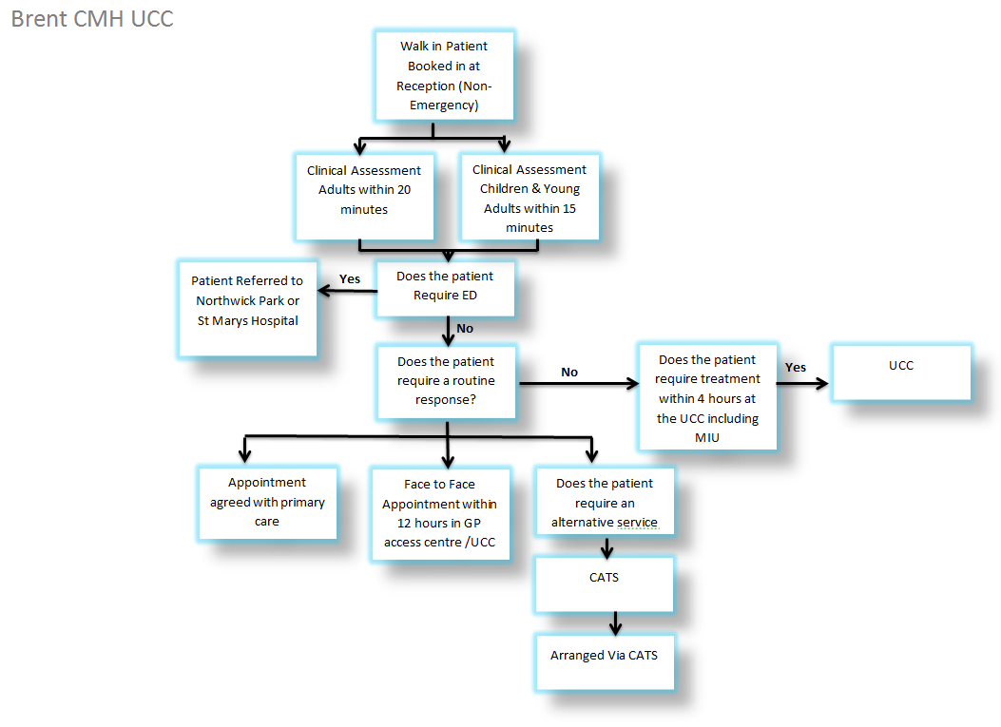

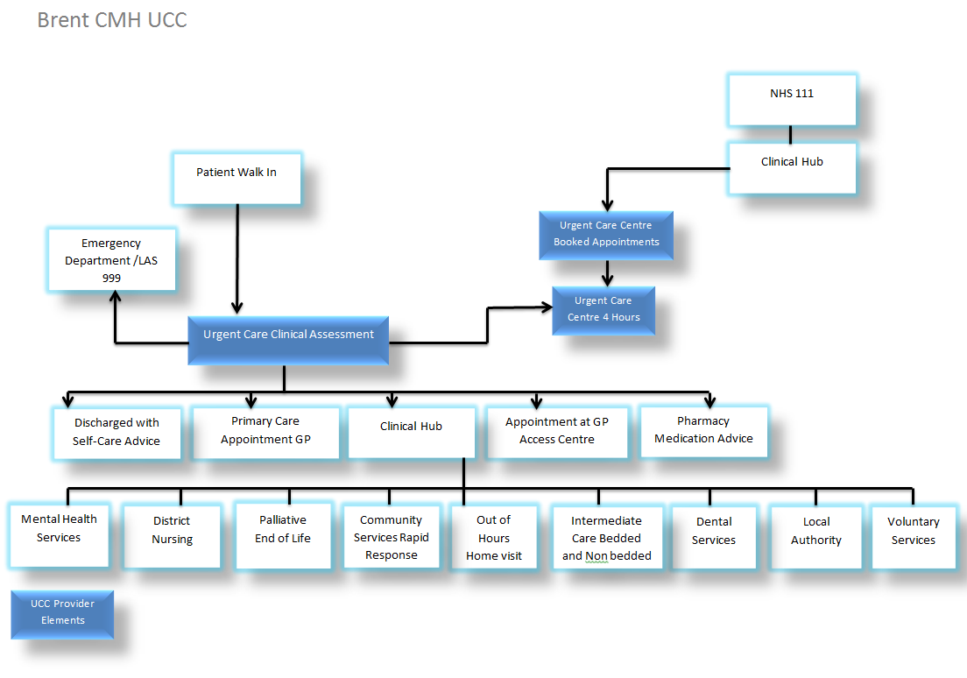

13.2 Treatment
The treatment element of the service model is based on three main areas, in each case delivered by an appropriately trained healthcare professional for all registered and unregistered patients.
- Minor injuries
- Urgent primary care illness
- Routine primary care

13.3 Arrival, Registration and Triage
As part of the arrival and triage process, the following activities will take place:
- Patient registration on the designated IT system
- Patient will receive a clinical assessment
- Patient will be supported with self-care advice/guidance
- Patient will be referred to the UCC
- Patient will be referred to ED at Northwick Park or St Mary’s hospital by LAS
- Patient will be re-directed/navigated to the most appropriate community/primary care service outside of the hospital according to clinical need and urgency
- Referrals, appointments, visits to other services will be facilitated by CATS
- Clinical contemporaneous notes recorded at all interventions
- As part of the registration process a robust protocol must be established and agreed to recognise immediate emergencies.
- Appropriate care pathway in place for patients who arrive by LAS as agreed protocol

As part of this specification, the CCG is prescribing the desired outcomes of the arrival and triage process, rather than the precise manner in which it is conducted and order in which the activities are undertaken.
Providers are free to define an appropriate arrival, triage and registration process which meets the requirements outlined, given the space available.
Once the service is operational, the Provider must agree to regular reviews of the assessment process itself. These reviews will form part of the ongoing clinical governance review mechanism and will be shared with the Commissioners.

13.4 Clinical Assessment

The Urgent Care Centre will provide the front of department reception for the department and will act as the patient’s first point of access to the UCC. This will include all Walk In patients and appropriate LAS presentations with the exception of emergencies conveyed in accordance with agreed pathways.
Whilst operating in this integrated way, the UCC should retain the distinctive culture and approach of a primary care service.
Patients will be clinically assessed and directed to the most appropriate pathway for their need by the appropriately qualified and experienced clinical practitioner areas using agreed triage guidelines.

Approaches to clinical assessment and potential positive re-direction back into Primary Care must be consistent across all Urgent Care providers in Brent and Harrow, including GP practices and Walk-in Centres/GP Access Centres and the Clinical Advice and Triage Service (CATS). The provider is required to work with the other service providers within the local health economy to ensure that a common re-direction protocol is developed. Patient details will be captured on the appropriate IT system at reception and follow the agreed patient pathway following registration, and triage.
Clinical streaming may result in one of the following outcomes:
- Treatment directed to the Emergency Department Adult (ED)
- Treatment directed to the Emergency Department Paediatric (PAED)
- Urgent treatment in the Urgent Care Centre (UCC)
- Treatment of Minor Injuries
- Routine treatment within the Urgent Care Centre (UCC)
- Navigation to an appropriate community service
- Navigation to a specialist or specific provider via the Clinical Advice and Treatment Service (CATS)
- Psychiatric Liaison within the department
- Facilitate referrals to specialty from primary care
- Ambulatory care
- GP Access Hubs
- Rapid Response Service

14. Clinical Assessment

14.1 Clinical Assessment

Initial clinical assessment within the UCC will be undertaken by a suitably qualified clinical practitioner with the appropriate primary and urgent care experience required to provide this level of clinically safe assessment.
The Provider will be expected to develop a sustainable mix of multi-disciplinary staff to undertake this role and should be assured on a skills based competency framework. The Provider will take full management responsibility for the clinical assessment of the patient journey and will provide a clinically appropriate workforce to meet the required demand.
It is anticipated that the function of clinical assessment will be undertaken by senior grade clinical staff that retain autonomous competencies to undertake their role.

The provider will ensure that the appropriate mechanisms are implemented so that a Clinical Lead will assume management responsibility (accountability) for all medical and nursing staff within the UCC. All staff will be assessed against a suitable competency framework by the Provider and monitored by a clinical governance assurance process.

The clinical practitioner undertaking triage assessment will retain the responsibility for ensuring the safe and effective direction of patients to the most appropriate clinician or alternative pathway/healthcare provider.

Patients who are re-directed to an alternative care pathway will have their details recorded on the IT system that includes: contact information, the clinical decision for pathway selection and the specific details of where the patient has been navigated to and location to which they are streamed. These will be collected via the UCC clinical system and held for audit, data analysis and information governance purposes.

The assessment model is key to ensure that patients are successfully applied to the correct pathway whilst health promotion, education and supporting patients to self-care are an essential element to the assessment process.

15. Medical Emergencies

The Urgent Care Centre provides services and treatment for urgent minor illness and injuries. Patients with more significant, complex or emergency requirements will be directed to the Emergency Departments located at Northwick Park Hospital or St Marys Hospital.

A similar process will apply for patients that arrive via the London Ambulance Service with patients that do not require the services of the Emergency Department.
In the event of a medical emergency within the Urgent Care Centre that requires crash team assistance, the service shall be immediately available by following the hospital process and in accordance with the agreed SaHF pathways.

Patient Re-Direction Pathway

The Urgent Care Centre should operate as a key component and function within the Integrated Urgent Care System.
Patient re-direction applies when the patient that as presenting clinical complaint that is routine in its nature and urgency and does not require the specific services of the UCC. The pathway to re-direct a patient from the UCC to another service should be agreed between providers: Local GP Practices should be engaged and informed of the process in redirection for patients with support from the CCG.

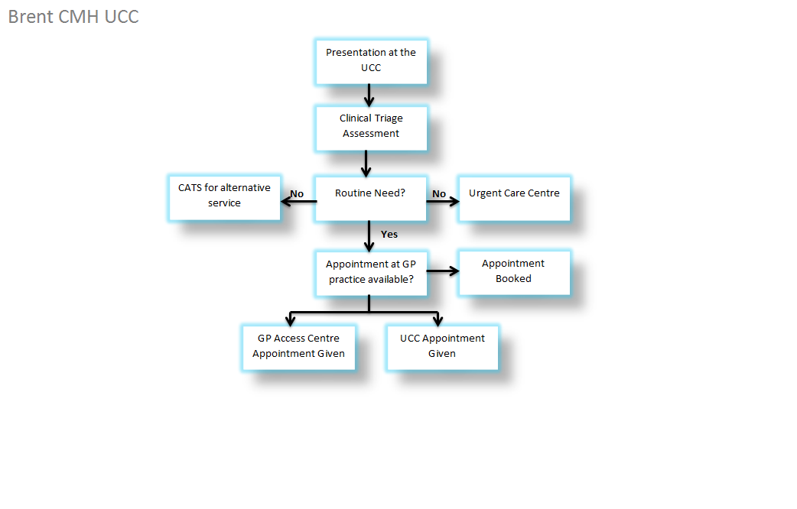

Agreed pathways between CATS, GP practices and GP Access Centre must be in place and maintained

Agreed pathways between CATS, GP Practices and Walk Centres/GP Access Centres must be in place and maintained to ensure all patient re-direction pathways are effective and consistent across all providers.
A significant amount of walk-in activity at the UCC are patients who attend to access routine primary care or with conditions that can be routinely treated within general practice.
Positive re-direction of these patients will form part of a key performance indictor to the contract.
After clinical assessment, UCC reception staff will have the ability to book a routine available appointment either directly with the patient’s GP practice or via the Clinical Advice and Triage Service.
If the GP Practice cannot be reached (for example, when it is closed), or there are no available appointments in the UCC, the healthcare need is to be assessed. Any routine attendances will be referred back to the patient’s own GP to maintain continuity of care or if required via the CATS provider. The summary of the clinical event will be sent to the patient’s registered GP practice.

Unregistered Patients

Patients attending the UCC who are not registered with a GP will receive the same level of treatment as a registered patient and will receive a triage assessment by the UCC. Patients that are not registered with a GP practice will have access to the same Integrated Urgent Care pathways. Patients that access Integrated Urgent Care Service Including the Urgent Care Centre will be supported wherever possible to register with a local GP practice.
Patients who are not registered with a GP Practice should not experience a delay in accessing care.
Unregistered patients from outside Brent and Harrow will be asked to contact the Registration Department of their local CCG.

Referrals Back to Community Based Services

Patients may attend and receive initial clinical triage assessment at the UCC, where the optimal result is to navigate the patient to an alternative appropriate community pathway, including general dental services, pharmacy services, and community nursing, and social and voluntary services. Reception staff at the UCC will have up-to-date details of all community and primary care based services and will be able to provide patients with contact numbers/service details and opening times in order that they are redirected to core primary care service provision, or the Clinical Advice and Triage Service will provide the navigation, information and facilitation to the service required.
In support of this, the UCC staff may provide information to patients or their carers to the following health care organisations (list not exhaustive) based on the recommendation of the Clinical Practitioner that undertakes the triage assessment:

GP surgeries

Patients’ own Practice Nurse/Nurse Practitioner

Local Family Planning Clinics

Local Pharmacies

Local Wound Care Clinics (c/o booking system)

Local Social Care Services

Emergency Dental Services

Local Intermediate Care Services

Community Nurses

Local mental health services

AA, Samaritans and other voluntary services

Communication of Episode to the Patient’s GP
After any clinical intervention at the UCC, the details including a summary of the care provided will be supplied to the patients GP practice. This will advise if any follow up is required with the patient. The notification will be sent to the GP practice that the patient is registered with within 6 hours. This requirement will be a core key performance indicator of the contract.

The summary of the episode of care should include:
- Any advice that was given to support the patient to self-care
- The patient’s details and NHS number (where known)
- The patient’s presenting condition and diagnosis
- Details of any diagnostics conducted and, where possible, the results
- Any treatment provided and medications prescribed
- Details of any referral made to specialist services to address the patient’s immediate needs
- Any recommendations made to the patient for services to which they may self-refer
- Any recommendations about appropriate services (including social care services) that the GP might wish to refer the patient for their ongoing needs.
- Safety netting advice issued to the patient

The UCC should not be used as a facility for routine follow up treatment or assessments.
Patients will be provided with a printed summary of their episode of care that summarises their presenting condition, diagnosis and the treatment that was provided. Where necessary patients should be given appropriate printed materials relating to their specific condition. Leaflets for most common conditions can be accessed at the Patient UK website.

Management of Waiting Times
Waiting times will be managed according to clinical pathways to ensure compliance with targets and will escalate, where required according to the documented procedures.
Initial clinical triage(for over 18’s) assessment should start within 20 minutes of the patients arrival
Initial clinical triage (for under 18’s) assessment should start within 15 minutes of the patients arrival
There should be an agreed and documented process for identification of patients that need to be directed immediately to the Emergency Department (Northwick Park or St Mary’s Hospital) from the UCC reception area.
It is recognised at certain ‘points of contact’ tests or urgent diagnostic tests may need to be carried out to assist in the clinical decision to refer on either to a specialty or the ED.
The providers should be aware of the waiting time standards and those attributable to each of the pathways.
Patient Pathway | Discharge or treatment or appointment complete within:
Urgent Care Centre | 4 hours (240 minutes)
Minor Injury Unit | 4 hours (240 minutes)
Routine Primary Care Appointment | 12 hours (720 minutes)

(reference: Royal College of Emergency Medicine Guidance)
https://portal.rcem.ac.uk/LIVE/docs/College%20Guidelines/5w.%20Management%20of%20Pain%20in%20Adults%20(Revised%20December%202014).pdf
http://www.rcpch.ac.uk/sites/default/files/page/Intercollegiate%20Emegency%20Standards%202012%20FINAL%20WEB.pdf

20.1 Management of Non-Attending Appointments for Routine Primary Care:

For patients who receive appointments for a routine primary care appointment within the UCC a policy must be in place to follow up any non-attendance. The process should include clinical judgment where required, all attempts to contact the patient and the reason for not attending should be recorded. This would include facilities for texting or other appointment reminder facility. A KPI will be included for this.

Care Delivery

21.1 Minor Injury

As a result of clinical triage assessment, patients may be directed to the Minor Injury Unit (MIU) Pathway. The MIU will be integral with the Urgent Care Centre and will provide treatment, diagnostics including x-ray and investigations. Treatment of patients within the MIU should be completed within 4 hours of the patient’s arrival at the hospital.
The following are examples of the treatment provided within the Minor Injury Unit, this is not exhaustive and is intended as a guide only:
- Interpretation of X-rays and other diagnostics/ investigations
- Treatment of uncomplicated fractures.
- Non-complex local anesthesia for wound closure,
- Incision and drainage of abscesses not requiring general anesthesia
- Minor ENT/ophthalmic procedures
- Minor burns

Patients will be treated in order of arrival unless superseded by clinical urgency. Adult patients will wait in the designated waiting room. Children under the age of 16 years will wait in the pediatric waiting room or other suitable designated area.

21.2 Pathology and Radiology requests in the Urgent Care Centre
The below list is a guide (not exclusive) for the Provider to deliver in the Urgent Care Centre.
For Urgent Bloods
Should be a turnaround in two hours
- Full Blood Count (FBC)
- D Dimer
- Renal Profile
- Liver Profile
- ESR
- Calcium
- Potassium

Other pathology requests

- MSU microbiology
- Stool microbiology
- Swab Throat and wound
Point of Care bloods (Table side tests)
- Blood sugar
- Troponin
- CRP
- INR
- Potassium
- Urine dipstix
- Pregnancy urine test
- Xrays (as per minor injury) : including chest x-rays
- ECG

All of the above tests are to be included in provider costs. The Provider must have equipment, systems and processes in place to ensure the continuity of the follow up is carried out. This includes between change of staffing at the UCC and the follow up information to the patient. Any further management after this will be managed by the patient’s own GP.
A monthly report will be required re number of referrals for blood tests

Routine Primary Care Appointments
Following initial clinical triage assessment, patients who have a non-urgent and routine clinical need will, where required have an appointment with a primary care clinician arranged for them. This may be in the UCC, GP Access Centre or GP practice environment. Where an appointment is required it will be made within the following time parameters and according clinical need:
Routine Primary Care – Appointment within 12 hours (720 minutes)
Appointments should be made in conjunction with the convenience for the patients and should be booked within the time parameter from the time of arrival at the UCC.
The Clinical Advice and Triage Service (CATS) will also have the ability to book routine primary care appointments within the UCC.
Patients will be seen according to their appointment time and not their arrival time. Clinical urgency will always take precedence over booked appointment times and according to the decision of the clinician.

23. Paediatrics

The provider is required to deliver appropriate and responsive care to all children that access the service with an initial clinical triage assessment within 15 minutes of the patient’s arrival. This must be in accordance with the standards set out in the Children’s Act 2004, The Children and Families Act 2014, National Service Framework for Children and any applicable local protocol within North West London Health economy. Children and young people must be seen by suitably qualified clinicians specifically children under the age of 2 years suitable for the UCC and link with the Paediatrics ED.
The Provider shall be responsible for ensuring that their staff:
- Have and retain the relevant professional registration, indemnity and have undergone enhanced checks from the Disclosure and Barring Service
- Have appropriate paediatric experience and exposure in the treatment of babies and children, including core paediatric competencies
- Be fully trained in the safeguarding of children and be aware of escalation processes

For children and young people the episode of care must be communicated to their GP practice and health visitor or school nurse by the administration team no later than 8am on following working day that the child or young person’s episode of care took place.
Where children and young people require a referral to paediatric services, the provider will have an agreed process in place to ensure an integrated referral pathway to paediatric services.
Children under the age of 5 years that present to the Urgent Care Centre having already accessed healthcare services on 2 or more occasions over a 5 day period will instigate a referral for paediatric review

Transfer to/ from UCC with A&E
In instances where a patient requires referral to the ED or Paediatric ED, the provider will have agreed processes in place for the safe transfer of care between departments/hospitals and in accordance with agreed SaHF pathways.
As part of the development of integrated urgent care provision, an internal transfer process will be developed between the UCC, ED the CATS and relevant services.
A ‘Patient Transfer’ protocol for establishing an appropriate time to transfer patients between services will be agreed between the provider, Northwick Park Hospital and St Marys Hospital as the providers of the Emergency Departments. This protocol will support both services in delivering the 4 hour Standard, and will not put either the UCC or the ED department in a detrimental position to be able to treat a patient safely and appropriately without exceeding the 4 hour time period. The protocol should take place within 30 minutes of presentation (note that this should apply to transfers in both directions, i.e. from ED to the UCC as well as vice versa).The protocol will need to cover the full range of eventualities, including:
- A walk-in patient identified as requiring ED at the first point of contact (registration/ pre-triage)
- A walk-in patient identified as requiring ED following treatment by the UCC
- Support to the UCC in the event of a medical emergency
- Ambulance conveyance to UCC or ED
- A booked appointment patient directed from the CATS service
- Ambulatory Care
As part of this protocol, patients transferring from the UCC to the ED department should have their arrival time recorded noted and this should be communicated to the ED staff. The four hour clinical standard will apply from the patient’s arrival at the UCC and not from the time of any transfer. This equally applies to patients that are initially registered with the ED.
The patient’s record should be electronically transferred between UCC and ED services without new records needing to be inputted. IT interoperability should be in place between the UCC and ED.

Patient details to be transferred between Provider and host patient databases

All providers must ensure that there are information governance processes in place for the sharing and transfer of patient information

Patient information will be tracked for data collection and future planning purposes.
Utilisation of this pathway should be audited on a regular basis as part of the clinical governance processes by the UCC provider.

Referral to Specialty

Patients that are referred to a hospital specialty by a UCC clinician should follow the agreed and defined process. Transfer of clinical responsibility is established once the referral has been accepted by the specialist clinician or department and the patient transferred. This referral process must be agreed between providers and documented as a policy.

Access to Specialty Advice

At times, the UCC clinician may have the requirement to access specialist or consultant advice for a patient’s condition. The provider will agree the appropriate pathways with relevant providers across Brent Harrow and Hillingdon to facilitate this hospital specialty.

Access to Diagnostics and Investigations

The UCC will be able to deal with urgent diagnostic actions. It is therefore not anticipated that the level of diagnostics provided will exceed that provided in a standard GP Surgery, other than the additional diagnostics that may be required for minor injuries (eg X-ray). Requests for diagnostic testing will be audited on a regular basis.

Generally, these diagnostics and investigations will be available to the UCC on the same day, and within a defined time period which will allow the result of the diagnostic/ investigation to inform a treatment decision before the patient returns home. For example, the UCC will be able to request same day pathology and X-ray services when clinically appropriate.
Some diagnostics and investigations will be available to the UCC, but not provided the same day. As part of this pathway, the patient may be followed up at the UCC or a specialist acute service. For example, the UCC will have access to request ultrasound.
The payment mechanism contains a list of investigations and diagnostics accessible by the UCC within each tariff cost. Providers will be responsible for payment for all tests.

All diagnostic tests will be available for both adults and children attending the UCC and all tests should be sent back to the patients GP.

Interpretation and Reporting

The UCC is expected to interpret all diagnostics and investigations it requests, except for those which it requests as part of an onward referral to a specialist clinic. This applies to Radiology as well as Pathology.
For Radiology, the UCC is required to develop a process through which X-rays can be subject to a medical interpretation, as part of the episode of care, including instant X-ray interpretations.
It will be for the UCC provider to demonstrate that the process defined is safe and effective developing the capability within the service or contracting services from a third party.
As part of the service all X-rays will be reported to the CCG as part of the performance and quality report.

Discharge from Urgent Care Centre

Patients will be discharged at the end of their episode of care or appointment. It remains the requesting clinician’s responsibility to ensure that all diagnostic results are followed up appropriately.

The provider will issue discharge summaries to GP practices, providing relevant clinical and treatment information, medication and any necessary follow-up care.

The Provider will ensure that, for any follow-up care required, the UCC will transfer the patient appropriately, for example to,

- Community/Intermediate bedded care services
- Care at home via community services
- Fracture clinic or ED follow-up clinic for fractures

The processes to ensure follow up care is managed effectively needs to be agreed between the provider and the follow up services involved. The provider will work collaboratively with any new services relevant to Brent patients which are established at any time throughout the lift of the contract.

The UCC Provider will be expected to agree direct referral pathways to additional specialist services and clinics including specialist gynaecology, (GUM) Genitourinary Medicine and (ACU) Ambulatory Care Unit Where an admission is required this will be made directly to the specialty concerned. Patients will not usually be referred back to ED for diagnostics or admission except when it is in the patient’s best clinical interests.

30. Medicines Management

30.1 Prescribing and Supply

The supply of medication from the Urgent Care Centre will be:
Preferably by the issuing of an FP10 prescription form;
Supplied directly to patients as a pre-pack, including under a patient group direction (PGD), for nurses who are unable to independently prescribe. This will be for use out of hours/ when local pharmacies may be closed, or immediate treatment is required.
The Provider should not duplicate services currently available to the patient. Thus, except for at risk patients as determined by clinical assessment, the Provider will not be expected to provide repeat prescriptions. Any repeat prescriptions issued should be for a maximum of one week except oral contraceptive pill where one month’s supply will be given. In all other circumstances requests for repeat prescriptions will be signposted to the NHS 111 service which will assess the appropriateness of the request and signpost the service user to a community pharmacy commissioned by NHS England to provide under the Pharmacy Urgent Repeat Medication Service (PURMS).
In the majority of situations where immediate treatment is needed the UCC will provide medicines to patients as pre packs. Typically this will be a course of antibiotics. The responsibility of procuring stock of pre-packs will be the responsibility of the Provider.

30.2 Formulary

The Provider will be expected to use the locally-agreed antibiotic guidelines (Brent and Harrow CCG) and the NWL Integrated Formulary, and not to prescribe drugs from the locally-agreed (NWL sector) agreed “Red Drugs” list. (hospital only drugs). The Provider will also be expected to comply with other locally agreed policies and guidelines to manage prescribing spend.

30.3 Clinical Governance of Medicines Management

The Provider is responsible for clinical governance and compliance with applicable national guidance for all aspects of medicines management, including safe handling of medicines/devices, and prescribing and providing/ administering drugs. The Provider will comply with the Medicines Act 1968 and the Human Medicines Regulations of 2012 in addition to the relevant professional codes and standards such as the NMC code, NMC Standards for Medicines Management and the GMC Good practice in prescribing and managing medicines and devices.
The Provider will have a documented and audited Medicines Management Policy for medicines, in particular for controlled drugs.
Any incidents must be investigated by the Provider, with outcomes reported following the Commissioner’s incident reporting process.
The Provider will need to comply with the Misuse of Drugs Regulations 2001. In addition, regulations made under the Health Act 2006 require each healthcare organisation to appoint an Accountable Officer, responsible for the safe and effective use of Controlled Drugs in their organisation. The regulations also include standard operating procedures for the use and management of controlled drugs. The Provider will be required to have appropriate processes in place to agree and adopt such SOPs for their use.

30.4 Administering

Administration of medicines will comply with national and professional standards by authorised staff. The Provider is expected to have a mechanism available through which a full course of medicines can be provided/ administered out of hours, where clinically appropriate, without returning to the UCC, hospital pharmacy or GP practice.
Where a patient needs to start a course of medicine without delay or because delay could compromise care, the patient should receive the full course at the time of the consultation.
30.5 Monitoring, Reporting and Financial Implications.

The commissioner will not be invoiced by the Provider separately for medicines which have been dispensed through the UCC route (e.g. pre-pack stock). Such costs will be borne by the Provider within the contract value.
Where the Provider prescribes using FP10s, the prescribing costs will be met by the Commissioner’s FP10 prescribing budget assigned to the Provider. It will be the responsibility of the Provider to ensure all FP10 prescribing is undertaken against the budget code assigned to the UCC by the Commissioner.
The Provider will be responsible for closely monitoring prescribing spend against the budget set by the Commissioner, and will alert the Commissioner at an early stage of any forecasted overspend against the budget set for that year.
Reviews of patient’s medications where clinically appropriate for the management of the patient’s urgent needs.

30.6 Reporting and Financial Implications

Brent CCG will not be invoiced by the Provider separately for medicines which have been dispensed through the UCC route. All tariffs are therefore ‘drug inclusive’.

31. Accommodation

31.1 Key Space Requirements

The space requirements of the UCC should reflect the patient numbers expected to attend as per the activity profiles. The UCC accommodation currently in use at Central Middx Hospital will be available to the successful provider.
A dedicated triage area within close vicinity to the reception area is in included in the space.
The provider will be expected to work with LNWHT to develop an approach to space utilisation based around the following key requirements:
- The clinical scope of the UCC must not be constrained by the availability of space;
- UCC space must be set aside for patients who require observation, where the duration is likely to be below the four hour threshold for treatment and a dedicated paediatric waiting area.
- The successful provider will be required to enter into a lease with London North West Hospitals Trust (Freeholder) for the accommodation for the duration of the contract period.

32. Staffing

The Urgent Care Centre provides a significant opportunity to develop and enhance the skills and competence of health care professionals across the local health economy.
It is intended there is a strong primary care presence both in the triage assessment role and in the assessment, diagnosis and treatment role. It is anticipated that the skill mix may change and include a wider range of practitioners with varying competencies as the UCC becomes established and protocols are implemented and reviewed. The UCC should be staffed by multidisciplinary teams including
- At least one registered medical practitioner for primary and emergency care
- One other registered healthcare practitioner

The clinical model recognises that outside of rota planning there will still be peaks and troughs of activity within the UCC, the Emergency Department and the CATS service and the need to agree escalation policies between the three services. It is expected that the service will adhere to safe staffing principles and develop these in line with NHS England.
The Provider will be solely responsible for the employment of staff, payment of benefits and any disputes arising from employment-related matters.
Providers can assume that the Transfer of Undertakings (Protection of Employment) regulations (TUPE) may apply when preparing their bids, and must ensure that adequate time is built into implementation timelines where it is anticipated that TUPE may apply. Providers will need to confirm that they will comply with the TUPE regulations as appropriate to this procurement.

32.1 Clinical Leadership
The provider will be expected to develop an infrastructure of clinical management and leadership, ensuring that all governance requirements have the relevant clinical leads.
There should be a senior clinician responsible for the clinical management and safety of the UCC at all times.
The UCC should have a named and accountable Medical Director/Clinical Lead with Primary Care experience and Lead Nurse with the appropriate urgent care primary care management and leadership skills.
The designated Clinical/Medical Director will take responsibility for the practice of all staff that treat patients autonomously. The Clinical Director also will take responsibility for the development, approval and implementation of developed care pathways and protocols.

32.2 Skill Mix
As part of the development of an integrated urgent care service the UCC Provider will work closely with partner organisations to provide and develop the appropriate skill mix of staff to ensure that the service specification and model of care can be delivered and maintained at all times.
In the initial phase, a suitably qualified and senior primary care clinician will be used to initially triage assess patients, it is anticipated that these clinicians will be experienced in primary and urgent care and be GPs or Nurse Practitioners. .
It is expected that the UCC will demonstrate a work force that can competently demonstrate integration with, providers of:
- Emergency Care
- Mental Health
- Social Care
- Obstetrics and Gynaecology
- Primary Care
- Paediatrics

33. Training and Development

The provider is expected to provide and manage the requirements of staff training, including for junior clinicians. This applies both to those specialising in primary care, such as GP Registrars, but also to those specialising in emergency medicine. The Provider is expected to ensure that all staff receives core mandatory training in line with NHS Guidelines and local clinical guidelines.
All staff working in an urgent care centres must be competent in the basic skills required for safe practice as a first responder in caring for the acutely ill. These competencies at a minimum level of competence in caring for adults and children include :
- Basic life support
- Recognition of serious illness and injury
- Pain assessment
- Identification of vulnerable adults
- Ability to recognise that someone may be experiencing a mental health problem
- Awareness of safeguarding

At any time there should be access to at least one registered practitioner who is trained and competent in advanced life support and paediatric advanced life support
Further guidance on the competencies expected of all staff working in facilities providing unscheduled care is available in the Unscheduled care facilities guidance produced by the College of Emergency Medicine and Emergency Nurse Consultant Association.
Appropriate competency frameworks should be used for staff development and training, but they are not minimum requirements for staff being employed in urgent care centre teams. Relevant competency frameworks include :
Guidance and competencies for the provision of services using practitioners with special interests (PwSIs) – Urgent and Emergency Care
Competence and Curriculum Framework for the Emergency Care Practitioner
Advanced Nurse Practitioners – an RCN guide to the advanced nurse practitioner role, competencies and programme accreditation.
All practitioners working in the urgent care centre must adhere to the principle of the Nursing and Midwifery Councils code.
http://www.londonhp.nhs.uk/wp-content/uploads/2011/03/Urgent-care-centres-delivery-model.pdf
The College of Emergency Medicine, Emergency Nurse Consultant Association and Faculty of Emergency Nursing (2009) Unscheduled care facilities
Department of Health (2009) Guidance and competencies for the provision of services using practitioners with special interests (PwSIs) – Urgent and Emergency Care
Department of Health (2007) Competence and Curriculum Framework for the Emergency Care Practitioner
Royal College of Nursing (2008) Advanced nurse practitioners – an RCN guide to the advanced nurse practitioner role, competencies and programme accreditation or most up to date versions.
Nursing and Midwifery Council (2015) The Code: Standards of conduct, performance and ethics for nurses and midwives
Providers must have in place an appraisal policy and process to review an individual’s performance to identify and provide support in areas where development may be required. This must be in place for all clinical and non-clinical staff.

34. Location
The Urgent Care Service will be provided from Central Middx Hospital within the designated appropriate clinical space. Floor plans of exclusive space for the Urgent Care Centre and shared areas will be available to the successful provider(s).

35. Population Covered

The Urgent Care Centre service will provide care for any patients that are referred or directed to or attend as a walk-in patient irrespectively of whether the patient is registered with a GP practice or not and irrespective of where the patient may reside

36. Acceptance and Exclusion Criteria

36.1 Acceptance Criteria

- Anybody with an urgent healthcare need or minor injury

36.2 Mental Health

With the exception of the exclusions below, the Provider will be expected to work with local mental health providers to ensure optimal treatment of all unscheduled mental health presentations.
The following will be available to the Provider:
A mental health assessment room, shared with the Trust
The 24/7 Mental Health Crisis team, available either within the UCC or on call

36.3 Exclusion Criteria: Adults

The following criteria should be applied by the UCC when considering whether an adult patient is suitable for treatment by the UCC:
Basic principles
- The nature of the condition of the presenting complaint
- Is the condition an emergency / life threatening
- Is the condition urgent
- Is the condition routine
- Can the condition be supported with the provision of self-care advice

The most appropriate clinical response to the initial assessment is

- Emergency: Direction to ED as it’s an emergency
- Urgent: Direction to the UCC for treatment required within 4 hours
- Minor Injury : Direction to UCC MIU for treatment within 4 hours
- Routine: Appointment with a primary care clinician within 12 hours
- Other: Non-urgent facilitation to another service through CATS

Condition-specific guidelines (exclusions)
The following list of examples (whilst not limited) are not appropriate for treatment within the UCC and should be directed to the ED:
- Unstable Angina
- Severe Acute Shortness of Breath
- Severe Heart Failure
- Burns > 5%
- Stroke
- Overdose / Intoxicated and not able to mobilise
- Significant Head Injuries
- Complex Fractures/Long Bone Fracture of Legs
- Those considered to have neutropenic sepsis
- Sickle Cell Crisis
- Severe bleeding

(see Appendix for further detail on exclusion for Adults)

36.4 Exclusion Criteria: Children

The following criteria should be applied by the Urgent Care Clinician when considering whether a paediatric patient is suitable for treatment by the UCC.
The following are examples of conditions that are not suitable for the UCC:
Basic principles
- All children that self-present to the UCC and are non-emergency should receive an initial face to face triage assessment within 15 minutes of their arrival at the centre.
- The following are examples of conditions that are not suitable for the UCC:
- Any immediate life-threatening emergency should be referred to ED.
- Children expected to require clinical observation for in excess of four hours should go to Paeds on call or Paeds ED.

Condition-specific guidelines (exclusions)
- Complex fractures and any likely to require manipulation
- Procedure requiring sedation
- Overdose/poisoning/intoxicated and not able to mobilise
- Those considered to have neutropenic sepsis
- Sickle cell crisis
- Altered consciousness
- Significant head injuries
- Those that have presented twice in the UCC in last 24 hours
- Severe bleeding
- Unstable Angina
- Severe Acute Shortness of Breath
- Severe Heart Failure
- Burns > 5%
- Stroke
- Overdose / Intoxicated and not able to mobilise
- Significant Head Injuries
- Children under the age of 5 years that present to the Urgent Care Centre having already accessed healthcare services on 2 or more occasions over a 5 day period will instigate a referral for paediatric review.

37. Interdependencies with Other Services

The UCC will be closely integrated with other services on the site and the wider Brent and Harrow health economy. The UCC will work closely with ED and the CATS to ensure smooth patient pathways and effective appropriate initial triage assessment of patients to the most appropriate service in response to their clinical need.

The Provider will be expected to work with the Clinical Hub (CATS service) and UCC at Northwick Park Hospital to identify the most efficient way to operate a 24/7 service during periods of low demand and between the hours of midnight and 08.00am.

Other interdependencies include:

- All hospital departments
- All local health economy providers
- All local social care providers

38. Applicable National Standards

Quality Standards
The Service Provider must comply with all Department of Health and NHS guidance on accepted best practice, including NICE guidance. Where the Service Provider has deviated from any national or locally agreed clinical guidance, the Provider is required to notify the commissioning CCG in writing as soon as this is known, along with the reasons for non-compliance.
Brent CCG wishes to ensure that the quality of the service to be provided is of a consistently high standard and that all professionals abide by the guidance of their professional self-regulatory body. The Provider is expected to outline clinical governance mechanisms to be applied when concerns about the quality of the service is raised.
The UCC and the Emergency department must operate within a common framework of standards and share governance processes. Without prejudice to any other provision in the Agreement, the Provider shall deliver the services in accordance with Good Clinical Practice, Good Healthcare Practice, and shall comply with the following standards and recommendations as a minimum. The minimum standards and recommendations are :
- NWL Core quality requirements
- Any Care Quality Commission (CQC) standards in force from time to time during the term of this Agreement.
- Issued by the National Institute of Clinical Excellence
- Issued by any relevant professional body and agreed between the parties
- From any audit and Serious Untoward Incident and Adverse Incident Reporting, including the reporting of such to the commissioning CCG
- Included within locally or national tariff funded National Service Frameworks, agreed Integrated Care Pathways and agreed shared protocols and guidelines
- Defined in the up to date NHS Standard Contract for Community Services.

39. Contract Management

Brent CCG will ensure the timely delivery of a high quality service by measuring provider performance against contractually agreed Key Performance Indicators. This will include monthly performance monitoring meetings, quarterly governance meetings and annual reviews. Contract monitoring and performance will be led by Brent CCG.

40. Clinical Governance

The Provider will be expected to comply with the clinical governance framework of Brent CCG and to function under agreed operational and clinical policies.

The operational systems will support the following principles:
- Clear lines of responsibility and accountability
- A programme of quality improvement activities
- Clear policies aimed at managing risk and procedures to identify and remedy poor professional performance
The provider will be expected to monitor the efficacy of these operational systems via regular clinical audits and record checks. They will also be required to undertake spot checks to ensure that staff clinical competencies are well matched to the roles they are expected to perform.
The provider will be expected to hold regular internal clinical governance meetings. Terms of reference for this group will include:

40.1 Creation and Regular Review of the Joint Clinical Policy, including:
  - Triage guidelines for Initial Clinical Triage staff
  - Staff competency framework
  - Transfers and Pathways
  - Reception triage for identifying immediate ED cases
  - Diagnostics – both completion and following up when transferred
  - Staff resilience when increased activity
  - Use of joint spaces
  - Management of complaints when includes more than one provider

40.2 Service Audit, including:
  - On a case by case basis, the appropriateness of the initial clinical triage where a patient’s treatment is begun in the UCC and subsequently transferred to A&E
  - On a case by case basis, the appropriateness of the initial clinical triage where a patient’s treatment is begun in A&E and subsequently transferred to the UCC
  - On a case by case basis, the appropriateness of the initial clinical triage where a patient’s treatment is begun in the CATS service and subsequently transferred to the UCC
  - On a case by case basis, the appropriateness of the initial clinical triage where a patient’s treatment has begun in the CATS service and subsequently transferred to the UCC and then subsequently transferred to A&E
  - At overview level, patient case mixes will be reviewed regularly to assure clinical governance and standards and retain confidence in both services.
  - On a regular basis, audit against staff competency framework
  - SUIs, complaints and professional feedback
40.3 Recommendations for service improvement
A clinician representing Brent CCG will have a standing invite to these governance meetings. They will also have the right to review anonymized patient records on request.

41. Patient Involvement
The Provider is required to carry out patient satisfaction surveys (which form part of the Quality KPIs) in relation to the service which has been agreed with the Commissioner to ensure the information provided is beneficial to both parties. This survey is an addition to any such surveys that may be carried out by the Provider, for example the Friends and Family Test. In discharging its obligations under this Clause, the Provider shall have regard to any Department of Health guidance relating to patient satisfaction.
The results of the patient satisfaction survey will be discussed with service users and evidence of the survey results, recommendations and action plan to implement the recommendations will be submitted to Brent CCG. The Provider will also be expected to demonstrate how the results from the survey will be used to make improvements to service delivery.

42. Clinical Risk Management and Legal Protection

The Provider will ensure that clinical risk management is an integral part of daily management. The organisation will use clinical risk management to improve decision-making and encourage the continued improvement of service delivery and the best use of resources. It will be necessary for a comprehensive risk assessment to be undertaken by the Provider to ensure that the patient journey is safe and appropriate.

43. Risk Management

The Provider will implement mechanisms for managing risk, including disaster recovery, contingency and business continuity plans. The provider will keep Brent CCG informed about detail of the risk management structures and processes that exist, and how they are implemented.

44. Accountability

The Provider will be accountable to the Brent CCG Governing Body. The Provider will be responsible for performance, clinical and financial management of the service.
Brent CCG expects an open and transparent relationship with the provider in line with the Duty of Candour.

45. Incident Reporting

All incidents (both clinical and non-clinical) must be reported. The service will ensure that there are appropriate reporting mechanisms for all incidents and that these reports feed into the relevant monitoring and reporting systems via STEIS (Serious Incident Management System) to be submitted to BHH CCGs SI team. There will also be effective procedures for the management of all Serious Incidents.

46. Policies and Procedures

All services will be required to have in place policies and procedures which comply with general legislation and any relevant NHS guidance affecting the service, including but not confined to:
- The Health and Safety at Work Act 1974 including Needle Stick Management,
- Control of Substances Hazardous to Health Regulations 2002 (COSHH),
- Clinical waste and sharps disposal
- Infection control policy
- Incident reporting
- Human Rights Act 1998
- Race Relations (Amendment) Act 2000
- Equalities Act 2010
- Disability Discrimination Act 1995
- Information Governance
- NHS Code of Practice on Confidentiality 2003
- Medical records and Storage
- Consent to treatment
- Data Protection and Freedom of Information
- Discrimination
- Working Time Regulations 1998 (as amended)
- London Multi agency safeguarding adult procedures (2016)
- Care Act 2014
- Accessible Information Standard

The Provider will ensure that all policies are reviewed as appropriate and will state the review date clearly.
The Provider will carry out pre-employment checks to ensure that all GPs, employed or otherwise engaged to work in the UCC, are registered on Performers List in the UK, in accordance with the National Health Service (Performers List) Regulations 2004.
Providers are to have in place people management policies such as Disciplinary, Grievance, Capability, Absence Management, Harassment and Bullying at work to ensure there are mechanisms to address performance, attendance or conduct issues in the workplace. A recruitment policy must be in place that is in line with the NHS Employment Check Standards. These standards exist to outline the type and level of checks employers must carry out before recruiting staff into NHS positions.

47. Safeguarding

NHS Brent CCG is responsible for ensuring that organisations from which it commissions services provide a safe system that safeguards children and adults. The provider is expected to have safeguarding policies for both adults and children in place

47.1 Safeguarding Adults
The provider (s) must have arrangements in place to enable full compliance with the legislation governing safeguarding adults (Care Act 2014). The Provider must ensure that Service Users as well as staff are protected from abuse and improper treatment in accordance with the Law, and must take appropriate action to respond to any allegation of abuse.
This includes:
- Have an established leadership and accountability framework for safeguarding adults within the organisation that meets the statutory requirements for safeguarding adults, Prevent and Mental Capacity Act. This includes having Board Level leads and named professionals in place to cover these aspects of care.

- Have up to date policies and procedures in place for staff to follow in relation to safeguarding. Prevent and Mental Capacity Act (MCA)

- Have clear systems in place for ensuring that staff are able to recognise adults at risk and respond appropriately in line with the London Adult Safeguarding Procedures (2016) and Care Act 2014.

- Arrange, deliver and monitor the training of staff in relation to safeguarding. Prevent and MCA in line with the Intercollegiate Competency Framework.

- Compliance with the Local Safeguarding Adult Board in safeguarding enquiries and safeguarding adult reviews and other Multi Agency Safeguarding meetings.

- Provide quarterly reports as per the North West London safeguarding Standards and the NHS Standard service conditions.

47.2 Safeguarding Children

Safeguarding Children

The provider (s) must have arrangements in place to enable full compliance with the legislation governing safeguarding children (Children Act 1989 & 2004) and guided by the principles embodied in Working together to safeguard children (March 2015). The Provider has a duty of care to ensure that children and young people who use the service (s) are protected from harm or neglect, and must take appropriate action to respond to any concerns about their well-being or allegations of abuse.

This includes:

- Have an established leadership and accountability framework for safeguarding children within the organisation that meets the statutory requirements for safeguarding children. This will include having Board level leads and Named Professionals for Safeguarding Children.

- Have up to date policies and procedures in place for staff to follow in relation to safeguarding children.

- Have clear systems in place for ensuring that staff are able to recognise children and young people at risk of harm and respond appropriately in accordance with the Pan London Safeguarding Children Procedures (2016) and local policies.

- Have arrangements in place to deliver and monitor the training of all staff in relation to safeguarding children in accordance with the Intercollegiate Competency Framework (2014).

- Compliance with the Local Safeguarding Children Board and assist with any safeguarding children matters and Serious Case Reviews.

- Provide quarterly reports as per the North West London Safeguarding Standards and the NHS Standard service conditions.

48. Key Service Outcomes

To include

- Timely and appropriate access to urgent unplanned care whilst ensuring that the patient’s on-going healthcare needs are met in the most appropriate setting
- Delivery of an effective 24/7 urgent care service that will run alongside the routine GP Primary Care services enabling a streamlined process of continuity of care for that episode if necessary.
- Consistent and appropriate responses at the patient’s first point of contact
- Patients getting the right care, by the most appropriate person, in the right setting, at the right time
- Initial triage to all patients to the appropriate service within 30 minutes of their arrival
- Seeing, treating and discharging patients within 4 hours of their arrival
- Appropriate positive re-direction of non-urgent cases back to primary care or to another more suitable service, if and when appropriate
- Appropriate positive re-direction of non-urgent cases back to the CATS service, if and when appropriate
- Facilitation of unregistered patients to register with a GP
- Provision of a seamless pathway for patients which may include further assessment within A&E or referral to a hospital specialist
- A reduction in A&E attendances (as the UCC will treat all minor illness and minor injuries)
- Appropriate safeguarding referrals and mental capacity act assessments where required

49. Location of Provider Premises

The Provider’s Premises are located at:

Central Middx Hospital
Acton Lane
London
NW10 7NS

50. Developing the Integrated Urgent Care Model

50.1 Clinical Advice and Triage Service

The key purpose of the Clinical Advice and Treatment Service (CATS) is to bring together a wide variety of generalist and specialist clinical experience into an integrated clinical assessment service that can work collaboratively together with NHS 111 and all relevant providers of urgent and community care.

The provider of the CATS will be responsible for leading on the development of this integrated network. The longer term strategy is to develop a single point of referral for all reactive home and community-based care services that can be accessed by patients (via NHS 111) and primary care clinicians and local health professionals on a 24/7 basis. The objective is to ensure that coordinated, personalised and effective care can be delivered in the community at all times.

This will need to be achieved through a variety of ways including:

- Providing a single clinical telephone assessment
- Standardising, or improving the interoperability of, telephony and IT systems of providers
- Improving the sharing of information across the CATS network
- Availability of the patient record
- Availability of relevant care plans
- Reducing duplication and transfers of clinical responsibility and accountability
- Joint-working across the CATS service, including different clinicians and services contributing to a single episode of care
- Developing clear pathways between NHS 111, CATS and all other urgent and community care providers
- Driving efficiencies across the CATS network through the co-location of services and potential sharing of workforce and assets
- Ensuring that there are arrangements in place to support the warm transfer of calls between clinicians operating within the virtual CATS network

Commissioners recognise that the network will be a continual process of development across the life of the contract and that support will be required to make changes as required to contractual relationships.

Commissioners would like to see the following areas developed within this network as a priority:

- Mental Health (including Dementia)
- Intermediate care, non-bedded and step up/down beds
- Palliative / End of Life Care
- Whole Systems Integrated Care

51. Mental Health

The Single Points of Access (SPA) is in operation for the 8 CCGs in North West London. In November 2015 the SPA provided by Central and North West London FT went live for the boroughs of; Brent, Harrow, Hillingdon, Central London and West London. In April 2016 the SPA went live provided by West London Mental Health Trust; for Hammersmith and Fulham, Hounslow, and Ealing.
As a priority, the providers of the integrated urgent care service will be required to work with mental health providers to ensure that patients with a primary mental health condition should be 'warm transferred' to the mental health Single Point of Access. Providers will also be required to improve the identifications of patients who ring NHS 111 with a mental health symptom, ensuring that there is a clear pathway from NHS 111 and the integrated CATS to a mental health clinician.
Care plans that are in place for patients with a known mental health condition must be easily accessible for the NHS 111 and Clinical Advice and Triage Service to access, where the patient’s call is an exacerbation or crisis of their mental health condition the call must be directly transferred to the mental health SPA or according to the instructions of the care plan. Patients with a known mental health condition that call for a requirement that is alternative to their mental health condition should flow through the service generically, however any care plans in place must be available to the appropriate clinicians throughout the care pathway.
Patients in Brent should directly access the SPA when needed, however care plans should be available as above in the event that patients access the integrated urgent care service(s) via NHS 111 or are transferred to CATS.

52. Intermediate Care

There are a number of community intermediate care services in place across North West London. These services include rapid response services which support patients in need of a short-term intervention to mitigate the risk of hospital admission by providing care in the home environment.

The multidisciplinary Rapid Response team is consultant led and will provide rapid assessment within 2 hours of referral and deliver a clinical package of care in the home environment. The service operates 7 days a week and currently accepts direct referrals to 6.00pm. The Integrated Rehabilitation and Reablement service is comprised of two components, assessment and therapy service and community based reablement home care and provides day to day support under the guidance of a lead professional. The services operates Monday to Friday between 9am – 5pm

As a priority, the providers of the integrated care service will be required to work with community and intermediate care service providers to ensure that patients ringing NHS 111 with an intermediate care need are responded to in the most effective way in line with Intermediate Care pathways

In-hours this will be about ensuring relevant patients are sent to a community intermediate care specialist first time and that if they are transferred from a CATS clinician they are not re-assessed or re-triaged. CCGs currently have pathways in place to step patients down from hospital during the out of hour’s period and to step patients up in to an intermediate care bed and avoid a hospital admission when this is clinically appropriate. This pathway would need to be sustained by the provider and to work with Step Up patients as the current pilot develops ensuring pathways are followed and maintained.

In addition, during the out of hours period, it will be essential for CATS to develop the clinical skill-mix to ensure that patients requiring short-term intervention can mitigate the risk of hospital admission and are responded to effectively by home-visiting services.

53. Discharge from Integrated Urgent Care Service

The provider(s) of the Integrated Urgent Care Service will send details electronically of all consultations (including appropriate clinical information) to the practice where the patient is registered within 6 hours of the completion of the episode of care.

Where more than one organisation is involved in the provision of services or patient pathway, there must be clearly agreed responsibilities in respect of the transition of patient data. These responsibilities must be clearly aligned to the commissioner’s intention for the Integrated Urgent Care Service, which is that, regardless of how many provider organisations are involved in delivering the service, patient care across the service is treated as a single episode of care, within the Integrated Urgent Care system.

A communication message should be sent to patients on discharge with a summary of any:

- Self-care advice;
- Booked appointments or direct referrals (including time, date and address)
- Any information of services for self-referral
- Other onward referral

The communication should be generic and sent via SMS or email according to the patient’s preference.

54. Supporting Infrastructure

Commissioners are seeking innovation in the introduction of new technologies and ways of working that may enhance the Service over the term of the contracts for the Integrated Urgent Care Service(s) to enhance patient experience and support the wider urgent care system.
The provision of this service will be significantly dependent on the use of information management technologies in support of integrating information and business processes in support of care delivery. This innovation aims to place the patient at the centre by making all relevant information on the patient available by appropriate sharing and fast, safe and efficient ways of communication with all service providers across the local health economy
The Provider will be expected to demonstrate that its core clinical system and business processes meet the requirements below and that an appropriate and robust IT infrastructure is in place to support this. These should include
- A robust and resilient IT infrastructure
- A fit for purpose core clinical system
- Adequate and secure access to clinical systems
- Full compliance with information governance
- Robust business continuity and disaster recovery plans and processes

54.1 Information Technology and Information Governance

The provider(s) of Integrated Urgent Care Service(s) will need to ensure the interoperability of their IT systems and core clinical system across each other and across wider IT systems within the local geography. This is particularly applicable to EMIS as the GP system of choice across Brent Harrow and Hillingdon.
The Provider will need to interface with the application stated following the guidance of the ITK. The Integrated Urgent Care Service(s) should be mindful that under GP system of choice that the GP system landscape can change rapidly and the Integrated Urgent Care Service(s) should be able to integrate with any of the menu of systems as stipulated by HSCIC.
The Provider(s) shall adhere to the national interoperability with locally determined functionalities and standards that are in force at the time of this procurement and future updated standards (National and Local) which may be varied from time to time. It is expected that these standards will be updated after March 2016.
The Provider shall adhere to all NHS standards for Information Governance and be compliant with the Information Governance toolkit, achieving a minimum of level 2. The Provider shall evidence robust plans for maintaining and improving achievement.

54.2 Access Patient Records

The provider(s) of the Integrated Urgent Care Service(s) must ensure that the patient record is shared with clinicians and appropriate support workers across organisational boundaries, where appropriate, to support patient care. The main system used across primary care within Brent, Harrow and Hillingdon is Emis. SystmOne is also used across the wider North West London Collaboration of CCGs.

54.3 Clinical Records

The aim across NWL is to ensure that where patients have a care plan in place that they are treated in accordance with the plan. To support this aim all clinicians and appropriate support workers within the Integrated Urgent Care Service(s) should have access to relevant aspects of a patients’ care records, where the Patient has consented to this being available. The provider(s) of Integrated Urgent Care Service(s) will be required to ensure that their system(s) are interoperable with Emis.

The provider(s) will also need to ensure their system(s) have the interfacing capability to view, retrieve in real time, store and remove notes that were not generated in Emis. The number of notes this applies to will change during the life of the contract. Access to these records and databases will require a number of systems or gateways including but not limited to:
- Adastra
- Cerna
- Summary Care Record
- Medical Interoperability Gateway (MIG)
- Child Protection Information Sharing (CP-IS) system
- End of life / Co-ordinate my Care (CMC)
- Pan-London PRM cloud-based solution supporting integrated record sharing.
- access Special Patients Notes (SPNs) for Out of Area patients as and when they are made available;
- Previous encounters data base
- Mental Health Crisis Plans
- Dementia
- Agreed emergency care / Crisis plans
The Provider will also be required to ensure that all staff login with Smart cards and that their system(s) connect with the NHS Spine

54.4 Functionality in support of Interoperability expected

- A system for Special Patient Notes must be in place for provider(s) and other providers to receive, upload and manage all notes.

- Ability to share and view agreed data sets from all systems listed above e.g. care plans, patient status alerts
- A system for special patient notes must be in place for provider(s) and other providers to receive upload and manage all notes
- Ability to perform e-prescribing
- Ability to book appointments directly into other local systems
- Ability to send/receive defined and agreed tasks including notifications to/from other local systems and clinicians
- Ability to send text messages from within the system
- Ability to electronically pass on referrals to other local clinicians clinical systems
- Ability to integrate and or interface with the Directory of Services.
- Ability to send electronic discharges into the GPs clinical systems

54.5 Text Message/Email Summaries

At the end of all relevant calls, callers should receive a short email or message to their mobile phone confirming:
- Any self-care advice
- Any direct referral or booking information including the time of appointment if provided with the address details including post code
- Any information on services for self-referral

54.6 Directory of Services

The Directory of Services (DoS) provides access to service information, which is a critical element of the Integrated Urgent Care Service(s).

The Provider(s) IT system will need to be able to interrogate the DoS to identify the local services best able to meet the patient’s assessed needs. The DoS returns will clearly indicate the agreed local referral protocols for each service and the message to relay to the patient will indicate the agreed approach to local clinical assessment i.e. whether the local service accepts the type and timescale of the disposition or accepts the type and continues the assessment locally to agree the timescale and setting for any further patient contact (advice, appointment or visit).

All clinicians involved in supporting the Integrated Urgent Care Service(s) will use the mobile DoS to identify the most appropriate service to refer the patient to.

55. Training

55.1 All Staff

All staff involved in handling Integrated Urgent Care calls will undertake training that covers the following areas as mandatory:
- Learning from the outcome of the review of complex and primary calls
- Compliance with the licence requirements of the relevant Clinical Decision Support Software (CDSS) (Clinical assessment system and clinical assessment training);
- Safeguarding - An overarching requirement is that all staff must be trained in recognising and dealing with vulnerable adults and children, Providers will have in place approved policies which meet with statutory requirements;
- How to interact with urgent care services;
- The role of Directory of Services;
- NHS values - General NHS 111 principles, culture and values;
- Delivering excellent customer service;

Use of core clinical systems including SCR, SPN, EPaCCs and shared care
- records;
- Consent to access and share patient records; and,
- Local formalisation and partnership working training.

Staff will also receive mandatory training in an agreed range of areas including health and safety, risk management and fire safety as agreed with the North West London CCGs and in line with LNWHT procedures.
Moving and Handling
Health, Safety and Welfare
Infection, Prevention and Control
Equality, Diversity and Human Rights
Fire Safety
Prevent Awareness
Safeguarding Children and Young People
Safeguarding Adults
Display Screen Equipment training
Information Governance Refresher training

Additionally staff will be required to undertake training in a variety of specialised areas, including but not limited to:
- Mental Health,
- Learning Disabilities,
- Dementia,
- Others

55.2 Training of Doctors and Other Healthcare Professionals

The provider will work with Health Education England to become an approved training location for doctors and other healthcare professionals. This will include providing training opportunities for GP Registrars, subject to agreement with Health Education England.

56. Medicines and Poisons Training

The National Poisons Information Service (NPIS) is commissioned by Public Health England to support the handling of accidental poisoning and overdose calls in urgent care (http://www.npis.org/index.html). Toxbase is a web based resource provided by NPIS for health care professionals to support clinicians handling suspected incidents of toxic ingestion. It is anticipated that the CATS will also become high users of the NPIS, and thus it is expected clinicians will be registered users of Toxbase.

Feedback from NPIS and the Toxbase service indicates that training of clinicians working in urgent care contact centres is essential to support safe decision making and managing patients who can be advised to stay at home or need to attend Emergency Departments for clinical assessment. The Provider(s) shall ensure that clinicians in the Service have undertaken the NPIS Toxbase training and are able to use the tools provided by the NPIS. The eToxbase learning module is a minimum requirement of training for all clinicians supported by additional medicines and Electronic British National Formulary (eBNF) training in the context of therapeutic overdose. Further Information can be found at https://www.toxbase.org/

57. Service Resilience and Responsiveness

57.1 Business Continuity

Provider(s) of the Integrated Urgent Care Service(s) are expected to have arrangements in place so that in the event of fluctuations in demand, technical failure or staff shortages they can invoke contingency and continue to provide an acceptable level of service to the population.
The Provider(s) will need to be a part of local resilience plans for times of pressure; they will need to be responsive and agile to deal with healthcare pressure which could be local or national.

57.2 Risk Management

Prior to commencement of the Integrated Urgent Care Service the Provider(s) will be required to submit documentation describing how clinical and business risk assessment of the Service will be undertaken, detailing interface standards with other services and providers.

The Provider(s) shall ensure that risk analysis systems and processes include:
- A communications strategy;
- IM&T/ICT System failure scenarios and assessments;
- Identification of any single points of failure within the IM&T/ICT Service, Services and processes for managing the risks arising including any named 3rd party suppliers;
- Identification of risks arising from the interaction of the IM&T Service with the Services, any services provided by the Commissioners or external parties;
- Estimates of frequency of occurrence; and
- Business impact analysis (impact on staff and business procedures).

- The Provider(s) shall develop, deliver and monitor robust systems for managing clinical performance and clinical risk, including:
- Systems to enable clinical leaders to identify, report and manage poor clinical performance including taking appropriate action. The Commissioners shall be notified of any issues relating to the poor performance of any registered health care professional;
- Systems to enable clinical leaders and staff to identify, review and learn from complaints, critical incidents and ‘near misses’;
- Systems approved by the Commissioners for the identifying and reporting of Serious Incidents that are approved by the Commissioners; and
- Maintain and manage a comprehensive risk register methodology agreed with Commissioners and reported regularly both internally and to commissioners.

57.3 Response in a Major Incident

The Integrated Urgent Care Service(s) has a number of possible roles in response to a major incident. The Provider(s) must be engaged in planning and preparedness for these roles and shall take part in the response if required to do so by NHS England, Public Health England (PHE) or a multiagency gold command structure.

In certain major incident situations, such as a major chemical explosion, individuals may contact the Integrated Urgent Care Service(s) with concerns or symptoms. The Provider(s) will have mechanisms to identify this type of situation and will link with the appropriate commissioner and provider organisations to ensure appropriate business and service continuity arrangements are put into action.

The Provider(s) shall have mechanisms in place to be informed of a major incident by the NHS and other agencies and to give out the appropriate public health advice as directed by PHE or the gold command arrangements which may be in place.

If a major outbreak of a serious infectious disease occurs then Provider(s) will be an essential component of the response and may experience very high levels of demand. It is likely that Provider(s) will be part of the NHS command arrangements and will be expected to respond as directed by NHS England.

Therefore, the Provider(s) shall have:

- Staff trained to respond to a major incident at strategic level
- Major incident plans in place
- A programme of exercising and testing plans
- A plan for implementation of changes to systems to immediately meet the needs of the incident

The Provider(s) shall include, as part of its Major Incident Plan and Business Continuity Plan, mechanisms, procedures and policies on how they will identify any external forces that may affect services and how they plan to handle the matter. These external forces may include, but are not limited to, ambulance service strikes, acute hospital declarations of “black” status, resilience groups deciding issues that may affect service and other issues.

Any notification made to Provider(s) must immediately be notified to the Commissioners within 24 hours along with the plan to tackle these issues
The Provider(s) shall be fully conversant with the Commissioners’ emergency planning arrangements for major incidents and emergencies and to participate and respond as necessary and appropriate. In addition, the Provider will be expected to appropriately liaise with and assist other local providers with capacity management issues as part of the area escalation procedure

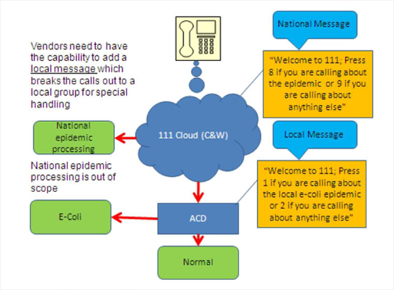

Furthermore all NHS funded organisations must recognise their EPRR responsibilities as detailed within section 46 & 47 of the Health and Social Care Act 2012

All NHS funded organisations need to be able to plan for and respond to a wide range of incidents and emergencies that could affect health or patient care. These could be anything from extreme weather conditions to an infectious disease outbreak or a major transport accident or a terrorist act. This is underpinned by legislation contained in the Civil Contingencies Act 2004 and the NHS Act 2006 (as amended).

This work is referred to in the health service as ‘emergency preparedness, resilience and response’ (EPRR).

In addition to meeting legislative duties, Provider Organisations are required to comply with guidance and framework documents, including but not limited to:

NHS England Business Continuity Management Framework NHS England Core Standards for Emergency Preparedness Resilience and Response (EPRR) NHS England EPRR Framework (2015) NHS England Operating Framework – Response to Pandemic Influenza ISO 22301 – Societal Security – Business Continuity Management Systems - Requirements; PAS 2015:2010 Framework for Health Services Resilience.

In accordance with the guidance and framework as outlined in the NHS England EPRR Framework 2015, provider organisations have a responsibility to:

- Support CCGs and NHS England, within their health economies, in discharging their EPRR functions and duties, locally and regionally, under the CCA 2004
- Have robust and effective structures in place to adequately plan, prepare and exercise the tactical and operational response arrangements both internally and with their local healthcare partners
- Ensure business continuity plans mitigate the impact of any emergency, so far as is reasonably practicable
- Ensure robust 24/7 communication “cascade and escalation” policies and procedures are in place, to inform CCGs and healthcare partners, as appropriate, of any incident impacting on service delivery
- Ensure that recovery planning is an integral part of its EPRR function
- Provide assurance that organisations are delivering their contractual obligations with respect to EPRR
- Ensure organisational planning and preparedness is based on current risk registers
- Provide appropriate director level representation at LHRP(s) and appropriate tactical and/or operational representation at local health economy planning groups in support of EPRR requirements

Furthermore the minimum requirements which NHS funded organisations must meet are set out in the Core Standards. These standards are in accordance with the CCA 2004, the NHS Act 2006 (as amended) and the Cabinet Office Expectations and Indicators of Good Practice set for Category 1 and 2 Responders. The latest version of the Core Standards can be found at http://www.england.nhs.uk/ourwork/eprr/gf/#core.

58. Clinical Governance

In accordance with National Guidance the UCC should demonstrate integrated clinical governance arrangements with clear lines of accountability to the commissioner, and are in place joining all facilities eg Emergency Dept, UCC and other Urgent Care Services.
The Provider(s) shall have in place a robust internal clinical governance structure with an identified senior clinical lead for each organisation. The clinical lead(s) will be responsible for assuring the clinical quality of the service(s) and that this is supported by a suite of robust policies and procedures. The policies and procedures (and any subsequent amendments to them) shall be submitted to the CCGs Clinical Group during mobilisation and afterwards via the Clinical Quality Review Group (CQRG) for review and approval. A range of metrics will be agreed to monitor service quality and these shall be reported to commissioners formally at CQRG and upon request by the Commissioner. The provider is expected to comply with the NWL core requirements and local quality indicators developed with the CCG.

The Provider(s) shall:
- Ensure a named Medical Director/Clinical Lead is appointed to the Service(s) to provide clinical leadership and that a substantial part of their role is spent at the Service(s) providing Clinical leadership to staff;
- Ensure the Clinical Lead is an experienced senior medical doctor who has the authority and responsibility to make decisions relating to the clinical direction of the Service;
- Ensure the Clinical Lead has had sufficient time and capacity to effectively undertake their duties. Part of the role of the Clinical Lead will be to link with local Primary Care, community based services and local urgent care providers across Brent, Harrow and Hillingdon CCGs in addition to the other inner London CCGs in NWL to promote and maintain a whole system integrated response; and
- The Clinical lead, as part of their role, will be required to engage with /participate in work that develops on-going understanding of the health needs of the local population and of local health care services.
- The Clinical lead should develop a policy for providing urgent care and clear pathways of care for all common conditions, in line with the UCC specification and ratified by the service providers board, with reference to the SaHF pathways, (See Appendix)

The Provider(s) shall ensure that:
- There is a named Governance Lead with a clinical governance supporting structure; and
- There is a clinical governance audit programme and processes to monitor clinical standards. This will be linked to the Royal College GP audit toolkitso there is systemic approach to measuring outcomes across NWL

The Provider shall ensure that all Serious Incidents (SIs) are notified to the CCG Clinical Lead and Commissioner via BHH SI team no later than the next working day after they incident occurred. Provider(s) shall report SIs via Serious Incident Management System (STEIS) where the incident meets SI criteria as defined in the current version of NHS England’s Serious Incident Framework or meets criteria for Never Event (NHS England Revised Never Events Policy and Framework).

The Clinical Lead(s) of the provider(s) delivering the Integrated Urgent Care Service(s) will need to participate in the development of shared governance structures with other urgent care providers in NWL and to move towards the implementation of system wide metrics to fully understand the performance of each component of the urgent care system. This is required to assure quality and ensure there is high quality and seamless integrated care for patients. This will require the Clinical Lead to work with the CCG, primary care networks and other services to achieve this outcome.

To support this, commissioners are requiring that a Joint Clinical Governance Group across all providers engaged in delivering the Integrated Urgent Care Service(s) is set up to foster joint working and drive continuous improvement. Membership will include clinicians from the appropriate providers and appropriate CCGs.

59. Engagement with Healthcare Professionals and Professional Feedback

Feedback from healthcare professionals is imperative in respect of the governance, safety and quality of the Integrated Urgent Care Service(s) and to enhance patient experience.
In addition to the formal processes for reporting an incident or making a complaint where there is significant cause for concern, systems to gain feedback from clinicians must be developed including end to end calls audit reviews. Existing policies and processes that provide evidence and facilitate raised awareness of issues should be used to inform improved systems for the collection and collation of information that will identify potential gaps, service conflicts, complaints and concerns.
Systems must include:
- Robust data capture in relation to incidents, complaints and concerns to enable full investigation;
- Provision of feedback mechanisms to allow healthcare professionals to comment on the quality and safety of Integrated Urgent Care Service(s);
- Implementation of actions to improve the quality of Integrated Urgent Care Service(s) to the commissioner and relevant healthcare professionals and,
- Dissemination of learning and sharing of best practice as a result of HCP feedback
In addition the provider will support attendance at clinical governance meetings.

60. Applicable National Standards (e.g.NICE)
Integrated Urgent Care Service(s) across Brent Harrow and Hillingdon must meet all national standards of service quality including, but not only, those set out in the following policy documents:
- NHS Integrated Urgent Care Commissioning Standards, NHS England, October 2015;
- NHS 111 Interoperability Standards 2.3
- The Interoperability Toolkit (ITK) set of national standards
- National Quality Requirements in the Delivery of Out-Of-Hours Services, DH, July 2006, Gateway ref: 6893;
- DH fact sheet 7: commissioning out-of-hours services, December 2005, Gateway ref:5917;
- Recommendations from Dr David Colin-Thomé and Professor Steve Field report on Out of Hours (2010);
- Out of Hours Standards, East of England (2010);
- Health and Social Care Act 2008 (Regulated Activities) Regulations 2014National Service Frameworks (NSFs);
- Department of Health Direction on Confidentiality (DH 2000);
- NHS England Serious Incident Framework 2015;
- Data Protection Act 1998;
- Freedom of Information Act 2000; and,
- Information Governance standards as set out in National Programme for Information Technology 2006 – 2007
- Out-of-Hours Services A Commissioning Hand book
- NHSE (2015) Safeguarding Vulnerable People in the NHS: Accountability and Assurance Framework.
- Care Act 2014

Provider(s) must be compliant to Level 2 for the Information Governance Statement of Complaint (IGSoC) toolkit or above to enable record sharing with other IGSoC compliant organisations without the need for a data/record sharing agreement.

The Integrated Urgent Care Service(s) must be aware that this specification may be subject to change in the light of changes in the National OOH Quality Requirements, and any other amendments or additions to the relevant legislation. The Integrated Urgent Care Service provider(s) will recognise the possible changes to the ‘in’ and ‘out' of hours times and have mechanisms in place that adjust resources and costs appropriately

61. KPIs and Metrics

A Schedule of meetings will be in place and Provider (s) must ensure an attendance by a representative is in place for each meeting

Provider(s) should ensure the data required to populate the Integrated Urgent Care Minimum Data Set (MDS) is supplied. This data should comply with current metrics in line with the MDS Provider Specification

The Current data collection is derived from the existing Out-of-Hours National Quality Requirements (NQRs) and the NHS 111 Minimum Data Set (MDS), however NHS England are working to establish a new suite of metrics for Integrated Urgent care.

This will result in the creation of a revised set of data items for the Integrated Urgent Care Model aligned to the quality framework categories of efficiency, safety and patient experience, the new MDS will be grouped under the integrated delivery elements of access, assessment, advice and treatment.

The Provider(s) must comply with these metrics once agreed.

A suite of KPIS for local submission will be issued (to follow). These will be included within the local quality schedule in addition to the NWL core requirements.

Provider Remedial Plans will be requested by the Commissioner in the event of continuous failure in any KPI or Metrics.

