

www.gov.uk/naturalengland
Request for Quotation Plus Annexes

FENN’S, WHIXALL & BETTISFIELD MOSSES NATIONAL NATURE RESERVE
Near Whitchurch, Shropshire

CONTROL OF BIRCH and PINE
on
Fenn’s Moss
In Sections 26, 48, and 51.

Request for Quotation
FENN’S, WHIXALL & BETTISFIELD MOSSES NATIONAL NATURE RESERVE
Near Whitchurch, Shropshire. CONTROL OF BIRCH AND PINE on Fenn’s Moss in Sections 26, 48, and 51 (23.13ha).

You are invited, to submit a quotation for the requirement described in the specification below.

Please confirm, by email, receipt of these documents and whether you intend to submit a quote.

Your response should be returned to the following email address by:

Email: eleana.Williams@naturalengland.org.uk and steve.dobbin@naturalengland.org.uk
copied to: peter.bowyer@naturalengland.org.uk
Date: Monday, 16th January 2023
Time: 10am

Ensure you state the reference number and ‘Final Submission’ in the subject field to make it clear that it is your response.

Contact Details and Timeline

Eleana Williams will be your contact for any questions linked to the content of the quote pack or the process. Please submit any questions by email and note that, unless commercially sensitive, both the question and the response will be circulated to all tenderers.

Action | Date
Date of issue of RFQ | 20 December 2023 @ 2pm
Viewing dates | 10 January 2023 @ 9.30am
Deadline for receipt of Quotation | 16 January 2023 @ 10am
Intended date of Contract Award | 16 January 2023
Intended Contract Start Date | 23 January 2023
Completion Date | 17 February 2023

Glossary

Unless the context otherwise requires the following words and expressions used within this Request for Quotation shall have the following meanings (to be interpreted in the singular or plural as the context requires):

“Authority” | Means the Department for Environment, Food and Rural Affairs acting as part of the Crown.
“RFQ” | Means this Request for Quotation and all related documents published by the Authority and made available to suppliers
“Contract” | Means the contract to be entered into by the Authority and the successful supplier.

Conditions applying to the RFQ

You should examine your response to the RFQ and related documents ensuring it is complete prior to submitting your completed quotation.

Your quotation must contain sufficient information to enable the Authority to evaluate it fairly and effectively. You should ensure that you have prepared your quotation fully and accurately and that prices quoted are arithmetically correct for the units stated.

The supplier by submitting a quotation is deemed to accept the terms and conditions in the RFQ. Failure to comply with the instructions set out in the RTQ may result in the supplier’s exclusion from this procurement.

Acceptance of Quotations

By issuing this RFQ the Authority does not bind itself to accept any quotation and reserves the right not to award a contract to any supplier who submits a quotation.

Costs

The Authority will not reimburse you for any costs and expenses which you incur preparing and submitting your quotation, even if the Authority amends or terminates the procurement process.

Mandatory Requirements

The RFQ includes mandatory requirements and, if you do not comply with them, your quotation will not be evaluated. All mandatory requirements are set out in Bravo.

Clarifications

The Authority reserves the right to discuss, confidentially, any aspect of your quotation with you prior to any award of Contract to clarify matters.

Amendments

The Authority may amend the RFQ at any time prior to the deadline for receipt. If it amends the RFQ the Authority will notify you in writing and may extend the deadline for receipt in order to give you a reasonable time in which to take the amendment into account.

Conditions of Contract

The terms and conditions attached Short Form (Services) will govern any contract awarded as a result of this RFQ process. The Authority will not accept any material changes to these terms and conditions proposed by a supplier.

Specification

The Authority is Natural England. The Authority’s priorities are to secure a healthy natural environment; a sustainable, low-carbon economy; a thriving farming sector and a sustainable, healthy and secure food supply. Further information about the Authority can be found at: www.naturalengland.org.uk

- Background:
Fenn’s, Whixall & Bettisfield Mosses NNR is Britain’s 3rd largest lowland raised peat-bog located near Whitchurch, Shropshire and Wrexham in Wales, in total approaching 1000ha (see Map, Annex 1.1). The NNR is a designated Special Area of Conservation, a Site of Special Scientific Interest and listed in the Ramsar Convention. The site, along with Wem Moss NNR has just completed the delivery phase of a large restoration project called the BogLIFE project which was led on the site by Natural England working in partnership with Natural Resources Wales and the Shropshire Wildlife Trust.

- Site/Access:
The sites of work are within the Fenn’s Moss area of Fenn's, Whixall & Bettisfield Mosses National Nature Reserve (NNR), located four miles south-west of Whitchurch (Shropshire). The NNR is split into management sections; the sections relevant to this contract are Section 26, Section 48 and Section 51, (see Annex 1.2 for NNR management section map).

Access to Section 51:
Access will be via Conery Lane, turning right onto Moss Lane just beyond the stables. Vehicle parking area is just before the entrance to Lodge Farm on the right-hand side of the track: what3words ///necks.elders.loaf .

Access to Section 48:
There are two potential parking areas to access the work sites on Section 48. The first is at the hammerhead located at the bottom of Conery Lane. The second is accessed via the disused railway line with parking area being on the Piccadilly Crossroads: what3words ///shielding.parade.enigma .

Access to Section 26:
This can be accessed from the parking area on the Piccadilly crossroads detailed above.

Rules Regarding Access:
Access tracks must not be blocked or damaged as some are Public Rights of Way and used by the public including residents, dog-walkers, horse-riders, NNR staff/volunteers and other contractors using machinery at times. Access onto the NNR via the disused railway line is through locked gates, keys to which will be provided to the successful contractor and which must be returned on completion of the contract.

Some of the site access tracks marked as purple and black dashed lines on Annexes 3.1 - 3.3, may be used by ATV’s or tracked vehicles should conditions allow. The vehicles intended for use on these tracks must be stated in the tender and use of the tracks by ATV/tracked vehicle must be discussed with a NNR reserve manager prior to use.

The appointed contractor must accompany Reserve Managers, Eleana Williams (07880 462312) and/or Steve Dobbin (07826 530767) prior to commencing work in any given area to inspect the scope of the work. The contractor must inform Eleana Williams and/or Steve Dobbin daily by text or email Eleana.Williams@naturalengland.org.uk / Steve.Dobbin@naturalengland.org.uk when work is to be undertaken.
- Task:
The aim of the contract is to herbicide treat birch and pine by cut and treat starting w/c 23rd January 2023.

This contract specifically covers areas of the moss where peat restoration work has been carried out using a process called cell bunding. Briefly, a network of impermeable, raised but low, (approx. 30cm tall) peat-berms (bunds) topped with vegetation have been created by machine in a network of cells in order to retain water on the bog, thereby aiding the re-wetting and regeneration of the bog which contributes hugely to atmospheric Carbon capture when active (see Annex 4 for photographs). Birch and Pine are undesirable as they act to dry out the bog and/or de-stabilise the low peat-banks that have been created.

The work is planned to begin on the 23rd January 2023 and needs to have been completed by 17th February 2023 at the latest. In your methodology, please state your availability and predicted timescale to complete the works.

In Section 4 of this specification and mapped in Annexes 3.1 and 3.3 are the areas identified to have birch and pine treated with an aquatic approved glyphosate herbicide.

The birch varies in height from approximately 0.5m to 3m tall scrub. Its density varies between and within work areas but an approximate ground cover/density varying being a light and moderate density. N.B. please be aware that the densities are estimates for general guidance only and not absolute or confirmed areas/densities to be relied on for cost estimation. It is strongly recommended that you visit the site prior to submitting a quote.

The task is to cut all birch and pine above the specified height (see section 4 of the specification) at their base and treat the stumps within 6hrs using an aquatic approved herbicide. All pines within the work areas are to be cut below the lowest branch and treated, where pines are small they can be pulled out of the ground instead of being cut if practical to do so. Other woody species such as Willow, Rowen, Alder buckthorn and Oak are only to be cut and treated if they are on the top or side wall of a bund.

Brash is to be piled into small (maximum 1m tall) piles across the Section 26 work area. Brash piles must not cover bunds. Where the scrub is sparce the cuttings can be left where they fall. Sections 48 and 51 do not need the brash to be stacked.

- Work Area Details:
The work areas to be treated are shown in Annexes 3.1 and 3.2 & 3.3, these areas equate to 23.13ha. Some areas may be excluded from the contract if costs exceed the available budget. The boundaries of all areas to be treated have been marked out with in readiness for the contract starting. Contractors may use their own flags for guidance or to define progress, but these must be removed on completion of each management section.

Section 26 West and East
Total Area for 26 West: 2.85 ha
Total Area of 26 East: 1.96 ha
Annex 3.1 map

100% of Birch above approx. 80cm / waist height across the area, both on and off bunds. 100% of pine of all heights. Other woody species such as Willow, Rowen, Alder buckthorn and Oak are only to be cut and treated if they are on the top or side wall of bund.

Boundaries: all have been marked out with canes flagged with red/white tape.

- There are two adjoining areas in Section 26. To help differentiate between these areas, lengths of orange tape (in addition to the standard red/white tape) will be tied to the boundary marker canes of the North-East work area.
- Scrub detailed above to be cleared up to and including peripheral bunds (where present) and 1m out from peripheral bunds. Note; whilst some of the boundaries are on bunds, others are not, and some are a combination of the two. In all cases, marker canes will be used to clarify.

Section 48 North
Total Area: 0.27ha
Annex 3.2 map

100% of Birch above approx. 50cm / knee height across all cells and bunds, up to and including peripheral bunds as well as 1m out from peripheral bunds. 100% of pine of all sizes across the same area. Other woody species such as Willow, Rowen, Alder buckthorn and Oak are only to be cut and treated if they are on the top or side wall of bund.

Boundaries: (all have been marked out with canes flagged with red/white tape)

- North – 1 out from the perimeter bund running parallel to the fence line
- East – 1m out from the perimeter bund running parallel to the ditch running North-South towards the public footpath
- South – 1 out from the perimeter bund running parallel to the public footpath and ditch line
- West – 1m out from the perimeter bund

Section 48 West
Total Area: 4.5ha
Annex 3.2 map

100% of Birch above approx. 50cm / knee height across all cells and bunds, up to and including peripheral bunds as well as 1m out from peripheral bunds. 100% of pine of all sizes across the same area. Other woody species such as Willow, Rowen, Alder buckthorn and Oak are only to be cut and treated if they are on the top or side wall of bund.

Boundaries: (all have been marked out with canes flagged with red/white tape)

- North – 1m out from the perimeter bund running parallel to the public footpath
- East – Up to the edge of the ditch running north-south through section 48
- South – 1m out from the perimeter bund running parallel to the footpath
- West – 1m out from the perimeter bund

Section 48 Centre
Total Area: 3.83ha
Annex 3.2 map

100% of Birch above approx. 50cm / knee height across all cells and bunds, up to and including peripheral bunds as well as 1m out from peripheral bunds. 100% of pine of all sizes across the same area. Other woody species such as Willow, Rowen, Alder buckthorn and Oak are only to be cut and treated if they are on the top or side wall of bund.

Boundaries: (all have been marked out with canes flagged with red/white tape)

- North - 1m out from the perimeter bunds. Running parallel to the public footpath
- East - 1m out from the perimeter bund, running parallel to the access track.
- West – Up to the edge of the ditch running north-south through the site. This includes any ditch crossings that are in this ditch
- South – Up to the edge of the ditch running east-west through the site. This includes any ditch crossings that are in this ditch

Section 48 East
Total Area: 1.02ha
Annex 3.2 map

100% of Birch above approx. 50cm / knee height across all cells and bunds, up to and including peripheral bunds as well as 1m out from peripheral bunds. 100% of pine of all sizes across the same area. Other woody species such as Willow, Rowen, Alder buckthorn and Oak are only to be cut and treated if they are on the top or side wall of bund.

Boundaries: (all have been marked out with canes flagged with red/white tape)

- North – 1m out from the perimeter bund
- East – 1m out from the perimeter bund
- South – 1m out from the perimeter bund, this runs parallel to the disused railway line and brash track
- West – 1m out from the perimeter bund, this runs parallel to the access track running north-south through section 48

Section 48 - South
Total Area: 7.5 ha
Annex 3.2 map

100% of Birch above approx. 50cm / knee height across all cells and bunds, up to and including peripheral bunds as well as 1m out from peripheral bunds. 100% of pine of all sizes across the same area. Other woody species such as Willow, Rowen, Alder buckthorn and Oak are only to be cut and treated if they are on the top or side wall of bund.

Boundaries: (all have been marked out with canes flagged with red/white tape)
- North – up to ditch running east-west, including crossing points
- East – 1m out from peripheral bund running parallel to track
- South – 1m out from peripheral bund running parallel to brash track
- West – up to ditch running north-south, including crossing points

Section 51
Total Area: 1.2ha
Annex 3.3 map

100% of Birch above approx. 50cm / knee height across all cells and bunds, up to and including peripheral bunds as well as 1m out from peripheral bunds. 100% of pine of all sizes across the same area. Other woody species such as Willow, Rowen, Alder buckthorn and Oak are only to be cut and treated if they are on the top or side wall of bund.

Boundaries: (all have been marked out with canes flagged with red/white tape)
- North – 1m out from peripheral bund adjacent to higher, un-bunded area.
- East – 1m out from peripheral bund running parallel to access road.
- South – 1m out from peripheral bund running parallel to public right of way.
- West – this is an internal bund, west of which becomes too waterlogged to allow cut and treat operations. As with the others, this bund is marked with canes and where possible the works are to include cut and treat operations 1m out from the bund.

- Herbicide (Cut and Treat):

When working in the moss whether bunded or not, caution should be exercised as some areas are very wet with soft bases, especially if there is no vegetation on the peat. Contractors should try to walk on grassy tussocks within the cells and try as far as possible to avoid walking on bog-mosses which are fragile and normally denote very wet areas. Depending on recent rainfall, it may not be possible to treat the very wettest cells and the NE reserve manager/s should be informed of any areas where this is the case.

The bund-walls are all firm and wide enough to walk on with care but some have a layer of tussocky, uneven vegetation; additionally, there are “borrow pits” where diggers have extracted underlying peat in order to create the bunds. These run directly next to the bund walls and are deeper and wetter than the cell base so should be avoided so concentration is required when working/walking on the bund walls.

Some areas have had previous scrub removal contracts on and may have scrub stumps and brash on the ground; these are trip hazards that can make walking over the area more difficult which can also be very wet and uneven; caution should therefore be exercised when working in or crossing these areas.

Birch growing from seed and stumps are to be cut and treated with an aquatic approved Glyphosate herbicide made up with water or an adjuvant at manufacturer’s recommended rates.

Blue dye must be mixed with the herbicide at manufacturer’s recommended concentration to enable the treated plants to be distinguished. Care must be taken to minimise run-off onto any non-target plants, particularly rare mire plants such as sphagnum, moss, Common Cotton-grass, Hare’s-tail Cotton-grass, Cross-leaved Heath, Crowberry and Cranberry. Marker canes with flags should be used to ensure that all areas are covered but must be removed after use.
All Herbicide, blue dye, adjuvant & water to be supplied by the contractor. Contractors must specify which Glyphosate formulation and adjuvant they will use in their method statement. The cut and treat methodology/ equipment must also be specified. The methodology should specify any measures/equipment that will be used to minimise run-off.

Scrub control can commence from 23rd January 2023 and must be completed by 17th February, 2023 but should not be carried out if rain is forecast within 6 hours of application and allowance for weather interruptions should factored into the contract timings.

Adders are known to hibernate on site, known hibernaculum’s will be marked with yellow and black hazard tape, and work is not to take place within those marked areas. If contractors spot an adder, do not work within 10m of sighting and notify the NE staff immediately.

The contractor must liaise with the NE reserve managers before commencing works on any of the sections. Natural England has a new Contractor policy (Sept 2022) which includes an on-site induction form which has to be completed prior to any works commencing.

- Contractor obligations:
Herbicide is only to be applied by a person holding NPTC PA1 & PA6AW certificates or equivalent. Copies of such certificates should be included in the tender. Any waste/spare herbicide is to be re-wiped on the area treated.

NO LONE WORKING. Contractors/workers are expected to work in pairs as a minimum when working on the bunds and with chemicals for Health and Safety reasons. Workers should carry a mobile ‘phone in case of an emergency and a throw-line must be available should any worker accidentally get “bogged”. The cells in certain areas have got very wet following restoration work and recent wet weather. The contractor is expected to provide first aid/emergency eye-wash provision and an adequate number of trained first-aiders.

Appropriate PPE including spray boots, visors, coveralls and nitrile gloves to be supplied and worn at all times by the contractor and workers. Warning signs to be erected on approach tracks. Copies of First Aid Training Certificates are to be included in the Tender.

Sit in ATV’s/ATV’s or 4x4 vehicles only to be used on site by persons with current NPTC/LANTRA accredited certificates of training. Herbicide is to be applied by a person holding NPTC PA1 & PA6/AW/MC certificate or equivalent. Chainsaws are only to be used by persons with current chainsaw certificates including NPTC CS30, 31 & 36 (or equivalent). Low eco-toxicity non-fling bio-degradable chainsaw oil to be used. Hand and Arm vibration syndrome (HAVS) regulations & guidelines to be followed. Clearing saws are only to be used by persons with current NPTC brush-cutter/clearing saw certificates. Hand and Arm vibration syndrome (HAVS) regulations & guidelines to be followed. Copies of such certificates to be included in the tender.

Care must be taken not to damage the tracks if using ATVs/ Powered wheelbarrows/ 4x4vehicles to access the work areas. Natural England reserves the right to limit access if excessive damage is being caused to the tracks.

The contractor shall indemnify Natural England & Natural Resources Wales against all reasonable claims arising out of his/her operations and shall insure against all claims made as a result of these operations either by Natural England/Natural Resources Wales or third parties.
All work must comply with HASAW, COSHH, HAVS, Noise and FEPA regulations. Care must be taken because of the presence of ditches/borrow-pits, wet holes, cut stumps, brash, brambles, tree-roots, adders and other animals on site.

No smoking on site.

A list of site hazards is attached below. The contractor must submit their Method Statement and example Risk Assessments in the Tender but full site-specific Risk Assessments before starting the Contract. These must be approved prior to the commencement of work. Natural England examples of operational Risk Assessments are included as examples - ANNEX 5.
A record of all herbicide used must be completed on the Herbicide Record sheet attached ANNEX 6. This must be returned to the Reserve Managers when submitting invoices.

The contractor must inform the NE reserve managers by email or text as to when work is being carried out so that work progress can be inspected, and any issues discussed.
No dogs or other animals to be brought onto site.

Any accidents on the site must be reported immediately to the Reserve Managers so an incident report can be completed.
7. SITE HAZARDS:

a. Disorienting, uneven, and unstable terrain. Cut tree & scrub stumps, uprooted stumps and branches are frequent with bramble in places. Sections 51 and 48 were conifer plantations and have a particularly high density of stumps and brash.

b. In places the bund-walls are not always discernibly different from the cells and all bunds have a borrow-pit running along one side of them which is generally deeper and wetter than the bulk of the cell within.

c. Access and the bunded cells can be waterlogged in wet weather.

d. Throughout the site it is possible to sink into soft peat but particularly in the borrow pits, machine ruts and old ditches.

e. The area is includes drainage ditches and peat cuttings, which may be hidden by vegetation, either empty or filled with deep water and soft peat. Banks may be unstable.

f. Trees on the bog margins can be shallow-rooted and can become unstable in high winds. Mature trees may shed branches, especially in windy weather.

g. Vegetation (particularly bracken and purple-moor grass litter) poses a fire risk in dry and windy conditions all year round. No smoking.

h. Adders, midges, horseflies and other biting insects are present on site.

i. Due regard must be exercised when working near Public Rights of Way/permissive NNR Trails for walkers, dogs and horse-riders especially with regard to chemical /fuel use.

j. There is a regular pheasant shoot on Fenn’s Moss. This affects Section 26 – there is no shooting on Sections 48 & 51. The dates and shoot contact info will be supplied to the successful contractor. The contractor to notify the NNR Reserve Managers if they will be on site on any of the shoot days. High visibility clothing to be worn on Fenn’s shoot days.

8. Contract Evaluation:

Invoicing:
Invoices should be received before end February 2023. Contractors shall make no financial investment in the project and, therefore, shall not benefit from any intellectual property rights arising from the project. The Purchase Order number must be included on the invoice, or it will be rejected.

Site Visits:
Site visits with Reserve Manager’s Steven Dobbin and Ellie Williams will be held on Tuesday, 10th January 2023 at 9.30am, meeting at the Conery Lane Layby ///hems.heat.purchaser . Details on how to get there will be sent to the contractors that confirm their attendance. These will be entirely outdoor-based. Unguided return visits are permitted as long as notice is given. Instructions will be sent out to those who book

Please contact Reserve Managers Ellie Williams 07880 462312/ Eleana.Williams@naturalengland.org.uk or Steve Dobbin 07826 530767/ Steve.Dobbin@naturalengland.org.uk by 1pm on Monday, 9th January 2023.
If you are unable to make any of these dates, please contact the Reserve Managers to arrange an alternative.

Prices
Prices must be submitted in £ sterling, inclusive of VAT.
It is anticipated that this contract will be awarded for a period of 4 weeks ending no later than February 17th 2023. Prices will remain fixed for the duration of the contract award period. We may at our sole discretion extend this contract to include related or further work. Any extension shall be agreed in advance of any work commencing and may be subject to further competition.

Pricing schedule:
For works detailed in the specification above. NOTE depending on available funding, not all of the work may be commissioned.

Quotation Submission:

We will award this contract in line with the most economically advantageous tender (MEAT) as set out in the following award criteria:
Price – 50%
Quality – 50%

Only part of the work may be contracted depending on the availability of funding.
The following quality criteria are weighted in accordance with the importance and relevance

The 50% quality aspect of the evaluation will be assessed on the below criteria and given the below weighting within the 50% quality score.
Criteria | Weighting | To Include:
Methodology | 50% | - Capacity  - Timescales  - Equipment  - Communication | - Method  - Transportation inc. fueling  - Reducing damage to bog and tracks
Experience and Expertise | 25% | - List of workers  - Their relevant qualifications | - Experience of working on peatlands  - Experience with Cut and treat  - Sub- contractors
Health and Safety | 20% | - Example risk assessment  - Health and Safety Policy | - Site-specific emergency plan for transport, pollution, and fire prevention  - Employees and Public Liability Insurance
Sustainability | 5% | - Sustainable practices employed through contract  - Sustainable practices in general operations

Score | Justification
For a score of hundred (100): | Excellent - Response is completely relevant and excellent overall. The response is comprehensive, unambiguous and demonstrates a thorough understanding of the requirement and provides details of how the requirement will be met in full.
For a score of seventy (70): | Good - Response is relevant and good. The response demonstrates a good understanding and provides details on how the requirements will be fulfilled.
For a score of fifty (50): | Acceptable - Response is relevant and acceptable. The response provides sufficient evidence to fulfil basic requirements.
For a score of twenty (20): | Poor - Response is partially relevant and/or poor. The response addresses some elements of the requirements but contains insufficient / limited detail or explanation to demonstrate how the requirement will be fulfilled.
For a score of zero (0): | Unacceptable - Nil or inadequate response. Fails to demonstrate an ability to meet the requirement.

Relevant certificates of employee’s working on the task, insurance certificates, and site-specific risk assessments MUST be provided by the successful contractor prior to starting.

Quotation: Removal of Birch and Pine on Fenn’s Moss through Cut and Treat 2022/23

NNR Management Section | Area (ha) | Fixed Price (Excluding VAT)
26 West | 2.85
26 East | 1.96
48 North | 0.27
48 Centre | 3.83
48 East | 1.02
48 South | 7.5
48 West | 4.5
51 | 1.2
 | Total Price excluding VAT
 | VAT
 | Total Price including VAT

I can commence work by ………………………………………………………………….

If successful will provide a copy of relevant sit in ATV/sit astride ATV, pesticide, first-aid, 4x4, brush-cutter/clearing saw, chainsaw, insurance certificates and site-specific risk assessment
……………………………………….…………………………………………………….

I attach a copy of my brief method statement for the job including use of all machinery / vehicles

………………………………………………………………..

I can do all/ part of the work (please specify) …………………………………………….

I envisage that I can complete the work within the required timescale .......................

Signed ……………………………………………………………………………………….

Position ………………………………………………………………………………………

Date …………………………………………………………………………………………

Disclosure

All Central Government Departments, their Executive Agencies and Non Departmental Public Bodies are subject to control and reporting within Government. In particular, they report to the Cabinet Office and HM Treasury for all expenditure. Further the Cabinet Office has a cross-Government role delivering overall Government policy on public procurement, including ensuring value for money and related aspects of good procurement practice.

For these purposes, the Authority may disclose within Government any details contained in your quotation. The information will not be disclosed outside Government during the procurement.

In addition, the Authority is subject to the Freedom of Information Act 2000 and the Environmental Information Regulations 2004, which provide a public right of access to information held by public bodies. In accordance with these two statutes, the Authority may be required to disclose information contained in your quotation to any person who submits a request for information pursuant to those statutes.

By submitting a quotation you consent to these terms as part of the procurement.

Disclaimers

Whilst the information in this RFQ and any supporting information referred to herein or provided to you by the Authority have been prepared in good faith the Authority does not warrant that this information is comprehensive or that it has been independently verified.

The Authority does not:

- make any representation or warranty (express or implied) as to the accuracy, reasonableness or completeness of the RFQ;

- accept any liability for the information contained in the RFQ or for the fairness, accuracy or completeness of that information; or

- accept any liability for any loss or damage (other than in respect of fraudulent misrepresentation or any other liability which cannot lawfully be excluded) arising as a result of reliance on such information or any subsequent communication.

Any supplier considering entering into contractual relationships with the Authority following receipt of the RFQ should make its own investigations and independent assessment of the Authority and its requirements for the goods and/or services and should seek its own professional financial and legal advice.

Protection of Personal Data

In order to comply with the General Data Protection Regulations 2018 the contractor must agree to the following:

- You must only process any personal data in strict accordance with instructions from the Authority
- You must ensure that all the personal data that we disclose to you or you collect on our behalf under this agreement are kept confidential.
- You must take reasonable steps to ensure the reliability of employees who have access to personal data.
- Only employees who may be required to assist in meeting the obligations under this agreement may have access to the personal data.
- Any disclosure of personal data must be made in confidence and extend only so far as that which is specifically necessary for the purposes of this agreement.
- You must ensure that there are appropriate security measures in place to safeguard against any unauthorised access or unlawful processing or accidental loss, destruction or damage or disclosure of the personal data.
- On termination of this agreement, for whatever reason, the personal data must be returned to us promptly and safely, together with all copies in your possession or control.

General Data Protection Regulations 2018
For the purposes of the Regulations the Authority is the data processor.

The personal information that we have asked you provide on individuals (data subjects) that will be working for you on this contract will be used in compiling the tender list and in assessing your offer. If you are unsuccessful the information will be held and destroyed within two years of the award of contracts. If you are awarded a contract it will be retained for the duration of the contract and destroyed within seven years of the contract’s expiry.

We may monitor the performance of the individuals during the execution of the contract, and the results of our monitoring, together with the information that you have provided, will be used in determining what work is allocated under the contract, and in any renewal of the contract or in the award of future contracts of a similar nature. The information will not be disclosed to anyone outside the Authority without the consent of the data subject, unless the Authority is required by law to make such disclosures.

List of Annexes:

- Annex 1.1 Location map
- Annex 1.2 Fenn’s, Whixall & Bettisfield Mosses NNR Management
Sections
- Annex 2 Work areas and access
- Annex 3.1 Section 26 Works Area
- Annex 3.2 Section 48 Works Area
- Annex 3.3 Section 51 Works Area
- Annex 4 Photographic examples
- Annex 5 Sample Risk Assessments (for guidance)
- Annex 6 Herbicide Record Sheet
- Annex 7 Condensed Terms and Conditions Example

Annex 1.1: Location Map

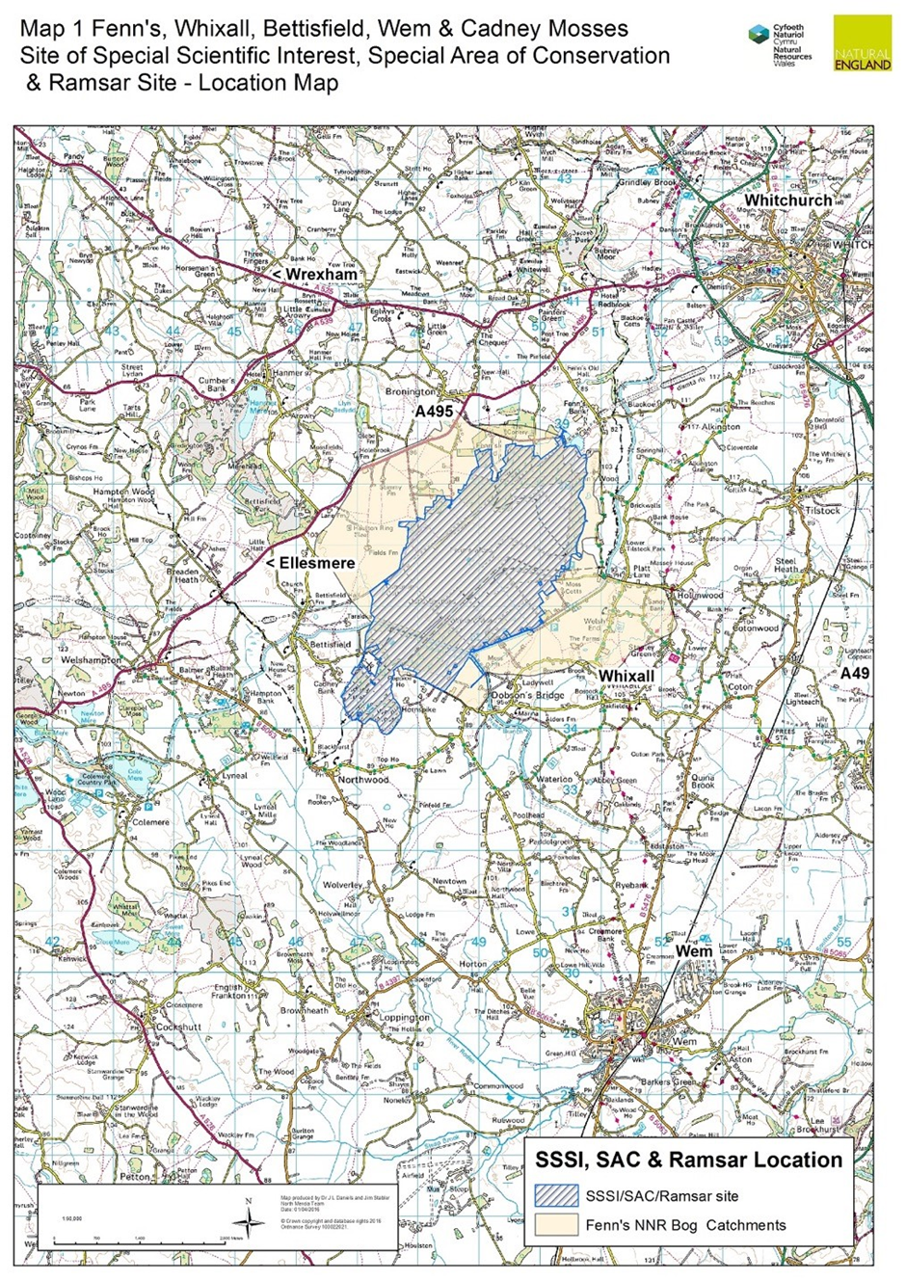

Annex 1.2: NNR Management Sections

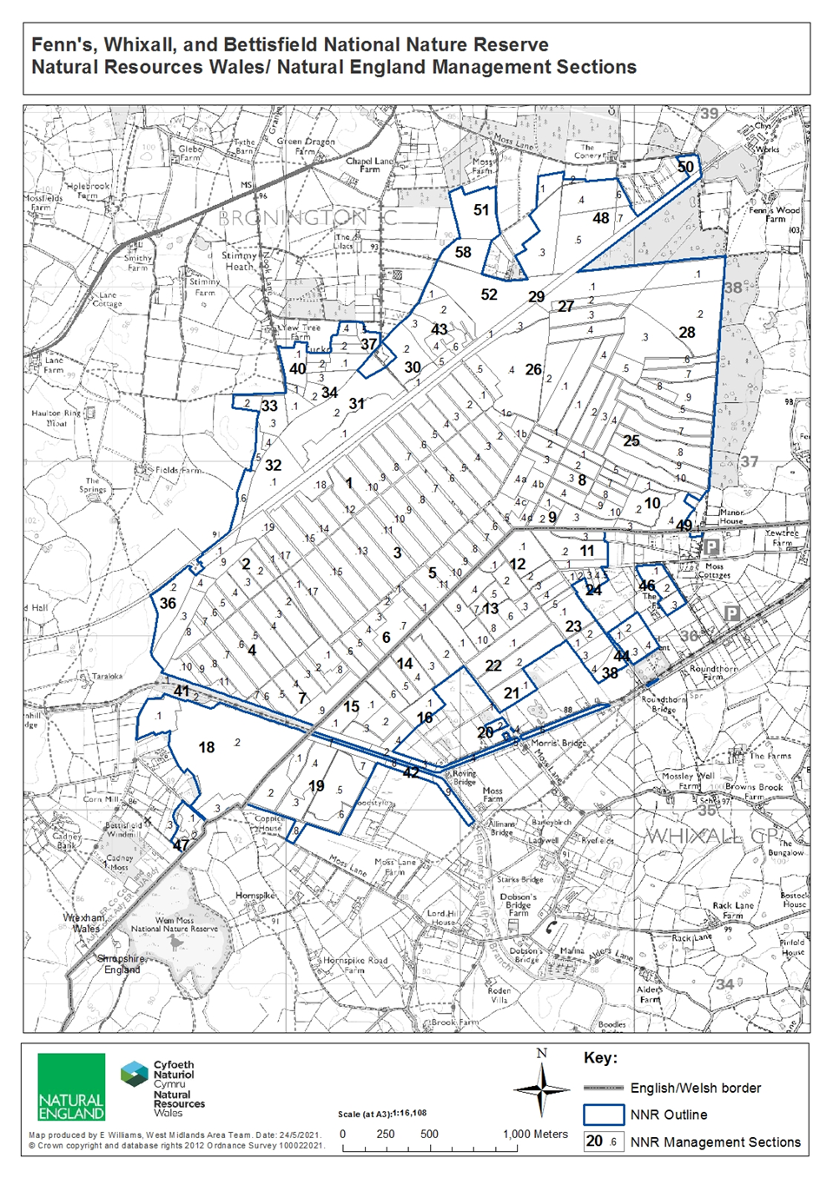

Annex 2: All work areas and Access
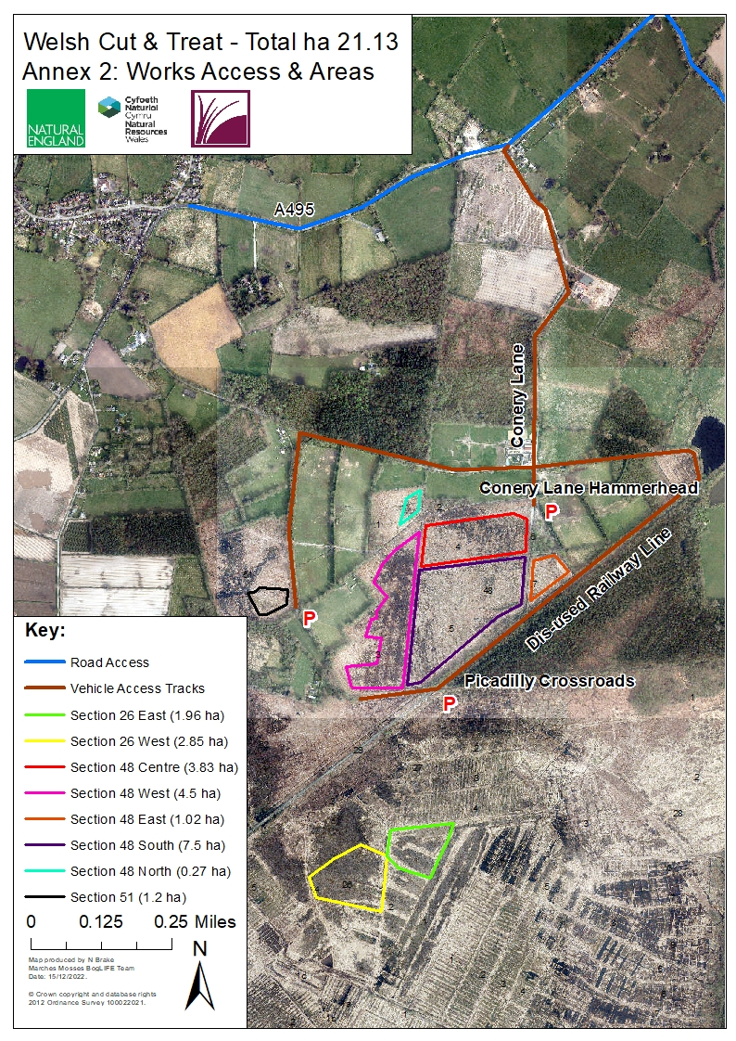

Annex 3: Detailed Work Area Maps

Annex 3.1: Detailed map of S26

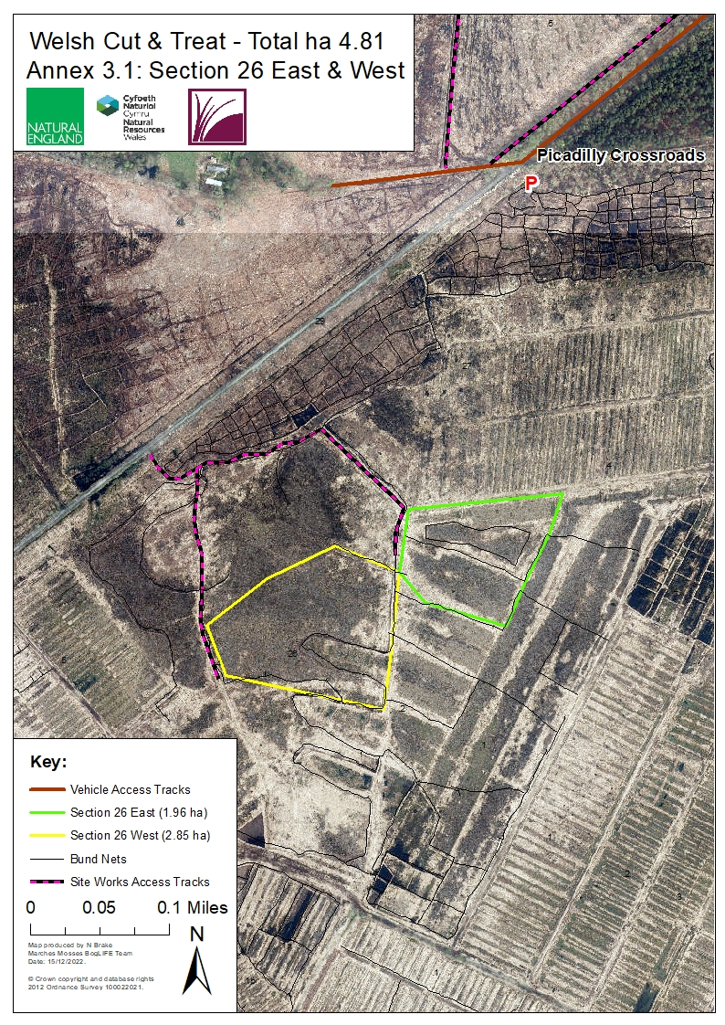

Annex 3.2: Detailed Map of works in Section 48.
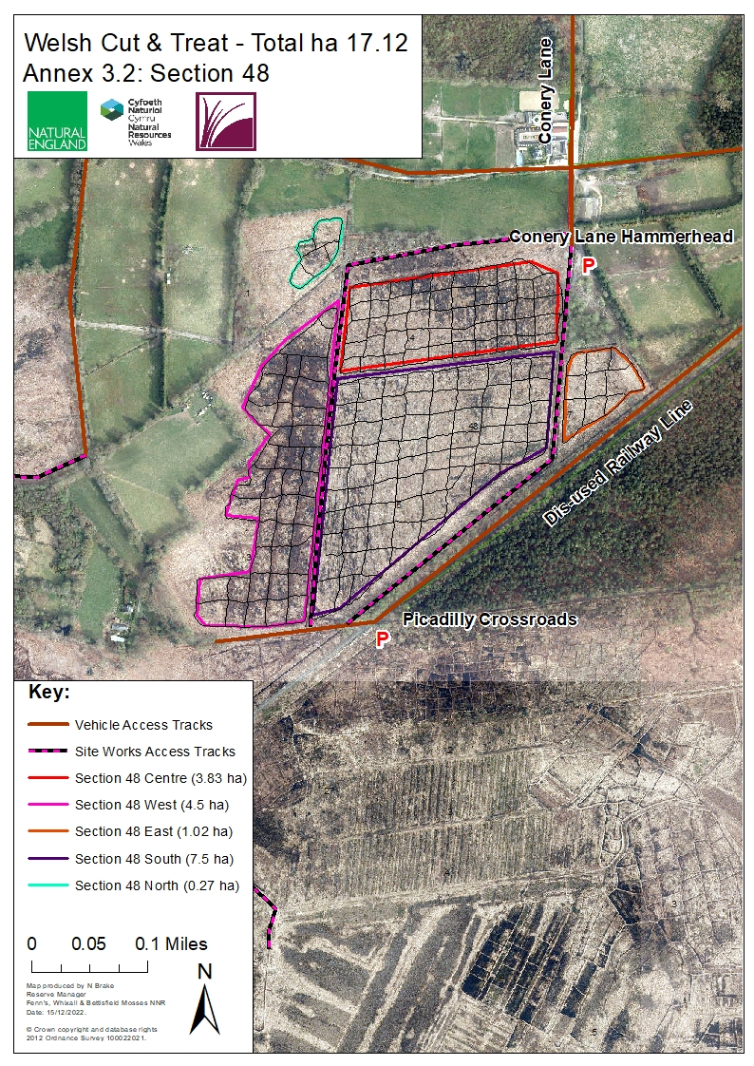
Annex 3.3: Detailed Map of works in Section 51.

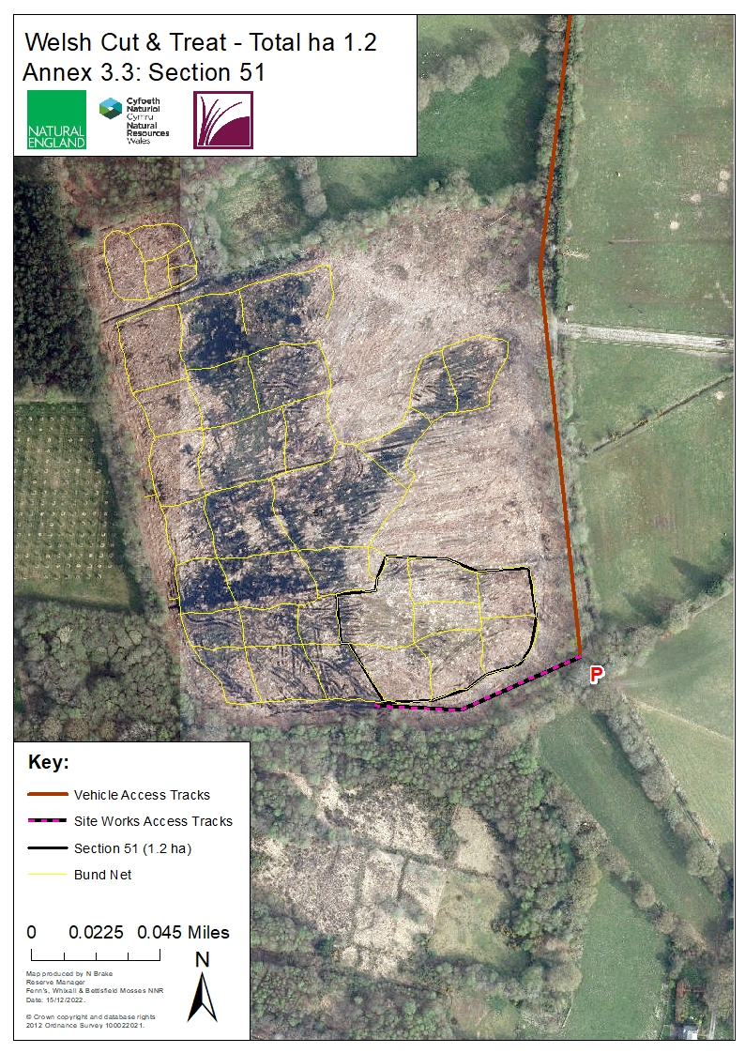

Annex 4: Photo examples of background

Initial Bunding Process (– simply for info)
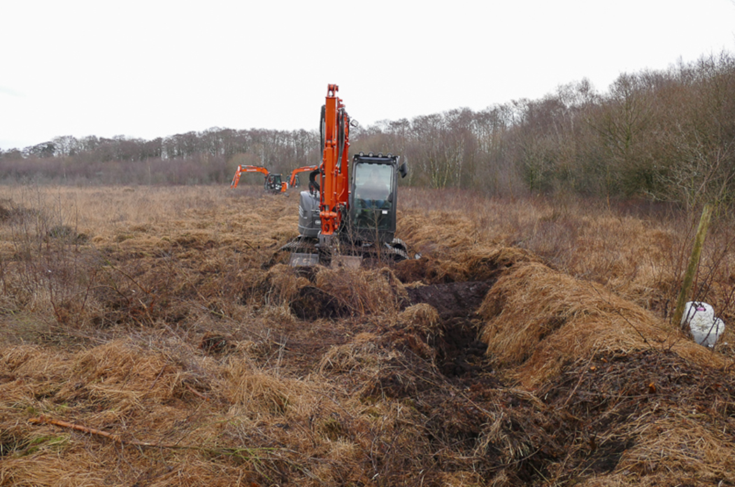
A network of peat banks (bunds) are made and covered with vegetation

Bunded Area 2 years later. The bunds are the green strips and the cells the wetter areas between. In this example, re-wetting has been successful with only sparse Birch re-growth on the bund walls.
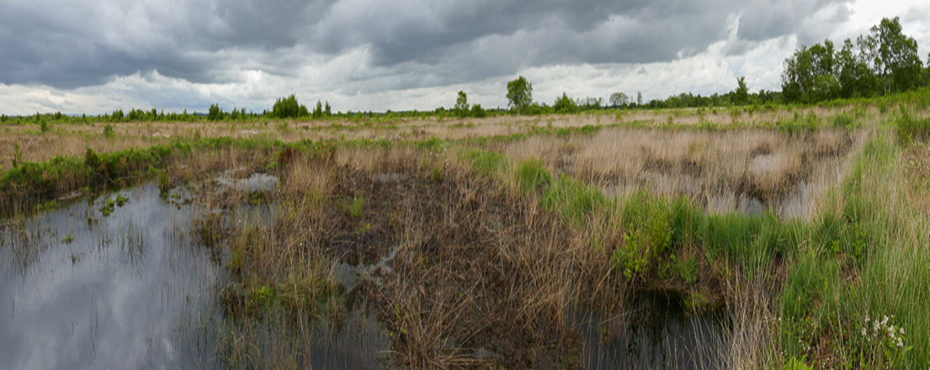

Annex 5: Sample Risk Assessments

- Working on Peatlands:

NNRs covered by this risk assessment: | Fenn’s, Whixall and Bettisfield Mosses NNR |  |  | Date completed: | 30/03/2020
Assessment of (e.g. Activity, Equipment, Individual) | Working on Peatlands |  |  | Review date (max 1 year): | 30/03/2021
Training required? Tick all that apply |  |  |  | Signed off by (SRM/ Line Manager):
Training course: |  |  |  | Mandatory/Optional | Applicable?
First Aid at Work |  |  |  | Mandatory
Other (Please specify):
Notes (e.g. mandatory safety precautions) | Site safety maps are kept in all NNR vehicles. This map together with site safety information is emailed to third parties as appropriate.  Vodafone signal on NE Phones is generally good. Third parties to check phone signal whilst on site. Emergency contacts card in all NNR Vehicles & NE first aid kits.  Follow NE lone working policy as appropriate.  Risk assessments are available for all related operations – refer to these as necessary. In particular refer to:  - General safety - Personal  - General safety - Site (Fenns, Whixall and Bettisfield Mosses)  First aid kit in all NNR vehicles & each member of staff has a personal NE Kit. Eyewash in all NNR First aid kits & NNR Vehicles.  Note: young persons, new & expectant mothers etc., a separate risk assessment should be recorded.
Minimum PPE/RPE requirements | - Work Gloves  - Rubber gloves and Nitrile Examination Gloves – when working with water  - Steel toe capped high ankle boots/ wellingtons (EN ISO 20345:20011)
What are the hazards common to all? | Who might be harmed and how? | What precautions are you already taking? | What additional local precautions are required?
Uneven, often soft terrain, particularly on rehabilitated cuttings. Old peat pits. | Staff, Volunteers and Contractors  Slips and Trips | Where possible avoid work in the wettest areas over the winter season.  Wear suitable footwear (waterproof if necessary) with a firm grip. | Pre-plan works using site maps to determine where heavily cut areas are in the work area.  Walk over site with caution in-case peat pits are over grown/covered by brash.
Danger of machinery bogging down and overturning. Uneven tracks. Vehicles tip sideways when one pair of wheels is kept on the firm track side and the other is in soft peat. | Staff, Volunteers and Contractors  Cuts, Bruises, Whip Lash, Concussion | Only trained drivers to drive machinery.  Fill track holes with peat/chip.  Protect personnel in vehicles and goods on trailers.  Tractor link-boxes must not be used for personnel carriage.  Cover blades of all sharp tools. All small or sharp-edged tools in trailers/tractor link boxes must should be carried in a tool box.  There are First Aid kits in every vehicle. | Pick routes to avoid known wet spots on tracks and peat cuttings.
Ditches, bog pools, fire pools, pits Fenn’s Main drain weir, wide U-pipes and other watercourses.  Minor ditches 0.5-1 m deep. Main drains >1 m deep. Overhanging and floating plants, sides unstable. Soft, ‘bottomless’ base to dammed cuttings | Staff, Volunteers and Contractors.  Drowning, Hypothermia | Maintain official crossing places and make personnel and others aware of their positions. | Otherwise cross established peat dams Ensure workers know the drain pattern in the work area.  No lone working on very soft saturated areas, by the main drain & Sect. 14 south and 11.1  Avoid the Fenn’s weir and ensure netting is maintained on large U-pipes.  Maintain safety fencing at the Fenn’s Old Works railway culvert, the Marl Allotment ditch and Bettisfield pond  Bring throw line when working close to main drains.  Leave the Moss at dusk unless on special monitoring tasks.  One side of fire pools is graded to permit escape. Keep spare set of clothing at NNR Base in case of falling in ditches. Emergency shower at NNR base.  Maintain deep drain, weir, crossing point and fire pool signs and posts.
Deep pools/ borrow pits by dams and bunds | Staff, Volunteers and Contractors  Drowning, Hypothermia |  | Warn users crossing dams or walking on bunds.  Test dams/bunds before crossing.  Don’t step off dams/bunds into water where you can’t see the ground beneath.
Slippery ditch crossings/ ragged mesh covering | Staff, Volunteers and Contractors  Slips, Trips, Cuts and Bruises | Replace rotten sleepers and maintain bridge marker posts and mesh on walkways.  Remove and replace any loose mesh.  Walk over crossings with caution. | Inspect for and clear of peat regularly.
Main Drain - polluted water and deep silt in base, half full downstream of wear so hard to climb out of. | Staff, Volunteers and Contractors  Weil’s disease, Sporotrichosis, Hypothermia and Drowning. | Wear rubber gloves with nitrile examination gloves underneath when working in ditches.  Wash hands before eating or drinking if they have been working in ditch.  Workers to be made aware of their flu like symptoms. | No lone working involving the Main Drain, without regular telephone contact with another worker.  Take throw-line if working by the Main Drain.  Be aware of shallower 100 yd interval side drains.
Unstable shallow-rooted trees prone to windblow. | Staff, Volunteers and Contractors  Crush injuries, Concussion, Cuts and Bruises. | Check the weather forecast prior to work near trees. | Keep out of unstable peat areas.  No lone working and wear waders in unstable carr area on 14.1 and 11.1 and along the Quob. Be aware that trees can flip if being winched.  Avoid trees on peat in high winds. If unavoidable wear a hard hat.
Adders | Staff, Volunteers and Contractors  Inflammation, Pain, Bruising, Nausea, Fast Heart Rate, Sweating, Breathing Difficulties, Confusion and Dizziness | Look before touching the ground/sitting down.  Wellingtons/high boots should be worn at all possible times.  Check for adders in areas where work is being carried out.  First aid procedure if bitten:  -Remain calm and keep the part of the body that been bitten as still as possible to prevent the spread of venom around the body.  -Remove jewellery/watches from around the bitten limb.  -Loosen clothing if possible.  -Keep the casualty still and calm.  -Seek immediate medical attention by dialling 999. | Signs on noticeboards explaining the first aid procedure.  Wear gauntlet gloves when lifting brash and rubbish.
Stings and Bites – Insects/Plants | Staff, Volunteers and Contractors  Irritation, Illness and Inflammation | Wear long sleeves/full length trousers.  Use Insect repellent.  Use anti-inflammatory on any effected areas.  Wear work gloves when working with stinging/ thorny plants.
Slippery irregular brash mats. Brash obscuring ditches. Roots can project from tracks. Projecting tree/bush stumps, obscured by vegetation. | Staff, Volunteers and Contractors  Slips and Trips | Warn public to keep off the brash tracks.  Trail routes are to be inspected regularly for projecting roots, overhanging trees etc.  Noting if tree work has previously taken place in that work area.
Projecting metal | Staff, Volunteers and Contractors  Cuts, Bruises, Slips and Trips | Inspect work areas.  Wear work gloves if moving metal.  Wear steel toe capped boots/wellingtons on site, especially if working near known metal.  Inform others wear metal has been found. Mark on annual audit.

- Use of Pesticides:

NNRs covered by this risk assessment: | Fenn’s, Whixall and Bettisfield Mosses NNR |  | Date completed: | 26/03/2020
Assessment of (e.g. Activity, Equipment, Individual) | Pesticide use |  | Review date (max 1 year): | 26/03/2021
Training required?  Yes |  |  | Signed off by (SRM/ Line Manager):
Training course: |  |  | Mandatory/Optional | Applicable? ()
PA 1 |  |  | Mandatory | ❐
PA 6 |  |  | Mandatory | ❐
PA 6AW – If by a water course |  |  | Mandatory | ❐
PA 6MC/INJ (as necessary) |  |  | Mandatory | ❐
PA2 - If using a mounted or trailed boom sprayer |  |  | Mandatory | ❐
PA2F - If using a mounted weed wipe |  |  | Mandatory | ❐
First aid at work |  |  | Mandatory | ❐
Notes (e.g. mandatory safety precautions) | Site safety maps are kept in all NNR vehicles. This map together with site safety information is emailed to third parties as appropriate.  Vodafone signal on NE phones is generally good. Third parties to check phone signal whilst on site.  Vodafone signal on NE phones around the base is variable but often non-existent within the buildings. If necessary, there are 2 landlines available in the adjacent office. Third parties to check phone signal whilst at the base.  Emergency contacts card in all NNR Vehicles & NE first aid kits.  Follow NE lone working policy as appropriate.  Risk assessments are available for all related operations – refer to these as necessary.  - General safety – Personal  - General safety – Site (Fenns, Whixall and Bettisfield Mosses)  - Reserve base – Works buildings  - Reserve base – Yard and external areas  First aid kit in all NNR vehicles and base buildings & each member of staff has a personal NE Kit. Eyewash in all NNR First aid kits & NNR Vehicles.  Note: young persons, new & expectant mothers etc., a separate risk assessment should be recorded.
Minimum PPE/RPE requirements | - Type 5 or 6 disposable coverall  - CE marked nitrile gloves  - Disposable examination nitrile gloves for underneath CE marked gloves (EN 374)  - Steel toe-capped wellingtons (EN ISO 20345:20011)  - CE marked face-shield  - Safety glasses (BS EN166)  - CE marked carbon-filter respirator system – if spraying for prolonged periods  - Ear protection – when using Stihl SR450 Mistblower (output 109 dB) (BS EN352)
What are the hazards common to all? | Who might be harmed and how? | What precautions are you already taking? | What additional local precautions are required?
Spillage/ Leakage | Staff, Volunteers, Contractors  Illness, Irritation, Chemical Burns, Loss of Eye Sight | Conduct a site assessment before pesticide use.  All precautions must be taken to stop spray/runoff entering water courses.  All chemicals must be stored in an appropriate chemical safe in their correct containers with their product labels. They must be transported/stored on site in accordance with COSHH regulations in the mini-chem safes.  All staff/volunteers/contractors mixing chemicals must hold appropriate NPTC Certificates of Competence. Volunteers only to use pesticides under direct supervision of qualified personnel.  All tops to be replaced after mixing and undiluted chemicals stored in locked container.  Spray excess diluted pesticide on specified areas. | Ensure the Pesticide Folder is taken out to site. This contains the NNR safety map, emergency plan, emergency contact card, product labels, COSHH sheets, this risk assessment and a blank risk assessment sheet.  At the NNR Base there is spill absorbing materials.
Ingesting, Skin in Direct Contact with harmful chemicals | Staff, Volunteers, Contractors  Illness, Irritation, Chemical Burns, Loss of Eye Sight | Appropriate protective clothing to be worn at all times, see PPE section above.  Regulations for mixing and disposal of chemicals and chemical containers must be observed.  Washing facilities must be available, both for personal use and for washing of equipment and clothing.  Food and drink must not be consumed until after ‘cleaning up’. Eyewash to be available on site.  To avoid contamination do not go into any vehicles with any pesticide equipment on.  Only spray in appropriate weather conditions, avoiding strong winds (to minimize drift)  Store chemicals in the NNR Base chemsafes and transport chemicals in mini-chemsafes. Spill kits should be available for mopping up spills at the NNR Base.  Specify an area for the cleaning of spraying equipment/PPE. | Read the COSHH sheet for the substance being used. Copies of the COSHH sheets are available in the Pesticide Folder and at the Manor House NNR Office.  If clothing becomes contaminated it must be removed immediately. An emergency shower is available at the Manor House NNR base.
Vibration and Noise | Staff, Volunteers, and Contractors  White-Finger Syndrome, Loss of hearing | HAVS usage limits for Stihl SR450 Mistblower, must be complied with (max sole daily usage 4 hrs 12 mins) and the usage form completed daily.  Wear ear protection when using Stihl SR450 Mistblower (output 109 dB).
Poked/ Direct contact with chemical on eye | Staff, Volunteers, Contractors  Damage to eye, loss of sight | Care must be taken when using paint brushes on bamboo canes to avoid poking people in the eye. Wear safety glasses to avoid splashes into eyes.
Heavy lifting | Staff, Volunteers, Contractors  Back strain | Do not overfill mistblowers & knapsack sprayers –if possible fill them on back of the ATV to make lifting onto back easier.  Ensure safe lifting techniques are followed. Carry equipment by your side to avoid trips.  Refer to Manual handling and lifting equipment RA.
Ingestion or Direct contact with chemical | Livestock  Illness/Irritation | Graziers must be informed if application is in fields containing stock.
Ingestion or Direct contact with chemical | Members of the public  Illness/Irritation | If the area is used by the public, it must be well signed for at least 24 hours after spraying. Warning signs must be erected and visible on track-ways near spraying areas.

What are the hazards specific to your site/ staff/ equipment? E.g. site features such as steep slopes, individual issues such as new starters, equipment features such as known complexities. | Who might be harmed and how? | What precautions are you already taking? | What additional local precautions are required?
Deep Peat | Staff, Volunteers, Contractors  Vehicles sink into peat | Where practical, spray from the back of a tracked vehicle
Deep Ditches | Staff, Volunteers, Contractors  Drowning | Use a long lance when spraying close to deep ditches.  Refer to Working in or near water RA.
Turnover of trainees, volunteers, work placement students | New starters, staff, volunteers, contractors, visitors | Ensure new starters are briefed in safe working practices, provided with appropriate PPE and supervised as necessary by qualified personnel when working with pesticides.
Please add more lines if required.
General comments: | A record must be kept of pesticide application in the NNR diary, which must be completed after each time of use, specifying weather conditions including temperature, wind direction and wind speed.  Complete the daily HAVS usage sheet if using the mistblower.

Annex 6: Herbicide Record

Company:

Date | Product | Quantity  undiluted  product  (litres) | Dilution |  | Application |  | Target  Species | NNR name | Section number
 |  |  | Diluent | Diluent  Product | Method | Rate

