CHANGE CONTROL NOTICE (CCN)

Contract Title: | Contract for the Provision of Travel and Venue Solutions (The Contract)
Contract Reference: | CCYZ22A04 | Contract Change Number: | CCYZ22A04-1
Date CCN issued: | 20/08/2025 | Date Change Effective from: | 31/08/2025
Between: The Crown Commercial Service (The Customer) and CTM (The Supplier)

- The Contract is varied as follows:

1.1. The contract will be extended by 6 months, for the period 1 September 2025 to 29 February 2026.
- Words and expressions in this Change Control Notice shall have the meanings given to them in the Contract.
- The Contract, including any previous Contract changes, authorised in writing by both Parties, shall remain effective and unaltered except as amended by this Change Control Notice.

Change authorised to proceed by: (Customer’s representative):
Liz Ellis-Brown
Head of Operational Finance

REDACTED TEXT under FOREDACTED TEXT under FOIA Section
40, Personal Information
21/08/25

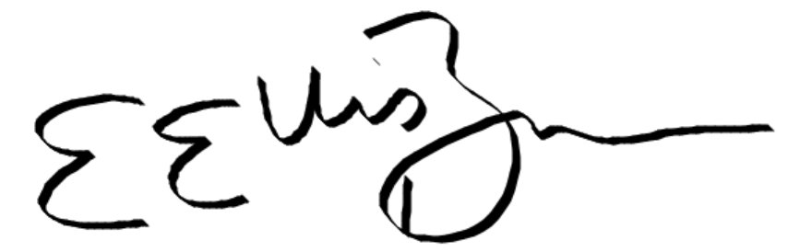

Signature Print Name and Job Title Date
26th August 2025
Michael Healy
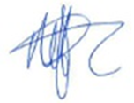
REDACTED TEXT under FOREDACTED TEXT under FOIA Section
40, Personal Information
Authorised for and on behalf of the Supplier:

Signature Print Name and Job Title Date
Liz Ellis-Brown
28/08/25
REDACTED TEXT under FOREDACTED TEXT under FOIA Section
40, Personal Information
Authorised for and on behalf of the Customer:

Signature Print Name and Job Title Date

