G-Cloud Call-off Contract Variation No. 1
Contract Ref: CCIT22A19 / CDIO-151

FROM:

Buyer | Cabinet Office “Buyer”
Buyer’s Address | REDACTED TEXT under FOIA Section 40, Personal Information
Invoice Address | REDACTED TEXT under FOIA Section 40, Personal Information

TO:

Supplier | Freshworks Inc
Supplier’s | REDACTED TEXT under FOIA Section 40, Personal Information
address:

Invoice address | REDACTED TEXT under FOIA Section 40, Personal Information

Account Manager | REDACTED TEXT under FOIA Section 40, Personal Information

In accordance with clause CO-32, VARIATION PROCEDURE, the Buyer hereby requests an agreement to a Variation to the Call-Off Agreement CCIT22A19 / CDIO-151 commencing on 1st December 2022 and ending on 30 November 2023 (12 months).
This change does not amount to a material change of the Framework Agreement and/or the Call-Off Agreement and is within the meaning of the Regulations and the Law.

The details of this "Variation" Number One (1) are as follows:
Reason for change:

The Buyer wishes to invoke a 12-month extension in accordance with the G-Cloud 12 Call- Off Contract Ref:CCIT22A19/ CDIO-151
Full Details of the proposed change:

- The expiry date of the Call-Off Contract shall now be 30th November, 2024
- The value of the extension period 01/12/2023 to 30/11/2024 is: £105,840 exVAT
Likely impact, if any, of the change on other aspects of the Call-Off Contract - None

All other CALL-OFF AGREEMENT TERMS AND CONDITIONS remain unchanged.
BY SIGNING AND RETURNING THIS VARIATION THE SUPPLIER AGREES to continue to provide the revised G-Cloud Services.

The Parties hereby acknowledge and agree that they have read the Call-Off Terms and the Order Form and by signing below agree to be bound by the terms of this Call-Off Agreement.

For and on behalf of the Supplier:

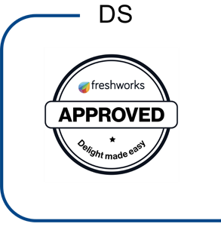
Name and Title | REDACTED TEXT under FOIA Section 40, Personal Information
Position | REDACTED TEXT under FOIA Section 40, Personal Information
Signature | REDACTED TEXT under FOIA Section 40, Personal Information
Date | November 21, 2023 | 7:56 AM PST

For and on behalf of the Buyer:

Name and Title | REDACTED TEXT under FOIA Section 40, Personal Information
Position | REDACTED TEXT under FOIA Section 40, Personal Information
Signature | REDACTED TEXT under FOIA Section 40, Personal Information
Date | November 21, 2023 | 12:00 AM PST

