IMMERSIVE CLASSROOMS TENDER - CLARIFICATIONS

Q. Please expand on “Immersive rooms must enable connection to & from remote locations.
A We will present to remote locations from the immersive rooms
Q Where is the remote location – Internal – External – Across the open internet?

A Both Internally and Externally

Q Can more details be provided for the 12 cameras required

A We require 2 sterile cameras for the Clean Room – Teams compatible cameras for the remaining 10 – We are open to other options/suggestions.

Q Is the aim to capture Clean Labs in 360° for viewing in an immersive space?

A Ideally yes

Q Please expand on “Portable Immersive Space” option

A A portable solution which enables transportation between college sites occasionally in the college van.

Q Are site visits required during tender stage and part of project delivery?

A Yes site visits should be part of this contract – we encourage a site survey to discuss what would work best as part of the contract.

Q Can you provide dimensions for the size of the immersive rooms?

A Room 1

Height 2.8m
Width 7.5m
Length 8.7m

Room 2

Height 2.5m
Width 5.6m
Length 10.2m
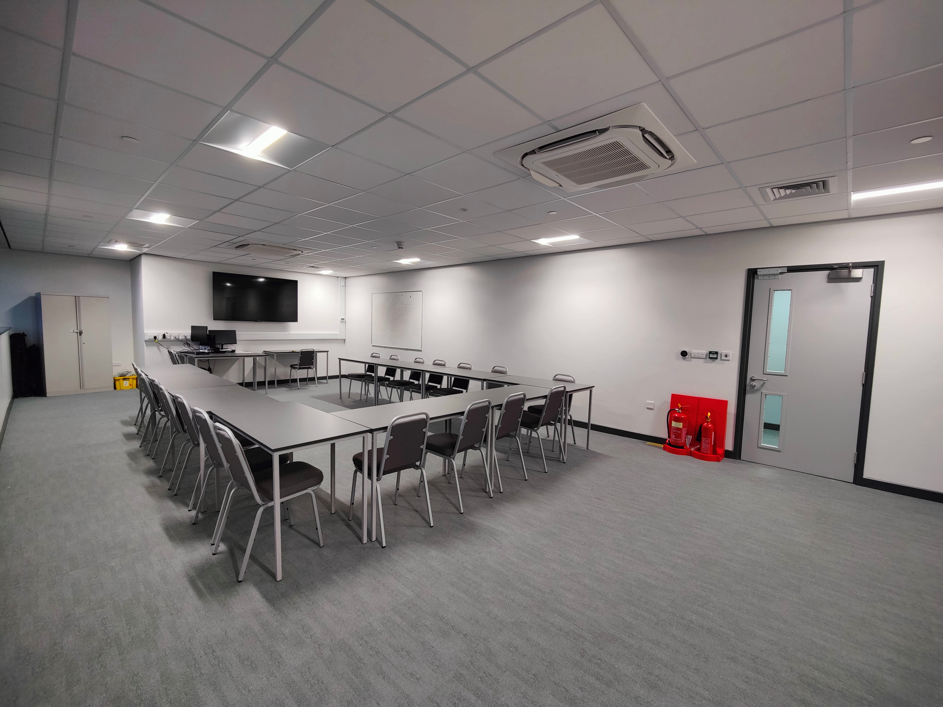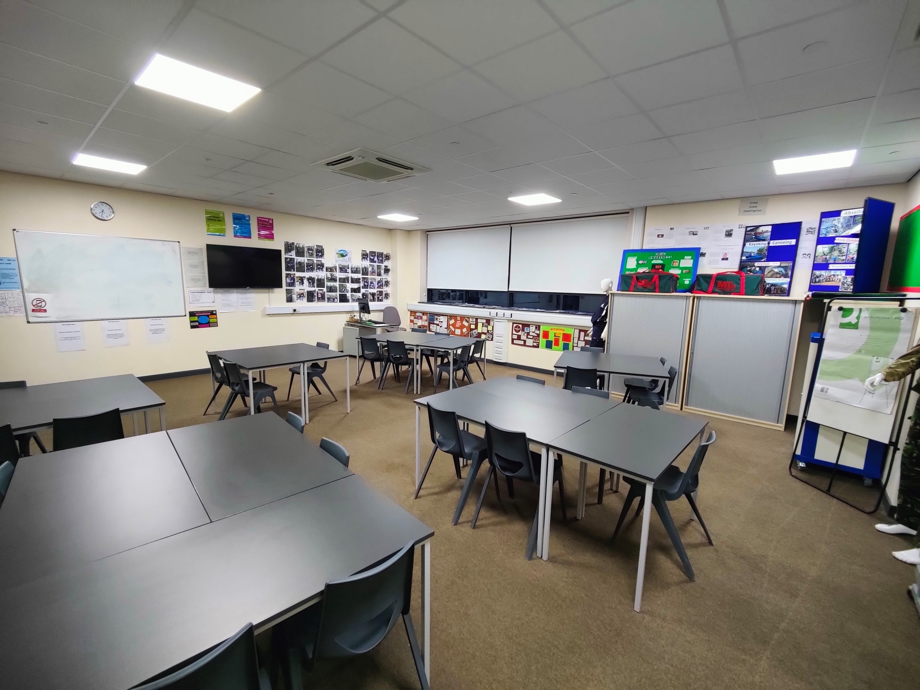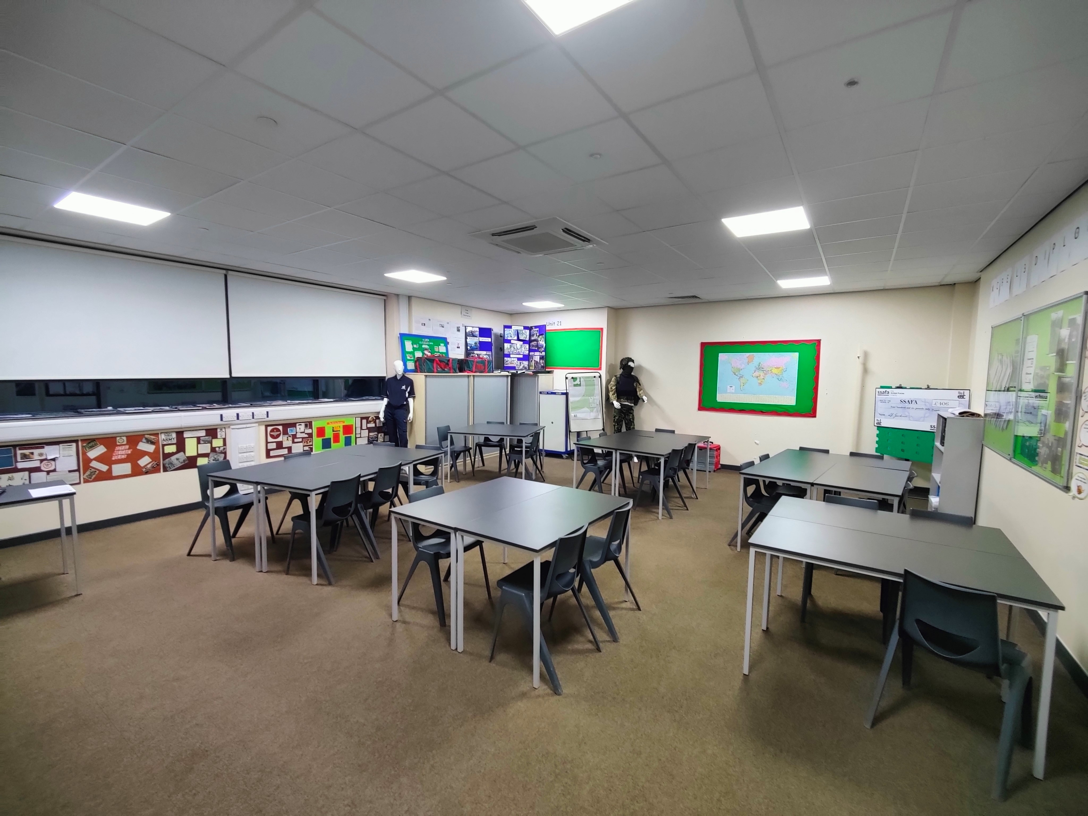

Q Do you require stand-alone immersive environments, or are they to be integrated into your rooms?

A 1 Fixed and 1 Portable

Q Do you have a preferred size/shape and configuration?

A Able to be transferable between sites preferably a cube or dome.

Q Can you expand on the type of content you wish to display in the immersive rooms?

A Access to real live sessions for students to clean labs.

Q Does this contract allow sub-contracting?

A No not on this occasion.

Q Does the winning supplier need to be UK based?

A On this occasion yes.

