Prior Information Notice (PIN): Disposability Assessment and Waste Package Assurance Framework 2024

**Title**: Disposability Assessment and Waste Package Assurance Framework 2024  
**Reference Numbe**r: C6116

Common Procurement Vocabulary Codes:

* 90513900 Sludge Disposal Services
* 90521300 Disposal of Radioactive Waste
* 90520000 Radioactive, Toxic. Medical and Hazardous Waste Services
* 90521000 Radioactive Waste Treatment Services
* 90521200 Radioactive Waste Storage Services
* 90521500 Packaging of Radioactive Waste
* 73000000 Research and Development Services and Related Consultancy Services

Short Description:

PIN relating to the upcoming procurement opportunity for a Framework which will replace the current ‘Disposability Assessment and Waste Package Assurance’ (RWM225) Framework. In support of Nuclear Waste Services (NWS) being responsible for the delivery of the Geological Disposal Facility, we maintain a programme of Disposability Assessments and undertake Package Assurance to ensure that disposable packages are available in the future. This encompasses waste arising at all Nuclear Decommissioning Authority (NDA) and non-NDA sites.

Schedule:

|  |  |
| --- | --- |
| **Activity** | **Date** |
| PIN Launch | 12th July 2023 |
| Supplier Response Form Return Deadline | 25th August 2023 |
| PIN Close | 25th August 2023 |
| Supplier Event Date | 5th September 2023 |

Communication:

Please respond to this opportunity using the contact details below:

Contact Name: Hannah Armstrong  
Email Address: [hannah.armstrong@nuclearwasteservices.co.uk](mailto:hannah.armstrong@nuclearwasteservices.co.uk)  
Email Subject: DA&WPA PIN Response

Background to the Organisation and Requirement:

1. Nuclear Waste Services (NWS) is an integration of the former two companies Low Level Waste Repository (LLWR) and Radioactive Waste management (RWM) to create an organisation focused on the management of the UK#s nuclear waste, safely and securely for generations to come. NWS are specialists in the treatment and disposal of nuclear waste, and a customer and community focused business with safety at its core. Our goal is to ensure that waste is managed in a way that protects people and the environment, now and in the future.
2. The Disposability Assessment and Waste Package Assurance 2024 Framework is being procured to replace an existing commercial arrangement, which is the current Disposability Assessment and Waste Package Assurance Framework (RWM225) already in place. RWM225 commenced on 1st April 2020 and has an end date of 31st March 2024.

General Information:

1. All information is provided in good faith to facilitate early market engagement with interested parties.
2. The information provided below is indicative only and subject to change as the project develops.
3. NWS wishes to utilise this PIN to garner information in relation to supplier interest in this opportunity and the supplier event day, and to request detailed feedback to enable the development of the framework in accordance with market capabilities and input.
   1. Please review the information and complete the Supplier Response Form in Annex 1
   2. Once complete, please return the form in accordance with the communication information provided above.

Supplier Event Information:

1. NWS is looking to undertake a supplier event day to provide the interested parties from the supply chain with the opportunity to engage with the Technical and Commercial teams.
2. The event will be held virtually on Microsoft Teams on 5th September 2023. Only registered people will be allowed to attend, and each organisation will be limited to two attendees.
3. To register interest, please complete the Supplier Response Form in Annex 1. Further information (agenda, dial in link and timings etc) on the Supplier Event will be provided no later than 29th August 2023.
4. It is likely that the Supplier Event will be recorded, if your organisation wishes not to be recorded, it is advisable either not to attend or stay on mute with camera off.
5. If the Supplier Event is recorded, the recording will be shared along with the slides shown at the event.

Indicative Framework Information:

1. The Framework is likely to contain 2 Lots; Provision of NWS Disposability Assessment to Waste Packagers and Package Assurance to ensure existing Waste Packages remain disposable now and in the future.
2. It will have a maximum duration of 4 years and is likely to be a combination of 3 years + 1 year extension, however the initial term and extension provisions are still to be determined and feedback is welcomed.
3. The estimated total framework value is £8,000,000.
4. Estimated date of publication of Framework tender opportunity is November 2023.

Indicative Lot Structure and Scope:

1. Below is an indicative Framework Lot Structure which includes the Aim and likely Scope for each Lot.

|  |  |
| --- | --- |
| **Lot 1 – Disposability Assessment** | |
| Title: | To support provision of NWS Disposability Assessment to waste packagers |
| Aim: | The principal aim of Disposability Assessment (DA) is to ensure that the subsequent packaging of Higher Activity Wastes (HAW), and interim storage of packaged wastes, results in waste packages that ultimately will be compatible with geological disposal, as far as this is possible in advance of the availability of the Waste Acceptance Criteria (WAC) for a geological disposal facility (GDF). |
| Scope: | In response to submissions received by waste producing organisations, NWS will carry out disposability assessment, potentially at several stages in the development and implementation of a packaging proposal. These submissions are planned and agreed between the waste producers and NWS through a prioritised programme of assessments. The prioritised programme is placed under a change control process to enable NWS to respond to changes in priorities within waste producer organisations.  To deliver this programme, NWS requires Consultant support for delivery of selected technical evaluations and safety assessments that inform each assessment, as mandated under procedure RWPR60. Disposability assessments would be carried out against the 2016 generic Disposal System Safety Case (gDSSC) and current RWPR60 Work Instructions. |

|  |  |
| --- | --- |
| **Lot 2 – Package Assurance** | |
| Title: | To support NWS in undertaking Package Assurance to ensure existing Waste Packages remain disposable now and in the future. |
| Aim: | Package Assurance aims to ensure that waste packages are manufactured in compliance with the requirements for geological disposal and that evidence of this compliance remains available until the time of disposal (such that fulfilment of waste acceptance criteria can be demonstrated). In practice, this includes ensuring that the endorsed packaging proposals have been fulfilled, that records are generated to support this position, and that the validity of the endorsement is maintained. |
| Scope: | NWS maintains a range of activities in this area, both through a continuing programme of assessments and audits, which is co-ordinated with the programme of Disposability Assessments, and through individual development activities.  The scope of the consultant support potentially includes:   * Delivery of Periodic Review Disposability Assessments (PRDA); repeated disposability assessments for endorsed processes used to test and maintain endorsement, or to collate and simplify existing positions * Delivery of Cross-cutting reviews (CCR); review of the impact of specific arising issues on selected or all existing endorsements * Support to NWS knowledge management in the area of waste management, including review, collation and reporting on existing records of activities * Delivery of Technical Audits of waste packager activities, including package manufacture and interim storage, and the delivery of waste package records * Support for the continuing development of waste package records requirements and guidance |

Indicative Social Value Information:

1. In accordance with PPN 06/20, the indicative Social Value requirements are:

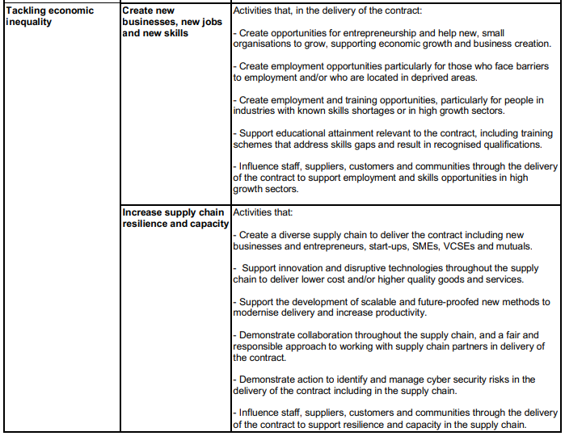

Annex 1: Supplier Response Form

**Please ensure the Supplier Response Form is sent via email to the contact details stated in the ‘Communication’ section above.**

|  |  |
| --- | --- |
| Supplier/Organisation Name |  |
| Name: |  |
| Contact Email Address: |  |
| Role within the Organisation: |  |
| Registration of Interest in Opportunity:  *Please note: registration in this opportunity means you are hereby allowing NWS to utilise your contact details for further communication in relation to this opportunity.* | *Yes/No* |
|  | |
| **Supplier Event – 5th September 2023** | |
| Are you interested in attending the Supplier Event? | *Yes/No* |
| Attendee Name(s) *(Maximum 2 per organisation)* |  |
| Attendee Email Address(es) |  |
|  | |
| **CPV Codes** | |
| Do you feel the CPV codes utilised for this PIN would be suitable to capture the relevant market interest for the forthcoming tender? |  |
|  | |
| **Duration** | |
| Do you feel the indicative duration term of 3+1 is suitable? |  |
|  | |
| **Lots** | |
| Which areas of the Scope of Lot 1 can your organisation provide? What areas can your organisation not provide? |  |
| Would your organisation look to tender for Lot 1? |  |
| Which areas of the Scope of Lot 2 can your organisation provide? What areas can your organisation not provide? |  |
| Would your organisation look to tender for Lot 2? |  |
|  | |
| **Social Value** | |
| Are the themes identified relevant and suitable for these requirements? |  |
| Are the themes identified achievable for your organisation? |  |
| Are there any measures your organisation feels would be appropriate, ideally using TOM’s model? |  |
|  | |
| General Comments/Feedback: |  |