Request for Quotation
Shore-based low tide counts and validation study of digital aerial survey methods at Morecambe Bay and Duddon Estuary Special Protection Area (SPA)

Issued 25th September 2023


Request for Quotation

Ref: PBDM_WP4_Task4.1_MB&DE_SPA_ground_RFQ
Title: Shore-based low tide counts and validation study of digital aerial survey methods at Morecambe Bay and Duddon Estuary Special Protection Area (SPA)
You are invited to submit a quotation for the requirement described in the specification, Section 2.
Please confirm by email, receipt of these documents and whether you intend to submit a quote or not.
Your response and quotation should be returned to the following email address :
Email: sarah.anthony@naturalengland.org.uk
by:
Date: 13th October 2023
Time: 17:00 BST
Ensure you include the name of the quotation and ‘Final Submission’ in the subject field to make it clear that it is your response.

Contact Details and Timetable
Sarah Anthony will be your contact for any questions linked to the content of the quote or the process. Please submit any clarification questions via email and note that, unless commercially sensitive, both the question and the response will be circulated to all tenderers.
Action | Date
Date of issue of RFQ | 25th September 2023 at 12:00 BST
Deadline for clarifications questions | 6th October 2023 at 17:00 BST
Deadline for receipt of Quotation | 13th October 2023 at 17:00 BST
Intended date of Contract Award | 30th October 2023
Intended Contract Start Date | 30th October 2023
Intended Delivery Date / Contract Duration | 31st March 2024/ 22 weeks (~6 months)

Section 1: General Information

Glossary
Unless the context otherwise requires, the following words and expressions used within this Request for Quotation shall have the following meanings (to be interpreted in the singular or plural as the context requires):
“Authority” | means Natural England who is the Contracting Authority.
“Contract” | means the contract to be entered into by the Authority and the successful supplier.
“Response” | means the information submitted by a supplier in response to the RFQ.
“RFQ” | means this Request for Quotation and all related documents published by the Authority and made available to suppliers.

Conditions applying to the RFQ
You should examine your Response and related documents ensuring it is complete and in accordance with the stated instructions prior to submission.
Your Response must contain sufficient information to enable the Authority to evaluate it fairly and effectively. You should ensure that you have prepared your Response fully and accurately and that prices quoted are arithmetically correct for the units stated.
By submitting a Response, you, the supplier, are deemed to accept the terms and conditions provided in the RFQ. Confirmation of this is required in Annex 2.
Failure to comply with the instructions set out in the RFQ may result in the supplier’s exclusion from this quotation process.

Acceptance of Quotations
By issuing this RFQ the Authority does not bind itself to accept any quotation and reserves the right not to award a contract to any supplier who submits a quotation.

Costs
The Authority will not reimburse you for any costs and expenses which you incur preparing and submitting your quotation, even if the Authority amends or terminates the procurement process.

Self-Declaration and Mandatory Requirements
The RFQ includes a self-declaration response (Annex 1) which covers basic information about the supplier, as well as any grounds for exclusion. If you do not comply with them, your quotation will not be evaluated.
Any mandatory requirements will be set out in Section 2, Specification of Requirements and, if you do not comply with them, your quotation will not be evaluated.

Clarifications
Any request for clarification regarding the RFQ and supporting documentation must be submitted via email no later than the deadline for clarifications set out in the Timetable. The Authority shall be under no obligation to respond to queries raised after the clarification deadline.
The Authority will respond to all reasonable clarifications as soon as possible but cannot guarantee a minimum response time. The Authority will publish all clarifications and its responses to all suppliers via email unless deemed commercially sensitive.
If a supplier believes that a request for clarification is commercially sensitive, it should clearly state this when submitting the clarification request. However, if the Authority considers either that:
- the clarification and response are not commercially sensitive; and
- all suppliers may benefit from its disclosure,
then the Authority will notify the supplier (via email), and the supplier will have an opportunity to withdraw the request for clarification by sending a further message requesting the withdrawal of the clarification request. If not withdrawn by the supplier within 2 working days of the Authority’s notification, the Authority may publish the clarification request and its response to all suppliers and the Authority shall not be liable to the supplier for any consequences of such publication.
The Authority reserves the right to seek clarification of any aspect of a quotation and/or provide additional information during the evaluation phase to carry out a fair evaluation. Where the Authority seeks clarification on any aspect of the quotation, the supplier must respond within the timeframe requested by the Authority.

Amendments
The Authority may amend the RFQ at any time prior to the deadline for receipt. If it amends the RFQ the Authority will notify you via email.
Suppliers may modify their quotation prior to the deadline for Responses. No Responses may be modified after the deadline for Responses.
Suppliers may withdraw their quotations at any time by submitting a notice via the email to the named contact.

Conditions of Contract
The Authority’s Standard Condensed Terms and Conditions (available at Procurement at Natural England - Natural England - GOV.UK (www.gov.uk)https://www.gov.uk/government/organisations/natural-england/about/procurement) provided as part of the RFQ will be included in any contract awarded as a result of this quotation process. The Authority will not accept any changes to these terms and conditions proposed by a supplier.
Suppliers should note that the quotation provided by the successful bidder will form part of the Contract.

Prices
Prices must be submitted in £ sterling, exclusive of VAT.

Disclosure
All Central Government Departments, their Executive Agencies and Non-Departmental Public Bodies are subject to control and reporting within Government. In particular, they report to the Cabinet Office and HM Treasury for all expenditure. Further the Cabinet Office has a cross-Government role delivering overall Government policy on public procurement, including ensuring value for money and related aspects of good procurement practice. For these purposes, the Authority may disclose within Government any details contained in your quotation. The information will not be disclosed outside Government during the procurement.
In addition, the Authority is subject to the Freedom of Information Act 2000 and the Environmental Information Regulations 2004, which provide a public right of access to information held by public bodies. In accordance with these two statutes, the Authority may be required to disclose information contained in your quotation to any person who submits a request for information pursuant to those statutes.
Further to the Government’s transparency agenda, all UK Government organisations must advertise on Contract Finder in accordance with the following publication thresholds:
- Central Contracting Authority’s: £12,000
- Sub Central Contracting Authority’s and NHS Trusts: £30,000
For the purpose of this RFQ the Authority is classified as a Central Contracting Authority with a publication threshold of £12,000 inclusive of VAT.
If this opportunity is advertised via Contracts Finder, we are obliged to publish details of the awarded contract including who has won the contract, the contract value, and indicate whether the winning supplier is a small and medium-sized enterprise (“SMEs”) or voluntary organisation or charity. A copy of the contract must also be published with confidential information redacted.
By submitting a Response, you consent to these terms as part of the procurement.

Disclaimers
Whilst the information in this RFQ and any supporting information referred to herein or provided to you by the Authority have been prepared in good faith the Authority does not warrant that this information is comprehensive or that it has been independently verified.
The Authority does not:
- make any representation or warranty (express or implied) as to the accuracy, reasonableness or completeness of the RFQ;
- accept any liability for the information contained in the RFQ or for the fairness, accuracy or completeness of that information; or
- accept any liability for any loss or damage (other than in respect of fraudulent misrepresentation or any other liability which cannot lawfully be excluded) arising as a result of reliance on such information or any subsequent communication.
Any supplier considering entering into contractual relationships with the Authority following receipt of the RFQ should make its own investigations and independent assessment of the Authority and its requirements for the goods and/or services and should seek its own professional financial and legal advice.

Protection of Personal Data
In order to comply with the General Data Protection Regulations 2018 the supplier must agree to the following:
You must only process any personal data in strict accordance with instructions from the Authority.
- You must ensure that all the personal data that we disclose to you or you collect on our behalf under this agreement are kept confidential.
- You must take reasonable steps to ensure the reliability of employees who have access to personal data.
- Only employees who may be required to assist in meeting the obligations under this agreement may have access to the personal data.
- Any disclosure of personal data must be made in confidence and extend only so far as that which is specifically necessary for the purposes of this agreement.
- You must ensure that there are appropriate security measures in place to safeguard against any unauthorised access or unlawful processing or accidental loss, destruction or damage or disclosure of the personal data.
- On termination of this agreement, for whatever reason, the personal data must be returned to us promptly and safely, together with all copies in your possession or control.

General Data Protection Regulations 2018
For the purposes of the Regulations the Authority is the data processor.
The personal information that we have asked you provide on individuals (data subjects) that will be working for you on this contract will be used in compiling the tender list and in assessing your offer. If you are unsuccessful the information will be held and destroyed within two years of the award of contracts. If you are awarded a contract, it will be retained for the duration of the contract and destroyed within seven years of the contract’s expiry.
We may monitor the performance of the individuals during the execution of the contract, and the results of our monitoring, together with the information that you have provided, will be used in determining what work is allocated under the contract, and in any renewal of the contract or in the award of future contracts of a similar nature. The information will not be disclosed to anyone outside the Authority without the consent of the data subject, unless the Authority is required by law to make such disclosures.

Equality, Diversity & Inclusion (EDI)
The Client is striving to create a diverse and inclusive working environment where every individual has equality of opportunity to progress and to apply their unique insights to making the UK a great place for living. The Service Provider is expected to respect this commitment in all dealings with Natural England staff and service users.
Suppliers are expected to;
- support Defra group to achieve its Public Sector Equality Duty as defined by the Equality Act 2010, and to support delivery of Defra group’s Equality & Diversity Strategy.
- meet the standards set out in the Government’s Supplier Code of Conduct
- work with Defra group to ensure equality, diversity and inclusion impacts are addressed (positive and negative) in the goods, services and works we procure, barriers are removed and opportunities realised.

Sustainable Procurement
Addressing global sustainability impacts and realising additional community benefits within commercial activity is core to Defra group’s approach, working with its supply chain is key to achieving sustainable outcomes. In addition to supporting Defra group to meet its outcomes we look to understand and reduce negative sustainability impacts associated with our commercial activity and realise benefits.
The Client encourages its suppliers to share these values, work to address negative impacts and realise opportunities, measure performance and success.
Suppliers are expected to have an understanding of the Sustainable Development Goals, the interconnections between them and the relevance to the Goods, Services and works procured on the Client’s behalf

Conflicts of Interest
The concept of a conflict of interest includes but is not limited to any situation where an Involved Person or Relevant Body has directly or indirectly, a financial, economic or other personal interest which might be perceived to compromise their impartiality and independence in the context of the procurement procedure and/or affect the integrity of the contract award.
We expect suppliers to mitigate appropriately against any real or perceived conflict of interest through their work with government. A supplier with a position of influence gained through a contract should not use that position to unfairly disadvantage any other supplier or reduce the potential for future competition.
Where the supplier is aware of any circumstances giving rise to a conflict of interest or has any indication that a conflict of interest exists or may arise you should inform the Authority of this as soon as possible (whether before or after they have submitted a quotation). Tenderers should remain alert to the possibility of conflicts of interest arising at all stages of the procurement and should update the Authority if any new circumstances or information arises, or there are any changes to information already provided to the Authority. Failure to do so, and/or to properly manage any conflicts of interest may result in a quotation being rejected.
Provided that it has been carried out in an open, fair and transparent manner, routine pre-market engagement carried out by the Authority should not represent a conflict of interest for the supplier.

Section 2: The Invitation

Specification of Requirements

Background to Natural England
The Authority is Natural England. The Authority’s priorities are to secure a healthy natural environment; a sustainable, low-carbon economy; a thriving farming sector and a sustainable, healthy and secure food supply. Further information about the Authority can be found at: Natural England

Requirement
Natural England is seeking a contractor to complete four tasks under this contract.

Task 1) Low tide counts of Kent, Leven, Lune and Wyre estuaries and Morecambe Bay West (including South Walney & Piel Channel Flats). To deliver a programme of 4 (four) once monthly (November 2023 – February 2024) standardised shore-based surveys of the abundance and distribution of all waterbird species (divers, grebes, cormorants, herons, swans, geese, ducks, rails, waders, gulls and terns) within the Leven, Kent, Lune and Wyre estuaries and Morecambe Bay West (including South Walney & Piel Channel Flats) in accordance with the BTO/RSPB/JNCC Wetland Bird Survey (WeBS) Low Tide Counts (LTC) scheme methodology (https://www.bto.org/our-science/projects/wetland-bird-survey/taking-part/low-tide-counts-methods).

Task 2) Bespoke ground-based low tide survey for validation of aerial survey method. To deliver ground-based surveys (entailing repeated counts through each of a minimum of three consecutive days) of the abundance and distribution of all waterbird species (divers, grebes, cormorants, herons, swans, geese, ducks, rails, waders, gulls and terns) within selected low tide count sectors within the ‘Morecambe Bay West’ and ‘Morecambe Bay Kent’ WeBS LTC sites according to a bespoke methodology set out in this RfQ (section 3.2), and to coincide in time with overflights of a digital aerial survey aircraft.

Task 3) To process and summarise the survey data from tasks 1 & 2.

Task 4) To produce a single report, using a Natural England template and following relevant guidance (see: Natural England publishing standards for commissioned reports - NECR000) outlining all methods and results, accompanied by all relevant output files, and other specified deliverables.

The evidence derived from this work (Task 1) will fill a significant evidence gap in our understanding of the current distributions of waterbirds (including gulls) at low tide within those parts of the Morecambe Bay & Duddon Estuary SPA that are included within the WeBS LTC scheme but which have been counted with differing frequency over the last twenty years. The results of the bespoke low tide counts (Task 2) will allow an analysis (outwith this contract) to validate the results of a simultaneous digital aerial survey and inform consideration by Natural England and the BTO of the scope for and any limitations to the wider application of the digital aerial survey methods in monitoring of waterbird population abundance and distribution across large and/or inaccessible estuarine sites such as Morecambe Bay & Duddon Estuary SPA. The data gathered under this project will also inform SPA condition assessments, environmental impact assessments, habitats regulations assessments and, by improving understanding of potential overlaps between bird distributions and those of anthropogenic activities, inform place-based decision making by regulatory authorities.
The following sections provide further details relating to: 1) the project background, 2) objectives, and 3) methods.

1. Background information

1.1 Site details
The Morecambe Bay and Duddon Estuary Special Protection Area was classified in February 2017. The SPA covers 669km² and extends between Rossall Point in Lancashire and Drigg Dunes in Cumbria (Figure 1). The site includes the former Morecambe Bay SPA and Duddon Estuary SPA and an extension to include the Ravenglass Estuary and intervening coast and the shallow offshore area off the southwest Cumbria coast. Morecambe Bay is the second largest embayment in Britain after The Wash, and has four estuaries – the Wyre, Lune, Kent and Leven. The extended Morecambe Bay & Duddon Estuary SPA also includes the estuary of the River Duddon and the River Esk at Ravenglass. It contains the largest continuous area of intertidal mudflats and sandflats in the UK which supports a variety of infaunal communities including cockle Cerastoderma edule beds. Morecambe Bay supports a wide range of other habitats including large areas of saltmarsh and transitional habitats as well as sand dune systems and coastal lagoons. Within the Bay there are areas of stony reef (known locally as scars or skears) which also support blue mussel Mytilus edulis beds and honeycomb worm Sabellaria alveolata reefs. Extensive eelgrass Zostera spp. beds are present around Foulney Island and in the south Walney Channel, the only examples in the Northwest of England. The Duddon and Ravenglass Estuaries support saltmarsh, intertidal mud and sand communities and sand dune systems with small areas of stony reef. The intermediate coast comprises extensive shingle and sand beaches. The parts of the SPA away from the coast are sandy and shallow, mostly less than 15 metres deep.
The SPA supports internationally important populations of twenty species of non-breeding waterbirds, and a non-breeding waterbird assemblage of more than 200,000 individuals. The citation sets out all the qualifying interests at the site. Those species of particular interest in this project are the twenty species of non-breeding waterbirds that are qualifying features in their own right plus four species i.e. common eider, common goldeneye, red-breasted merganser and cormorant that are main components of the waterbird assemblage.

1.2 Wetland Bird Survey Low Tide Counts scheme

The British Trust for Ornithology (BTO)/Royal Society for the Protection of Birds (RSPB)/Joint Nature Conservation Committee (JNCC) Wetland Bird Survey (WeBS) Low Tide Counts (LTC) scheme was initiated in the winter of 1992/93. The scheme aims to monitor, assess and regularly update information on the relative importance of intertidal feeding areas of UK estuaries for wintering waterbirds (divers, grebes, cormorants, herons, swans, geese, ducks, rails, waders, gulls and terns). Counts are made in accordance with an established methodology (https://www.bto.org/our-science/projects/wetland-bird-survey/taking-part/low-tide-counts-methods), mostly by volunteer observers, across multiple sectors within a site monthly between November and February.

In a review of the WeBS LTC scheme Clewley et al. (2022) noted that it was always recognised that several very large sites (including Morecambe Bay) would be difficult to count. The problem with large estuaries (or rather, wide expanses of intertidal habitat) is that many birds may be present at very great distances, thus reducing an observer’s ability to accurately determine the number and identity of birds present on the count section. Safety of counters is paramount and so they are discouraged from venturing out on to potentially dangerous intertidal habitats to record more distant birds. Accordingly in the case of Morecambe Bay, the LTC scheme has focussed on surveying a few discrete parts of the bay – i.e., the estuaries of the Rivers Kent, Leven, Lune, Wyre and ‘Morecambe Bay West’ an area encompassing intertidal habitat from the Leven Estuary to the South Walney & Piel Channel flats (Figures 2-6). All the defined low tide count sectors within these areas can be counted reliably and safely from shore-based vantage points.

Under the BTO WeBS LTC scheme the most recent low tide count data from each of the areas surveyed under this scheme are as follows: Leven Estuary (2005/06), Kent Estuary (2014/15), Lune Estuary (2005/06), Wyre Estuary (2021/22), Morecambe Bay West (2005/06). These data are available at BTO WeBS Reports. The remainder of Morecambe Bay (although not all the current SPA) was surveyed by visual aerial survey on four occasions in the winter of 2005/06 (Banks et al. 2006).

1.3 Ground-based survey vs digital aerial survey
The WeBS LTC scheme has to date been based entirely on ground-based surveying methods. Surveying has been conducted almost entirely by volunteer counters but with exceptional use of professional contractors in circumstances where, for example, due to the nature of the site, it was inappropriate to expect data to be gathered by the volunteer network.
The following text of relevance as background to this project has been copied from Clewley et al. (2022).
There have been various trials of alternative methods to conduct bird surveys around low tide, principally using aerial surveys, both visual (a ‘look-see’ approach from the air) and digital (photographic material to be processed after field visits). A visual aerial survey of Morecambe Bay was carried out using a low-flying aircraft across multiple visits during the 2005/06 winter (Musgrove et al. 2007). Given the extent of this site (over 36,000 ha), observation of the intertidal mudflats from the high tide mark is limited and thus aerial surveys have the potential to provide more complete coverage. However, species identification was problematic and generally only the distributions of larger, more distinctive species, such as Oystercatcher and Shelduck, were effectively surveyed. It wasn’t possible to identify many of the smaller species and as a result, concentrations of mixed flocks were instead identified to highlight key areas.
Since the Morecambe Bay aerial survey, advances have been made in digital aerial surveys (Buckland et al. 2012) and these have largely replaced visual surveys for marine birds at sea. Surveys use either digital video or stills, at a resolution sufficient to identify the majority of marine birds to species (Johnston et al. 2015), and which can be conducted from aircraft flying sufficiently high to avoid disturbance. Digital aerial surveys, however, have been less frequently employed for surveys of intertidal waterbirds. A recent pilot study was carried out on The Wash using aircraft to carry out a single high resolution digital aerial survey simultaneously with traditional ground-based survey methods (APEM 2018). A greater number of individuals and range of species were detected from the aerial imagery survey compared with the ground survey; however, the two methods were not directly comparable due to differences in the areas surveyed. Improvements in the quality of the imagery obtained, however, did lead to high rates of positive species identification with 87% of all birds identified to species, increasing to 94% if the small waders category (of which only 43% could be positively identified) was excluded. Calibrating results against ground-based surveys will be important if digital aerial surveys are to be more widely used in the future.

1.4 Study area
The extent of the Morecambe Bay and Duddon Estuary SPA (669km²) (Figure 1) is shown on Defra’s MAGIC mapping portal: A shapefile of all the UK SPAs can be downloaded from the JNCC resource hub for use in GIS systems.

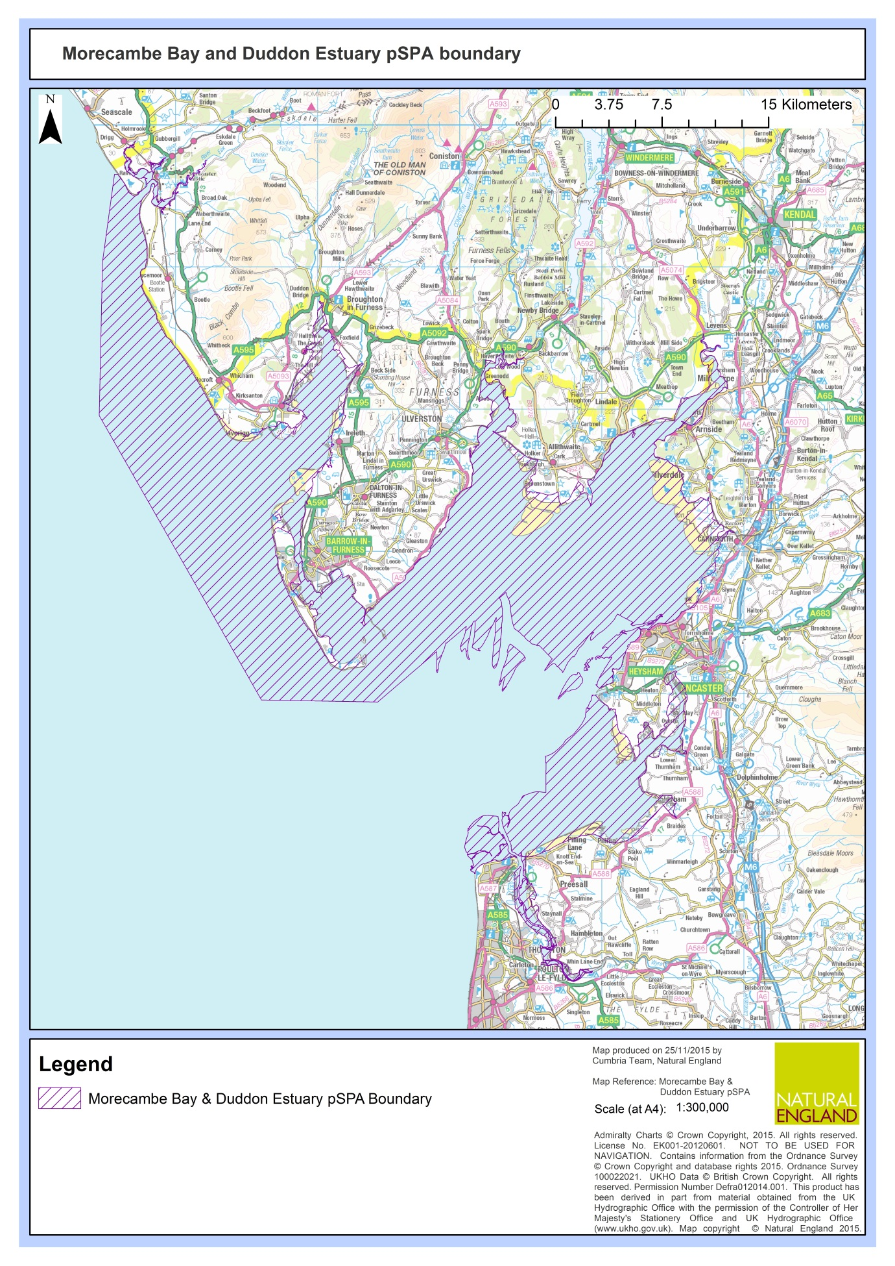
Figure 1. Map of the Morecambe Bay and Duddon Estuary SPA
1.4.1 Low tide counts of Kent, Leven, Lune and Wyre estuaries and Morecambe Bay West (including South Walney & Piel Channel Flats)
For this element of the project (Task 1), the focus is on those parts of the Morecambe Bay & Duddon Estuary SPA which are surveyed under the existing WeBS LTC scheme i.e. the Leven Estuary, Kent Estuary, Lune Estuary, Wyre Estuary, and Morecambe Bay West (including South Walney & Piel Channel Flats) (Figures 2-6). Each of these sites is subdivided into several, pre-established and clearly defined low tide count sectors which must be adhered to when surveying in this project (Figures 2-6).

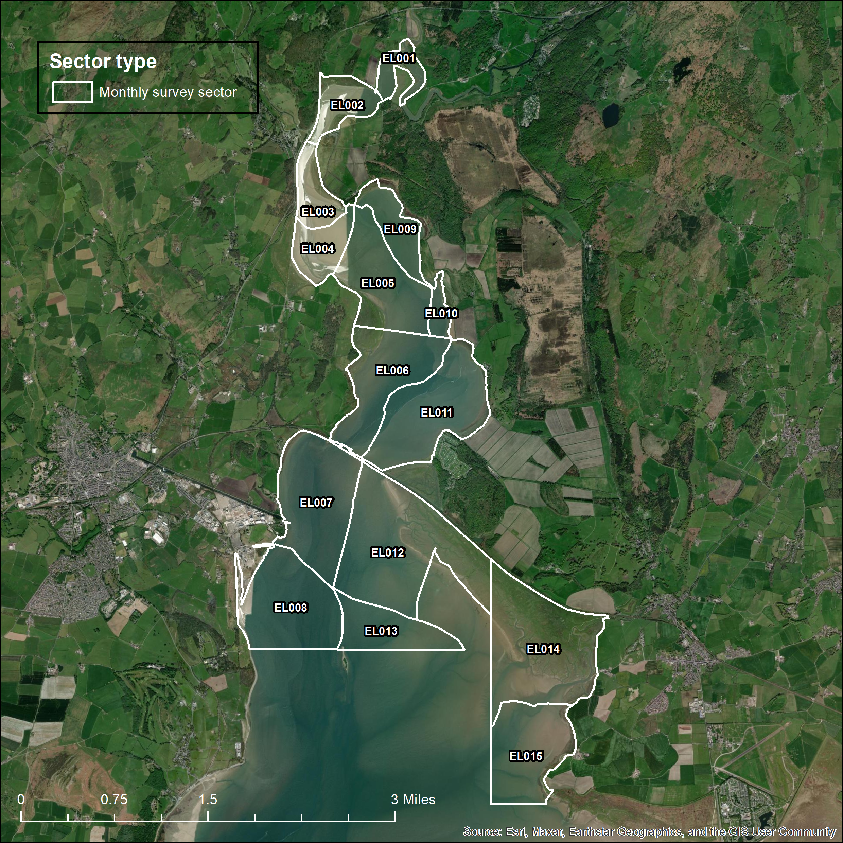
Figure 2. Map of the Morecambe Bay and Duddon Estuary SPA low tide count sectors within the Leven Estuary which are the focus of the low tide counts in this project (Task 1) (EL001-EL015).
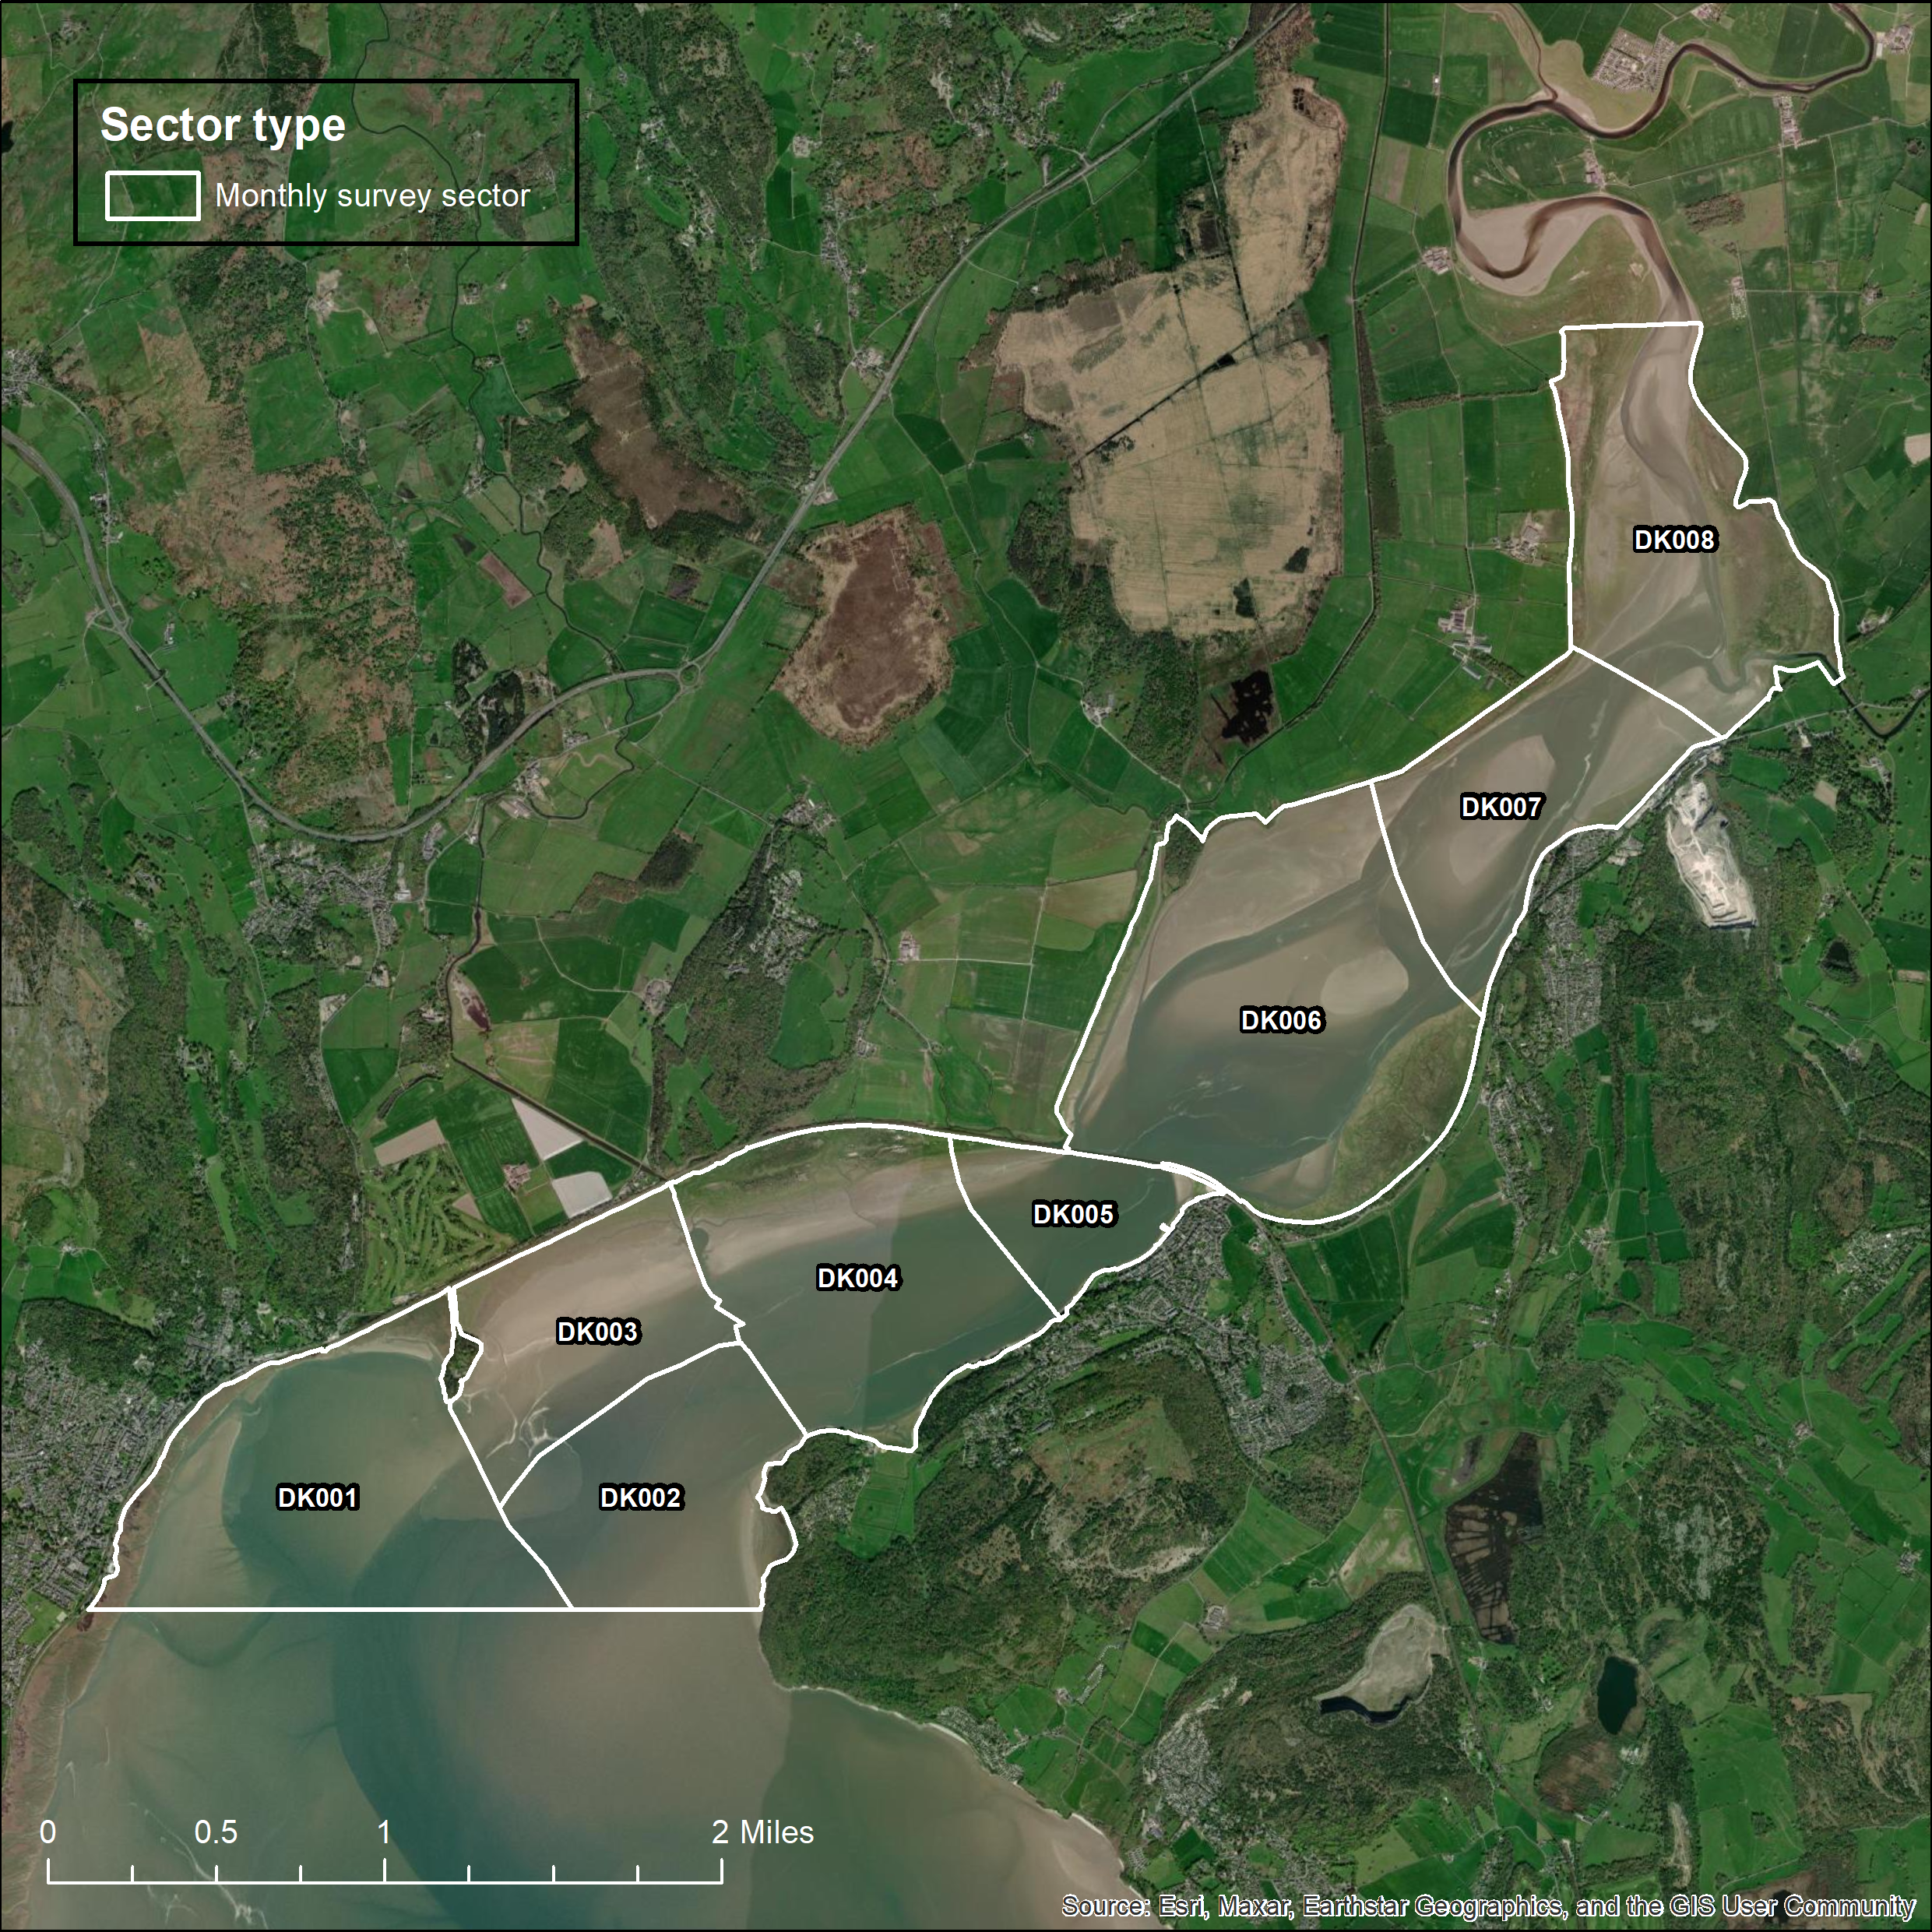
Figure 3. Map of the Morecambe Bay and Duddon Estuary SPA low tide count sectors within the Kent Estuary which are the focus of the low tide counts in this project (Task 1) (DK001-DK008).

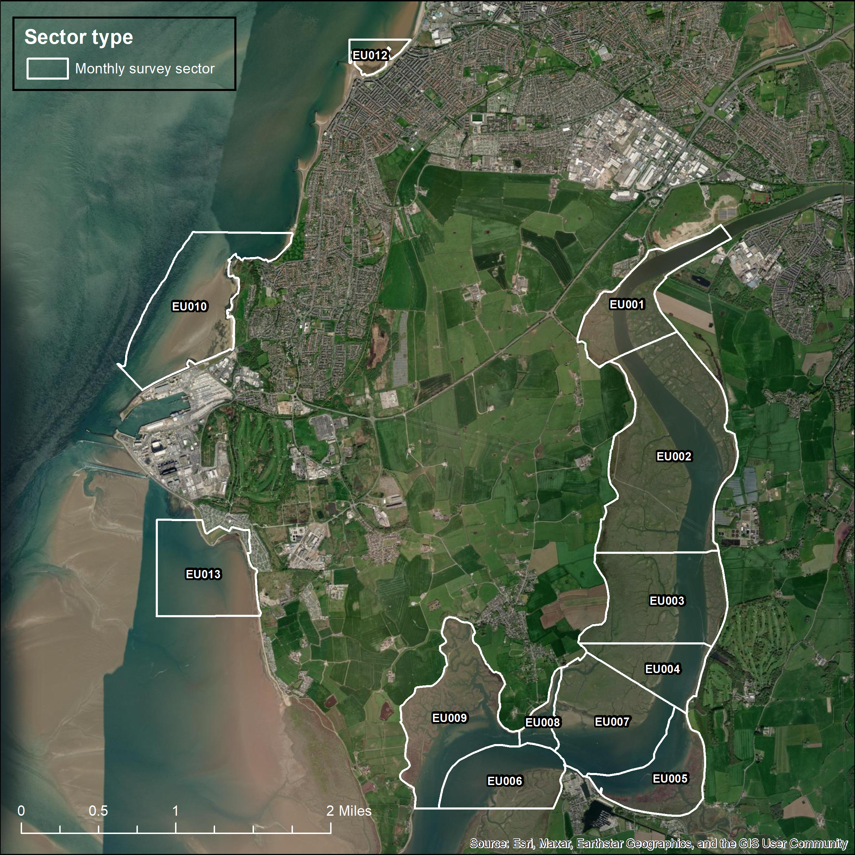
Figure 4. Map of the Morecambe Bay and Duddon Estuary SPA low tide count sectors within the Lune Estuary which are the focus of the low tide counts in this project (Task 1) (EU001-EU010, EU012 & EU013).
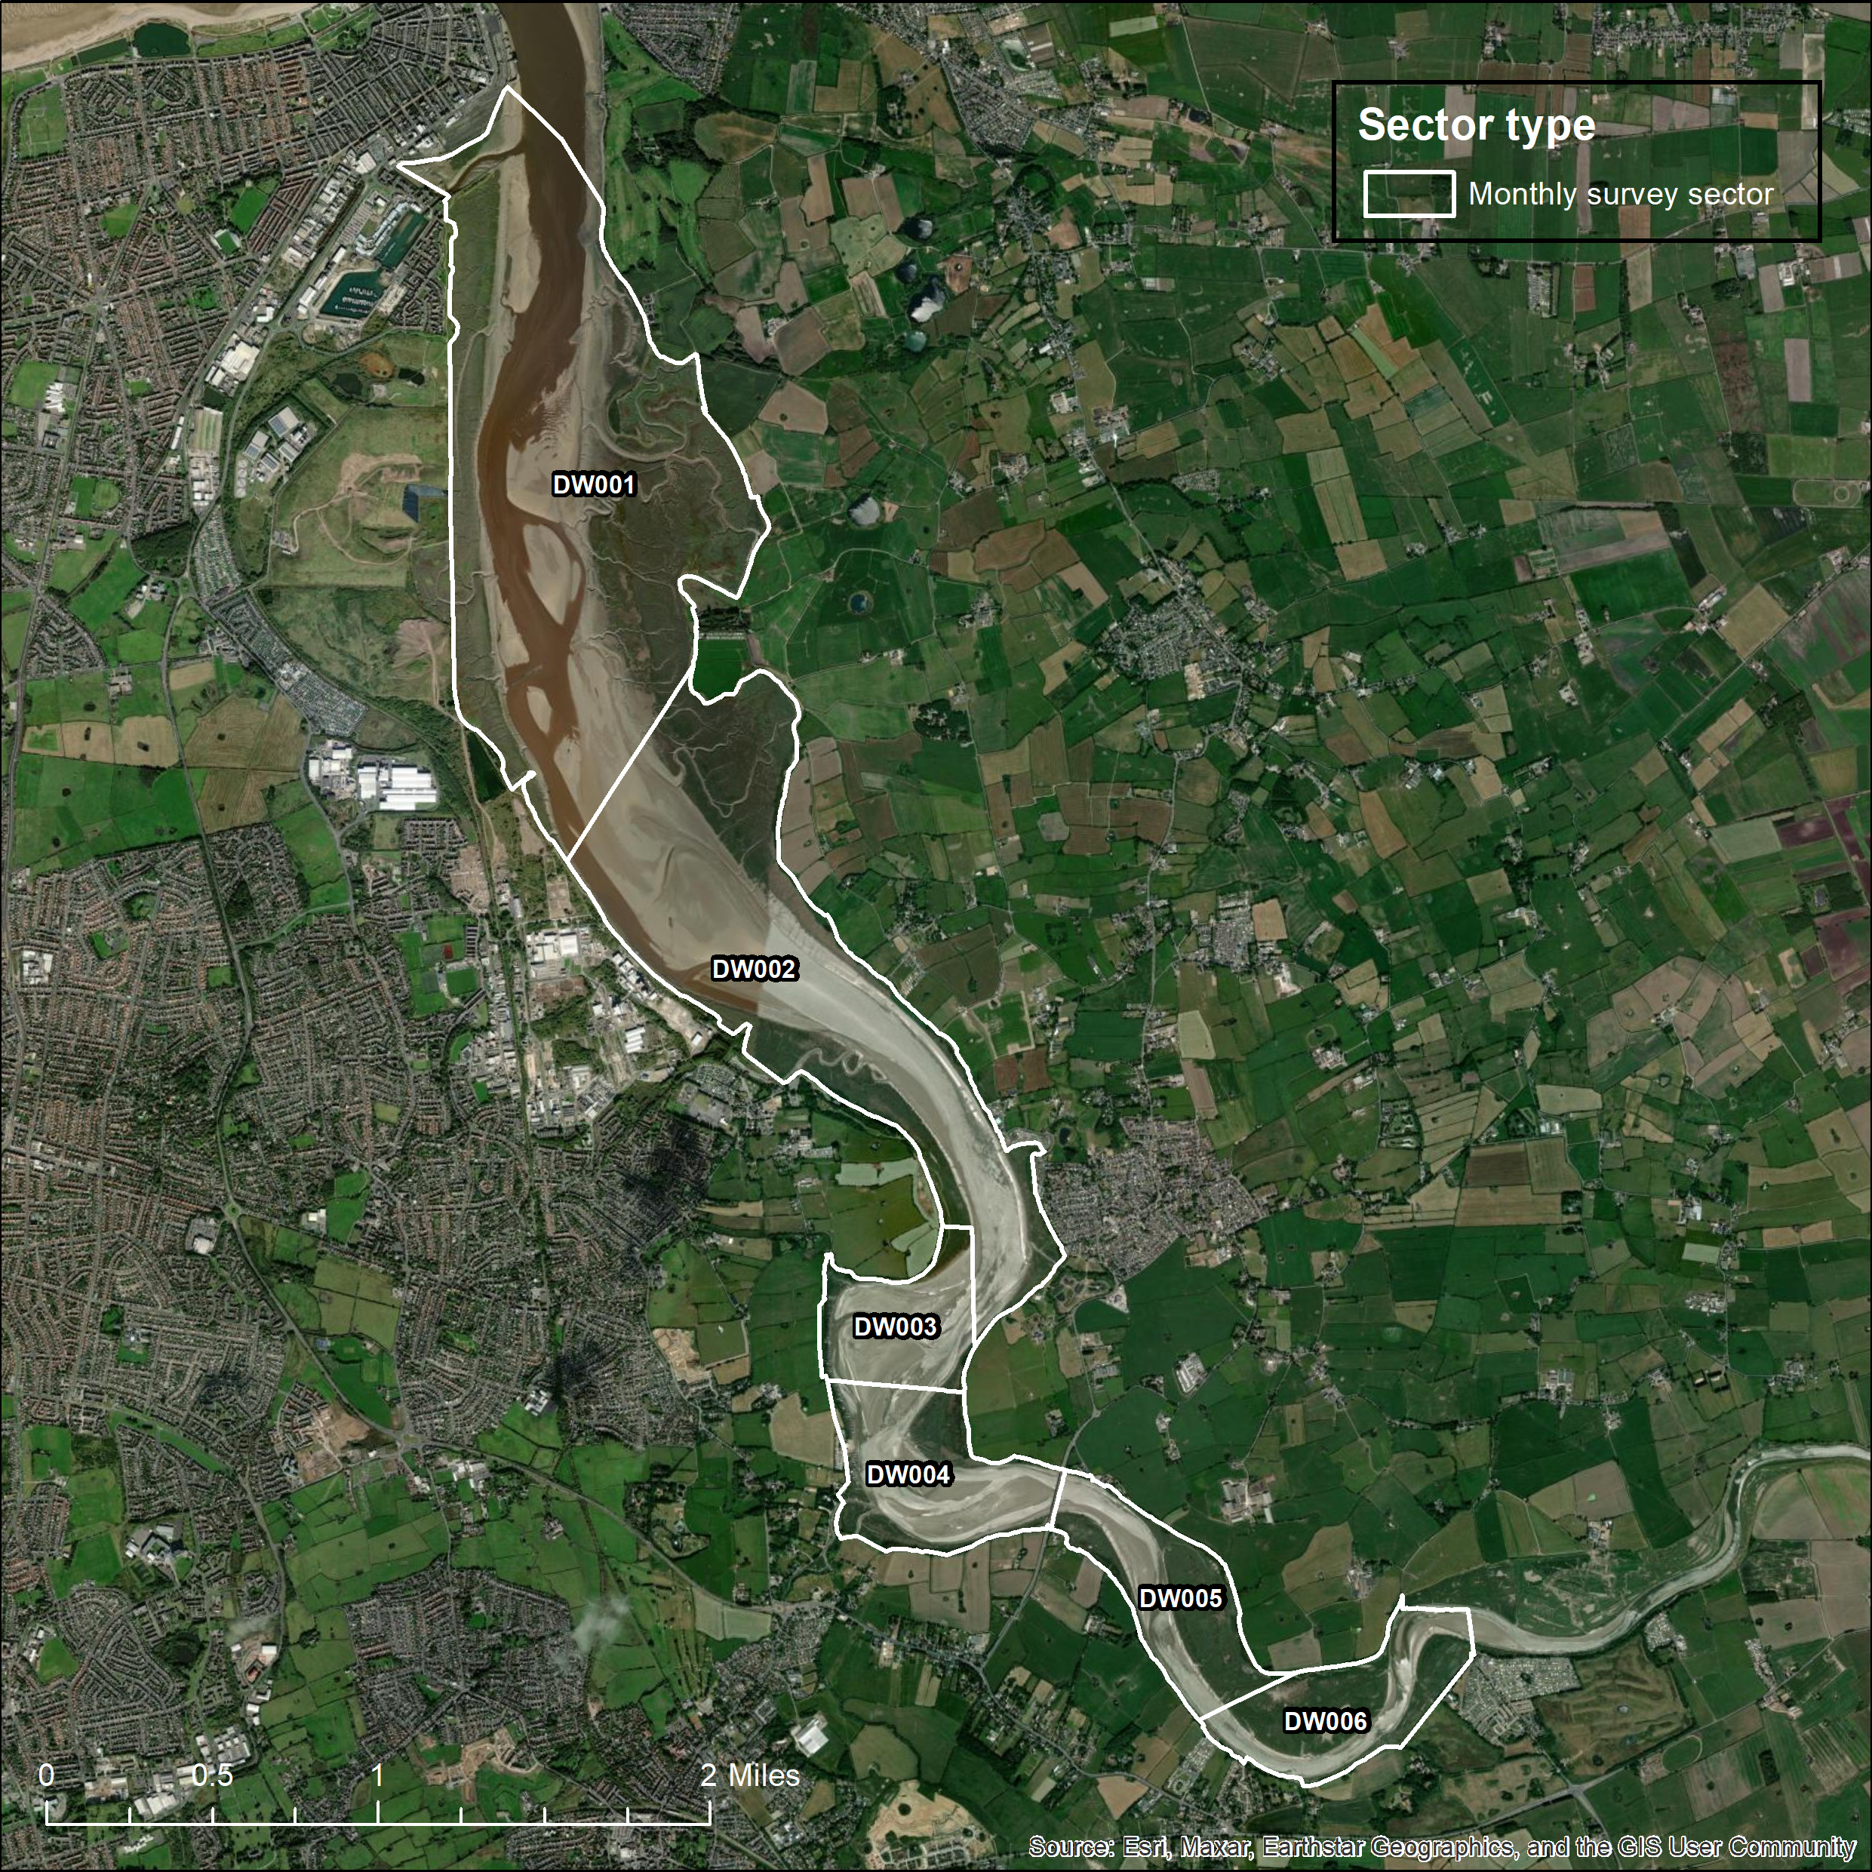
Figure 5. Map of the Morecambe Bay and Duddon Estuary SPA low tide count sectors within the Wyre Estuary which are the focus of the low tide counts in this project (Task 1) (DW001-DW006).

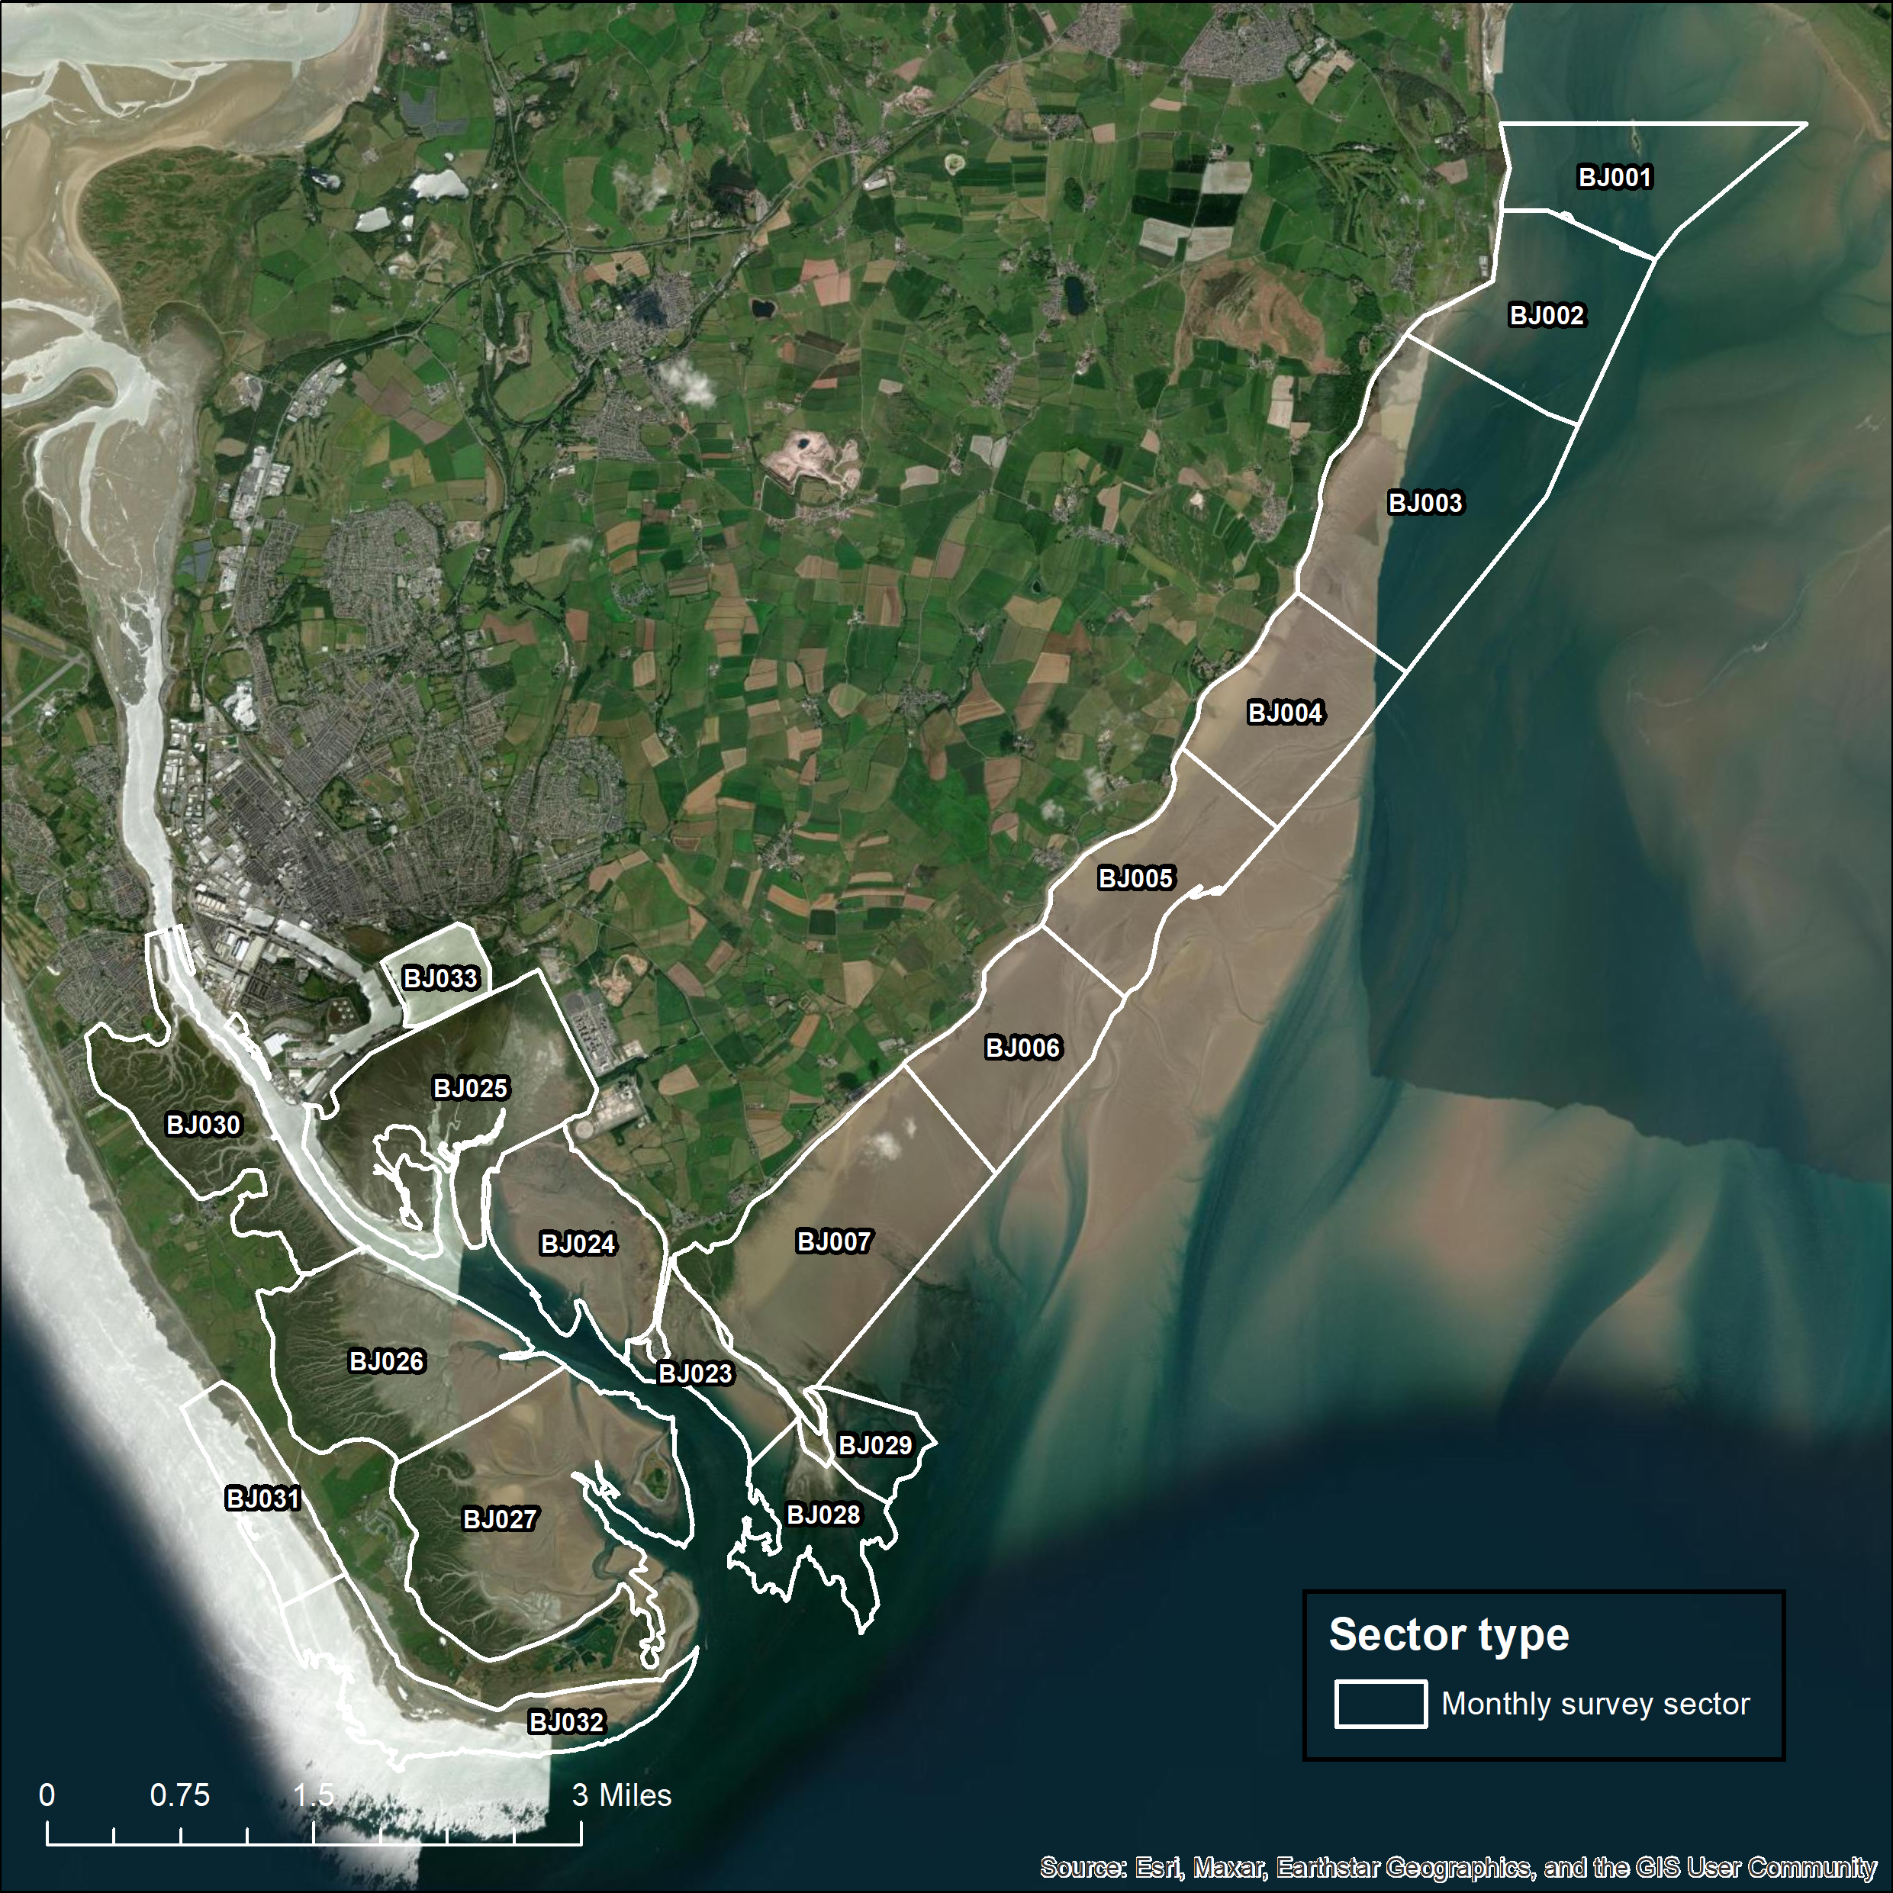
Figure 6. Map of the Morecambe Bay and Duddon Estuary SPA low tide count sectors within the Morecambe Bay West site (including South Walney & Piel Channel Flats) which are the focus of the low tide counts in this project (Task 1) (BJ001-BJ007 & BJ023-BJ033 (incorporating BJ008-BJ014)).

1.4.2 Bespoke ground-based low tide surveys for validation of aerial survey method
For this element of the project (Task 2), the focus is on the Morecambe Bay West and Morecambe Bay Kent WeBS LTC sites. Specifically, for this task, repeated counts are required of nine WeBS LTC sectors in Morecambe West (BJ002-007, BJ023, BJ028, BJ029) and five WeBS LTC sectors in Morecambe Bay Kent (DK001-005) (Figures 7 & 8). These count boundaries must be adhered to when surveying in this project.
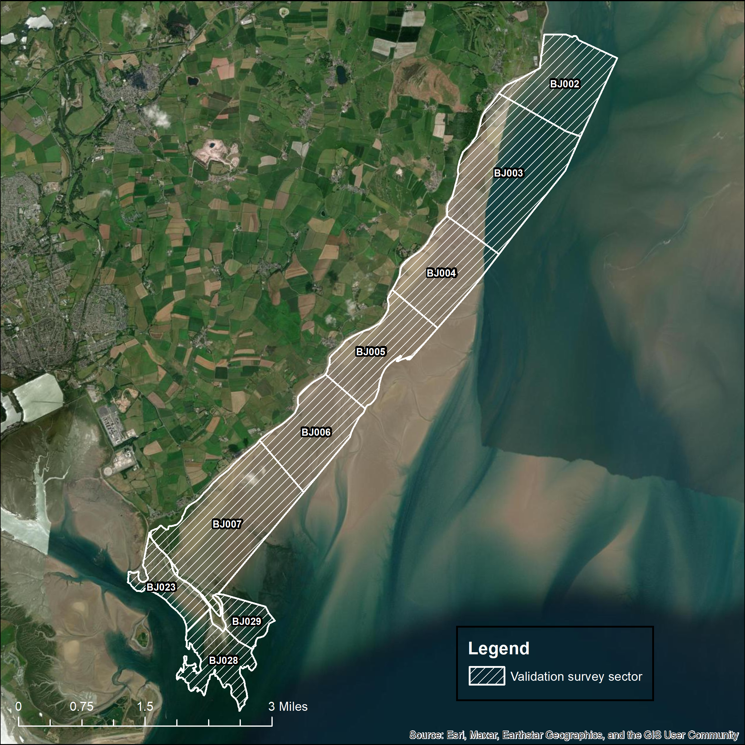
Figure 7. Map of the Morecambe Bay and Duddon Estuary SPA low tide count sectors which are the focus of the validation study (Task 2) i.e., Morecambe Bay West BJ002-007, BJ023, BJ028, BJ029.
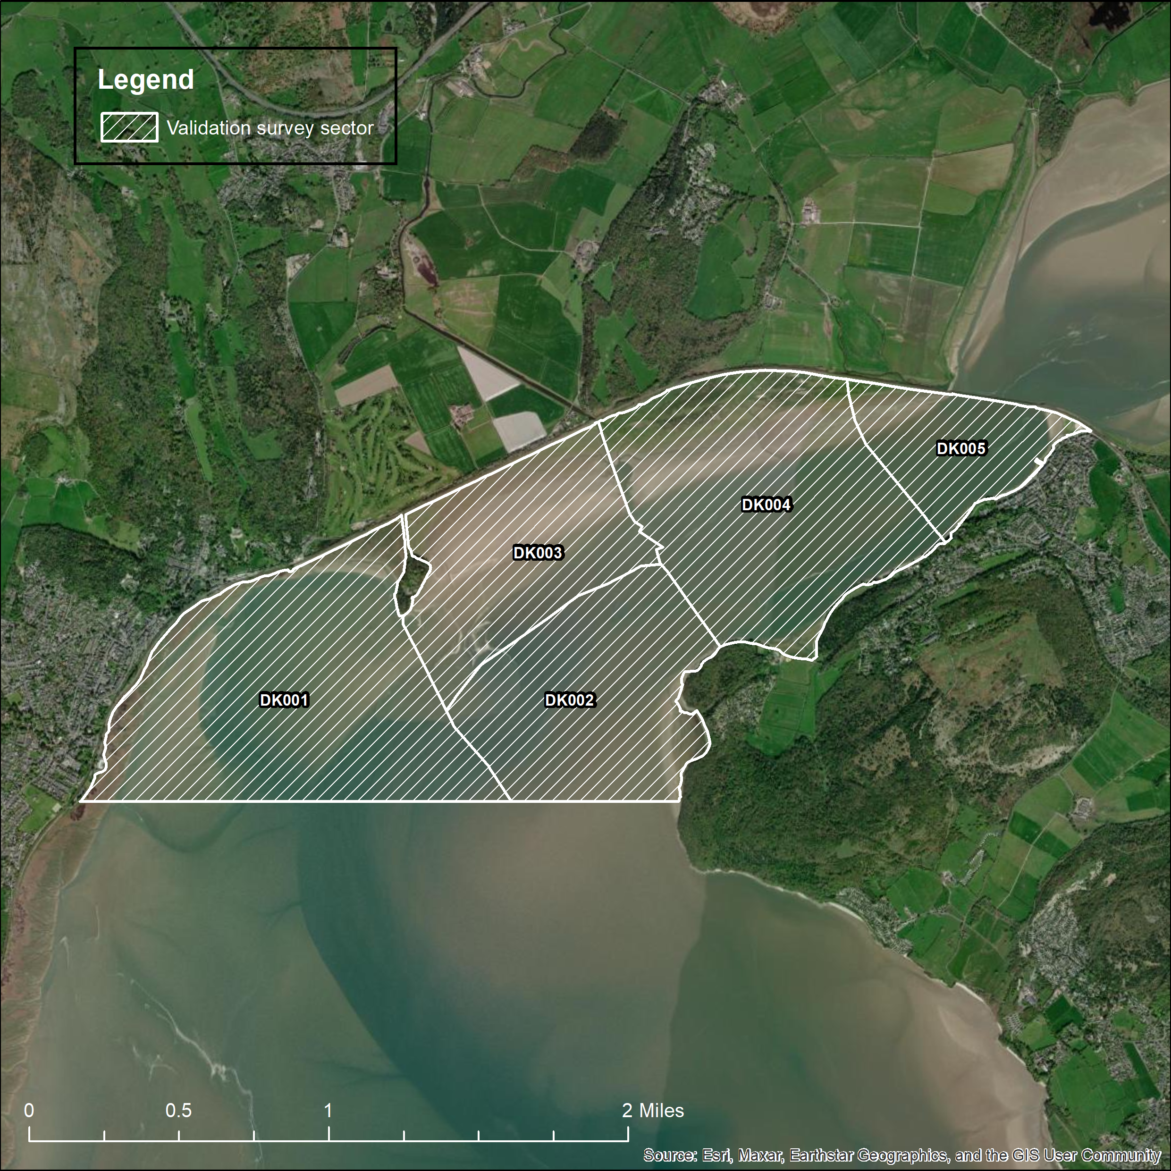
Figure 8. Map of the Morecambe Bay and Duddon Estuary SPA low tide count sectors which are the focus of the validation study (Task 2) i.e., Morecambe Bay Kent DK001-005.

2. Objectives
Natural England require the contractor to provide all aspects of ground-based surveys of wintering waterbirds (including gulls) including suitably qualified surveyors and appropriate field equipment, data processing, Quality Assurance and reporting to meet the requirements and objectives of the project. The contractor should use appropriate software and methods and provide a clear concise report and associated deliverables as detailed in this specification.

There are FIVE objectives for this contract. These are to:
- Conduct 4 (four) once monthly (November 2023 – February 2024), standardised, shore-based surveys of the abundance and distribution of all waterbirds (including gulls) within the Leven, Kent, Lune and Wyre estuaries and the Morecambe Bay West site (including South Walney & Piel Channel Flats) in accordance with the current WeBS LTC scheme methodology (https://www.bto.org/our-science/projects/wetland-bird-survey/taking-part/low-tide-counts-methods ).
- Conduct ground-based surveys (entailing repeated counts through each of a minimum of three consecutive days) of the abundance and distribution of all waterbirds (including gulls) within selected low tide count sectors within the ‘Morecambe Bay West’ and ‘Morecambe Bay Kent’ sites, according to a bespoke methodology set out in this RfQ (section 3.2). The survey of these areas must encompass the time at which an aircraft will be scheduled to pass over the survey areas (under a separate contract let by Natural England specifically for the purpose of this validation exercise).
- Process and summarise the survey data gathered in fulfilment of objectives a) and b).
- Quality assure results so that pre-agreed data standards are met (e.g. standards required for acceptance of data by the WeBS LTC scheme).
- Produce a single comprehensive report including survey methods and any other methods used in delivery of objectives a), b) and c), results, and a discussion of any analyses. The contractor should also provide relevant accompanying datasets and metadata/metadata record (where appropriate).
Section 3 provides further detail on the methodology required to deliver these objectives.

3. Methods

3.1 Low tide counts of Kent, Leven, Lune and Wyre estuaries and Morecambe Bay West (including South Walney & Piel Channel Flats) (Task 1)
The methods employed to deliver this task should correspond exactly with those set out in the established WeBS LTC scheme methodology. This is available online at https://www.bto.org/our-science/projects/wetland-bird-survey/taking-part/low-tide-counts-methods, and is included within Appendix 1 of Clewley et al. (2022). The standard LTC scheme recording from is also available online at: https://www.bto.org/sites/default/files/u18/downloads/counter_resources/lowtidecountform.pdf , and is included within Appendix 3 of Clewley et al. (2022). Each of the sites is subdivided into several, pre-established and clearly defined low tide count sectors which must be adhered to when surveying in this project.
Counts for task 1 should be undertaken once monthly from November 2023 – February 2024, over as few days as possible each month and on similar tides to the aerial survey of the whole SPA proposed for December 2023/January 2024.
In the month that the aerial survey takes place, counts should be undertaken as close as possible to the date of that survey. However, prioritisation should be given to the surveys of specific sectors under Task 2 (for validation of aerial survey method) being on the same date as the aerial survey of those sectors.
For all counts, birds should be identified to species.
All count data for Task 1 should be submitted to the WeBS LTC organiser (lowtide@bto.org) at the BTO through a standard spreadsheet (with metadata on count sector, date, time, etc) which should be obtained from the WeBS LTC organiser.
Full details of logistic considerations for survey work should be provided in the tender e.g. operational restrictions, or other factors that may justify excluding coverage of certain areas and how these restrictions will be addressed.
There are various risks that may constrain the ability to complete the survey and data processing within the required timescales, considering factors such as weather, access restrictions etc. Bidders should describe the potential risks and provide details of relevant contingency measures.
To enable successful delivery of the surveys, the successful Contractor is expected to:
- Plan the delivery of the low tide counts across all sites/months and submit these plans at tendering stage.
- Conduct the surveys, including organisation and positioning of surveyors and equipment, and ensuring that all health and safety requirements, including Covid-19 requirements, are met.
- Submit brief survey completion reports following the completion of each of the four, once monthly surveys.

3.2 Bespoke ground-based low tide surveys for validation of aerial survey method (Task 2).
The specific objectives of the validation study are, by means of collecting and subsequently comparing spatially and temporally matched survey data from both ground-based and digital arial surveys, to: (i) assess detection of birds by the aerial surveys, (ii) provide an understanding of the level of species identification achieved by aerial surveys, iii) determine if/how ability to detect and identify individuals to species level by aerial survey differs between species and iv) determine how reliably detected birds that could not be identified to species (from the air) can nonetheless be assigned to species.
For this element of the project (Task 2), the focus is on the Morecambe Bay West and Morecambe Bay Kent WeBS LTC sites (Figures 7 & 8). Specifically counts are required of nine WeBS LTC sectors in Morecambe West (BJ002-007, BJ023, BJ028, BJ029) and five WeBS LTC sectors in Morecambe Bay Kent (DK001-005). These count boundaries must be adhered to when surveying in this project. However, subdivision of these count sectors may be of benefit to: a) keep total counts of any species in the 100s to low 1000s and b) facilitate precise counting by observers. Any such subdivision would also be advantageous for subsequent analyses, but should follow clear landscape features, e.g. channels, within those sectors and be accurately mapped by the Contractor. Subdivision of existing WeBS LTC sectors should be agreed in discussion with the WeBS LTC organiser (lowtide@bto.org) at the BTO prior to surveys, such that new sector codes and GIS shapefiles can be generated.
The counts should be carried out in December 2023 or January 2024, coordinated with the expected date of the aerial survey being undertaken for this validation work. Repeat counts over a minimum of three days around and including the aerial survey date are required (to understand day-to-day variation in numbers and how the relative timing of counts affects comparisons) with one of these days ideally being the exact date of the aerial survey. Counts on each day should be undertaken to include the same tide conditions as the aerial survey. It is expected that on the date of the aerial survey, the count sectors which are the focus of this task will be surveyed two or three times, e.g., on the falling and rising tide and/or over low tide, and ground-based counts should thus also be repeated at these times on each of the days.
Counts should provide full coverage of each of the sectors above. For all counts, birds should be identified to species.
As for Task 1, the methods employed to deliver this task should correspond exactly with those set out in the established WeBS LTC scheme methodology. This is available online at https://www.bto.org/our-science/projects/wetland-bird-survey/taking-part/low-tide-counts-methods , and is included within Appendix 1 of Clewley et al. (2022). The standard LTC scheme recording from is also available online at: https://www.bto.org/sites/default/files/u18/downloads/counter_resources/lowtidecountform.pdf , and is included within Appendix 3 of Clewley et al. (2022).
All count data for Task 2 should also be submitted to the WeBS LTC organiser (lowtide@bto.org) at the BTO through a standard spreadsheet (with metadata on count sector, date, time, state of tide, etc) which should be obtained from the organiser.
Full details of logistic considerations for survey work should be provided in the tender e.g. operational restrictions, or other factors that may justify excluding coverage of certain areas and how these restrictions will be addressed.
There are various risks that may constrain the ability to complete the survey and data processing within the required timescales, considering factors such as weather, access restrictions etc. Bidders should describe the potential risks and provide details of relevant contingency measures.

To enable successful delivery of the surveys, the successful Contractor is expected to:

- Plan the delivery of the validation study ground-based survey(s) and submit these plans at tendering stage.
- Provide a protocol, agreed with the supplier of the aerial-based validation surveys, setting out the means of coordination of the ground-based and aerial based survey of the selected validation sites/low tide count sectors to be surveyed as part of the validation study to maximise synchronicity of data collection.
- Liaise closely with the aerial-based survey contractors to ensure simultaneous surveys of each sub-area by both methods.
- Conduct the surveys, including organisation and positioning of surveyors and equipment, and ensuring that all health and safety requirements, including Covid-19 requirements, are met.
- Submit a brief survey completion report following the completion of the validation study ground-based surveys.
The results of these bespoke low tide counts will be used (outwith this project) to validate the results of the simultaneous digital aerial survey and inform consideration by Natural England and the BTO of the scope for and any limitations to the wider application of the digital aerial survey methods in monitoring of waterbird population abundance and distribution across large and/or inaccessible estuarine sites such as Morecambe Bay & Duddon Estuary SPA.

3.3 Processing the count data (Task 3)
Count data gathered in delivering both Tasks 1 & 2 should be processed to generate as a minimum, a brief analysis of numbers (means, peaks, variation) for each species for each count sector for each LTC site in each survey month (Task 1) and for each repeat count conducted of each species on each day within each of the count sectors (and any agreed subdivisions of those) (Task 2).

3.4 Reporting (Task 4)
The contractor should use the Natural England report template and follow associated guidance when producing their report (see: Natural England publishing standards for commissioned reports - NECR000). This aims to speed up the report publication process and promote rapid access to evidence where appropriate.
In addition to the brief survey reports to be submitted to Natural England after each survey competed under Tasks 1 and 2, the Contractor should deliver a single final report detailing the outcomes of the surveys and high-level summaries of the processed data. The report should use a standard scientific layout including the following:
  - an executive summary,
  - an introduction and background to the work,
  - a methods section detailing the adopted surveying approach for each of Tasks 1 & 2,
  - a results section providing tables of count data for all species in each WeBS LTC scheme count sector on each survey of each site surveyed as part of Task 1,
  - a results section providing tables of all repeat count data for all species in each WeBS LTC scheme count sector (and/or agreed subdivisions of these) surveyed as part of Task 2, i.e. the validation study,
  - a discussion of the findings from the ground-based surveys needed to inform the validation study, outlining any caveats concerning the use of and limitations to the count data presented and recommendations regarding its best use in the subsequent validation analyses (to be completed under a separate contract).

Sustainability
Natural England protects and improves the environment and is committed to reducing the sustainability impacts of its activities directly and through its supply chains. We expect the Contractor to share this commitment and adopt a sound, proactive sustainable approach in keeping with the 25 yr environmental plan/our commitments compliant with all applicable legislation. This includes understanding and reducing direct and indirect sustainability impacts and realising opportunities, including but not restricted to; resilience to climate change, reducing greenhouse gas emissions, water use and quality, biosecurity, resource efficiency and waste, reducing the risk of pollution, biodiversity, modern slavery and equality, diversity & inclusion, negative community impacts.
As a delivery partner, the successful contractor is expected to pursue sustainability in their operations, thereby ensuring the Contracting Authority is not contracting with a supplier whose operational outputs run contrary to the Contracting Authority’s objectives. The successful contractor will need to approach the project with a focus on the entire life cycle of the project.

Outputs and Contract Management

Project deliverables
On award of the contract, the supplier will be required to deliver the following:

- Ground-based survey work
- A protocol agreed with the supplier of the aerial surveys setting out the means of coordination of the ground-based and aerial-based survey(s) of the specific sub-set of sites / low tide count sectors to be surveyed as part of the validation study to maximise synchronicity of data collection.
- Four brief survey completion reports (one within 7 days of completion of each of the standard monthly low tide counts) in Microsoft Word format detailing pertinent information regarding the survey (dates, time, weather, disturbance, any other issues affecting data quality etc).
- A brief survey completion report (within 7 days of completion of the validation study survey) in Microsoft Word format detailing pertinent information regarding the survey (dates, time, weather, disturbance, any other issues affecting data quality etc).

- Analyses
- Numbers (e.g. means, peaks, variation) for each species for each count sector for each LTC site in each survey month (Task 1) and for each repeat count conducted of each species on each day within each of the count sectors (and any agreed subdivisions of those) (Task 2).

- A single final technical report
Following Natural England guidance and using the Natural England Microsoft Word template (Available from: Natural England publishing standards for commissioned reports - NECR000). The report should provide the following:
  - an executive summary,
  - an introduction and background to the work,
  - a methods section detailing the adopted surveying approach for each of Tasks 1 & 2,
  - a results section providing tables of count data for all species in each WeBS LTC scheme count sector on each survey of each site surveyed as part of Task 1,
  - a results section providing tables of all repeat count data for all species in each WeBS LTC scheme count sector (and/or agreed subdivisions of these) surveyed as part of Task 2, i.e. the validation study,
  - a discussion of the findings from the ground-based surveys needed to inform the validation study, outlining any caveats concerning the use of and limitations to the count data presented and recommendations regarding its best use in the subsequent validation analyses (to be completed under a separate contract).

- Accompanying datasets.
- Quality assured datasets of validated observations for all species recorded – so that pre-agreed data standards are met e.g. compliance with requirements for entry into the WeBS LTC scheme database.
- Where relevant, datasets should include a sheet with meta-data and field name explanations.
- All data provided must (where appropriate) comply with Natural England metadata and GIS standards (see Annex 3).
- All count data should also be submitted to the WeBS LTC organiser (lowtide@bto.org) at the BTO through a standard spreadsheet which should be obtained from the organiser.

Following agreement from Natural England, all relevant datafiles and associated metadata records may be required to be submitted by the contractor to a pre-agreed public repository within a pre-agreed period following completion of the surveys.

Project management
Once let, the following project milestones will apply:
Milestone | Responsible Party | Date of completion
Project inception meeting/ teleconference between contractor/sub-contractor, Natural England, British Trust for Ornithology (BTO)* | Natural England, BTO and Contractor* | W/C 30th October 2023
Contractor agrees protocol with supplier of aerial-based validation survey data to ensure synchronicity between aerial survey and ground-based survey for task 2 and submits protocol to Natural England/BTO | Contractor (in collaboration with contractor supplying digital aerial survey) | By 10th November 2023
Contractor submits brief survey completion report following first low tide count (task 1) | contractor | End-November 2023
Contractor submits brief survey completion report following second low tide count (task 1) | contractor | End-December 2023
Teleconference between Natural England, BTO, and contractor to discuss progress and any issues arising | Natural England, BTO, Contractor | End- December 2023
Contractor submits brief survey completion report following third low tide count (task 1) | contractor | End January 2024
Contractor submits brief survey completion report following validation survey (task 2) | contractor | End January 2024
Contractor submits brief survey completion report following fourth low tide count (task 1) | contractor | End February 2024
Teleconference between Natural England, BTO, contractor and digital aerial survey contractor to discuss progress with analyses and any issues arising | Natural England, BTO, Contractor and supplier of digital aerial survey | End-February 2024
Contractor submits draft final technical report to NE/BTO | Contractor | 15th March 2024
Natural England/BTO provide feedback on draft final technical report | Natural England and BTO | 22nd March 2024
Teleconference between Natural England, BTO and contractor to discuss feedback on draft final technical report | Natural England, BTO and contractor | 22nd March 2024
Contractor submits final technical report addressing Natural England/BTO comments on draft report to satisfaction on NE project officer | Contractor | 29th March 2024
Submission of ArcGIS layers, other associated datasets and metadata to agreed standards. | Contractor | 29th March 2024
Wash-up meeting | Natural England, BTO and Contractor | 29th March 2024
Contract to be completed | Natural England and Contractor | 29th March 2024
* Depending upon timelines, the supplier of the aerial-based survey element of the validation study (task 2) may be invited to attend this inception call.
This is the envisaged contract timetable. Bidders should highlight any proposed deviation from this timeline within their bid. Any delays to this timetable during the contract should be immediately discussed with the Project Officer.
In addition to the four meetings/teleconferences itemised in the table of project milestones, Natural England requires that short catch-up calls between the NE project officer and lead point of contact for the contractor are scheduled every two weeks to provide an opportunity to discuss any additional issues arising and provide an update on progress.
In support of this contract, Natural England/BTO will provide the successful Contractor with:
- Project support from dedicated project lead (NE project officer).
- GI layers delineating all the standard WeBS LTC scheme count sectors within the areas of interest (task 1)
- GI layers delineating the proposed boundaries of the count sectors to be surveyed as part of the validation study (task 2)
- Feedback comments on the draft final technical report
- Opportunity to feedback and discuss progress with the NE project lead and BTO at regular intervals throughout the project.

Data ownership, intellectual property rights and copyright
All data captured and produced shall be fully owned by and copyrighted to Natural England. This shall include any intellectual property rights that might otherwise impede on Natural England’s usage and data sharing of the outputs. Natural England may share any project outputs with third parties (for example the BTO) including for the purposes of additional analyses outside the final scope of any contract awarded against this statement of requirements. Any data supplied by Natural England/BTO to potential bidders and the successful contractor are for use in this project only and should not be retained once the bidding process (for unsuccessful bidders) or project (for the successful contractor) has been completed. In addition, neither bidders nor the successful contractor must pass such data on to any third parties unless with explicit prior permission from Natural England/BTO. The contractor is responsible for ensuring that all products submitted are of a satisfactory standard. The Natural England Nominated Officer may undertake a QA review of all project deliverables prior to approving subsequent payment for the work. Following discussion with and agreement from Natural England, the contractor is responsible for submitting all datafiles and associated metadata records to a pre-agreed public repository within a pre-agreed period following completion of the project.

Payment
The Authority will raise purchase orders to cover the cost of the services and will issue to the awarded supplier following contract award.
The Authority’s preference is for all invoices to be sent electronically, quoting a valid Purchase Order number. Payment of 50% of the total contract value will be made on receipt of a detailed invoice following completion (to the satisfaction of the Natural England Nominated Officer) of the first two low tide counts, and submission of brief completion reports on both surveys. The remaining 50% of the total contract value will be made on receipt of a detailed invoice following completion (to the satisfaction of the Natural England Nominated Officer) of all the milestones detailed above, and formal acceptance by them of the specified outputs. All invoices should be dated no later than 31st March 2024.
It is anticipated that this contract will be awarded for a period of 22 weeks (~ 6 months) to end no later than 31st March 2024. Prices will remain fixed for the duration of the contract award period. We may at our sole discretion extend this contract to include related or further work. Any extension shall be agreed in writing in advance of any work commencing and may be subject to further competition.

Evaluation Methodology
We will award this contract in line with the most economically advantageous tender (MEAT) as set out in the following award criteria:
Technical – 50%
Commercial – 50%

Evaluation criteria
Evaluation weightings are 50% technical and 50% commercial, the winning tenderer will be the highest scoring combined score.
The summary table below provides an overview of the overall evaluation breakdown.
Award Criteria | Weighting (%) | Evaluation Topic & Weighting | Sub-Criteria | Weighted Question
Technical | 50% | Service / Product Proposal | Methodology | Q1. Please provide details of the methodology proposed to deliver the requirements set out in the Specification. (60% of technical score available)
 |  |  | Staff Technical Expertise | Q2. Please provide details of the project team providing the requirements set out in the Specification. (30% of technical score available)
 |  |  | Risk assessment | Please provide a project risk assessment. (10% of technical score available)
Commercial | 50% | Whole life cost of the proposed Contract | Commercial Model | Q3. Please provide costs (100% of commercial score available)

Technical (50%)
Technical evaluations will be based on responses to specific questions covering key criteria which are outlined below. Scores for questions will be based on the following:
Description | Score | Definition
Very good | 100 | Addresses all the Authority’s requirements with all the relevant supporting information set out in the RFQ. There are no weaknesses and therefore the tender response gives the Authority complete confidence that all the requirements will be met to a high standard.
Good | 70 | Addresses all the Authority’s requirements with all the relevant supporting information set out in the RFQ. The response contains minor weaknesses and therefore the tender response gives the Authority confidence that all the requirements will be met to a good standard.
Moderate | 50 | Addresses most of the requirements with most of the relevant supporting information set out in the RFQ. The response contains moderate weaknesses and therefore the tender response gives the Authority confidence that most of the requirements will be met to a suitable standard.
Weak | 20 | Substantially addresses the requirements but not all and provides supporting information that is of limited or no relevance or a methodology containing significant weaknesses and therefore raises concerns for the Authority that the requirements may not all be met.
Unacceptable | 0 | No response or provides a response that gives the Authority no confidence that the requirement will be met.
Technical evaluation is assessed using the evaluation topics and sub-criteria stated in the Evaluation Criteria section above.
Separate submissions for each technical question should be provided and will be evaluated in isolation. Tenderers should provide answers that meet the criteria of each technical question set out in the following tables.

Q1. Methodology | Detailed Evaluation Criteria
Please submit a document with the filename: “PBDM_WP4_Task4.1_MB&DE_SPA_  ground_E01_Company Name”.  Your response must not exceed a maximum of 6 sides of A4 (in addition to any title page), font size Arial 11. | The response must demonstrate the delivery method for each requirement specified in the Specification (2. Objectives) of this RFQ, and where relevant, demonstrate how these methods comply with those set out in the Specification (3. Methods) or provide reasons for why they do not. The response must include information in sufficient detail to allow a full appraisal of the suitability of the approach to deliver for the project.  Your response will be evaluated on the basis of whether it:  - Demonstrates a clear understanding of the nature of the requirements.  - Includes a clear, practical, achievable and cost-effective methodology to deliver these requirements including provision of:  - a clear survey plan, protocol and programme for delivery of tasks 1 & 2;  - details of clear and established procedures for capturing, securing, storing, processing and QA-ing count data with typical durations from data capture to fully available data;  - details of contingency processes for disrupted or aborted surveys;  - information on any added value your organization can bring to the project.  .  A minimum score of 50 averaged across evaluators is required to be met for this question. Any average score below this will be scored as a Fail.

Q2. Staff Technical Expertise | Detailed Evaluation Criteria
Please submit a document with the filename “PBDM_WP4_Task4.1_MB&DE_SPA_  ground_E02_Your Company Name”.  Your response must not exceed a maximum of 6 sides of A4 (in addition to any title page), font size Arial 11. | The response must demonstrate that the staff members (including any sub-contractors if appropriate) who will be assigned to delivery of this specific project have sufficient technical expertise across the broad range of technical skills required to deliver the project objectives including both generic skills and specific skills including but not limited to:  - Project management  - Planning and conducting ground-based surveys of waterbirds (including gulls) on intertidal habitats  - Identification of all species likely to be encountered in the study area  - Handling, storing and securing data  - Ensuring Quality Assurance of data products  - Use of appropriate data processing tools  - Implementing data standards  This will include examples of skills, expertise, and relevant training. The project team should have an appropriate balance of inputs by senior and junior staff. Lines of reporting to staff (to senior staff and/or the project manager) should be clearly presented and sufficient.  The information provided should include:  - For each member of the Project team, information on the amount of time input to this specific project, their roles, responsibilities, levels of seniority, the value added that they will bring to the project, their lines of reporting and their availability to do the work.  - The name(s) of the individual(s) who will have overall management responsibility for the project and will report to Natural England’s project officer and the person who will be responsible for ensuring that the Project is completed satisfactorily.  Your response will be evaluated based on:  - The level and relevance of expertise and skills, provided by the Project team and any sub-contractors and the value added delivered by this. This will consider expertise and skills in: project management; ornithology; field surveys of waterbird distribution and abundance, data collection and collation and knowledge of data standards.  - The suitability and adequacy of the staff making the inputs to each stage of the Project (in terms of their expertise and skills), the quantity of their inputs and their availability to do the work. For each member of the Project team, information on the amount of time input (days/hours) to this specific project. We suggest this information is provided in a table.  - The appropriateness of the balance of inputs by senior and junior staff and clarity and sufficiency of lines of reporting. Please provide the name(s) of the individual(s) who will have overall management responsibility for the project and will report to Natural England’s project officer and the person who will be responsible for ensuring that the Project is completed satisfactorily. We suggest a project specific organogram is provided. Consideration should be given to cover for key roles given any unforeseen circumstances.  A minimum score of 50 averaged across evaluators is required to be met for this question. Any average score below this will be scored as a Fail.
Q3 Risk assessment | Detailed evaluation criteria
Please submit a document with the filename: “PBDM_WP4_Task4.1_MB&DE_SPA  _ground_E03_Your_Company Name”.  Your response must not exceed a maximum of 6 sides of A4 (in addition to any title page), font size Arial 11. | Provide a project risk assessment tailored to the requirement to cover matters regarding:  - Health and Safety risks associated with conducting the surveys needed to fulfil the objectives of this project, and associated mitigation measures.  - All other (non-H&S) risks associated with delivery of the surveys and subsequent data processing, analyses, reporting etc needed to fulfil the objectives of this project, and associated mitigation measures and contingencies.  Evaluation criteria:  Your response will be evaluated on the basis of whether it:  - Demonstrates a clear understanding of the Health & Safety issues associated with delivery of the surveys needed to fulfil the objectives of this project and describes effective measures to mitigate those risks.  - Demonstrates a clear understanding of all other risks associated with delivery of the surveys specifically and the project in general to fulfil the objectives of this project and describes effective measures to mitigate those risks.  Note that this response should include, but NOT be limited to matters concerning H&S in conducting the field surveys, and should address ALL risks to project delivery.  A minimum score of 50 averaged across evaluators is required to be met for this question. Any average score below this will be scored as a Fail.

Commercial (50%)
The Contract is to be awarded as a fixed price which will be paid according to the completion of the deliverables stated in the Specification of Requirements.
Suppliers are required to submit a total cost to provide the deliverables stated in the Specification of Requirements. In addition to this, the Commercial Response template must be completed to provide a breakdown of the whole life costs against each deliverable used in the delivery of this requirement.

Calculation Method
The method for calculating the weighted scores is as follows:
- Commercial
Score = (Lowest Quotation Price / Supplier’s Quotation Price) x 50% (Maximum available marks)
- Technical
Score = (Bidder’s Total Technical Score / Highest Technical Score) x 50% (Maximum available marks)
The total score (weighted) (TWS) is then calculated by adding the total weighted commercial score (WC) to the total weighted technical score (WT): WC + WT = TWS.

Information to be returned
Please note, the following information requested must be provided. Incomplete tender submissions may be discounted.
Please complete and return the following information:
- completed Commercial Response template
- separate response submission for each technical question (in accordance with the response instructions)
- completed Mandatory Requirements (Annex 1)
- completed Acceptance of Terms and Conditions (Annex 2)

Award
Once the evaluation of the Response(s) is complete all suppliers will be notified of the outcome via email.
The successful supplier will be issued the contract, incorporating their Response, for signature. The Authority will then counter sign and generate a Purchase Order.

7. References

APEM (2018). Digital Aerial Imagery Proof of Concept Surveys – The Wash SPA. APEM Scientific Report P00002312. Natural England, May 2018, v4.0 Final, 56 pp.

Banks, A.N., Ellis, P., Holloway, S.J., Holt, C., Horner, R., Maclean, I.M.D., Marchant, J., Musgrove, A.J., Schofield, R.A., Sheldon, J. & Stenning, J. (2006) Surveying waterbirds in Morecambe Bay for the Wetland Bird Survey (WeBS) Low Tide Count Scheme. BTO Research Report No. 443.

Buckland, S.T., Burt, M.L., Rexstad, E.A., Mellor, M., Williams, A.E. & Woodward, R. (2012). Aerial surveys of seabirds: the advent of digital methods. Journal of Applied Ecology 49: 960–967

Clewley, G.D., Calbrade, N.A., Austin, G.E., Frost, T.M. & Burton, N.H.K. (2022). A review of the BTO/RSPB/JNCC Wetland Bird Survey (WeBS) Low Tide Counts scheme with recommendations for its future operation. BTO Research Report 744. 52pp.

Johnston, A., Thaxter, C.B., Austin, G.E., Cook, A.S., Humphreys, E.M., Still, D.A., Mackay, A., Irvine, R., Webb, A. & Burton, N.H. (2015). Modelling the abundance and distribution of marine birds accounting for uncertain species identification. Journal of Applied Ecology 52: 150–160

Musgrove, A.J., Collier, M.P., Banks, A.N., Calbrade, N.A., Hearn, R.D. & Austin, G.E. (2007). Waterbirds in the UK 2005/06: the wetland bird survey. BTO, WWT, RSPB and JNCC, Thetford.

Annex 1 Mandatory Requirements

Part 1 Potential Supplier Information
Please answer the following self-declaration questions in full and include this Annex in your quotation response.

Part 1.1 Potential Supplier Information:
Question no. | Question | Response
1.1(a) | Full name of the potential supplier submitting the information
1.1(b) | Registered office address (if applicable)
1.1(c) | Company registration number (if applicable)
1.1(d) | Charity registration number (if applicable)
1.1(e) | Head office DUNS number (if applicable)
1.1(f) | Registered VAT number
1.1(g) | Are you a Small, Medium or Micro Enterprise (SME)? | (Yes / No)
Note: See EU definition of SME https://ec.europa.eu/growth/smes/business-friendly-environment/sme-definition_en

Part 1.2 Contact details and declaration
By submitting a quotation to this RFQ I declare that to the best of my knowledge the answers submitted and information contained in this document are correct and accurate.
I declare that, upon request and without delay you will provide the certificates or documentary evidence referred to in this document.
I understand that the information will be used in the selection process to assess my organisation’s suitability to be invited to participate further in this procurement.
I understand that the authority may reject this submission in its entirety if there is a failure to answer all the relevant questions fully, or if false/misleading information or content is provided in any section.
I am aware of the consequences of serious misrepresentation.

Question no. | Question | Response
1.2(a) | Contact name
1.2(b) | Name of organisation
1.2(c) | Role in organisation
1.2(d) | Phone number
1.2(e) | E-mail address
1.2(f) | Postal address
1.2(g) | Signature (electronic is acceptable)
1.2(h) | Date

Part 2 Exclusion Grounds

Part 2.1 Grounds for mandatory exclusion
Question no. | Question | Response
2.1(a) | Please indicate if, within the past five years you, your organisation or any other person who has powers of representation, decision or control in the organisation been convicted anywhere in the world of any of the offences within the summary below.
 | Participation in a criminal organisation. | (Yes / No)  If yes please provide details at 2.1 (b)
 | Corruption. | ((Yes / No)  If yes please provide details at 2.1 (b)
 | Fraud. | (Yes / No)  If yes please provide details at 2.1 (b)
 | Terrorist offences or offences linked to terrorist activities | (Yes / No)  If yes please provide details at 2.1 (b)
 | Money laundering or terrorist financing | (Yes / No)  If yes please provide details at 2.1 (b)
 | Child labour and other forms of trafficking in human beings | (Yes / No)  If yes please provide details at 2.1 (b)
2.1(b) | If you have answered yes to question 2.1(a), please provide further details.  Date of conviction, specify which of the grounds listed the conviction was for, and the reasons for conviction.  Identity of who has been convicted  If the relevant documentation is available electronically please provide the web address, issuing authority, precise reference of the documents.
2.1 (c) | If you have answered Yes to any of the points above have measures been taken to demonstrate the reliability of the organisation despite the existence of a relevant ground for exclusion? (i.e. Self-Cleaning) | (Yes / No)
2.1(d) | Has it been established, for your organisation by a judicial or administrative decision having final and binding effect in accordance with the legal provisions of any part of the United Kingdom or the legal provisions of the country in which the organisation is established (if outside the UK), that the organisation is in breach of obligations related to the payment of tax or social security contributions? | (Yes / No)
2.1(e) | If you have answered yes to question 2.3(a), please provide further details. Please also confirm you have paid or have entered into a binding arrangement with a view to paying, the outstanding sum including where applicable any accrued interest and/or fines.

Part 2.2 Grounds for discretionary exclusion
Question no. | Question | Response
2.2(a) | The detailed grounds for discretionary exclusion of an organisation are set out on this webpage, which should be referred to before completing these questions.  Please indicate if, within the past three years, anywhere in the world any of the following situations have applied to you, your organisation or any other person who has powers of representation, decision or control in the organisation
2.2(b) | Breach of environmental obligations? | (Yes / No)  If yes please provide details at 2.2 (f)
2.2(c) | Breach of social obligations? | (Yes / No)  If yes please provide details at 2.2 (f)
2.2(d) | Breach of labour law obligations? | (Yes / No)  If yes please provide details at 2.2 (f)
2.2(e) | Shown significant or persistent deficiencies in the performance of a substantive requirement under a prior public contract, a prior contract with a contracting entity, or a prior concession contract, which led to early termination of that prior contract, damages or other comparable sanctions? | (Yes / No)  If yes please provide details at 2.2 (f)
2.2 (f) | If you have answered Yes to any of the above, explain what measures been taken to demonstrate the reliability of the organisation despite the existence of a relevant ground for exclusion? (Self Cleaning)

Annex 2 Acceptance of Terms and Conditions
I/We accept in full the terms and conditions appended to this Request for Quote document.
Company ____________________________________________________
Signature ____________________________________________________
Print Name ____________________________________________________
Position ____________________________________________________
Date ____________________________________________________

ANNEX 3 Natural England data requirements
This Annex provides high level guidance for contractors regarding Metadata and Geographic Information System deliverables. Final details of requirements for this project, with reference to section 5 of the Specification, will be agreed with the Nominated Officer.
Natural England reserve the right to check the quality of all digital data and reserve the right to return any data that does not meet these compliance requirements. If any part of this guidance is unclear please make early contact with the Natural England Nominated Officer who will be able to provide clarification in consultation with data management colleagues.

Metadata
A generic MEDIN compliant discovery metadata record should be completed for the project outputs as a whole and for each GIS layer generated. By generating MEDIN compliant metadata, Natural England gain required compliance with both INSPIRE Directive and UK GEMINI 2.1 metadata requirements, while using term list vocabularies fit for marine purposes. There are a variety of mechanisms for generating MEDIN compliant metadata available at the following link along with a full description of the MEDIN standard, XML encoding, and guidance documentation: https://www.medin.org.uk/medin-discovery-metadata-standard. Metadata derived as part of this project must be submitted to Natural England in an XML file which Natural England will archive through Data Archive Centres (DACs). Guidance ‘MEDIN Guidance for Contractors’ can be provided to the winning contractor.
Beyond the discovery metadata requirement it is essential that the final GI datasets are accompanied by a detailed ‘readme.doc’ describing the file structure within submitted outputs, and clearly outlining file associations (e.g. layer files for colours/ fill patterns).

Geographic Information data - format for deliverables
GIS products should be compatible with ArcGIS Desktop 10.2. Data will be supplied as a series of Feature classes in a File geodatabase (.gdb) to an attribute structure to be agreed between the contractor and Natural England on commencement of the contract. One or more ArcMap Document files (.mxd) must be provided to pull out data into distinct layers based on its attribution and these will apply appropriate layer styling.

Data in the Feature classes of File geodatabases will be supplied using the following coordinate system parameters:
Attribute | Value
Geographic Coordinate System | GCS_WGS_1984
Datum | D_WGS_1984
Prime Meridian | Greenwich
Angular Unit | Degree

For the purposes of this project ArcMap document files (.mxd) are to display WGS84 data projected from requested feature classes in Lambert Azimuthal Equal Area projection based on ETRS 1989, using an appropriate (eg Petroleum EPSG) transformation between WGS 1984 and ETRS 1989.

https://magic.defra.gov.uk/

