**Clarification Questions and answers RFQ157 19/10/2020**

1. Do you have the structural engineers design for any additional foundation? Davicon`s quote mentions that the estimated maximum axial load is 237Kn to the existing floor slab – can you confirm that the existing will carry this load?

The as-built floor slab drawings have been made available to view via Contract Finder on a previous set of clarifications. Also shown below.  All design and calculations are the responsibility of the Mezzanine floor manufacturer and will form part of the Design and Build contract.



1. The baseplates are 250mm square which will cause them to project out passed the base of the walls, if they are fixed directly on the existing floor, what are your thoughts on this?

The current proposed position of columns is acceptable, and does not affect any of the requirements under building control. Design options to reduce the impact on columns, like offset base plates can form part of your contractor proposals.

1. The support columns are shown to be sited 360mm to their centre off of the rear wall and therefore within the fire escape corridor. What are your thoughts on this?

These columns do not conflict with the required minimum space allowed for escape. However offset base plates can be used to reduce this and can form part of your contractor proposals.

1. There is also a support column sited within the disabled toilet OG  0.05 is this ok?

This is fine as long as the column does not impact on the minimum dimension required for the accessibility provision.

1. Please can you provide clarification on the Db rating for the internal walls, the rating of 59dB as per the pricing schedule would entail a very expensive partition detail which is substantially thicker than the internal partition walls on your layout plans?

The specification provided is what is needed and must be priced accordingly. The drawing allows 100mm for the partitioning system, please see the whitebook selector which shows a design to achieve the requested specification giving a 126mm overall stud thickness.  This slight increase and alteration will form part of the Design and Build contractual requirements.

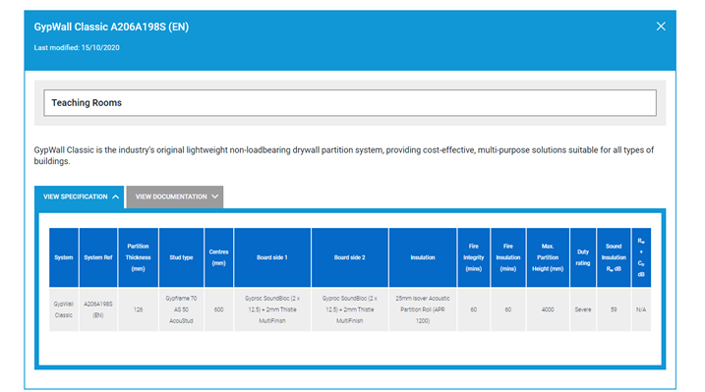

**Please see below responses direct from Silcock, Dawson and Partners for M&E questions**

1. Could we please have a LV Mains Distribution Schematic. Without this it is unclear which DB’s require metering, which sub-boards are to be split metered – LV Schematic below.



2)      Please clarify how the client wants the emergency knock offs to work in the workshops. Will the EM buttons take out the whole board or just selected power circuits on each board? The specification is unclear – EM knockout button should kill the whole board in each of the workshops.

3)      The electrical spec mentions CCTV and Access control in appendix A (pages 83-91) but there is nothing specified or detailed on any of the drawings, are these items required – Drawing PMTC-SDP-XX-00-DR-E-510 indicates the location of the standalone door access system for them main entrance door and location of the Video intercom.  Regarding CCTV it was agreed with the Client to provide Data point at high level adjacent to the main entrance door  for future CCTV camera only.



4)      We assume there is an existing lightning protection system? – We assume that the building has been provided with lightning protection (if required) as part of the base build.

5)      Is there an M&E pricing document? Please see document below

