**Natural England, Moccas Park and Gillians Wood NNR**

**Specification of Works : 2024**

**Track regrading works Gillians Wood (Formerly known as Moccas Hill Wood)**

Natural England is here to conserve and enhance the natural environment, for its intrinsic value, the well-being and enjoyment of people and the economic prosperity that it brings.

National Nature Reserves are central to the work of Natural England; they safeguard the finest examples of habitat and wildlife and where possible make them available for public enjoyment.

The specified work is to regrade the current forest road to provide safe all-weather access for both public and private vehicles, including 44ton forestry vehicles.

1. **Location : Gillians Wood, Pentre Ln, Hereford HR3 6AX**

[**What3words ///responded.respect.scrap**](https://what3words.com/responded.respect.scrap)

1. **Access :** Access is only available from Pentre lane, no vehicles are allowed off the forest road and tracks during the project.

[**What3words ///order.equity.himself**](https://what3words.com/order.equity.himself)

.

1. **Survey :**

* Contractors are encouraged to have a site visit with the project manager but can visit the site at any time to fully understand the full scope of the project.

1. **Scope of Work : Please see attached map**

* **Section 1 -** Regrade aprox 500m forest road, this will be done by ripping up the current surface, running a stone crusher over the surface then grading to shed water to the northern side. This should then be compacted. This is the main access track for visitors and forestry operations. Due to the slope of the track a number of speed humps / water diverters (at least 4) need to be installed to shed water from the track.
* **Section 1.2 -** Approx 140m of the above track is below the surrounding ground level this will need the surface level raising so that water does not collect on the track.
* **Section 2 -** Regrade approx 160m of track, ideally this will be done by ripping up the current surface, running a stone crusher over the surface then grading to shed water to the northern side. This should then be compacted.
* **Section 3 -** Scrape of soil from track and area in front of and leading to the tree nursery. Fill with crushed stone a small section of sucken track aprox 3sqm. All arisings can be disposed of off the track on the eastern side.
* **Section 4** – Regrade approx 1300m of forest track using a grader, grade of central area growth and edges. Leaving the surface with a camber to shed water.
* Stone used for the tracks must be limestone with a mixture of fines to allow a compacted finish suitable for both 44ton forestry vehicles and private cars.
* Clear out cattle grid next to road, all material can be left on site as agreed with the project manager.

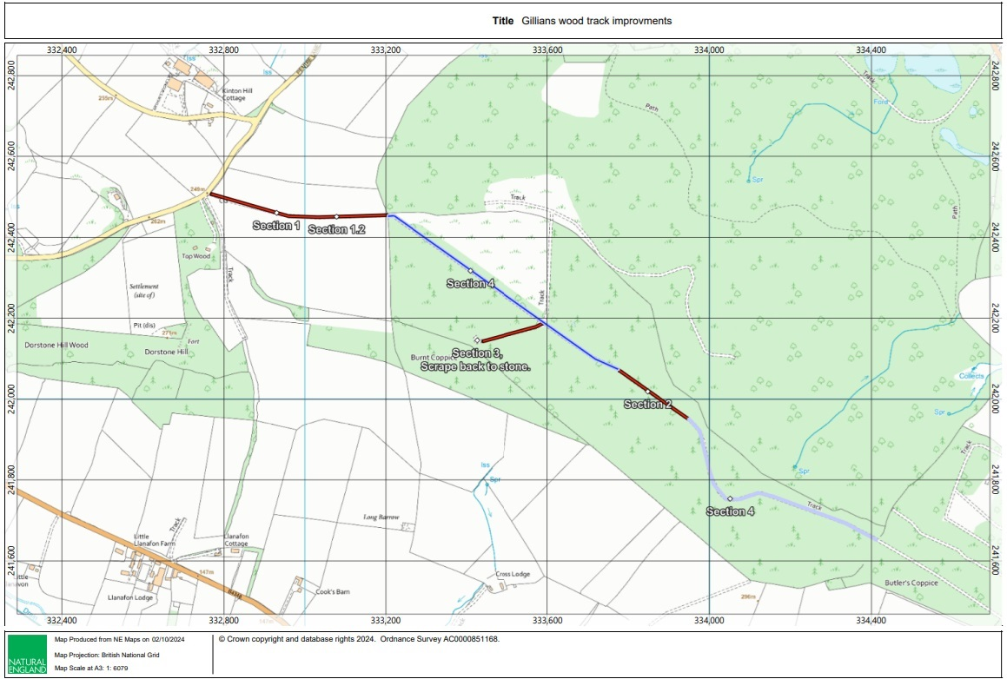



1. **Period of Contract :**

Works are to be fully **COMPLETED AND INVOICED BY February the 28th 2025**

**6. Conditions:**

Once the works are agreed in writing no variation from quoted prices will take place without written instructions from Natural England’s Project Officer.

The contractor will supply & deliver all labour, materials, necessary plant & spare parts, equipment, tools and fuel to complete the work.

Appropriate protective clothing must be worn by all operators.

A high standard of First Aid and emergency provisions must be available for inspection and in place at the start of operations.

Public safety must be ensured at all times. Warning signs to inform people of potential danger must be erected during any operations.

Copies of the following documents must be supplied before work commences :

* A detailed Method Statement
* A full Risk Assessment
* Copies of Public and Employer Liability Insurance Certificates

On completion of the work the contractor will clear from the site all unused materials and equipment, leaving the site in a clean and tidy condition.

The contractor will make good any damage to access tracks, bridges, gates and fences on completion of the work.

**7. Evaluation of Tenders :**

Natural England will score tenders on their potential to meet a number of weighted criteria. A decision on the award of the contract will be made subsequent to this scoring process. Criteria for evaluation of tenders will be:

* Value for money
* Previous experience of similar work
* Understanding of the work requirements
* Understanding of the health and safety requirements
* Ability to deliver within agreed timescales

Contractors should be aware that Natural England is looking for quality and will not necessarily take the lowest tender, but rather it will adopt the Most Economically Advantageous Tender approach to letting a tender.

**Project Officer : Tom Simpson**

**Address : Lodge Hill, Dry Mill Lane, Bewdley, Worcestershire, DY12 2LY**

**E Mail : tom.simpson@naturalengland.org.uk**

**Tel: 01299 400686**

**Mob: 07817 957328**