

BCHA Proposed IT Strategy Report
• 15/12/2021 • Confidential • External • Private
Contents
1 Introduction 4
2 Background 5
2.1 Situation 5
2.2 Problem/Implication 5
2.3 Need 5
2.4 Solution 5
2.5 Scope 5
2.6 Previous works 5
3 Executive Summary 6
3.1 Description of solution 6
3.2 Rationale for solution 6
3.3 Implementation summary 7
3.4 Key Decisions 8
4 IT Strategy 9
4.1 Agile, Mobile, location-independent working 9
4.2 File System 9
4.3 Collaboration 9
4.4 Hosting 10
4.5 Networking & Connectivity 10
4.6 Desktop Hardware 10
4.7 Desktop Roll-out 11
4.8 Software & Licencing 11
4.9 Printing 12
4.10 Security 12
4.11 IT Department Structure 14
4.12 Training & Support 15
4.13 Business Continuity 15
5 Contractual Situation 17
5.1 Current Contractual Situation 17
6 Technical Plan 18
6.1 Phase 1 – Make Homelessness, Health and Wellbeing agile 18
6.2 Phase 2 – Make Customer, Homes & Tenancy agile 18
6.3 Phase 3 – Move Open Housing to Capita SaaS 19
6.4 Additional works 19
6.5 Summary 19
7 Hardware Replacement 24
7.1 User categorisation 24
7.2 Networking & Infrastructure 24
8 Alternative Strategies 25
8.1 In-House 25
8.2 Someone else’s datacentre 25
8.3 Is a Virtual Desktop required? 25
8.4 Virtual desktop alternatives 25
8.5 Continue as you are 25
8.6 Stick with thin clients 25
8.7 Chromebooks & iPads 26
8.8 Samsung DeX 26
8.9 Device provisioning and management 26
8.10 Splitting the company 26
9 Appendix 1 - Current Technical Situation 27
9.1 Local 27
9.2 EUD 32
9.3 Cloud 32
9.4 Connectivity 34
9.5 Telephony 35

Introduction
The IT adviser has been asked by BCHA to undertake an IT Strategy Assessment. This document and accompanying presentation presents our findings in line with the deliverables detailed in our proposal document - BCHA IT Strategy Assessment Proposal.
The work we have undertaken is as follows –
- Stakeholder Workshop to determine –
  - IT issues and priorities
  - The most suitable IT strategy for the business
- Detailed Analysis comprising -
  - Technical audit
  - Action plan to improve IT adoption and productivity amongst users
  - Uncover quick wins and immediate fixes (where practical)
  - Review IT contracts and identify cost saving opportunities
- Strategic Output as follows -
  - Documented IT strategy (this document)
  - Identify right service elements to deliver on requirements
  - Phased / costed options to deliver quick wins / IT Strategy rollout
The IT Strategy is a living document and will be subject to change given the pace of innovation in IT and prevailing market conditions.

Background

Situation
BCHA are a charitable Housing Association based in Bournemouth, the two primary functions of the business are the building, provision and management of an affordable home portfolio and supporting individuals to lead independent fulfilled lives. The support function has over 50% of the staff but the portfolio management team appear to produce the lion’s share of the revenue.

Problem/Implication
The current IT infrastructure, whilst historically good, is no longer fit for purpose and is failing to meet the agile worker desires of the business to the extent that IT is now often seen as a hindrance to business users, when it should be an enabler and facilitator, improving efficiency and giving the business a competitive edge.

Need
BCHA has asked the IT adviser to undertake an IT Strategy Assessment to comprise a review of business requirements, and the technology solutions and standards required to meet those needs cost-effectively, in essence development of an IT Digital Strategy.

Solution
The IT Strategy (section 3) details The IT adviser’s proposed IT infrastructure to best support the Digital Strategy.

Scope
This document is primarily concerned with the User Environment, that is the IT experience the user engages with daily.

Previous works
A Strategy Assessment exercise has already been carried out, this identified the following 7 items as IT priorities, these should form part of any IT Strategy.
Priority
High | Our people have the right training and can use all our systems to effectively support our customers
High | Provide the right systems, devices and support to enable people to work when, where and how they need to
High | Creating an agreed IT strategy, with a visible tech roadmap, that is aligned with the 5 year business strategy
Medium | Ability to view and slice data to enable the business to make good business decisions
Medium | Have a happy IT function that has the time to have a proactive customer service ethic, listens to, and understands the business
Low | Data is stored in one place (or replicated consistently) so there is a single source of the truth. Users know how to get to it.
Low | IT agreements allow BCHA to start, stop, scale up and down to meet business needs

Executive Summary

Description of solution
This IT strategy transitions BCHA away from thin clients, to a solution where users will be able to access files and applications from their PCs, Macs, tablets and mobile phones. The IT strategy describes an environment where company data is hosted in the cloud, specifically Microsoft’s Azure platform for legacy applications, and file sharing, email, Word, Excel etc through Microsoft 365. Access to files and applications is via laptop or desktop computer or mobile phone, where appropriate.
Legacy applications will be presented to users as thin apps (cloud-based) to the users’ desktop providing a familiar ‘local’ feel whilst maintaining the performance and security of a data centre based application. A subset of users will require access to multiple legacy applications; in this scenario a full remote Azure Virtual Desktop may be a more suitable experience for these users. This would operate in a similar way to your existing Horizon virtual desktop.
In short, the proposed solution delivers –
- accessibility from many different devices, enabling flexible and mobile working
- short minimum contractual terms
- costs based on headcount and consumption
This flexibility also provides a more straightforward transition to different IT support operating models; internal or external.

Rationale for solution
The rationale for adopting this approach is the output from the initial Stakeholder Workshop, the technical fact-find and our experience of the IT landscape. In a nutshell your users and organisational priority requirements are –
- Greater flexibility to be able to work where, how and when they need to
- An IT Strategy that is driven by their Business Strategy with a roadmap of 3 – 5 years and incorporating suppleness to allow adaptation to future trends / market conditions
- Training and support to ensure that staff are able to maximise their customers’ experience of BCHA in a simple, efficient and responsive manner
- Better reporting capability and ease of data access and analysis to allow the business to make informed decisions based on up to date information
- By getting the right systems and strategy in place and maintaining IT hygiene factors the IT function should become less stressed and a happier place to work, this will mean better internal support as the IT Team will be less focused on fire-fighting and have more time to focus on prevention and improving staff experience
- Commercial flexibility to allow variation of IT service components in line with BCHA corresponding changing business needs
- Single source of truth, ie simplified and easy to access data storage

Implementation summary
The Strategy Implementation plan is broken down into 3 phases with the final phase a delayed optional phase based on a 3rd party application’s maturity.
Phase 1 – Initial setup and migration of the largest department by headcount
This means migrating Make Homelessness, Health and Wellbeing to an agile, cloud environment, migrating all files shares to SharePoint and providing the users of these departments with new laptops / desktops
Phase 2 – Migration of the main hosted LOB (line of business) apps and the remaining users
Customer, Homes and Tenancy staff would be transitioned to the new environment during this phase which would also include the migration of Open Housing and other applications to Azure as well as the provision of new laptops / desktops to staff not included in Phase 1
Phase 3 – Migration of the primary LOB app (Open Housing) to a hosted SaaS environment provided by the supplier
The phased implementation approach is summarised in the diagram below -
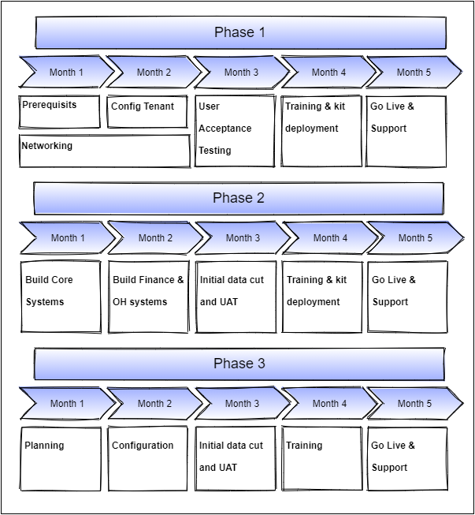

Key Decisions

Budget
The potential engagement of the IT Strategy will represent a significant budget outlay. As part of this work-piece we are also developing an IT cost model and will be liaising with Martin to make this more precise so BCHA has full visibility of the financial commitment that will underpin the IT Strategy.

Licencing
We’re proposing that the majority of users switch from Office 365 E1 to Microsoft 365 F1, the price for these licences are the same (ie £6.00 per user per month) however the F1 licence allows for increased security profile. We’re mindful that there is also a Microsoft SPLA agreement (potentially due for renewal) which allows (some) users to run desktop Office applications (Word, Excel, PowerPoint etc).
Part of the scoping exercise will be to determine which users require the full desktop Office experience or if the web / mobile functionality will suffice, there is a significant cost differential, but this may be balanced out by removal of SPLA costs
Careful consideration will be taken should users transition to web/mobile based app usage with the appropriate training to ensure that this is not perceived a move to reduced functionality.

Hosting
The proposed solution is based on hosting in Azure. Azure costings are based on consumption and whilst this is predictable it is not fixed so accommodation for budgetary flex should be allowed.

Hardware Investment
The proposed solution is dependent on significant investment in desktop hardware and the supporting network infrastructure.

Training & Support
Implementing any new system causes disruption, investment in the training of staff and the support services, both internal and external, to support the new ways of working will greatly assist in the transition and engagement to see an earlier ROI.

SaaS
Moving to the Capita SaaS based environment for Open Housing (Phase 3) will require significant investigation and testing, investment will be required in training and discovery to ensure this new service meets the requirements of the business.

IT Strategy
BCHA requires a cloud first IT Strategy that is focused on the internal user and is aligned to the organisations' Business and Digital Strategy. The IT Strategy will define the technology and services, that allow users to securely log in anytime, anyplace, anywhere to deliver on the overall business strategy.

Agile, Mobile, location-independent working
Using any form of device, mobile through to desktop, users will be able to work from any location, including BCHA offices, employees’ home offices, and any client location. Users will be able to roam seamlessly from one location to another without re-configuration.

File System
The current file servers and file shares will be migrated to SharePoint Online (part of Microsoft 365).
SharePoint is a more modern and superior file management system that will reduce version control issues, encouraging “one version of the truth”.
Users will be able to easily and quickly access the most up-to-date version of any file to which they are authorised to have access, whilst working in any approved work location using any approved device. Version control will enable users to be confident they are using the latest version of the file and be able to revert to an older version at any time.
Users will be able to access their files using their familiar File Explorer when utilised with the OneDrive Sync tool, via Teams, or the SharePoint web interface.
Using OneDrive sync users will have access to their files when online access is not available (no wi-fi or Internet access), provided they have the appropriate Microsoft 365 Office license.

Collaboration
Microsoft Teams will be used for all communication and collaboration requirements, giving users access to presence and status information, chat, calls, and videoconference. Also, Teams will support department staff collaborating on files that minimises both copies and version conflicts, so maximising the productivity of users when communicating and collaborating with their colleagues.
Meeting and conference rooms will be set up to support instant, simple (idiot-proof) collaboration between users and customers across different locations. Users can easily connect their devices to present to the screen. Connecting to customer calls or joining colleagues in different offices is straightforward.
Where collaboration and conference spaces exist equipment in these spaces should be configured as room devices and not user devices to prevent security lapses.
Teams is bundled with Office, so it is in effect “free”. Moving forward the communications and collaboration best practice should be to use Teams and not Outlook. Teams should be used for all internal communications, while Outlook should be used for more formal communications with customer, suppliers and partners.
Email communication causes more problems than it solves: 3 examples:
- The “whoop whoop” circulars which clog inboxes and cause higher priority emails to get lost in the noise
- The use of email as a filing system, forwarding office documents, resulting version control issues.
- Poor email etiquette and hygiene, unstructured use of subject lines, to: vs. cc: etc. meaning it’s very hard to find the communication you want when you need it.
Teams deals with this using:
- Provides channels for communication on common subjects (like whoop whoop) which don’t crowd out other communications.
- Integrates to other apps (e.g., links to files rather than embedding them, so people work on a single instance of a file rather than many copies)
- Allows users to review a single-subject communication trail without having to filter out the “noise” of other subject matter.

Hosting
All applications will be Software as a Service (SaaS) or hosted in Azure.
The aim is to move to SaaS web-browser applications only, with no need for a virtual desktop. However, for the foreseeable future there will be a mix of thin apps, hosted in Azure and SaaS applications, because a number of legacy applications will remain. The goal is to move to a complete SaaS based model for business applications.
Migrating to a centralised hosted environment, Azure, also ensures that systems and data isn’t tied to any singular provider.

Networking & Connectivity
Internet connectivity for St Swithuns, the Factory and the Datacentre will be via two different providers to provide resilience. Such connectivity will be capable of supporting full 2-way multi-media communications and collaboration working for all users. All other locations should have a single reliable connection with the correct speed line capable of supporting the volume of users in each location.
Centrally managed Wi-Fi coverage across all offices will be of a quality that ensures users don’t necessarily need a wired connection to work. Where physical infrastructure is required, the wiring, and physical security of the networking hardware will need to be addressed.
Updating and providing a common managed platform will also provide IT with alerts should there be any failures within the infrastructure and better troubleshooting capability in the event of reported issues.
User devices including PCs, laptops, tablets and phones, will automatically login to the Wi-Fi in each office without having to reconfigure anything. User-supplied “BYOD” devices will need to be approved, and locked-down for security purposes.

Desktop Hardware
Originally BCHA’s strategy was to standardise on VMWare Horizon desktop accessed via thin clients (10Zig terminals) to create a secure, easy to maintain, widely accessible virtual desktop environment.
However, this architecture was based in proprietary data centres and created proprietary “network issues” that impacted performance, reliability and cost. This in turn impacted business functionality, such as video and audio conferencing, and streaming.
Currently BCHA uses a mixture of thin clients, and laptops (for mobile users).
Due to changes in system management software over time, we envisage local desktops will become more cost-effective than virtual desktops from a support and maintenance perspective, and this will allow BCHA to eliminate the cost of virtual desktop servers whilst keeping support costs low, and simultaneously improve user productivity and performance of applications by using processing power on the local device.
Therefore, the strategy is to migrate from “thin” terminals to “fat” PCs [and laptops] which can support high speed application performance, and high-quality audio and video to the desktop without bandwidth, concurrency, or latency issues. This strategy will give BCHA the flexibility to migrate from a virtual desktop environment to a more classic SaaS model without major disruption, according to the requirements of the business.
During any hardware replacement programme consideration will need to be given to the use cases of each situation. Where a 10Zig exists in an outlying office and there are several staff that are shift workers in the location, a shared desktop PC may be the solution. Where a staff member hardly ever goes to an office and is classed as an on the road post a small light tablet or laptop may be deemed the right solution. For Tenant access devices, potentially an all-in-one device with the Guest or Visitor account enabled.

BYOD
A company policy that would allow for staff to use their own, correctly secured and configured, devices, commonly known as Bring Your Own Device (BYOD), should be considered. From a technological standpoint most of the work to enable this will be done as part of the zero trust setup with a few additional policies required to be added. Introducing this would allow those who want to use a personal device, an iPad or Chromebook for instance, to use one without the need for the business to manage and support the device directly.

Desktop Roll-out
Using Microsoft Endpoint Manager, InTune and Autopilot the deployment of new hardware could be an almost zero-touch experience for the IT team. For example, the solution will allow a new device to be shipped direct from the device vendor to a capable user who can unbox and power it on themselves, input their details (e.g., their email address) after which point the device will set itself up and install all necessary software, and security policies. Enabling Endpoint manager via Autopilot is or has become a standard option for vendors like Dell and is a onetime 10 minute setup process.

Software & Licencing
BCHA will continue to standardise on the Microsoft suite of apps.
All users default configuration will be web-based Office apps (“Microsoft 365 F3” @ £6). The desktop-based equivalent is 4-6x the price (£28.10 for “Microsoft 365 E3” and £48.10 for “Microsoft 365 E5”).
For 500 users, this web-only model could save up to £150k p.a. on the full fat option and will make the adoption of the new IT Strategy more affordable. A matrix will be produced to identify those users who require the desktop Office applications, these can be added with the application for Microsoft Apps for enterprise addon (£11.50).
For users with the M365 F3 licence, there are no installed Office applications on the user’s desktop, access to Outlook, Word, Excel etc is only via the web browser or mobile app on devices with a 10.1-inch screen or less.
Note: BCHA’s current software licensing model with Vodafone is not sufficiently flexible and so not cost efficient. Additionally we understand that SPLA licensing is also in place and potentially due for renewal this should be reviewed and rationalised to Microsoft 365 licencing as appropriate.

Printing
Any user will be able to print securely from any BCHA managed device to any BCHA printer. Follow-me printing should be implemented across all sites so users can recover their print jobs from any printer, on demand. Printing to a single print device / queue from the users device or the virtual desktop simplifies printing for end users - they will not have to concern themselves with printing to the correct printer.
Implementation of a managed print solution will introduce the ability to manage costs and identify areas where savings can be made.
For home users, printing from home to a local printer can be authorised although this will then fall outside of the monitoring systems.
Being able to monitor the quantity of printing by department and user will generate the information required to enable efficiency activities to take place to reduce reliance on printing.

Security
With a change of operating platform comes a change of operating vulnerabilities, the attack vectors for external actors change and so the security stance of the organisation has to change to counter it. Data on laptops and mobile phones needs to be encrypted and secured behind multiple layers of authentication. Any device containing organisational data needs to be able to have that data erased remotely, should any situation occur where that is necessary. The intention with all security measures will always be to keep BCHA’s data secure no matter where it is and what device it is on. The items below are the specific areas that should be understood and addressed.

Zero Trust
Zero Trust Security works on the principal of trust no one and challenge everything; addressing the vulnerabilities around the user, their devices, data, applications, as well as user education.
A Zero Trust Security strategy will be introduced to prevent unauthorised access to, distribution of, misuse of, and loss of data belonging to BCHA. End user devices will be secure and actively managed to protect company data regardless of the location or device from which they are accessed to support office-based workers, home-based workers, and mobile users working at client locations.
Zero trust is built on the simple principals of close all the doors, when asked to open a door first question why and who wants to pass, then when a satisfactory answer is received open it and then ensure only those authorised can pass. Don’t start with the doors open and a free for all.
Note: the policies that would be put in place will not be onerous for the user, unless they are logging to systems from an irregular location or an unusual time.

Users
Users will always take the path of least resistance and given the chance will create simple, easy to guess passwords and provide a weak link in your security chain, BCHA needs to protect the business against an incident where one of its users has their credentials compromised by creating a solution where the path of least resistance is the most secure.
To protect user credentials, there are four core features that should be adopted:
- Adoption of Pass Phrases, longer, simpler for a human and more difficult for a computer to crack passwords – Example a bruit force attack at 1000 tries per second CorrectHorseBatteryStaple 550 years to crack, Tr0ubador&3 3 days to crack
- Multi-factor authentication (MFA) - On its own MFA will prevent 99.9% of identity attacks
- Conditional access - Introduce conditional access policies based on location, user and device
- Single Sign-on (SSO) - Use SSO across BCHA’s environment and SaaS applications to reduce multiple identities to one single strong set of credentials

Devices
Managing people is difficult enough when you are in the office, but when many BCHA employees are external, the problem becomes much bigger.
What happens if a user’s personal device is lost or compromised because they have a weak PIN? And how do you prevent corporate data from being copied into personal or third-party applications?
Features in Microsoft Endpoint Manager (Included in the Microsoft 365 E3 and Microsoft 365 F3 Licence) will prevent data from being copied from managed applications into personal applications and forcing users to save company data into OneDrive for Business.
Endpoint Manager together with Azure Active Directory and appropriate configuration and compliance policies can manage all aspects of device and data encryption, ensuring decryption keys are centrally held and available, making the process invisible to the end user.
Microsoft Endpoint Manager should be used to manage all company and BYOD devices at both a device and data level:
- Data control – separation of corporate data from personal data, allowing just corporate data to be removed from a user’s smart phone if for example, a user leaves the organisation
- Device level - to enforce device encryption, pin requirements and devices to be kept up to date with the latest patches and not jailbroken

Applications (email and collaboration tools)
BCHA should implement Microsoft Defender for Office 365 to safeguard BCHA against malware attacks through Microsoft apps such as Outlook and Teams.
Microsoft Defender for Office 365 works in several ways, but the two key features to focus on are safe links, safe attachments.
- As a user hovers over a link in an email or Teams, Microsoft Defender for Office 365 will identify if it is pointing to a malicious page that is trying to steal a user’s credentials.
- Safe attachments scans every attachment coming in via email or being uploaded into Teams. Each attachment or file is put into a special virtual container and ‘detonated’. In other words, Safe-Attachments replicates a user double clicking on the attachment, as they would when opening an email attachment, and then Microsoft Defender for Office 365, analyses the attachments behaviour and if it sees the attachment is trying to do something suspicious like install itself in Outlook so that it can scan your emails, watch what you're doing, or install itself deep in the computer's operating system, it'll block that attachment, even though that attachment didn't register as a virus.

Cyber Security Training
No matter how many precautions are put in place, the user will end up being the weakest link in any organisation’s cybersecurity strategy, and therefore training should be seen as a core element of a successful strategy.
Cybsafe (www.cybsafe.com), is a provider of just-in-time cybersecurity training and simulated phishing attacks that will increase user awareness and, therefore better protect BCHA from cyber breaches involving phishing techniques.

IT Department Structure
Based on current IT service desk workloads the IT team requires additional resources. Increasing the team by a headcount of 3 should enable all the team to offer a much better customer service experience and carry out some system and process improvement exercises.
The proposed IT Department should consist of the following:
- IT Manager / Director
- Project / Change / Operations Engineer (New)
- IT Trainer
- Open Housing Application Specialist
- Service Desk lead / Manager (New)
- 3rd Line engineer
- 2 x 2nd Line Engineer (1x Local 1x West)
- 2 x 1st Line Engineer (2x Local)
The above is suggested based on some assumptions; this is an ‘as is’ just to keep rolling as you are without any major project work being introduced to the mix. The average currently is about 25 tickets being raised each day, and an average open/close time of 36 hours.
If a major project (moving to part or wholly to the new IT strategy) were to be initiated, then additional IT support resources would be required. The recommendation is to introduce at least one more 2nd line engineer.
Introducing the Service desk lead / Manager will allow the IT Manager / Director to focus on the big picture and to direct the Project / Change / Operations Engineers activities to better service the internal customers. The Project / Change / Operations Engineer is also the person that could work with users to carry out process improvement activities utilising the new systems. Moving the IT Trainer and Application specialist into the IT Department will provide consistency and better customer outcomes from their engagements.
The IT trainer and the in-house open Housing specialist need to fall under or work very closely with the IT team to provide a consistent message to end users and ensure feedback from users reaches the IT team.
Definitions:
- 1st Line engineer – take calls and respond to emails, limited technical skills but has the ability to learn, can do simple technical tasks like password resets and follow guides for known problems as provided by others in the team.
- 2nd Line engineer – can take calls if no 1st line available. Has a general understanding of the systems in use and is able to troubleshoot issues and diagnose problems but has a limited amount of time to work on each issue, possibly 4 hours, then it is passed to 3rd line.
- 3rd Line engineer – can troubleshoot and diagnose issues and takes the escalations from 2nd line. Has a much broader and in-depth knowledge of the systems in use.
- Project / Change / Operations engineer – responsible for maintenance of the systems beyond the day-to-day maintenance, major system updates etc, responsible for implementing new systems as directed by the IT manager and having overall ownership of the systems. Acts as a final point of escalation from the 3rd line engineer.
- Service Desk lead / Manager – day to day line management of the 1st – 3rd line engineers, Job queue and ticket management. Training of the engineers in the soft skills required to be a good service desk operative and producing KPI’s for the IT Manager.

Training & Support
Implementation of new systems and new ways of working will require training plans and schedules to ensure training is given prior to the systems being deployed and this will become part of the induction procedure.
Specifically, training will be required for -
- Physical aspects of new devices
- Accessing new systems
- Setting up MFA and most importantly – why
- Using Teams effectively
- Using SharePoint effectively, including offline use

Additionally Training will be required for the IT Team to enable them to successfully support the new systems.

Business Continuity
Any data or systems lost or corrupted must be restored quickly to minimise the business impact. All data must be backed up and retained to an agreed schedule and be easily and promptly restored as required.
The IT systems will be architected with resilience to mitigate the component failure, ensuring agreed levels of uptime and recovery point objectives are met.
The cloud environment, comprising Azure and Microsoft 365, that we are proposing as part of the IT Strategy includes solid building blocks for business continuity planning that will enhance the current disaster recovery profile for BCHA. We will work through these requirements with BCHA in detail duirng a planning exercise covering scenarios like loss of office, loss of power, loss of internet etc. This will inform the requirements for the platform and we propose that a separate Business Continuity project is then initiated to deliver on the business needs.
Typically, as a minimum -
- Where necessary data may be restored easily and promptly regardless of cause (e.g., accidental deletion, relocation, or corruption).
- Daily backups for last 3 months, monthly backups for last 12 months, annual backups for last 10 years.
- All data will be backed up to a secondary location and will be retained to an agreed schedule (dailies, monthlies up to and including one annual back-up for the last 10 years).
- In the event of any component failure (be that hardware, software, device or service) BCHA’s business is not adversely affected to a significant extent, nor for an extended period of time.
- Recovery capabilities should be tested annually to confirm the solution meets the identified requirements, and documentation will be provided to evidence both tests and results.
- The IT systems will have a guaranteed uptime, allowances will be made for scheduled maintenance that is agreed in advance.

Contractual Situation

Current Contractual Situation
TELA (MSP)
5 year contract, but with a staggered start, all services are now on a rolling contract.
July 2015
- Mobile telephony (Samsung phones)
- SOTI MDM
January 2016
- ‘SmartDesk’ Remote desktop – Extended by 36 Months now expires Feb 2022
April 2016
- Datacentre hosting / Backup
July 2016
- Local Telephony (Handsets & Headsets)
- Switch hardware
- Internet connectivity (PSTN & Draytek)

Vodafone, bundled within TELA contract, (365 Licences)
- 365 Licences (E1 & E3)
- Mobile Iron MDM

Navisight (Remote Desktop hosting)
The IT Manager is in discussion with Navisight to maintain the Remote desktop solution directly.
Daizy (IoT platform)
This is effectively outside of the scope of this engagement though there will need to be engagement to provide the infrastructure the IoT platform requires to operate from.
EE (Mobile phones & Mobile Iron)
Minimum contract spend in place
Expires April 2023
Homeless link (Inform)
Annual contract support is via break-fix
Capita (Open Housing)
5 year support agreement starting 8th Feb 2016
Extended by 3 years now expires November 2023
Smart Office Solutions
New contract in place for 5 years for the printer management signed 19th July 2021.

Technical Plan
Homelessness, Health & Wellbeing make up more than 50% of the business. They are not ‘money making’ but are the face of BCHA. Providing this team with an agile but secure cloud solution will enable them to be the best they possibly can when serving BCHA’s customers.
Homelessness, Health & Wellbeing
- 51% of staff (according to BreathHR)
- 50% have logins for inform
- <50% have logins for Open Housing
Customer, Homes & Tenancy whilst being a relatively small department generates more per head than the rest of the business. Making this team more efficient, through the introduction of an effective cloud solution, will help the department maximise is revenue generating capability.
Customer, Homes & Tenancy
- <10% of staff (according to BreathHR)
- <10% have logins for inform
- 75% have logins for Open Housing
There are several steps to get to the nirvana of migrating BCHA to an agile cloud-based IT strategy. At any step the process can be paused or halted for re-evaluation or if it is felt the goal has been reached.
With all users having access to a full fat desktop device, presenting applications as a ‘thin app’ via the AVD solution will reduce costs within the AVD solution.

Phase 1 – Make Homelessness, Health and Wellbeing agile
- Leave only Open Housing & Finance system requiring ‘local’ resource.
- Leave OH & Horizon remote desktop solution in place.
- Migrate all file shares to SharePoint.
- Replace devices held by Homelessness, Health & Wellbeing staff with Azure AD joined devices providing secure access to company resources from anywhere. All devices will be managed by Endpoint manager & Intune with Defender AV and Bit locker.
- Other departments can be moved away from reliance on the Horizon desktop as laptop resources are made available.

Phase 2 – Make Customer, Homes & Tenancy agile
- Migrate the Open Housing system to Azure.
- Provide access to the new OH platform utilising the thin app model.
- Migrate all remaining systems from Horizon to Azure & present as thin apps.
- Replace devices held by Customer, Homes & Tenancy staff with Azure AD joined devices providing secure access to company resources from anywhere.
- Complete migration of all other departments to Laptops.

Phase 3 – Move Open Housing to Capita SaaS
- Migrate Open Housing from Azure to SaaS platform to take advantage of the platform upgrades.
Note:
The Open Housing SaaS solution is currently regarded as ‘a bit too new’ to entrust moving to at this time but I’d encourage investigations and engagement with Capita as there could be huge discounts to be had in being their loss leader to get others to move. This together with the enhanced support that could be forthcoming in their desire to get it right may be worth the risk of a new platform.

Additional works
During Phase 1 the issues with the networking infrastructure will need to be addressed, simplifying and securing the structured networking at each location. Addressing the requirements for redundant lines at the largest sites, including the Factory and St Swithuns sites.
A consolidated list of end user hardware will need to be completed and assessed against criteria to determine a useable life span for each device, considering, CPU, RAM, Drive type and anything else that could hamper its longevity (TPM2 chip for Windows 11).

Summary
Ultimately BCHA has a desire to migrate to “Phase 3”, moving the whole business to an agile cloud strategy..
Phase 3 should be completed only when the Open Housing SaaS solution is deemed sufficiently robust.
The below diagrams show now through to Phase 3
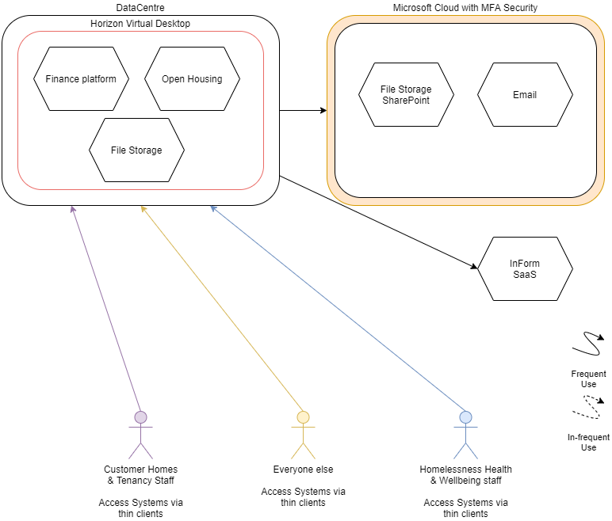
Figure 1 Current situation

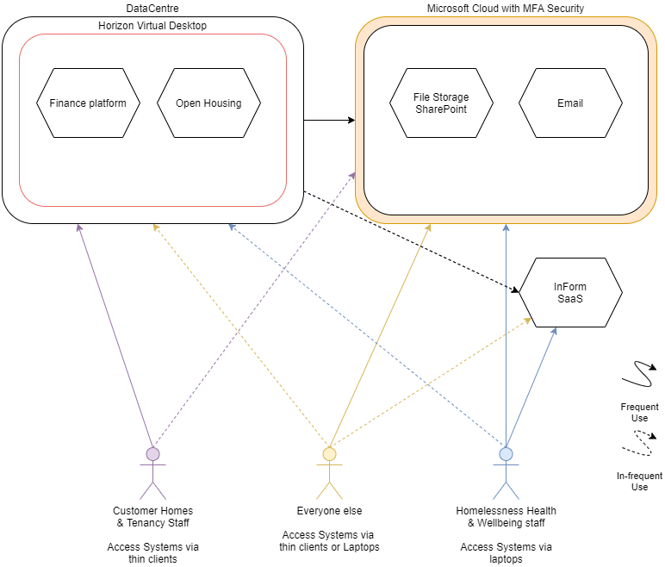
Figure 2 Phase 1

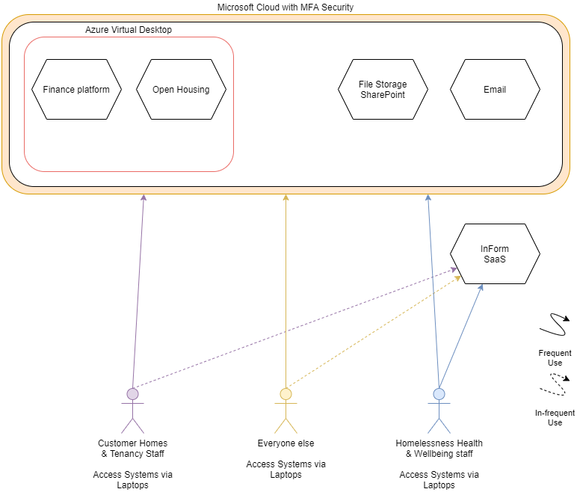
Figure 3 Phase 2
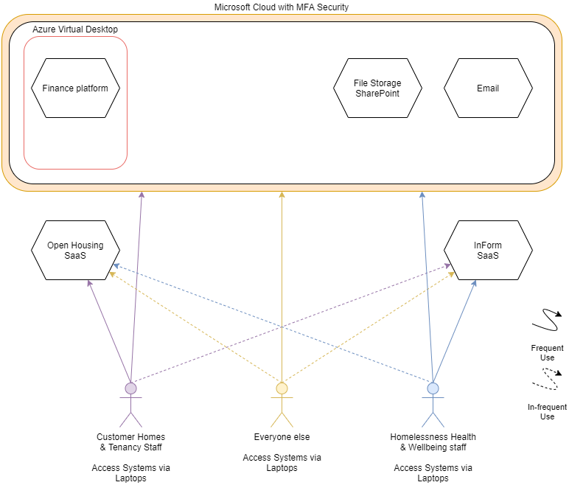
Figure 4 Phase 3
The timeline below summarises the estimated schedule of work required to roll-out each step.
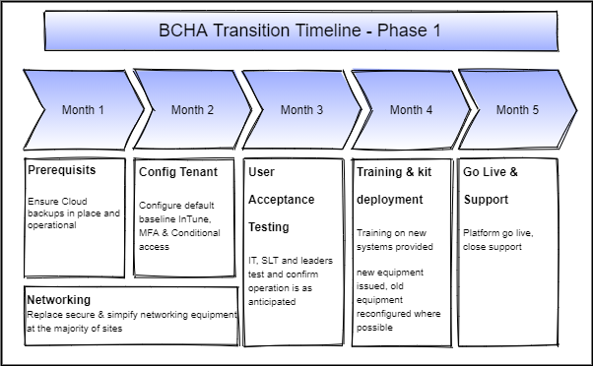
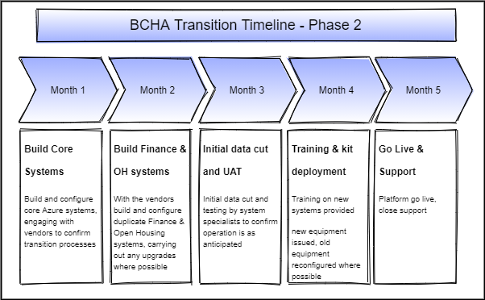

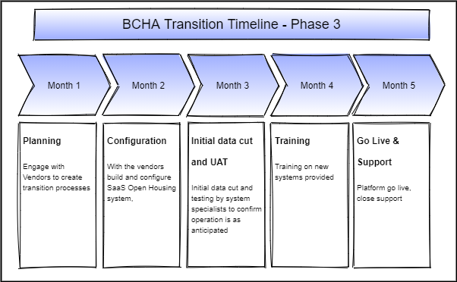

Hardware Replacement

User categorisation
End user device type is generally driven by user requirements and this is facilitated by categorising staff according to their needs. Broadly we would define user types as follows –
- Office-based
  - Standard (40%)
  - Finance (10%)
- Remote-working (20%)
- Mobile (20%)
- Super User (5%)
- Senior Exec (5%)
As a for instance a Office-based Standard user would be provided with a laptop (13” screen, i5, 16GB RAM, 256GB SSD) and a 24” monitor dock (this is a monitor that incorporates the functionality of a laptop docking station (ie USB C)
An office-based Finance user may require 2 x screens (one for normal apps, the other for finance apps)
Remote-workers may need the same set up as Office-based Standard users
Mobile users may have just a laptop / tablet
Super users may require a higher machine specification
We have applied arbitrary percentages to each category and would work through this, categorisation and hardware specification with BCHA, in general this is undertaken with an organisation Finance Director

Networking & Infrastructure

Networking
The desire from the IT Manager is to continue with the roll out of the Ubiquiti platform as it will provide a single dashboard for management and maintenance, and we agree this is a good scalable solution that will fit all locations.
A Unifi Security Gateway at each location can provide internet filtering and monitoring. Switches and Wi-Fi access points can be installed dependent on each location’s requirements.

Infrastructure
During each site upgrade the physical cabling and security of the installed equipment will need to be addressed to ensure tampering with the equipment isn’t possible and that it functions as well as it possibly can.

Alternative Strategies
Part of establishing the right IT Strategy for BCHA is to start with a clean sheet and be open to the full range of technologies, support models and commercial agreements. Below we have listed alternative paths which ultimately do not form part of our recommendation. We think it is helpful to include this detail as it transparently shows our thinking and also allows further discussion should there be compelling reasons (which we are not aware of yet) for partial inclusion in the IT Strategy

In-House
All services could certainly be brought in house, consideration would need to be given to
- Physical infrastructure
  - Server room, cooling
  - Fire suppression
  - Cabling infrastructure
  - Off-site bandwidth
- Personnel
  - In-house skillset
  - Increase in team size

Someone else’s datacentre
The biggest risk of a plan involving migration to an alternative supplier’s datacentre would not actually be the risk of something going wrong with the data move, which is not inconsequential, it’s around the ‘what if’ scenario of the new 3rd party relationship deteriorating when you have all of your eggs in their basket relationship. Hosting in Azure means that you can move, should it be necessary, between partners with no disruption to your data or hosting environment.

Is a Virtual Desktop required?
Your application are currently delivered through Horizon Virtual Desktop. We’re proposing that for many users we will publish these application directly to their Windows desktop without the need to login to a VDI. This will simplify user experience and decrease IT management and support overhead.

Virtual desktop alternatives
There are a number of similar technologies to Azure Virtual Desktop (AVD) each having their own subtle differences. For instance Citrix, both locally hosted, remote hosted and cloud version and VMware Horizon again both local, remote and cloud. Both sit on top of either Azure, AWS or Google’s hosting services, The IT Adviser’s core competences are aligned with Microsoft, but we are open to discussing alternative partner platforms.

Continue as you are
Continuing with the status quo as it is clearly not an option, the environment is not capable of providing the agile, mobile first requirements of the business

Stick with thin clients
To stick with what you know, would only work for a relatively small percentage of the company, removing
thin clients and standardising on fat clients (laptops and desktops) will allow for mobile working, give the service desk a single type of environment to manage but also reduce the reliance on the virtual desktop by using hosted apps

Chromebooks & iPads
Serious consideration was given to the feasibility of utilising the virtual desktop from a subset of BCHA provided ‘thin’ devices however our thinking is that the support of this different device type would be an extra burden on the IT team. Better to offer the possibility of a BYOD environment and allow those that really want to use their personal Chromebook or iPad to do so without the need to support it beyond supplying the virtual desktop.

Samsung DeX
Utilising one device, for mobile comms, Office access and as a full desktop was investigated, the outcome however was that anyone on a Microsoft 365 F3 licence wouldn’t be able to use the mobile office applications on the device whilst it was docked to a larger screen as it’s limited to a max 10.1 screen. However this Microsoft licence uplift could be mitigated through reduced hardware costs by moving to tablets and mobile devices as opposed to higher cost laptops and desktops. Windows desktop access would still be available via the remote desktop app when required. Pen input could be available on tablet and the Note series of devices as required Management of the devices would be via Intune, but some consideration would be required as potentially a Google or Samsung account may also be necessary. Whilst this route has some merit it was discounted for being too reliant on a single manufacturer and the take-up has not been widespread.

Device provisioning and management
There are many alternative device management solutions but in the end it’s all about what you need to do. Provision devices, ensure they are up to date, ensure they are encrypted, secure and have specific settings configured. Managing software deployment and configuration, managing encryption keys, keeping all the data accessible. Utilising the standard Microsoft tools available as part of the subscription is the logical solution.

Splitting the company
Charity status confers significant discounts through Microsoft and potentially other technology providers. Is this realisable for BCHA?

Appendix 1 - Current Technical Situation
Historically the BCHA system has been a classic thin client & virtual desktop solution utilising a VMWare Horizon solution provided by Navisight through TELA.
A switch to Microsoft 365 for Mail services has exposed users to the Microsoft 365 ecosystem. SharePoint has been configured well as an intranet for instance but Teams use has gone unchecked and it’s starting to sprawl. A historic mistake in network topology has left some necessity for service duplication and added a layer of complexity to network operations.

Local
Head Office (St Swithuns House)
- Single VMWare host hosting
  - Print Server
  - Unifi Controller
  - RDP server for access to the training platform
- NAS set as backup targets
The Factory
- Single VMWare Host housing
  - Print Server
  - Net2 Server
- Nas set as backup targets
- Nas for CCTV system
Datacentre
- File server
- App Server
- SQL Server
- Open Housing server

Active Directory
There are 2 AD domains,
Head office – workgroup.co.uk
Datacentre & Factory – bcha.smartdesk.local

Servers
Name | IP | OS | P/V | Role | Location
AD01 |  | 2012 r2
AD02 |  | 2012 r2
BCHA1 | 10.22.5.5 | 2012 r2 |  | IIS, File Services
BCHA2 | 10.22.5.10 | 2012 r2 |  | IIS, File Services
BCHA3 | 10.22.5.4 | 2012 r2 |  | IIS Print Services File Services
BCHA-AD01 | 10.22.5.8 | 2016 |  | AD DS DHCP DNS, File Services
BCHA-AD02 |  | 2016
BCHA-Prnt | 198.100.100.251  192.168.97.158 | 2012 r2 |  |  | St Swithuns
BCHA-SQL-1  BCHA-NAS-01 | 198.100.100.248 | 2012 r2 |  |  | St Swithuns
BCHA-UKDA-AD02 | 10.128.73.11 | 2016 |  |  | Datacentre
BCHA-UKDA-AD03 | 10.128.73.13 | 2016 |  |  | Datacentre
BCHA-UKDA-AD04 | 10.128.118.10 | 2019 |  | AD DS DHCP DNS, File Services | Datacentre
BCHA-UKDA-VL01 | 10.128.75.183 | 2016 |  |  | Datacentre
DaaS-AD01 |  | 2012 r2
GPCLONEDBCHA |  | 2008 r2
HeadWarlock | 10.128.118.93 | 2019 |  | File Services (virtual desktop) | Datacentre
Longbow | 10.128.118.59 | 2019 |  | IIS, File Services (Virtual desktop) | Datacentre
TotalMobileAppS | 10.22.5.7 | 2012 r2 |  | IIS, File Services
WebspeedTransSe | 10.22.5.6 | 2012 r2 |  | IIS, File Services
Banana 31 | 10.128.118.X | 2016 |  | Remote Desktop Hosts | Datacentre
Cherry 170 | 10.128.118.X | 2019 |  | Remote Desktop Hosts | Datacentre
Float 146 | 10.128.75.X | 2016 |  | Remote Desktop Hosts | Datacentre
NaviTest | 10.128.74.X | 2016 |  | Remote Desktop Hosts | Datacentre
Pool-D, E & F 339 | 10.128.75.X | 2008 r2 |  | Remote Desktop Hosts | Datacentre
Static 37 | 10.128.74.X | 2016 |  | Remote Desktop Hosts | Datacentre
Test | 10.128.75.X | 2016 |  | Remote Desktop Hosts | Datacentre
Test Pool | 10.128.74.X | 2016 |  | Remote Desktop Hosts | Datacentre

Group Policy
GP is extensively used, as would be expected in a mature Active Directory Domain. I can see numerous policies for configuring software installs, user account settings and device settings.

DHCP Source
BCHA-UKDA-AD04
- 10.128.118. 30 - 250
BCHA-AD01 (all scopes disabled)
- 10.22.5. 1 – 254
- 10.128.73. 1 – 254
- 10.128.74. 1 – 254
- 10.128.75. 1 – 254

DNS Source
10.128.118.10 - BCHA-UKDA-AD04
10.22.5.8 - BCHA-AD01

SQL
BCHA2 is the main SQL server but there are instances of SQL express on other servers, clearly to facilitate software on those servers.
Database Instance | Database | Data File Location
BCHA2\Exchequer | Exchequer | L:\Exchequer Instance
 | IRIS CommunicationsEngine | L:\Exchequer Instance
BCHA2\LIVE | ih | Z:\OPENHousing\LIVE\DATA
 | Live_hstm_OPHSTrace | Z:\TotalMobile\Data\Live\hstm\OPHSTrace
 | Live_hstm_Scheduler | Z:\TotalMobile\Data\Live\hstm\Scheduler
 | Live_hstm_TotalMobile | Z:\TotalMobile\Data\Live\hstm\TotalMobile
 | Live_hstm_TotalMobile_DataMart | Z:\TotalMobile\Data\Live\hstm\DataMart
BCHA2\TEST | CCSMTest | C:\Program Files\Microsoft SQL Server\MSSQL12.TEST\MSSQL\DATA
 | ih | L:\OPENHousing\TEST\DATA
 | ReportServer$TEST | C:\Program Files\Microsoft SQL Server\MSSQL12.TEST\MSSQL\DATA
 | ReportServer$TESTTempDB | C:\Program Files\Microsoft SQL Server\MSSQL12.TEST\MSSQL\DATA

Software
The following list is the majority of the systems available to staff, I have included initial thoughts on proposed actions for the apps to facilitate the move to agile working.
Application | Type | Action
BreathHR (currently being migrated to Cezanne) | Website | None Required
Archiving DB | Local Access Database | Rebuild as SharePoint list?
Casual labour reporting tool | SharePoint form | None required
CJSM | Website | None Required
Inform | Website | None Required
Open Housing | Local App | Hosted app
PDF creator | Local App | Replace with PDF print
ProVal | Local app / SQL DB | Hosted app – recently updated
Salary Extras | Website | None Required
Serious Incident Database | Local Access Database | Under review
Skillgate | Website | None Required
TotalMobile | Website | None Required – Part of OH
Xelion (softphone) | Java App | Local Install
Adobe Acrobat | Local app | Local Install
Locator Plus | Local App | Hosted app
Jamm | Access Database (32bit)
Payright | Webpage | None Required
Salvation Army | Webpage | None Required
Pervasive Exchequer | Local App | Hosted SQL App (Finance)
ADP | Local App | Local Install

Local Backup
Datacentre back up is managed by TELA and is a rolling 30 day daily. A secondary backup of the Factory and St Swithuns devices is carried out via a barracuda device to a NAS device held in the Factory. This secondary process is under the direct control of the BCHA IT team. There is potentially an old, unused E-Vault backup solution.

File storage
BCHA3 is the primary file server, providing departmental file storage areas and user storage and profile space. The vast majority of the data is on 2 1TB drives. The data initially looks to be well organised so migration to a SharePoint solution would appear to be relatively easy to plan. Care will need to be given to permission levels of the data within each folder.
Server & Share | Local Path | Name & Mapped Drive
BCHA1\OpenApp | E:\OpenApp | OpenApp(O:)
BCHA3\BCHA | G:\BCHA | BCHA Files (B:)
BCHA3\F | F:\ | Drive (F:)
BCHA3\HR | G:\dept.Shares\HR
BCHA3\IT | G:\dept.Shares\IT
BCHA3\LSW | G:\dept.Shares\LSW
BCHA3\Marketing | G:\dept.Shares\Marketing
BCHA3\RECOOP | G:\dept.Shares\RECOOP
BCHA3\Housing | G:\dept.Shares\Housing
BCHA3\NewLeafRepairs | G:\dept.Shares\NewLeafRepairs
BCHA3\Governance | G:\dept.Shares\Governance
BCHA3\Asset Management | G:\dept.Shares\Asset Management
BCHA3\Factory | G:\dept.Shares\The Factory
BCHA3\Development | G:\dept.Shares\Development
BCHA3\Customer | G:\dept.Shares\Cust.svcs
BCHA3\CHT | G:\dept.Shares\CHT
BCHA3\Finance | G:\dept.Shares\Finance
BCHA3\UserFolders$ | R:\UserFolders
BCHA3\UserProfiles$ | R:\UserProfiles
BCHA3\UserShare$ | G:\User.Shares | {LoginName} (P:)

Printing
Printing is via group policy in VMWare to local printers, there is no centralised print management solution, the wide range of printers are managed by Smart Office Solutions. Implementing a managed print solution would enable follow me printing and ensuring prints come from the right printers and allow for cost tracking, printer utilisation tracking.
Name | IP | Model
Weymouth_CFR_3110 | 10.101.119.2 | C MF311-1
Westville_Flats_3110 | 10.101.108.2 | C MF311-1
Waverley_House_3110 | 10.100.123.2 | C MF311-1
Westbrook_Court_3110 | 10.100.154.2 | C MF311-1
Wareham_CFR_3110 | 10.100.162.2 | Develop C MF335-2
The_Factory_Payroll_3110 | 10.100.191.6 | Unknown
The_Factory_MP_3003 | 10.100.191.4 | RICOH MP C3003
The Factory_Finance_308 | 10.100.191.5 | Generic 30C-9
St_Barnabas_3110a | 10.100.135.8 | C MF311-1
STFH_3110 | 10.100.171.2 | Unknown
Soroptomist_House_3351 | 10.100.151.2 | Develop C MF335-2
SandyHurst | 10.100.176.2 | C MF311-1
Robert_Gabriel_House_3110 | 10.100.121.2 | Develop C MF335-2
Quest_Office_3110 | 10.100.108.2 | C MF311-1
Poole_Refuge_3110b | 10.100.131.2 | Develop C MF335-2
Pentille_Road_3110 | 10.100.136.2 | C MF311-1
PDVP_3110 | 10.100.153.2 | C MF311-1
Pathways_3351 | 10.100.161.2 | Develop C MF335-2
Orchard_Court_3110 | 10.100.120.2 | C MF311-1
Morwenna_Court_3110 | 10.100.118.2 | C MF311-1
Millenium_House_3110 | 10.100.110.2 | C MF311-1
James_Michael_House_3110_New | 10.100.145.2_1 | C MF311-1
James_Michael_House_3110 | 10.100.145.2 | Develop C MF335-2
HO_Tenancy_Sustainment_3110 | 198.100.100.21 | C MF311-1
HO_Supported_Housing_3351 | 198.100.100.31 | Develop C MF335-2
HO_HR_308 | 198.100.100.193 | Generic 30C-9
HO_Housing_Customer_Services_308 | 198.100.100.14 | Generic 30C-9
HO_Employability_Skills_308 | 198.100.100.17 | Generic 45C-9
HO_CEO_3351a | 198.100.100.11 | Develop C MF335-2
HO_1st_Floor_308c | 198.100.100.19 | Generic 30C-9
George_House_3351b | 10.100.196.5 | Develop C MF335-2
George_House_3351a | 10.100.196.2 | Develop C MF335-2
Gabriel_House_3351 | 198.100.113.2 | Unknown
Fiergen_Court_3110 | 10.100.190.2 | C MF311-1
Felix_House_3110 | 10.100.144.2 | C MF311-1
Ermington_Terrace_3351 | 10.100.104.2 | Develop C MF335-2
Dorset_Lodge_3110b | 10.100.160.3 | Unknown
Dorset_Lodge_3110a | 10.100.160.2 | C MF311-1
Dolphin_House_3110 | 10.100.152.2 | C MF311-1
Denley_House_3110 | 10.100.180.2 | C MF311-1
Cornelia_Lodge_3110 | 10.100.126.2 | C MF311-1
Boxwood_Road_3110 | 10.100.116.2 | C MF311-1
Bournemouth_Refuge_3351 | 10.100.170.2 | Develop C MF335-2
Amica_House_3110 | 10.100.149.2 | C MF311-1
Addison_Road_3110 | 10.100.138.2 | Unknown
98_Richmond_Park_Road_3351 | 10.100.114.2 | Develop C MF335-2
59_Southbourne_Road_3110 | 10.100.199.2 | Develop C MF335-2
2_Lansdowne_Gardens_3110_b | 10.100.112.3 | C MF311-1
2_Lansdowne_Gardens_3110_a | 10.100.112.2 | Unknown
28_Winston_Avenue_3110 | 10.100.102.2 | C MF311-1
28_Church_Street_3110 | 10.100.140.2 | C MF311-1
26_St_Johns_Road_3110 | 10.100.200.2 | Develop C MF335-2
21_Christchurch_ITSuite_308d | 198.100.100.180 | Generic 30C-9
21_Christchurch_iSupport_3351b | 198.100.100.20 | v
21_Christchurch_Ignite_3351 | 198.100.100.234 | Unknown
10_St_Pauls_3110_Donna | 198.100.110.2 | C MF311-1
10_St_Pauls_3110_a | 198.100.110.4 | C MF311-1

EUD

Software
The following software has been identified as deployed via GP to the listed device groups.
Software Title | Key group
ESet | BCHA AD
Ofiice 2016 (32 bit) | Virtual Desktop
Insight Dashboard | Virtual Desktop
Libre Office | Restricted access desktops
PDF Creator | Virtual Desktop
Report Builder | Virtual Desktop
WMF & .Net | Virtual Desktop
7Zip | Virtual Desktop
Acrobat Reader XI | Virtual Desktop & Restricted access Desktops
Flash Active X | Virtual Desktop & Restricted access Desktops
Google Chrome | Virtual Desktop & Restricted access Desktops
Java | Virtual Desktop
Teams | All Users
Tight VNC | Virtual Desktop & Restricted access Desktops

End User Device (EUD)
Historically 10Zig Thin clients, model 4472, have been used to access the Horizon virtual desktop platform, with the pandemic more laptops have been issued and used, the vast majority of the laptops, whilst coming from a reputable source, are pre-loved. Devices are AD joined in the traditional way.

Encryption
The thin clients have no requirement for encryption as no data is stored locally. Laptops are not managed in such a way as to be able to enforce and manage device encryption.

Support
All EUD’s are manged by the internal support desk.

RMM
RMM is via the service desk ITarian platform,

Centralised AV
ESet is deployed via Group Policy to all domain joined devices and managed by the service desk.

Patching
Limited OS patching is carried out via the RMM ITarian platform.

Cloud
Whilst BCHA are a not-for-profit organisation Microsoft have an exemption in place for housing associations so that they don’t get the reduced rates for other not for profit organisations. Use of the resources provided by the licences employed is sporadic and organic but some elements are gaining traction.

AD sync
AD Sync is setup on BCHA-AD01 and is set to sync on default settings of 30 minutes and instantly for Password changes.
- Password Writeback is enabled
- Password Hash sync is enabled

Domains in use – aliases
The Following Domains are set up within the 365
- BCHA.org.uk (Default)
- Bournebiglocal.com
- Hyped.org.uk
- Newleafcompany.co.uk
- Recoop.org.uk
- Sequalenterprises.co.uk
- Sequalsolutions.co.uk
- SequalWorks.co.uk
- Stfh.org.uk
- Thefactory1st.com
- The factorypoole.co.uk
- Wgbs.org.uk

Licensing
Licence | Quantity
Microsoft Office E1 | 500
Microsoft Office E3 | 20
Microsoft Office E5 | 1
PowerBI Pro | 1
Project Plan 1 | 3
Project Plan 3 | 1

Exchange
Exchange appears to be well set up with a connector to Exclaimer Cloud for auto application of email signatures. There are several redundant connectors which could do with cleaning up.
- DarkTrace Antigena
- Checkpoint Journaling – outbound
- Checkpoint Journaling - inbound
DKIM requires its setup completing, the domains are listed and all set to authoritative, but the DKIM is disabled for each domain.
SPF records are in place
DMARC is not configured

Mail filtering & Journaling
There is no mail filtering or journaling solution in place though it would appear trials of systems have been conducted in the past.

SharePoint
SharePoint has been set up as an intranet and appears to be actively used by pockets of the business. It is not used widely as a document repository. Some of the sharing defaults have been adjusted making SharePoint more secure.

Teams
Teams is enabled but no specific configuration has been done to alter the base functionality, more recently creation of Groups within the 365 environment has been restricted and this has restricted the creation of teams to just the IT team.

MFA & Conditional access
MFA is set on and some configuration policies are set, investigations will need to be done to confirm deployment. There is at least 1 policy set to allow access form the DC IP, allowing for unrestricted access whilst on the remote desktop, access to the remote desktop is not covered by MFA.

MDM & MAM
For phones this is configured through Mobile Iron, but this doesn’t extend to laptops.

Intune
Intune is not configured

Backup
There is no cloud backup *this will need rectifying*

Connectivity
There are VPNs between
- Head office and the Datacentre
- The Factory and the Datacentre
- Outlaying sites and the Head Office
Outlaying VPN’s use the head office as an end point as the Datacentre hosting of multiple VPN’s would be a costed option.

External
St Swithuns has a 50/100 leased line and did have a 100mb FTTC for redundancy but this is no longer functional.
The factory has a 100/100 leased line and an FTTC line for tenant use that can be utilised as a backup line.
Outlaying sites have FTTC or ADSL2 as a minimum.

Internal

Networking internal infrastructure
Head office, St Swithuns House, is in need of its structured cabling being replaced but this has been delayed multiple times due to potential moves out of the building.
Remote locations don’t have secure cabs for the equipment so equipment is regularly tampered with.
Discussions are happening about supplying Wi-Fi in accommodation, to facilitate the IoT rollout, this could also be used by tenants but could also be used to facilitate ‘smart’ NFC etc, door access solutions.

Vlans
There are just 2 VLANs a corporate one and one for management.

Switches
Remote sites tend to have Draytek as their landing points, these aren’t physically secure and have been known to be reset by users.

Wi-Fi
Wi-Fi in the two main offices is Ubiquiti and there is a desire to deploy this to the remote locations with PoE Ubiquiti switches to allow for full remote management. There are 2 SSID’s for Corp and Internet breakout only.

Telephony
Telephony is supplied by Xelion through Tela. It is a VoIP based system hosted in Azure, provisioning of services is through TELA and is not as straight forwards and simple as would be desired and so the BCHA team have been managing the system themselves for over 18 months with no input from TELA.

