Kingsgate Park Informal Play Area
Design Brief
Location: Sundridge Park, Yate, Bristol, BS37 4EP
January 2023
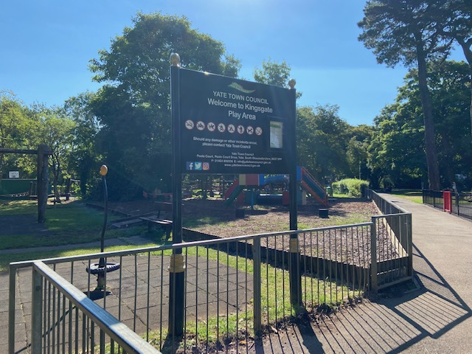

- Kingsgate Park – Background

Yate Town Council, the client, wishes to refurbish the play area at Kingsgate Park (KGP), to install new play equipment and to replace equipment beyond its life cycle. KGP has exceptionally high visitor numbers. It is a much-loved play area - the most popular in Yate parish, it also attracts visitors from outside the local area, making it a key facility for community health and wellbeing.

  - Phase 1 Refurbishment – Not for Tender
The timber play equipment will be refurbished by the original supplier in spring 2023. The design and layout of the existing timber equipment will be unchanged. This includes the tree top trail, the junior timber trail, the zip wire (cable rider), the hammock swing and upright climbing/stepping trails.

The Multi Use Games Area (MUGA) within the play area, is due to be refurbished in spring 2023. These works will be undertaken separately to this project brief, using external funding from Enovert Community Trust.

Phase 1 works may take place prior to, or at the same time as, Phase 2 works.

  - Phase 2 New Equipment – Open for Tender
Phase 2 works aim to:
- install additional play equipment and to replace equipment beyond its life cycle;
- relocate existing popular equipment to more suitable locations within KGP;
- improve accessibility and access to play for those with varying abilities and confidence levels;
- improve the design for a changing climate.
Phase 2 works will be funded in full by Yate Town Council. Funding for this project was secured in December 2022.
Phase 2 works must commence on site in Spring 2023 and conclude by September 2023. Works must be phased to ensure the public can continue to use areas within the play area, where safe to do so, particularly during school holiday periods.
Phase 2 works may need to work alongside or collaboratively with the refurbishment suppliers (outlined in 1.1). Refurbishment works will commence in early Spring 2023.
A public consultation in July 2022 highlighted:
- Local people are very engaged with environmental issues, developing KGP to have a natural feel, using innovative and sustainable materials, including recycled materials or timber;
- An environmentally conscious design would further strengthen the work already being undertaken by the Town Council and local community groups including the Friends of Kingsgate Park, who have recently undertaken biodiversity improvements in the adjoining nature reserve, and accessibility improvements including colour coded entrances and accessible seating.
- In addition to providing a fun area for children to play, it is felt that the enhancements would help to establish the area as a centre for inclusivity. New equipment should allow for enjoyment and engagement by those with varying abilities, neurodiverse characteristics, and confidence levels.

- Design Specification Phase 2

Tenderers are invited to put forward proposals for an exciting bespoke scheme for an adventurous play area, located within the existing play area at KGP. Returned designs should emphasise nature-based creativity and fun, holistic play and the importance of allowing for varying levels of interaction with the equipment, to support varying levels of confidence and ability.

The site location and area is included at the end of this proposal.

The proposal should consider the following elements:

- The following equipment will remain unchanged:
  - Roundabout (relocation could be considered);
  - Hammock swing.
- The following equipment will be relocated:
  - Spinning equipment.
- The following equipment will be removed and replaced with new equipment:
  - Seesaw – preference for inclusive/DDA compliant equipment
  - Metal climbing frame (in toddler area), with the following considerations:
    - replaced with something more exciting;
    - consider replacement unit with multiple features e.g. a pully system;
    - use low heat conducting / low carbon footprint materials e.g. wood or recycled plastic;
      - relocation to a shaded area or, consider additional planting to offer shade for equipment;
    - removal of metal edging, to be replaced with soil bunds if edging is needed;
  - swing sets (all except hammock) – replace with larger swing set to include more swings, including parent and child swing.
- The following are suggestions for new equipment:
  - balance equipment (toddler area);
  - soft close gates - all areas;
  - sand play/bucket and pully equipment (suitable for ages 6-11 years, could be combined with toddler climbing frame, as above);
  - play sculptures e.g. bespoke sculptural play feature, to form a centrepiece, for the wider area. Could be insect or animal themed.
  - quiet play and socialisation equipment and/or areas;
  - opportunities for the creation of informal seating and socialisation areas. Different sitting heights and opportunities for social interaction should be considered.
- The following accessibility improvements should be included in the returned design:
  - dust and cinder paths provide direct access to DDA equipment. Paths to be DDA compliant to improve access for buggies and mobility equipment;
  - new equipment should be accessible (as much as possible), to be used and enjoyed by different people, not just those considered to be “able bodied”;
  - Locations and layouts for new equipment should not adversely affect quiet play / socialisation areas.
- The following landscaping and climate resilience considerations should be included in the returned design:
  - Additional trees / shrubbery and soft landscaping to:
    - provide shade in the play area;
    - improve drainage in areas where excessive water gathers;
    - to enhance biodiversity;
    - to create soft boundaries between areas of high energy play (e.g. MUGA) and quiet play/ socialisation areas.
- The following safety, maintenance and legislative requirements should be included in the returned design:
  - Surfacing to be low maintenance, e.g. bark or rubber grass mats, to assist in maintaining the surrounding grass/ground;
  - Designs should not include any equipment that requires planning permission, or that exceeds planning and/or safety restrictions.

- Structures: Structures need to fit into the space available, within the existing boundaries of the play area. The structures need to offer a play experience for children of all ages but should be geared towards younger children (up to 11 years). The site is a very popular location and any materials selected will need to be appropriate to the location and robust, with a long term life cycle. The contractor will be required to provide warranties for the longevity of the materials proposed, to meet the requirements of the specification. It is envisaged that the surfacing beneath the equipment and between trail items will be grass rubber mats, or bark. The contractor’s proposals should show details of this, or any proposed alternative, along with implications for accessibility.
There are trees and shrubs within the play area site. Contractors may wish to consider incorporating the natural features within the overall design of the play area. However careful consideration should be given to the long-term effects that compaction and the installation of play equipment may have on root systems and tree health.
Contractors may wish to consider relocating soft landscaping, to maximise the space, and to provide shade from weather conditions. Any planting removed should be replaced. Design proposals must attempt to minimise any impact on biodiversity. The removal of Ash trees to maximise design opportunities can be considered.
- Adaptability and added value: YTC welcome design proposals that add play value to the Kingsgate project. It is important that suppliers can adapt and include additional ideas as the project develops (for example, during public consultation). Ideas outside the scope outlined above, should be costed, and presented separately.

- Long-Term Maintenance: The playground is maintained by Yate Town Council. The contractor’s proposals should indicate the maintenance requirements of the new equipment and surfacing, including the inspection requirements, guarantees and availability of spare parts.
- Accessibility: The contractor’s proposals should include elements that are accessible to all children and supporting text should describe the use, accessibility and play value of all elements.
- Site Access: Vehicle access is via Elmwood Road (off Sundridge Park). Contractor’s parking / access to be agreed with the Town Council prior to commencement of the contract.
- Insurance Requirements: Contractors are required to hold current Public Liability, Professional Indemnity, Employers Liability and Contract works insurances with the appropriate levels of cover for this tender opportunity.
- Site Safety: Contractors are required to provide a method statement to demonstrate proposals for site safety during the installation process, including any provision for temporary fencing and safety of the public whilst machinery is manoeuvring on site.
- Site Accommodation: Location of site compound and welfare facilities to be agreed with the Town Council. (Toilets are available on site).
- Existing Services: NRSWA search information will be available upon request. However it is the Contractor's own responsibility to establish the presence and precise location of, and ramifications of the presence of all services and statutory undertakings on site when carrying out works in accordance with the Contract.
The Contractor will be responsible for informing those bodies responsible for services etc. where damage is caused and will bear the subsequent cost of making good such damage. " The Contractor will be responsible for informing such bodies where works may involve the encroachment, disconnection or hazard to those services etc. Where appropriate the Contractor will take adequate measures for the protection of all pipes, ducts, sewers, service mains, overhead cables and the like during the execution of the works. " The Contractor must not interfere with the operation of existing services such as Gas, Water, Electricity, Telephones, buried cables or sewers, drains and roadside ditches without the permission of the Project Manager, statutory authority or private owner as appropriate. In all instances of damage/interference, the Project Manager must be notified.
- Site management: The contractor should maintain roads and footpaths within and adjacent to the site and keep clear of mud and debris. Any damage caused by site traffic or otherwise during the works to be made good to the satisfaction of the Council.
- Handover: At completion, the contractor must provide a manual for the maintenance and operation of the equipment, must instruct council staff on same and also, of use of equipment. Documentation required: general product information, inspection and maintenance information, information on spare parts, supply of any tools for operation, maintenance and cleaning purposes.
- Programme: Prior to commencement of the contract, the contractor to provide a programme for the works, including any subcontractor’s works.

- Contract: The successful tender will be required to enter a JCT Design and Build form of contract with the client; Yate Town Council. An elemental breakdown of tender will be required for valuations/ variation, or should YTC wish to omit an item, or work element from tender.

- Contractor’s Submission

Tenderers are invited to design a scheme which will incorporate the themes outlined above. Tenderers are required to submit the following information:

- Drawings, including a site plan and appropriate illustrations;
- Detailed specification of works;
- Written description of the play value of proposed elements within the design;
- A priced and timed schedule of work items, listing individual elements with potential installation timeframe;
- Allowance for a RoSPA inspection at both design and installation stages (to be paid for by the contractor);
- Provide a method statement, prior to beginning work on site, to describe how the work will be managed on site, including safety provisions and protection of the public;
- A minimum of 3 references, from projects with similar scale/financial value;
- Financial checks may be undertaken on selected contractors, post-tender and prior to appointment, depending on contract value;
- On completion, provide the client with a maintenance manual, user instructions and any guarantees/warranties.
NB* Due diligence documents are sought during tender stage to inform appointment. The tender stage requests risk assessments, method statements, and references as well as insurances (additional professional negligence insurance if not part public liability insurance) including documents from sub-contractors.

- Budget

Funding available for this project is capped at £200,000 excluding VAT. The design should be tailored to suit this budget. The proposals should be presented to easily identify individually priced elements.

- Assessment
Submitted proposals will be judged against the following criteria:
- Play value. Schemes should include an explanation of the play value of each item of equipment and also describe how accessibility has been considered.
- Design. Schemes will be assessed in respect of their suitability for the site, including proposed materials and the degree to which the existing features of the site are accommodated into the layout. And how the proposed scheme enhances the wider space and local environment.
- Access and Inclusion. Designs that maximise opportunities for enjoyment and engagement, for a wide range of users, including those with varying abilities, neurodiverse characteristics, and confidence levels.
- Cost. Whilst the budget is set, the contractor’s designed portion will need to exhibit value for money. Ongoing and long-term replacement costs will be considered.
- Sustainability. Including value return on investment, lifecycle of products/services, choice of materials, consideration for environmental improvements (e.g. biodiversity), processes and procedures that minimise adverse effect on the environment, while maximising opportunities for engagement with nature.

- Location of Site
Google Maps link to location: Kingsgate Park Play Area - Google Maps
Site Image of location (main play area only):
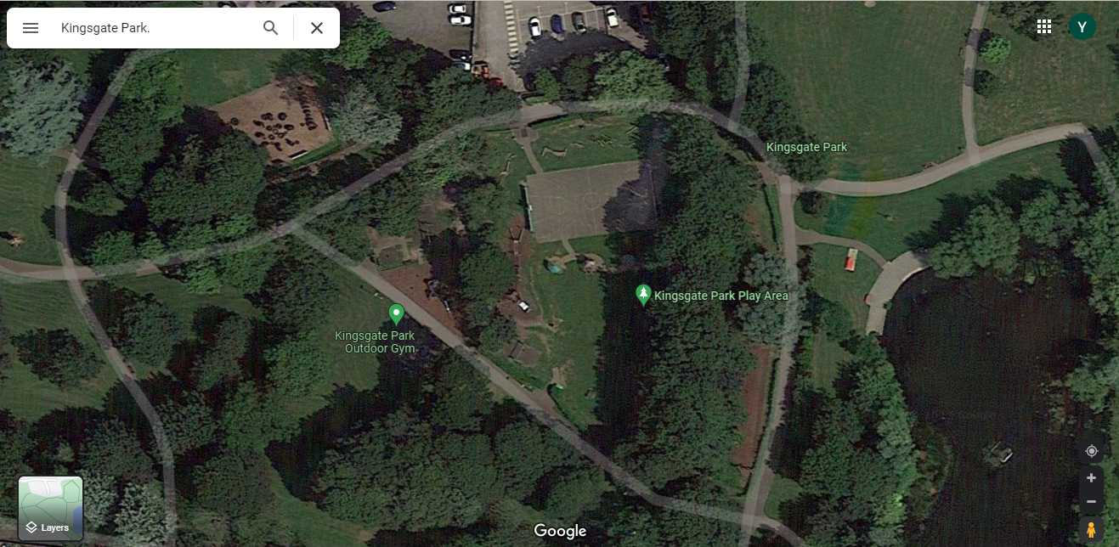
Area for works, within red line:
- Client Details

Yate Town Council
Poole Court
Poole Court Drive
Yate
Bristol
BS37 5PP

FAO: Leah Collier
Tel: 01454 866512
Email: lcollier@yatetowncouncil.gov.uk

- Contract Administrator

Yate Town Council
Poole Court
Yate
Bristol
BS37 5PP

FAO: Leah Collier
Tel: 01454 866512
Email: lcollier@yatetowncouncil.gov.uk

