Invitation to Quote for Stand Build
AHDB Exports Stand
Gulfood 2021
Dubai

Contact Name: Rachel Morrison Email: Rachel.Morrison@ahdb.org.uk

Company Name: AHDB Exports Website: www.ahdb.org.uk

Address: Stoneleigh Park Tel: +44 (0) 779 193 9614
Kenilworth
Warwickshire
CV8 2TL Contract Period: 16th Dec 20 to 25th March 21
United Kingdom

Show Name: Gulfood Show Dates: 21st to 25th Feb 2021

Hall: Meat and Poultry Stand Number: B3-2

Stand Size: 64msq Open Sides: 3

Budget: £35,000

Show Venue: Dubai World Trade Centre Deadline: Quotation to be received by
Sheikh Zayed Road Tuesday 8 December 2020
United Arab Emirates

- Introduction

This document outlines the requirements for the AHDB Exports stand at Gulfood 2020.

AHDB Exports are part of AHDB (the Agriculture, Horticulture Development Board) and based in Warwickshire, England.

We are a non-departmental Government public body working to promote British Pork and English Beef and Lamb both at home and abroad and will be attending with Hybu Cig Cymru - Meat Promotion Wales (HCC) who promote Welsh Beef and Lamb both at home and abroad.

2. Objective of attending the show

To provide a platform for our levy paying meat producers to create new business relationships with international meat buyers.

3. The Stand

We have booked a prime location for our stand (stand B3-2) in Hall 3. The floor plan can be viewed under point 6 showing our exact location.

Our stand measures 8m x 8m, a total floor-space of 64sqm.

The look and feel of our stand is important and must portray the quality of British meat and be clearly British. The stand will need to be seen from a distance and be visually appealing.

HCC will be in attendance on our stand and will require a space of 21sqm. There will need to be a clear division without a partition between AHDB and HCC.

We also require a fascia board to clearly distinguish who we are, which can be seen from a distance and draw people to our stand.

Lighting should be low heat creating.

3.1 Stand Build Requirements

To include all electrics, hot and cold water supplies, waste water disposal. Refrigeration units need to be in place and operational by the morning of Saturday 20th February, ready to receive all edible consumables.

Stand build dates are TBC

The stand needs to have the following elements and provisions.

Cooking area
This is a shared space for AHDB and HCC and needs to include the following elements

- Counter surface area to be approx. 2.5m long by 0.75 deep
- 1 x H9 electric hot plate for cooking meat (Lowe refrigeration or equivalent)
- 1x Induction hob (with frying pans) for cooking mat
- Counter to have underneath lockable storage cupboards with shelves for cooking pans/ingredients
- Water dispenser which must include hot and cold water.
- Drinking water cooler dispenser with additional bottles and disposable cups
- Quick serve coffee machine and facilities to make a Tea and coffee for those on the stand (approx. 150 servings per day)

There should be a protective partition at the front of the cooking area where the electric hot plates will be located to protect spectators whilst they watch products being cooked.

Storeroom

- Lockable door.
- SINK-2 dual sink (Lowe refrigeration or equivalent) with hot and cold water supply, and waste water disposal.
- Worktop for food preparation
- 2 x H3A fridge underneath the counter (Lowe refrigeration or equivalent)
- 1 large waste bin
- Wall shelving for literature storage
- Additional double electrical socket
- Coat hooks / rack

AHDB area:
To be used by AHDB staff and exporters
- 1 x A1 display chiller with display grass (Lowe Refrigeration)
- Welcome/ reception desk with lockage storage underneath.
- Plasma TV on the rear wall, with space for branding around the TV
- Multiples of poseur tables with 3 stools each to provide meeting points. Please note the number of tables and chairs is dependent on visitors being able to walk around the stand freely and without obstruction and meet the social distancing requirements outlined by the organiser.
- Bin
- Literature rack
- Electrical sockets for charging items

HCC area:
To be used by HCC staff and exporters and should be a defined area but without dividing walls (perhaps defined by using different flooring)

- 1 x A1 display chiller with display grass (Lowe Refrigeration)
- Welcome/ reception desk with lockage storage underneath.
- Multiples of poseur tables with 3 stools each to provide meeting points. Please note the number of tables and chairs is dependent on visitors being able to walk around the stand freely and without obstruction and meet the social distancing requirements outlined by the organiser.
- Bin
- Literature rack
- Electrical sockets for charging items

Sundries
- Drinks: Tea, coffee, sugar, milk, stirrers, soft drinks, and disposable cups for approx. 150 servings per day.
- Disposable cutlery, plates and napkins (approx.100 each per day)
- Red resin cutting board approx. 600x450 mm – raw products
- Yellow resin cutting board 300x450mm – cooked product
- Hot plate scrapper
- J cloths
- Cleaning fluids
- Anti-bacterial spray
- Anti-slip matt for chopping boards
- Disposable latex gloves

3.2 Additional Requirements

If available, please include an additional cost to the quotation for the incorporation of stand analytics software that can provide data post event on visitor numbers, dwell time, visitor flow and heat mapping on the stand.

4 Layout

Below is a proposed layout of the stand for your guidance:
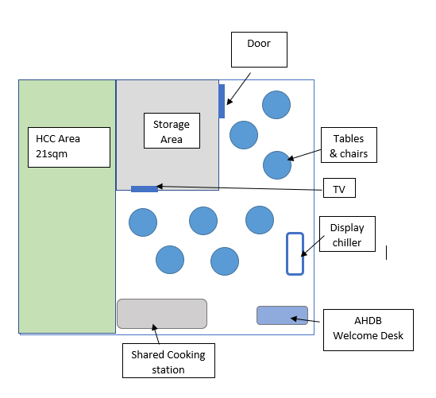

5. Graphics

HCC & AHDB will provide full and print ready artwork for all graphics.

The fascia board needs to clearly distinguish who we are and will be co-branded as Food is great and Cymru Wales. It will need to be seen from a distance in all directions and draw people to our stand.

There will need to be dedicated walls/panels for HCC and AHDB graphics along with a defined area to show export partner logos.

AHDB graphic panels
The theme will be based on Great British Lamb using landscape images with live animals and food images on separate panels.

Our key message “Quality Meat from Britain” in English and Arabic – will need to be shown in a prominent position.

Our USP is based around a quality product and so the stand design also needs to emulate this quality.

Our stand in 2020
Below are images of our stand in 2020 for reference:

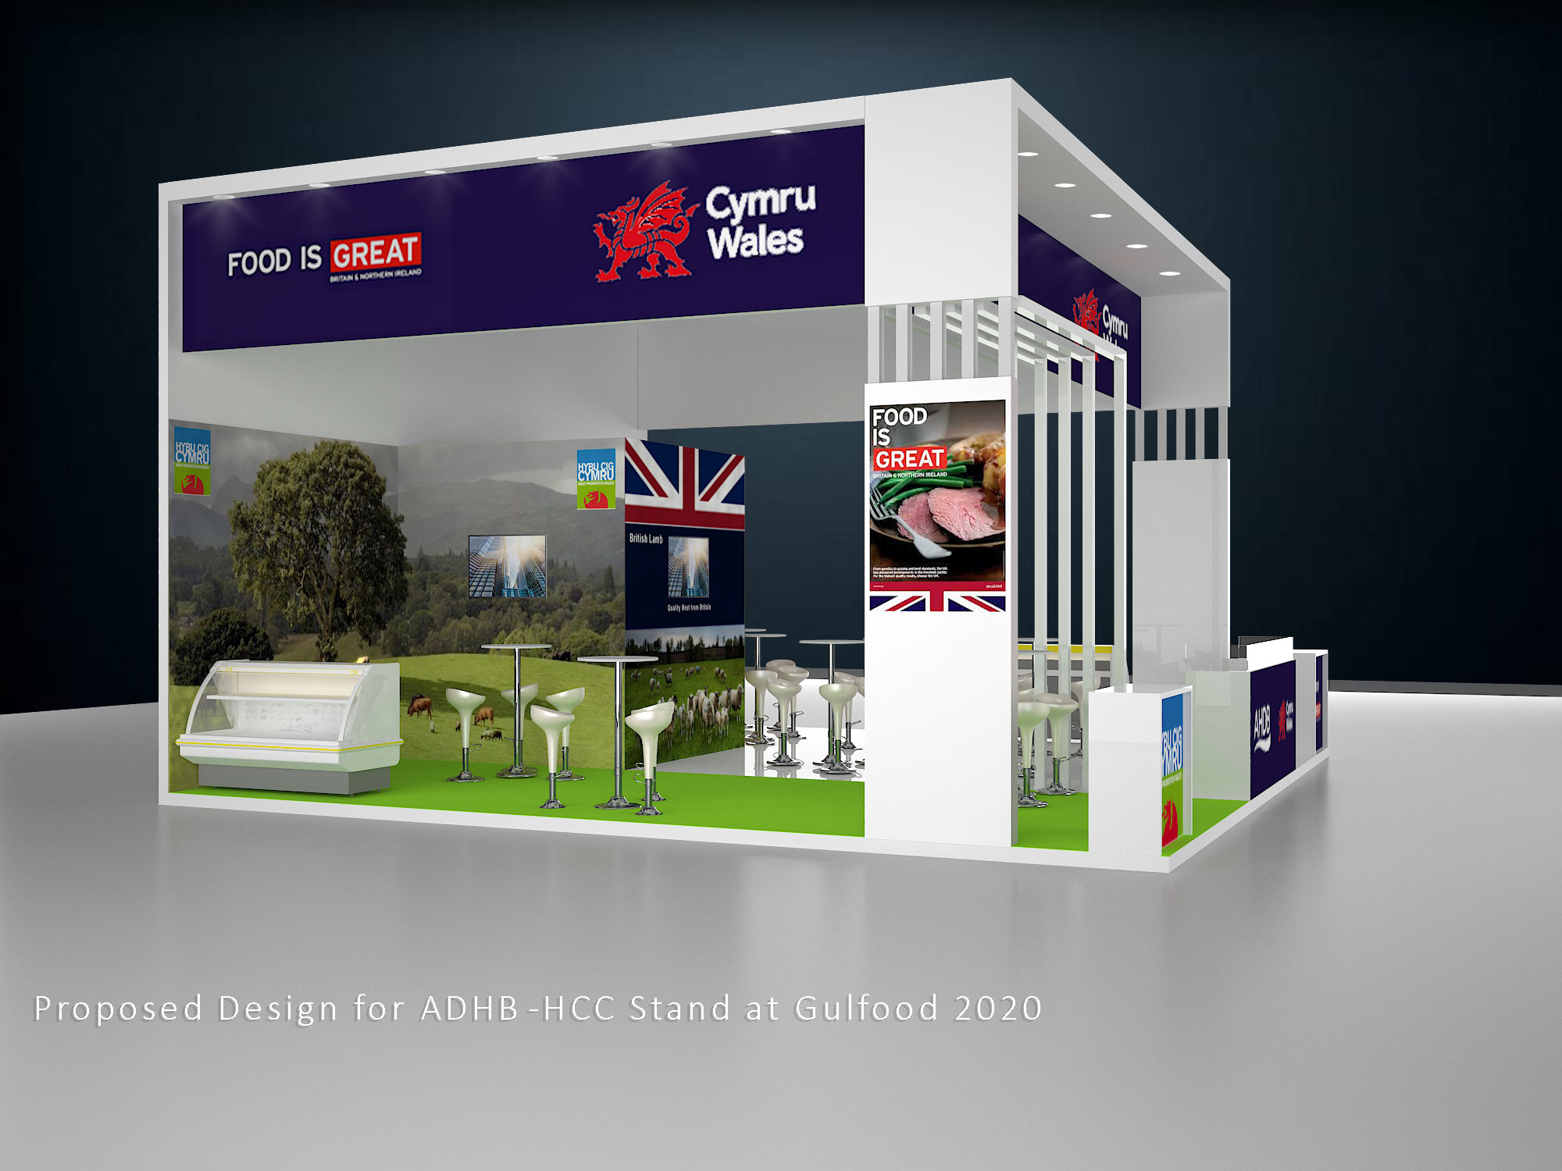

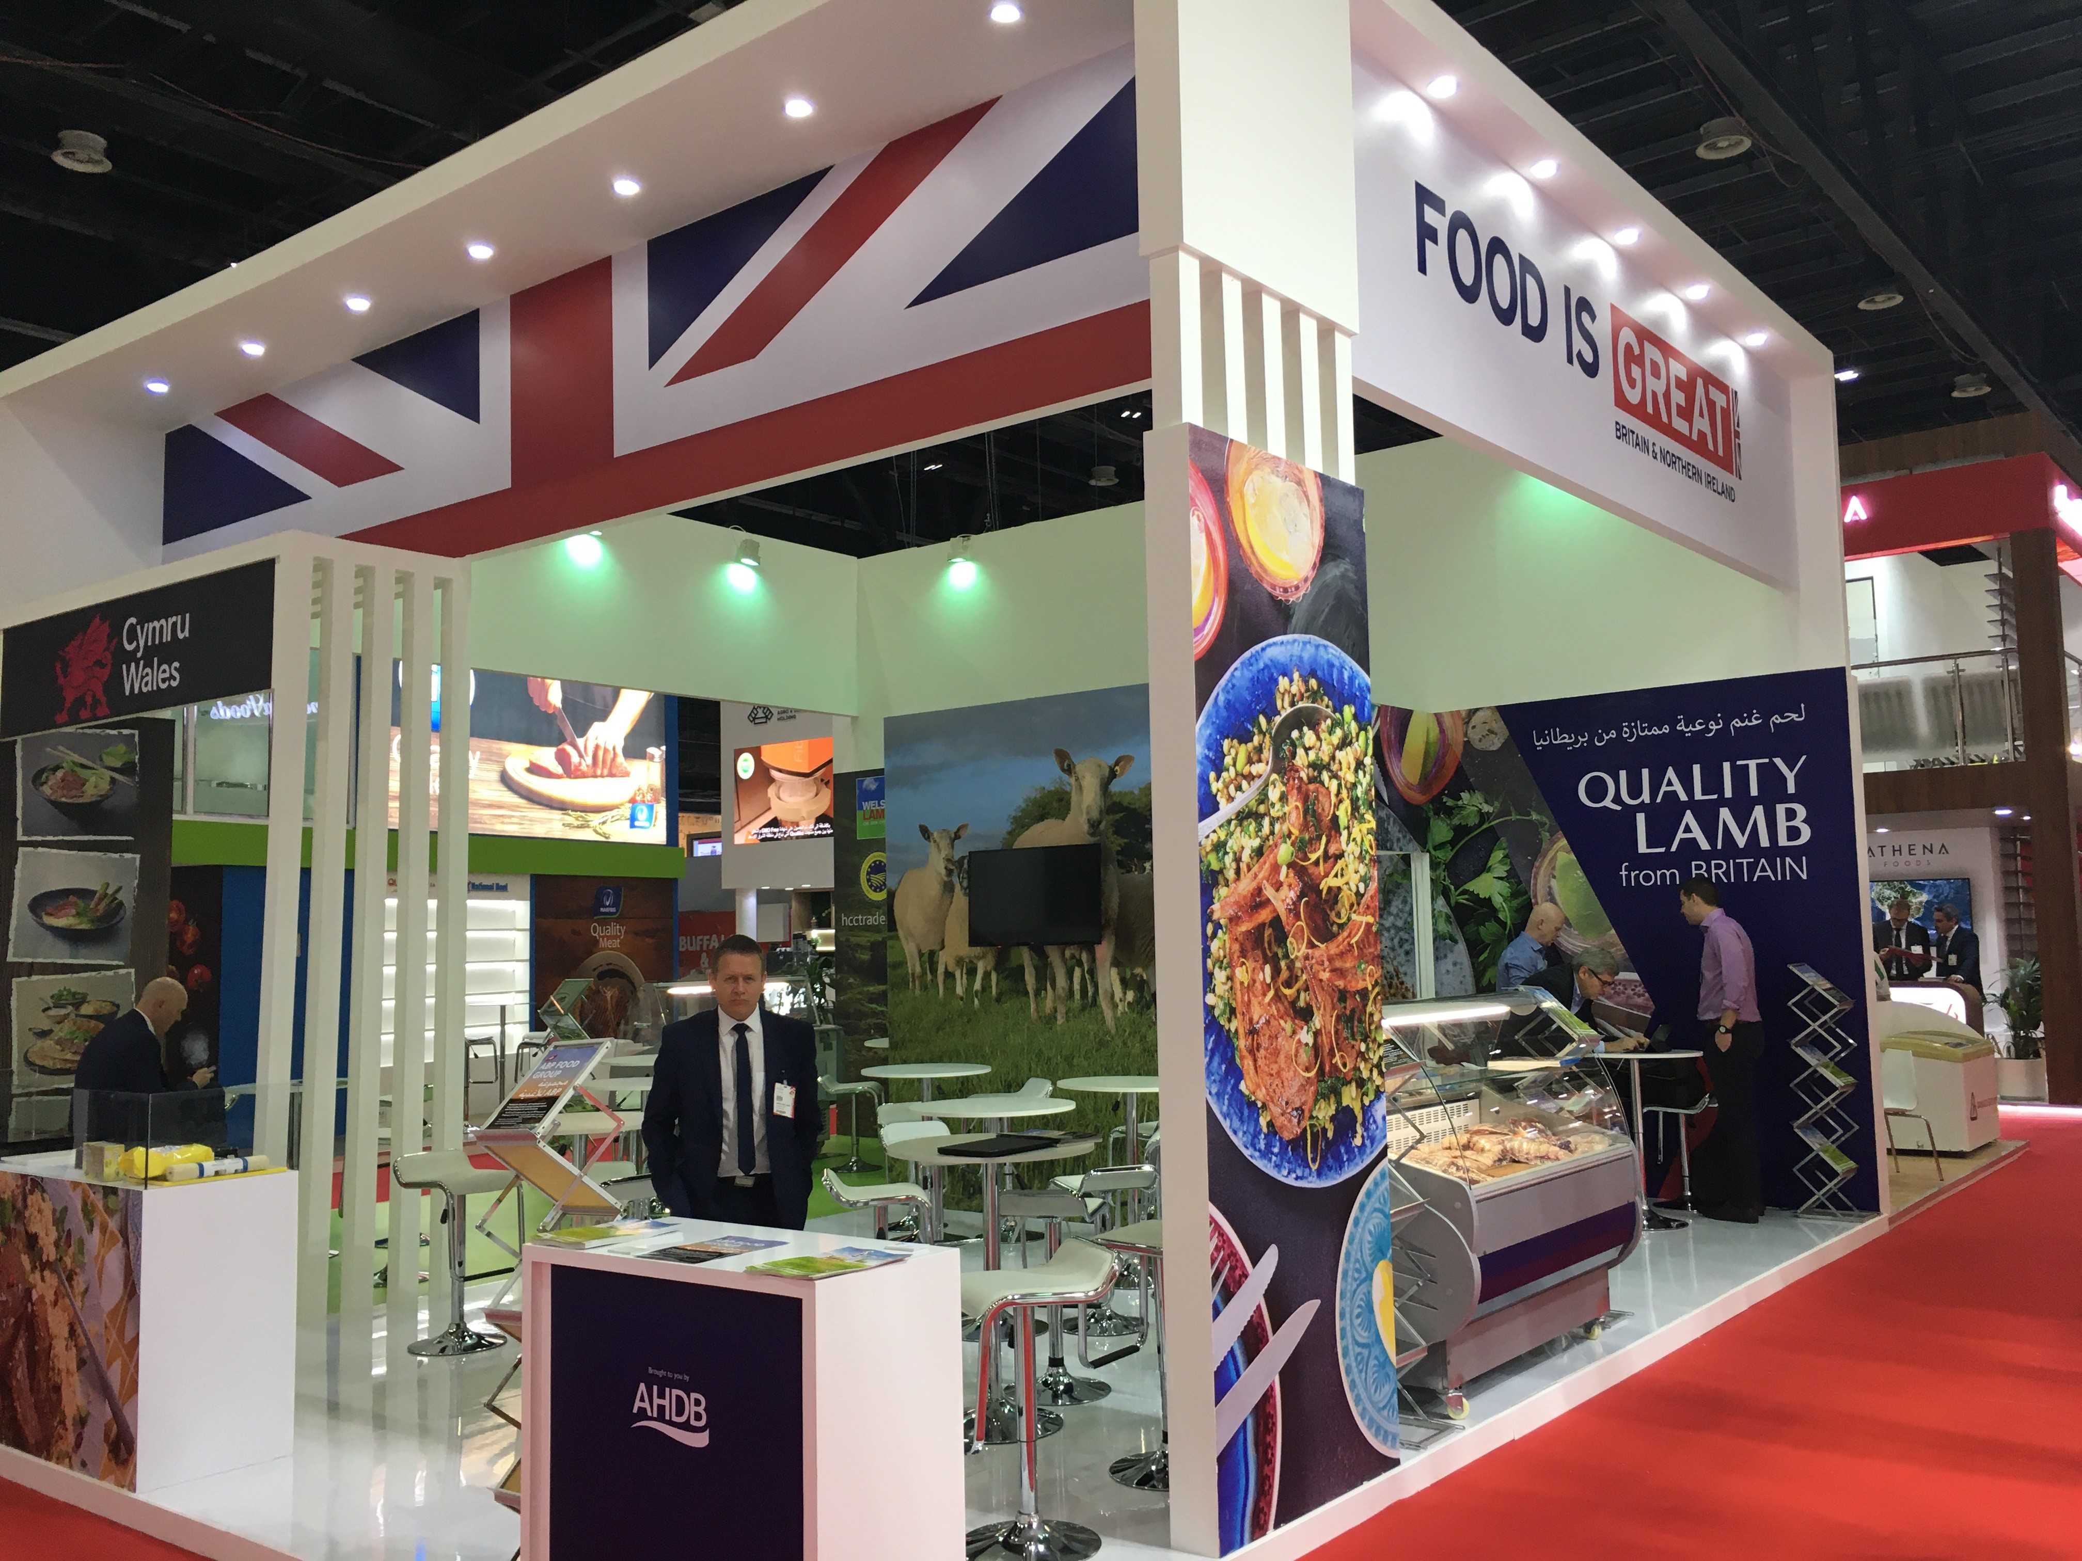

6. Hall Plan

Below is the layout of hall 3 Meat and Poultry, showing the location of our stand.

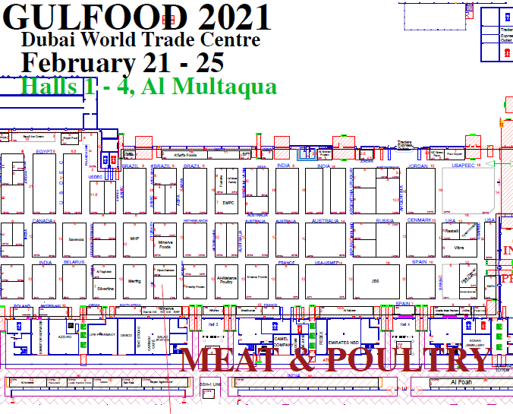

7. Quote Process

The contractor shall deliver the whole of the services, complete in all parts and furnished with every necessary detail, notwithstanding any omission or inconsistency in the specification.

The quote should be clearly itemised for all services and provision, and where possible split by area (cooking area, storeroom, HCC area, AHDB area) stating if any sub-contractors will be used.

Except as otherwise stipulated in the specific conditions of service required, the contract shall remain at the fixed price and rates shall not be revised.

The Stand Manager can order reasonable additions to or reduce from the service specified. These amendments shall be requested in writing and agreed by both parties.

8. Evaluation of Quotes

Your quote should include:

- “To-scale” visuals of your stand design, including dimensions
- Itemised breakdown of all costs
- Note any parts that you are not able to deliver

Our award criteria:

- Price (40%)
- Design, creative impression, and equipment (50%)
- Ability to meet event timelines, build-up and break-down (10%)

Please email your design proposals to Rachel.Morrison@ahdb.org.uk by Tuesday 8 December 2020, 5pm.

Any interested parties with queries relating to the tender please email Rachel.Morrison@ahdb.org.uk .

