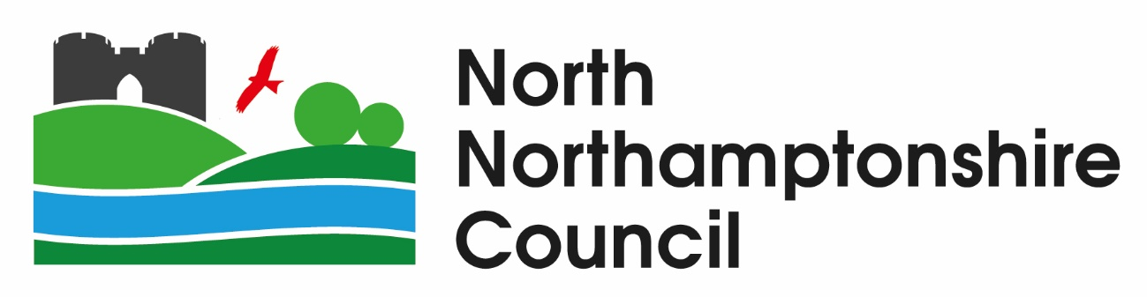

Pre-Procurement Market Engagement Questionnaire

Treatment & Disposal of Residual Waste and Operation of Household Waste Recycling Centres

Contents
1. Background and Service information 3
2. Pre-Procurement Market Engagement Questionnaire 4

Background and Service information

  - North Northamptonshire Council (hereafter referred to as “NNC”) is undertaking a soft market test exercise to obtain views from the market for the procurement of a residual waste treatment/disposal contract and the operation of Household Waste Recycling Centres (hereafter referred to as “HWRC”) and management & disposal of HWRC materials and/or waste.

  - NNC currently has a waste disposal contract with Thalia for all kerbside collected residual waste which is due to expire on Monday, 31st March 2025. There are no further extension periods available. The contract is responsible for the treatment/disposal of c80,755 tonnes* of residual waste (*2022/23 actuals). The contract was originally procured by Northamptonshire County Council. It is now owned by NNC (note, it is not associated with or used by West Northamptonshire Council (hereafter referred to as “WNC”).

  - NNC also has a contract with Urbaser to operate four (4) Household Waste Recycling Centres across NNC. This contract also expires on Monday, 31st March 2025. There are no further extension periods available. NNC currently provides a lead authority function for WNC, who rely on the same contract for the operation of their HWRCs. The intention is for both authorities to establish their own, independent HWRC arrangements post-March 2025. This pre-procurement market engagement questionnaire refers to the NNC procurement exercise only.

  - A separate commission is underway to determine whether the HWRC service should be delivered “in-house” or continue to be delivered by an external organisation. The commission also includes an evaluation of the number and location of facilities – we do not yet know the outcome. If NNC decides to continue with an externalised service, the procurement for both contracts will be combined either as one (1) lot or split into two (2) lots, with potential suppliers being able to bid for one or both lots.

  - NNC has a desire for waste to remain in the UK, to minimise carbon emissions associated with travel, in line with its Carbon Management Plan and aim of being carbon neutral by 2030.

  - Three (3) transfer stations are currently in use:
    - Rushton, near Corby;
    - Great Billing, near Northampton; and
    - Side Gate Lane, near Wellingborough
NNC do not own these facilities and are not able to make arrangements for them to be available.

  - NNC own three (3) HWRC sites:
    - Wellingborough;
    - Kettering; and
    - Rushden
An additional site in Corby is leased. The lease is due to expire before the new contract commences. It is proposed that the three (3) owned sites will be made available to the new supplier.

  - NNC is keen to obtain views from the market, to help shape the forthcoming procurement and would welcome your views in several areas.

Pre-Procurement Market Engagement Questionnaire

  - Your organisation is invited to share its views by answering the questions below, which will help inform decisions made by NNC.

  - Please insert your answers within this Word document (you can edit the space within each question, to provide your for your answer) and return by 12:00 noon on Friday, 28th July 2023 via e-mail to procurement@northnorthats.gov.uk.

  - This questionnaire and answers from it may be disclosed and/or published by NNC to ensure appropriate transparency of its procurement process (e.g., why NNC made a particular decision). All reasonable efforts will be made by NNC to ensure details are suitably anonymised and/or redacted to ensure no trade secrets, intellectual property, confidential and/or commercially sensitive material are disclosed, which would cause commercial competitive disadvantage to any organisation providing a response(s) to this questionnaire, from disclosure. Where uncertainty exists, NNC will discuss any intended disclosure and/or publication with the organisation who provided the response, prior to the disclosure and/or publication of any detail.

General Information
Name of Organisation | Click to enter text.
Contact Name | Click to enter text.
Role in Organisation | Click to enter text.
E-mail Address | Click to enter text.
Signature  electronic is acceptable | Click to enter text.
Date | Click to enter date.

Waste Treatment
Does your organisation operate a facility(ies) with spare capacity?
If yes:
- Is your organisation responsible for filling this spare capacity?
- What do you anticipate the spare capacity (tonnes per annum) will be within the following periods:
- 0-5 years;
- 5-10 years; and
- 10-15 years?
- Can you please state the location of the anticipated capacity?
Answer:
Click to enter text.

Waste Treatment
Does your organisation have any plans to increase capacity for waste treatment, either at existing facilities or by developing new facilities?
If yes, please can you tell us what you anticipate the spare capacity will be (tonnes), in what timescale, and location?
Answer:
Click to enter text.

Waste Treatment
If you bid for a contract to treat waste at a facility with spare capacity, what would be your organisation’s preferred duration of contract?
Answer:
Click to enter text.

Waste Treatment
NNC wishes to use transfer facilities located within the boundary of NNC. Do you have access to your own or merchant facilities which could be made available?
If yes, for how long?
Answer:
Click to enter text.

Waste Treatment
If NNC were able to make transfer facilities available, would you propose to use them?
Would you want to operate them, or would you prefer NNC to operate them?
Note: NNC’s current preference is for the successful supplier to operate them.
Answer:
Click to enter text.

Household Waste Recycling Centres
NNC owns three (3) HWRC sites (Wellingborough, Kettering, Rushden). The fourth site (Corby) is leased. Would you be willing to provide a site in the Corby area, or would you prefer NNC to provide a site for you to manage?
Answer:
Click to enter text.

Household Waste Recycling Centres
NNC proposes that the successful supplier is responsible for managing the disposal and sale of materials from HWRCs (excluding residual waste). What is your preferred material sales/revenue approach and how will this benefit NNC?
Answer:
Click to enter text.

Procurement Approach
NNC is keen to obtain a sustainable commercially attractive deal. How do you suggest NNC design the procurement to facilitate this?
Answer:
Click to enter text.

Procurement Approach
The procurement is for residual waste treatment and disposal and the operation of HWRCs (and associated materials). As other existing NNC contracts expire (e.g., for the treatment/processing of dry recycled material, food waste, green waste, and other waste streams) which of the following options would you be interested in?
- including these waste streams in this procurement; or
- bidding for them separately and offering resultant efficiencies from operating multiple waste stream contracts, to NNC?
Answer:
Click to enter text.

Procurement Approach
NNC currently favour going to market with two (2) lots:
- Lot 1: Treatment and disposal of residual waste; and
- Lot 2: Operation of HWRCs and disposal/sale of materials (excluding residual waste).
Would you be in interested in bidding for one, or both lots? Please confirm specifically whether you would bid for Lot 1 only, Lot 2 only, or both Lot 1 and Lot 2.
Answer:
Choose an item.
Click to enter text.

Procurement Approach
Please provide any further information, detail, and/or comment you would like to share to help NNC design its procurement and/or scope of requirement.
Answer:
Click to enter text.

We would like to thank you, on behalf of NNC, for considering this pre-procurement market engagement exercise and for the time taken in the preparation of your response.

