**Appendix three**

**Crossing Point and Culvert Repair Points Specification and logistics.**

See table 1 below for full breakdown of what is required at each point.

**Item 1.**

Renovate existing crossing point

**Grid reference:** TL97441307 **Compartment:** 1/8

**Suggested action:**

* Install a 9m length of 300mm twinwall pipe with upstand and an appropriate simple timber and sandbag headwall.
* 16 Rock roll units installed on sandbags on south side only, covering up to the level of the crossing point, keyed into a profiled bankside.
* Estimated 20m3 of material (to be sourced from Bale works) required to widen crossing point back to original width and build up sides to support rock-roll
* Estimated 20m3 of type 1 required to raise surface of track

See figure 1 for detailed plan in the Appendix Two.

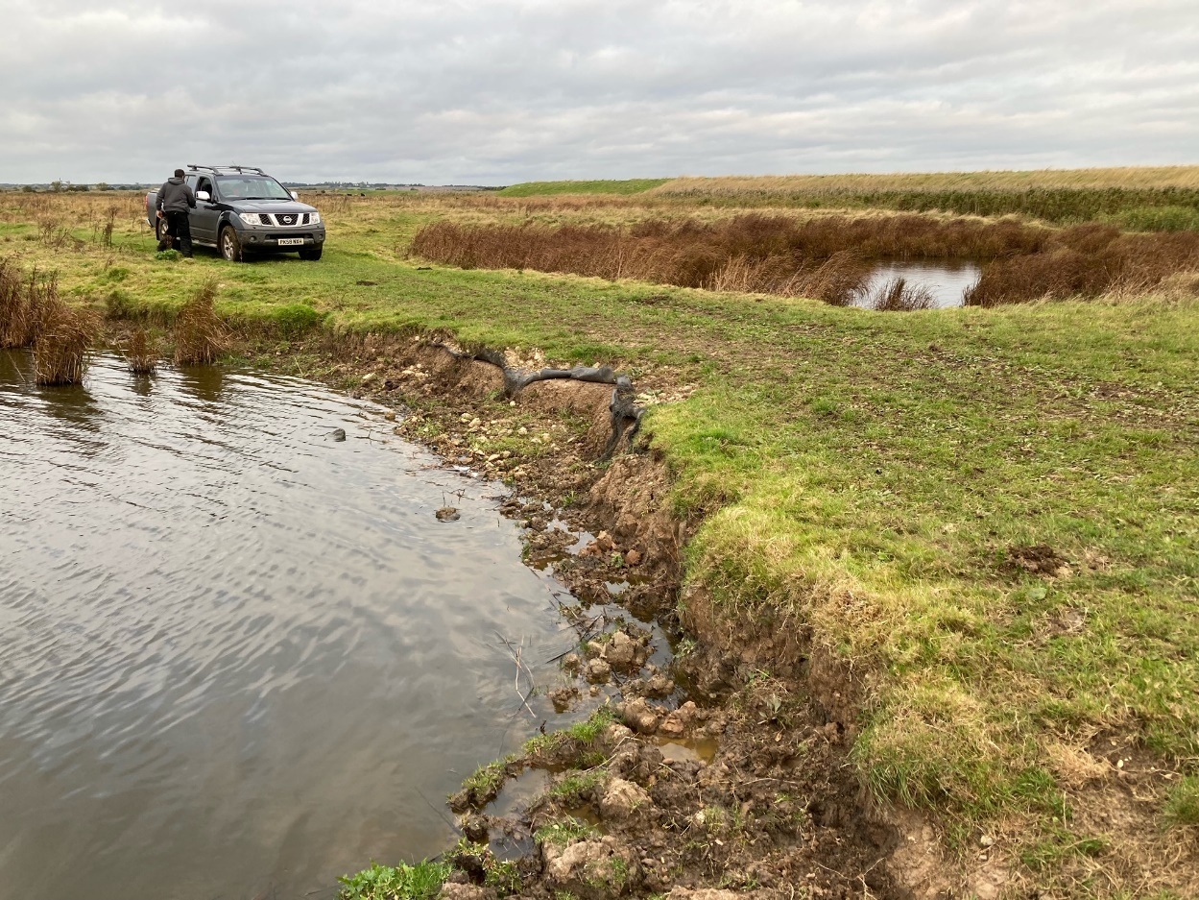

**Photo above showing south side of crossing point**

**Item 2:**

Renovate existing crossing point

**Grid reference:** TL97581305 **Compartment:** Field 1/8

**Suggested actions:**

* Build up both sides of crossing point with approximately 10m3 of material gained from Bale works
* Raise area with type 1 by approximately 30cm
* A picture containing grass, outdoor, sky, nature

  Description automatically generatedA picture containing nature

  Description automatically generatedEstimated 40m3 of type 1 required

**Photos above showing left- and right-hand sides of low point**

**Item 3:**

Renovate existing crossing point

**Grid reference:** TL97761298 **Compartment:** Field 1/8

**Suggested actions:**

* Install a 9m length of 300mm twinwall pipe with upstand and an appropriate simple timber and sandbag headwall.
* 16 Rock roll units installed on sandbags on south side only, covering up to the level of the crossing point, keyed into a profiled bankside.
* Estimated 20m3 of material (to be sourced from Bale works) required to widen crossing point back to original width and build up sides to support rock-roll
* Estimated 20m3 of type 1 required to raise surface of track

See figure 1 for detailed plan in the Appendix Two.

**Photo above showing south side of crossing point**

**Item 4:**

Renovate existing crossing point

**Grid reference:** TL98011284 **Compartment:** Field 1/8

**Suggested actions:**

* Install a 9m length of 300mm twinwall pipe with upstand and an appropriate simple timber and sandbag headwall.
* Approximately 1m3 of type one to cover up any excavations

See figure 1 for detailed plan in the Appendix Two.

**Item 6:**

Renovate existing crossing point (first area from south to north)

**Grid reference:** TL97521213 **Compartment:** Field 6

**Suggested actions:**

* Build up crossing point with material sourced from Bale
* Total area approximately 12x9m
* Estimated 80m3 of material required
* Dress the surface with turf gained from Bale works

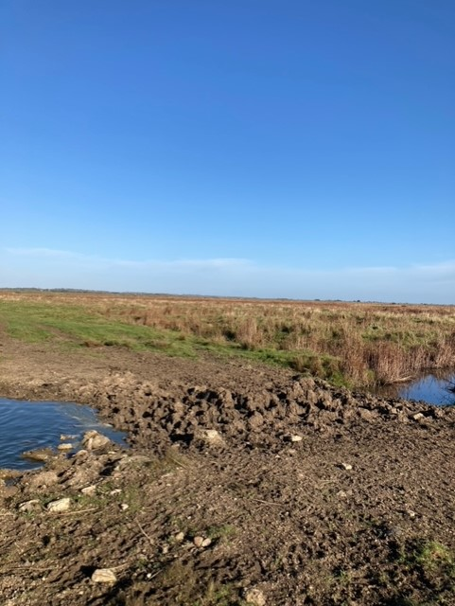

**Item 7:**

Renovate existing crossing point (second area from south to north)

**Grid reference:** TL97511221 **Compartment:** Field 6

**Suggested actions:**

* Build up crossing point with material sourced from Bale
* Total area length approximately 15x5m
* Estimated 40m3 of material required
* Dress the surface with turf gained from Bale works

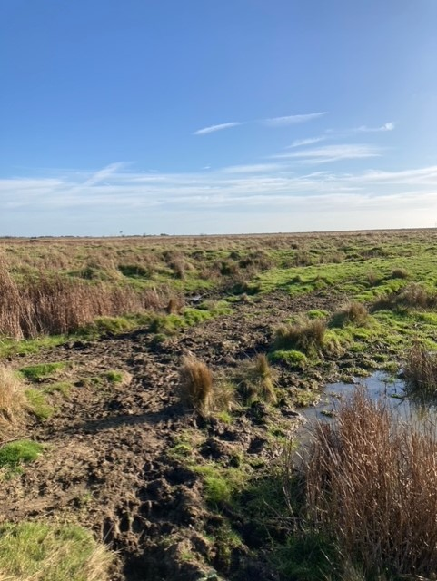

**Item 8:**

Renovate existing crossing point (third area from south to north)

**Grid reference:** **Compartment:** Field 6 and 7

**Suggested actions:**

* Build up crossing point with material sourced from Bale
* Estimated 120m3 of material required to widen crossing point back to original width and height. Build up sides to support rock-roll
* 24 Rock roll units installed on sandbags on both sides, covering up to the level of the crossing point, keyed into a profiled bankside.
* Estimated 20m3 of Type 1 required to dress surface

See figure 2 for detailed plan in the Appendix Two.

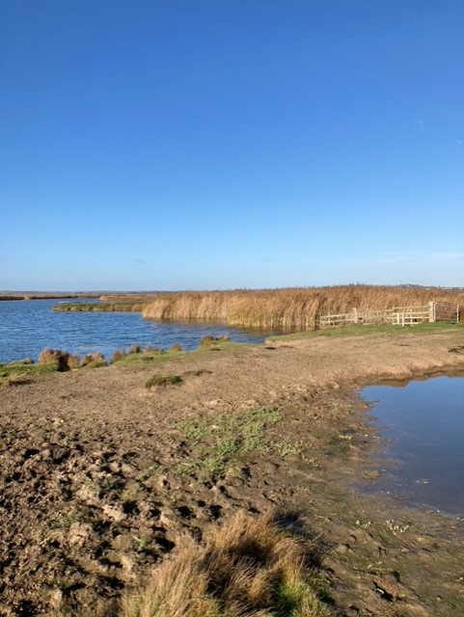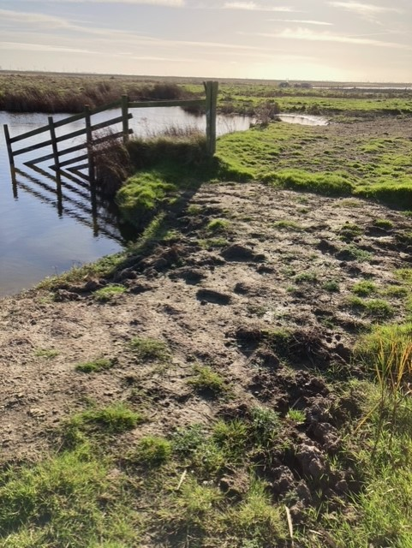

**View from the south (left) and north (right)**

**Item 9:**

Renovate existing crossing point (fourth area from south to north)

**Grid reference:** TL97511228 **Compartment:** Field 7

**Suggested actions:**

* Build up crossing point with material sourced from Bale to surrounding ground height
* Total area approximately 4x2m
* Estimated 10m3 of material required
* Top area with turf sourced from Bale works

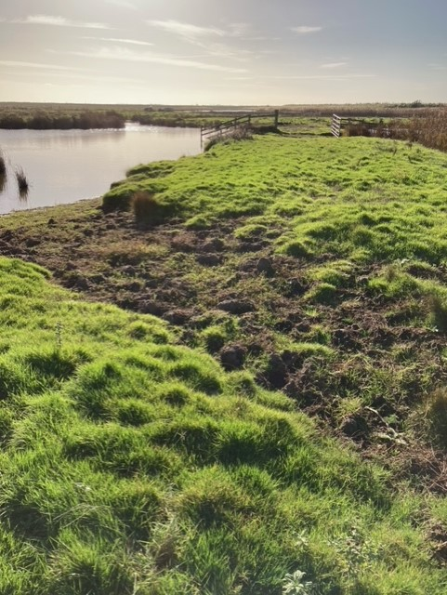

**Item 10:**

Renovate existing crossing point (fifth area from south to north)

**Grid reference:** TL97521229 **Compartment:** Field 7

**Suggested actions:**

* Build up crossing point with material sourced from Bale to surrounding ground height
* Total area approximately 4x2m
* Estimated 10m3 of material required
* Top area with turf sourced from Bale works

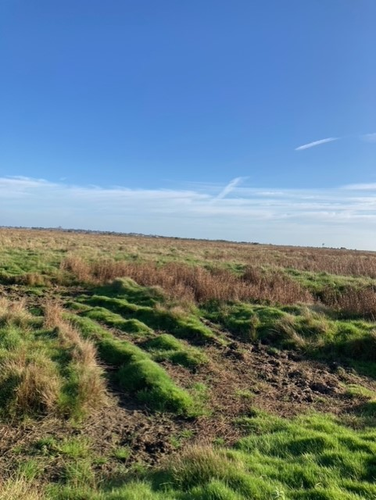

**Table 1: Estimated Specification per crossing point**

|  |  |  |  |  |  |  |  |
| --- | --- | --- | --- | --- | --- | --- | --- |
| **Crossing Point** | **Pipe & control structure** | **Rock-Roll (units)** | **Sandbags (Number)** | **Spoil required (m3)** | **Type 1 required (m3)** | **Length (metres)** | **Width (meters)** |
| **1** | 1 | 16 |  | 20 | 20 | 25 | 4 |
| **2** | 0 | 0 |  | 10 | 40 | 44 | 4 |
| **3** | 1 | 16 |  | 20 | 20 | 20 | 4 |
| **4** | 1 | 0 |  | 0 | 1 | 20 | 5 |
| **6** | 0 | 0 |  | 80 | 0 | 12 | 9 |
| **7** | 0 | 0 |  | 40 | 0 | 15 | 5 |
| **8** | 1 | 24 |  | 120 | 20 | 33 | 7 |
| **9** | 0 | 0 |  | 10 | 0 | 4 | 2 |
| **10** | 0 | 0 |  | 10 | 0 | 4 | 2 |
| **TOTAL** | **3** | **64** |  | **310** | **101** |  |  |