Appendix A - Meeting Room Details
All cables should be concealed under the floors and in the double or single skin plasterboard walls, unless stated in the room description below.
The floor is a raised metal construction with removable 600x600 tiles and, unless stated, the walls contain a draw wire that can be used to pull new cables in from the floor void to behind the monitor to supply camera and speaker, which will be fixed below and above the monitor.
Power is available at the floor socket or below the monitor in the floor void. Bidders should allow for a 3m UK 3 Pin IEC C7 Figure 8 Mains Power Cable and a Split Power Cable C8 to Dual C7 in each room.
TV/Monitors and stands will be provided by The National Archives in every room, where necessary. Cameras and speakers will be fixed directly to the wall, unless stated separately.
There are 8 rooms in total:
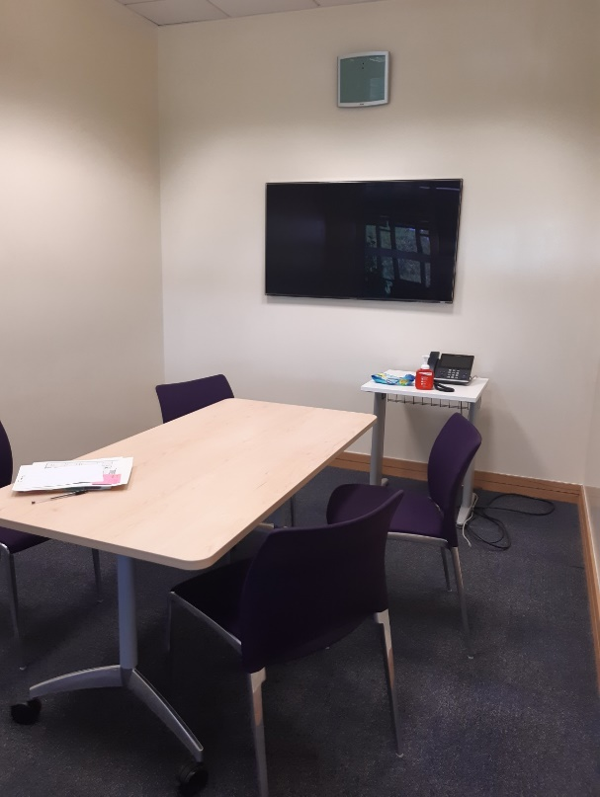
Meeting Room: 21O
4 - 6 People
Floor box is positioned within 1 metre of the monitor
Teams Touch Panel will be sited on a table above the floor box and the MCore Mini-PC will be fixed to the underside of the table using self-adhesive hook and loop tape

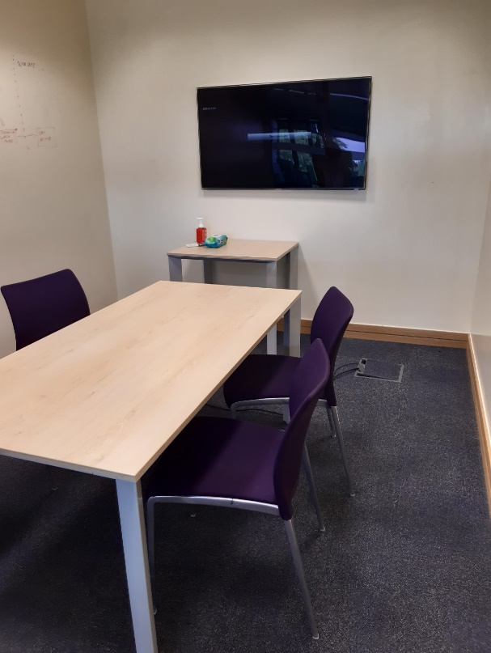
Meeting Room: 21N
4 - 6 People
Floor box is positioned within 1 metre of the monitor
Teams Touch Panel will be sited on a table above the floor box and the MCore Mini-PC will be fixed to the underside of the table using self-adhesive hook and loop tape

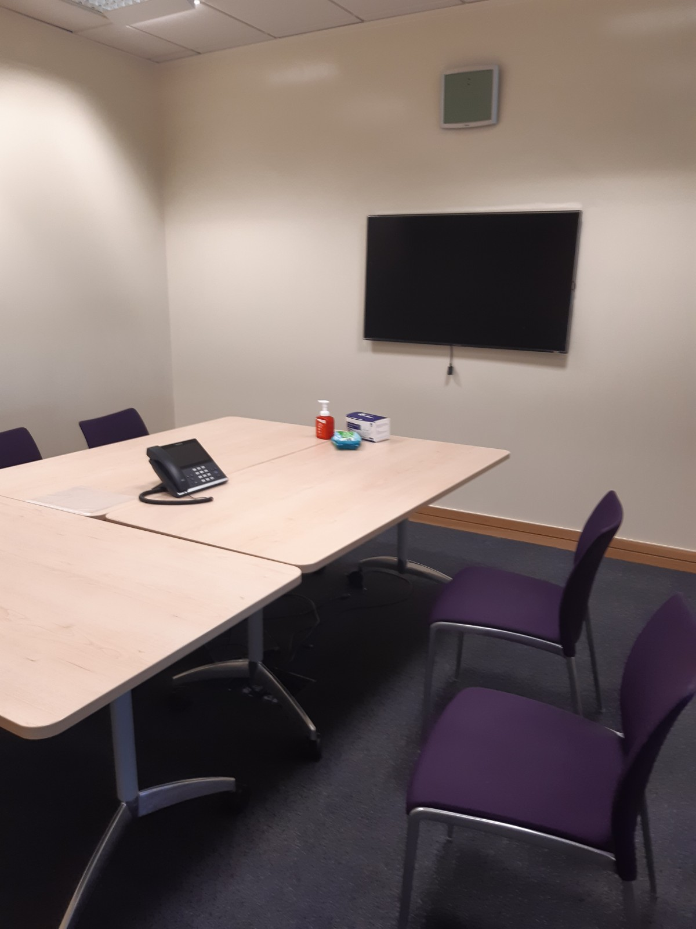Meeting Room: 21M
6 - 8 People
Floor box is positioned within 2.5 metres of the monitor
Teams Touch Panel will be sited on the table cluster above the floor box and the MCore Mini-PC will be fixed to the underside of the tables using self-adhesive hook and loop tape

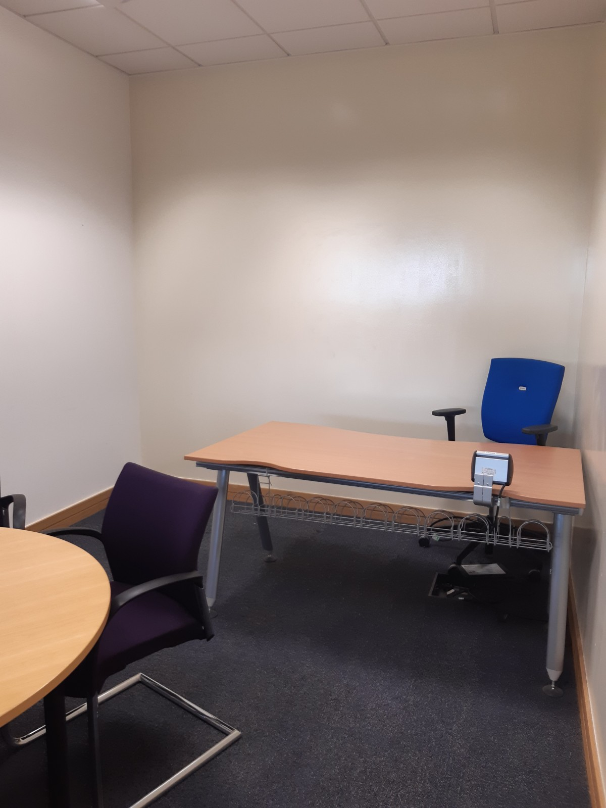Meeting Room: 21J
4 - 6 People
Floor box is positioned within 1 metre of the monitor
Teams Touch Panel will be sited on a table above the floor box and the MCore Mini-PC will be fixed to the underside of the table using self-adhesive hook and loop tape
Monitor to be sited on this wall
Furniture will be reconfigured

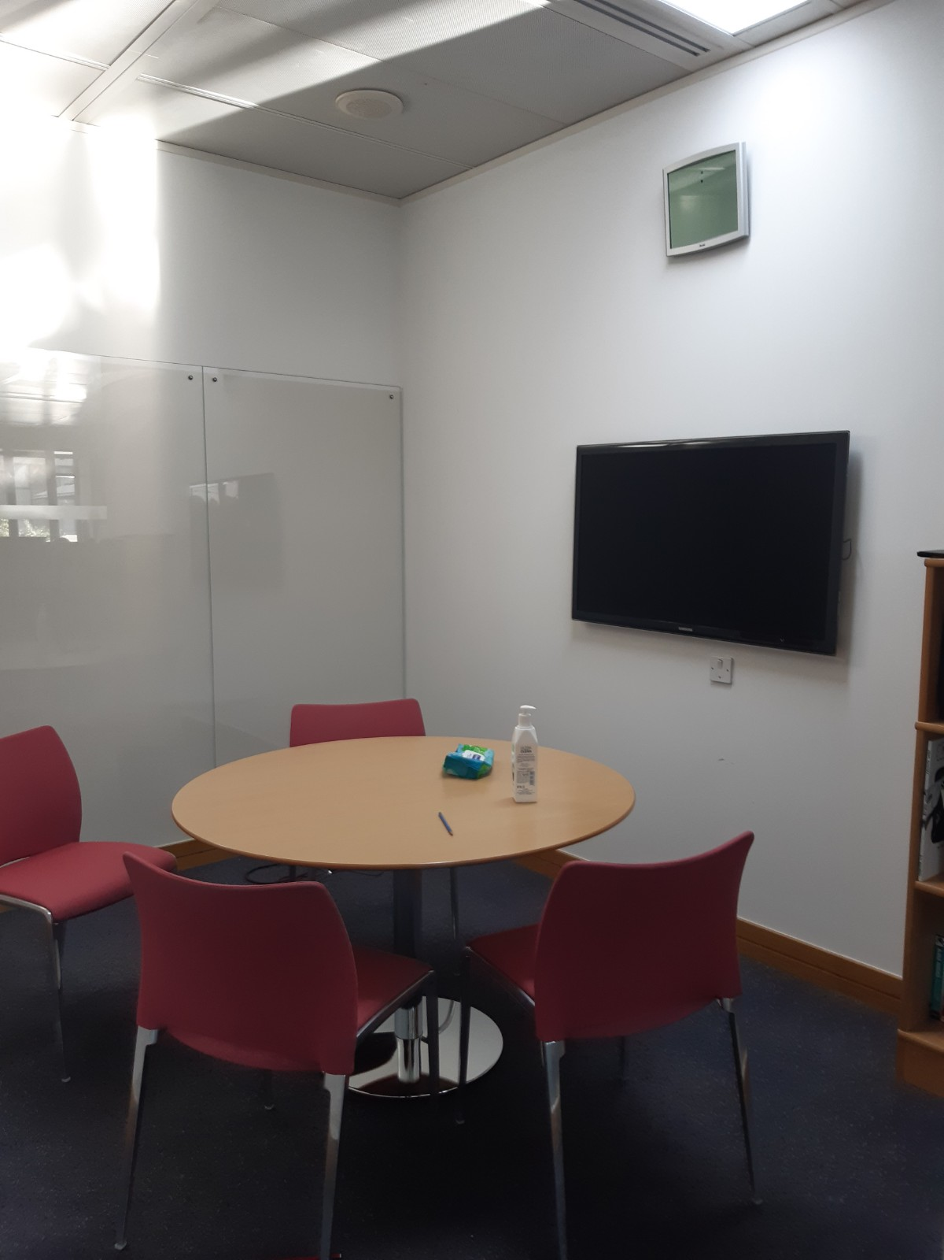Meeting Room: 21I
4 People
Floor box is positioned within 1 metre of the monitor
Teams Touch Panel will be sited on a table above the floor box and the MCore Mini-PC will be fixed to the underside of the table using self-adhesive hook and loop tape
Furniture will be reconfigured

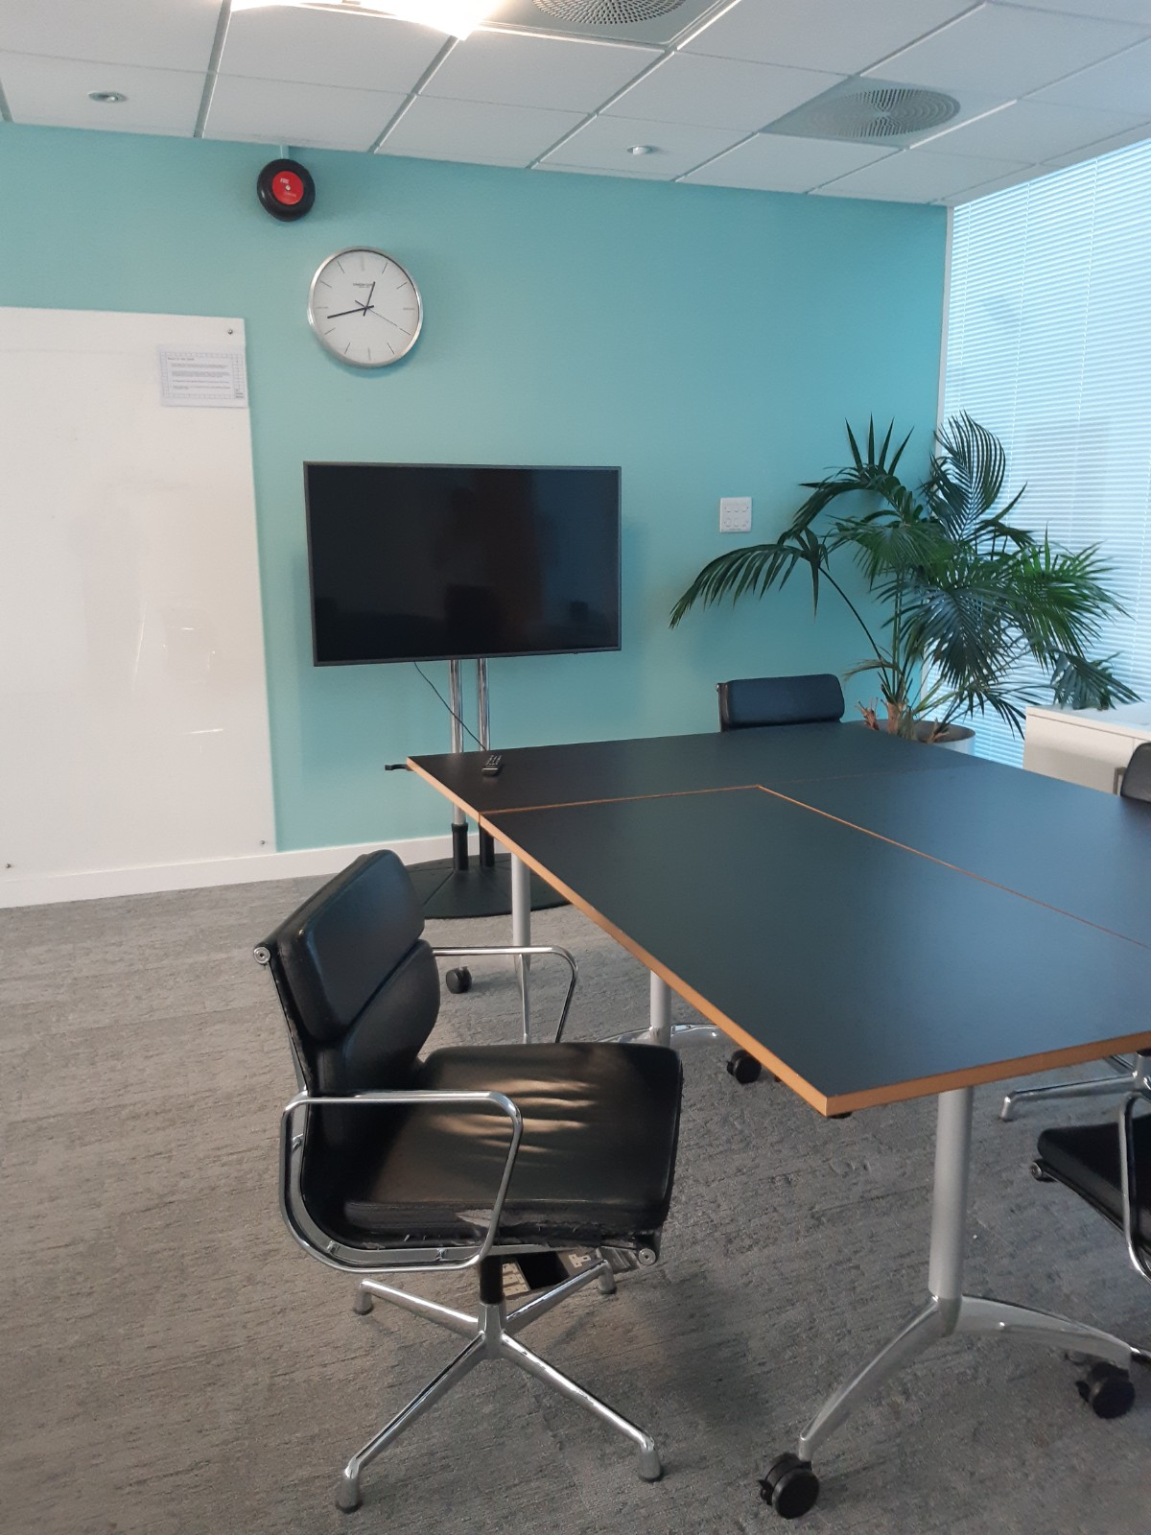Meeting Room: Research Hub
8 - 10 People
Floor box is positioned within 1 metre of the monitor and at the far-end of the table (as viewed)
Teams room equipment will be fixed to the TV/Monitor on the stand. Cables will not be concealed in the walls but will be placed in the floor void between the monitor stand and floor box
Teams Touch Panel will be sited on the table cluster above the floor box and the MCore Mini-PC will be fixed to the underside of the tables using self-adhesive hook and loop tape

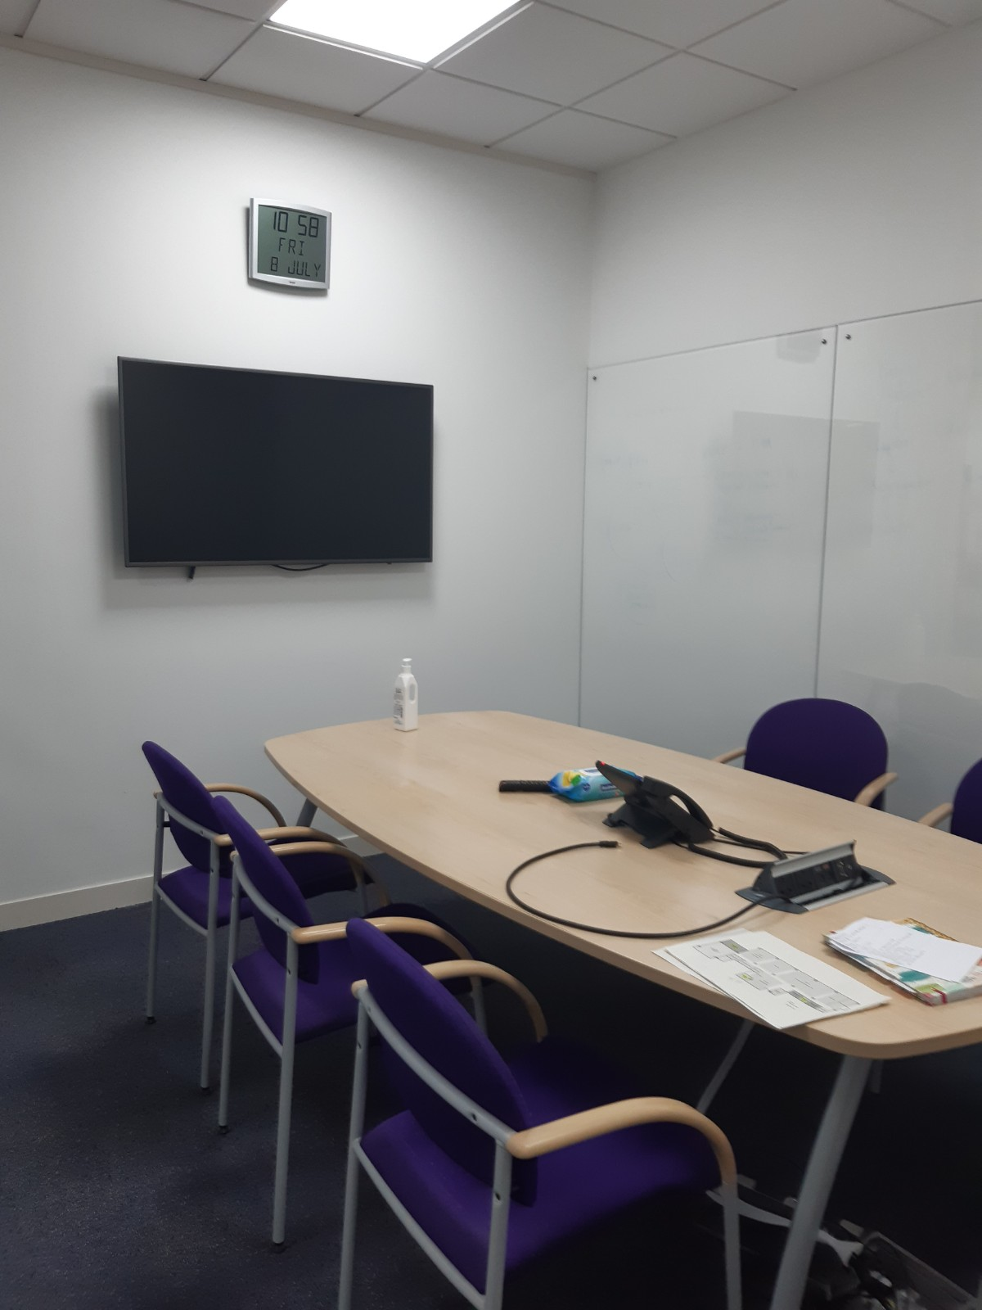Meeting Room: 1GC
6 People
Floor port is positioned within 3 metres of the monitor
Teams Touch Panel will be sited on the table cluster above the floor box and the MCore Mini-PC will be fixed to the underside of the tables using self-adhesive hook and loop tape

