PROJECT | Growing Sussex 5G Innovation Region (GS5GIR)

NAME OF ORGANISATION | West Sussex County Council

Contents
1.1 Introduction to West Sussex
1.2 The Sussex “Growing” Sector
1.3 Growing Sussex 5G Innovation Region (GS5GIR) – Introduction and Objectives
1.4 5G Innovation Regions Programme – Department of Science Innovation & Technology (DSIT)
1.5 Procurement Overview
1.6 College & Grower Locations
1.7 Case Studies
1.8 Technology / Agile Deployment Approach
1.9 Stackable Use Cases / Place-Based Approach / Commercial Model
1.10 Gainshare Approach
2 Confidentiality and Freedom of Information
Appendix 1 College Maps
Appendix 2 Growers Site Maps & Nearby Businesses
Appendix 3 Colleges - Fibre Proximity & Exchange Locations
Appendix 4– Growers - Fibre Proximity & Exchange Location
Appendix 5 – Case Studies

1.1 Introduction to Sussex
Sussex is located on the South coast of England. West Sussex covering 768 square miles with a population of 882,700 (375,200 households) in 2021 and East Sussex with an area of 692 square miles and a population of 545,870 (240,122 households).
Both East & West Sussex are administered under a two-tier local authority system. West Sussex is made up of West Sussex County Council (WSCC) and the seven districts and borough areas of Adur, Arun, Chichester, Crawley, Horsham, Mid Sussex and Worthing. East Sussex is made up of East Sussex County Council (ESCC) and the five districts of Eastbourne, Hastings, Lewes, Rother and Wealden.
Sussex is bordered by Brighton and Hove, Hampshire to the west, Kent to the north-east and Surrey to the north. A significant proportion of the population lives in the larger towns such as Bexhill, Bognor Regis, Crowborough, Crawley, Eastbourne, Hastings, Horsham and Worthing, yet a significant number of the resident population and businesses are located in the rural areas too.
According to the Department for the Environment, Food and Rural Affairs (Defra) Horsham, Chichester, Rother and Welden districts are classified as largely/predominately ‘rural’ areas.
Over 50% of the land in Sussex is protected countryside, as compared to 23% nationally. The relatively high percentage of protected land is due to a large area of West Sussex being part of the South Downs National Park and two Areas of Outstanding Natural Beauty; the High Weald and Chichester Harbour.
1.2 The Sussex “Growing” Sector
Our region’s strength is in growing food and drink, supporting the Southeast to produce half the UK’s fruit and a quarter of all glass house production. Sussex comprises 277 growers generating more than £1b in annual sales.
The West Sussex horticultural sector is one of high productivity and strategic importance to the county and region. It generates £1billion in annual sales, contributes £750 GVA and employs 10,000 FTE comprising 6,500 permanent jobs and 3,500 seasonal workers. It is experiencing escalating demand generated by consumer trends which include increasing interest in veganism, locally sourced produce and minimising risk to food disruption by reducing reliance on imported products.
Sussex is home to the leading wineries of the UK, with currently 138 vineyards representing a quarter of Great Britain under vine. The sector has ambitious plans to increase its current value of £25million to £283million by 2040, generating 3,633 new jobs and securing the county’s position as the UK’s premier wine tourism destination.
The South Downs National Park Authority (SDNPA) commissioned research to understand the impact of the rapid increase in viticulture and associated wine production on the landscape – there has been a 90% increase in vineyard coverage in the national park since 2016 with currently 51 vineyards (covering 436 hectares (ha)) and 11 wineries. They employ 358 people (including seasonal labour), attract 33,000 visitors a year, contributing approximately £24.5 million (directly) to the local economy and £54m to the wider economy.
1.3 Growing Sussex 5G Innovation Region (GS5GIR) – Introduction and Objectives
WSCC has won funding to become one of ten successful 5G Innovation regions announced by the Department of Science, Innovation and Technology (DSIT). An exciting project to innovate and increase food and drink production using digital applications and skills has won government backing in Sussex, known as Growing Sussex 5G Innovation Region.
The project, led by West Sussex County Council, is wide ranging in its ambitions. It will co-develop foundational technology use cases (such as 5G and Artificial Intelligence) with telecoms and technology partners, education centres and commercial producers to develop future farming and growing practices that increase sustainable food and drink productivity.
A focus will be to develop a highly qualified, digitally skilled workforce capable of using digital applications in their workplace to drive demand for commercially provided connectivity solutions, including advanced wireless and 5G.
Our rationale is evidenced by producers’ need to digitally transform to attract/retain digitally skilled growers, land managers and data scientists to benefit from innovations in IOT, AI and automation across cultivation, production and supply chain management (including packing, tracking and logistics). WSCC, West Sussex Growers Association (WSGA) and Brinsbury (agricultural) College have undertaken research showing that a lack of rural connectivity and limited digital skills are key barriers delaying the sectors’ adoption of emerging technologies. From this baseline we will stimulate untapped demand for advanced wireless connectivity to benefit from the national boom in agritech and data management applications supporting advances in sustainable food and drink production.
The proposed 5G innovation ecosystem network will develop food and drink “growing” use cases with telecoms and technology partners, education, researchers and commercial producers to develop future farming and growing practices. In co-operation with an agricultural centre of learning and local growers in the region, the project will develop a local, more qualified and digitally skilled specialist workforce. The purpose is to make these sectors more efficient and to create demand for scalable expansion of 5G and wireless infrastructure. The scalable expansion will be achieved two-fold, at the local sites via the use of stackable use cases and by informing an evidenced and repeatable commercial model tailored to the needs of the growing sector.
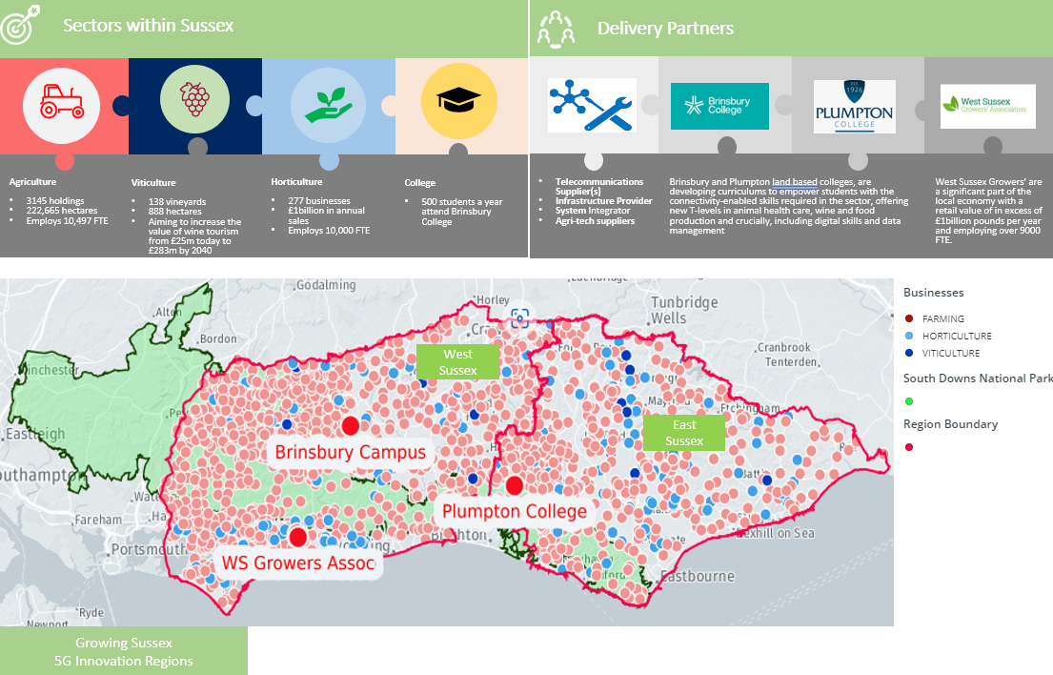
Figure 1: Sussex Region, Sector Overview & Delivery Partners
1.4 5G Innovation Regions Programme – Department of Science Innovation & Technology (DSIT)
The Department for Science, Innovation and Technology (DSIT) is leading the government’s approach to driving innovation and unlocking opportunities for economic growth through making use of world-class digital infrastructure. DSIT invited applications into a £40 million fund for local authorities across the UK to establish themselves as ‘5G Innovation Regions’ (5GIRs).
5GIRs is part of a wider programme to drive 5G adoption, with a focus on key sectors where there is local capability and opportunities. Funding will enable regions to unlock opportunities across the digital economy which utilise advanced wireless connectivity.
The objectives of the DSIT programme are to:
- drive economic growth across the UK by supporting places to adopt advanced wireless technologies for services based around local opportunities for growth
- accelerate commercial investment in 5G and other advanced wireless technologies by aggregating and demonstrating demand
- foster the 5G ecosystem enabling “learning by doing”
1.5 Procurement Overview
West Sussex County Council intends to procure a suitable delivery partner for the design, implementation and operation of a hybrid 5G and advanced wireless network and the delivery of agreed “Use Cases” across three site locations (Growers and Colleges).
The procurement will cover the following activities:
- design, installation and testing of the hybrid 5G and advanced wireless network
- solutions to address the identified “growing” use cases, associated benefits & costs savings
- systems integration to ensure that the Use Case solutions and the network work together
- capacity to deliver further Use Cases to expand the scope of the project over time
- support for the colleges and growers to implement the Use Cases
- hardware, software and devices to support the network and the Use Cases
- ongoing maintenance & support
participation in showcasing and network events at the college and grower sites and development of playbooks to encourage further use and innovation
- an ecosystem of innovation partners to bring further value and showcase the advanced wireless network
The opportunity will be open to all suitably qualified suppliers able to deliver the requirements over the long term, either as single suppliers or as a prime contractor utilizing third parties/ partners to deliver some of the elements.
In terms of timescales, the council intends to start a procurement in Jan 2024 with a view to awarding a contract by March / April 2024. The awarded supplier would then be expected to deliver the advanced wireless infrastructure and use case implementation at all the sites, in time for the start of the academic year in Sept 2024. It is anticipated that the term of the contract will be for 3 years, with a requirement to spend the DSIT funding in the first 18 months.
There may be opportunities during the contract period to add additional site locations if further funding is acquired.
1.6 College & Grower Locations
Brinsbury College & Plumpton College will offer opportunities for innovation in the test and trial of new products and services in an educational agriculture setting.
Students will deploy new growing practices innovatively and contribute to the development of products. The Colleges, as a centre for promoting innovation, will host demonstrator projects, show casing new applications and bringing together technology manufacturers and wireless operators at educational events with growers and farmers, as well as provide ‘real life’ test environments to researchers and innovators.
A planned programme of learning and collaboration events will be key to ensuring the growers understand the benefits and adopt the technologies, ultimately becoming customers of the connectivity/products and services and driving commercial investment in advanced wireless technologies to meet demand.
Brinsbury college is set in 570 acres of countryside and woodland, with a working farm, lakes and stables. The campus, near Pulborough, is the base for all land-based courses and is home to a working farm, animal care centre, forge and stables, as well as large areas of woodland.
Plumpton College is a Further and Higher education college in Plumpton, East Sussex, with courses in a variety of land based and related subjects. The college provides a range of full-time and part-time land-based courses, FE courses to Foundation Degree and BSc courses. Now farming around 2,500 acres the estate has grown to become one of the leading centres for land-based education in the UK. One of the most recent additions has been a superb commercial winery.
Due to the extensive land coverage at the colleges, the use cases will indicate which areas of the campus they apply to. Please see maps in Appendix 1 to demonstrate the size and location of the entire campus(es).
Via its stakeholder relationships with existing sector networks such as the West Sussex Growers Association (WSGA) and the Farming Rural Issues Group South East (FRIGSE) the Council is also collaborating with two commercial grower sites, known here as Grower site 1 and Grower site 2. They are both located in a geographical cluster of related businesses near Walberton, Barnham and Yapton in West Sussex.
The Growers will deploy new growing practices innovatively and will contribute to the understanding of requirements and challenges of implementing the Use Cases and associated wireless technologies in a real-life business environment. Please see maps in Appendix 2 to demonstrate the location of the growers sites and other nearby businesses.
The fibre proximity, exchange location and indicative broadband speeds can be found in Appendix 3 for the colleges and Appendix 4 for the grower sites.
1.7 Case Studies
The council are leading an engaged and energised body of stakeholders that is forming cohesively around use cases for foundational technologies such as AI/augmented reality to support food and drink productivity, energy efficiency and carbon reduction. We will continue to foster and resource this collaboration.
An example of the Use Cases can be seen in Appendix 1. They are representative of other growing regions, making our learning repeatable and use cases replicable.
1.8 Technology / Agile Deployment Approach
This project includes the two colleges and the two growers at the Barnham cluster site (see section 1.6 and Appendixes 1-4). The Council wishes the sites to be set up in such a way that use cases can span or move between them without further infrastructure deployment, so inter-site communication is an important aspect of the project vision. It is therefore important that a common approach to the technology design and deployment is taken, rather than simply producing three separate network and technology stacks. A series of Playbooks need to be produced including how growers should best go about evaluating, buying, deploying, testing and operating advanced wireless technologies to transform operations and improve productivity.
Key criteria for the design:
- Future-leaning. It is possible that a network could be delivered using a combination of 4G, Wi-Fi, LoRaWAN and LEO which would broadly meet today’s demand for wireless networking at our sites. But this would completely miss DSIT and WSCC’s objective to enable and drive commercial adoption of advanced wireless, so it is essential that bidders design and cost their bids with the next 5 years in mind rather than the previous 5.
- Adaptable. This is a learning project, and bidders must enable a technology environment capable of shifting workloads, capacity, spectrum, applications around the three sites as needed. Capable of integrating and extending into other solutions from other vendors.
- Secure. These are businesses delivering food and other valuable produce to our nation’s dinner tables, forming a key part of our critical infrastructure, our cultural life and our economy. The people working in them and the customers served by them must be able to operate confidently and with the knowledge that food has been produced safely, has a known provenance and has not been interfered with at any stage. Data about those people and businesses must also be secured, as must valuable equipment, tools, materials and sites.
- Manageable. Advanced wireless technologies, as well as the applications, devices, data and workflows must be delivered in a manner which can be managed with ICT skill levels normal in small and medium sized enterprises. This will give the colleges and growers autonomy to focus on their core business operations rather than managing the technology once the initial set up and testing have been done. This includes the ability to perform ‘level-1’ support tasks – initial fault recognition, reporting and troubleshooting, moves and changes to devices and network function, adding and removing access points when new coverage is required.
- Sustainable. This covers both economic and carbon sustainability – the network must be paid for within the constraints of the 5GIR capital grant funding, and that must cover the entire grant period, as well as show how it will be funded beyond that period.
A key consideration in this context is access to spectrum – the solution must not be dependent on the use of any single spectrum band or license which is tied to any given operator.
It must also be designed in a manner which over time reduces the carbon footprint of the network and technology deployed, contributing to improving the green credentials of the growing industry.
The Council would like to implement an Agile approach to deployment at the college and grower sites. For instance, the delivery is broken into numerous smaller iterations of deployments, including faster delivery, test and improvement cycles. The short iterations will deliver value rapidly, and allow improvements to plans over time and achieve more in shorter time frame demanded by the DSIT funding timescales.
To support a rapid and iterative deployment, the Council has considered the use of temporary structures where needed, for instance the use of temporary masts. This would allow flexibility in the design too. There would be a requirement to in parallel replace any temporary with permanent infrastructure in parallel and before the 18-month funding window completes. Thought would need to be given to any planning considerations this would entail.
1.9 Stacked Use Cases / Place-Based Approach / Commercial Model
The project aims to drive benefits from 5G and advanced wireless for the “growing” industry by maximising the take-up of services by customers in all sectors from the same technology at each location.
Our regional “growing” industry is diverse, comprising small and medium growers as well as large, consolidated businesses. We are representative of other growing regions, making our learning repeatable and use cases most crucially replicable.
DSIT funding will accelerate the use of advanced wireless infrastructure by growers understanding the benefits and being able to invest in technology through an affordable commercial model, supported by financial assistance through a Framework if required. A clustered approach will help lower the costs of adoption by providing private services over shared passive infrastructure.
Scalability will be realised by the deployment of new advanced wireless networks to additional growers /colleges, in the region, through the delivery of a replicable commercial model.

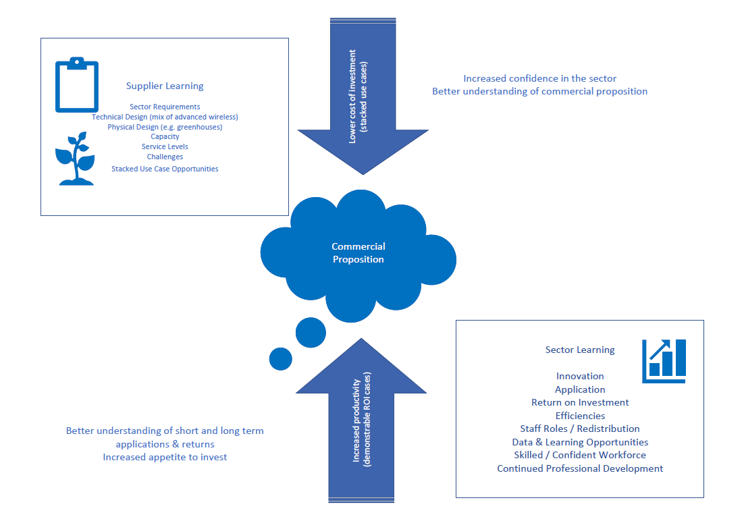
Figure 2: Development of a Commercial Approach

A regional programme of specialist events will ensure growers understand the benefits and adopt the technologies, becoming customers of the connectivity, products and services and driving commercial investment in advanced wireless technologies to meet demand. These will be made available as use cases that can be applied to other growers.
As an outcome of the supplier itself will develop and refine a commercial model that is repeatable within the growing sectors in other areas of the UK.
Through these use cases and commercial models, the programme aims to ensure that its benefits can be replicated in similar applications nationwide. It is exploring how these other areas could be included in the procurement process. A gainshare model could be a valuable mechanism through which GS5GIR and the supplier could jointly drive growth and benefits by reinvesting the additional value of services take-up.
2 Confidentiality and Freedom of Information
All information included in this document is confidential and only for the recipient’s knowledge.
Spirit Public Sector Limited has been appointed by West Sussex County Council to provide technical advice in support of the GS5GIR Project, as such responses received may also be shared confidentially with Spirit Public Sector Limited. Responses may also be shared with the DSIT in relation to the funding from the 5G Innovation Regions programme.
Please be aware that we are subject to the disclosure requirements of the Freedom of Information Act (FoIA) and that potentially any information we hold is liable to disclosure under that Act. For this reason, we would strongly advise that any information you consider to be confidential is labelled as such. In the event that a request is subsequently made for disclosure under the FOIA that request will be dealt with in accordance with the legislation.
Please note that all communications with WSCC in relation to this project, any query or question should be made in writing via email to rachel.ayres@westsussex.gov.uk. If a question you submit is commercially sensitive and you require a confidential response, please inform the Council and before providing a response we will confirm if the answer can be given confidentially.
- The Council does not commit to proceed with a procurement exercise following this market engagement.
- For the avoidance of doubt, no information provided in response to this questionnaire will be used by the Council in assessing suppliers now, or during any future procurement process.

Appendix 1 – College Maps
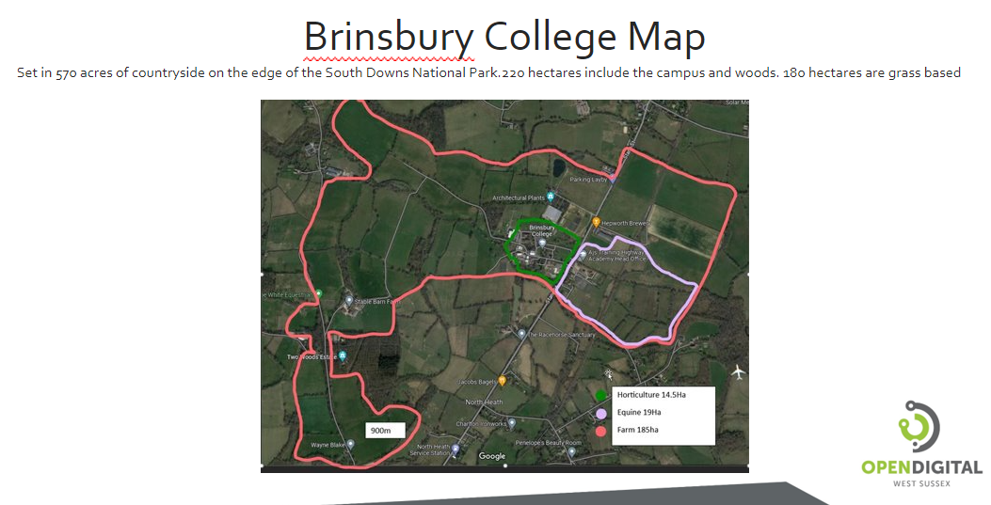

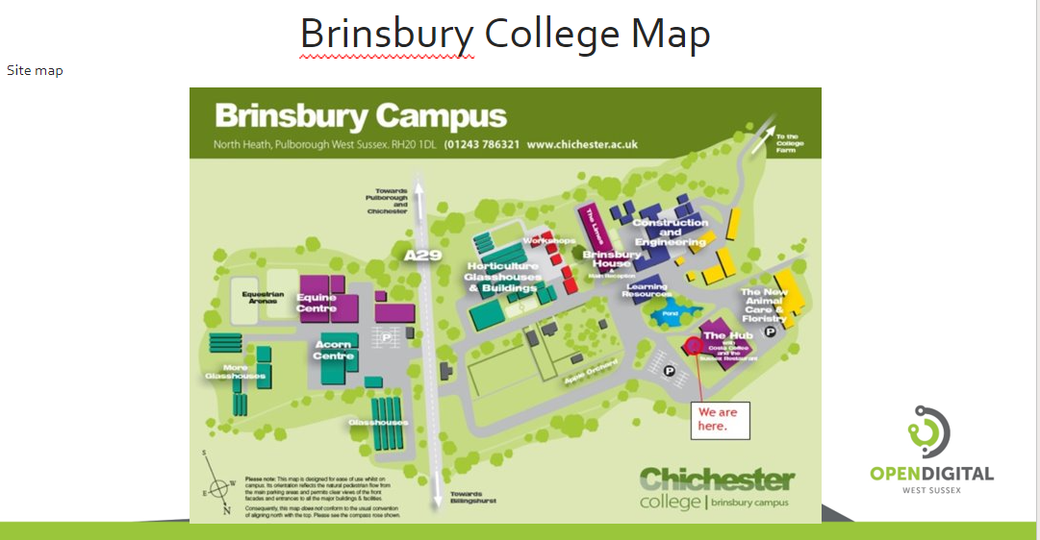

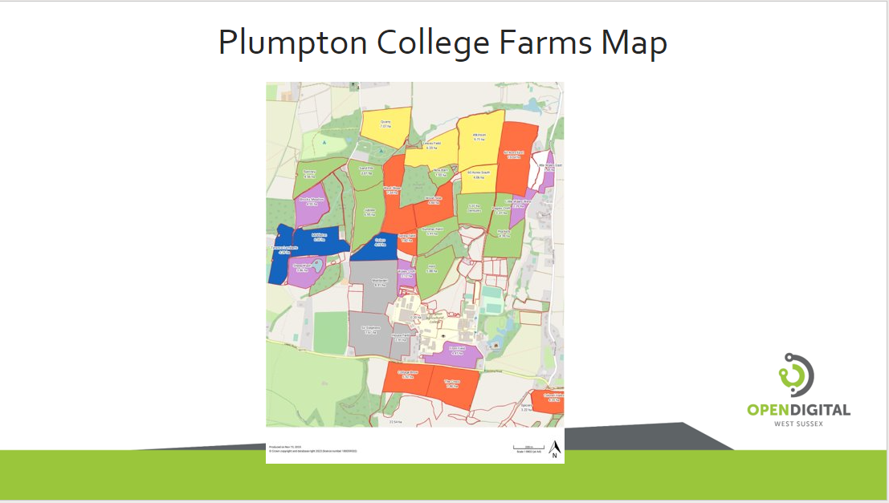

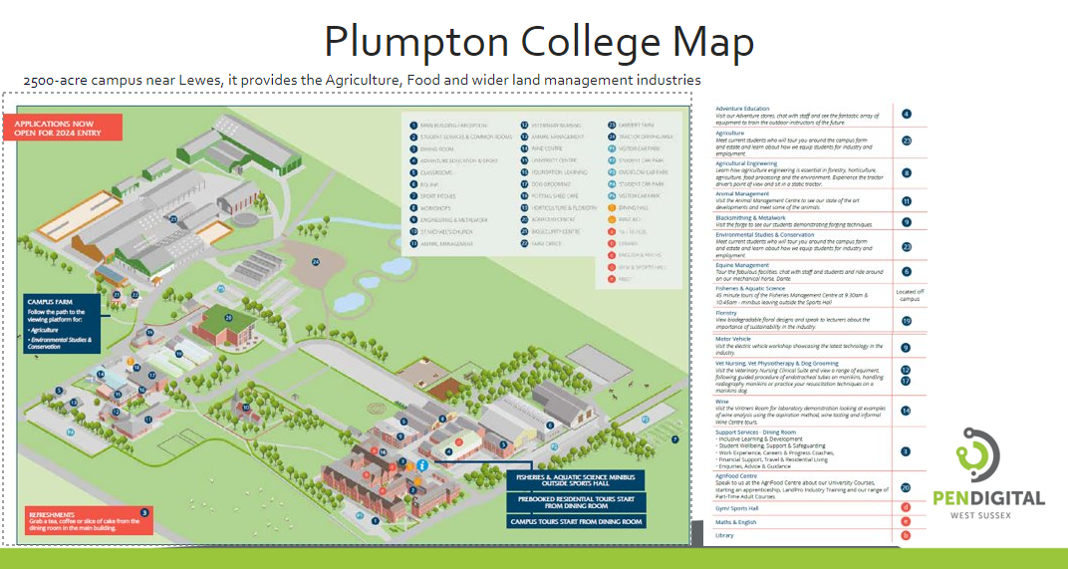

Appendix 2 Growers Site Maps & Nearby Businesses

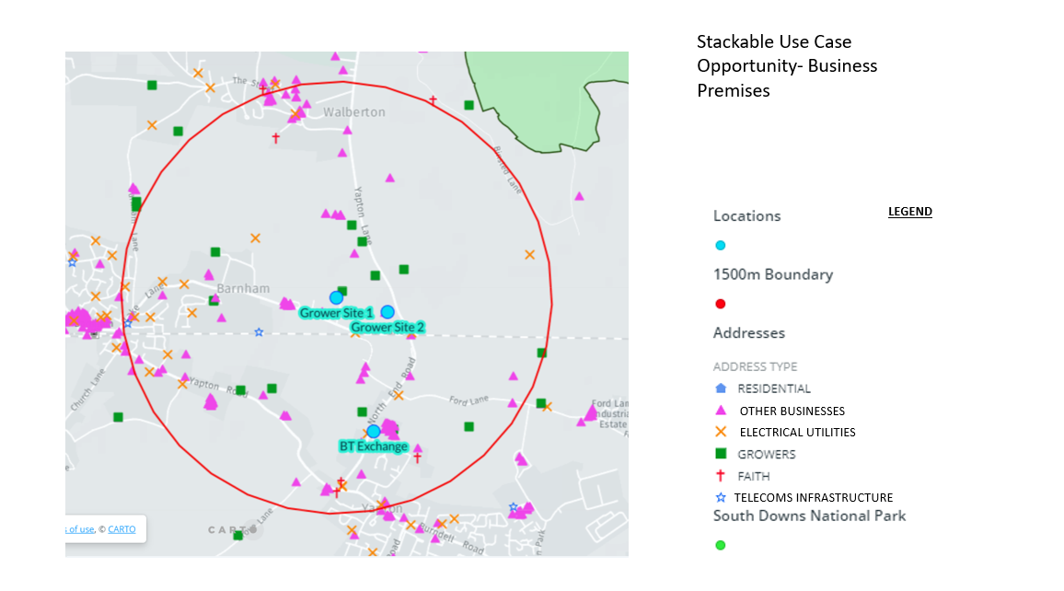
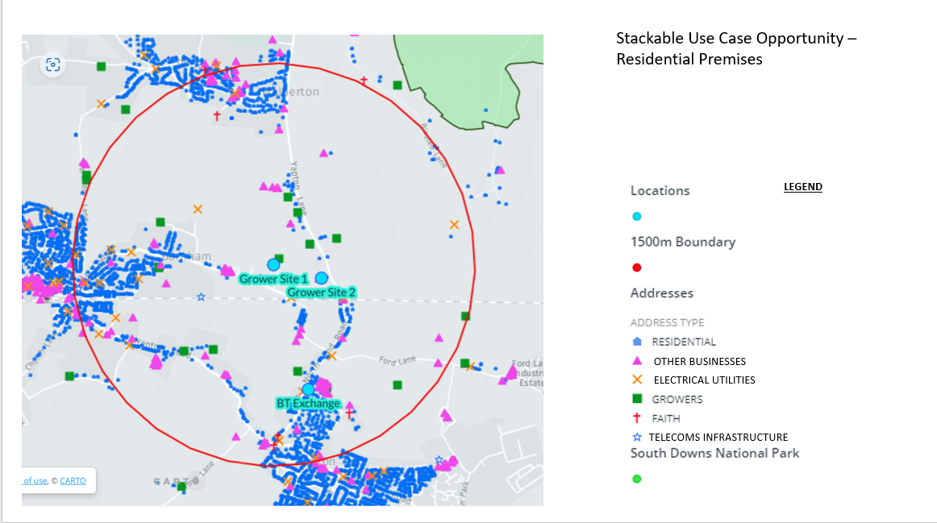

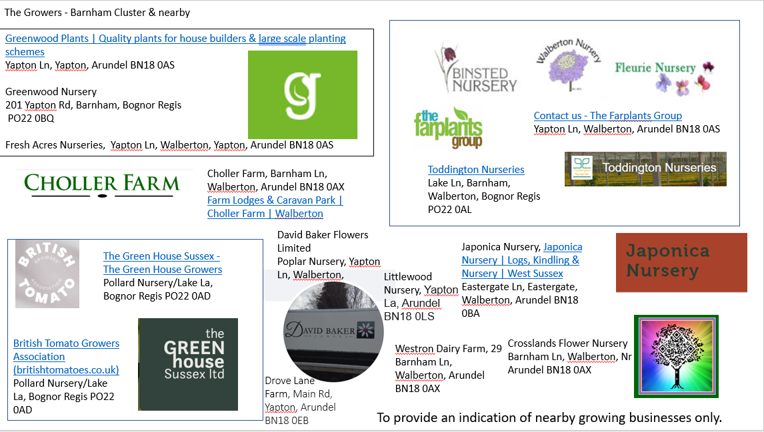

Appendix 3 – Colleges - Fibre Proximity & Exchange Locations
A list of nearby businesses – an indication only.
- AJ’s Training Highways Academy, Croft Works, West Chiltington, Hailsham BN27 3JF http://www.ajstraining.co.uk
- The Racehorse Sanctuary, North Heath, Pulborough RH20 1DJ The Racehorse Sanctuary - Pulborough, West Sussex
- Architectural Plants, Stane St, North Heath, Pulborough RH20 1DJ http://www.architecturalplants.com
- Acorn Training Centre, Unnamed Road, Pulborough RH20 2HR
- Jacobs Bagels, The Old School, Stane St, Pulborough RH20 1DJ, https://www.jacobsbagels.com/
- Charlton Ironworks, North Heath Farm, Gay Street Lane, North Heath, Pulborough RH20 2HW, http://www.charltonwroughtironwork.com/
- Moons Farm, Horse stable, stud farm. Gay St Ln, Pulborough RH20 2HW
- Stable Barn Farm, Dairy Farm, Pulborough RH20 1DD
- Two Woods Estate, Two Woods Estate, Black Gate Ln, Pulborough RH20 1DD, https://www.twowoodsestate.com/
- KB Vet Physio, Blakewood Stables, Beaglejack Barn, Black Gate Ln, Pulborough RH20 1DD, http://www.kbvetphysio.com/
- Joe White Equestrian Centre, Black Gate Ln, Pulborough RH20 1DD,
- Toat Brooks Farm, Pulborough RH20 1DD
- Tullens Fruit Farm, Pickhurst La, Pulborough RH20 1DA
Premises in this area are served by the Pulborough Exchange, located at:
Located at:-
British Telecom,
Telephone Exchange,
Lower Street,
PULBOROUGH.
RH20 2AZ

Network identifier code for the Pulborough exchange is SDPLBRG. Suppliers available at the Exchange are BT Broadband & Mobile, EE Home Broadband, Plusnet, Talk Talk and Sky
Fibre to the Cabinet, Fibre to the Premises services are available to customers connected to the Pulborough exchange. You may have a slow VDSL2/FTTC service available, but ADSL or ADSL2+ services are believed to offer a faster download option in this postcode.
There is FTTP at locations close to the Brinsbury College, which indicates the availability of fibre across the railway line.
For instance, there is FTTP available at some premises within RH20 1DD. Despite the availability of FTTP, the average speed in RH20 1DD in the last 12 months is a download speed of 0.5mbps and upload of 0.2mbps. It could be inferred from this, demand for an improved broad band package in the area.
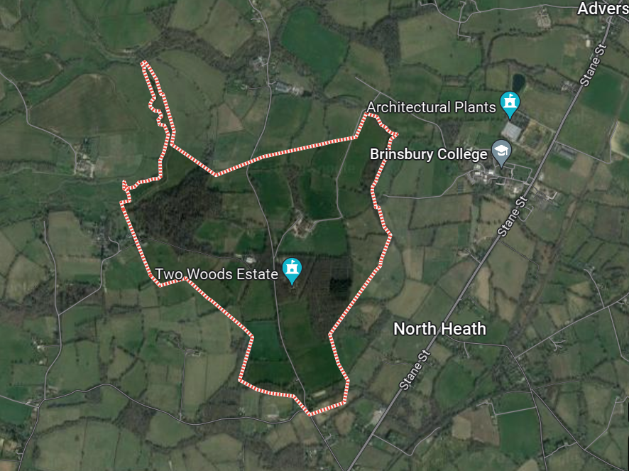
An indicative route from Pulborough Exchange to RH20 1DD is shown below.
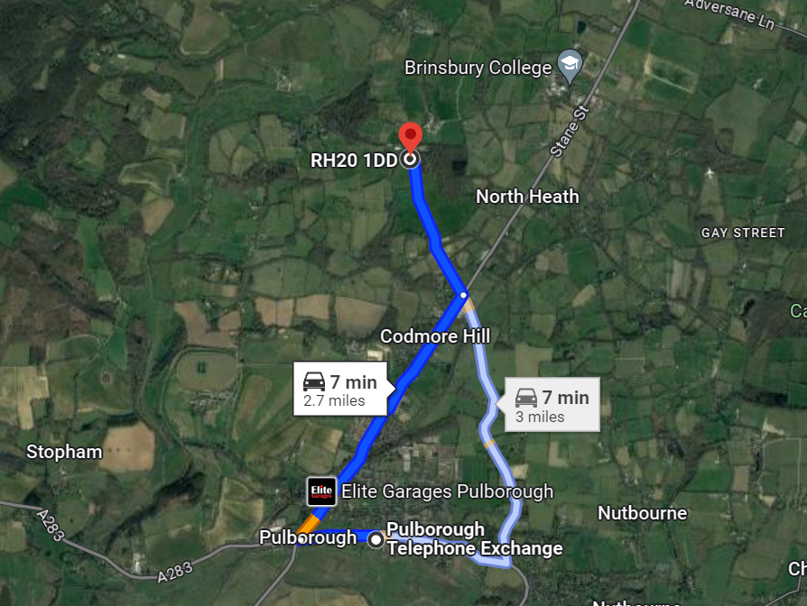

Plumpton College - Fibre Availability & Stackable Use Cases
A list of nearby businesses – an indication only.
- The Link Centre, Sussex Rural Business Centre, Plumpton College, Ditchling Rd, Lewes BN7 3AE, http://www.thelinkcentre.co.uk/
- Plumpton College Wine Centre, Wales Farm Lane, off Ditchling road, Plumpton, Lewes BN7 3AS, http://www.plumpton.ac.uk/department/wine-and-wine-research/21
- Wales Farm, Plumpton, Lewes BN7 3AS, http://www.plumpton.ac.uk/
- AgriFood Centre, Wales Farm Ln, Lewes BN7 3AE, http://www.plumpton.ac.uk/
- The Half Moon Inn, Ditchling Rd, Plumpton, Brighton BN7 3AF, https://www.thehalfmoonplumpton.co.uk/
- G&J Martin Farm, Warningore Farm, Novington Ln, East Chiltington, Lewes BN7 3AT
- Sussex Property Assesors, Mayberry, Plumpton Ln, Lewes BN7 3AH, http://www.sussexpropertyassessors.co.uk
- Tiny Thai Restaurant, Streat, Hassocks BN6 8RS, http://www.tinythai.co.uk/
- Westmeston Parish Hall, Lewes Rd, Westmeston, Hassocks BN6 8RL, https://www.westmeston.org.uk/parish-hall
Premises in this area are served by the Plumpton Exchange, located at:
Located at:-
British Telecom,
Telephone Exchange,
North Barnes Lane,
Plumpton Green,
LEWES.
BN7 3DX
Network identifier code for the Plumpton exchange is SDPLMPT. Fibre to the Cabinet (FTTC) is available.to customers connected to the Plumpton exchange. There does not appear to be any FTTP in this area.
An indicative route from Plumpton Exchange to Plumpton College is shown below.
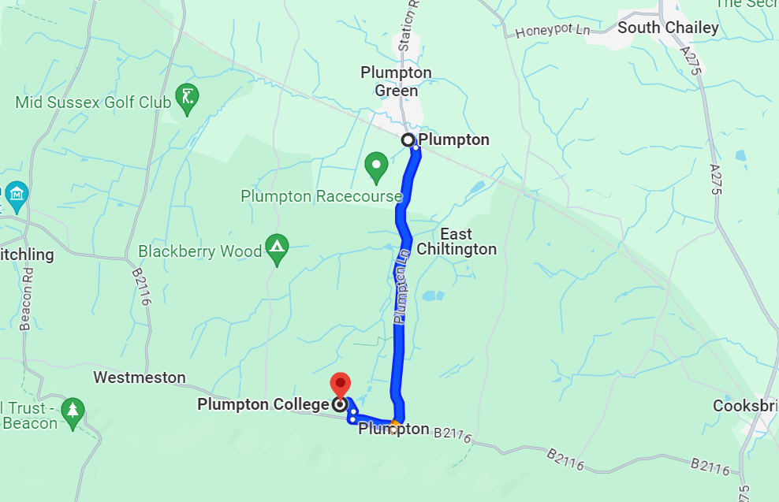

Appendix 4 – Growers - Fibre Proximity & Exchange Location
Premises in this area are served by the Yapton Exchange, located at:
Located at:-
British Telecom,
Telephone Exchange,
Church Lane,
Yapton,
ARUNDEL.
BN18 0EH
Network identifier code for the Yapton exchange is SDYPTN. Fibre to the Cabinet, Fibre to the Premises & Fibre on Demand services are available to customers connected to the Yapton exchange.
There is FTTP at locations close to the Barnham Cluster, which indicates the availability of fibre across the railway line.
For instance, there is FTTP available at some premises within PO22 0AE. Box Broadband FTTP services are available in this postcode. It could be inferred from this that there is fibre provision north of the railway line.
Despite the availability of FTTP, the average speed in PO22 0AE in the last 12 months is a download speed of 2.5mbps and upload of 1.7mbps. It could be inferred from this, demand for an improved broad band package in the area.
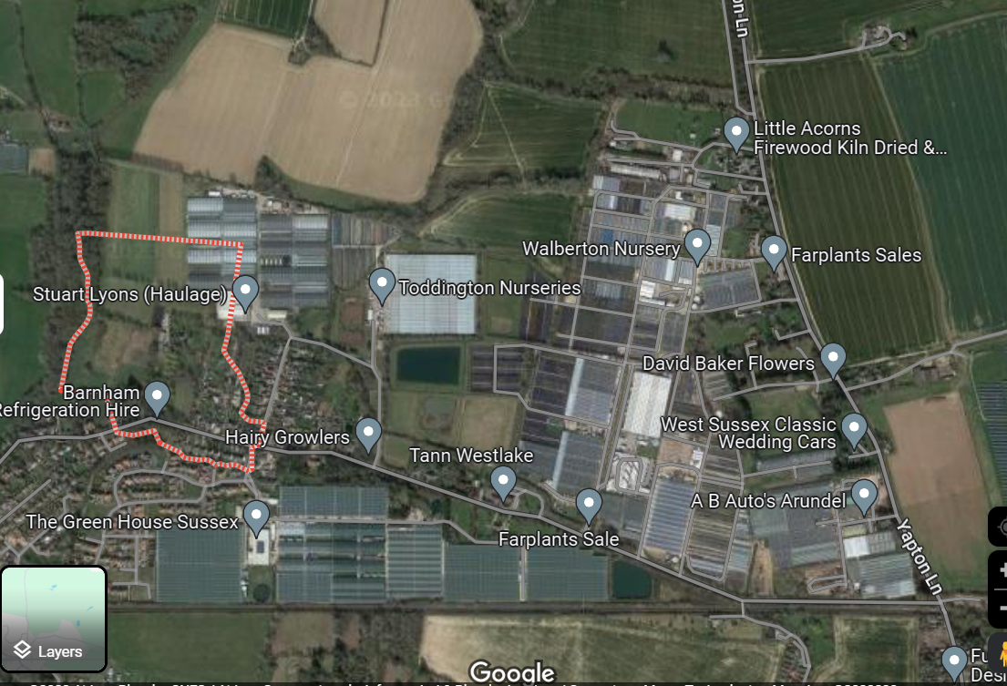
Indicative route maps from the Yapton Exchange to the postcode, show the potential railway crossing.
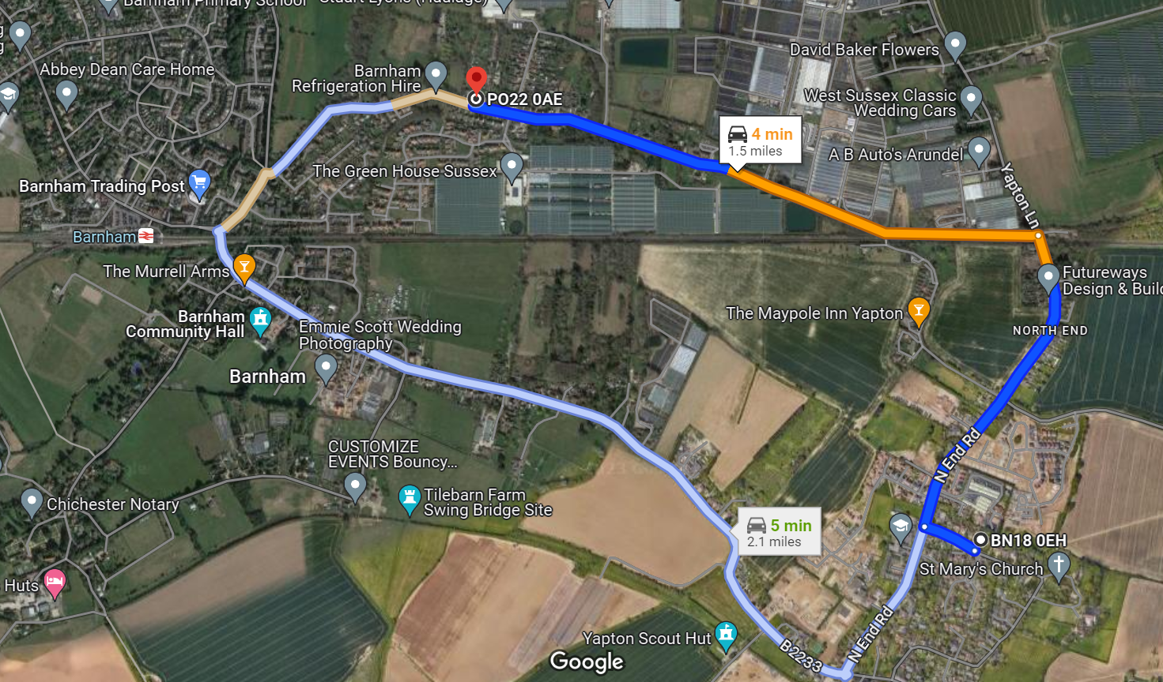
There is also FTTP available at some premises within BN18 0PQ. Box Broadband FTTP services are available in this postcode. It could be inferred from this that there is fibre provision north of the railway line.
Despite the availability of FTTP, the average speed in BN18 0PQ in the last 12 months is a download speed of 11.3mbps and upload of 12.1mbps. It could be inferred from this, demand for an improved broad band package in the area.
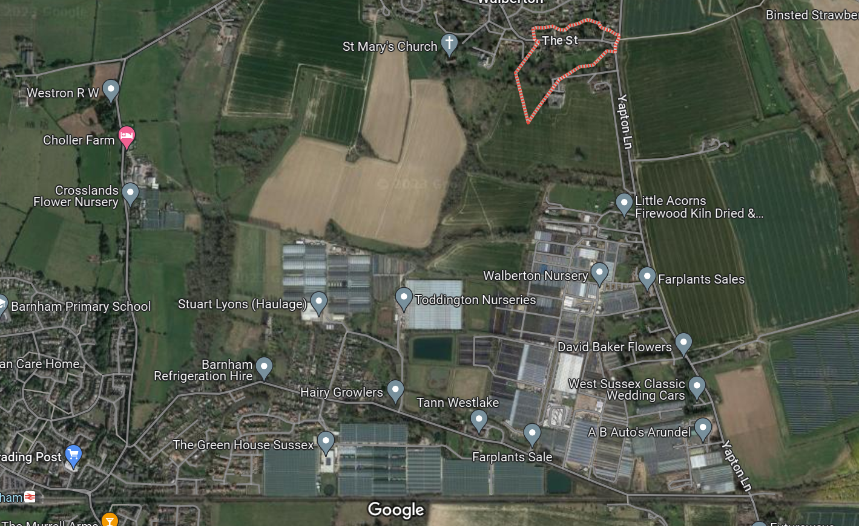

Indicative route maps from the Yapton Exchange to the postcode, show the potential railway crossing.
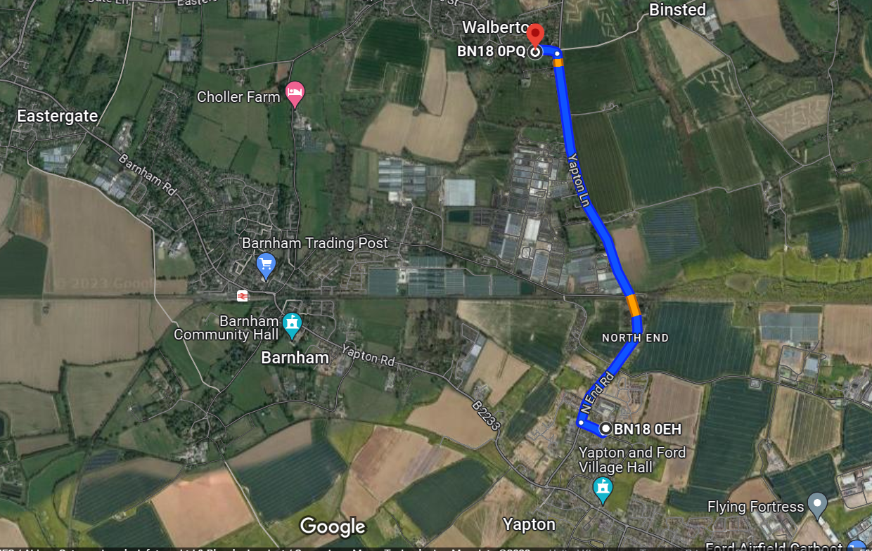

Appendix 5 – Case Studies
User Case ID | Use Case Title | Use Case Description | Device | User | Benefit | Technical Solution
GS5GIR UC 1 | Monitor of climate conditions (outdoor) | Data collection can be used to inform growers of outdoor plants of current weather conditions and potential threats which may affect plant health. Staff can monitor conditions from home, reducing the need to be on site.(e.g. Grapevines are sensitive to freezing temperatures during the growing season; spring frost frequently damages opening buds and young shoots) | Sensor IoT | Brinsbury College  Plumpton College  Nurseries | Air and soil temperature, pH, rainfall and the exposure to UV and solar radiation, can directly improve production practices
GS5GIR UC 2 | Soil Moisture, temperature, nutrients | Growers can understand the soil temperature and moisture levels remotely using real-time date of soil conditions reducing time-consuming tasks such as manual measurements and visual inspections. | Sensor IoT | Brinsbury College  Plumpton College  Nurseries | Optimise farming operations, identify trends and make subtle adjustments to conditions to maximise crop yield and quality
GS5GIR UC 3 | Greenhouse environment (temp and humidity) | Growers utilising a complete monitoring system for their greenhouse will be able to obtain data on plants that need to be watered at the right time and kept at a certain temperature. Staff are not  always around to check the status of plants. A system will enable remote monitoring via an app on a smartphone when away from the greenhouse. | Sensor IoT | Brinsbury College  Plumpton College  Nurseries | Quality Control - Monitor diseases and allows for targeted intervention, automatically adjusting the conditions.  Need for mobile information access -  Plant Specification manual.  Plant, weed, pest identification in the houses, tunnels and fields. | The integration of IoT systems in greenhouses would be augmented by the deployment of advanced 5G technology and Low-Earth Orbit (LEO) constellation broadband internet with low latency and high speeds
GS5GIR UC 4 | Crop Health | Growers and Farmers can remotely access information, have the ability to make data-driven decisions, optimising resources and implement precision agriculture techniques to address issues. | Sensor IoT | Brinsbury College  Plumpton College  Nurseries | Identify potential problems such as pest and diseases that could decimate crops. Field is checked continuously and in real-time without any effort from humans
GS5GIR UC 5 | Animal Health | Cows produce the most milk and the highest quality milk when they are healthy, feel safe, and receive high quality feed. Dairy farmers need sufficient means of monitoring for underlying health issues. From a student point of view, it would be beneficial to have real time data to enable immediate review and share results and discuss. | Sensor IoT | Brinsbury College  Plumpton College | sensors (collar tags) to deliver temperature, health, activity, and nutrition insights on each individual cow as well as collective information about the herd
GS5GIR UC 6 | Livestock monitoring – animal behaviour | Farmers want the ability to monitor their animals anytime, anywhere and also save time and money whilst also increasing control and safety of the animals. Being able to view the cameras on multiple devices can share the responsibility of monitoring the livestock. Need to meet the capability of what the students will experience in real world settings. | Cameras | Brinsbury College  Plumpton College | Animal health and safety.  Financial benefits resulting from reduced animal mortality. Remote monitoring saving time/labour | 4G and Wi-Fi
GS5GIR UC 7 | Security | Monitoring who is where and when on site.  Monitor staff, working procedures, and pupils for safety reasons.  Geolocation of assets. | Cameras | Brinsbury College  Plumpton College | The use of cameras is an effective way to deter criminals. Reduces the theft of farming equipment being stolen, livestock theft, and fuel theft. Criminal now target high-value tractors, quad bikes and other farm vehicles and equipment.
GS5GIR UC 8 | Live streaming where appropriate (Private and Public) | Colleges can develop engaging curriculum-aligned live lessons reaching a wider audience group. Create a window into life on working farms/agriculture/colleges | Cameras | Brinsbury College  Plumpton College | Remote learning. Assist with promotion of college.  Live streaming during lambing season
GS5GIR UC 9 | Greenhouse Monitoring | Use digitisation to create new business offerings | Cameras | Nurseries | Watch It Grow - pictures of product growing  Product provenance tracking, spraying, growth, pick dates etc available to customers.
GS5GIR UC 10 | Crop monitoring using drones | Allows farmers to check crop health, plan fertilisation, assess damaged and map fields at high-resolution. | Drones and Robots | Brinsbury College | Thermal imaging, enabling farmers to pinpoint specific areas on their farms that warrant attention. Helping farmer make informed decisions
GS5GIR UC 11 | Crop monitoring using AI | Produce crops that are less prone to disease and better adapted to weather conditions | AI | Brinsbury College  Plumpton College | Utilises AI analysis to deliver specific and accurate advice and support to help growers and agronomists to grow high quality, profitable crops. Allows staff to focus time on task/areas of concern.
GS5GIR UC 12 | Farm/Viticulture Management Software | Improved connectivity allowing use of existing management software to full potential inside/outside the classroom and in the field. | Software | Brinsbury College  Plumpton College  Nurseries | The use of the platforms enable collection and analysis of data to demonstrate compliance and meet legislative requirements, and support timely management decisions.  (Gatekeeper, Winegrid,Vintrace(helps Plumpton with accreditation, Wintree).  Access to real-time data.  Workforce planning
GS5GIR UC 13 | Data Management Technology | Use data to evidence the results on work to reduce carbon emissions (AOC) and support Red tractor  AFS accreditation  Simplify the IT management and  complexity by using convergent networks  ( Wi Fi, PMR, IoT, PMR)  IoT solution to support crop production,  animal monitoring, and behaviour  analytics | Software | Brinsbury College  Plumpton College  Nurseries | Improving operation efficiencies.  Analysing data and creating skills for digital scientists.
GS5GIR UC 14 | Immersive Learning | Induction week VR experience or access  to the farm remotely (360 camera). Allows mobility impaired/neurodiverse students to access fields/paddocks, who might specialise in data management, but are unable to physically experience farming environment amongst large herds etc. | Virtual Reality Headset | Brinsbury College | Student participation in learning environments which are not accessible to all
GS5GIR UC 15 | Integrated wi-fi and mobile coverage indoors | The teaching experience requires the students to use the college network and the carrier that the college decides to use. Students should not use their own devices. If doing more data driven tasks, they should use the college network. Provides single student account identification/log in and better account security also eliminates current practice of using personal data allowance for learning and/or sharing account log ins |  | Brinsbury College | Providing seamless outdoor/indoor experience
GS5GIR UC 16 | Integrated wi-fi and mobile coverage outdoors | Health and safety are a fundamental requirement, farming remains one of the UK’s most hazardous industries in the UK. Better connectivity will enable communication with the staff working in remote locations. |  | Brinsbury College  Plumpton College  Nurseries | A reduction in injuries and ill health and the resulting financial and personal costs;  better farming practice to help develop a sustainable farming business;  reduced sickness payments and recruitment/training costs for replacement workers;  reduced risk of damage to the reputation of the business
GS5GIR UC 17 | Innovation and collaboration | Space for test and trial activities to take place with universities and industry looking to develop an innovative agritech ecosystem using Robotics, AI & Machine Learning etc |  |  | The University of Brighton has established state of art Robotics and Automation lab. It has the capabilities to accelerating the deployment and uptake of commercial stage game-changing agile robots with artificial intelligence (AI) to find the solutions of some of the serious practical challenges in faced by agriculture and horticulture industry

Farrpoint: West Sussex Horticulture and Communications Infrastructure Report 2023
5G Innovation Regions: closed for applications - GOV.UK (www.gov.uk)

