RAF Centenary Project
CPAD01 Bund Amendment

Introduction

The Royal Air Force Museum has recently undertaken a site redevelopment as part of its programme for the Centenary of the RAF (celebrated in 2018). As part of the redevelopment, the museum created a large bund in front of the main visitor entrance at H1. The Museum wishes to commission works to amend this part of the landscape, creating a footpath through it.

General Information

The Royal Air Force Museum is the National Museum telling the story of the RAF through its people and collections.
It receives Grant-in-Aid from the Ministry of Defence to support the National Collection and is a non-departmental public body audited by the National Audit Office. The RAF Museum is constituted as a charity which employs the Museum staff. It is regulated by the Charities Commission and is governed by a Board of Trustees.
It operates a trading arm, the RAF Museum Enterprises Ltd, through which it raises funds from its commercial operations – principally retail and catering functions.
New activities and capital projects are funded through traditional philanthropic sources, such as the Heritage Lottery Fund, trusts & foundations, grant-making bodies, corporate sponsorship and private individuals.
The Royal Air Force Museum has two sites in the United Kingdom that are open to the public; one in Colindale in North London and one just outside Wolverhampton located next to RAF Cosford.

Both Museum sites are free to enter and contain a world-class collection and display of aircraft, integrated with special exhibitions, films, interactives, artwork, engines, missiles, photographs, medals and uniforms. With research and education facilities, the Museum takes an innovative approach to telling these stories through new exhibitions and interpretation.

The ambition of the Museum is to ensure that the Royal Air Force’s story endures and enriches future generations.

The vision of the RAF Museum is to be a world-leading museum that engages, inspires and connects everyone with the RAF story through the exploration of its people and its collections.

The Royal Air Force has shaped our nation and our society. It has influenced how we live our lives today through its impact on world events, society and technology.

The Museum’s Purpose is to tell the story of the Royal Air Force through its people and collections.

- For our visitors, we make our collections and the RAF story relevant and stimulating
- For current and former RAF personnel and their families, we preserve, honour and share the stories of their service
- For our nation, we help people to understand the impact of the RAF in the world.

The Bund

The Bund was created as one of a series of security measures (bunds, bollards and indirect approaches) that would prevent forced entry into H1 and the rest of the site by an unauthorised vehicle.

Following the opening of our transformed London site, a number of complaints have been received around the lengthy walk from the centre of our site to the car park. This current project has been designed to mitigate this issue and, therefore, improve visitor experience by creating a new route through one of the bunds which lead more directly between the car park and our Hangar 1 entrance.

The new design (see Appendix for drawings) will deliver a new concrete path between Hangar 1 entrance/exit and the visitor car park. The sides will have concrete block bases with a tapered grassed bund on either side. The angle and width of the path, and the installation of bollards at either end have been designed to minimise the security risk of vehicles gaining access at speed to the glazed area of Hangar 1.
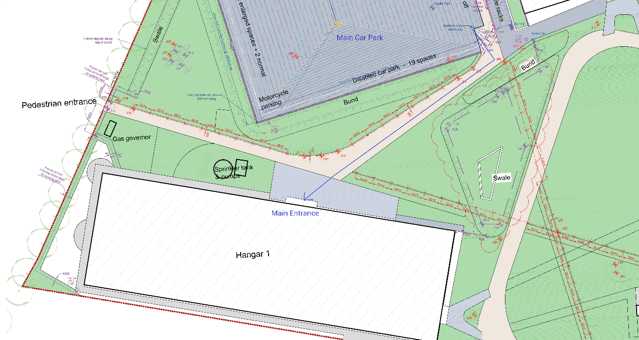
Figure 1. Current visitor flow from car park shown by blue arrow.
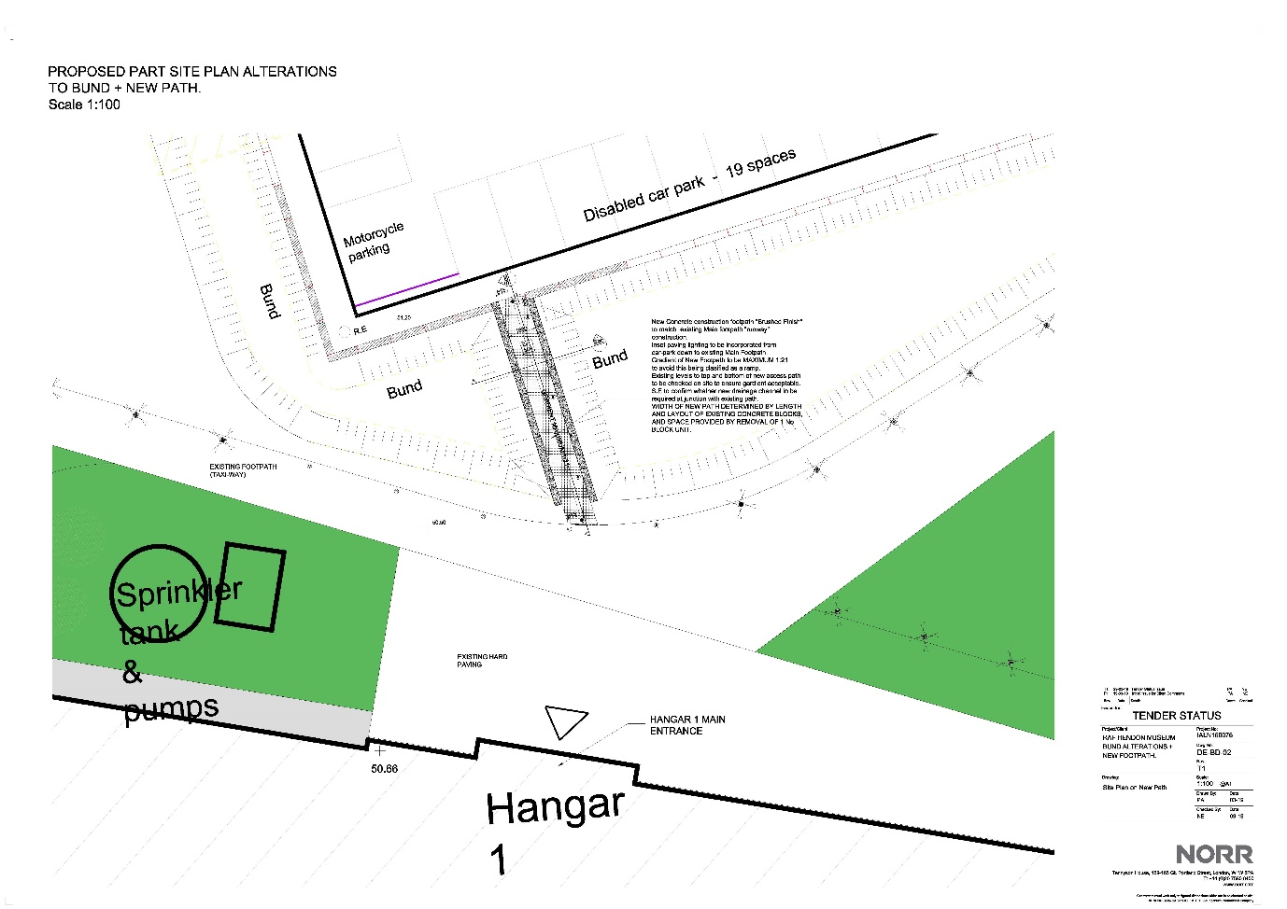

Objectives

- To improve visitor experience at our London site
- To create a more direct route between Hangar 1 entrance/exit and our visitor car park
- To retain the additional level of security provided by the existing bund.

Requirements

- All surfaces, finishes, products and materials must match those that currently make up the existing car park features, bund and pedestrian footpath
- The new bollards must be the same type as those in use nearby. These must be removeable by our front of house team, but not by visitors.

Schedule of Works

The following should be costed in envelope B of the tender submission:
- WAC testing (if necessary, see 15.5)
- Excavation of Bund
- Disposal
- Trim batters to profile
- Concrete barrier blocks
- Footpath Construction
- Damp proof membrane
- Sharp sand base
- Concrete slab
- Concrete foundation
- Isolation joints
- Edging
- Redress batters
- Connect to existing drainage
- Land drain
- ACO channel
- Manholes
- Sump
- SW pipe
- Rodding eye
- Paving lighting
- Power to paving lighting
- Bollards
- Making good

Location

The system will be located at the RAF Museum’s London site, in Colindale.

Access

- The Museum is open to the public 7 days a week; 10am-6pm March - October, and 10am-5pm November – February. Deliveries will be outside those hours
- Construction will take place during museum opening hours. Suitable risk management measures will need to be put in place by the contractor
- Any works that disrupt visitor traffic flow will need to be negotiated with the Museum and may need to be undertaken outside of opening hours.

Constraints

- The Museum’s opening hours (as mentioned in Access)
- The car park will be used by visitors during construction
- The prominent location of the site in relation to the Museum’s main visitor entrance
- The pedestrian path will be used by visitors during construction, though visitors could be diverted (to be discussed)
- Presence of underground services (see Appendix).

Contractor Deliverables

The final output of the brief will be the amendment of the bund as per the tender pack. This is to be delivered through:

- Appropriate surveys of the site and taking detailed dimensions
- Implementation of appropriate risk management measures
- Onsite construction with some activity restrictions during public opening hours

Responsibilities

The appointed individual or company will at all times ensure:

- Compliance with Health & Safety at Work Act (including risk assessments, method statements, and relevant certification) and be able to show proof if required
- Adherence to all legislation and best practice for construction and landscaping.

The appointed contractor will also:

- Provide all equipment necessary to carry out the agreed contract
- Be mindful of the Museum’s visitors and local residents
- Show a willingness to reduce impact on the environment.

Not in Scope

- Any road marking, or signage.
- Laying of new topsoil and re-seeding

Programme

Tenderers are to propose a suitable programme as part of their response, bearing in mind that the Museum would like to begin works whenever possible.

Tender Deliverables

The tender submission should consist of:
- Quality Submission
A maximum of 12 sides A4 featuring:
- Details of experience of successful delivery of two similar projects and references
- Proposed methodology, programme and timescales

- Cost plan

Please refer to Annex C of the Invitation to Tender for full details of the process.

Appendices

The following items are attached separately with the tender information pack.

O&Ms
  - Hangar 1 surroundings services and furniture
  - Car Park Construction Drawing
  - K1947-800--AS BUILT Drains and cable runs car park
  - Appendix K1947-900_C3 Car Park Surfaces
  - 15.5 Appendix LS4286D0MR (RAF Museum - Preliminary Waste Assessment - Land Science)
Design pack
  - RAF Hendon Museum - Proposed Bund alterations + New Footpath -DE-BD-01 Rev T1
  - RAF Hendon Museum - Proposed Bund alterations + New Footpath Site Plan -DE-BD- 02 Rev T1
  - 100 C00034-SWH-ZZ-00-DR-S-0100-T01
  - 102 C00034-SWH-ZZ-00-M2-S-0102-T01
  - 110 C00034-SWH-ZZ-00-M2-S-0110-T01

