Expression of interest

Title: Evaluation of the Early Years Professional Development Programme (EY PDP)
Project reference: 2018/059
Deadline for expressions of interest: 27 June 2019

Summary
Expressions of interest are sought for a contractor, or consortium with lead contractor, to conduct an evaluation of the Department for Education’s Early Years Professional Development Programme (PDP – known formerly as the Professional Development Fund Programme). This programme will support pre-reception early years practitioners to improve their practice in working with children between the ages of 2 and 4, between January 2020 and July 2021, and aims to improve outcomes in language, literacy and numeracy for the children in disadvantaged areas, with an emphasis on improving school readiness.
We are seeking expressions of interest from organisations who can demonstrate the capacity, knowledge, experience and flexibility to conduct a mixed-methodology evaluation of the PDP including a randomised controlled trial of impact on child outcomes, a pre- and post-programme observational evaluation of quality in early years settings, and a process evaluation.
The Department has a budget in the region of £500,000 excluding VAT to conduct this evaluation (with value for money a key consideration).
This expression of interest was posted on 7 June 2019.

Background
Context
Disadvantaged children are behind their peers in language development as early as age two. However, good quality early years provision can benefit children’s later outcomes, suggesting the importance of good quality early years provision for disadvantaged children. Early years setting structural characteristics such as availability of training has been linked to observations of process quality, and evidence suggests that preparatory and in-service training are both associated with increased positive outcomes for children in certain circumstances. The EEF suggest that training existing staff is a more promising way to raise quality than increasing the number of hours children attend or improving the physical environment in settings. Recent evidence shows that investing in focused professional development activity in the early years, to improve skills and practice in the existing workforce, can lead to rapid improvements in setting-level quality, children’s cognitive outcomes in language and numeracy development, and their socio-emotional development.
The Secretary of State has set out his ambition to halve the number of children finishing their Reception year without the early communication and reading skills they need to thrive by 2028. ‘Unlocking talent, fulfilling potential’ set out DfE’s strategic aim to close the ‘word gap’ for disadvantaged children in early years. The approach to implementing this successfully has focused around improving the quality of early years provision in disadvantaged areas through the means of in-service training which is associated with increased positive outomes for children in certain circumstances. Early years settings structural characteristics such as the availability of training has been linked to observations of process quality.

The Early Years Professional Development Programme
The main purpose of the Early Years Professional Development Programme is to support pre-reception early years practitioners (EYPs) to improve their practice in working with children between the ages of 2 and 4. This aims to improve outcomes in language, literacy and numeracy for children in disadvantaged areas, with an emphasis on improving school readiness. The PDP delivery approach consists of:
- DfE grant funding for local authorities (LAs) to convene local partnerships between early years settings, and identify local ‘champions’ who will receive Continued Professional Development (CPD) training and cascade this to early years staff within the local partnerships of approximately 10-15 settings
- DfE procuring a national delivery partner to provide CPD to the ‘champions’ who will then cascade the CPD within their local partnerships.
The PDP will provide a comprehensive and sustained programme of CPD for early years practitioners working in selected pre-reception settings in disadvantaged areas. The key purpose of this is to equip practitioners with the right skills through training in order to improve workforce capability to ensure the 2-4 year olds attending these settings are better prepared for their school reception year. The programme is specifically designed to help address some of the barriers that can make it difficult for early years practioners to access effective CPD. These can include settings not knowing the best CPD to access, and cost pressures that make it difficult for them to purchase training and cover the supply costs to relase staff to attend. Delivering high quality CPD is focused on improving workforce skills in supporting children’s language development, early literacy and numeracy. The champions will be responsible for providing ongoing support and mentoring to the EYPs as part of the CPD programme. The national delivery partner will provide advice and support to the champions as they cascade.
A total of 53 LAs have been selected to receive PDP funding. They were selected based on criteria at LA level which included:
- Having low Early Years Foundation Stage Profile (EYFSP) scores for children eligible for free school meals (FSM),
- Having large gaps between the Good Level of Development and Communication and Language Development scores for FSM and non-FSM eligible children,
- Having high total numbers of FSM children and high % of FSM children in each area;
- Being identified as one of the Government’s Opportunity Areas (if not already included through the preceding metrics).
Each LA will set up between 1 and 4 partnerships of approximately 10-15 settings per partnership. Across these 53 LAs, the PDP will be rolled out to about 400-450 Champions in approximately 112 partnerships (up to 4 champions per partnership), reaching a total of approximately 1,200-1,700 settings and around 60,000 children between January 2020 and July 2021.
All types of early years provision for 2, 3 and 4 year olds are eligible for the PDP. We expect the private, voulntary and independent (PVI) settings to make up the majority of those involved, with maintained settings and childminders also included.
Champions will be trained between January to May 2020. They will cascade CPD to EYPs between April 2020 and May 2021.

Evaluation aims
The aim of this project is to conduct a full evaluation of the PDP, comprising a process evaluation of the delivery model, an evaluation of its impact on the observed quality of EY settings, and a randomised controlled trial of the impact on children’s outcomes.

Methodology
The successful bidder will be responsible for working with the department’s project manager to design and conduct the evaluation. We will, at the tender stage, ask bidders for a full description of their proposed methodogy. The final evaluation design will be subject to agreement between the Department, the PDP delivery partner and the evaluation contractor to ensure it is both robust and deliverable.

Summary
The following aspects of process and impact evaluation will be required:
- Impact evaluation covering the following aspects of impact:
- What is the impact of the PDF on children’s cognitive outcomes?
  - Early receptive and expressive language (required primary objective)
  - Early numeracy (optional secondary objective)
It is essential that the evaluation of impact on children’s outcomes includes a language assessment, and we are also interested in assessing a secondary objective numeracy if this can be delivered at a reasonable cost.
- What is the impact of the PDP on the observed quality of early years settings?
- Process evaluation covering aspects of the delivery model such as:
- Delivery Framework
- Training of “Champions”
- Cascade of training to early years professionals within settings

Feasibility stage
We expect the project to include a feasibility stage, in which the evaluation contractor will be required to work with the Department and the PDP delivery partner to explore the feasibility of implementing their proposed design for evaluating impact on children’s outcomes. The evaluation of impact on children’s outcomes would go ahead only if we are satisfied that it is possible to deliver an evaluation of the required quality within the time and budget parameters of the project. The feasibility stage would also involve finalising the programme’s theory of change and agreeing measures of fidelity.
Process evaluation
A process evaluation will be required to provide evidence on programme delivery, including inputs, outputs, fidelity to the aims of the programme, perceived outcomes, identification of facilitators and challenges/barriers and how they have been addressed. This should cover all elements of the delivery:
A: Delivery framework: how was the delivery framework implemented? What is the level of fidelity to the aims of the programme? What roles were played by the LA, National Delivery Partner and Local Partnerships? Was there consistency in implementation and delivery across different locations?
B: Training the “Champions”: how was the training delivered? What was the level of variation in content, delivery format, duration? Attendance and completion rates. What is the self-reported effect of the training on champions’ knowledge and skills to disseminate this learning?

C: Cascade: How was the cascade implemented? What was the reach and take-up of training among practitioners? Was the cascated training delivered with fidelity? What is the self-reported effect of cascaded training on practitioners’ awareness, knowledge and confidence?

The process evaluation will include both qualitative and quantitative elements. The process evaluation should be integrated with the impact evaluation, for example, to enable secondary analyses of impact based on aspects of delivery.
The qualitative element of the process evaluation should focus on understanding different actors’ roles and experiences of the implementation and the delivery framework and training. For example LA staff involved with setting up the partnerships, representatives of the CPD partner, managerial staff, champions and EY practitioners receiving cascaded training (approx. 60-75 interviews).
The quantitative element of the process evaluation may include:
- Analysis of admin data from LAs and CPD partner.
- Surveys of “champions”.
- Surveys of EY practitioners.

Impact evaluation
Two aspects of impact evaluation will be required, covering the impact on children’s outcomes and the impact on observed quality of EY settings.
Impact on children’s outcomes:
Subject to the feasibility stage outlined above, the evaluation contractor will be required to conduct a randomised controlled trial (RCT) to evaluate the impact of the PDP on children’s outcomes to assess whether there is an improvement for children in PDP settings and whether any improvement is greater than for children in non-PDP settings. The evaluation must include an assesement of impact on early language development, and may include an assessment of impact on early numeracy, using valid and reliable measures. Validated scales such as the British Ability Scales or Preschool Language Scale may be considered.
To facilitate the evaluation design, we anticipate adapting the delivery of the PDP so that in a sample of participating LAs, eligible settings would be randomly assigned to either the PDP or a control group. We currently expect to use a waiting list design, where control group settings would receive the cascaded element of the PDP at a later point in time, however the final approach will be agreed in collaboration beween DfE, the PDP delivery partner and the evaluation contractor.
Impact on quality of early years settings:
In order for children’s developmental outcomes to improve, the PDP must first have a sufficient positive impact on EY practitioners to lead to an increase in setting quality. The evaluation contractor will be required to design an evaluation to measure this interim outcome, for example involving pre- and post-PDP observational evaluations of setting quality, across treatment and control settings, using valid and reliable measures to quantify the impact of the PDP. Observational rating scales such as the Early Childhood Environmental Rating scale extension (ECERS-E) and the Sustained Shared Thinking and Emotional Wellbeing scale (SSTEW) may be considered.

Figure 1: Proposed evaluation and programme activity in intervention and control group settings
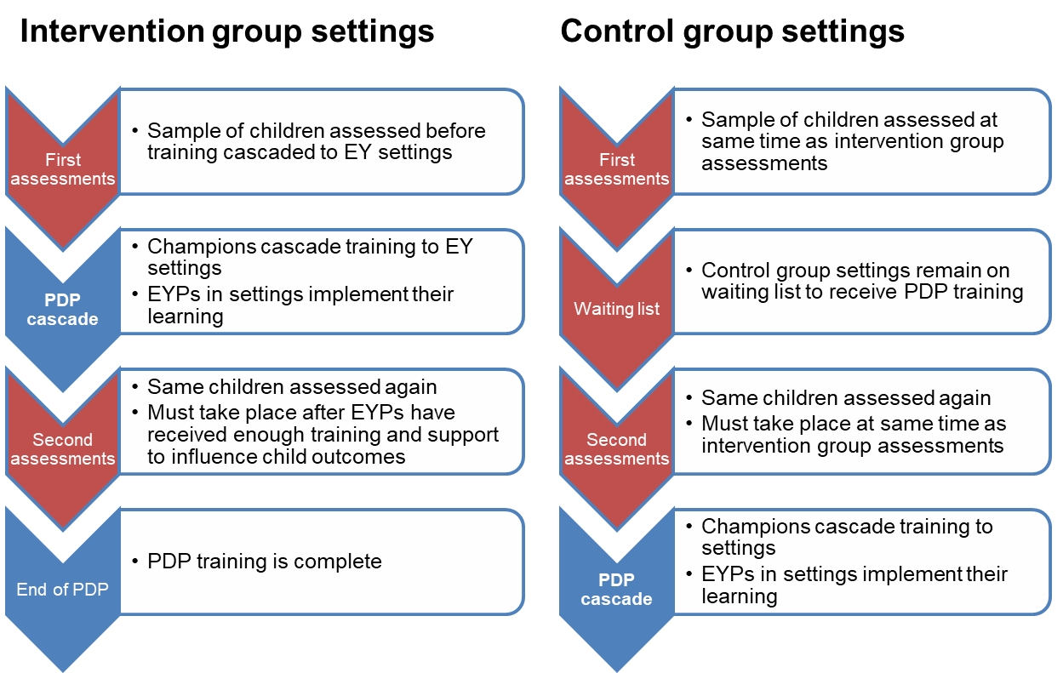

An alternative to the waiting list design would be for the control group settings not to receive the PDP, or to receive an alternative condition or incentive for their participation in the research elements of the project. For example LAs could identify 50 eligible settings, of which 25 are randomly selected to receive the PDP intervention).
Sample size
The evaluation contractor will be required to determine the optimum sample size and to implement strategies to minimise attrition. We anticipate that the minimum sample size required to provide sufficient power to detect impact on child development would be an achieved sample of 1,300 children with both a baseline and follow-up assessment (approximately 650 children, from up to 165 settings, in each arm). Given the number of settings expected per LA, we anticipate this sample to be spread across a subsample of 9 to 12 of the PDP LAs. Note that these figures are indicative and we will seek detailed recommendations on sample design, including sample size, at the tender stage. Note that we assume the children sampled for the impact study will be aged 2 to 3 years at the time the first (baseline) assessments are conducted in order that they are more likely to be attending the same settings at the follow-up time point; intention to treat analysis may be required for any children that change settings during the study.

Data collection
We expect the project to involve:
- face-to-face child assessments before and after the PDP intervention, likely to be carried out within EY settings,
- collection of data to measure factors that are expected to affect childrens outcomes such as demographics, socio-economic status, use of childcare, and the Home Learning Environment. Some data may be available in administrative data and/or from settings, while some direct data collection from parents (or a sample of parents) may also be required.
The follow-up child assessment would be conducted 6 months to a year after commencement of the intervention, subject to the advice of the evaluator and PDP delivery partner. Considerations include allowing sufficient time for the intervention to be delivered and be embedded, as well as pragmatic requirements to ensure the PDP delivery to the waiting list control group is completed within an acceptable time period and that children who were assessed at baseline are likely to still be within the same settings at the follow-up time point. The evaluator would need to implement strategies to minimise attrition between pre- and post-test, and to follow-up children that may be absent on test days, or have moved settings.
Data analysis and linking
Bidders will be required to demonstrate that they have expertise in relevant statistical analysis techniques to measure impact.
At the data collection stage we intend to ensure the relevant permissions are in place to enable data linking between the sampled children and the National Pupil Database, for example to be able to compare the Early Years Foundation Stage Profile (EYFSP) results for the intervention and control groups in future.

Timing
Please find a provisional evaluation timetable below:
- Deadline for EOIs: 5pm on 27 June 2019
- Invitation to Tender Issued: w/c 8 July 2019
- Deadline for ITT submission: w/c 5 August 2019
- Tender panel interviews, if required: w/c 16 September
- Contract awarded: w/c 23 September
- Interim reporting (impact evaluation): late summer 2021
- Final reporting: December 2021
We will require regular progress reporting throughout the project and interim reporting (e.g. on the process evaluation) at milestones to be agreed.

Assessment criteria
Expressions of interest will be assessed against the following criteria.
To proceed to the invitation to tender (ITT) stage, bidders are required to provide specific evidence that they have the required experience and expertise.

Project management, organisational capacity and risk management
- Organisational capacity, effective project management skills and experience of implementing a policy evaluation of this scope and complexity, meeting quality requirements within specified time constraints. Clear identification of risks and contingencies. Evidence of successfully working in partnership with delivery organisations and responding flexibly to changes to policies and programmes affecting evaluation design/implementation. Evidence of organisational procedures for ethics and safeguarding.

Technical expertise in evaluation methodology and analysis
- Proven technical expertise in mixed-methods evaluation design and analysis relevant to the project, including RCT design and process evaluation, sampling, research instrument design, choice of assessment tools, qualitative and statistical analysis, and ability to report the results clearly, accessibly and accurately to a range of stakeholders.

Experience conducting relevant research with similar respondent groups
- A record of success in conducting direct assessments of pre-school children; using observational rating scales to assess early years settings; and of carrying out research with local authorities, early years providers/practitioners, and parents of young children. Examples of previous projects securing high response rates and minimising attrition, particularly from harder-to-reach respondent groups.

Subject knowledge relevant to the project
- Sufficient knowledge and understanding of current policies, trends and issues in the early years sector to inform the design, implementation and reporting of the project (including professional development for early years practitioners; child development; disadvantage/deprivation).

Each criterion has equal weighting. Evidence against each of these criteria will be scored using the following scale:

0. Totally fails to meet the requirement
1. Meets some of the requirement, with limited supporting information
2. Meets some of the requirement, with reasonable explanation
3. Fully meets the requirement, with detailed explanation/evidence in support
4. Exceeds the requirement, with detailed explanation/ evidence in support.
Expressions of interest that score below 2 on any criteria will not proceed to the ITT stage.

Content, structure and length of EOI
In your EOI, please include a short summary of what you see as the main considerations for the successful design and implementation of this evaluation, including any risks and possible mitigations. The rest of the EOI may be structured according to the above assessment criteria.
Expressions of interests submitted must be no more than 2,500 words overall. Please note anything longer will be disregarded. We will not consider attachments or follow hyperlinks within proposals.

Closing date for EOIs: 5pm on 27 June 2019
Send your EOI form to: frances.forsyth@education.gov.uk (please email a Microsoft Word compatible copy of your completed EOI)

How to submit an expressions of interest
You must submit an expression of interest (EOI) in order to be considered to be invited to tender. To do so, please complete the NEW EOI Form which can be found under attachments. A submission of an EOI does not guarantee an invitation to tender and the Department does not routinely advise organisations that they have not been successful in being invited to tender. Feedback is however available on request.
All contracts are let on the basis of the Department’s Terms and Conditions. You are encouraged to check these before submitting your expression of interest, as these form part of your contractual obligations.

© Crown copyright 2019

https://www.gov.uk/government/publications/study-of-early-education-and-development-survey-of-families
https://assets.publishing.service.gov.uk/government/uploads/system/uploads/attachment_data/file/351496/RR354_-_Students__educational_and_developmental_outcomes_at_age_16.pdf
Melhuish & Gardiner (2017) Study of Early Education and Development (SEED): Study of Quality of Early Years Provision in England
Bonetti & Brown, EPI (2018) Structural elements of quality early years provision: A review of the evidence
EEF Early Years Evidence Summary
NSW Dept. of Education (2018), Fostering Effective Early Learning Study
“Setting” means any site of registered childcare provision for 2- , 3- and 4 year olds. The focus of the PDP will be on private, voulntary and independent (PVI) provision, with maintained settings and childminders also included.

