NML Waterfront Masterplan Questions & Answers

Q - The NML Waterfront Masterplan Tender Specification document states that the maximum fee is £80,000 (page 13), is this including or excluding VAT and expenses?
A - The maximum fee of £80,000 is exclusive of VAT, but must include all expenses.
Please refer to page 9 of the tender document:
2.11 Responding to the Tender
In responding to this tender, the bidder you specifically agrees to the following:
Having examined all parts of the tender that the supply of the Goods and/or Services to NML will be at the rates/prices as provided. All prices must be quoted on the basis indicated in the accompanying documents, except where the bidder proposes alternative priced procedures, and should exclude VAT. Discounts for prompt payment should be stated. The basis of the price shall be inclusive of all costs and delivery to NML.

Q- Could you please confirm if we are required to supply two or three references?
A - It should be three references

Q - Company Details
e) The proportion of the total business accounted for by the proposed services
Could you please clarify this question.
Are you requiring a percentage of the services being carried out? i.e. how much of the structural work are you to carry out – which could be 100%?
Or are you requiring the monetary value?
A - it is the monetary value of this contract versus your total
Q - Item 4.7.2, Form of Agreement, notes that the winning bidder shall be appointed using the NML Contract, and that a copy of this form of contract is to be issued under a separate cover. Would you be able to issue out a draft of this form of contract for consideration?
A - The draft Service Agreement is with our legal advisors and will be issued in due course.

Q - After reviewing the H&S assessment it appears to be written for a general works contractor rather than design consultants. Is there an alternative H&S form, or is this standard across all NML appointments?
A - The H&S form is standard across NML appointments.

Q - Item 3.3 – Project Stage 2 - states ‘analysis of current condition and use of NML waterfront buildings …. Public realm and location of utilities’. Is the NML expecting a full underground utilities survey across the entire site? Or to identify the current surface termination points of these utilities? The former will attract a higher cost from the relevant companies.
A - No the utilities review would simply be usage and the location of surface termination, so as to inform options for improvements.

Q - Could you elaborate on which disciplines you envisage we need to include in our multidisciplinary team? Do we need to include a business planning consultant?
A - See Sections 1.2, 1.3, 1.4 and project programme in section 3.3 of the tender document.
“The aim of the project is to analyse what makes a successful visitor attraction, the opportunities offered by the site and existing venues, and to use the conclusions to drive development. As such, the consultancy team may not necessarily be architect led however, they must posses the broad range of skills to address the brief. Expertise is required in the design of hospitality, retail, exhibition, events, work and play spaces.”
“The masterplan must be costed and sustainable, with a focus on visitor experience/ public offer and commercial opportunities within NML waterfront buildings and public spaces.”
“We need to examine the site to devise the best plan for developments to improve visitor experience and engagement; sustainability; display of collections; wayfinding and public realm; educational and curatorial requirements; and commercial activities. The masterplanning project will steer developments and aid us in delivering our strategic aims over the next ten years.”
We have left this up to the Bidder to assemble the team they feel can address the requirements of the brief. However, the investigation and shaping of information to compose funding bids and future outline business case is expected.

Q - 4.3.4 stipulates we need to provide two referees, 4.9 requires three – please can you clarify?
A - Apologies, this is a typo and it should state three.

Q - Section 4.3.3 refers to ‘Product name / version’ in relation to proposed sub-contractors; could you please explain what is meant by this?
A - This is a standard NML tender template, this requirement may not be relevant to this project. However, if proposing the provision of specialist technical services or methods you may refer to software etc here.

Q - We are required to acknowledge the NML Procurement Protocol form. Is there an acknowledgment form for this or will a simple statement suffice?
A - Appendix E is the document that needs to be signed and returned.

Q - Given the requirement to supply insurances, 3 years’ accounts, response to quality questions etc, I envisage our response will comprise at least three emails if we are to adhere to the 8Mb limit. I trust this is acceptable? Alternatively we could send a link to our submission documents via we Transfer?
A - Multiple emails is acceptable.

Q - Item 4.9 on Page 18 of the Tender Specification refers to a Pricing Document, but I cannot find this included anywhere. Is there a template to be completed, or should we create our own pricing document?
A - We require you to send a pricing breakdown back to us

Q - Appendix D (H&S Questionnaire) is for Contractors. Are we required to complete this as part of our tender submission?
A - Yes please

Q - Item 4.5 on Page 17 of the Tender Specification refers to an NML Procurement Protocal Supplier Agreement. I have downloaded Appendix E (NML Procurement Protocol), but cannot see what needs to be completed/signed by us.
A - The document has been updated on Contracts Finder to include the signature page

Q - Could the client please clarify what measured survey information is available for each of the buildings and external areas in Study Areas 1 to 5?
If no information is available then could the client please identify if any further budget is available to undertake these surveys as and when required?
A - Yes the buildings and external areas in Study Areas 1 to 5 have been surveyed. We have detailed information available, which will be shared with the winning bidder on appointment.

Q - Are there any page restrictions on any sections?
A - No page restrictions

Q - Is there meant to be a form for 4.3.1 Company Details or we just to list answers to company details?
A - Just list answers please

Q - Could you confirm whether records of the annual energy consumption for the Maritime Museum will be made available to the successful tenderer.
A - Yes we have energy consumption records which will be made available to the successful bidder.

Q - The tender documents state that you are wishing to commission a team of multi-disciplinary consultants. Is there a list of required disciplines available or should the bidder decide upon whom to include in their proposal?
A - The bidder should decide on their proposed team and which skills they intend to bring to the project.

Q - Please could you confirm who will undertake the role of Principal Designer (in relation to the CDM regulations)? Will the client be undertaking this role, or should the bidding teams include for this within their scope and costs?
A - The team will be required to provide design briefs rather than any actual designs therefore the role of Principal Designer will not be required in this instance.

Q - Can NML confirm that the cost of any survey work, that may need to be commissioned as part of the review of the fabric of the existing buildings, is to be excluded from the tender pricing?
A - We have survey information regarding the current M&E infrastructure and will be provided on appointment of the winning bidder. This information includes location, condition, and utility costs.
The tender pricing is to include any other proposed studies to be undertaken.

Q - Could you confirm that there is no requirement for public consultation at this stage of the project?
A - Internal and external stakeholder consultation is necessary throughout the project. NML will undertake public consultation further in time once the development options have been defined by the master planning process.

Q - Do you require a Cost Consultant to be part of the multidisciplinary team? Our experience is that this relationship is more frequently, and appropriately, a direct appointment to our clients.
A - We are looking for indicative costs for the developments and therefore a cost consultant would be beneficial to your team. The lead consultant is to appoint all consultants to make up their team.

Q - Will you require a planning consultant as part of the team or will this input be provided directly by NML or via direct consultation with the local authority planning team?
A - We have left team composition open to the bidding teams to propose.

Q - Is detailed CAD survey information available for the site and the individual buildings in the project that will be made available for use by the team?
A - Yes we have site plans and survey information which will be made available on appointment of the winning bidder.

Q - Can you confirm the current floor area of the Maritime Museum, whether you foresee a refurbishment only or refurbishment and extension project being required? Is there any estimate of the likely construction budget for this element of the brief available?
A - Floor area of the Merseyside Maritime Museum is:
Area m2 | 1,490 – Basement  1,285 – Ground  601 – Mezzanine over ground  1,575 – First  1,731 – Second  1,723 – Third  1,803 – Fourth  Total = 10,235 m2
Refurbishment only no extension. No estimated budget, we are looking for indicative costs from the design brief and master planning project. Once options and indicative costings have been defined, we can seek funding for the design and construction.

Q - It is requested, page 12 project stage 4 item, for the team to develop the business plan and financial models. Is this correct?
A - NML will need to develop a business case for fundraising purposes, therefore the team will be required to assist with providing the information to inform the business case for development.

Q - You ask under 4.3.1, i) for certifications and last audits, giving ISO certification as an example (e.g). Can you confirm that ISO certification is not mandatory and that other, aligned management systems will be appropriate?
A - Other appropriate management systems would be acceptable.

Q - Can you confirm that you do not foresee any public consultations being undertaken as part of this appointment phase?
A - Internal and external stakeholder consultation is necessary throughout the project. NML will undertake public consultation further in time once the development options have been defined by the master planning process.

Q - p. 6. Reference is made to ‘analyse what makes a successful visitor attraction’. Does that mean that international benchmarking of equivalent sites and attractions should be considered part of the scope?
A - This could be considered part of the scope to help inform proposals for improvements, and understand how the site could be better utilized.

Q - p. 6 Reference is made to a master plan that ‘must be costed and sustainable’. Has an overall capital budget been established at this point? And what level of costing is expected as part of the master plan? Should we include a QS on our team for instance, or rely on our basic knowledge of industry standards and benchmarks for our costing estimates.
A - Capital budget has been secured for the master-planning process only. We will need to undertake the master-planning process to decide options for what to do with the site, and ascertain indicative costs of undertaking the development works. Once we have indicative costs we will seek funding to undertake the proposed works. Therefore a QS would be beneficial to your team.

Q - p.6 Reference is made to ‘a focus on visitor experience/ public offer and commercial opportunities’. Does that mean the master plan is mainly focused on the public realm/ exterior spaces rather than interiors of the museums? And does this mean it is mainly focused on public, non-exhibition experiences rather than exhibitions (other than the interpretation of the docks mentioned in the brief)?
A - The master plan aims are to improve the site as a whole, by looking at the five study areas and developing plans for phased improvements/refurbishment throughout the buildings and external areas.

Q - p. 6. Reference is made to RIBA stage 2 for the Merseyside Maritime Museum, whereas the rest of the master plan is RIBA Stage 1. Could you explain why that one area should be studied in greater detail. Is that because the thinking for Merseyside Maritime Museum, is more advanced than the other areas, or there is a need to move that part of the project forward faster, or some other reason.
A - The Merseyside Maritime Museum requires greater review as it was redeveloped in the 1980’s and has undergone little work since. The M&E infrastructure is in need of updating, and there are issues surrounding the building layout and usage.

Q - p. 11 In phase 2, reference is made to ‘ Ascertain planning and heritage considerations. Confirm condition and capacity of existing engineering systems, future viability of current installation and recommendations for replacement or upgrades.’ Are there existing studies related to the heritage conditions and the engineering/ utilities on the site that this master plan study can build upon?
A - Yes we have survey information regarding location, capacity and condition of current M&E infrastructure which may be built upon. There is also information available regarding heritage conditions.

Q -p. 12 in phase 3 reference is made to ‘Produce visualisation of what site could look like’. Is it possible to further define the purpose and need for visualization, either in terms of types of views (birds-eye versus visitor-point-of-view, quantity, method (hand-drawn versus computer generated).
A - Visualisation is required for fundraising purposes, we will need to demonstrate what the site could look like. However, we do not expect detailed designs by any means. Computer generated visitor-point-of-view images would be ample for fundraising purposes.

Q - p. 18 do you require two or three references, at one point two is mentioned, at another three.
A - Apologies this is a typo and it should state three references.

Q - Does NML have an audience segmentation model that goes beyond market categories, is there a visitor learning model?
A - We undertake visitor surveys in all museums which detail the market categories. We are awaiting clarification regarding this enquiry and will update accordingly.

Q - What information is held around the movement of visitors. Eg. Tracking study
A - The survey information we have is related to visitors numbers and demographics for each museum. We have not undertaken any tracking studies in the external areas.

Q - Could we get the exact route of the continuous pedestrian bridge of the dock, where it lies and which path it takes, with all the connection points?
A - Further detail to be provided on appointment of winning bidder.

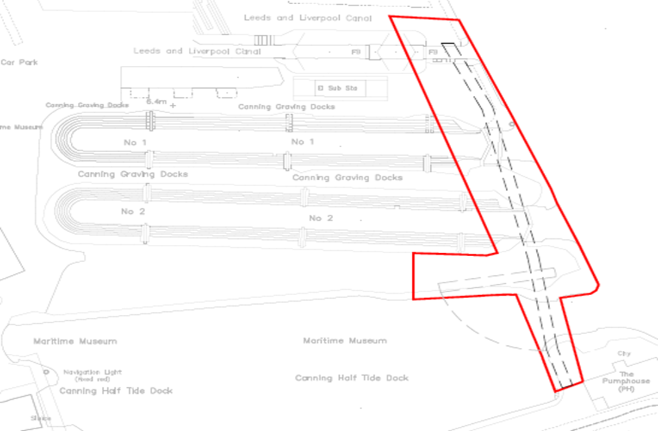

Q - We understand the Albert Dock Welcome Centre has received planning permission. Could we see the initial ideas / visualisations, and any supporting briefing documents that illustrate its functions?
A - Yes this will be made available to the winning bidder on appointment.

Q - Who is the Client team / reference people, with their responsibilities, for the masterplanning project, including SRO / Project Sponsor, ie ultimate sign off person
A - This information will be provided on appointment.

Q - What is the sign-off process on the Client side for each phase?
A - On appointment we will agree detailed scope, outputs, objectives, and production schedules with the sign-off process for each stage.

Q - You mention stakeholder consultations happening in Stage 3 – could you give an indication of how many people are expected to be involved internally?
A - Around 15 NML staff/ trustees

Q - We have not received the Tender Appendices, apart from Appendix B. Could we get these please?
A - Appendices can be found with the Tender document on Contracts Finder
https://www.contractsfinder.service.gov.uk/Notice/fcab4e72-2f83-4d39-bf00-6a0cd7658787?p=@FQxUlRRPT0=NjJNT08=U

Q - Do you have video conferencing facilities available for meetings when prudent?
A - We can partake in skype calls but do not have video conferencing facilities.

Q - Could you qualify what is meant by ‘Development of exhibition space’ on p 31 of the brief(relating to alterations to the MOL). We are trying to ascertain the scale of design work that you may be seeking.
A - NML need to review the current exhibition spaces in MoL and how to make better use of the space available. We are seeking design briefs for each of the five study areas.
MoL is the newest museum and therefore requires minimal alterations.
Internal consultation is required to ascertain long term plans in terms of temporary and permanent exhibition requirements in MoL.

Q - Will interpretative input required to inform the development of RIBA Stage 2 plans for the exhibition needs at the Maritime Museum be provided by the NML team?
A - Yes full stakeholder consultation is necessary through out the project to ascertain what are the educational, curatorial, commercial, visitor experience requirements.

Q - Must the work stages (as set out on pages 11-12) be followed exactly, or are you open to an alternative work plan if we can demonstrate effectiveness?
A - No the bidder may propose alternative work plan if you can demonstrate effectiveness

