Tender Specification

NORTH EAST ACCESS TO FINANCE LIMITED (NEA2F)

DEVELOPMENT OF A DATABASE FOR THE MONITORING, REPORTING AND TRACKING OF INVESTMENTS MADE FROM THE NORTH EAST FUND

Tender Reference: NEA2F/032

November 2016

3rd Floor, Baltimore House
Abbots Hill
Gateshead NE8 3DF

CONTENTS

Section |  | Page
1 | Introduction | 3
2 | Background | 4
3 | Specification of Requirements | 5
4 | Contractual Arrangements | 11
5 | Tender Submissions | 12
6 | Award Criteria | 13
 | Appendix 1 – Product Funds | 14
 | Appendix 2 – Group Structure | 16
 | Appendix 3 – Screenshots of current database | 17

- INTRODUCTION

  - The Invitation to Tender
The Contracting Authority for the purpose of this Invitation to Tender is North East Access to Finance (NEA2F) (CRN: 07000338) whose registered office is 3rd Floor Baltimore House, Abbots Hill, Gateshead NE8 3DF.

The purpose of this Invitation to Tender is to develop a database for the monitoring and reporting of venture capital investments. The database should provide for multiple users and will provide facilities for data capture, standardised and bespoke reporting and the collation of output data such as jobs created within a wide portfolio of SMEs.

The database will support a publicly-backed venture capital holding fund which will operate across the North East Local Enterprise Partnership area of England to be known as “The North East Fund”. It will be a successor to the Finance for Business North East fund (see www.northeastfinance.org), which was established in 2010 as part of the EU / European Investment Fund’s Joint European Resources for Micro to medium Enterprises (JEREMIE) initiative.

Ownership of the database and any intellectual property rights will be vested in the Implementing Body (detailed below), on whose behalf this contract is being procured.

  - Enquiries
Any questions or queries relating to this tender should be directed to David Malston by email at david.malston@northeastfinance.org.

  - ERDF funding
Bidders should note that the project to which this tender relates is part-funded by the European Regional Development Fund 2014-2020 Programme.

2. BACKGROUND

  - Fund of Funds
The North East Fund will be a £120m Fund of Funds, capitalised with contributions from the European Regional Development Fund 2014-2020 Programme, together with returns generated from previous UK Government and ERDF-backed venture capital funds and loan finance from the European Investment Bank.

The Implementing Body (similar to the Holding Fund Manager in the current JEREMIE programme) is expected to invest in a number of new venture capital and loan funds which are likely to be structured as Limited Partnerships. Each of these will be managed by independent, FCA-authorised fund management companies, appointed through a competitive public procurement process which is now under way.

Within this model, five individual funds will be established catering for both debt and equity requirements, and different types and scales of businesses. These will be invested over a five-year period commencing in Quarter 1 of 2017.

  - Delivery Vehicles
The Implementing Body (‘IB’) for the North East Fund will have responsibility for investing £120m in different product funds, establishing the product fund vehicles through which to invest, procuring fund management services in relation to individual product funds, monitoring the performance of those Fund Managers and the individual funds and reporting to the funders in relation to the performance of the funds. The process of establishing the IB as a legal entity and populate it with appropriate resource and expertise is under way.

Individual Fund Managers will be appointed to manage each of the product funds within the North East Fund structure.

3. SPECIFICATION OF REQUIREMENTS

  - Summary of requirements
We need the Implementing Body and the individual Fund Managers to have access to a centralised database. The main aim of this database is to allow for all related outputs from the project to be held in one central point and to ensure adequate monitoring to be performed.

This database will be used to collate a range of information that both the IB and the Fund Managers require in addition to internal data and reporting requirements of all parties.

The current JEREMIE holding fund has operated a bespoke database. However, the new North East Fund would like the new system to be built on a mainstream platform such as a Microsoft application. It is not necessary for any information held on the current JEREMIE system to be copied over to the new system, as they will operate independently.

  - Objectives
The database needs to be capable of running on different operating systems, PCs, laptops and tablets, with remote access by a wide range of users. We need:
- A safe, secure system that can be regularly backed up to prevent lost/corruption of data.
- Ability to capture a wide range of data from SMEs and PFMs.
- Comprehensive reporting facilities to state key deliverables/outputs.

The database will need to be designed to allow for the following objectives to be met:

- Outputs

- Outputs to be collated and reported on. Each fund and the North East Fund as a whole will have a range of output targets to achieve.
- The database will need to be able to monitor and produce reports on each output requirement both within each individual Fund Manager and at the IB level. In addition to this the IB will have the ability to view all outputs across the full range of funds at any given time.
- Outputs will include such measurable data as jobs created, jobs safeguarded and financial leverage achieved. Figures will be input into the database by individual SMEs and then collated and reported at a product fund and overall level.

- Monitoring
- The database will allow each Fund Manager to monitor their own funds and any given period and the IB to monitor any individual funds and the full North East Fund portfolio at any given time.

- There is a requirement for a date range to be included in the system to allow both the IB and each Fund Manager to see where they are or were at any given time. This will need to be on both a specific and a cumulative basis.

- Manipulation of Data
- The IB and the Fund Managers will need to be able to manipulate the data into various reports to provide an overview of the outputs in the programme.

- The IB will require aggregated reports covering all Fund Managers in addition to individual fund reporting to which each Fund Manager will have access.

  - Users
There will be a number of different users of the database that will require different access rights. These are as follows:

- Implementing Body: This user will have full access right to the whole system both as a viewer and an editor. This will include viewing all information collectively, by each fund and down to each individual SME.

- Product Fund Managers: This user will have full access to their own Fund (five separate funds in total) and the particular SMEs in which they have invested on the standard system. They may also require the ability to feed information between the database and their own in house systems.

- SMEs: SMEs who receive funding will have access to their own page only. They will only be able to enter output data for the current reporting period. All prior data can only be edited by the IB or the relevant Fund Manager. Once the current reporting period has passed the SME will not be able to amend information without the aid of the relevant Fund Manager. There may be as many as 1200 SMEs by the end of the programme.

In the current JEREMIE system, the SME populates their outputs to the system on a six monthly basis via a questionnaire style online report that feeds information through the output and individuals application pages. For audit purposes this will require a signature line including name and position of employee submitting the data on the SME’s behold plus a date stamp.

All users will require their own user names and passwords. Fund Managers will be responsible for setting and changing user names and passwords for SMEs in which they have invested in (unless this can be automatically generated by the system).

The IB will require the ability to edit any information held within the system. This will allow for the deleting of any unnecessary information or editing for correction purposes, for example to strip out and flag any double counting of outputs

It would also be a requirement that all outputs achieved from an SME invested in by more than one fund must be apportioned by value invested across the funds investing in it.

  - Inputs/Data capture
Each fund in the programme is required to produce a number of deliverables (outputs) from their funds. Each company which receives investment from each product fund is required to report on the performance of their company to the relevant PFM on a 6 monthly basis (31 March and 30 September).

Each SME will be set up to gain access to the system in the form of a questionnaire that, once populated, will feed information into the individual SME investment page. The access will be restricted to the current period’s reporting only; no prior period adjustment or any other adjustments can be made without Fund Manager authorisation.

The outputs that will be required for each SME to input are as follows:

i) Private Sector Leverage 1) Value £
2) Date
3) Source

ii) No. of jobs created & safeguarded 1) Male/ Female 2) Possible other criteria to be determined

All jobs data require start date, primary place of employment postcode, number of hours worked per week in addition to NI numbers of employees. This is required for evidence purposes. 36 Hours per week is counted as a full time position, a lower number of weekly hours worked must be counted on a pro-rata basis.

iii) SME Supported introducing new product/process or service to the market

iv) SME Supported introducing new product/process or service which are new to the firm

It will be the responsibility of each Fund Manager to ensure that the above outputs are collated from the SMEs in which they have invested, in addition to the following data which Fund Managers will be required to input to the system at point of investment and on an ad hoc basis. The following is a list of current output targets that the programme needs to capture:

1) No. of SME’s receiving support; target 1200 SME’s (equals 2+3)

2) No. of SME’s receiving financial support, target 600 SME’s

3) No. of SME’s receiving non-financial support target 600 SME’s (12+hours), the Fund Mangers will need the ability to record the numbers of hours worked on each rejected/gone away application to achieve target.

4) No. of new SME’s supported (start ups), target 170. Can count non-financial support as well as financial support (from points 2+3); possibly via a drop down on individual application pages showing stage of SME at point of investment (e.g. start up of existing SME).

5) Private sector Leverage, target £60m. This can be input both by SME and the PFM’s.

6) No. of SME’s cooperating with research institutions, target 10.

7) No. of SME’s supported introducing new to the market product/process or service, target 50.

8) No. of SME’s supported introducing new to the SME product/process or service, target 120
.
9) No. of Business (all sizes) supported receiving information, diagnostic and support, target 1,800

Please note that list is not exhaustive and may be added to in the coming months.

The IB and the Fund Managers will need to be able to amend any information found to be incorrect, and it would be useful if the system could keep a log of amendments made and the dates they were made.

  - Application tracking
The system needs to be able to monitor a number of different details specific to each individual investment. A key element that needs to be built into the system is to monitor the progress of an application or investment.

Each application will need to be monitored so that a Fund Manager or the IB can see what stage an investment has reached. On the previous system, a contact was set up for each enquiry. This was used to hold all details until and if an application was made. Once an application is made an application page is generated that will hold all investment and output related details. An example of these stages is as follows:
Application Status | Date Achieved
Portfolio | 01/05/2016
Under due diligence | 25/02/2016
Investment Recommendation issued & approved | 20/02/2016
Active consideration | 31/01/2016
Initial enquiry | 01/01/2016
Holding
Gone Away
Application declined

  - Standardised Monitoring & Reporting
All inputs shown above (section 3.4) are required to be able to be shown in report formats. These reports will need to be wide ranging at both IB and Fund Manager levels, with Fund Managers seeing their own fund details only and the IB having the ability to run reports both at individual fund level and across the whole programme.

Types of reports that we will require will be as follow:
- Investment reports – Individual deals (SMEs with investment values + leverage).
- Co-investment & Leverage – Details of all investments, with source and values.
- Portfolio report – Showing deals/values co-investment, sector, constituency and investment stage.
- Application status – Stage of the pipeline deals are held.
- Source of Application – Where applications come from e.g. intermediaries.
- Sector –The sector in which the SME operates.
- Geographic location – by Local Authority area.
- Council specific reports showing deals in all areas, totalled by each fund showing investment values, no of SMEs supported, leverage and total jobs safeguarded and created.
- Percentage of loan v equity deals.
- Duplicate SME’s and Duplicate NI numbers (check to avoid duplication).

- Output report – Report showing all output generated by number (SME and fund).
- WIP report – With ability to add filter to e.g. show only SME’s in active consideration.
- Emails sent – Showing what output emails have been issued to what email address.
- SME submitted data.
- Jobs Created report – details of all jobs created showing all required criteria.
- Jobs Safeguarded report – details of all jobs safeguarded showing all required criteria.

Most reports will require a date range driven by either investment dates or output 3/6 monthly date ranges or on a cumulative level.

Standardised reports will be required for both Fund Manager and IB in addition to this all parties may have needs for individual reports or application to be added to their individual systems (local level only).

  - Bespoke Reports and forms
From time to time there will be requirements for the IB or a Fund Manager to produce bespoke reports, for example to show jobs created by postcode.

The programme as a whole will use a few standardised forms, which should be available on the system.

3.8 Key personnel
Tenders must include the names of the key members of the proposed team for delivering the requirements, their respective roles and details of their relevant experience.

CVs should be included for all key members of the proposed team.

Tenderers should provide evidence of the nominated project manager’s track record of timely and effective delivery of work of the type detailed in this Specification.

4. CONTRACTUAL ARRANGEMENTS

4.1 Contract Price
Tenders should identify the overall cost of providing the service, along with a breakdown of individual costings and details of any assumptions made.

The budget range for the build of the system is £20,000 to £50,000 excluding VAT. Please note that the contract relates to the development/build only and not any ongoing works.

4.2 Timescales
Tenders should include a timetable for completion. We expect the Fund to be operational by 1 April 2017 and we need the system to be ready by the end of February 2017.

4.3 Contract Terms
The contract price will reflect the proposals in the successful bidder’s tender proposal document. NEA2F will require the right to terminate the contract at any time during its term by providing notice in writing. The contract will also be subject to NEA2F’s standard terms and conditions, which are on our website www.nea2f.co.uk.

4.4 Payment
Invoices will be paid within 30 days of receipt, provided that the services to which the invoice relates have been performed fully in accordance with the contract.

5. TENDER SUBMISSIONS

The deadline for tenders to be submitted is 12:00 noon on Friday 25 November 2016.

Tenders must be submitted in both electronic and hard copy form as follows:

Please send one hard copy (marked ‘Confidential Tender Documents: NEA2F/032’) to:
James Arkless
North East Access to Finance
3rd Floor, Baltimore House
Abbots Hill
Gateshead NE8 3DF

At the same time, please submit your tender by email to james.arkless@nea2f.co.uk.
In the interests of fairness, we will not open hard copy or email bids until the deadline.

NEA2F cannot reimburse any costs associated with the preparation and submission of a proposal for this piece of work.

NEA2F reserves the right:
- to request clarification on points in a tender document before finalising its assessment;
- to cancel the tender process at any time;
- not to accept the lowest-cost proposal; and
- to decline all proposals if none are considered satisfactory.

Confidentiality
To ensure a fair and transparent process:
- No approach of any kind in connection with this tender should be made to any other person within, or associated with North East Access to Finance.

- You must not disclose to anyone else any information which will be contained in your tender submission before the decision on award of the contract is notified to you.

- You must not try to obtain any information about anyone else’s tender submission or proposed submission before the decision on award of the contract is notified to you.

- You must not make any arrangement with another party about whether they should tender, or otherwise share details of tender prices with any other party.

Failure to comply with the above may result in disqualification.

6. AWARD CRITERIA

Tenders must demonstrate:
- how the proposed model for delivery meets the specifications and achieves the outcomes set out in this document;
- evidence of added value and innovative approaches to the contract;
- the quality, experience and track record of the team delivering the contract

The contract will be awarded to the most economically advantageous tender, assessed against the following criteria:
Criteria | Weighting
Price | 20%
Functional characteristics including:  - Fitness for purpose of the proposal  - Understanding of the requirements set out in the specification  - Methodology for achieving these. | 30%
Quality and technical merit of proposal and ability to deliver in the timescales required. | 30%
Team and added value, including:  - Quality and experience of the team delivering the contract (10%)  - Added Value – how the team will add value to the contract, including evidence of innovative approaches to this type of project. (10%) | 20%

Pricing will be evaluated as follows: the lowest priced bid(s) will be awarded the maximum 20% score, and other proposals will be awarded a proportionately lower score reflecting the amount by which they exceed the lowest price. All other criteria will be scored as follows:
Grading | Assessment of proposals | Score
Excellent | Meets all the contract requirements | 5
Good | Meets most of the contract requirements | 4
Acceptable | Meets some of the contract requirements | 3
Minor Reservations | Fails to meet some requirements in significant way | 2
Major Reservations | Fails to meet most of the contract requirements | 1
Unacceptable | Fails to meet any contract requirements | 0

Appendix 1: Product Funds

The North East Fund will be split into five separate funds, detailed as follows:

Fund 1 – Innovation Fund
The £30m Innovation Fund has been structured to facilitate investment into early-stage innovative companies at the pre-revenue and seed funding stages through both equity and mezzanine finance. The financial model developed for the Innovation Fund (IF) envisages two main types of investment:
- Circa £11.75m of Proof of Concept investment – comprising around 80% convertible loan and 20% equity with an average investment of approximately £130,000
- Circa £18.25m, of Innovation Fund (seed stage) investment - comprising around 80% equity and 20% debt with an average investment in the region of £330,000.
This Fund Manager would be expected to create a portfolio of initial investments whilst retaining a certain percentage of capital for follow-on investment purposes. Given the expected fund and investment size, investment stage and the normal market practice of retaining up to 40% of the capital for follow-on investments; a portfolio of around 150 investments could be expected. Any larger level of diversification than this may lead to sub-optimal performance.

Fund 2 – Early Stage Fund (£30m)
This fund would be expected to create a portfolio of seed / early stage equity investments with an average investment of circa £500,000 after taking into account capital for follow-on investment purposes. Given the expected fund size and the need to retain up to 40% of the capital for follow-on investments, a portfolio in the range of 60 initial investments could be expected. Any larger level of diversification than this may lead to sub-optimal performance.

This Fund will be positioned to focus on equity or quasi equity instruments (90%) but will retain a degree of flexibility depending upon the needs of specific enterprises and hence an expected element of convertible loans or debt (10%) is considered appropriate.

Fund managers will however have the discretion to structure transactions as they see fit, subject to (a) ensuring that all appropriate regulations are followed and (b) ensuring that annual cash return targets are achieved.

Fund 3 – Growth Capital Fund (£20m)
The fund will focus on enterprises that have faced difficulties in attracting such financing from more established routes (typically the main clearing banks which account for over 80% of SME lending) and where this financing will enable expansion plans to be undertaken. There will be no sectoral focus for the fund (other than observing all relevant excluded sectors).

An anticipated portfolio of circa 70 investments (around 85% funded with mezzanine finance) is envisaged. Fund managers will however have the discretion to structure transactions as they see fit, subject to (a) ensuring that all appropriate regulations are followed and (b) ensuring that annual cash return targets are achieved.

This instrument has a proposed range and average investment size based on the experience of similar funds which have recently been operation in the North East. At this size we are confident that an appropriately experienced fund manager can generate positive results in terms of absorption and returns with a fund of this type.

Fund 4 – Development Capital Fund (£30m)
The fund will be focussed on established enterprises that have been unable to attract competitive financing from more ‘traditional’ routes and where this financing will enable expansion plans to be implemented. No sectorial requirements are required for this activity (other than observing all relevant regulatory excluded sectors).

With investments / loan sizes expected to average around £750,000 per enterprise and only a limited expectation of follow-on financing, a portfolio of up to 40 investments/loans could be anticipated giving a good degree of diversification. Average investment sizes are larger on this fund than a comparator JEREMIE1 fund. The ability to make investments at this level was a key recommendation from our market consultation events and was confirmed as a need of the market as part of the ex-ante process.

This Fund should be positioned to offer differing forms of finance depending upon the needs of specific enterprises and hence a mixture of convertible loans or debt (70%) and equity (30%) is considered appropriate. Fund managers will however have the discretion to structure transactions as they see fit, subject to (a) ensuring that all appropriate regulations are followed and (b) ensuring that annual cash return targets are achieved.

Fund 5 – Small Loan Fund (£10m)
The Small Loan Fund targets this market failure and is expected to be implemented by an experienced Fund Manager with the skills, track record and local network to develop a strong portfolio of small loans in established and start-up enterprises.

With an average loan of circa £30,000 it is anticipated that the fund will make in the region of 320 loans. This is a higher average than the previous JEREMIE1 Micro Finance fund. The ex-ante evaluation identified that the national start up loan initiatives did provide assistance at the micro level to North East LEP area start-ups. This fund has therefore been modelled at a level higher than micro finance to ensure no duplication. Experience of Fund Managers managing the JEREMIE1 Micro fund has been that average investments have actually been closer to the £30k rather than the micro finance level of £5k+.

Appendix 2: Group Structure

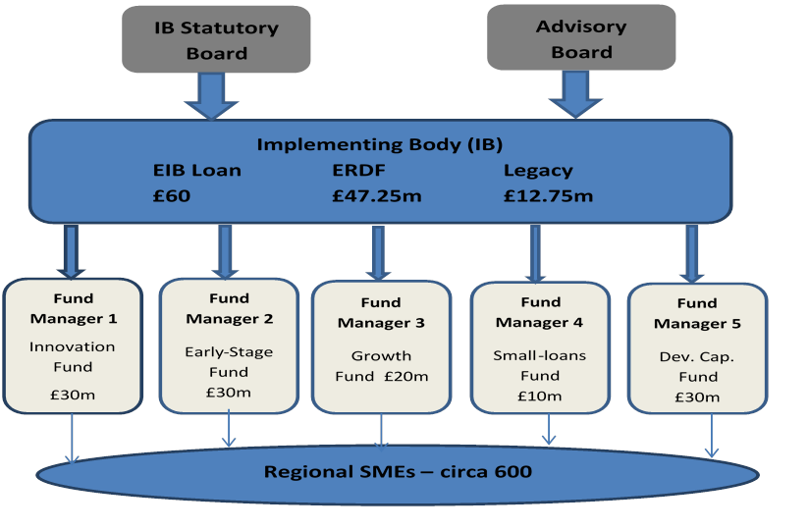
Appendix 3: Examples of current system, showing some of the main required fields

See next 3 pages
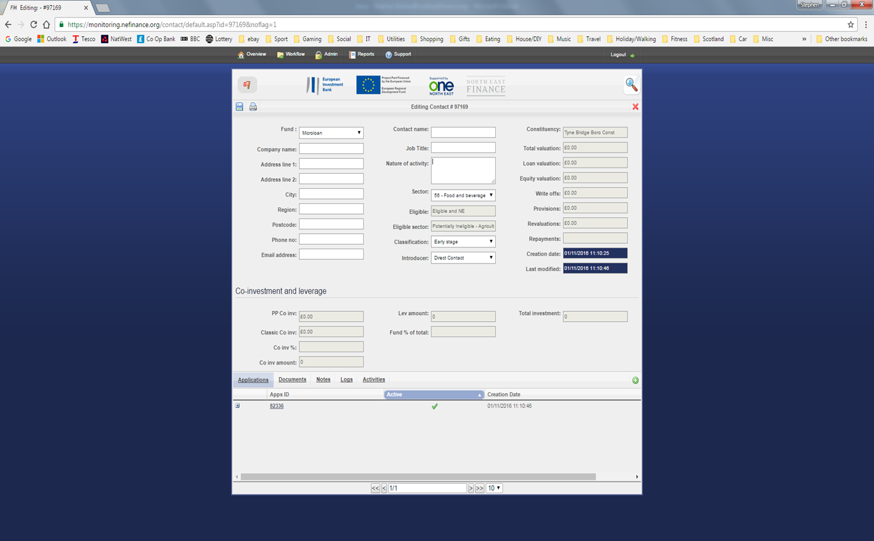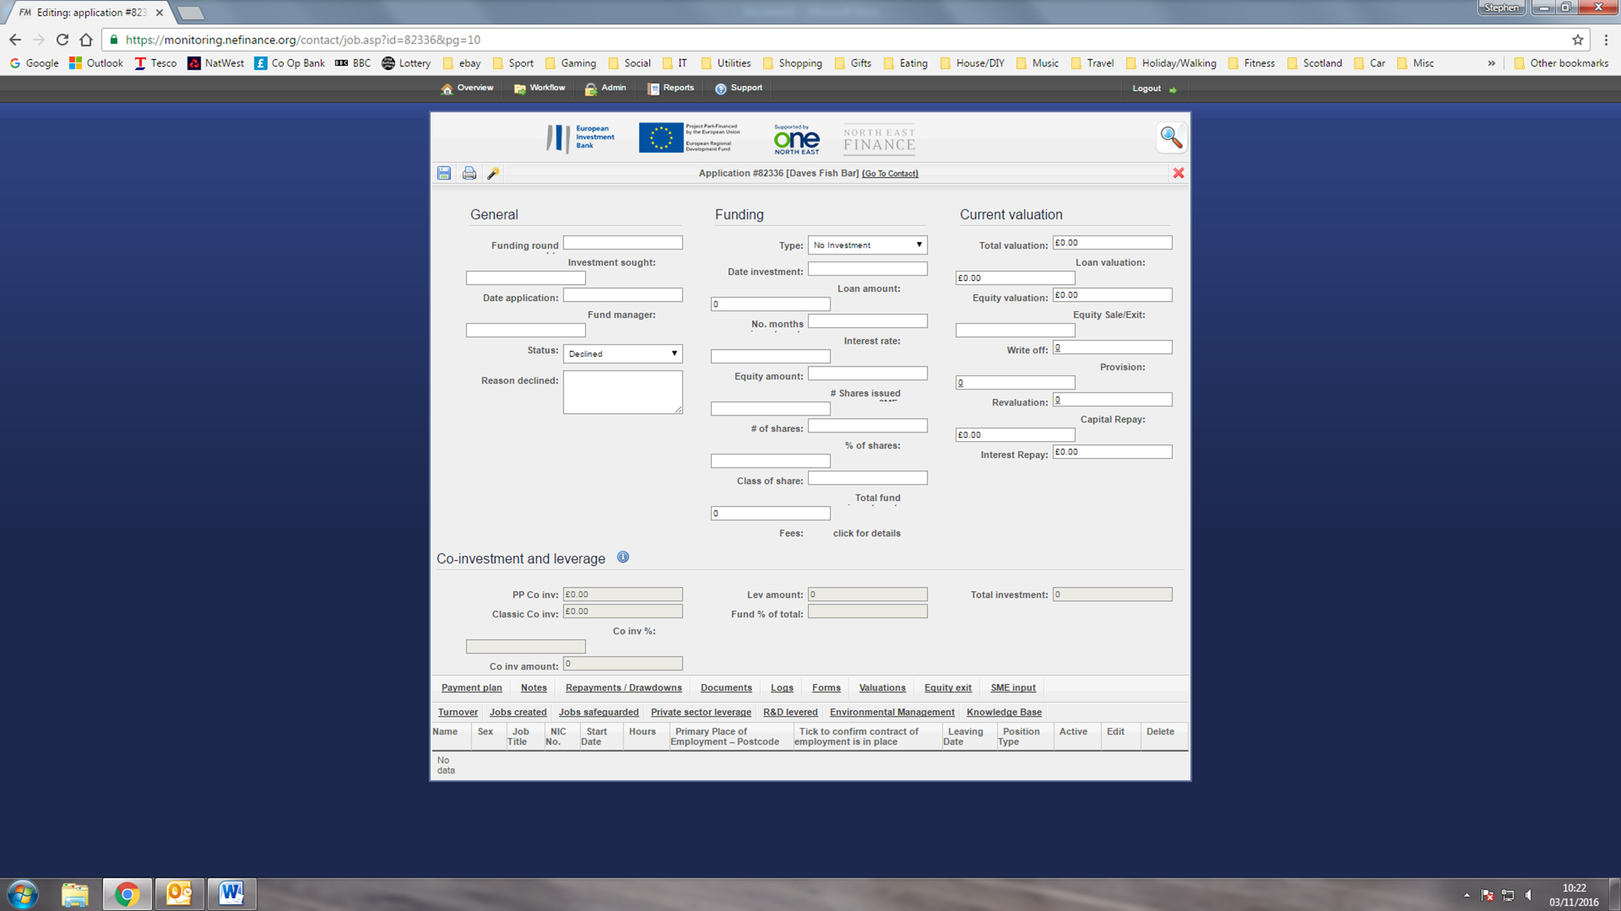
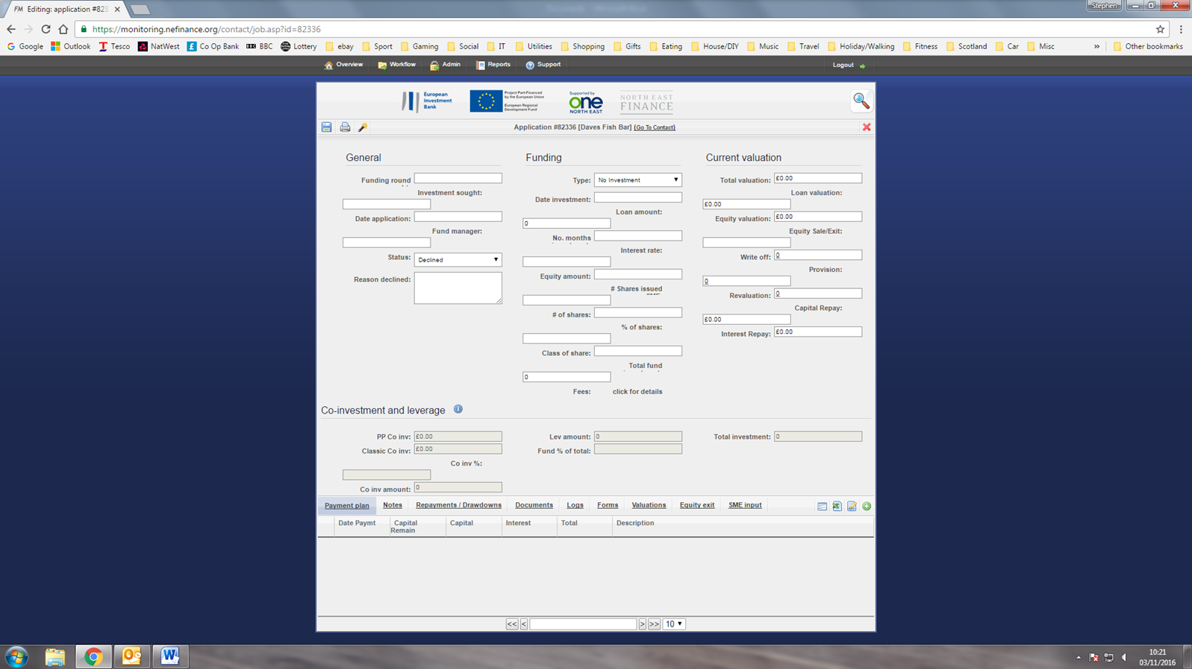

North East Access to Finance Limited
3rd Floor, Baltimore House
Abbots Hill
Gateshead NE8 3DF

Tender Reference: NEA2F/032

