WWF-UK Request for Proposal

Sustainable Futures Programme Evaluation

WWF-UK is looking to contract and work with an organisation to lead the evaluation of Sustainable Futures, a careers education programme delivered by WWF-UK, Villiers Park Educational Trust and Founders4Schools.

About WWF-UK

We’re WWF, the global environmental charity, and we’re bringing our world back to life. With nature in freefall, we’re urgently tackling the underlying causes that are driving the decline – especially the food system and climate change. And we’re finding solutions so future generations have a world with thriving habitats and wildlife.

It’s a huge challenge, but there is hope. We’re working globally with governments, companies, communities and others who have the will to act and the power to transform our world. We’re using our groundbreaking scientific research, our global influence, and the backing of our many supporters to make sure the natural world’s vital signs are recovering by 2030.

Context

The UK is seeking to be at the forefront of the global green industrial revolution. Young people could play a significant role in addressing the environmental challenges they inherit, as well as being able to thrive in a green economy in which the UK can meet its net zero target and restore nature. This is only possible if young people, their parents, carers and teachers are well informed about these changes and have access to the opportunities they may create.

To address this urgent need and help prepare young people for the future job market, WWF-UK, Villiers Park Educational Trust and Founders4Schools have developed a new careers education programme that has sustainability embedded throughout - Sustainable Futures.

Programme Overview

Tackling the climate and nature crisis will take a skilled and diverse workforce, and every job can play its part. Sustainable Futures is a free programme for secondary schools and colleges across the UK that equips 14–18-year-old students with the knowledge, skills and experiences to help them thrive in a future green economy, no matter what career path they choose. Teachers and career leaders are provided with the tools to inform, inspire and empower students to build a career with positive long-term prospects, that will benefit their own career path and help bring our world back to life.

The programme aims to build aspiration for, access to and awareness of sustainable careers. We will achieve this through the three programme pillars:
- Education and Training
- Business Engagement
- Campaigning and Communications.

Sustainability is threaded throughout the student activities that include:
- a short, certificated course
- business role model talks
- access to experiences of the workplace.

The programme focuses on engaging and supporting young people from disadvantaged backgrounds and diverse communities. The ultimate programme goal is for sustainability to be embedded as a formal component of the UK's careers guidance curriculum, and schools, employers and CEIAG providers to adopt sustainable careers activities, resources and principles established through the Sustainable Futures programme.
The programme was piloted in the 2021/22 academic year and is in its first full year of delivery this academic year (2022/23). The current funding for this phase of the programme finishes in the 2023/24 academic year, with plans to continue the programme beyond the current funding period. The Sustainable Futures programme has been made possible by the generous support of the Evolution Education Trust.

Main purpose and scope

WWF-UK is commissioning this evaluation to understand the impact of the Sustainable Futures programme during its current delivery phase from November 2022 until July 2024. We also want to shape how the programme evolves for the next delivery phase beyond July 2024, using evidence and data to inform our decisions and ensure we remain on track to achieve our 2030 goal.

Focus of the evaluation

The Sustainable Futures delivery partners currently collect data (more quantitative than qualitative) as part of our activities and outputs section in the programme Monitoring and Evaluation framework. This framework and relevant data will be shared with the successful evaluation organisation. For this evaluation work, we expect a mixture of data to be collected by the selected organisation, with a greater weighting towards qualitative.

Below gives an overview of four criteria the evaluation will focus on, including outcomes and examples of questions we want answered through this work. These should be used as a guide and final questions will be agreed during the inception meeting with WWF-UK and the successful evaluation organisation.

Criterion 1: Relevance and Quality of Design

We want to understand if the programme design represents the necessary and most appropriate approach to ensure we achieve our 2030 goal, which in turn contributes to the programme’s overall vision.

We want a mid-term evaluation undertaken (the end of this academic year, 2022/23), that includes recommendations for the future design and approach of the programme for the next delivery phase beyond July 2024 (including any key changes in contextual factors since the start of the programme). Below are some examples of questions we’d like answered.

- The programme has gone through various iterations, and we want to assess how the programme has developed since its inception.
  - Is the theory of change clear? Is anything missing?
  - Has the programme taken the most efficient strategic approach? Are there changes we could make to be more efficient?
  - How valid are the existing underpinning assumptions? Are we missing any assumptions?
  - Does the programme make a clearly aligned and meaningful contribution to the WWF-UK organisational strategy?​ Are there adjustments we could make to improve the alignment?

Criterion 2: Programme integration across audiences

Our programme includes different elements, each managed by different delivery partners, each designed to reach and engage either different audiences, or a similar audience at a different stage. We risk not maximising the benefits of our partnership if we have a disjointed audience journey or don’t have aligned messages across audiences.

We want the evaluation to inform how we drive actions between stakeholder groups, and would like the tenderer to deliver a conceptual model that illustrates the interrelationships between our stakeholders and the key factors influencing these relationships, based on their audience research. This will be used to ensure our programme is utilising opportunities across stakeholders and providing solutions to any shared challenges.

To ensure that the programme remains relevant to the context and priorities of stakeholders, we would like to know:
- What do interviews, focus groups or other proposed methodologies tell us about the pressures, drivers, enabling conditions, opportunities in which our stakeholders operate? (Please note that we are also commissioning two separate pieces of research into policy drivers and employer career quality frameworks which will help inform opportunities for the programme to have its greatest impact. These will be shared with the evaluation organisation.)
- What are the key stakeholder interests (young people, educators, employers) to ensure the programme is relevant to their priorities and interests?
- Is the programme focused on and does it remain relevant to issues of highest priority for our stakeholders and beneficiaries?

Criterion 3: Effectiveness

We want to understand the extent to which our 2024 programme outcomes have been achieved. We want to assess the effectiveness of the relationship between programme activities and outputs, and their intended outcomes.

- What outcomes have and have not been achieved (both intended and unintended)?
  - Can we tell how much of the change in the 2024 outcomes can be attributed to the programme and its activities or outputs, and if so, how much?
  - What impact does the progress (or lack of progress) of the outcomes have on the programme achieving its 2030 goal?

- Which programme activities are proving to be effective, and which are not?
  - What anticipated and unanticipated factors have promoted or impeded the programme’s progress?
  - What supporting or impeding factors might affect successful implementation in the next phase of delivery (post July 2024)?
  - What lessons can be taken and applied to improve effectiveness in the coming years?

- Have stakeholders been engaged at the right level throughout the programme cycle?
  - Which of our key stakeholders (young people, educators and employers) views about what changes are needed, are represented in our outcomes and would they think we are making progress on these?

- Are there well developed internal and external communications strategies and are they being implemented to good effect?

Criterion 4: Longevity

We want the evaluation to help us with the next phases of development of our own careers programmes (particularly WWF-UK). We know we can never expect to secure enough funding to reach every young person in every school. Our careers programmes will need to evolve to continue to meet the needs of beneficiaries, without the same direct support from the programme delivery partners.

- What elements/activities of the programme are most beneficial to stakeholders and can operate in a model that is sustainable?
- Are stakeholders (young people, educators, employers) likely to continue to engage with the programme resources and principles beyond the external support provided?
- Evidence that the programme has a good chance of sustainability:
    - Does the programme have clear policy support measures?
    - Have the disadvantaged and underrepresented groups been engaged and integrated into the programme, including no negative impact on these groups. and/or benefits realised by them?
    - Is there adequate institutional and organisational capacity and clear distribution of responsibilities among those organisations or individuals necessary to ensure continuity of programme activities or impacts (e.g. schools, employers, CEIAG providers).
- What external factors could have a high or medium likelihood of undoing or undermining the future sustainability of programme positive impacts? Is the programme adequately anticipating and taking measures to ensure resilience to these?
- Based upon existing plans and observations made during the mid-term evaluation, what are the key strategic options for the future of the programme and its current delivery partnership model (e.g. exit, scale down, replicate, scale-up, continue business-as-usual, major changes to approach)?

Methodology

The table in Annex A summarises the Sustainable Futures programme outcomes for July 2024 and suggested indicators. The programmes Theory of Change is in Annex B.

We want the tenderer to recommend and deliver the most appropriate methodologies that would be best suited to assessing these outcomes and helping to answer the questions proposed in the previous section. We anticipate that this could include in depth case studies (including longitudinal), interviews, focus groups, surveys (including longitudinal), etc.

Key deliverables

Deliverable | Description
1. Project management | An initial (virtual) inception meeting will be held to agree details of the project, practical considerations such as timelines, project milestones and communication. Communication with WWF-UK will be regular and include email, Zoom, and telephone communications as required.
2. Desk research | Desk research of project documents, outputs and relevant projects, supplied by WWF-UK and partners.
3. Primary research | This could include questionnaires, interview frameworks, interview schedules, workshops, cases studies of partners and audiences.
4. Final report | Final analysis to be delivered as an internal report (15 pages) with an externally shareable executive summary and a slide deck summarising outcomes, learnings, insights and recommendations for next steps.
Tenderer experience

The successful tender is likely to have experience of formative and summative evaluation of UK-wide programmes that deliver activities with more than one key audience. They may have experience of evaluating programmes in the education or careers sectors.

We can accept consortium or joint bids, if it’s clearly demonstrated the additional benefits and complementary expertise this could bring to the evaluation work. WWF-UK will need to enter into an agreement (and invoice) with a single supplier, with the lead organisation responsible for the management and delivery of other organisations in the joint bid. All organisations must adhere to WWF-UK’s Supplier Code of Conduct, along with other requirements outlined in this Request for Proposal.

The Application Process
Please note that WWF-UK would prefer to contract these services using our attached Standard Terms and Conditions. As part of your response, please indicate whether or not you would be content to use these terms or if you would wish to propose alternatives.

Please ensure your proposal is no longer than 10 pages in length and is submitted as a Word or PDF document.

The Selection Process

In line with our procurement process, we require at least 3 supplier responses to the brief. A panel comprising members from across Education and Youth Engagement, Design and Impact, and relevant representatives from other departments, will consider the responses and make a decision based on the following criteria:

  - The organisation’s proposed approach to the requirement
  - Depth and breadth of expertise in programme evaluation
  - Values, partnership, inclusivity – alignment with WWF-UK
  - Price – value for money

In your response, please demonstrate and evidence:
- Understanding of the brief and propose options for the approach. Please outline possible time frames and requirements of us in a high-level project plan.
- Depth and breadth of expertise in this field in the charity /not for profit / NGO and commercial / private sectors. Please include names of recent clients for who you have delivered similar work, with a particular focus on the safeguarding of young people
- Safeguarding expertise and experience. Please outline how you will ensure safeguarding is embedded in programme design and delivery. Please provide your policy, your expectations of WWF-UK's roles and responsibilities, as well as a breakdown of your training, monitoring, quality assurance, incident management and reporting procedures. We expect agencies to have at least the same level of safeguarding measures as outlined in our policy - https://www.wwf.org.uk/sites/default/files/2022-09/WWF-UK-Safeguarding-Policy-September-22.pdf - and if required, WWF-UK has the right to impose or instruct any further safeguarding measures to align to our policy.
- A strong team that can provide responsive service – i.e., not key person dependent – continuous service available. Please provide short biographies for all those who would be involved on the project
- A strong alignment with WWF’s vision and mission with values that respect diversity, equality and inclusivity and evidence of partnership working. Please provide a short statement on this and how you evidence your values in your work.
- Value for money; competitive pricing for expertise. We need fees to be clear and structured in a flexible way. Please provide a detailed budget, including day / hourly rates and price per project element, ideally with capped fees.
- Confidentiality and Data protection. Please provide your confidentiality statement and GDPR principles.
- Diversity, Equality, and Inclusivity (DE&I). Please share your approach to DE&I and how you would approach the project in this respect.
- References. Please provide two referee clients. (We would not approach without your permission).
- It is our preference that an appointed external partner adopts our standards terms and conditions for engaging with us. These are attached. Please can you state whether you would be comfortable with this and whether there are any terms which might create difficulty for you.
- Conflicts of Interest: Provide any details (if any) of actual or potential conflicts of Interests that would arise were you to be appointed, and details of how these conflicts would be mitigated.

Timelines and Next Steps

The budget range for this work is £40,000 - £48,500 (inclusive of VAT) please provide a detailed costed breakdown of spend in the proposal.

This request for proposal/quotation was issued: 16 February 2023.

The closing date for responses is 9 March 2023 at 9am. Applications received after that will not be considered.
Please send your proposal to Rosalind Mist, Director of Education and Youth Engagement, WWF-UK: RMist@wwf.org.uk

Evaluation of proposals will begin w/c 13 March 2023 and 3 agencies will be invited to interview w/c 20 March 2023.

A decision will be made, the contract awarded and an inception meeting to take place by 31 March 2023, with the project commencing from mid-April 2023 after accepting contract terms and running until August/September 2024.

Any potential providers can submit a query by email to Rosalind Mist, Director of Education and Youth Engagement, WWF-UK: RMist@wwf.org.uk, no later than 5 pm on 2 March 2023 (1 week before deadline)

Alternatively, please contact: WWF-UK Procurement Team: procurement@wwf.org.uk

--------------------------------------
Thank you for expressing an interest in working with and supporting WWF-UK with this important piece of work.

We look forward to receiving your response.
Annexes

Annex A – 2024 Aims and Outcomes

Aim 1 – Aspiration (Education and Training)
Ensuring that young people and those supporting and guiding them in their choices (parents/carers, educators, and agencies) perceive sustainable skills and jobs as attainable and aspirational – not just as a positive 'ethical' choice, but for the opportunity they give for professional success.
Ensuring that employers are aware of the demand for sustainable pathways, and are supported to review their offer and create opportunities that fit with a sustainable criteria defined through this programme.
Outcome 1.1  Educators understand the importance of sustainability in careers | Suggested indicator/s  - Number and percentage of educators reporting having an understanding of the importance of sustainability in careers  - Description of experiences of educators understanding the importance of sustainability in careers
Outcome 1.2  More schools embed sustainability in their careers provision | Suggested indicator/s  - % and evidence of schools embedding sustainability in careers provision
Outcome 1.3  An increase in young people's aspiration for participating in sustainable early careers pathways | Suggested indicator/s  - %, evidence and description of young people's aspiration for participating in sustainable early careers pathways
Aim 2 - Access (Business Engagement)
Providing the tools and guidance to help young people and those supporting and guiding their choices (parents/carers, educators, and agencies) to identify and access relevant and suitable pathways for young people, with a focus on engaging disadvantaged and underrepresented groups.
Supporting and encouraging employers to provide and publicise sustainable career pathways.
Outcome 2.1  Employers understand the importance of sustainability in careers | Suggested indicator/s  - Large organisations engaging more in events, networks and programmes that focus on sustainability in careers.
Outcome 2.2  Employers embed sustainability principles across their early career pathways | Suggested indicator/s  - Number, type and description of employers agreeing to collaborate and embedding sustainability principles
Outcome 2.3  Employers increase access to sustainable early career pathways for young people | Suggested indicator/s  - Number and description of sustainability focused early career opportunities offered by employers.
Aim 3 - Awareness (Comms & Campaigning)
Building an understanding of what is meant by a 'green skill', ‘green job’ and a 'sustainable career' among young people, educators and employers in the UK.
Creating awareness of sustainable career pathway opportunities.
Outcome 3.1  Young people engaged with the need and potential for sustainable careers.  (We plan to work with an external agency to deliver a young people focused comms campaign to help provide some insight on this outcome. We anticipate that the successful evaluation organisation will liaise with the external comms agency, but won’t be required to gather data themselves). | Suggested indicator/s  - Evidence of increased knowledge and awareness of the changing role of careers in achieving a green economy  - Percentage of young people with favourable attitudes towards embedding sustainability in careers
Outcome 3.2  A clear sector-wide policy ask [education/ business] for supporting sustainability in careers guidance | Suggested indicator/s  - Policy agenda alignment among key organisations in the sectors
Outcome 3.3  Sust. Futures resources [and brand] are recognised by educators as a key contributor to high quality careers education in schools and colleges. | Suggested indicator/s  - Number, percentage and description of resources used/ downloaded  - Educators referring and championing the programme  - Resources and partnerships with popular educational resource brands

Annex B – Sustainable Futures Programme – Theory of Change

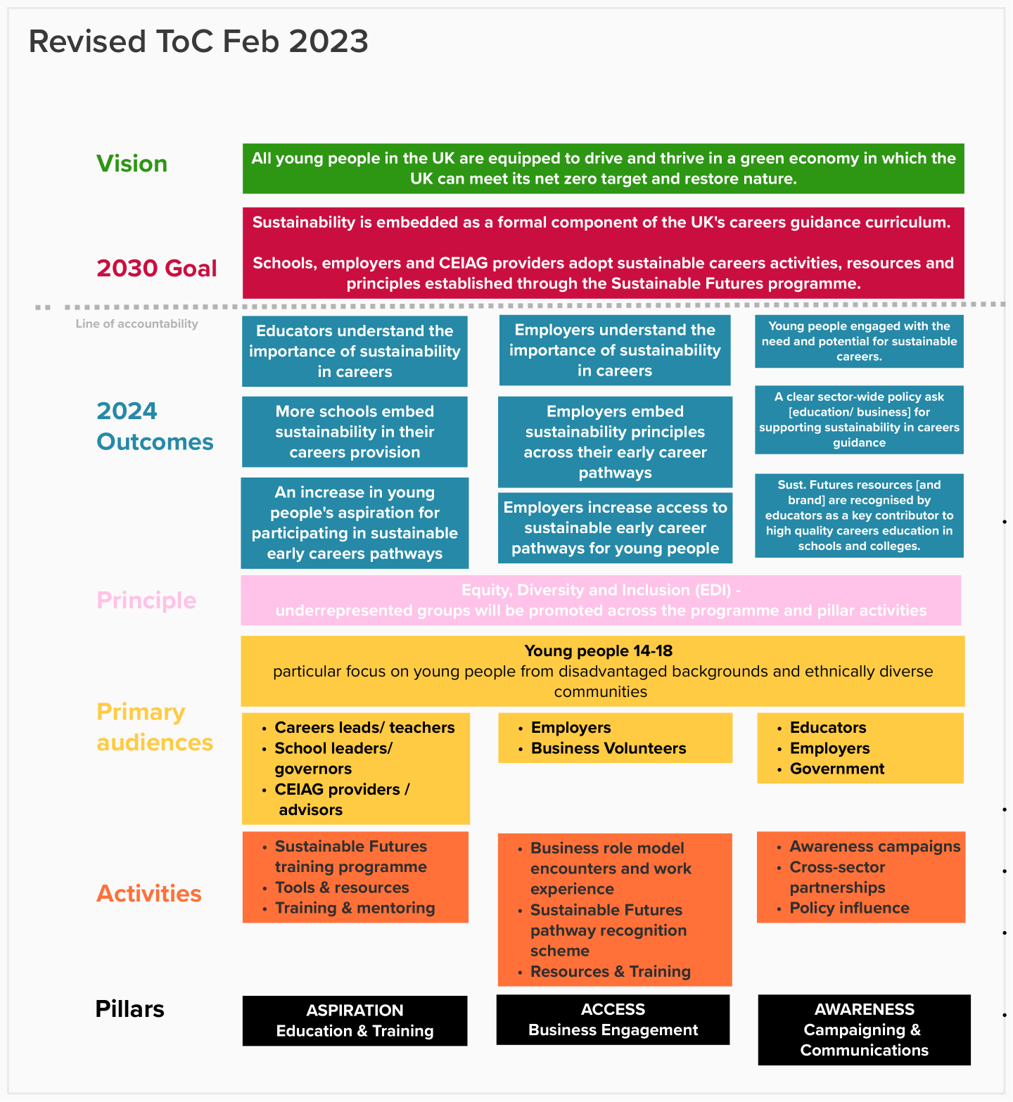
Key terms:
- EDI and promotion of underrepresented groups = across all the pillar activities we will ensure a range of diverse stakeholders are engaged (with a particular focus on racial diversity). Such as stakeholders participating in training to primary audiences in pillar 1, business volunteers delivering sustainability encounters and work experience to students in pillar 2 and stakeholders involved in the programme's communications and campaigns in pillar 3.
- Young people from disadvantaged backgrounds = eligible for Free School Meals.
- Young people from ethnically diverse communities = those that identify as Asian, Black, Mixed or Other.
- Early career pathways = work experience, internships, placements as part of their education, apprenticeships, traineeships.
- Sustainable careers = all jobs can be sustainable, not just green jobs.

