North Moor replacement of Culverts with Non-return Valves NRV Culverts NM Corner – Specifications of Requirements

Replace three existing 450mm culverts with non-return valves, and gateways, previously installed by the Environment Agency in the 1990s. Culverts to allow cattle to cross ditches. Non-return valves were fitted to act as a water supply into the North Moor Corner Raised Water Level area when water levels within internal ditches are lower than external levels.
The wooden headwalls of the culverts are severely degraded and in places material compacted around the culvert pipes has collapsed into the field and ditch. Replacement structures required to make the crossings safe and operational.

To create dry working area:
Either side of working area, install interlocking trench sheet piles with an excavator to create temporary dams across the ditch. Each pile to be inserted vertically into the ditch/ditch bank with downward pressure from the excavator ensuring the ball and socket joints are connected. Remove vegetation and detritus from working area with a ditching bucket from an excavator. Drain water/mud from the working area with a pump, pump to be used during working activities for the duration of the project.
Works will be conducted during periods of dry weather. Do not work during wet conditions where use of machinery may cause poaching of soft ground.

Method of works
Temporary works as detailed above will create a dry working area.
Working Method will follow:
Somerset IDB Gateway Construction Culvert Sequence Guide – but using Galvanised Steel Motorway Barrier Headwalls
Specifications will follow Somerset Drainage Boards Consortium:
NRV1 Culvert NM Corner IDB Consent Application
NRV2 Culvert NM Corner IDB Consent Application
NRV3 Culvert NM Corner IDB Consent Application
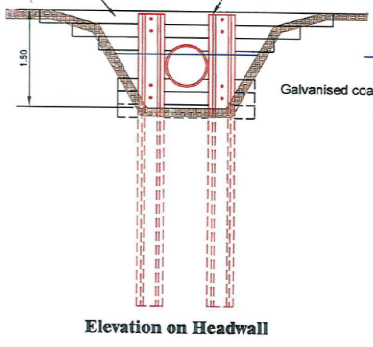
Steel motorway barrier headwalls will be created six metres apart using a tracked low-ground pressure excavator to push the vertical components of the headwalls 1 meter into the clay layer beneath the peat bed of the ditch. The peat is up to 2.5 meters deep; therefore, the vertical component of the headwall is required to reach approximate depth of 3.5 meters to anchor the structure to the clay bed beneath the peat soils. The top of the headwalls will be flush with ground level.
Piles will be driven into the ditch bed by the excavator, and crossing timbers affixed, to support the pipe once installed.
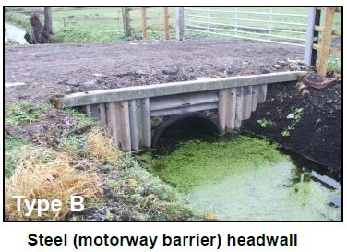
A foundation of compacted graded stone will be created upon which the 450mm wide, rigid, twin-walled plastic pipe will rest.
A geotextile membrane will be installed under the pipe which will sit on the stone bed and the steel motorway barrier headwall; the headwalls will be held in place with metal tie bars. Additional steel motorway barriers will be installed to the headwall to secure the pipe in place, with a box beam crash barrier along the top.
Clean crushed stone will be added and compacted in layers around the pipe. The geotextile membrane will be folded back over the pipe and further stone added and compacted. Minimum 400mm layer of stone to be added between the top of the pipe and ground level. The final layers of stone will be compacted using a road roller. The height of the completed culvert will be at ground level.
Each pipe will be fitted with a 450mm non-return (flap) valve.
A 12ft metal gate with wooden wings will be installed infield of the culvert to allow control of cattle movements. Galvanised metal to be used for gate posts.
Any damage to the ground caused by the workings or the excavator will be made good upon exit.

Environmental considerations
Excavator will be refuelled off-site, on hard standing, at a minimum 10m from ditches/watercourses/wetlands. Biodegradable oil shall be used where appropriate. Spill kit must be present on site and used if/when required.
During access, machinery will avoid soft areas of ground to reduce poaching. Firmer ground such as the edges of the fields to be used for access.
Stone used for the culvert will be clean and locally sourced.
Arisings from the derelict structure will be removed once the area has been dewatered, to prevent sedimentation downstream. Arisings will not be left on the land in low-lying areas, or deposited onto ditch banks as this would reduce the value of the land for wading birds and reduce the efficacy of the gateway.
Work will be completed as quickly as possible and over as small an area as is possible to work safely in, to reduce the potential impact on ditch flora and invertebrates. Clearance of vegetation will be conducted by Natural England prior to the works taking place, clearance operations will take place outside of the breeding bird season [March to August inclusive].
Works will occur within North Moor SSSI. Natural England assent has been granted for these works as part of North Moor SSSI Assent 0905231009RM. To avoid impacts to wintering and breeding waders and wildfowl, features of the SSSI, repair/replacement of like-for-like structures is granted with works restricted to September/October. Works may only occur outside of this time period if an ecological survey conducted by Natural England does not identify the presence of breeding or wintering waders or wildfowl which may be impacted by the works.
Parrett Internal Drainage Board consent C-PA-002650 has been granted for works.

Maintenance
Natural England, or tenants of Natural England, shall be responsible for maintenance of the structure for as long as Natural England owns the land.

Outputs and timescales

The main outputs for this project will be:

- Installation of 3x culverts with non-return valves.

Key timescales:

Project start 1st September 2024
Contract Completed by 31/03/2025

Prices will remain fixed for the duration of the contract award period. We may at our sole discretion extend this contract to include related or further work. Any extension shall be agreed in advance of any work commencing and may be subject to further competition.

Project management

The contractor will appoint a project leader who must have sufficient experience, authority to act on behalf of the contractor and time allocated to manage the project effectively. The contractor’s project leader (CPL) will be responsible for the management and delivery of the project and will act as the liaison point, particularly liaison between members of any consortium, with the Natural England project manager (NEPM).

Supporting Documentation

The following supporting documentation should be provided:
  - Health & safety Policies/certificates
  - Environment Policies
  - VAT registration number
  - Public Liability Insurance
  - Professional Indemnity Insurance
  - CV’s
  - Past Work
  - Sustainable Procurement Practices

Sustainability
As a delivery partner, the successful contractor is expected to pursue sustainability in their operations, thereby ensuring Natural England is not contracting with a supplier whose operational outputs run contrary to Natural England’s objectives. The successful contractor will need to approach the project with a focus on the entire life cycle of the project. The successful contractor is likely to be able to provide a copy of their environmental policy and any environmental accreditation schemes such as ISO 14001 or EMAS which they have been awarded or are working towards.

- Operational Sustainability - Explain to Natural England what your organisation is doing to incorporate sustainability within its operations. This may include any details you are able to provide in relation to steps you may be taking to reduce your carbon footprint.

- Environmental Management - Detail what you will do to assess the environmental impact of completing this project and provide mitigations. Examples may include operational measures to reduce emissions and noise impacts, efficient energy use, efficient use of raw materials and minimisation of waste where possible.

Key Natural England Contact

Project Officer – Philip Thorpe, Senior Adviser - Somerset, Tel – 07979119406
Email – philip.thorpe@naturalengland.org.uk
Location of works:
Wisteria Farm, Middlemoor Drove, North Newton. TA7 0BT.
What3Words for the three culvert locations:
crowds.supreme.swerving | prowling.manicured.safari | nuggets.rejoined.grant

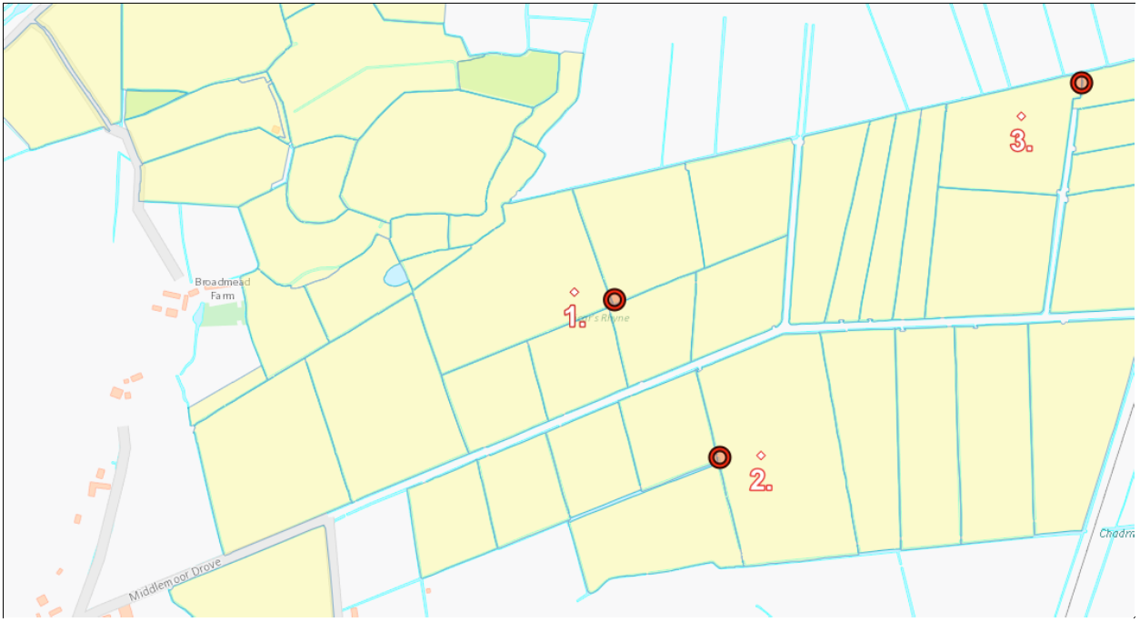
Figure 1. Map showing location of culverts to be renewed.
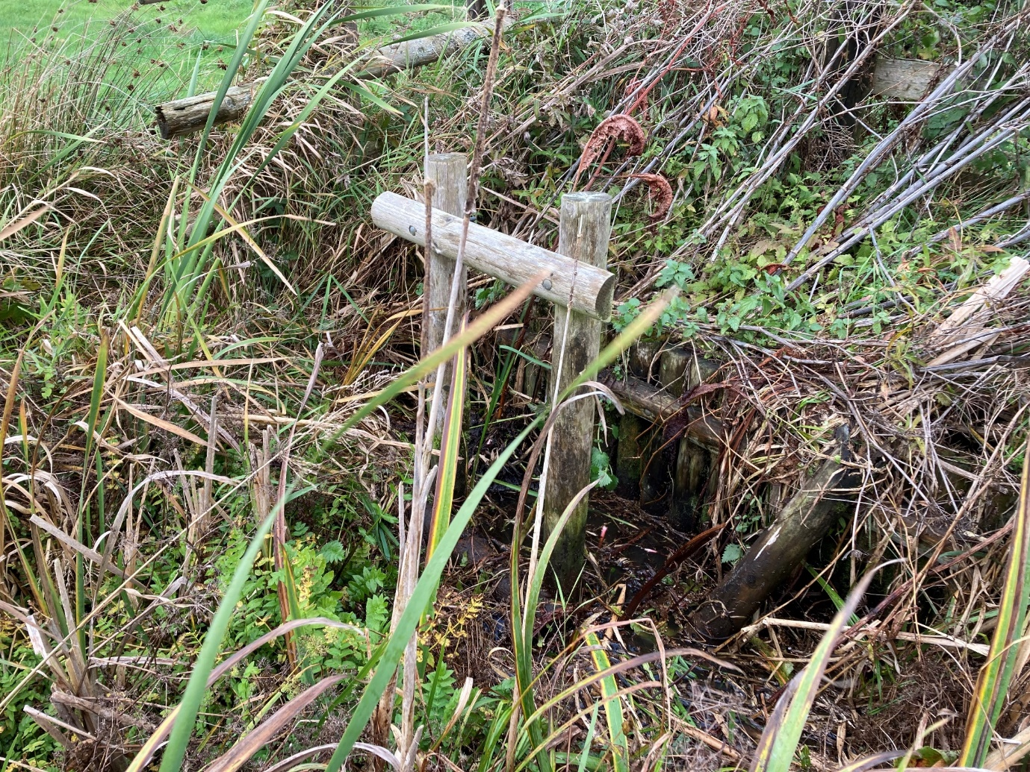
Figure 2. Photograph of culvert with wooden headwall and non-return valve.

