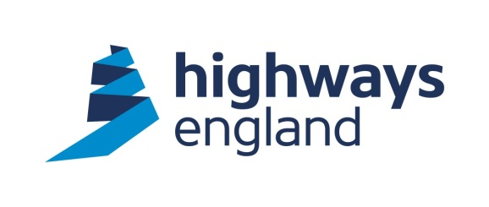  Our ref: KLM/L2  Your ref: Redacted  Raynesway Construction Services Ltd  Balfour Beatty Regional Civil Engineering  Maxim 7  Maxim Office Park  Parklands Avenue  Eurocentral  ML1 4WQ  For the attention of: Redacted | Highways England  Procurement  Lateral  8 City Walk  Leeds  LS11 9AT  Direct Line: Redacted  24th May 2018  http://highwaysengland.co.uk
Dear Sir

CLOSED BRANCH LINES MINOR WORKS – klm/l2 – Removal of fly tipping

Further to your quotation for the above works I am pleased to advise you that your price of £18,359 has been accepted.

You should note that we will not pay for any works unless it has been specifically authorised in writing within the terms of the agreement.

Please note the works are to be undertaken under the Works Framework Contract 2016-2020 and the conditions of contract for these works are the NEC3 Engineering and Construction Short Contract.

Invoices should be sent to Financial Services Payments at Highways England, The Cube, 199 Wharfside Street, Birmingham B1 1RN, quoting the Blanket Purchase Agreement number, Release number and Receipt number. These details will be provided to you by the Historical Railways Estate team as works are certified.

I trust the above is acceptable. The agreed Start Date is 28th May 2018. The Completion Date is 31st October 2018. Should you wish to discuss the matter further please contact Redacted the Project Manager for Historical Railways Estate on Redacted.

Please acknowledge receipt and acceptance of this letter by return.

Yours faithfully

Redacted

Redacted
Procurement Lead for Historical Railways Estate
Email: Redacted @highwaysengland.co.uk

