Clarifications to Bidder’s Questions:
Holderness coast habitat map using multibeam and backscatter datasets
Q1) Please could we check regarding the format of the responses to the questions – the instructions seem to suggest that all questions should be within one, four-page limit, yet the ‘information to be returned’ asks for a separate response document for each technical questions?
Please could you confirm whether it is a four-page limit for all questions responses combined (in a single document), or 5 separate responses (for each question) with four-page limit, or 4 separate responses (for each question theme) with a four-page limit?
A1) Please send the answers to all of the technical questions back in a single document, ideally not exceeding 4 pages in total. Then the commercial question should be answered using the commercial response template on contract finder.

Q2) The RFQ states:
The map is to include the nearshore area between Spurn Point and an area South of Flamborough Head, which will encompass:
- Smithic Sands
- Holderness Inshore Marine Conservation Zone (MCZ)
- Flamborough and Filey Coast Special Protection Area (SPA)
- Flamborough Head Special Area of Conservation (SAC) and Site of Special Scientific Interest (SSSI)
- Humber Estuary SAC, SPA and SSSI
Please clarify whether the area to be mapped fully encompasses all of these area features or only partially intersects with them, as depicted in the image below.
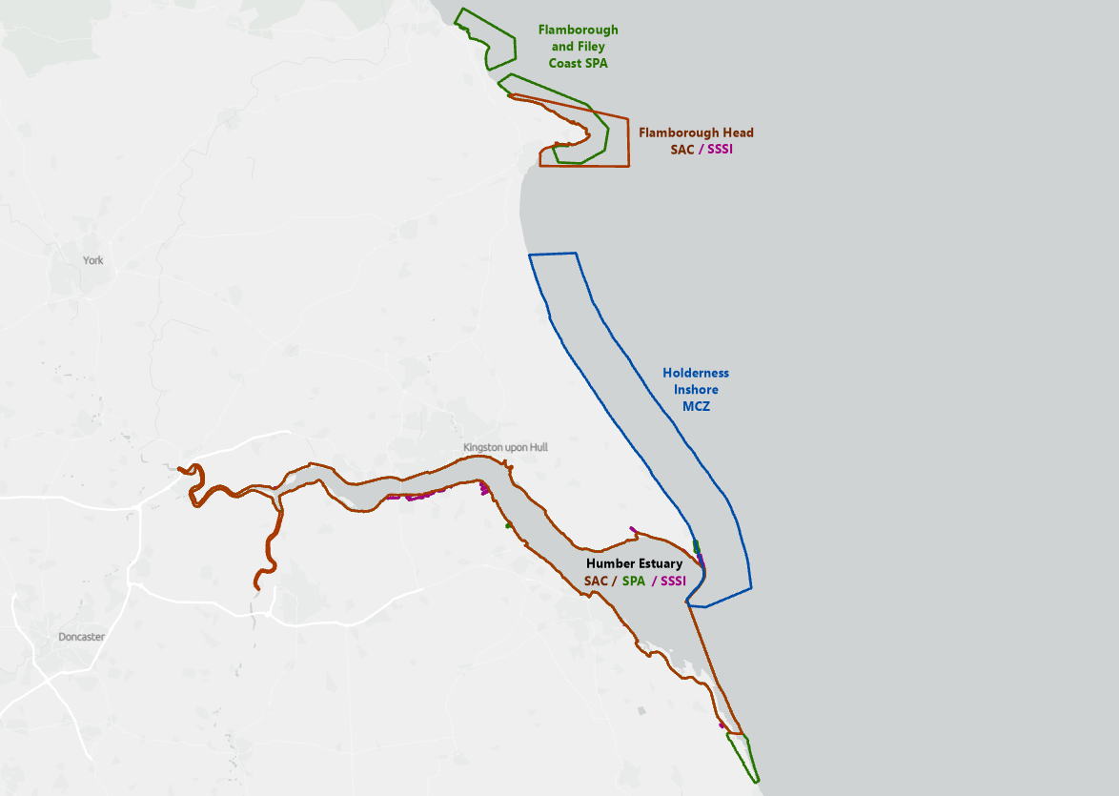
A2) The intention is for the mapped outputs to cover the whole of Holderness inshore MCZ, extending north to incorporate Smithic Sands, which will have a small overlap with the Flamborough Head SAC in southernmost section.
Q3) Please could you confirm if ArcPro is suitable and if a minimum requirement of 10.2 is meant, but shapefiles will still be compatible.
A3) 10.2 is the minimum version requirement, and ArcPro will be suitable.
Q4) Given the relatively short publication window to closing date […] is there a a possibility of a submission deadline extension?
A4) Unfortunately we are not able to offer an extension for the application.
Q5) Is is possible to provide a little more information on study area (e.g. approximate km² of data coverage and/or data sizes (GB)?
A5) The MCZ has an area of 309km2. The additional area to the north of this, incorporating Smithic Sands would be an additional 120-130km2. We have no specification re data size.
Q6) Can we confirm which version of EUNIS levels are required?
A6) 2012 version will directly align with the habitats of the MCZ as classified. Please use Level 3 of version.
Q7) Is there any requirement for a data search and review of third party data, noting timescales?
A7) Any additional data used would be at the bidder’s discretion
Q8) Will datasets with licence requirements be provided without us requiring to apply for licences?
A8) Yes, the data from the BGS will be provided with no requirement for additional licence provision
Q9) Is it possible to use any publicly available datasets to ground truth, or will these be included in the datasets?
A9) Ground truthing datasets will not be provided and would be additional at the discretion of the bidder.
Q10) For third party projects, such as other commercial projects that are able to draw knowledge from, what level of referencing is required?
A10) TBC
Q11) How are the datasets going to be issued, online via a designated site or on a physical hard driver?
A11) Method will be discussed / agreed once contract has been secured
Q12) We understand the datum is WGS84 – just to confirm that no projection is required (i.e. UTM31N?)
A12) No projection is required
Q13) Noted that the map needs to be ESRI ArcGIS 10.2, but would this need to be as ArcPro or ArcMap?
A13) Either would be suitable
Q14) Would an online deliverable version be an option?
A14) This could be discussed upon award of the contract
Q15) Is the PDF requirement a simple PDF or 3D PDF?
A15) This would be at the bidder’s discretion
Q16) We understand the requirement is for the proposal to be limited to 4 pages, are we able to supplement with appendices to provide additional evidence?

A16) You are welcome to include appendices as part of your application

Q17) Can you confirm the T&Cs used for this contract: i.e. Standard goods and services terms and conditions (£10,000 to £50,000) - GOV.UK (www.gov.uk)? If there are any amendments, will these be able to be discussed?

A17) We will provide confirmation shortly

