Early Market Engagement
Primary Medical Care Services

Memorandum of Information (MOI)
The Hesa Centre, Hayes

Incorporating:

Hayes Town Medical Centre (Practice Code: Y02812)
The Orchard Medical Practice (Practice Code: Y00352)

1. Introduction

1.1 Purpose of this Document
This Memorandum of Information (MOI) provides details of the NHS Hillingdon Clinical Commissioning Group (“the CCG”) current commissioning intentions for Primary Medical Care Services at The Hesa Primary Care Centre, 52 Station Road, Hayes, UB3 4DS.
As of 1st of April 2017, NHS Hillingdon CCG acquired level 3 delegated commissioning status and as such is now responsible for the commissioning of primary care services.
This MOI contains information relating to the provision of primary care services at the Hesa Primary Care Centre and is provided to enable potential providers to gain an understanding of the CCG’s current commissioning requirements. This is for the purposes of engaging stakeholders and the market in meaningful discussions about the aims and objectives of any future procurement process. The CCG’s current commissioning intentions are to select a provider following a competitive procurement process. Invitation to Tender (ITT) documentation, including a full specification are expected to be issued as per the timetable indicated below.

Activity / Milestone | Dates
Market Engagement | June/July 2017
Issue advert & ITT documentation | Early August 2017
ITT Submission DEADLINE | Mid - September 2017
Contract Award | Mid-October 2017
Service mobilisation period | October 2017 - March 2018
Full service commencement | 1 April 2018

2. Overview of Requirements

2.1 Summary of CCG Requirements
The CCG is seeking to appoint a provider of primary medical care services for the patient lists registered currently with the Orchard Practice and the Hayes Town Medical Practice to be known as The Hayes and Harlington Medical Practice. The two practices are currently managed under APMS contracts. The CCG’s current intention is to award a single contract for the two practices and for them to operate as one practice. It is expected that the terms of the contract opportunity will be consistent with standards, governance arrangements and pricing mechanism for London’s APMS contracts.

2.3 Objectives for the new service
The key objectives for the new service will be to:
- offer patients improved access to NHS primary medical care services through additional capacity, opening hours and consultation methods as necessary;
- maintain, and where necessary improve, the quality of primary medical care services available to patients;
- deliver affordable and Value for Money (VfM) NHS primary medical care services;
- ensure the service is underpinned by effective audit and best practice; and
- ensure a service that is properly integrated into the local health community and has effective links with all acute trusts within the locality, with the local authority, the CCG and other local Providers.

2.4 Potential Interested Providers
This document is intended to provide sufficient information such that potential providers will be able to understand the CCG’s requirements and make an evaluation of their capability and interest in bidding for the contract when it is advertised. Potential bidders are expected to be suitably qualified and experienced healthcare providers (including general practitioners, social enterprise / third sector organisations and other providers) with the necessary capacity and capability (or a demonstrable ability to provide the necessary capacity and capability) to provide the range of primary medical care services required by the CCG in a safe and effective manner. The CCG is open to the possibility that providers may bid in partnership with other organisations. It is anticipated that the contract awarded could be to a single Bidder or an accountable Provider leading a partnership or consortium.

3. Critical Success Factors (CSFs)

3.1 Access
- The new service must be provided at Hesa Primary Care Centre, 52 Station Road, Hayes, UB3 4DS and, where relevant, in other locations and facilities that meet local patient access preferences. Core opening hours will be from 8.00am to 6.30pm Monday to Friday. The successful Provider will also be required to demonstrate innovative ways of improving patient access e.g. telephone consultations, text reminders, electronic access to appointments, e-consultations etc.
Specifically the Provider will be expected to deliver the following:
- Any resident living within the catchment area of the Practice should be able to register
- Provider should ofer a minimum 72 appointments with GP or NP per 1000 patients per week
- Patients should also be able to book an appointment at least 2 weeks ahead
- The Provider should offer efficient telephone and on-line appointment access and advice. The Provider will be expected to provide telephone advice for its registered patients. Callers will either be satisfactorily answered on the phone (or called back), asked to come in for an emergency appointment, a routine same-day appointment, offered a home visit or referred on to a pharmacist or A&E, as appropriate.
- Offer urgent same day walk-in assessment linked to unplanned and/or urgent care. This service is to be similar to the ‘Telephone Service’ above but directed to patients that walk in.
- The Provider will be required to make provision for patients who require interpreting or translation services, or have other communication difficulties such as hard of hearing or may require sign language interpreting.
- An appointments reminder service via text messages and e-mail with provision for patients with special needs such as the blind, hard of hearing of patients with learning disabilities
- Offer ‘choose and book’ access to the diagnostic centres, secondary care and specialist services.
- Offer an average consultation time of at least 10 minutes with GP and 15 minutes with a nurse having due regard for the needs of elderly and other vulnerable patients, who may need longer consultations
- Patients will be able to book longer appointments if they feel they require it.
- Maintain a maximum waiting time of 30 minutes for all patients.
- In most non-urgent situations the patient will be able to see a clinician who is familiar with their health history, situation and circumstances.
- Develop close links with local pharmacy providers.

3.2 Capacity
The Provider will be required to demonstrate that it can provide sufficient clinical capacity to meet the challenging demands of the area, and develop appropriate skill mix to safely deliver the most appropriate interventions.

3.3 Skill
The Provider will be required to introduce specialist clinical skills applicable to the local patient needs.

3.4 Quality
The Provider will be required to provide a welcoming service, especially to those with the highest health needs, including the elderly, the disabled and parents with young children; and it should fit in well with the local community and services including active links with a range of local authority and voluntary sector services and CCG commissioned services.
The Provider will be required to deliver dedicated services to people with long-term conditions, including those with multiple conditions; maintaining disease registers and clinical and information systems, which support the pro-active management of these conditions
In addition, the Provider will be expected to provide a comprehensive health management and improvement service. This includes:
- Systematically detect patients at risk of disease, at an early stage of disease or with existing disease and provide advice, treatment care planning and/or referral;
- Ensure patients with disease are entered on the appropriate disease register;
- Work collaboratively with other agencies on the development of local care pathways for patients with long-term conditions to effectively manage avoidable admissions.
- Participate and promote expert patient and self-care programmes.
- Provide information about, and access to, self-management programmes for patients with long term conditions.
- Provide accessible information and advice to patients on self-care.
- Develop and make effective use of computer-based disease management templates and associated call and recall systems.
- Work with the CCG, local health and social care providers to provide continuity of care and, promote health in the community.
- Work with local schools and school nursing service to improve student education and health awareness, to include possible ‘young persons’ health clinics.
- Use flexible ways of working to achieve high utilisation of consulting and treatment spaces.
- Provide meeting spaces for community group meetings, proactively offered to local charities and organisations to develop community health.
- Work with the local community to initiate and develop a holistic approach to health improvement through initiatives such as addressing health inequalities, CVD, Smoking Cessation, nutrition and Exercise.

3.5 Integration
The Provider will be expected to integrate with, and positively contribute to, the local healthcare and social care community, both statutory and voluntary, and in particular with the local Clinical Commissioning Group.

3.6 Patient Involvement
The Provider will be expected to demonstrate a commitment to engage with local patients in a meaningful way so as to deliver services which take account of local patients’ needs, preferences and expectations. In particular, the Provider should consider how it work closely with its Patient Participation Group (PPG) to ensure that patients have a voice in the design and running of services as well as in ensuring that the needs of diverse groups of patients are addressed.

3.7 Innovation
The Provider will be expected to demonstrate its ability and preparedness to innovate in its delivery of primary care services for the registered patient population. In particular, the Provider will be expected to develop appropriate models of care tailored to the needs of patients with complex conditions, hard to reach patients and taking into account the multi-lingual and multi-cultural environment of the area. The Provider will also be expected to meet current workforce challenges by creating a positive organisational environment that will help attract and retain clinical and non-clinical staff as well as introducing innovative ways of working and new roles where appropriate. The Provider will also be encouraged to develop a training and educational environment and consider becoming a training practice.

4. Detailed Service Requirements

4.1 Current Commissioning Arrangements
The current commissioning arrangements cover two practices operating under separate APMS contracts within the same building at the Hesa Primary Care Centre. The Orchard contract is currently being operated by a Community Interest Company. The Hayes Town contract used to provide both primary care and walk in services, and now only provides primary care medical services to its patients. This is operated by a company providing primary and healthcare services in the UK. The combined registered list size at October 2016 was 13,737(Orchard 5131 and Hayes Town 8606). This equates to 12,229 weighted patients. The list sizes have seen minimal growth over the last three years however there are a number of developments planned in the South of Hillingdon area that will have an impact on population growth.

4.2 Demographic Information
The age-sex profile of the registered population (2016) is as set out in figure 1. below.
Figure 1: Age-sex profile of patients registered with the Orchard Practice and Hayes Town Medical Centre
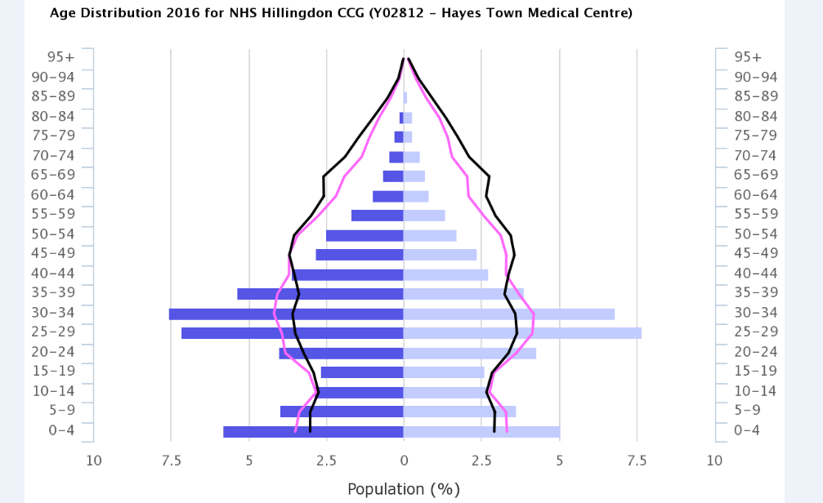 | 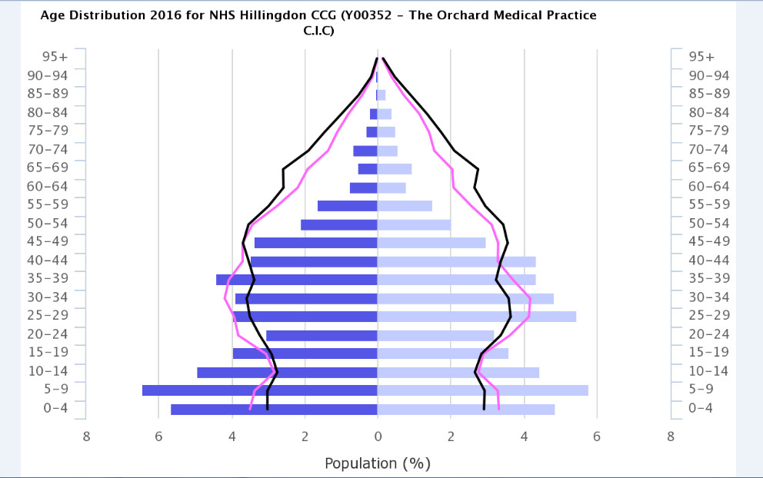
Whilst the ethnicities of both practices are currently similar, there is a higher proportion of Somali speaking patients registered at the Orchard practice.
- The ethnicity estimate Orchard Medical Practice CIC is 3.9% mixed, 41.2% Asian, 14.4% Black, 4.0% other non-white ethnic groups (PHE 2016). The main languages spoken by patients of The Orchard Medical Practice CIC are Somali (60%) followed by Urdu, Polish, Sinhalese (Sri Lankan) and Arabic (Lebanese).
- The ethnicity estimate of Hayes Town Medical Centre is 3.9% mixed, 43.2% Asian, 14.0% Black, 4.0% other non-white ethnic groups (PHE 2016). The main languages spoken by patients of Hayes Town Medical Centre is English (44%) followed by Punjabi (8%), Somali (5%), Urdu (4%), Polish (4%), Arabic (2%) and Bengali (1%).
Hillingdon is a relatively affluent borough, but with large differences existing between the north and south. The north of the borough is semi-rural, with large sections protected by green-belt regulation. The south of the borough is more urban and densely populated. It also has areas falling in the 20 per cent most deprived quartile nationally, and a significant number of areas have children living in poverty.

4.3 Scope of Services
In the future, the CCG expects it may also wish to commission either revised or additional services, funded separately if appropriate, in line with population-based commissioning plans across all forms of contract for primary medical care services (GMS, PMS and APMS). The successful Bidder will subsequently be required to enter into an APMS contract which will include these services. Details of any such requirements will be shared with bidders as soon as any offer is agreed. The table below contains information on the current Local Incentive Schemes (LIS) in offer by the CCG via local primary care contracts. Discussions are underway to commission a new (or similar) set of services in 2017/18
Table 1
Service | Type of contract offer
Diabetes (insulin initiation) | Practice based or at network level
End of life | Practice based
Commissioning LIS | Practice based or at network level
DMARDS | Practice based or at network level
Post-operative wound care | Practice based or at network level
Luteinising hormone releasing | Practice based or at network level
Latent TB | Practice based
Integrated Care Planning | Only at network/federation level-part of Hillingdon pilot Accountable Care Provider programme

The CCG is also considering how it can work with the successful Provider to develop a satellite clinic to support the Heathrow Villages in the UB3 area where difficulties with access to primary care services have been identified. The satellite clinic would aim to provide core primary medical services to about 500-1000 patients operating from premises to be identified.

4.4 The Hesa Centre Premises
The premises are situated within the ground floor of a conversion (from a post office. The landlord is NHS Property Services and the building is shared with other local community services. There is car parking at the back of the building and in nearby streets. It is situated at the beginning of the high street and provides a large amount of footfall. There are good bus links and a national rail station within 100 yards.
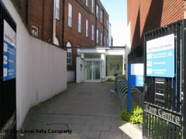

4.6 The CCG
Hillingdon Clinical Commissioning Group is a member of the North West London footprint of CCGs, Sustainability and Transformation Plan (STP). The 8 CCGs across North West London are working together with NHS providers, local authorities and patient representatives to deliver a five year plan for the NHS. This plan is called the Sustainability and Transformation Plan (STP). It is different from previous NHS plans because this it is a place-based five year plan built around patients and joint-working, rather than a more traditional approach based around individual organisations.
The Primary Care standards that all CCGs have agreed to follow in support of the vision for the STP are:
• Proactive care
• Accessible Care
• Coordinated Care
There are 46 general practices is the Hillingdon area with a combined list size of approximately 300,000. Together they constitute the membership of the CCG. The practices are grouped together in three localities: North Hillingdon, Uxbridge & West Drayton and Hayes & Harlington. Practices meet regularly in smaller ‘sub-locality’ groups and each elect a representative to the governing body of the CCG. The two practices at the Hesa Centre are members of the Hayes & Harlington locality
Also, Hillingdon CCG has encouraged collaborative working among GP providers in its borough. From September 2013, the CCG started working with local GPs to promote the idea of forming local practice networks.
At present both Orchard Practice and Hayes Town medical Centre are members of the Clover Health Limited network, which is focused on delivering person-centred integrated health and social care across its network of practices under integrated care planning (ICP). The network has 15 member practices. The practices from the Clover Health Limited network have now joined the Hillingdon Primary Care Confederation Ltd. that was formally established in May 2017 and is made up of 44 Hillingdon practices.
The Provider will be expected to engage with the networks and confederation to improve collaboration between general practices, deliver integrated care and support out of hospital care as set out in the Hillingdon Sustainability and Transformation Plan (STP) part of the North West London STP footprint.

4.7 Primary care hubs
As part of its transformation strategy Hillingdon CCG plans to establish 3 integrated primary care hubs in Hillingdon. The hubs will support the development and delivery of out of hospital services bringing together primary care, community services, diagnostics, specialist services etc.
The Hesa Health Centre has been designated as the site for the South Hillingdon hub. The Provider will be expected to play a leading role in the development of the Hillingdon hub in association with the local GP network and the Hillingdon GP federation.
One key service within the Hesa hub is the GP extended hours service. This is part of the GP forward view programme. The Hillingdon plan aims to ‘top up’ GP hours to deliver seven days services by providing access from 6.30 to 8 p.m. weekdays and 8 a.m. to 8 p.m. on weekends. The Provider will be expected to support this service by making space available out of hours within their premises.
In addition, all practices in Hillingdon including the Provider will be asked to sign a data sharing agreement to enable patients to be seen at any of the Hillingdon hubs as part of the extended GP hours service as well as to enable the Provider to participate in other collaborative service arrangements.

http://www.hillingdonccg.nhs.uk/
https://www.healthiernorthwestlondon.nhs.uk/

5. COMMERCIAL FRAMEWORK

Contract
The contract to be entered into by the CCG and the selected Provider(s) for the will be based on the Alternative Provider Medical Services (APMS) contract and will comply with the mandatory requirements of the APMS Directions 2008 (the Directions) and subsequent amendments including those issued on 1st April 2016. Within this framework, the APMS contract will be adapted as necessary to reflect the requirements of the CCG’s requirements.
The CCG intends to use the standard NHS England’s London Region APMS contract which standardises price and contractual terms across all new APMS Providers in London.

Contract Duration
The proposed Contract will be for a term of 5 years with the possibility of one extension of a further 5 years by mutual agreement between the Provider and the CCG.

Workforce

Policies and Strategies
The successful bidder will be required to provide evidence that all proposed workforce policies, strategies, processes and practices comply with all relevant employment legislation applicable in the UK and in addition comply with the provisions outlined in:
- NHS Employment Check Standards (2013)
- The Code of Practice for the International Recruitment of Healthcare
Professionals (December 2004) (the Code of Practice)
- Standards for Better Health (April 2006)
- Pensions
- CQC Registration Requirements (2012)
- Staff Transfers (TUPE)-– 2006 TUPE Regulations (as amended by the Collective Redundancies and Transfer of Undertakings (Protection of Employment) (Amendment) Regulations 2014)
Further policies that will be required will be set out in the tender documentation relating to this future contract opportunity.

TUPE
The attention of potential Bidders is drawn to the provisions of the European Acquired Rights Directive EC77/187 and TUPE (Transfer of Undertakings Protection of Employment Regulations). TUPE may apply to the transfer of the contract from the present provider to the new one, giving the present supplier’s staff (and possibly also staff employed by any present sub-contractors) the right to transfer to the employment of the successful bidder on the same terms and conditions. The above does not apply to the self-employed.
Applicants are advised against relying on the CCG’s view on the applicability of TUPE and should make their own judgement on the applicability. In the event that the CCG provides a view on the applicability of TUPE, the CCG accepts no liability on this matter. Applicants in taking part in the competitive process in accordance with the guidance set out in this document, accept that the CCG shall not be liable in any respect by expressing a view on the applicability of TUPE.

Training
The Provider must, if required by the CCG, be prepared to provide and / or accommodate, training, teaching and education for doctors including Foundation Programme and Specialist Training in General Practice and the training, teaching and education for other healthcare professionals.
The Provider will be required to comply with the requirements of the Postgraduate Medical Education and Training Board, Postgraduate Medical Deaneries, Royal College of General Practitioners, higher education training providers and the Healthcare Commission (if applicable), and any other relevant training bodies, for the supervision of clinical training.

Premises
The CCG requires the Provider to provide the services from the current premises as located at The Hesa Primary Care Centre, 52 Station Road, Hayes, UB3 4DS

Lease
The head lease for the building is held by NHS Property Services Ltd and the Provider will be required to enter into an under lease with NHS Property Services in order to occupy the property.

Service Charge
The Provider will be required to pay a service charge to NHS Property Services Limited which manages the site on behalf of the tenants.

Facilities Management
The Provider will need to manage the site efficiently and effectively and in accordance with the terms of the lease, in the pursuit of delivery of services to patients under the Contract.

Equipment
The Provider shall be responsible for providing all of the equipment necessary to provide services under the Contract.
Detail regarding equipment available to the Provider for use whilst in contract with The CCG will be shared as part of the procurement process.
The successful Bidder will be required to accept use of this equipment under Schedule 3 of the Contract.
There will be no funding made available for capital expenditure.

IM&T
The Provider will be required to use the Emis Web clinical system already installed at the practice until such time as update/modifications are required/installed by the CCG.

Payment Mechanism
Payment to the Provider is expected to be as follows:
- The current estimated maximum price per Carr-Hill normalised weighted patient is £96.43 inclusive of full KPI achievement and net of Out-of-Hours opt out deduction. The APMS Core Services Price will be increased appropriately to reflect any nationally agreed future changes to GMS Global Sum payments. The maximum value of the KPIs included in the price of £96.43, based on the highest level of achievement at Band A, is currently £5.35 per Carr-Hill normalised weighted patient. The actual contract price will be confirmed at ITT stage.
- PLUS QOF according to standard national schemes.
- PLUS Enhanced services (in accordance with those generally available within the locality and agreed with the Commissioner)

Annexures
Annexe 1-Hesa centre practices catchment area

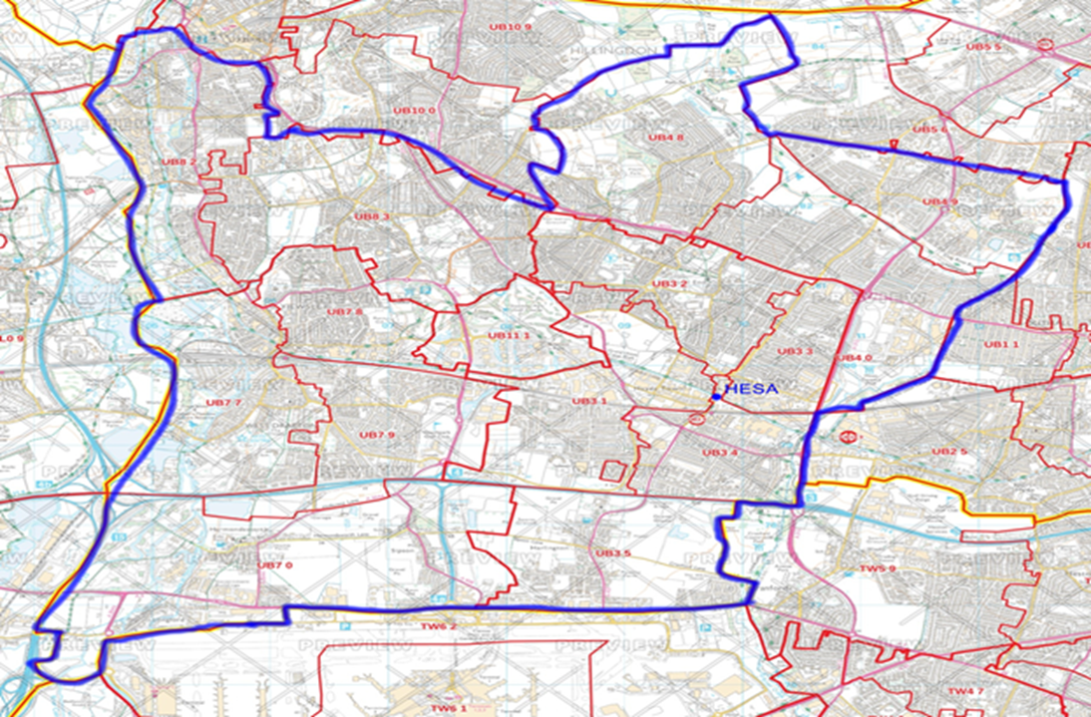

Annexe 2- Hillingdon Borough profile
Hillingdon has 22 electoral wards within three localities: Ruislip & Northwood in the northern part of the Borough, Uxbridge & West Drayton in the central part of the Borough, and Hayes& Harlington in the southern part of Hillingdon. Ruislip & Northwood consists of eight wards, and Uxbridge & West Drayton and Hayes & Harlington both consist of seven wards. The Hayes and Harlington practice is situated in the Botwell ward.

Figure 3: Hillingdon Borough Map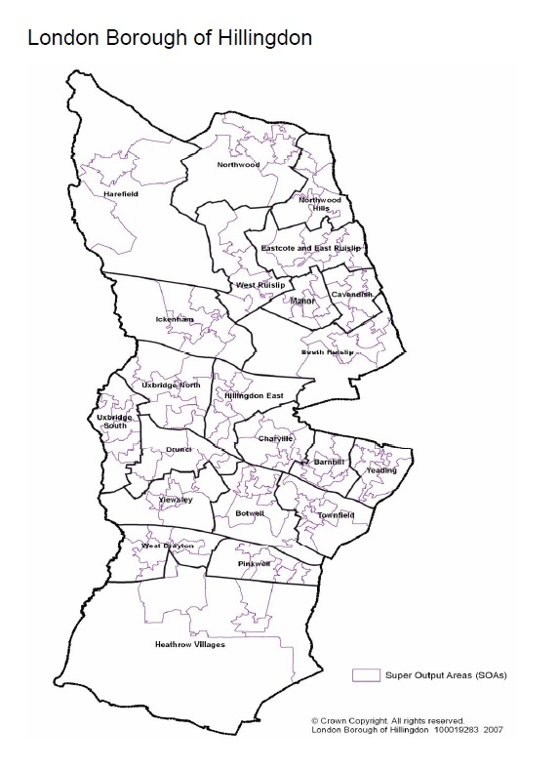

Hillingdon is the second largest of London’s 32 boroughs covering an area of 42 square miles (11,571 hectares), over half of which is countryside and woodland. Hillingdon has always been a transport hub, and home to Heathrow Airport - the world's busiest international airport. It is also the home of RAF Northolt.
Hillingdon is traversed by the grand union canal, the M4 motorway, A40, A4020 and the Great Western Railway. With all those road networks and three of London’s underground lines (Piccadilly, Metropolitan and Central lines) starting and ending in the Borough,
Hillingdon is a major transport hub. South of the Borough is home to the world’s busiest international airport Heathrow, which occupies 1,227 hectares land, and handled 72.3 million passengers in 2013. The arrival of Crossrail in 2018, with new stations at West Drayton and Hayes will open up access to central London even further.
Hillingdon is an ethnically diverse borough with 45% of residents from Black and Minority Ethnic groups. 39.8% of residents identify themselves as White British background (this includes English, Northern Irish, Scottish, Welsh, Irish, Gypsy or Irish Traveller and Other White). 3.9% from Mixed / Multiple Ethnic groups, 37.1% from Asian / Asian British background (including Indian, Pakistani, Bangladeshi and Chinese), 15.4% from Black / African / Caribbean / Black British backgrounds and 3.9% from other ethnic backgrounds (including Arab).

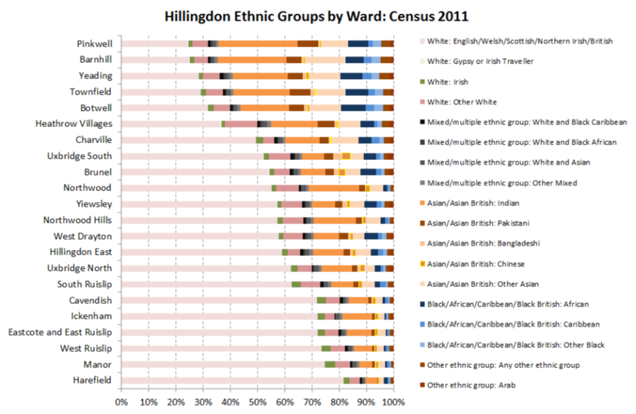
Circulatory diseases and cancers are the two major causes of death in Hillingdon.
Deaths as a consequence of circulatory diseases accounted for an annual average of 830 deaths (30% of all deaths) in the period 2010-2014.
Deaths from all cancers accounted for an annual average of 830 deaths (30% of total) in the period 2010-2014.
An annual average of 398 deaths (14% of total) in the period 2010-2014 were as a consequence of respiratory diseases; the remaining 713 deaths (26% of total) were as a result of other causes.
The overall number of deaths varies on the basis of age structure of population. Therefore, younger populations as in Hayes and Harlington, Uxbridge and West Drayton localities have lower number of deaths when compared with Ruislip and Northwood, where the proportion of older people is higher in the population.
Life expectancy in Hillingdon is estimated at 80.3 years for males and 83.7 years for females (data from 2010-14). This is similar to the averages for London and England.
There are inequalities within the Borough at ward level. The gap in male life expectancy between Eastcote and East Ruislip and Botwell is eight years and the gap in female life expectancy between Eastcote and East Ruislip and Botwell is 8.5 years.
Hillingdon's life expectancy at age 65 for males for the 2010-14 period is 19.1 years, similar to London (19.1) and above the England average (18.7). The female life expectancy at age 65 for Hillingdon is 21.6 years which is higher than the England average (21.2) and similar to the London average (21.9).

The borough’s key health trends are:
- Although population growth as a whole is low (around 0.6 per cent a year) the majority of growth will be in the elderly population, implying a greater need for health and social care services
- The number of older people with dementia is expected to increase by seven per cent over five years to 2015
- A higher burden of households (3.8 per cent) will need support for physical disabilities, frail elderly etc. and 29 per cent of households with frail elderly members living in housing unsuitable for their needs
- Childhood obesity is rising, with 20 per cent of year 6 students classified as obese, and likely to suffer from cardiovascular diseases in time
- Significantly higher numbers of alcohol related hospital admissions compared to England (19 per cent higher for men, nine per cent for women)

Hillingdon is a relatively affluent borough, but with large differences existing between the north and south. The north of the borough is semi-rural, with large sections protected by green-belt regulation. The south of the borough is more urban and densely populated. It also has areas falling in the 20 per cent most deprived quartile nationally, and a significant number of areas have children living in poverty, local developments in the area including Crossrail is expected to impact on population growth in Hillingdon, both for business and residential schemes

https://www.healthiernorthwestlondon.nhs.uk/sites/nhsnwlondon/files/documents/nwl_stp_october_submission_v01pub.pdf
www.hillingdonccg.nhs.uk/download.cfm?doc=docm93jijm4n1026&ver=2251
https://www.england.nhs.uk/wp-content/uploads/2016/04/gpfv.pdf
JSNA (2015): https://www.hillingdon.gov.uk/article/24634/Pharmaceutical-Needs-Assessment-2015
JSNA (2015) https://www.hillingdon.gov.uk/article/21876/Main-report
JSNA (2015): https://www.hillingdon.gov.uk/article/29660/Mortality-and-mortality-rates
JSNA (2015): https://www.hillingdon.gov.uk/article/29584/Life-expectancy
http://www.hillingdonccg.nhs.uk/improving-health-in-hillingdon

