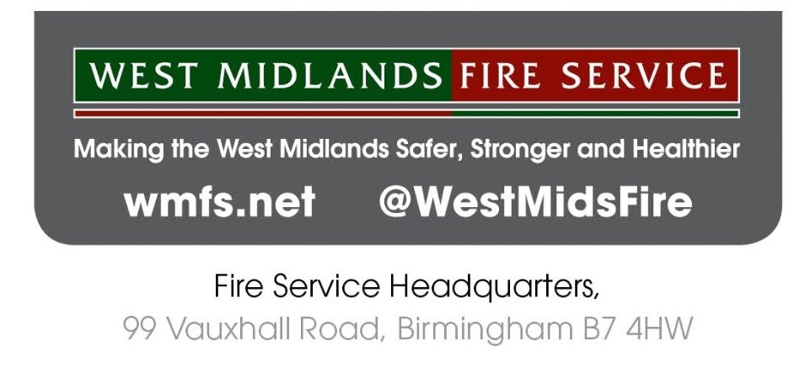
Requirements - Behavioural Assessment Tools
Background
West Midlands Fire Service are undertaking a full review of our approach to how we manage our vacancies. There are key areas of focus for the review to ensure that our selection process and procedures continue to improve in the aspects of openness, transparency, consistency and inclusivity.
The tools that we utilise for selection is a key element of this review and we are keen to explore behavioural assessment tools that are available at different management levels including Supervisory, Middle and Strategic Manager. Any tools utilised will make full use of digital technology.
This is an early engagement exercise for us to gain an understanding of what is available currently on the market and indicative costs. Different costing options that are available would be useful to understand.
As this project is in its early stages, there is no guarantee, at this stage, of a contract being awarded.
Current Process
West Midlands Fire Service (WMFS) currently carries out selection which is driven by vacancies arising. Local Managers are responsible for managing recruitment and selection activity to fill their vacancies, within the parameters of the organisation’s selection framework.
To further develop our approach to recruitment and selection activity, WMFS will focus on creating talent pools from which local selection decisions can be made. Behavioural assessments will be implemented at each management level, i.e.: Supervisory, Middle and Strategic. Those successful during behavioural assessment will subsequently be eligible for role-based selection when vacancies arise.
Requirements
A suite of online testing tools that explore the following requirements:
- Suitable for all employees – both uniformed and non-uniformed roles

- Selection tools will be behavioural based, at the following levels:

- Supervisory Management
- Middle Management
- Strategic Management

- Tools will be applicable to both external recruitment as well as internal selection procedures.

- Behavioural assessments at each level will need to be conducted at various times throughout the year to ensure accessibility for candidates and meet the needs of the organisation.

- Tools need to fully embrace digital technologies and have in built ability to support varying needs of candidates (dyslexia friendly software)

- Tools must be current and relevant to assessment level.

- There needs to be evidence of building a suite of different sets of tools at all levels to cater for candidates that may reapply in the future.

- Testing platform could be fully managed and administered by a company with the potential to train our own assessors if so desired.

- Testing platform needs to be user friendly and support multiple users at any one time.

- System should be able to generate detailed feedback from the exercises to be delivered both in writing and verbally.

- Consideration will be given to different costing options including licence fees, cost per head, or annual contract basis.

- Tools should have been tested and verified to ensure they do not directly impact any group (underrepresented groups not directly impacted)

- Regular management reporting will be required to include adverse impact analysis.

These are the initial key requirements and may change or be added to dependant on how the project progresses and evolves.
To express an interest in this project please complete the short form below and return via the EU Supply tendering portal by 24 June 2021
Up to five companies, of different sizes, will be invited to demo their solution at the beginning of July.
Name of Company:

Contact Details:

Company Registration Number:
Number of Employees:

Do you have an ‘off the shelf’ solution to provide our requirements: | YES/NO
Do you provide the solution to any other Public Sector or Fire Services? Which one?
Please provide a brief overview of the system:

Are you available to provide a demo of the solution at the beginning of July? | YES/NO

