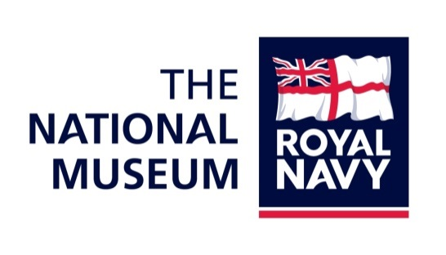

HMS M.33:
Brief for undertaking specification and installation of air handling system to ship in dry dock

- Introduction
HMS M.33 is a Monitor-class gun-ship, built in Belfast for the Royal Navy in 1915 for service in the Great War. She is one of only three surviving Royal Navy vessels from the First World War and the only remaining fighting vessel from the Gallipoli campaign. She was later adapted as a minelayer and a workshop, being finally sold by the Navy in 1987. Hampshire County Council undertook restoration works on the ship in 1990, and after being transferred to the NMRN, she is now permanently moored within no.1 dock in Portsmouth Historic Dockyard.
In 2015 the ship was opened to the public after completion of a restoration and conservation project funded by a Heritage Lottery grant. HMS M.33 is part the National Museum of the Royal Navy which is now responsible for delivering the conservation, maintenance and interpretation of the vessel and its relative collections going into the future.
On assessing the performance and condition of the ship over the first year of being open to the public, the National Museum of the Royal Navy has identified the need to introduce artificial environmental control within the lower deck of the vessel. Due to her construction, the ship suffers from large fluctuations in temperature and very high humidity. Artificial control to introduce stable conditions is necessary both for the long-term preservation of the vessel and also the comfort and enjoyment of visitors and staff.

- The Brief

2.1 This brief sets out the requirements for artificial environment within the interior spaces of the ship. The engine room and forward mess have been highlighted as problem areas of the lower deck and are the main targeted areas for improvement. As such, the brief relates only to the lower deck of the ship, and specifically to the engine room and forward mess (these areas highlighted on plan below). The NMRN will consider different approaches to the problem that may tackle these specific areas with separate units, or a single system that runs throughout the lower deck. Contractors are therefore invited to present:
- Specification for a system that will target the engine room and forward mess areas, with costs for supply and installation
2.2 Further to the installation of the air handling system, NMRN anticipate the need for maintenance and servicing of the plant in future. Without completion of the installation these works necessarily remain as yet unspecified. To that end, contractors should also prepare the following, where possible:
- Recommended maintenance schedule for plant going forwards, and service rates that may apply, should the contractor be able to fulfil this
- Any other recommendations on improvements that can be made in insulating the vessel without significant intervention to the historic fabric

- Specific considerations

Currently the environmental conditions on the vessel closely mirror the exterior conditions, as the vessel is uninsulated. In the last year we have experienced temperatures as low as -3°C and as high as 52°C within the lower deck. Relative humidity fluctuates wildly causing condensation, and ranges between 25-98% across the year.
The following should be taken as the targeted conditions that the system should deliver within the lower deck:
- Target annual temperature range should be 12-28°C
- Target annual relative humidity range should be 40-60%
- Fluctuations in humidity should not exceed 10% per day
- Conditions should exclude the formation of condensation in interior spaces

Post-installation, success will be measured by environmental data capture using Tinytag loggers to record temperature and relative humidity on the lower deck. To be successful, the system must deliver the targeted conditions within 90% of running time. The system must be robust enough for constant use, as conditions on the ship are challenging and it is expected that this will be necessary.
Contractors must demonstrate an understanding of the need to provide a system that will allow the delivery of stable environmental conditions on board the vessel. The following factors should be considered:
- Noise levels from plant must not impinge upon the delivery of the Audio Visual show in the engine room, staff presentations in entrance, school groups working in forward mess
- Plant will be fed only from existing power supply to the dock, and should have potential to be isolated from the rest of the vessel
- Understanding of the need to preserve historic fabric as irreversible works to historic fabric will be unacceptable
- System must be robust enough to withstand the marine environment

- Information in support
The NMRN has the following information to provide to the contractor to allow informed decisions to be made in providing an appropriate specification:
- Environmental data comprising temperature and relative humidity records for one calendar year
- Plans of the ship, also information on location of historic vs recently-installed deck plates
- Dock supply information showing connection points to power
- Asbestos survey report for the vessel
It should be assumed that wherever practicably possible, existing openings/hatchways/port-holes/vents should be used for input/output through the hull of the ship, and that any works to breach the ship’s fabric must be limited to non-historic fabric, eg. recently-installed deck plates.
- Our Requirements
The contractors should have an in-depth understanding of and experience in the installation, use and maintenance of appropriate air handling equipment for public spaces.
The contractors should familiarise themselves with the vessel and be fully aware of the typical conditions on board (and therefore the expected output of the system), to ensure that the system installed is reliable and efficient while remaining economic.
Contractors should provide evidence for efficiency and value for money as reasoning for the approach suggested in the tender.
Contractors should supply a clear statement of annual running costs, through-life costs and expected lifespan of recommended plant.
The contractor is required to exercise awareness and appropriate practise within both a public and historic environment. Any working methods used should not pose a risk to the public or the historic setting. Any material intervention during works on the historic vessel must be notified to the National Museum of the Royal Navy and receive written consent. It is expected that any investigative assessment will be non-interventive.

- What we want in response to this brief
The contractor should provide a project design in response to this brief.
The project design should set out how the air handling system will be designed to fit the spaces (whether bespoke or not), propose the method of installation with size of team required, how the consultant will comply with H&S legislation, and any matters not covered by the brief.
The project design should include:
- Names and CVs of proposed team members and their specific responsibilities, and any arrangements for subcontracting parts of the work, including two relevant examples of previous work case studies
- A timetable for the project, including milestones and dates, which takes account of the time needed from consultations
- The extent of professional insurance or indemnity cover
- A breakdown of chargeable hourly rates (for all individuals) for installation works, including any travel and accommodation costs, subsistence, rental of equipment
- Chargeable hourly rates for maintenance/service, including any travel costs and response times for future care of the system
Consultations are available for contractors and a site visit will be necessary in order to complete the project design. Please contact Diana McCormack, Historic Ships Conservator, via email at hst.procurement@nmrn.org.uk to initially organise these actions.

- Submitting the Project Design & Quote
Please send the project design in a Microsoft Word or Pdf format to hst.procurement@nmrn.org.uk. Tenders should be submitted no later than 12noon on 31st March 2017.
Successful contractors will be selected on the basis of:
- Understanding of the brief
- Quality of method statement and approach
- Value for money.
- Tenders should be submitted no later than 12noon on 31st March 2017.
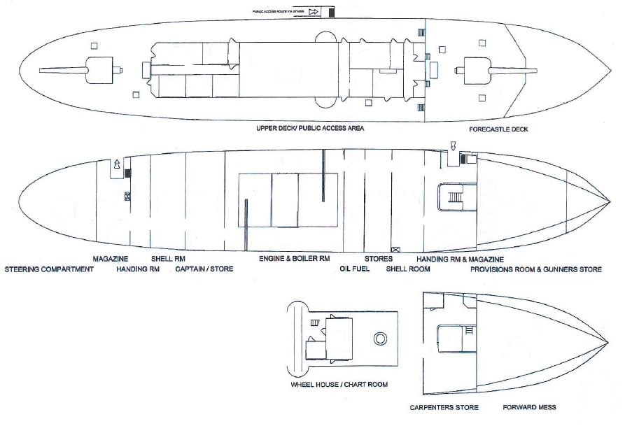
The Forward Mess sits on a half-deck at the forward end of the ship; access is by a short ladder from the lower deck only.

