Thurrock Council

Oracle Fusion Sourcing

User Guide FOR SUPPLIERS

- RESPONDING TO AN INVITATION TO QUOTE Page 2

- NON REGISTERED SUPPLIERS Page 7

- RESPONDING TO OPEN TENDERS Page 15

- RESPONDING TO AN INVITATION TO QUOTE

If you are being invited to quote you will receive an email containing the following message:

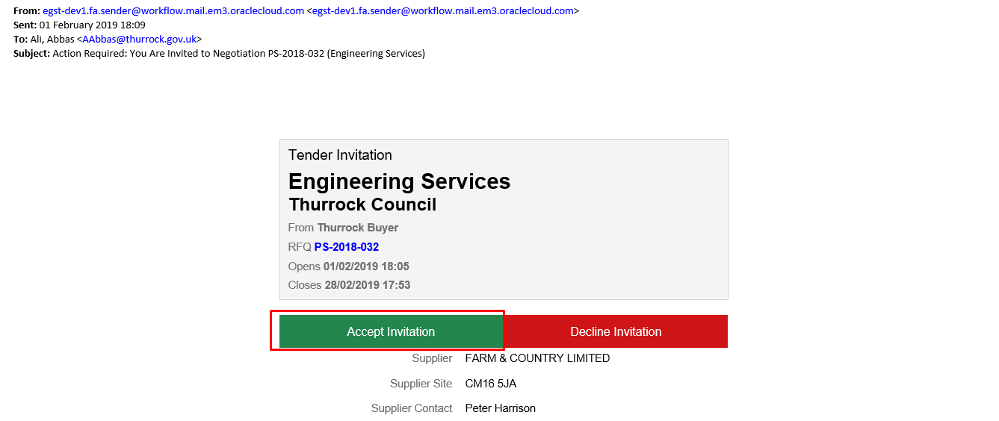

You can either Accept or decline the invitation. If you want to accept the invitation click on “Accept Invitation” and you will be directed to the login page.
After entering your login details this will navigate you to the Supplier Portal.

  - Click on “View Active Tenders” to create the Response for the Active Tender
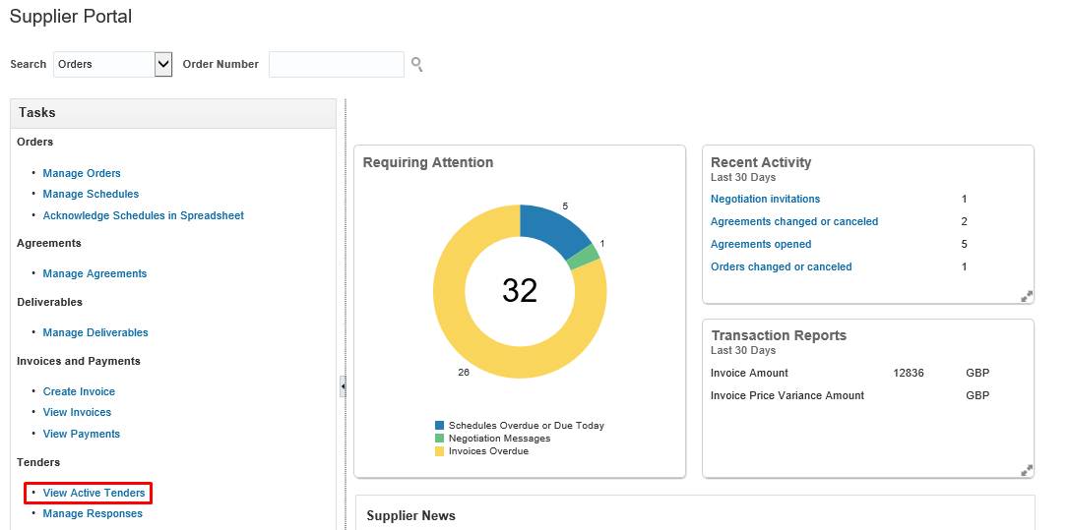

  - Click on Acknowledge Participation button to acknowlegde the Active Tender.
Click on the Tender number to view Tender information before Acknowlegement.

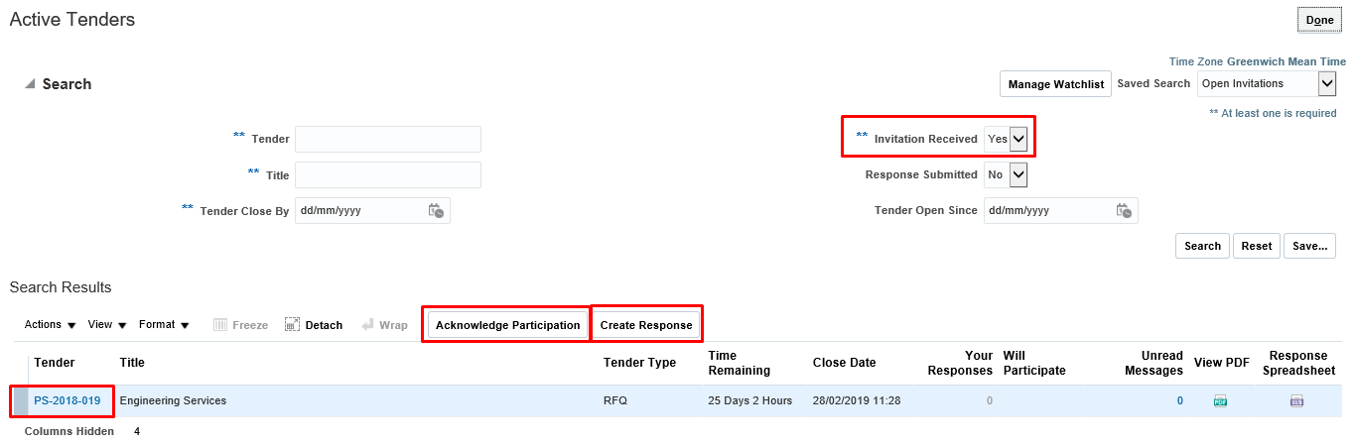

Click on Create Response to submit a response to the Active Tender.

1.4 On Acknowledge Participation message box you can add anote to Buyer (Optional) and then Click on Ok.
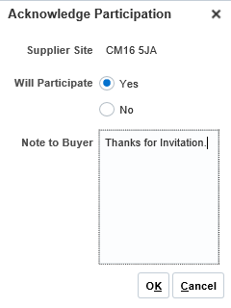

1.5 Click on Create Response button to create responses for the requirements of the Client.
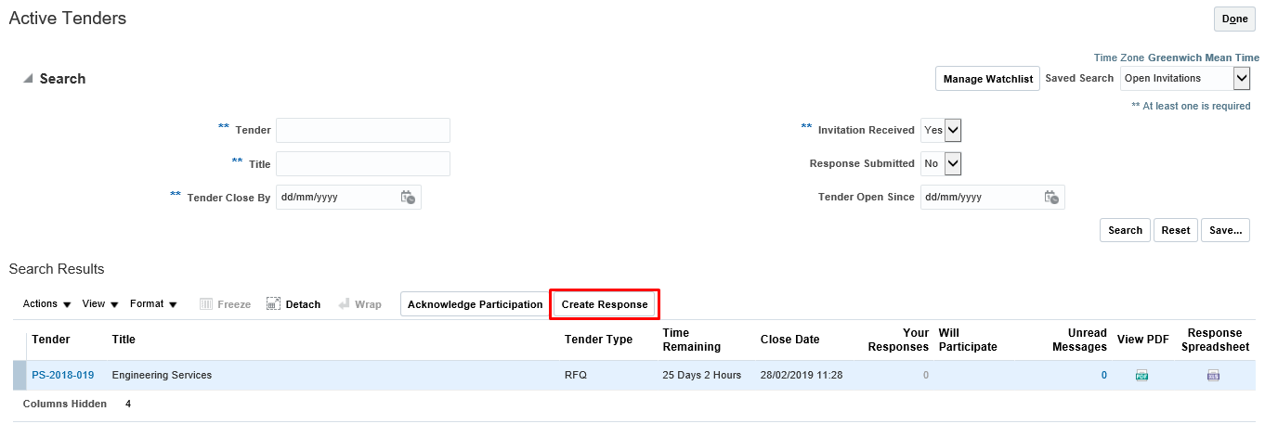

1.6 Requirements: This is where you will respond to the Quality Evaluation Criteria Questions
Enter the response against the requirement section 1.
Add your Supporting Attachment if required under this question. The Requirements with “*” mark are mandatory.
Once all the Requirements of Section 1 has been entered, you can select section 2 which will take you to the next set of questions and complete as above.
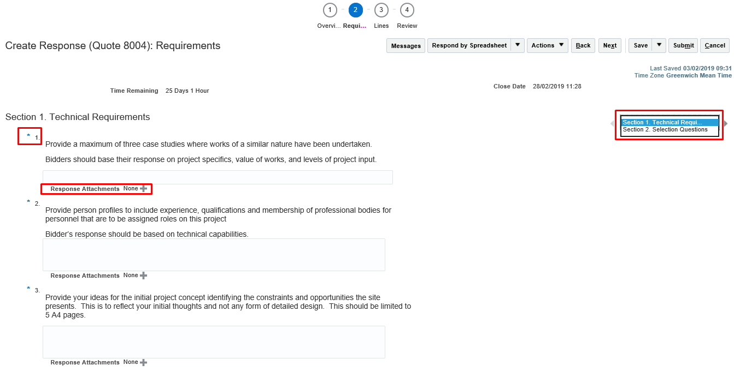
To add attachment click on “+” icon.
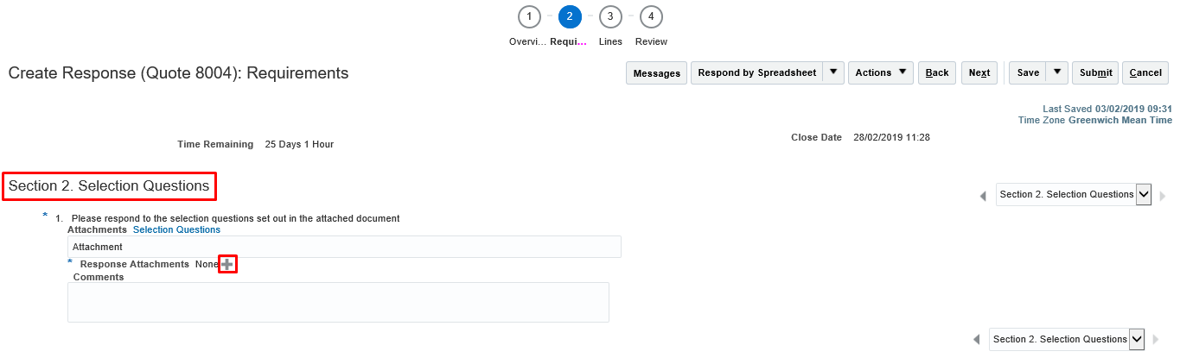
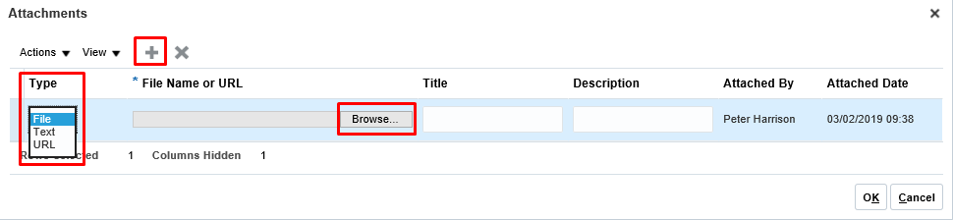

Once the attachment has been added click on save and navigate to to the Price Lines by clicking Next.
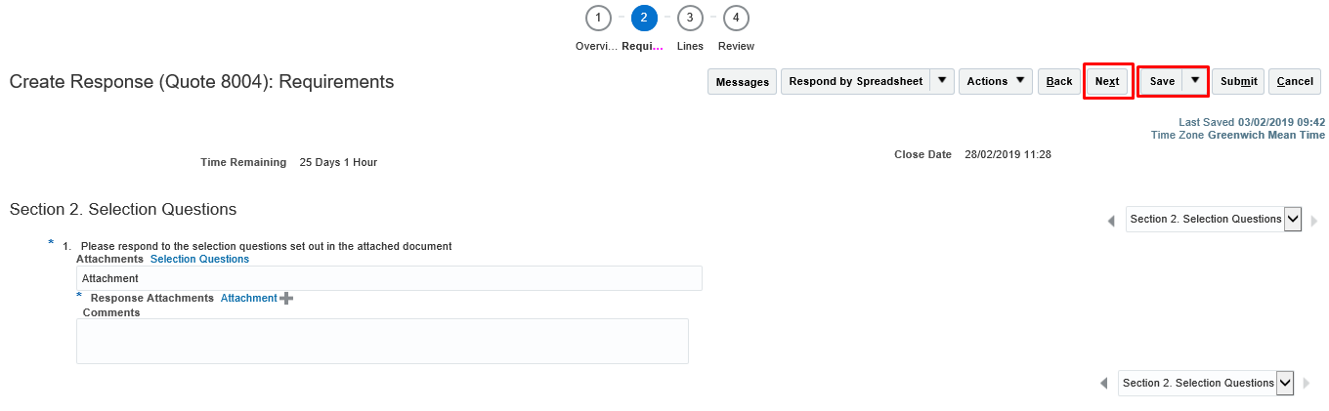

1.9 Price Lines: This is where you will enter your prices where required
Provide the ‘Response price’ against the line and click Next.
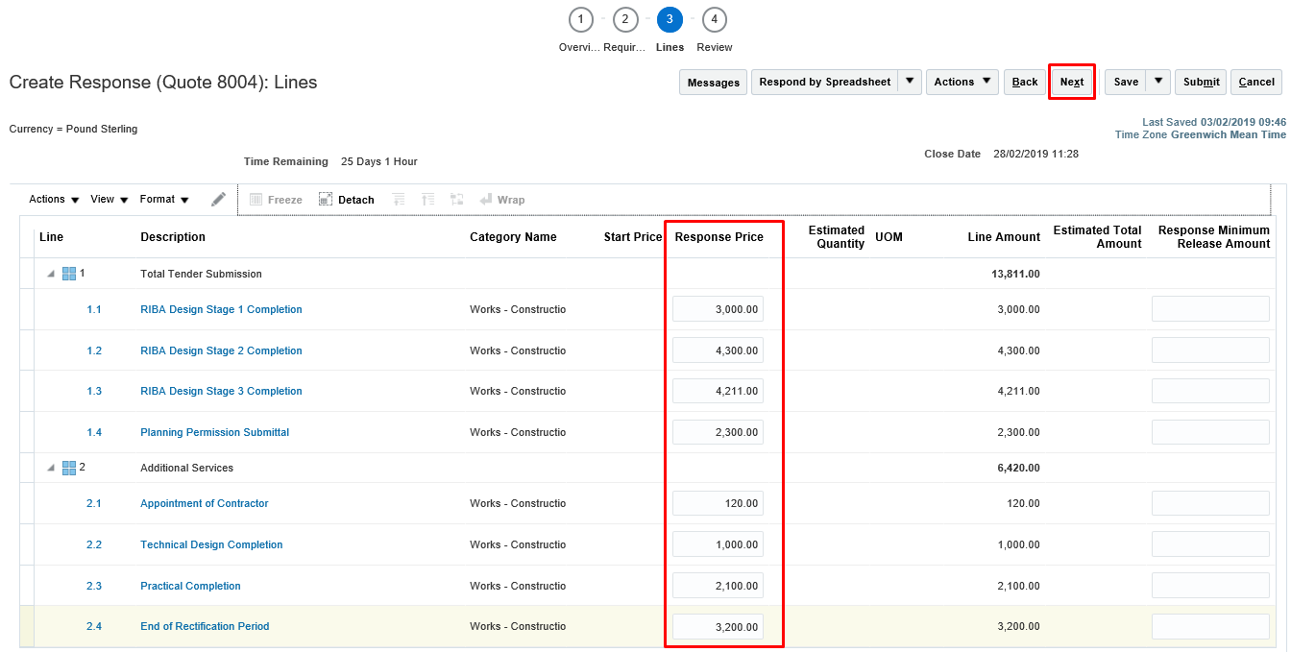

1.10 Review: This is where you can check all your responses and attachments before submitting your response
One you are happy with all of your responses by checking under the headings “Overview” “Requirements” and “Price Lines” and ensure you have uploaded any required attachments Click on ‘Submit’ to submit the response.
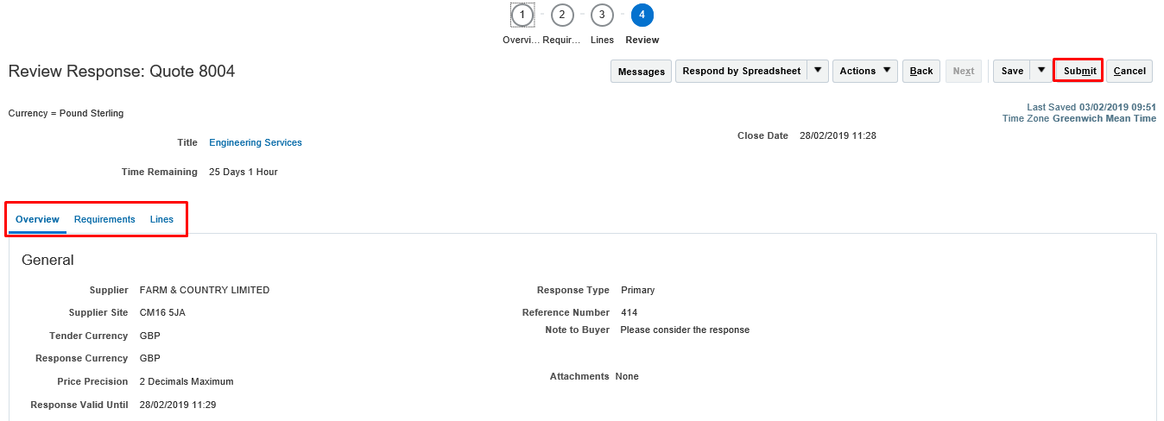
A Confirmation message will pop up that the response was submitted then Click “OK”
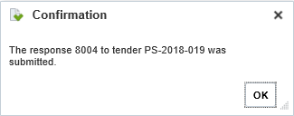

NON REGISTERED SUPPLIERS

2.1 If you are not already registered with Thurrock Council and want to participate to the Tender, you will need to register first.
Click on the supplier registration link provided on the tender advert.
You will be navigated to the Company Registration page as below
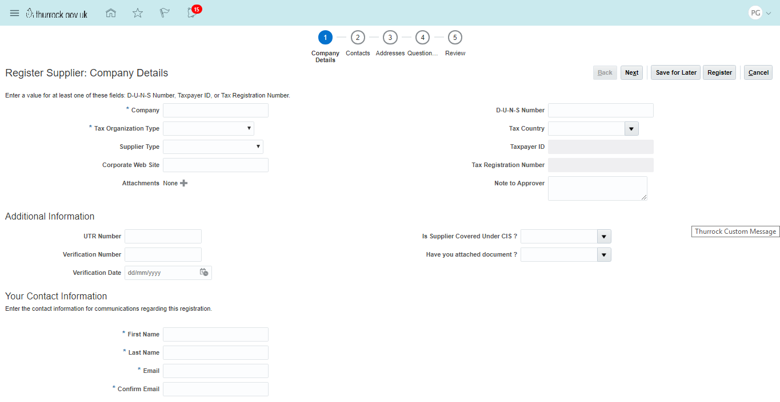
Provide the Details under ‘’Company Details”
Name as per Registration: Specify the Organisation Name as per the Company Registration Certificate or other relevant certificate issue by Authority.
Tax Organisation Type: Enter your Tax Organisation type from the following List of Values:
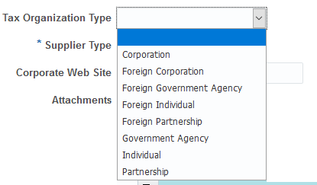

Supplier Type: Select a Supplier type from the list of values displayed in the below screenshot
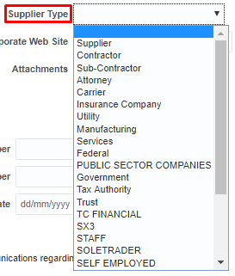

Corporate Web Site
Attachments: Attach Documents (including PDF, Excel, Zip, Word etc.) i.e Insurance Certificates, Qualifications etc that are required by the Thurrock Council for the verification purposes.
Click (+) icon to attach document. Click ‘Choose file’ to upload file from your desktop or laptop
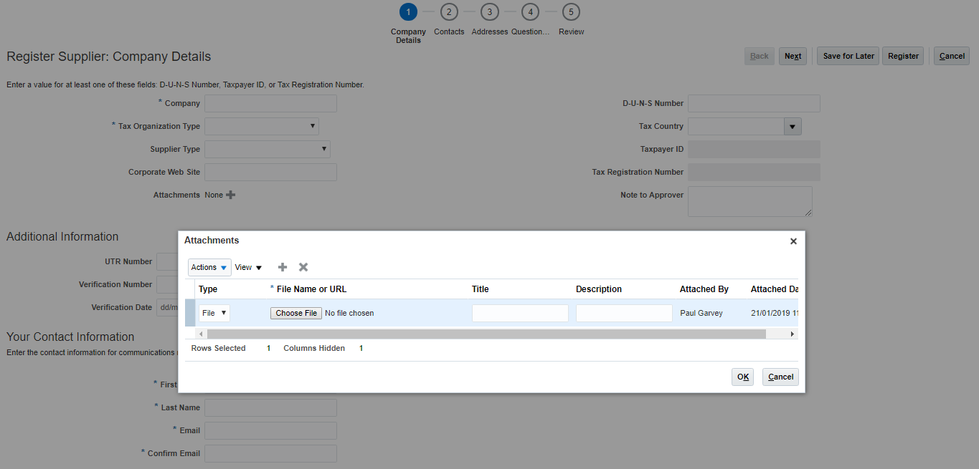

Specify the title of the attachment and click ‘OK’

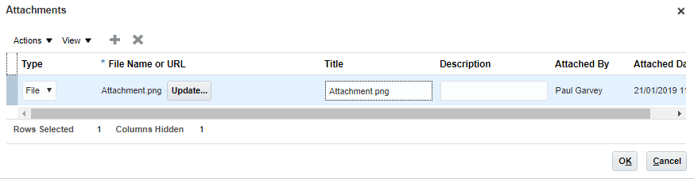

Tax Country: Specify the country in which your organisation is registered.
Tax Payer ID
Tax Registration Number: Provide VAT Number.
Note to Approver: Provide notes if any to Thurrock Supplier admin team which you think is useful for the team to verify the details
Contact Details: Specify the Contact Details

Click ‘Next’ after you have specified the above mentioned information
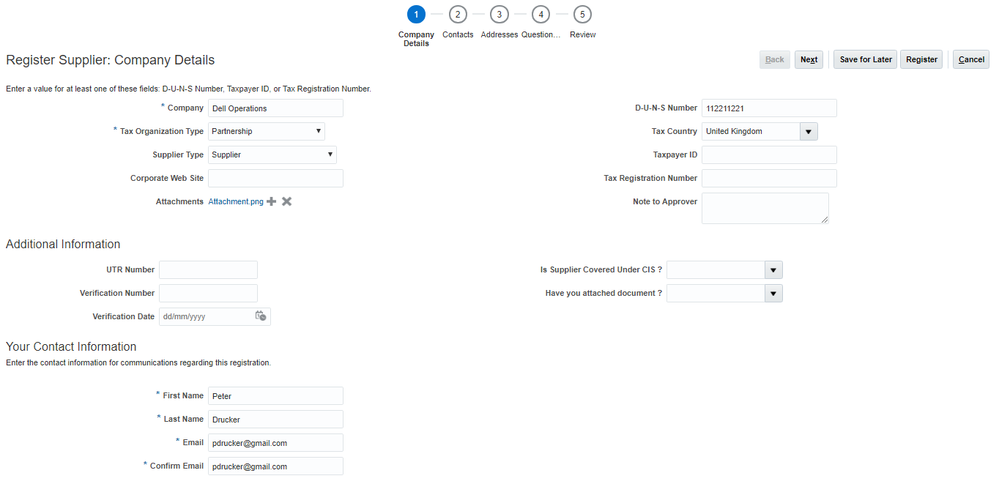
Specify any additional Contacts you wish to add.
Click (+) Icon to create the contact by Specifying below mentioned information
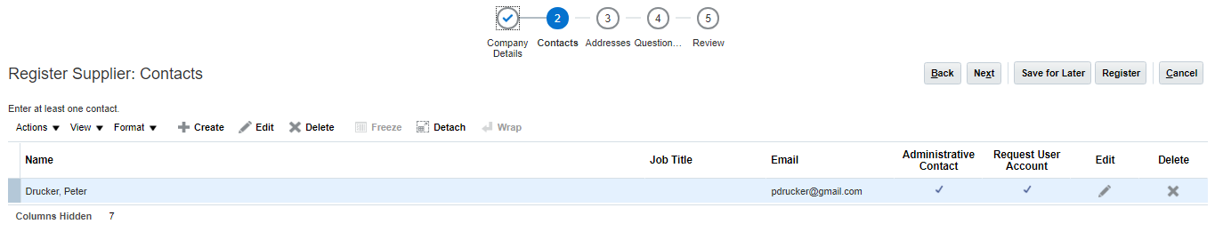
First Name
Last Name
Email Address
Request User Account: Select check box if the additional contact needs access to Thurrock Supplier Portal upon registration.
Click “ok” after details are entered.

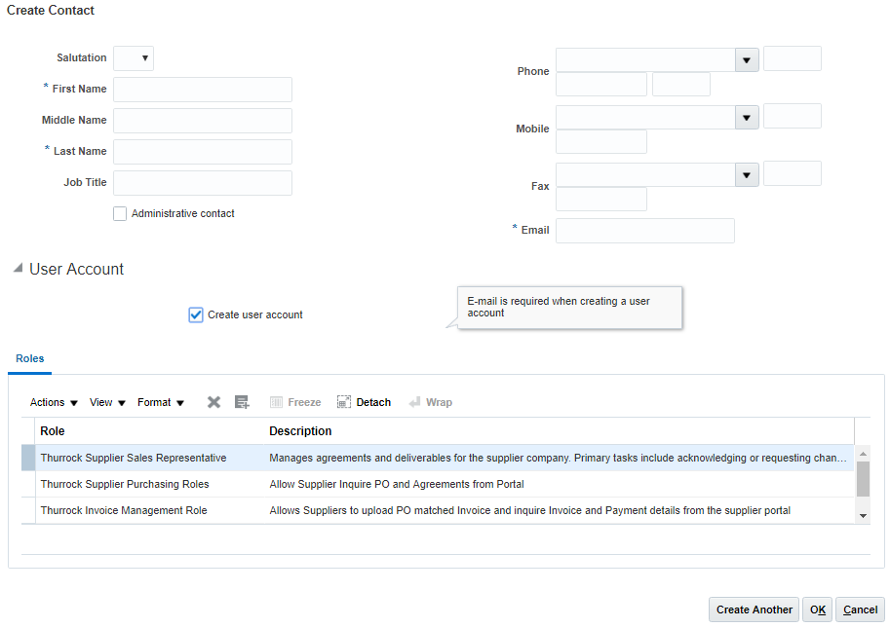
Click ‘Next’

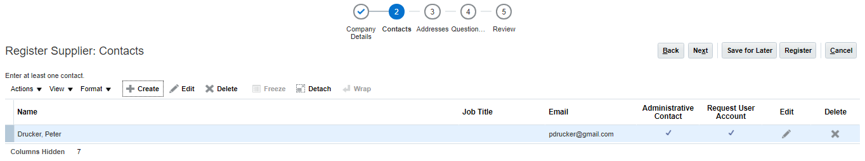

Specify the Address of your organisation’s office by clicking (+) icon
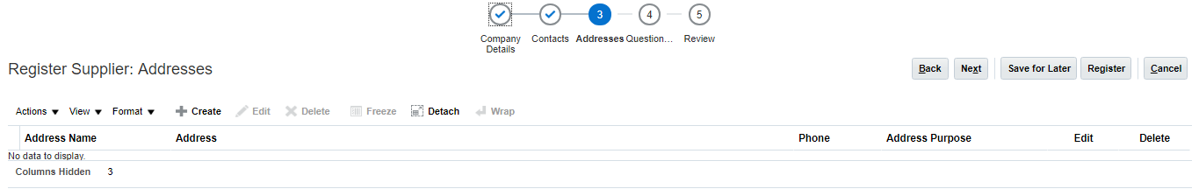

Specify Address Information
Post Code: Address Post Code
Country: Country in which Address is registered
Address Line 1: This is mandatory
Address Line 2:
Address Line 3
City: This is mandatory
Address Purpose: Specify If this Address can be used for placing the Purchase orders and sending Remittance advises by clicking checkbox ‘Ordering’ and ‘Remit to’
Email Address

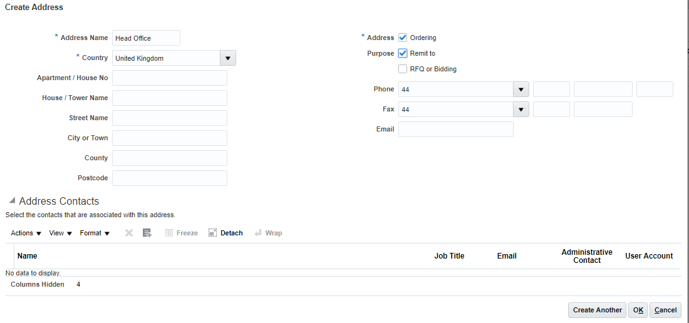
You can specify one or more addresses as per the steps mentioned above.
Once all the addresses are specified click ‘Next’
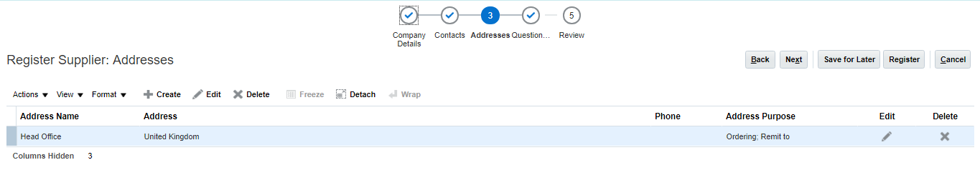

You will need to complete the “Selection Questionnaire”. All questions with “*” mark are mandatory.
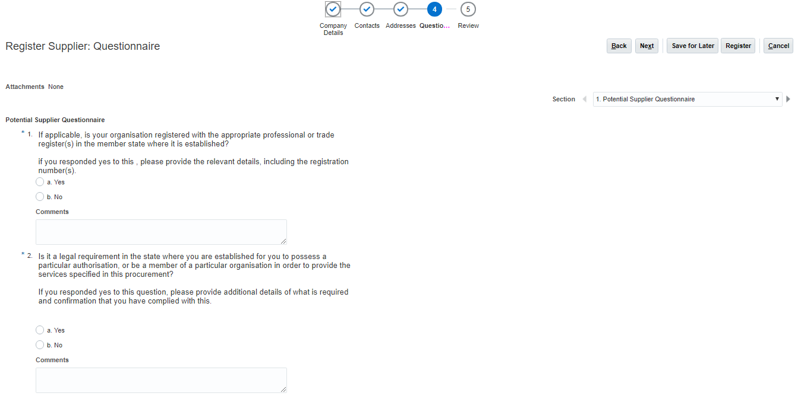
Review all of the details you have entered for your organisation.
If you need to amend any of the details you have entered in any of the sections, click ‘Back’ until you land on to the relevant section of the registration page.
Alternatively, you can click on the relevant section name to navigate directly to the section.
Click ‘Submit’ and then your registration details will be submitted for approval by Thurrock Council.
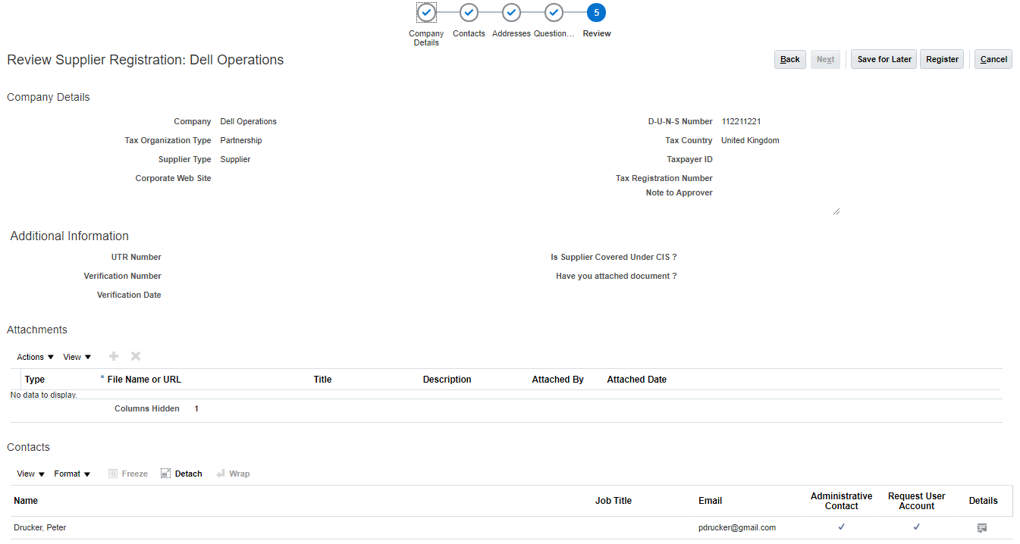

You will receive the following message.

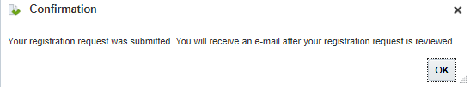

Once the Registration request has been submitted and approved by the Thurrock Council you can then participate in Tenders.
To participate to the Tender after registration follow the steps as in Section 1 above.

- RESPONDING TO OPEN TENDERS

To View “Open” tenders that you have not been invited to click on “Active Tenders”

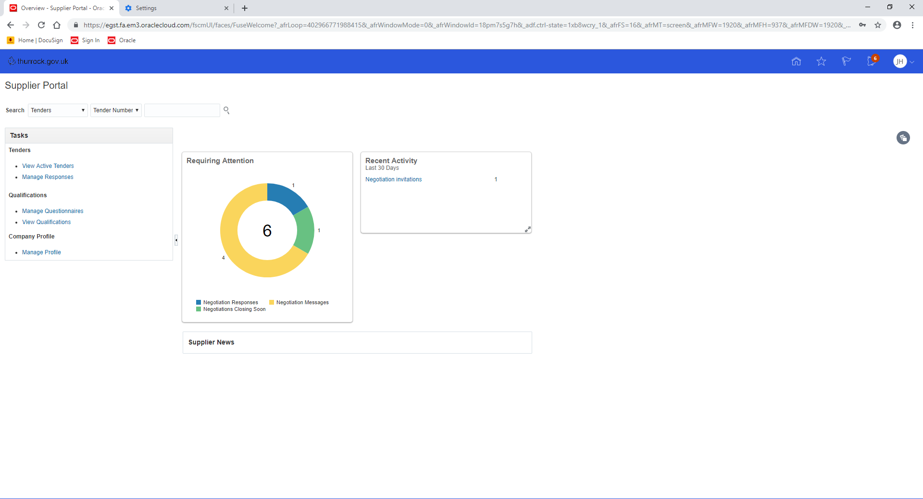

Then change the “Invitation Received” to “NO” and the “Response Submitted” to “NO”
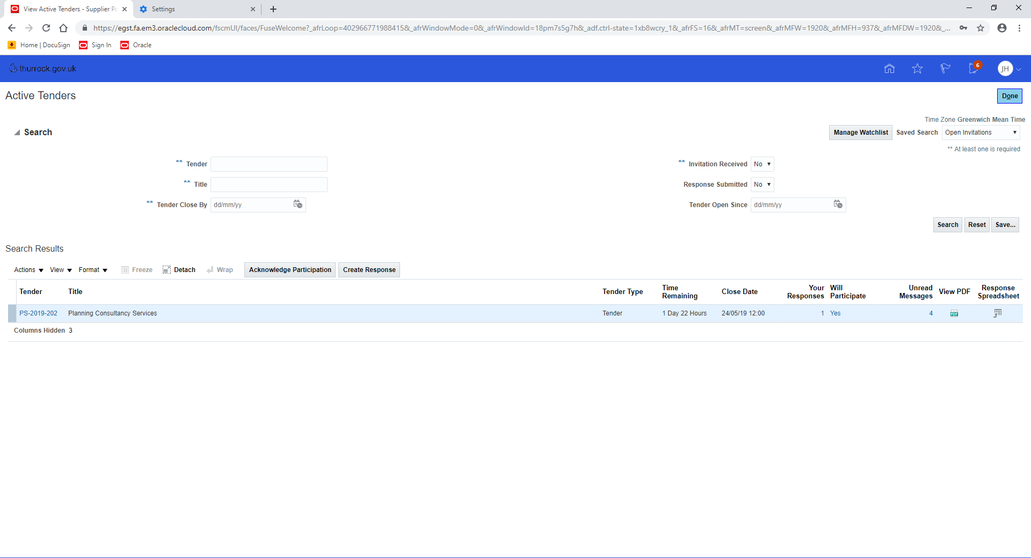

Ensure that in the Search field it is “Open Invitations” then click “Search”
This will then display all “Open” Tenders. To view the requirements under a particular tender click on the “PS reference number”
You can see the time remaining for responding to a tender and view any associated documents.
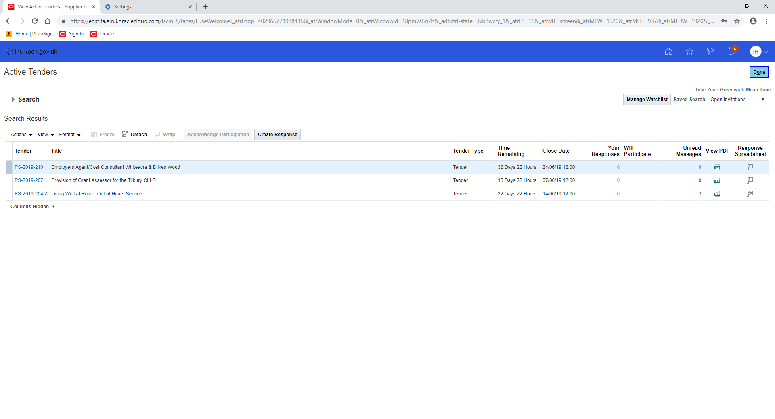
To submit a bid for one of the “Open” tenders then just follow the steps from 1.3 above.

