HIGHWAYS ENGLAND TRAFFIC OFFICER VEHICLES
Specialist Vehicle & Equipment Conversion Specification

CONTENTS

1. INTRODUCTION 3
2. DEFINITIONS 4
3. QUALITY, SUPPORT & FITTING REQUIREMENTS 5
4. MANUALS & DOCUMENTATION 7
5. VEHICLE DELIVERY 8
6. DECOMMISSIONING 9

ANNEXES 11
7. ANNEX A – Radio Communications 12
8. ANNEX B – Lighting Systems 14
9. ANNEX C – Closed Circuit Television (CCTV) 23
10. ANNEX D – Mobile Phone 24
11. ANNEX E – Livery 25
12. ANNEX F – Storage 35
13. ANNEX G – Auxiliary Equipment 36
14. ANNEX H – Telematics System 40

APPENDICES 41
15. Appendix 1 – Communications Equipment and Installation Responsibilities 42
16. Appendix 2 – Customer Works Equipment 43
17. Appendix 3 – Highways England Locations 45
18. Appendix 4 – Road Vehicles Lighting Regulations 1989 – Highways England Exemption VS 20/2016 47
19. Appendix 5 – Jaguar Land Rover Discovery 5 vehicle specification 50

INTRODUCTION

  - This document outlines the requirements for the conversion of a 4x4 type passenger car, intended to meet all the operational requirements of the Highways England Traffic Officer Vehicles (TOV).

  - The minimum conversion and delivery rate is converting five (5) vehicles in five (5) working days, with a further two (2) working days for delivery. Once the new vehicle build is agreed and signed off as fit for purpose. HE expects a delivery plan to be produced by the awarded supplier.

  - The specific contents of this document as detailed below may not be varied by Suppliers without prior written confirmation from Highways England Contracts Team (Vehicles).

  - The base 4x4 vehicle will be acquired through the government Crown Commercial Service (CCS).

  - The Supplier will ensure the Customers Agents are present during all conversion meeting and final sign off. The Customers Agents are the managing agents for Highways England. The Customers Agents will manage the supply, technical support, commissioning and in-service maintenance.

  - The Supplier will be responsible for the provision of all equipment, including the fitment of a lighting system, but not parts provided by Capita or Exeros (see Appendix 1) or any Highways England supplied specialist equipment (Appendix 2) this will be fitted by the Customer on delivery of vehicle. Other equipment i.e. Peli Search Light, will be provided as a free issue.

  - For technical assistance, the Supplier is able to register with TOPIx. TOPIx is Jaguar Land Rover’s technical system provision and, as required by block exemption legislation, is made available in the public domain so that any 3rd party working on manufacturer’s vehicles has access to purchase subscriptions for technical information such as Workshop Manuals, Electrical Diagrams, Technical Bulletins, and Diagnostic Release Notes.

DEFINITIONS

  - A list of definitions referenced throughout this document can be found below;

Customer
Highways England

Supplier
Appointed supplier responsible for conversion, delivery and decommissioning of the base 4x4 vehicle.

Operator
Highways England Traffic Officer

Traffic Officer Vehicle (TOV)
A fully functional Traffic Officer vehicle supplied for operational use by the Traffic Officer Service.

Highways England Contracts Team
The Customers team responsible for the delivery and management of Traffic Officer Vehicles on behalf of the Traffic Officer Service.

Customers Agent
Agent working on behalf of Highways England, who will manage the supply, technical support, commissioning and in-service maintenance as operated by the Traffic Officer Service.

Customers Communication Equipment Supplier
Agent working on behalf of Highways England who will manage its Radio Communication requirements and work with the Supplier on the installation and testing of that equipment.

Base 4x4 vehicle
The vehicle prior to being converted to a fully functional Traffic Officer Vehicle for Highways England. For this Call Off, the vehicle is a Jaguar Land Rover Discovery 5 3L SDV6 306HP Diesel Auto SE.

Legacy vehicles
A Legacy vehicle is any existing Traffic Officer Vehicle, converted and in service.

New vehicles
A new vehicle is any vehicle converted and delivered via this commission.

QUALITY, SUPPORT & FITTING REQUIREMENTS

  - All parts to be used in the conversion will be new and to original equipment manufacturers (OEM) standards, except for items being given a second life; such items will be confirmed by the Customers Agent at a later date.

  - The Supplier shall be entirely responsible for delivering a fit for purpose and defect free vehicle to the Customer.

  - All work practises and installation methods shall be in line with Framework standards.

  - The Supplier shall cover all works forming part of this conversion with a 2 year warranty for parts and labour. The warranty period shall not commence until the vehicle is delivered and accepted as fit for normal service.

  - The Supplier shall attend all incidents whereby a TOV is off the road due to a conversion related defect, within 24 hours of notification (or fund a third party agent who is competent to provide that service).

  - The Customers Agent must be kept informed of all such activities and outcomes.

  - The Supplier will hold a European Quality accreditation such as EN29000, ISO 9000 series or BS 5750. Proof of this must be provided with any bid proposal for this conversion.

  - No modifications shall be carried out by the Supplier or any of its sub-contractors which could adversely affect the original vehicle safety ratings or type approval.

  - No modifications shall be carried out by the Supplier or any of its sub-contractors which could adversely affect or invalidate the vehicle manufacturer’s warranty.

  - All additional wiring will be installed in order to maintain the original manufacturer’s warranty and not have any adverse effect on the vehicle electronic systems. The wiring and positioning of components shall be consistent across all vehicles in any production batch, and furthermore across separate batches of otherwise similar vehicles. All wires must be clearly identifiable against a wiring diagram, either by permanently affixed labels/tabs at each end of the connection loom/cable run or by distinct colour coding. Connectors must be of the highest standard and must be of a permanent nature.

  - Component positioning, especially around dashboard and seating ergonomics will be paramount.

  - To facilitate the use by either dual or single crew occupancy each TOV will have the light bar controller, variable message controller and airwave facia components mounted in the upper centre of the dashboard. This fitting will be undertaken to take into account the dashboard ergonomics, shall not obstruct or interfere with the operation of any of the essential vehicle equipment or dashboard airbag deployment zones

  - All equipment fitted as part of the TOV conversion shall not obstruct or interfere with the operation of any of the essential vehicle equipment or controls. This includes airbag deployment zones.

MANUALS & DOCUMENTATION

  - The Supplier shall create a Specialist Equipment Installation Procedure (SEIP) manual and submit it to Customers Agent and Highways England Contracts Team for approval.

  - A draft will be provided to the Customers Agent by the Supplier prior to build commencement and the full production version of the SEIP after the completion, review and sign off of the first off of any new vehicle type build. Final versions are to be supplied prior to the completion of the batch of vehicles with clear index of any changes made by batch of vehicles if relevant.

  - The SEIP shall detail the make, model, and size or capacity etc of all Specialist Equipment, and the installation method, location, and fixing of the equipment into the vehicle, wiring diagrams and fuse type and ratings to ensure consistency of the conversion. No changes to build specification may then be made by the Supplier without written authority from the Customers Agent or Highways England Contracts Team.

  - The Supplier shall provide the following documents (distribution & quantity in brackets):

  - Full production version SEIP detailing fleet numbers within this build batch (from – to) (1 hardcopy Highways England Contracts Team 1 hardcopy to Customers Agent + both parties are also to be supplied with an electronic indexed PDF document showing;

    - Position of all additional fixed components and method of installation
    - Function of each component, including relationship to other components
    - Fault diagnosis guide
    - Wiring diagrams (schematic acceptable) showing:
    - Colours / ID markings
    - Connector types
    - Current loading
    - Fuse ratings (where applicable) and location
    - Livery guides
    - Photographs showing interior and exterior images to the front, rear and side and dashboard / cabin area showing all major component fittings.

  - User Guide to be provided by the Supplier with every vehicle in an A5 format, capable of being incorporated into the manufacturer issued handbook wallet. This guide must provide simple instruction, including illustrations on the use of all controls within the vehicle and guidance in the event of an emergency system failure. This guide must be printed in a durable format and capable of being replaced if required..

  - Build quality control sheet must be sent to Customers Agent prior to vehicle delivery.

  - Final Delivery Inspection document (template provided by Highways England Contracts Team / Customers Agent at award of Call Off Contract) to be used to confirm compliance with specifications and functional testing and circulate as indicated on the document. To be signed on receipt of vehicle by Highways England.

VEHICLE DELIVERY

  - The minimum conversion and delivery rate is converting five (5) vehicles in five (5) working days, with a further two (2) working days for delivery. Once the new vehicle build is agreed and signed off as fit for purpose. HE expects a delivery plan to be produced by the awarded supplier.

  - The Supplier is to ensure that all vehicles are delivered complete with a User Guide.

  - The Supplier shall ensure that all vehicle manufacturer pre-delivery inspections, supply and fitting of number plates are carried out on all vehicles provided. Including all handbooks, service log book (provided and correctly stamped by the supplying dealer).

  - The Supplier must notify the Customers Agent at least 2 weeks prior to intended delivery that the vehicle will be ready.

  - The Supplier shall ensure that all vehicles are up to show room standards of cleanliness (i.e. clean, polished and smear-free) when delivered to Highways England and must meet the following requirements;

    - Minimum of 2 gallons of fuel.
    - A spare set of keys.
    - Fit for purpose and without defects.

  - The Supplier shall ensure a professional handover of all vehicles delivered to Highways England and meet’s the employer’s duty of care, in relation to the operation of the vehicle, as follows:

    - A full explanation of the controls and features of the vehicle.
    - A Signed Delivery sheet including checks and confirmation that operating instructions have been given to Highways England.
    - An A5 size User Guide included within the Traffic Officer Vehicle log book.

  - The Supplier shall deliver the vehicle to an address as agreed by the Highways England Contracts Team (Vehicles), a delivery window of 4 hours is to be provided and Highways England will provide a contact point and telephone number. Any delivery outside of the pre agreed window must be communicated at the earliest opportunity. In most cases the vehicles will be delivered to one of the Regional Control Centres (RCC) locations; however in exceptional circumstances Highways England may require delivery to one of its Outstation locations (see Appendix 3).

DECOMMISSIONING

  - Overview

    - As part of the conversion service the Supplier must include the costs associated with end of life decommissioning for up to 70 legacy vehicles replaced by new vehicles delivered via this commission.

    - The costs submitted by the Supplier will include vehicle collection from its operational location and may include storage prior to disposal and onward movement to a sale centre within a 150 mile radius.

    - For any legacy vehicle, Highways England will advise the Supplier at a minimum of two weeks’ notice of the intention of returning a vehicle for the decommissioning process. It must be noted that due to operational requirements these initial plans may change although the Supplier will be advised in this event.

    - Equipment decommissioned from vehicles are to be carefully removed ready for storage at a facility to be determined by Highways England. The supplier is to allow for temporary storage and delivery of this equipment when requested

  - Vehicle Collection Requirements

    - Vehicles are to be collected from one of the 38 outstations (detailed in Appendix 3 – Highways England Locations), please note a new vehicle being swapped for an old vehicle must not be assumed. Return vehicle collections may take place from a different location on a different day.

    - Highways England staff will ensure the vehicle is;

      - Clean
      - Sufficiently fuelled for return
      - De-kitted
      - Radio Module removed
      - All Highways England paperwork removed
      - Service book present
      - Vehicle Handbooks present
      - Spare wheel (if fitted),
      - Jack and wheel brace present
      - Two / Three operational keys

  - Vehicle Decommissioning Requirements

    - The decommissioning work will return the vehicle back to its original specification and condition as far as is reasonably possible. The British Vehicle Rental & Leasing Association (BVRLA) guidelines will apply to establish an acceptable condition for disposal.

    - The Supplier must provide a decommission inspection report document, images may be requested for any repairs required.

    - Within 2 working days of receipt of the return vehicle the Supplier must conduct a preliminary inspection in order to notify the Customers Agent of any significant issues, including but not limited to;

      - Presence of spare wheel (if fitted)
      - Presence of owner’s manuals and service documents
      - Customers Agent will provide electronic service history for all vehicles to the Supplier – this must be placed inside the vehicle
      - Condition of tyres
      - Significant damage or missing parts
      - Faults on the vehicle systems of an electrical or mechanical nature.

    - If any defects are discovered the Customers Agent must be invited to the Suppliers premises at the earliest opportunity (min 5 workings days’ notice) to conduct an inspection.

    - Where necessary the Supplier will agree to obtain quotes for all body repairs or other repairs in a timely manner on behalf of Highways England.

    - The following list of decommissioning requirements is not exhaustive and the Suppliers may contribute added value;

      - Removal of Livery, clean and polish external paintwork
      - Removal of all Capita equipment, looms and key components (some small elements may remain in the vehicle by prior agreement)
      - Removal of all specialist lighting equipment
      - Removal of the Variable Message Sign and controller
      - Removal and retention of any other Highways England items from the vehicle.
      - Full interior valet, including head linings where necessary
      - The Highways England contracted turnaround time for standard decommissioning of any vehicle is 5 working days from return of the vehicle to the decommissioning agent.
      - Any holes in the bodywork must be covered where possible.
      - All trim elements must be securely refitted and holes covered where possible.
      - All removed equipment must be held securely pending a decision on its future use or its return to the Customer.

ANNEXES

ANNEX A – Radio Communications

  - Highways England’s prime communication supplier is Capita. The Supplier will work with Capita and their assigned technicians to ensure the communication equipment is fitted within the conversion build schedule. The Supplier is required to install various elements of the Capita kit; these are detailed in Appendix 1 – Communications Equipment and Installation Responsibilities.

  - Capita will issue a Preferred Vehicle Installation Document (PVID) for each vehicle type. Where the vehicle is a ‘first of type’ for the Highways England conversion, the Supplier must make suitable resources and staff available to work with Capita to engineer a solution for that vehicle type and for Capita to produce their PVID which must then be adhered to by the Supplier, on all subsequent builds for that vehicle type.

    - The wiring loom which forms part of the Capita installation kit shall be made available free of charge to the Supplier, who shall fit it to the vehicle as part of the conversion.

    - The Supplier shall liaise with Capita to provide their Airwave technician with access to the vehicle at reasonable advanced notice at the Supplier premises, for a period of up to 8 hours, to install the following Customer Specialist Equipment*.

      - SRM/SRG Sepura unit (comes complete with transceiver, display head & pivot hinge, transceiver mounting plate & 12v power cable)
      - 5m data cable
      - PTT / microphone kit with flexi stalk
      - Low profile Speaker unit
      - Fist microphone or secondary PTT
      - GPS/Tetra Kombi antenna

*Please read Appendix 1 – Communications Equipment and Installation Responsibilities which may amend certain items of the above list – Appendix 1 takes precedence

    - After installation and testing of an Airwave radio the Capita Airwave technician will certify the installation as fit for purpose.

    - The certification will be carried out by the Capita Airwave technician using specialist radio module for that purpose that will be removed on completion of the test.

    - The Customer (end user) will fit the vehicle's operational radio module after vehicle delivery.

    - When any legacy vehicle is returned for de-commissioning the Supplier shall remove the Capita Equipment and this will be made available to Highways England as part of the decommissioning process documented above.

    - As the Airwave Radio service is a secure communications network the radio module must be able to be easily removed when the vehicles is taken out of service. The radio module must be secured to the equipment backboard using easily removable fixings, i.e. wing nuts. Self-tappers or speed clip fixings are not permitted.

ANNEX B – Lighting Systems

  - All auxiliary lighting systems should meet the requirements below and be compliant with the Road Vehicles Lighting Regulations, including Highways England exemption VS 20/2016 (Appendix 4 – Road Vehicles Lighting Regulations 1989 – Highways England Exemption VS 20/2016).

  - The main elements of the lighting equipment are as follows;

    - Roof light bar and 16 button programmable controller
    - Rear facing Variable Message Sign (VMS) and scrolling menu controller
    - Additional front, side and rear position lights

Under no circumstances are any deviations to VS 20/2016 permitted.

  - Variable Message Sign Specification

    - A fixed Variable Message Sign is to be located inside the rear door window. The whole of the sign is to be visible without the obstruction of any part of the vehicle, including the wipers when in the parked position. The position of the sign is to be located so that there is clearance with the load carrier and equipment carried. Position and mounting configurations must be approved by the Highways England Vehicles Team.

    - Alternatively, a motorised flip-down / up sign may be acceptable for some vehicle types where rearward vision is compromised. This must be approved by the Highways England Contracts Team.

    - Signed specification as follows:
      - Minimum 110mm character height.
      - Maximum height of sign when extended to be 140mm (in order to maintain rear visibility).
      - Minimum 9 character width.
      - Up to 20 pre-programmed messages.
      - Steady amber super bright / high intensity display, with excellent contrast and capable of still being read clearly at up to 50 metres, directly behind the vehicle in bright/direct sunlight.
      - Dimming control for night time / poor visibility operation.
      - Cab mounted illuminated controller must be able to show current displayed message and menu options simultaneously.

  - The approved messages are (to be displayed in this order):
      - DONT PASS
      - STAY BACK
      - THANK YOU
      - Right direction arrow (left to right)
      - Left direction arrow (right to left)
      - WIDE LOAD
      - LONG LOAD
      - INCIDENT
      - SLOW DOWN
      - FOLLOW ME (Dartford Crossing only) ID vehicles during build to determine if required

  - Some regional locations may require specialised messages to be programmed. These will be communicated in the event of this requirement.

Table 1
Image | Dimensions  (mm – L-D-H)
Panel:
573 x 42 x 140

Controller
105 x 25 x 65

(note, additional space required under controller for loom)
Kit includes a loom from handset to panel – on some vehicles this may need to be extended. The kit does not include mounting brackets.

  - Lighting & Alert Systems Specification

    - In addition to the standard manufacturers lighting, all vehicles shall have the following items fitted:
      - Roof mounted light bar.
      - Front mounted amber grille lamps.
      - Rear mounted red lamps.
      - Brake light flashers.
      - Light bar control system and controller
      - Headlamp flash system.
      - Bull horn.

    - The way in which this equipment is used, the sequence in which the lights flash and the messages that are displayed, are all strictly controlled to ensure that agreed traffic management methods are maintained.

    - All lighting equipment in this specification must be of an LED type, unless otherwise stated.

  - Roof Mounted Light Bar Specification

    - Front of bar
      - Four forward facing amber lights, linked to flash at the same time as the front grille lamps.
      - Centre of bar to have a blank space, equivalent to 2 LED’s, for possible future upgrade.

    - Side of Bar
      - Two amber lights on each side of the light bar ensuring an overall 360 degrees of visibility.
      - Two side facing white alley lights (one on each side).

    - Rear of Bar
      - Two pairs of rear facing amber lights, located at the outer edges of the light bar.
      - A maximum of two pair of rear red lights (to alternate in flash pattern with the opposite side ambers), located adjacent to the outer amber lights. The roof reds may be linked to repeat with the diagonally opposing lower mounted rear red lights so long as the requirements of VS 20/2016 are met.
      - Centre of bar to have a blank space, equivalent to 2 LED’s, for possible future upgrade.

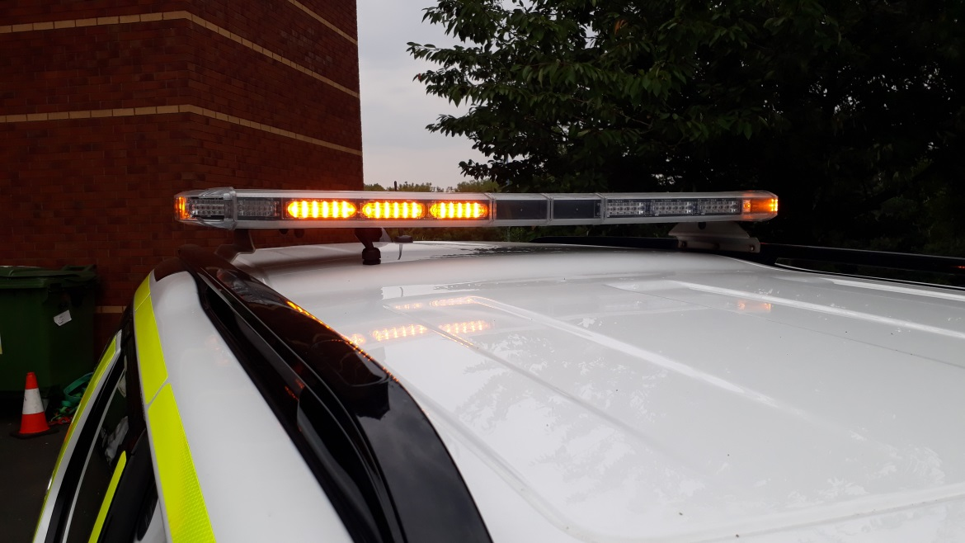

 |  |  |  |  |  | Front
 |  |  |  |  |  | amber grille lamps
 |  |  |  |  | 15 |  | 16
1 |  |  | 2 |  | 3 | Front | 4 |  | 5 |  |  | 6
 | A |  | A |  | A |  | A |  | A |  | A
 | A |  | A |  | R |  | R |  | A |  | A
7 |  |  | 8 |  | 9 | Rear | 10 |  | 11 |  |  | 12
 |  |  |  |  |  | Rear
 |  |  |  |  |  | low level lamps
 |  |  |  |  | 13 |  | 14

Table 2
Light bar Operation Sequences
360 | 1 = 1a + 4a + 5a + 15a + 7a + 8a
 | 2 = 2a + 3a + 6a + 16a + 11a + 12a
Front Ambers | 1 = 1a + 4a + 5a + 15A
 | 2 = 2a + 3a + 6a + 16a
Rear Ambers | 1 = 7a + 8a
 | 2 = 11a + 12a
Rear Reds | 1 = 10r + 13r
 | 2 = 9r + 14r
EMERGENCY (same as 360) | 1 = 1a + 4a + 5a + 15a + 7a + 8a
 | 2 = 2a + 3a + 6a + 16a + 11a + 12a
Arrival | 1 = 7a + 8a + 10r + 13r
 | 2 = 11a + 12a + 9r + 14r
(a = amber, r = red)

  - Light bar Mounting
      - Universal removable mounting kit to mount light bar to vehicle.
      - Mounted towards rear end of vehicle roof.
      - Mounted in a way to minimise damage to the vehicle

    - Note: The vehicle must have an audible warning if the light bar is in use while the vehicle is being driven.

  - Light bar Control System and Controller

    - The light bar controller shall be installed with the ability to pivot, to allow use by either the driver or passenger. The cradle for the light bar controller is to be positioned as close as possible to the driver at the highest practical position. The controller shall provide the following functions:

Table 3
Switch | Legend | Light Bar Function | Additional Function
1 | EMERGENCY | All amber lights | All amber lights
2 | ARRIVAL | Rear amber and red lights
3 | REDS | All rear red lights | Additional rear reds if tail gate obscures rear light bar visibility
4 | RESET / TEST | All Lights off | Walk Test
5 | HEAD LAMP FLASH | N/A | Headlamp Flash system
6 | RIGHT ALLEY | Right alley light | N/A
7 | BULL HORN | N/A | Bull Horn. Emergency mode vehicle horn switch to activate or controller at any time
8 | FRONT AMBER | All front amber lights | Front Grille lights
9 | 360 | All amber lights
10 | REAR AMBER | All rear amber lights
11 | EMERGENCY START | N/A | Allow aux battery voltage to main battery for starting
12 | LEFT ALLEY | Left alley light
13 | FAULT | Error light if communication error between bar light / controller
14 | RUN LOCK | N/A | To enable run lock
15 | INTERIOR | N/A | Interior strip lamp
16 | LOW POWER | Low power setting | Low power to all other additional lights

11
14

3

1

5

8

12

15

9

6

16

13

2

4

7

10

      - Automatic dimming facility to reduce controller illumination.
      - Permanent back light illumination for low light viewing of legends on all switches (must switch off when vehicle engine is not running).

  - Front Mounted Amber Grille Lamps

    - Two amber lamps are to be fixed to both sides of the vehicle. Lamps are to be linked to forward-facing amber lights in the light bar and mounted at headlamp level. The positioning (offset from each side) should maximise visibility without placing the light units in an exposed area (to avoid damage). Fitment must minimise bodywork intrusion/cutting. Type and configurations must be approved by Highways England.

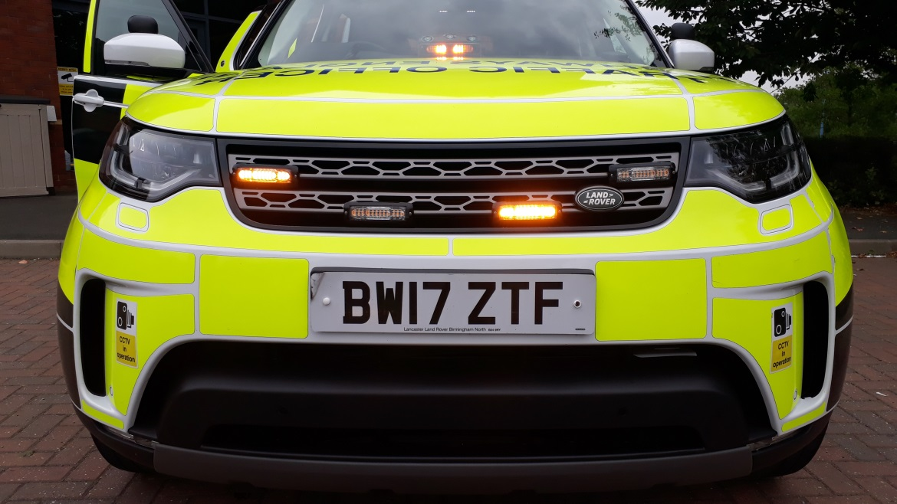

  - Rear Mounted Low Level Red Lamps

    - Two additional rear window hideaway red lights linked to alternate with upper level red lights in the light bar may be required to be fitted if enhanced visibility is required. Type and configurations must be approved by Highways England and comply with VS 20/2016.

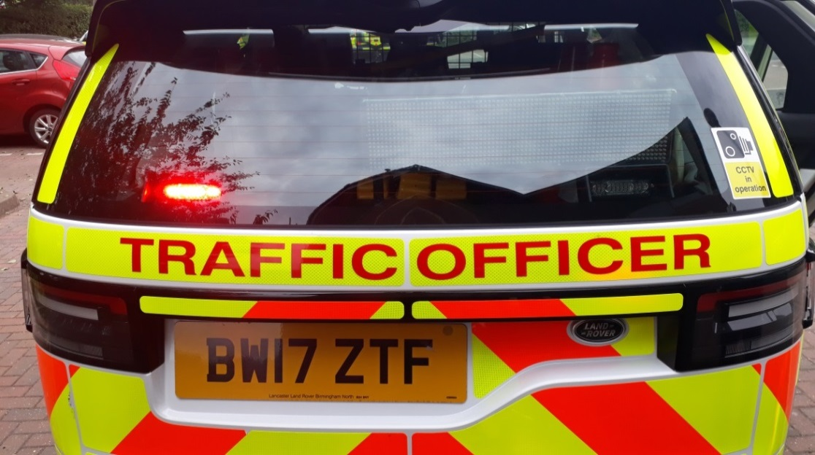

  - Vehicles with lifting tailgate

    - If the vehicle lighting or light bar is obscured when the rear tailgate is open, then 2 amber and 2 red additional LEDs must be mounted in the tailgate edge (of matching specification to those in the light bar) and shall be automatically operated, controlled by a tilt switch.

    - In order to ensure that VS 20/2016 is compliant a maximum of 4 red lights may flash at any one time. If the tailgate is opened and blocks the light bar rear visibility then the inner pair of red lights in the light bar must be disabled, to allow an additional pair of red lights to be fitted on the rear aspect of the vehicle.

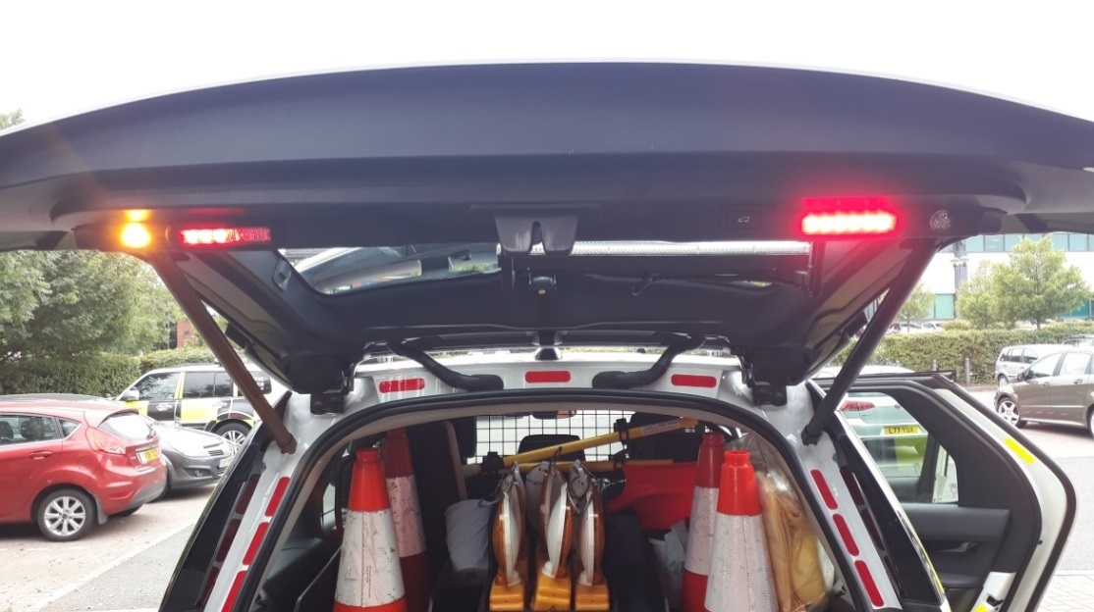

  - Alternating Headlamp Flash System

    - To aid the vehicle moving through traffic the vehicle is fitted with an alternating head lamp flash system. The system is operated from the light bar controller with a dedicated module controlling the lights.

    - Please note: In order to ensure that VS 20/2016 is compliant under no circumstances may any light be flashed other than the headlights.

  - Windscreen Mounted Amber Pod

    - A single amber light pod unit (of suitable light intensity) will be mounted in the lower centre section of the windscreen. It will operate with a side by side action and will be triggered on activation of the emergency mode on the light bar controller. Any external module control buttons on the unit will be disabled.

    - Please note. The unit must not obstruct the vehicle ventilation system. Type and configurations must be approved by Highways England.

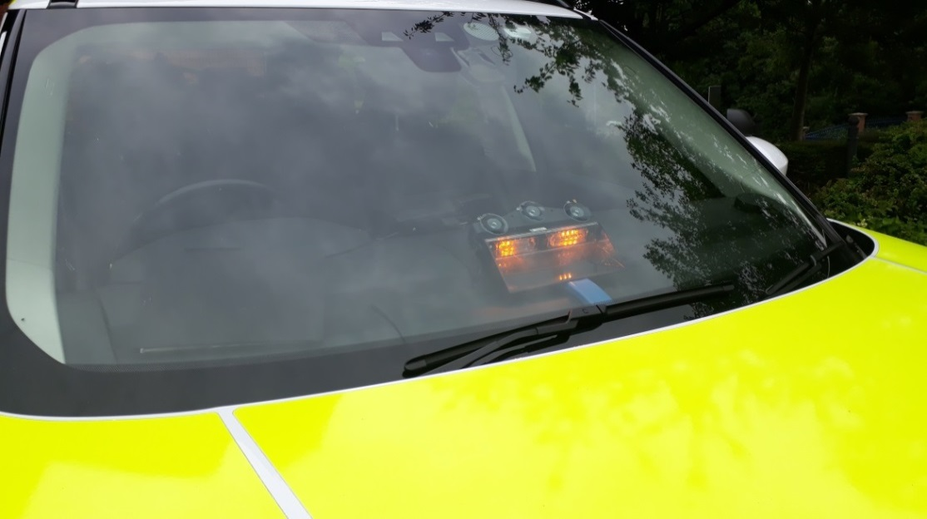

    - Note: The function mode button will be disabled. The windscreen demist function must be checked prior to release to ensure sufficient airflow.

  - Bullhorn

    - The Bullhorn will be operated from either the light bar controller at any time or alternatively when emergency mode is activated the vehicle horn control will duplicate this function.

    - The speaker is to be mounted within the front grille pointing forward (primary solution). If this is not possible due to insufficient space a “flute and pipe” option (secondary solution) is permitted, but must match the decibel and tone levels of the primary solution. Type and configurations must be approved by Highways England.

    - Note. Equipment supplier must be able to provide a written statement which confirms that the bull horn output is not strident.

  - Photometric Specification

    - Specification to meet UN - ECE Regulation 65, which covers warning beacons/lamps, is to be found at http://www.unece.org/trans/main/wp29/wp29regs61-80.html

    - This base regulation is to be consolidated with any amendments.

ANNEX C – Closed Circuit Television (CCTV)

  - Highways England’s prime CCTV supplier is Exeros. The Supplier will work with Exeros and their assigned technicians to ensure the CCTV equipment is fitted within the conversion build schedule.

  - Exeros will issue a Preferred Vehicle Installation Document (PVID) for each vehicle type. Where the vehicle is a ‘first of type’ for the Highways England conversion, the Supplier must allow access to the Supplier’s site for Exeros to install the CCTV equipment.

    - The Supplier shall liaise with Exeros to provide their CCTV technician with access to the vehicle at reasonable advanced notice at the Supplier premises, for a period of up to 8 hours, to install the following Customer Specialist Equipment*.

      - One forward-facing 1080BP Digital High-Definition camera
      - One rear-facing 1080BP Digital High-Definition camera
      - One Digital Video Recording (DVR) unit compromising a removable 1TB Hard Drive and including 4G connection for live-streaming capability
      - All associated cabling

*Please read Appendix 1 – Communications Equipment and Installation Responsibilities which may amend certain items of the above list – Appendix 1 takes precedence

    - After installation and testing of the equipment, the Exeros technician will certify the installation as fit for purpose.

    - The certification will be carried out by the Exeros technician.

    - When any legacy vehicle is returned for de-commissioning the Supplier shall remove the Exeros equipment and this will be made available to Highways England as part of the decommissioning process documented above.

ANNEX D – Mobile Phone

  - A universal holder is required to be fitted.

  - Bluetooth when on an active call must automatically mute the in-vehicle audio equipment. The in-vehicle stereo speakers shall be used to project the telephone conversation.

  - The interior of the centre arm rest is to be fitted (if required) with a surface mount cigar lighter socket for charging the mobile phone – this is to be protected by a fuse.

ANNEX E – Livery

  - Livery Specification

    - A full colour image exists for each of the current vehicles, detailing the approved livery. Any new images must be approved by the Highways England before use.

    - Vehicles shall comply with the requirements outlined in Table 4 below.

Table 4
Images | Comments
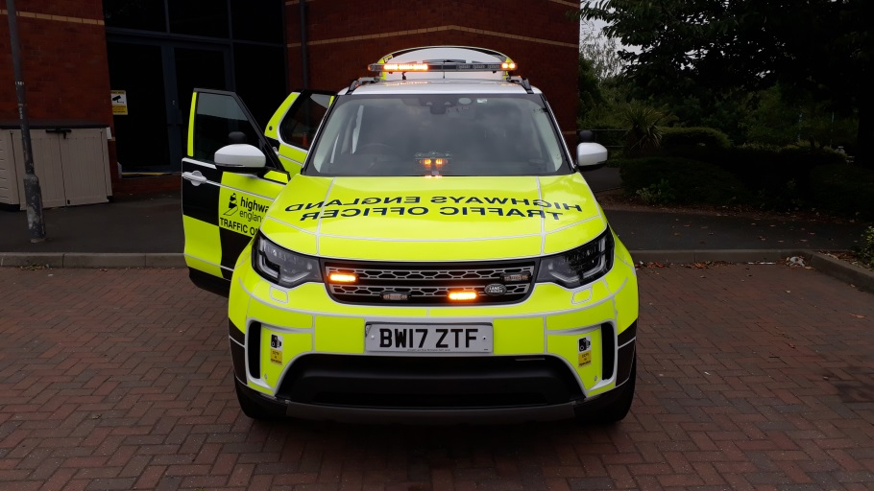 | The bonnet to be fully covered in fluorescent yellow vinyl material, so far as vehicle contours permit.
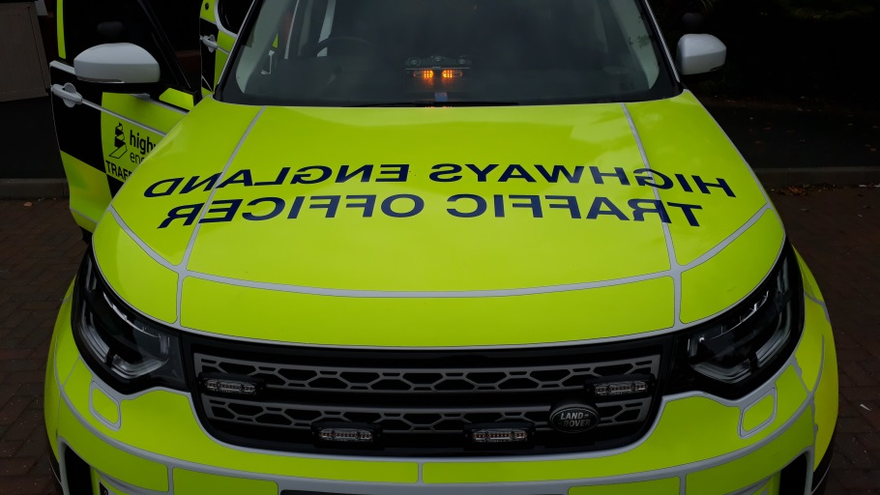 | “Highways England Traffic Officer” lettering, 100 mm high, in reverse script, Helvetica font, on front of bonnet in blue glass bead material. Colour to be Pantone® 287 (HA Blue).
 | Where width permits (minimum 25 mm width to be used), fluorescent yellow vinyl strips to be applied to engine grille, as vehicle configuration permits.
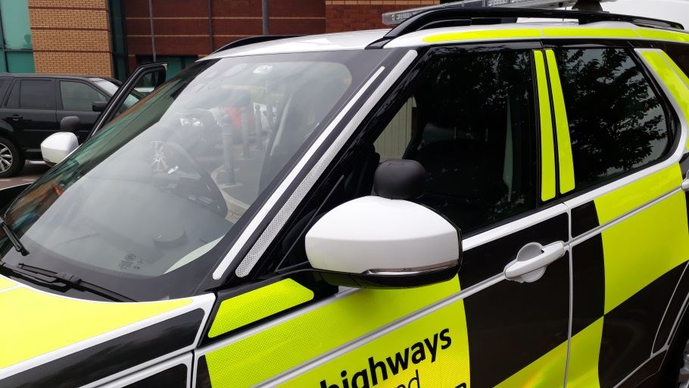 | ”A” pillars to have 50 mm (depending upon width available) white retro-reflective high grade material applied.  All remaining pillars and the roof line above the pillars, to have 50 mm (depending upon width available) yellow retro-reflective high grade material applied.
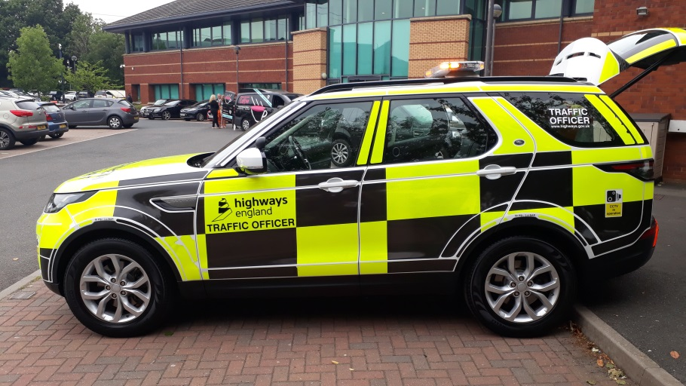 | Battenburg in alternating black reflective vinyl and fluorescent yellow retro reflective high grade material. Battenburg horizontal width is to be  600 mm or greater where possible. Vertical height is to be approximately 300 mm or 450 mm, excluding the lowest row.
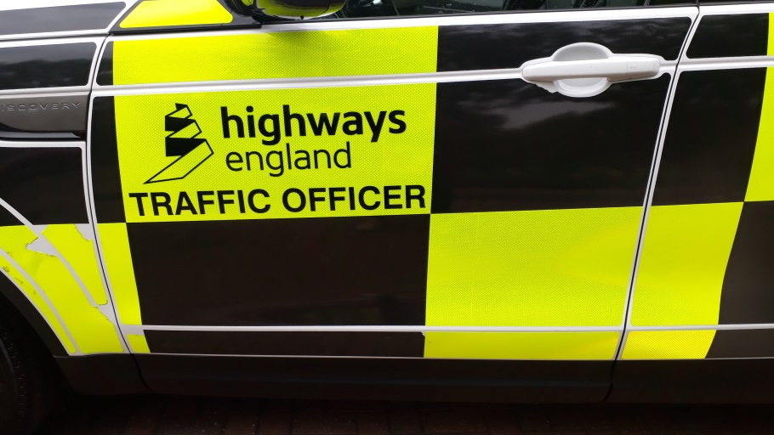 | Uppermost fluorescent yellow Battenburg block on front doors to contain the Highways England logo, with the words “TRAFFIC OFFICER” below in Transport Heavy font. Logo and text to be in black reflective vinyl.
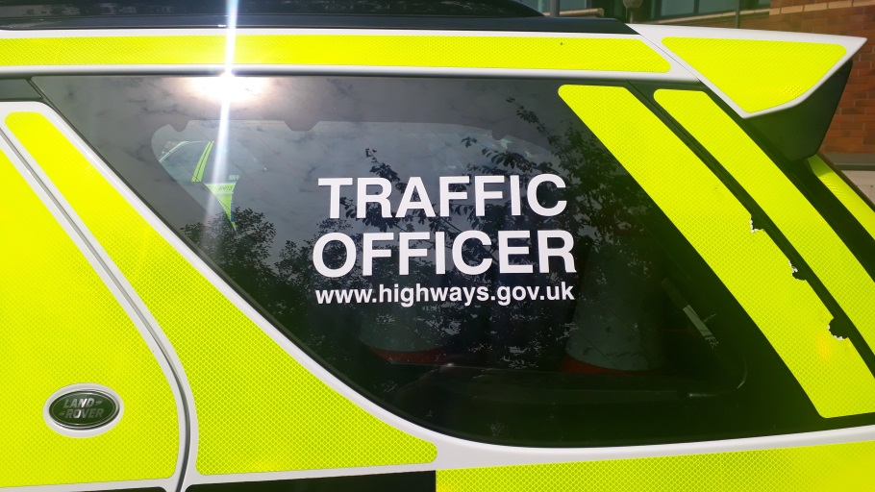 | “TRAFFIC OFFICER” wording in white non-reflective vinyl, 80 mm high Transport Heavy font, and “www.highways.gov.uk” in 40mm high Transport Heavy 22.5mm lowercase font to be placed centrally on rear side windows. Fixing of the wording should preferably be on the inside of the windows.
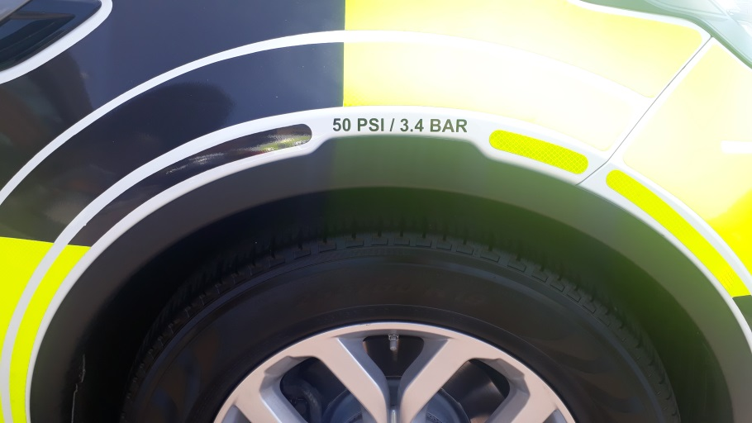 | Tyre pressures above all 4 wheel arches, bar and psi settings at gross vehicle weight
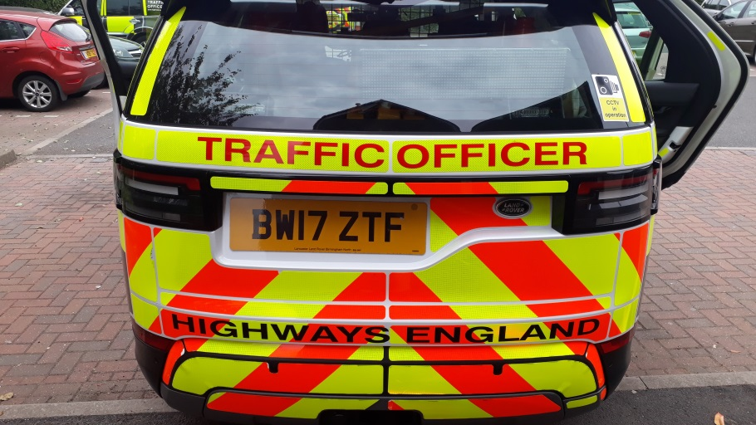 | Alternate orange and yellow diagonal stripes in fluorescent retro-reflective (dual purpose) high grade material, minimum 150 mm wide at 60˚. Chevron scheme to point ‘Up’.  Any vehicle fittings should be cut around. Where practicable, the top half of the rear of the vehicle should be outlined in yellow retro-reflective high grade material, a minimum 25 mm wide around door pillars (Pillar D, rear facing) and 50 mm wide around top of rear door edge.
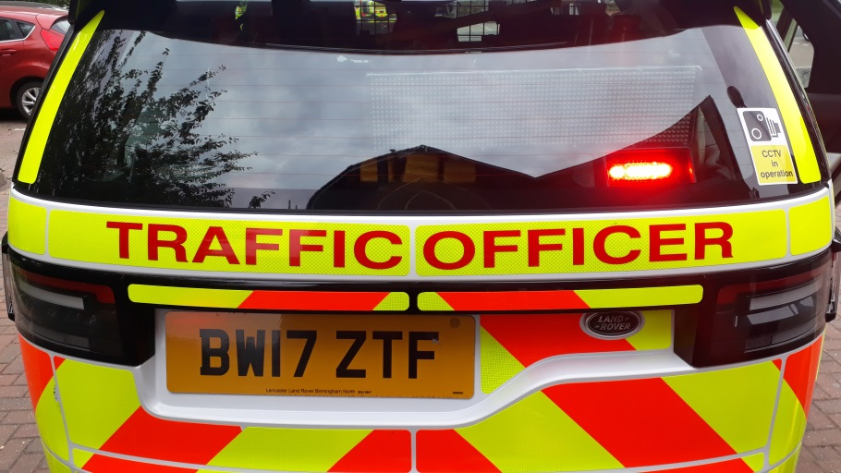 | “TRAFFIC OFFICER” wording in red retro-reflective high grade material, minimum 60 mm high in Transport Heavy font to be located on yellow strip on rear of vehicle.
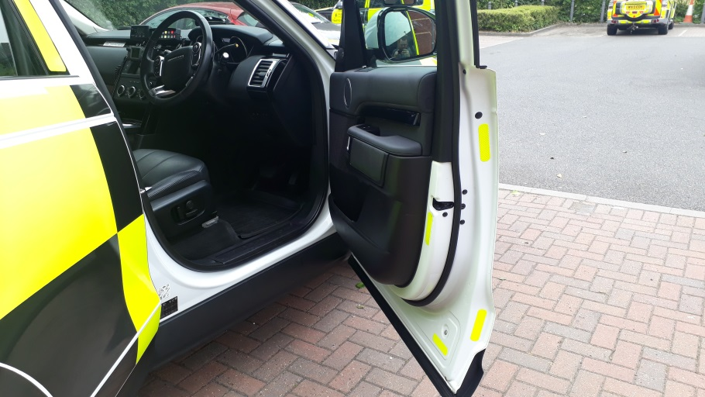 | Internal surfaces and door shuts within the rear boot area to be marked in yellow retro-reflective high grade material, 50 mm wide where appropriate (i.e. rear facing vertical surfaces of equipment box).  50 mm (or 25 mm depending upon width available and curvature of panels), yellow retro-reflective high grade material, vehicle edging to fit inside doors as space permits.
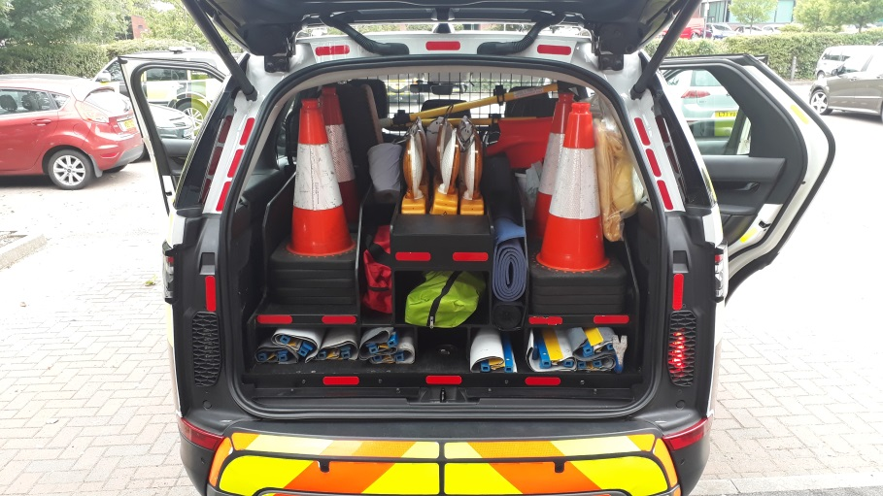 | The outer edges of the open doors, rear door / tailgate and the section across the top of the open door / tailgate to be marked in red retro- reflective high grade material, 50 mm wide or as a minimum, 25 mm wide.
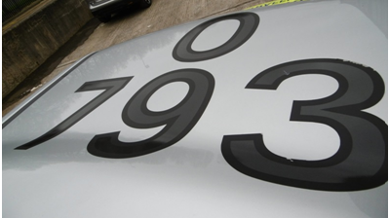 | 300 x 300 mm numbers in black reflective vinyl. Triple digit numbers to be specified by Highways England Vehicles Team.  All markings to be outlined with 15 mm non-reflective black vinyl.  Markings to be located between the front of the vehicle and the light bar.  See the following section for detailed roof marking specification.
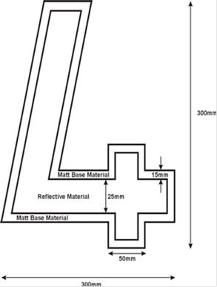 | Roof marking character dimensions.
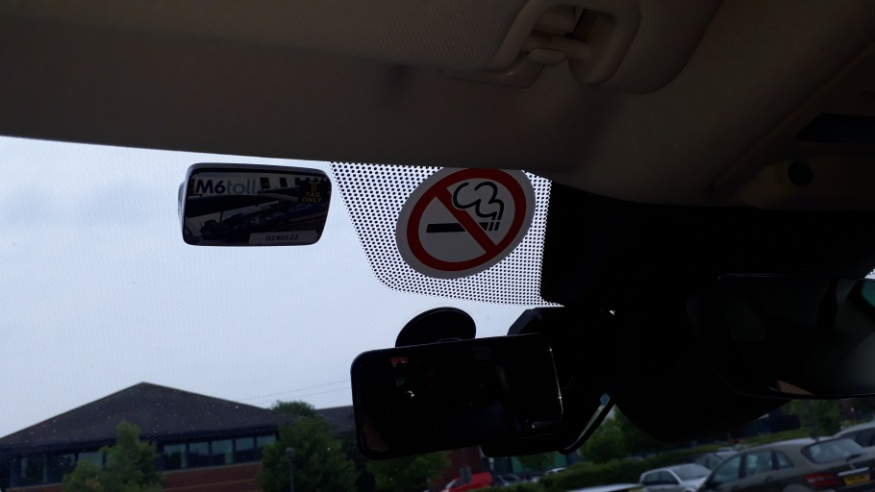 | No Smoking Sticker should be fitted in a visible location within the vehicle.
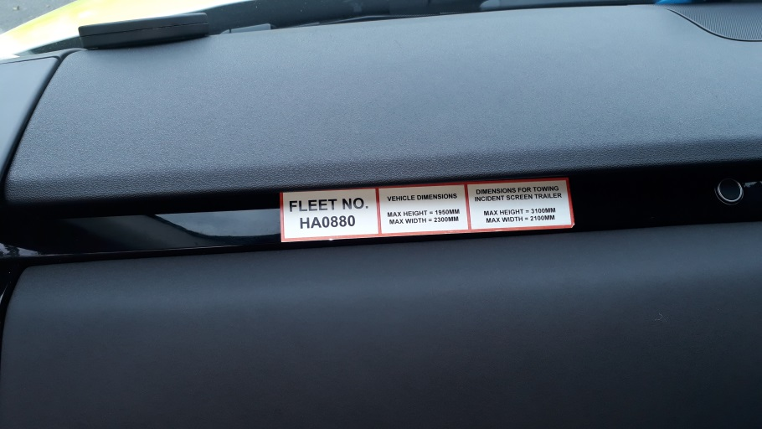 | Fleet number, vehicle dimension and trailer dimension sticker.  To be positioned in a visible location within the vehicle.
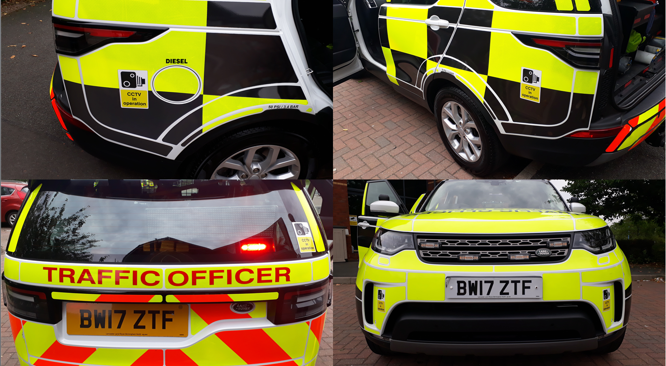 | “CCTV In Operation” images to be included behind rear wheel arches, in rear view mirror and on front bumper. Dimensions of images (Height (mm) – Width (mm))  Rear Wheel Arches: 195 x 130  Rear Windscreen: 135 x 90  Front Bumper: 135 x 90

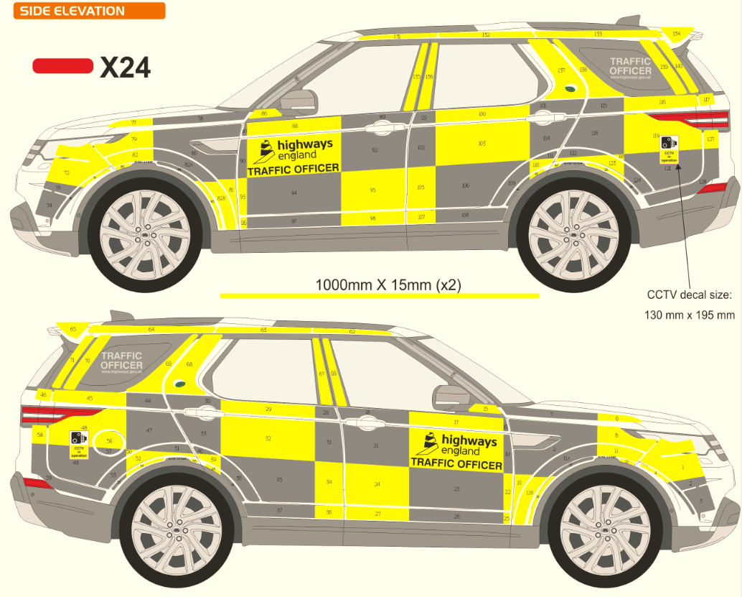
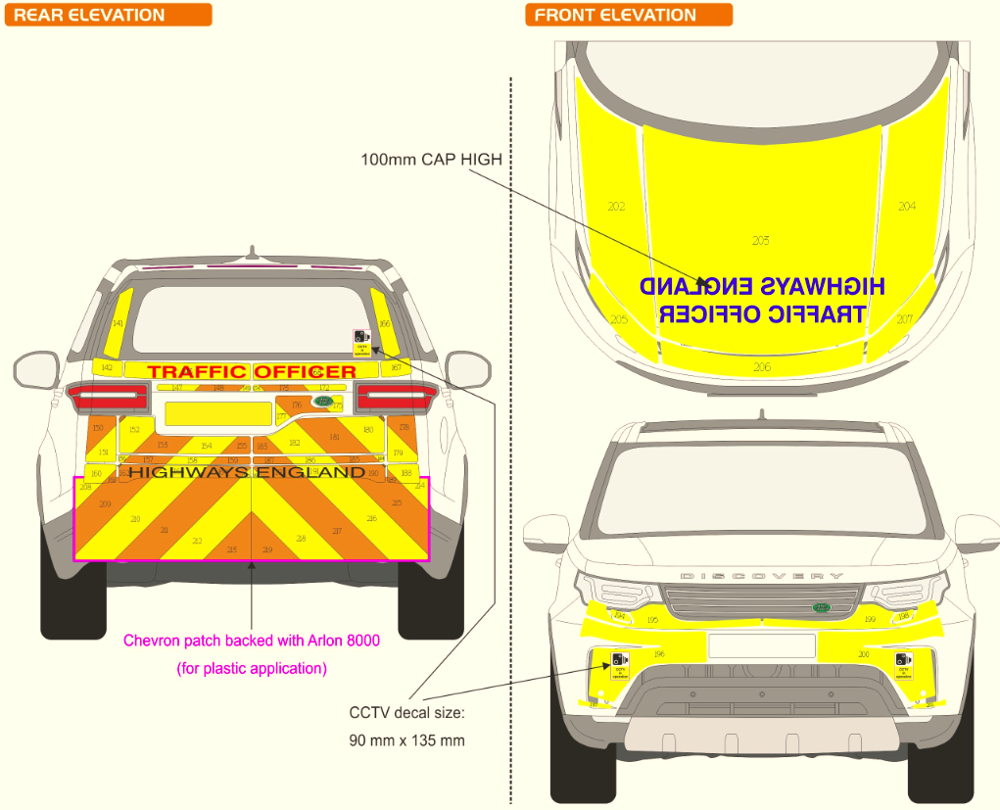

  - General Livery Comments

    - Battenburg Design

      - The Battenberg design shall incorporate the following:
      - Horizontal length – minimum 600 mm (except front and rear panels).
      - Vertical height – minimum 300 mm (except front and rear panels).
      - Pattern design starts at the centre of the vehicle with a black reflective vinyl panel (Panel A) and be extend horizontally to the front and rear of the vehicle using an alternating black and yellow retro reflective material along the side of the vehicle.
      - The pattern extends downwards starting with a yellow retro reflective panel vertically below Panel A. This extends horizontally to the front and rear of the vehicle. The lowest row is sized to fill the side of the vehicle below the original row of panels.
      - Recommended number of panels for top row is seven.
      - Both end panels must end in fluorescent yellow and may be less than 600mm long, but ideally not less than 400mm long.

    - Vinyl Material

The following forms a recommendation for the minimum level of performance of livery films that would be acceptable if the conspicuity benefits of the “Battenburg” livery scheme are to be realised over a typical three year vehicle lifespan.

    - General Product Information

Table 5
ITEM | REQUIREMENT(S)
Material thickness | Preferably less than 1.7mm
Orientation requirements | As per manufacturer’s instructions
Applicable automatic cutting methods | Die, plotter or manually cut-able using laser/knife
Life expectancy | Minimum 3 years
Warranty period | Minimum 3 years
Temperature range | -25°C to 50°C

    - Coefficient of Retro Reflection (RA) Minimum Values

Table 6
Observation Angle | Entrance Angle | RA
Observation Angle | Entrance Angle | Fl. Yellow (Green) | Fl. Orange | Blue | White | Red
0.20° | 5° | 300 | 160 | 25 | 350 | 60
0.20° | 30° | 150 | 80 | 12 | 150 | 25
0.20° | 45° | 33 | 18 | 3 | 40 | 7
33° | 5° | 80 | 80 | 10 | 150 | 25
33° | 30° | 60 | 50 | 4 | 60 | 10
33° | 45° | 16 | 20 | 2 | 30 | 5
0.50° | 5° | 50 | 45 | 7 | 110 | 20
0.50° | 30° | 20 | 20 | 3 | 60 | 10
0.50° | 45° | 9 | 8 | 1.3 | 20 | 3.6
1.00° | 5° | 8 | 8 | 1 | 9 | 2.5
1.00° | 30° | 6 | 4 | 0.75 | 6 | 1
1.00° | 45° | 2 | 2 | - | 3 | -
Coefficient of retro reflection, RA, is a measure of the amount of light radiation retro reflected from a surface relative to the amount of light radiation incident upon the surface, per unit area. Units are candelas per lux per square metre, cd.lx⁻¹.m ⁻². Further details are available from CIE publication 54.2 – 2001.
Note: These values are similar to those quoted in BS873: 1983 and ASTM D
4956 – 01a.

    - Maximum Permissible Retro Reflectivity Degradation

Table 7
Performance Degradation | Fl. Yellow (Green) | Fl. Orange | Blue | White | Red
Acceptable maximum | 50% | 20% | 20% | 20% | 20%
Degradation period (years) | 3 | 3 | 3 | 3 | 3
Note: these values are per ISO 4892-1:1994 and ISO 4892-2:1994.

    - Day time and Night time Chromaticity

Table 8
Daytime Chromaticity | CIE D65 Illuminant
Daytime Chromaticity | 1 |  | 2 |  | 3 |  | 4
Daytime Chromaticity | X | Y | X | Y | X | Y | X | Y
Fl. Yellow (Green) | 0.375 | 0.620 | 0.460 | 0.532 | 0.398 | 0.450 | 0.350 | 0.508
Fl. Orange | 0.506 | 0.404 | 0.570 | 0.429 | 0.655 | 0.345 | 0.560 | 0.340
Blue | 0.065 | 0.216 | 0.190 | 0.255 | 0.245 | 0.210 | 0.144 | 0.030
White | 0.285 | 0.325 | 0.335 | 0.375 | 0.355 | 0.355 | 0.305 | 0.305
Red | 0.550 | 0.358 | 0.640 | 0.365 | 0.735 | 0.265 | 0.660 | 0.233
Note: These values are similar to those quoted in BS 873: 1983 and ASTM D 4956-01a
Footnote: Night time chromaticity data is not yet available.

    - Fluorescent and Non-Fluorescent Luminance Factor

Table 9
Fluorescent Materials | Luminance Factor (min)
Fluorescent Materials | CIE D65 |  | CIE D150
Fluorescent Materials | Total | Fluorescent | Total
F. Yellow (Green) | 30 | 15 | 40
Fl. Orange | 15 | 7 | 15
Blue | 0.7 | n/a | n/a
White | 17 | n/a | n/a
Red | 0.5 | n/a | n/a

    - Standards Compliance

Table 10
Impact Resistance | ASTM D4956 – 01a: 6:10 or ASTM D2794 –93
Shrinkage | ASTM D4956 – 01a: 6.6
Flexibility | ASTM D4956 – 01a: 6.7
Chemical / solvent resistance | BS 873: Part 1:1983 section 12 (solvent wipe test) Chemicals – at minimum, should be resistant to diesel, petrol and LPG that can occur during refuelling. Solvents – at minimum, should be resistant to white spirit, turpentine, kerosene and cleaning solutions likely to be used.

    - Power Washing

The film, as applied to the vehicle and conditioned as necessary, shall withstand washing during routine maintenance under the conditions specified below;

Table 11
Maximum fluid temperature | 38°C or lower
Minimum incident angle of spray axis | 15° or less to perpendicular of surface. I.e. as near to 90° (right angle) with surface that is being cleaned, as possible.
Nozzle distance from surface | 1.2m of further. Any closer risks damaging the livery edge seal
Nozzle pressure | 5.5 bar / 80psi or less.
Spray fan pattern required | As per manufacturer’s instructions. I.e. direct jets of water should be avoided. Water should be ‘sprayed’ out if possible.

When time permits, vehicles will be hand washed with soapy water, using a soft sponge.

  - Notes

    - These values should be considered to be minimum performance guidelines for livery film materials.

    - If specific films are resistant to cleaning at a higher temperature, incident angle or pressure, or at a shorter distance between the nozzle and the film surface, this may be considered to be superior performance.
All retro reflective material shall be of the highest available grade, unless stated otherwise.

    - Livery film shall not be folded over the edges and cut-outs of vehicle panels, but instead should be cut short of them. It is recommended that a clear fuel-resistant film is fitted over the fuel filler area; reference should be made to the manufacturer’s instructions as this may not be necessary.

    - All open panel prismatic material shall be edge sealed to prevent the ingress of water and dirt. (Reference should however be made to the manufacturer’s instructions as some livery materials do not required edge sealing).

    - All panels shall be cut in the same orientation to maximise reflectivity and colour.

    - A livery guide is to be provided within each User Guide as outlined in Section 5.2, an electronic version is to be provided to the Customer and the Customers Agent, the guide is to detail reorder codes.

    - The Customers Agent is measured on vehicle availability, therefore Livery suppliers are to provide a fast turnaround time to minimise VOR (vehicle off road) time. Small batches ordered prior to midday are to be dispatched same working day.

ANNEX F – Storage

  - Vehicles shall comply with the following requirements;

    - Provision of a Storage System to store Customer Works Equipment as detailed in Appendix 2, using a securely mounted Highways England Traffic Officer Vehicle approved storage layout that will enable the Customer Works Equipment to be easily accessible, and where possible will meet the current standard equipment layout.

    - Sliding shelving will have low friction high durability runners and positive locking devices that are easy to use with a gloved hand. Maximised slide out capability is required to ensure ease of use and to minimise manual handling risks.

    - See-through mesh grille bulkhead capable of preventing equipment from entering the saloon in the event of an accident.

    - Manufacturers lashing points and other protrusions to be removed (these are to be retained for re-fitment during decommissioning) to prevent damage to the Customer Works Equipment. Similarly the Storage System will be free from sharp edges which might damage equipment or users.

    - Where possible ‘diamond grade’ (or similar) reflective material in yellow / red will be applied to any rear facing surface forming part of the Storage System which is capable of being so covered.

  - Note:

    - Vehicles must be positively checked so that each vehicle's axle and GVW limits are not exceeded when the vehicle is modified to meet this specification, with a full complement of a driver and 3 passengers (90kgs per person) where applicable, including all equipment carried in the rear cargo area.

    - A notional allowance of 15kgs may be estimated for the weight of the radio installation, equally divided between axles.

    - Weighbridge record data must be provided to the Customers Agent and Highways England by the Supplier, on completion of the first prototype vehicle.

    - Customer works equipment detailed in Appendix 2, excluding the bulkhead and storage system, weighs approximately 170kgs.

    - A sample works equipment kit will be provided by Highways England to the Supplier to enable development of the racking solution.

ANNEX G – Auxiliary Equipment

  - Overview

    - This specification calls for a number of other detailed enhancements or modifications to the vehicle in order to fully meet the operational requirements of the Traffic Officer. These are divided into two categories; Interior & Exterior.

  - Interior Equipment

    - Run-Lock

      - Equipped with a “Run-lock” type of facility, to safely allow the engine to continue running while the vehicle is unattended; it must be possible to remove the key (ignition lock or keyless systems) with the engine running.
      - The engine must cut out immediately if any attempt is made to move the vehicle without the vehicle key being present, including with ‘keyless ignition’ type systems.
      - On keyless systems, the engine may continue to run once Run-lock is engaged but the engine must cut-out if the Traffic Officer with the key is not in the immediate vicinity of the vehicle when an attempt is made to drive it.
      - The system must be simple to reset when the key is present.

    - Disable standard vehicle auto-locking

      - All automatic door locking systems to be disabled. This includes doors that that are designed to automatically lock in the event of the vehicle being left unlocked and vehicle doors that are designed to automatically lock when the vehicle reaches a certain speed.

    - Auto stop / start

      - Disable stop / start function if possible.

    - Extra interior mirror

      - Additional shatter proof suction mounted rear view mirror for use by the front passenger is to be provided and fitted.

    - Height warning/Info sign

      - Conspicuous labelling in the front of the saloon, identifying the vehicle’s overall height (including light bar) and width, Incident Screen Trailer height and width, and its roof ID number is to be fitted.

    - Safety Hammer

      - Two emergency escape hammers / seatbelt cutters, with hardened stainless steel tip and blade, for cutting seat belts to be securely fitted in the front of the vehicle; one on the driver’s side and one on the passenger side. Must include a glass breaking tip.

    - Interior lamp

      - Single, centrally mounted LED light unit, as a map-reading light above the front seats. Controlled from the lighting system controller.
      - Single, centrally mounted LED light unit, mounted above the equipment storage area. To illuminate automatically on opening of the rear door.

    - Additional 12v power supply (add to any standard vehicle fittings to achieve this requirement);

      - Four auxiliary 12 volt supply sockets in the vehicle. The location of the sockets are as follows;

        - 1 x front driver/passenger area,
        - 1 x centre arm rest (for mobile phone)
        - 1 x rear passenger area
        - 1 x rear boot area

    - 3rd row of seats removed (if fitted)

      - All seat and associated components are to be marked with the source vehicle information and stored by the Supplier for re-fitting on decommissioning.

    - Load Cell Device

      - The Load Cell wiring kit (2 core wire and Velcro strap – supplied by Highways England – Free Issue) is to be routed through the rear of the glove box, a small hole (wiring sized) is acceptable in a non-visible location, the wiring is to be coiled up and held tidy with the supplied Velcro strap into the glove box, the lead is to be of suitable length to reach to the rear of the N/S/F Seat, but secured to restrict the wiring from being pulled through further.
      - The positive wire is to be protected by a 2 Amp fuse. The fuse Box is to be labelled Load Cell, all wiring is to be sufficiently insulated and secured during the build process.

    - Peli search light and charger

      - A free issue hand-held rechargeable heavy duty LED torch is to be supplier by Highways England and must be fitted into a suitable location inside the vehicle passenger area. It must be easily accessible by the vehicles crew. Fitment is to be a damage free installation allowing the removal of manufactures floor mats with ease for the cleaning of the vehicle, to include 12v power supply from auxiliary battery for charging.

  - Exterior Equipment

    - Tow Bar

      - Fitted with an EC type approved (Directive 94/20/EC) dual coupling tow bar, with towing ball and drop pin and twin electrics. The tow bar ball is to be set at between 44 to 46cms height, facilitating 70kg Incident Screen Trailer nose weight.

        - Minimum D rating of 15.8kN and tow ball rated to 17.0kN

      - The 2nd electric kit (12s) is to be modified for the flashing of trailer beacons & LED’s;

        - Pin 2 – Positive feed from emergency mode output (4amp load)
        - Pin 7 – Earth connection
        - Pin 4 + 5 to be wired to telematics system (Incident Screen Trailer sensing).

    - Non-locking wheels nuts

      - If the vehicle is supplied as standard with alloy wheels with locking wheel nuts, these nuts shall be replaced with ordinary non-locking wheel nuts. Removed locking nuts must be retained by the Supplier for refitting at the decommissioning stage.

    - Wide angle mirrors attached to door mirrors

      - Wide angle door mirrors are to be fitted to each of the exterior door mirrors.

    - Spare wheel – fitment and access (if fitted)

      - Spare wheel and tyre must not obstruct the access of the Traffic Officer equipment.
      - Provision must be made for access to the spare wheel release mechanism if it is obstructed by any equipment added as part of the conversion.
      - The spare wheel may be removed if required, to accommodate the vehicle conversion.

    - Power Supply and Auxiliary battery (including Emergency start function)

      - The vehicle power supply shall include a non-surge/stall interference system.
      - Capable of supplying sufficient power to all electrical equipment as defined in this specification without affecting the safe operation of the vehicle.
      - Capable of supplying sufficient power to all electrical equipment as defined in this specification when the ignition is turned off, for at least one hour. The vehicle shall be capable of then restarting again with the headlamps on (provision may be made for an ‘Emergency Start’ auxiliary control on the lighting system controller.

Note
If the proposed vehicle solution requires an auxiliary battery, the Supplier shall state this clearly in its proposal, and consider the weight of the battery and its effect on GVW of the vehicle when the full complement of Traffic Officer Equipment is carried.

If the proposed vehicle solution requires an auxiliary battery, the Supplier is to ensure that – should the auxiliary battery be boxed in – to maintain operational safety, a battery isolator shall be installed/inserted behind the intermediate seat, under the equipment cage. Similarly, the incremental harness system should be capable of being fully isolated. This is to ensure that on repair, the vehicle can go back to an ‘as built’ manufacturer standard vehicle to ensure diagnosis of base vehicle faults.

ANNEX H – Telematics System

  - Highways England’s Customers Agent (Fraikin Ltd) will work with the Supplier and their assigned technicians to ensure the telematics equipment is fitted within the conversion build schedule.

  - The Customers Agent will issue a Preferred Vehicle Installation Document (PVID) for each vehicle type. Where the vehicle is a ‘first of type’ for the Highways England conversion, the Supplier must make suitable resources and staff available to work with the Customers Agent to engineer a solution for that vehicle type and for the Customer Agent to produce their PVID which must then be adhered to by the Supplier, on all subsequent builds for that vehicle type.

    - The Supplier shall liaise with the Customers Agent to provide their technician with access to the vehicle at reasonable advanced notice at the Supplier premises, for a period of up to 8 hours, to install the following Customer Specialist Equipment*.

      - [kit list to be confirmed]

*Please read Appendix 1 – Communications Equipment and Installation Responsibilities which may amend certain items of the above list – Appendix 1 takes precedence

    - After installation and testing of the telematics system, the Customers Agent technician will certify the installation as fit for purpose.

    - The certification will be carried out by the Customer Agent.

    - When any legacy vehicle is returned for de-commissioning the Supplier shall remove the telematics system and this will be made available to Highways England as part of the decommissioning process documented above.

APPENDICES

Appendix 1 – Communications Equipment and Installation Responsibilities

Table 12
 |  | Supplier |  | Capita |  | Exeros |  | Fraikin Ltd
 |  | Labour | Parts | Labour | Parts | Labour | Parts | Labour | Parts
1 | Installation backboard | Y | Y
2 | Sepura SRG power cable | Y |  |  | Y
3 | Vehicle power cables | Y | Y
4 | Ignition sense cable | Y | Y
5 | Remote control cable 5mtr (data lead) | Y |  |  | Y
6 | Speaker cables | Y | Y
7 | Speaker | Y |  |  | Y
8 | Fuse box, carriers & fuses | Y | Y
9 | Sepura console dash mount kit bracket (pivot type) | Y |  |  | Y
10 | Hands free kit including MIC | Y |  |  | Y
11 | Peiker PTT switch | Y |  |  | Y
12 | Fist MIC & carrier | Y |  |  | Y
13 | Tetra UHF & radio GPS Kombi antenna & lead | Y |  |  | Y
14 | Sepura radio console head | Y |  |  | Y
15 | Radio (during test only) |  |  | Y | Y
16 | One forward-facing 1080BP Digital High-Definition camera |  |  |  |  | Y | Y
17 | One rear-facing 1080BP Digital High-Definition camera |  |  |  |  | Y | Y
18 | One Digital Video Recording (DVR) unit compromising a removable 1TB Hard Drive and including 4G connection for live-streaming capability |  |  |  |  | Y | Y
19 | All associated cabling |  |  |  |  | Y | Y
20 | Telematics system & associated parts |  |  |  |  |  |  | Y | Y

Appendix 2 – Customer Works Equipment

  - Table 13 contains a list of the current equipment carried within the Traffic Office Vehicle; the stowage solution pictured in 16.2 is to allow storage for all items detailed in Table 13. Highways England will arrange for a supplier day where tendering suppliers can view the existing layout of the kit in the Traffic Officer vehicle during the tender period.

  - Note: Suppliers will not be expected to fit the equipment into the vehicle for delivery unless marked in the relevant field.

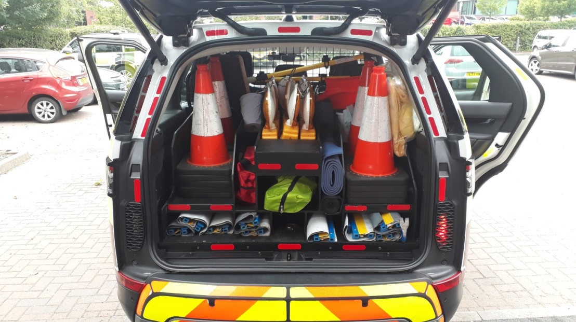

Table 13
Equipment Items In Boot | Qty | Description
Traffic Cone | 20 | 500mm road cones with red base complete with triple reflective sleeves (red/white/red)
INCIDENT SLOW Sign face* | 2 | DfT drawing files no. HA26/28/15 Plan No.10 Ref.S2. Collapsible 900x600 mm (WxH) Class 1 prismatic high visibility reflective material to withstand continuous folding
DIVERT Sign face (610 arrow)* | 6 | TSRGD Drawing No. 610 Collapsible 600x600 mm Class 1 prismatic high visibility reflective face on 900x600mm grey panel. Material to withstand continuous folding – studded directional change option required
NO ENTRY Sign face* | 1 | TSRGD Drawing No. 616 Collapsible 600x600 mm Class 1 prismatic high visibility reflective face on 900x600mm grey panel. Material to withstand continuous folding
Road Danger Lamps | 10 | Amber sequential flashing back-lit hi-intensity LED lamps (Battery operated)
Load Cell Equipment | 1 | Consists of load cell unit and visual display unit
Single Tow Strap | 1
Brothers strap | 1
Tow Strap Bag | 1 | Green
Tow Strap Bag | 1 | Red
Bow Shackles | 4
Poncho | 10 | Waterproof plastic, yellow in colour
Crowbar | 1 | 760mm length
Broom | 2 | Extendable plastic handle
Shovel | 1 | Plastic
Peli searchlight and charger | 1 | Installed by Prime Supplier as part of conversion
First Aid Kit | 1 | First aid kit for up to 10 persons
Resuscitation Aid | 2 | Plastic sheeting with one-way valve mouthpiece
15L Chemical Spill Kit | 1 | 12 Absorbent pads, 2 absorbent socks, instructions, 2 disposable bags with ties
Bin Liners | 10 | 0.45m x 0.75m x 1m (opened)
Tape | 1 roll | Red/white adhesive floor marking tape. 50mm x 33m
Box of Nitrile Disposable Gloves | 1 | Comply with EN 420 (mixed sizes)
Multi-Purpose Wipes | 1 | Pack 200 Multi-Purpose Wipes
Binoculars/Monocular | 1 | General purpose.
Adult Thermal Foil Blanket | 10
Individual Eye Wash | 5
De-Icer | 1
Hazardous Waste bags | 5
SPAG Sorb | 6 | 10 litre bags of SPAG Sorb
Anemometer | 1
Safe Cutting Tool | 1
Tyre Pressure Gauge | 1
Door Edge Protectors | 4 | To be fitted where applicable

Appendix 3 – Highways England Locations

  - Below is a list of all Highways England Regional Control Centres (RCC) and Outstations.
Table 14
Region | Location | Address | Post Code | RCC | Outstation
North West | Rob Lane | Newton Le Willows | WA12 0DR | Y | Y
 | Knutsford | Northwich Road, Tabley | WA16 0TG |  | Y
 | Lowhurst | Wreay, Carlisle | CA4 0RH |  | Y
 | Millness | Crooklands, Milnthorpe | LA7 7NR |  | Y
 | Milnrow | Elizabethan Way, Rochdale | OL16 0EJ |  | Y
 | Samlesbury | Preston New Road, Samlesbury, Preston | PR5 0UJ |  | Y
North East | Calder Park | Wakefield | WF2 7UA | Y
 | Carrville | Barton | DL10 5NH |  | Y
 | Barton | Durham | DH1 1TZ |  | Y
 | Tingley | Leeds | WF3 1SW |  | Y
 | Sprotbrough | South Yorkshire | DN5 7PY |  | Y
West Midlands | Quinton | 1 Ridgeway, Quinton | B32 1AF | Y | Y
 | Ansty | Main Road, Ansty, Coventry | CV7 9JA |  | Y
 | Hilton Park | Shareshill | WV11 2AP |  | Y
 | Longbridge | Hilton Park Motorway Compound | CV34 6RB |  | Y
 | Strensham | Strensham Motorway Compound | WR8 9LJ |  | Y
East Midlands | East Mids RCC | Eric Belfield House | NG8 6PZ | Y
 | Felley | Felley Motorway Compound | NGA5 0AS |  | Y
 | Shepshed | Shepshed Motorway Compound | LE12 9DJ |  | Y
 | Watford Gap | Watford Gap Motorway Compound | NN6 7UZ |  | Y
East | South Mimms | St. Albans Road | EN6 3PN | Y | Y
 | Chieveley | Chieveley HA Depot, Moto Service Area | RG18 9XX |  | Y
 | Dartford | Le Crossing | DA1 5PR |  | Y
 | Heston | Heston Highways England Depot | TW5 9RY |  | Y
 | Milton Common | Milton Common Depot | OX9 2UN |  | Y
 | Toddington | Carillion URS, M1 Motorway Depot | LU5 6HP |  | Y
 | Whittlesford | Whittlesford Motorway Maintenance Depot | CB2 2NL |  | Y
South West | South West RCC | St Brendan’s Court | BS11 9FB | Y
 | Almondsbury | Almondsbury Motorway Maintenance Depot | BS32 4AG |  | Y
 | Chelston | Chelston Motorway Compound | TA21 9PL |  | Y
 | Stanton St Quintin | Stanton St Quintin Motorway Maintenance Compound | SN14 6BD |  | Y
 | Pridhamsleigh | Old Pridhamsleigh Quarry, Buckfastleigh, Devon | TQ11 0JR |  | Y
South East | South East RCC | Godstone | RH9 8BQ | Y
 | Coldharbour | London Road, Coldharbour | ME20 7SL |  | Y
 | Easton Lane | Winnal, Winchester | SO23 7TY |  | Y
 | Heston | M4 Maintenance Compound, Heston | TW5 9RY |  | Y
 | Weatherhill | Hathersham Close, Smallfield | RH6 9JE |  | Y

Appendix 4 – Road Vehicles Lighting Regulations 1989 – Highways England Exemption VS 20/2016

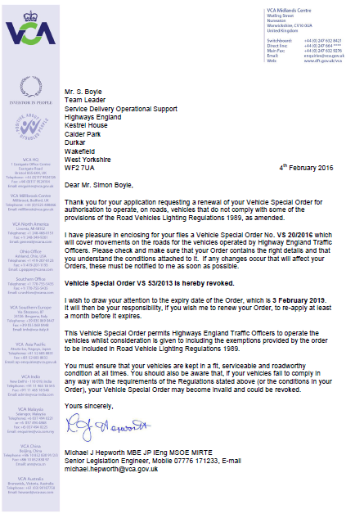

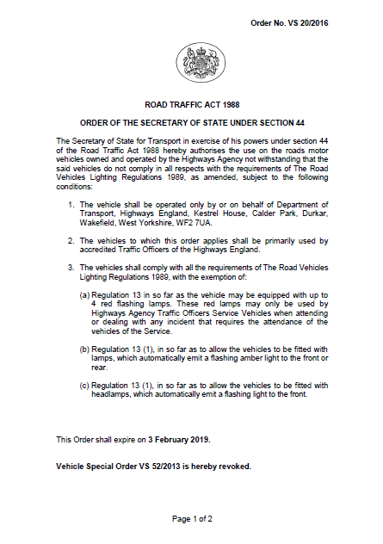

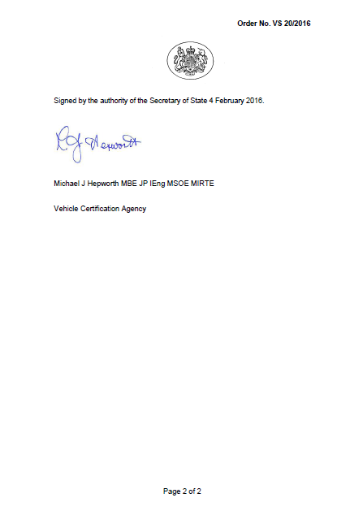

Appendix 5 – Jaguar Land Rover Discovery 5 vehicle specification

