Seaton Town Council

SPECIFICATION FOR RENOVATING THE FIRST FLOOR, MARSHLANDS BUILDING INTERIOR

1. Introduction
2. Location of the Marshlands building
3. Summary of major works required
4. Marshlands First Floor Plan
5. Summary of structural survey report
6. Renovation options
7. Room dimensions
8. Type of finish
9. General conditions and timeframe
10. **Introduction**

Marshlands Centre is a substantial seafront property (‘Marshlands’) owned by Seaton Town Council (‘the Council’). Marshlands has two distinct parts – the original part is on the seafront side, with a later addition on the Harbour Road-side. The elements are joined by a connecting UPVC walkway. There is also a large courtyard on the seafront side of Marshlands.

1. **Location**

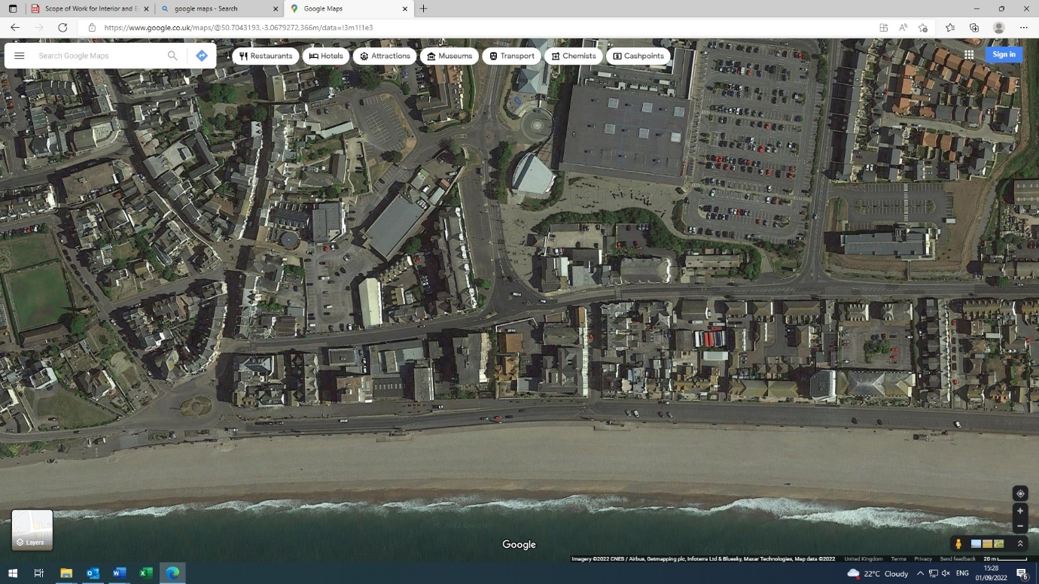

Seaton Town Council

Marshlands Centre

Harbour Road

Seaton

EX2 2LT

1. **Summary of the major works required**

* Removal of chimney and load bearing walls
* Removal of stud walls to open area
* Renovation of nine rooms and removal of items within
* Building interior to be plaster boarded, skimmed and painted, and provide new wood skirting boards
* Installation of kitchen sink, work top and cabinets in old bathroom area
* Removal of disabled toilet and new disabled toilet/mixed gender use toilets to be created in another part of the space
* Installation of plasterboard ceiling with new lighting in all rooms
* Removal and rewire electrical installation, including trucking for telephony/internet connection
* Installation of soundproof flooring throughout the first floor of the building

The contractor shall provide all labour, material tools, equipment, supervision and other related

items required to complete the project, as per scope of work and specifications. It is expected that potential contractors will visit the site, verify the existing site conditions and carry out a comprehensive assessment in order to develop their proposal.

1. **Marshlands First Floor Plan - Existing**

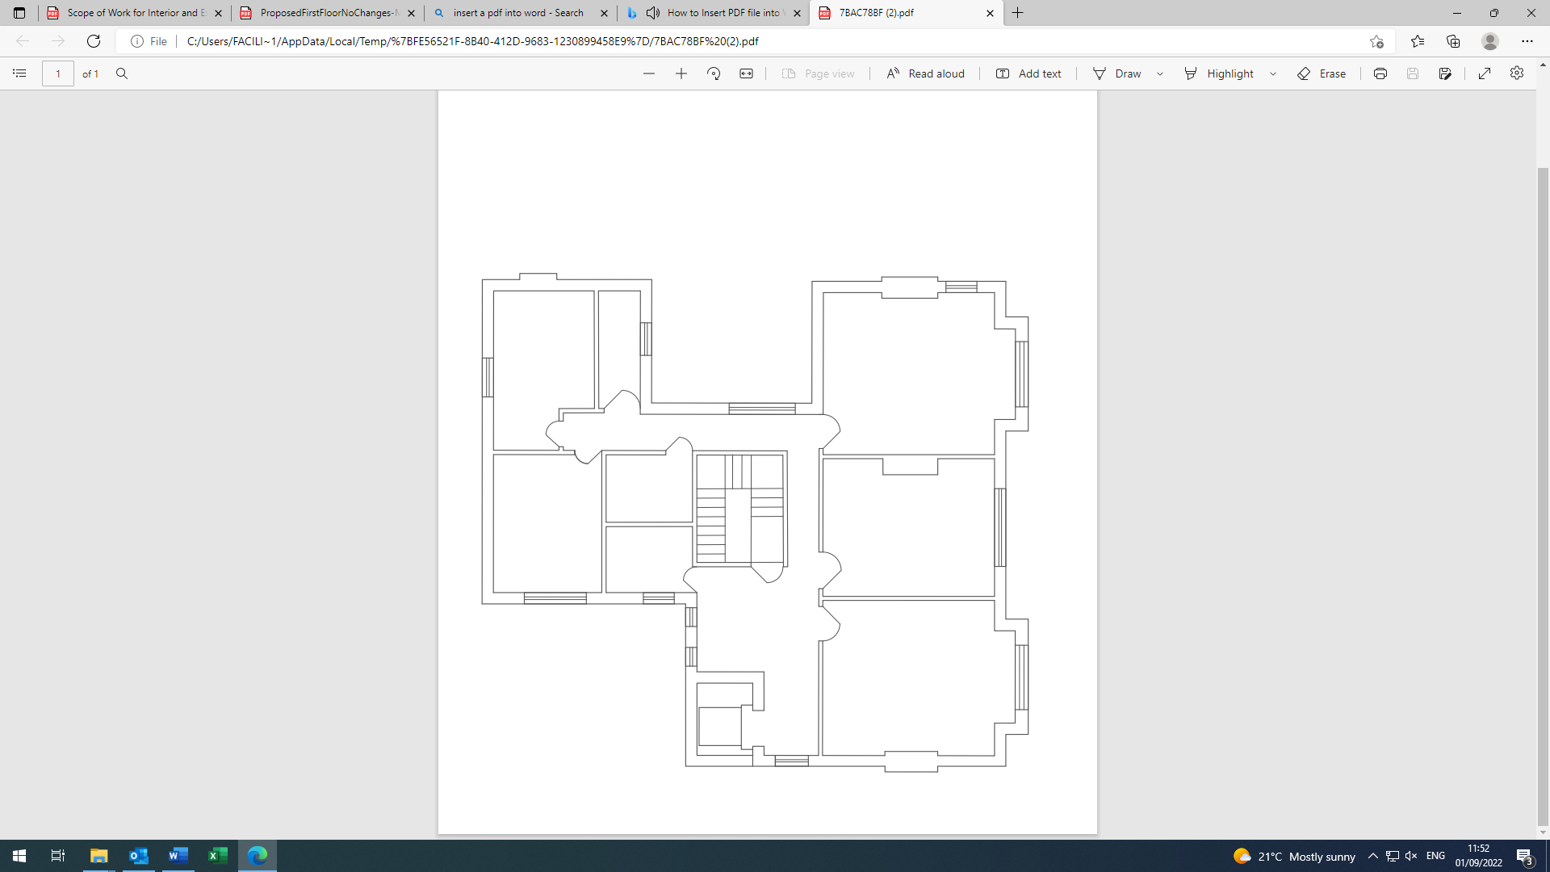

Room 1

Room 2

Room 3

Corridor

Lift

Disabled

Toilet

Office Room

Store

Room

Bathroom

Toilet

Corridor

The first floor of Marshlands comprises a corridor that is accessed by a staircase, through an automatic fire door from the ground floor and eight Individual rooms. Disability access is by the lift, which currently is not in use as it requires repair. This is subject to a separate quotation process by specialist lift contractors.

Rooms 1-3 are south facing in location and separated by load bearing walls and a chimney stack. The rooms are accessible by three automatic fire doors.

On the north side of the building there are five rooms separated by a mixture of load bearing and stud walls. Two rooms are designated toilet amenities, two rooms comprise a small office and storage space. The existing bathroom is now an open space with fixtures and fittings removed.

The first floor is decorated with a mixture of old woodchip paper and magnolia paint on walls and carpets or vinyl flooring throughout.

1. **Summary of Structural Survey Report**

**It should be noted that the structural survey included a proviso that any works would be dependent on first carrying out an assessment of the condition of the load bearing walls on the first and ground floor, so the Council would expect this to form part of any quotation process.**

1. **Renovation Options**

As a result of research already carried out, the Council is considering 3 distinct options for the renovation and reuse of Marshlands. These are summarized below:

**Option 1**

**7**

**1**

**2**

**6**

**4**

1. Remove internal load bearing walls and chimney stack, in accordance with structural survey report on the south facing rooms 1-3, to create one large open space.
2. Installation of steel beams to support the roof structure, as per structural survey report.
3. Apply for building regulations and other regulations that need to be complied with.
4. Remove internal walls between the storeroom, bathroom and disabled toilet to create a kitchenette/breakout space.
5. Remove disabled toilet fixtures and fittings, and plumbing.
6. Installation of kitchenette in breakout room space and plumb in.
7. Move internal stud wall in toilet room, to create a new toilet that accommodates disabled and unisex genders and be disabled regulation compliant.
8. Installation of new toilet fixture and fixings, and plumbing.
9. Installation of new radiators, to replace old.
10. Installation of plasterboard (fire resistant applicable) throughout rooms, corridor and skim. Paint with Dulux Pebblestone emulsion.
11. Installation of plasterboard (fire resistant applicable) ceiling throughout rooms, corridor and skim. Paint with Dulux White emulsion.
12. Paint doors with Dulux white gloss.
13. Installation of new wooden skirting boards. Paint boards with Dulux white gloss.
14. Remove carpet and vinyl floor throughout the first floor.
15. Installation of soundproof laminate flooring throughout rooms and corridor, vinyl in new toilet.
16. Installation of round LED lighting throughout rooms and corridor.
17. Remove old fixtures and fittings in rooms and corridor that are obsolete.
18. Installation of new electric board.
19. Remove obsolete call points, display box and electric wiring.
20. Installation of trunking in rooms 1-3, breakout room and office.
21. Installation of sockets, light switches, telephony and ethernet connections in rooms 1-3, breakout room and office.
22. Remove waste and dispose of in accordance with all relevant regulatory regimes.

**Renovation Option 2**

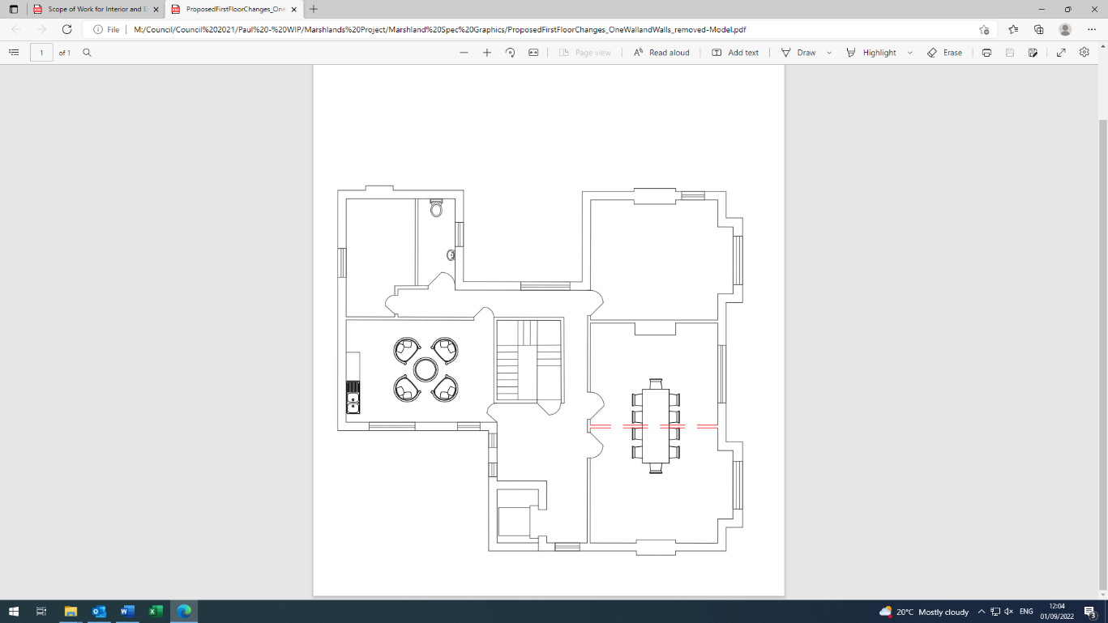

**1**

**2**

**7**

**6**

**4**

1. Remove internal load bearing wall as per structural survey report on the south facing rooms 1-2, to create a smaller open space.
2. Installation of steel beam to support the roof structure as per structural survey report.
3. Apply for building regulations and other regulations that need to be complied with.
4. Remove internal walls between the storeroom, bathroom and disabled toilet to create a breakout room space.
5. Remove disabled toilet fixtures and fittings, and plumbing.
6. Installation of kitchenette in breakout room space and plumb in.
7. Move internal stud wall in toilet room, to create a new toilet that accommodates disabled and unisex genders and be disabled regulation compliant.
8. Installation of new toilet fixture and fixings, and plumbing.
9. Installation of new radiators, to replace old.
10. Installation of plasterboard throughout rooms, corridor and skim. Paint with Dulux Pebblestone emulsion.
11. Installation of plasterboard ceiling throughout rooms, corridor and skim. Paint with Dulux White emulsion.
12. Paint doors with Dulux white gloss.
13. Installation of new wooden skirting boards. Paint boards with Dulux white gloss.
14. Remove carpet and vinyl floor throughout the first floor.
15. Installation of soundproof laminate flooring throughout rooms and corridor, vinyl in new toilet.
16. Installation of round LED lighting throughout rooms and corridor.
17. Remove old fixtures and fittings in rooms and corridor that are obsolete.
18. Installation of new electric board.
19. Remove obsolete call points, display box and electric wiring.
20. Installation of trunking in rooms 1-3, breakout room and office.
21. Installation of sockets, light switches, telephony and ethernet connections in rooms 1-3, breakout room and office.
22. Remove waste and dispose of in accordance with all relevant regulatory regimes.

**Renovation Option 3**

**7**

**3**

**1**

1. Remove internal walls between the storeroom, bathroom and disabled toilet to create a breakout room space.
2. Remove disabled toilet fixtures and fittings, and plumbing.
3. Installation of kitchenette in breakout room space and plumb in.
4. Move internal stud wall in toilet room, to create a new toilet that accommodates disabled and unisex genders and be disabled regulation compliant.
5. Installation of new toilet fixture and fixings, and plumbing.
6. Installation of new radiators, to replace old.
7. Installation of plasterboard throughout rooms, corridor and skim. Paint with Dulux Pebblestone emulsion.
8. Installation of plasterboard ceiling throughout rooms, corridor and skim. Paint with Dulux White emulsion.
9. Paint doors with Dulux white gloss.
10. Installation of new wooden skirting boards. Paint boards with Dulux white gloss.
11. Remove carpet and vinyl floor throughout the first floor.
12. Installation of soundproof laminate flooring throughout rooms and corridor, vinyl in new toilet.
13. Installation of round LED lighting throughout rooms and corridor.
14. Remove old fixtures and fittings in rooms and corridor that are obsolete.
15. Installation of new electric board.
16. Remove obsolete call points, display box and electric wiring.
17. Installation of trunking in rooms 1-3, breakout room and office.
18. Installation of sockets, light switches, telephony and ethernet connections in rooms 1-3, breakout room and office.
19. Remove waste and dispose of in accordance with all relevant regulatory regimes.
20. **Room dimensions and GIFA**

**Room 1:**

|  |  |  |  |
| --- | --- | --- | --- |
|  |  |  |  |

**Room 2:**

|  |  |  |  |
| --- | --- | --- | --- |
|  |  |  |  |

**Room 3:**

|  |  |  |  |
| --- | --- | --- | --- |
|  |  |  |  |

**Corridor:**

|  |  |  |  |
| --- | --- | --- | --- |
|  |  |  |  |

**Disabled Toilet Room:**

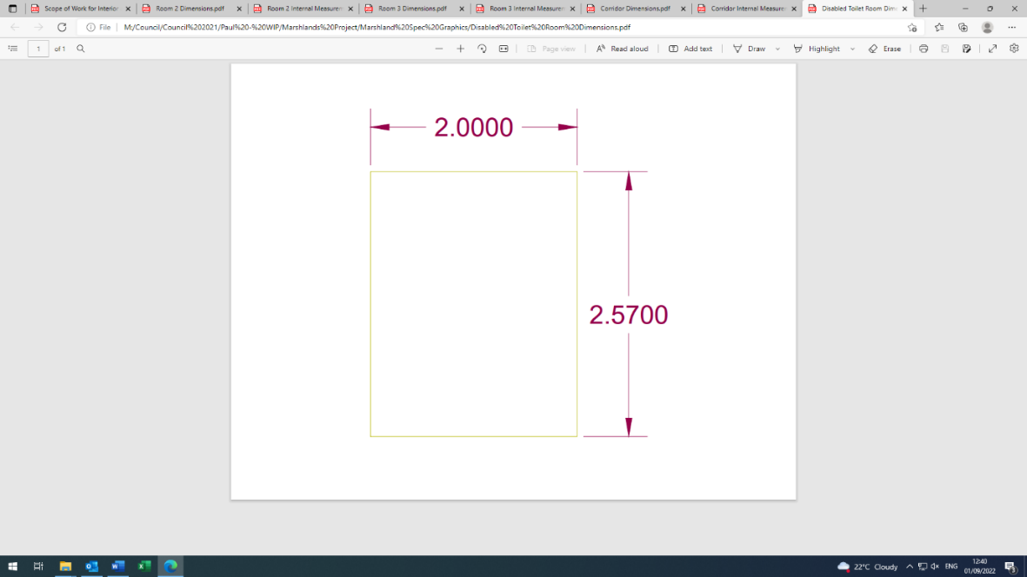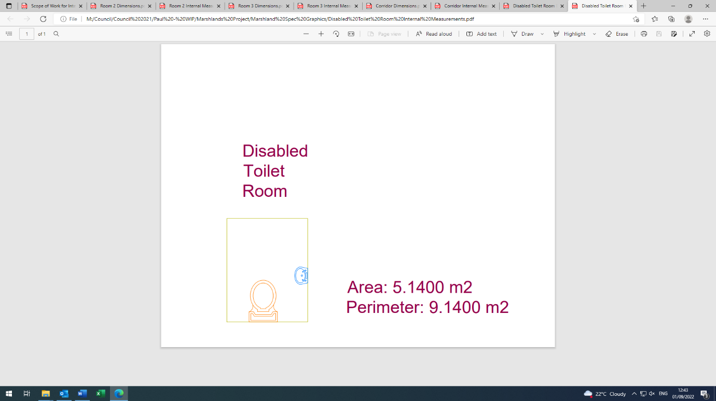

|  |  |
| --- | --- |
|  |  |

**Storeroom:**

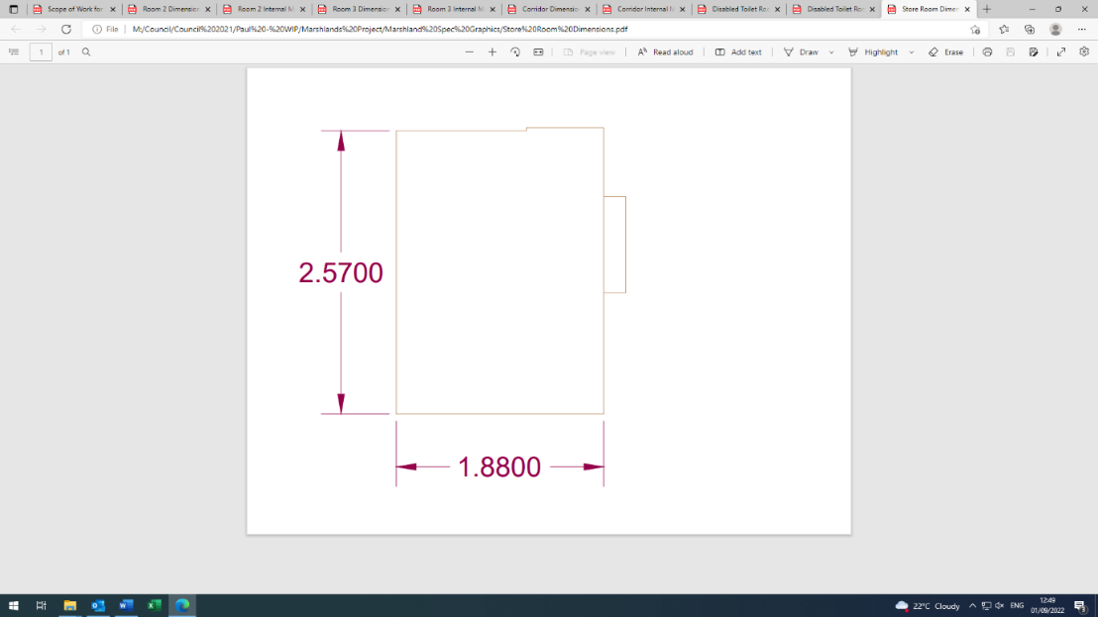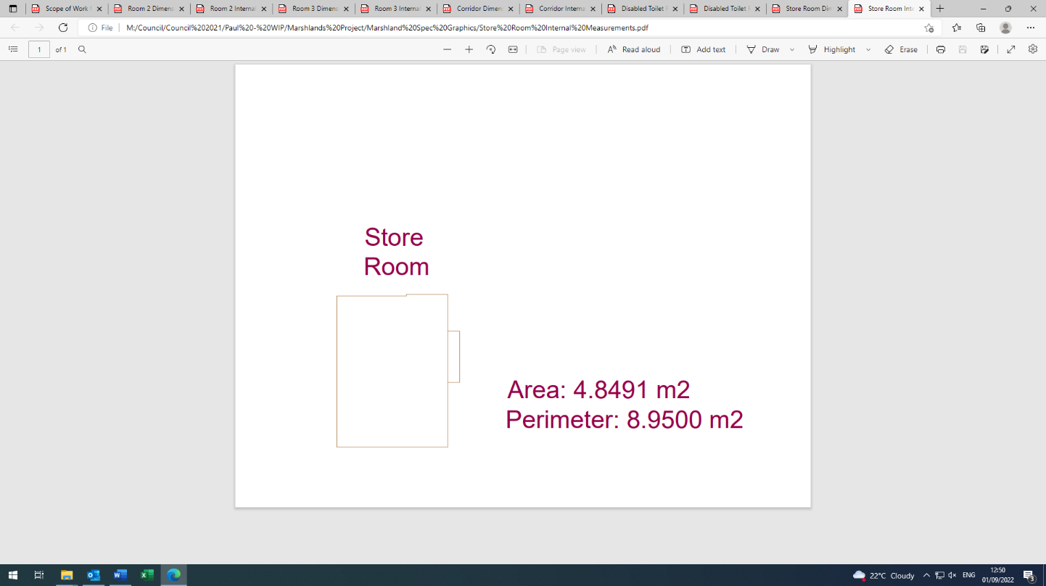

|  |  |
| --- | --- |
|  |  |

**Bathroom:**

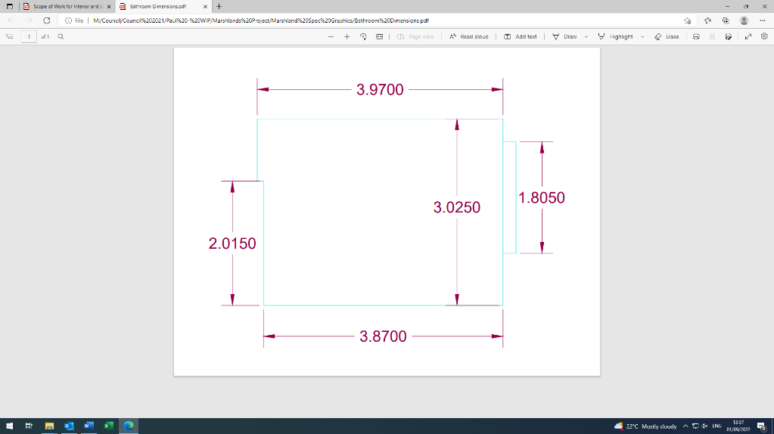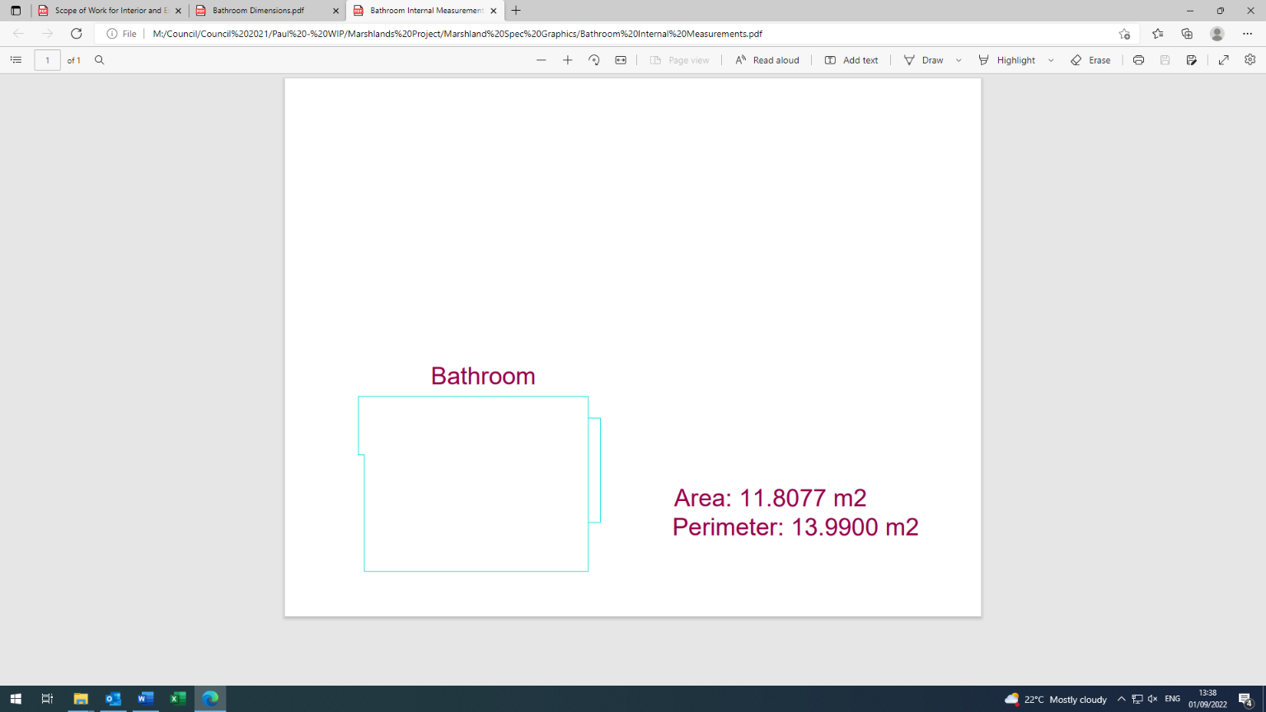

|  |  |  |
| --- | --- | --- |
|  |  |  |

**Office Room:**

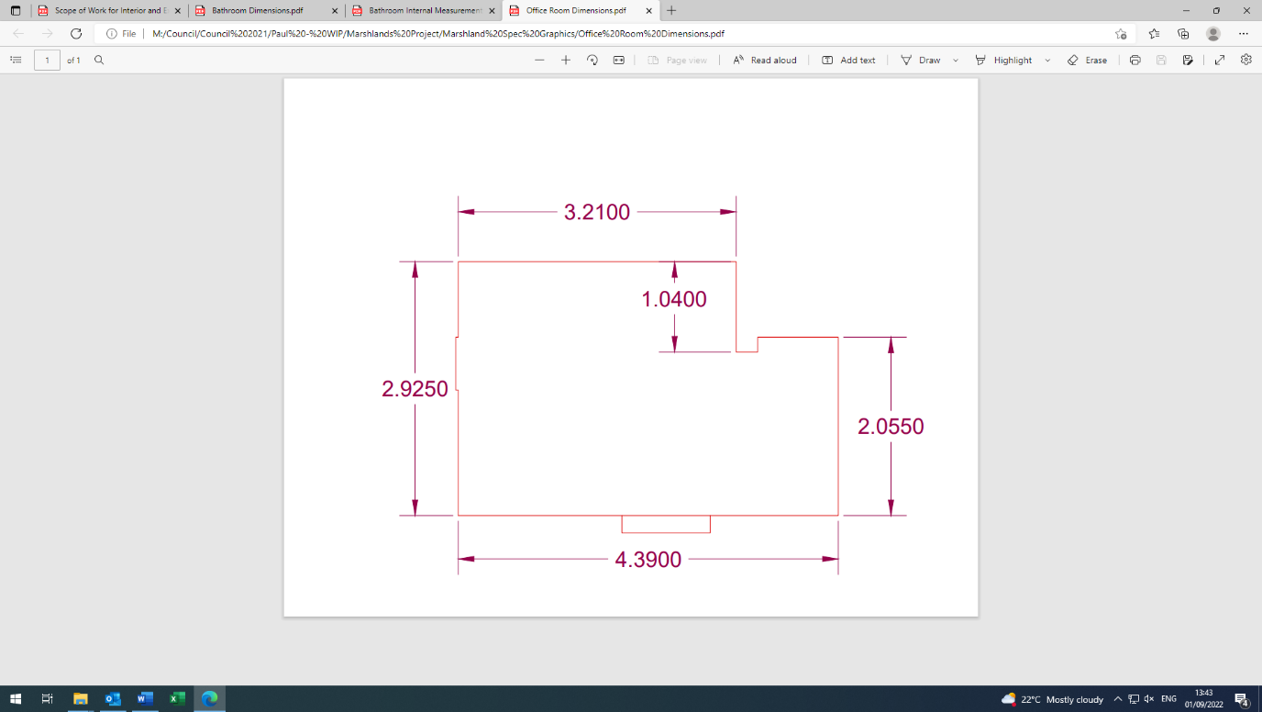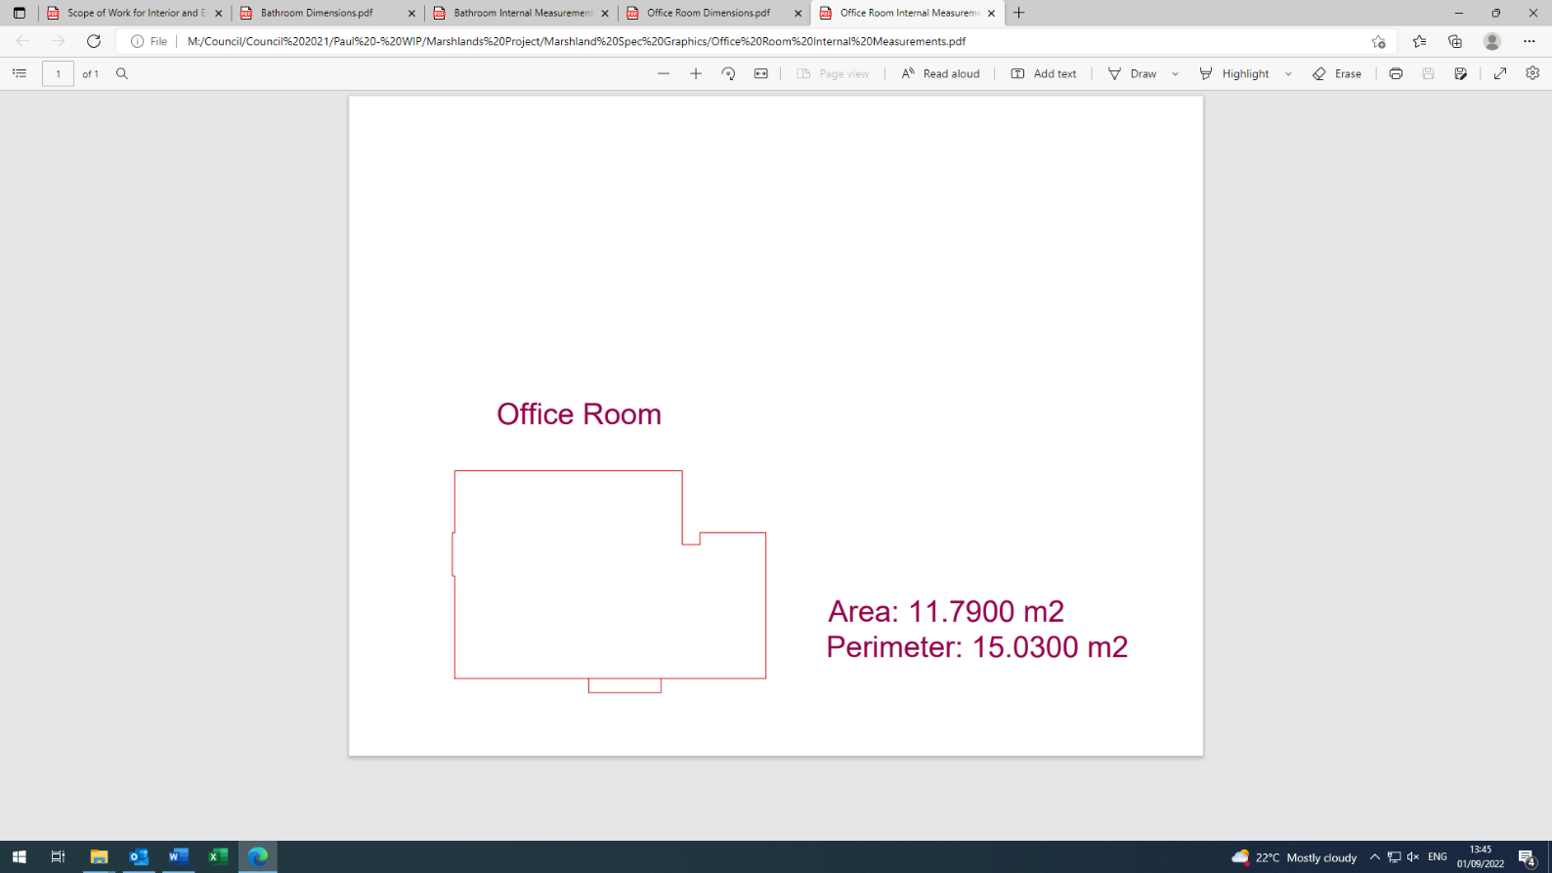

|  |  |
| --- | --- |
|  |  |

**General Toilet Room:**

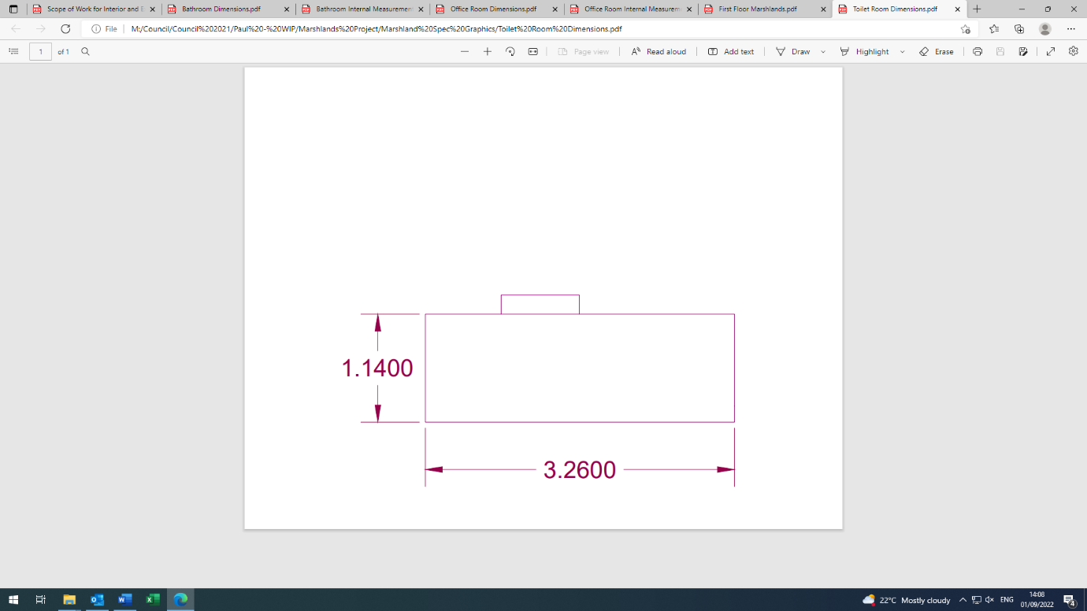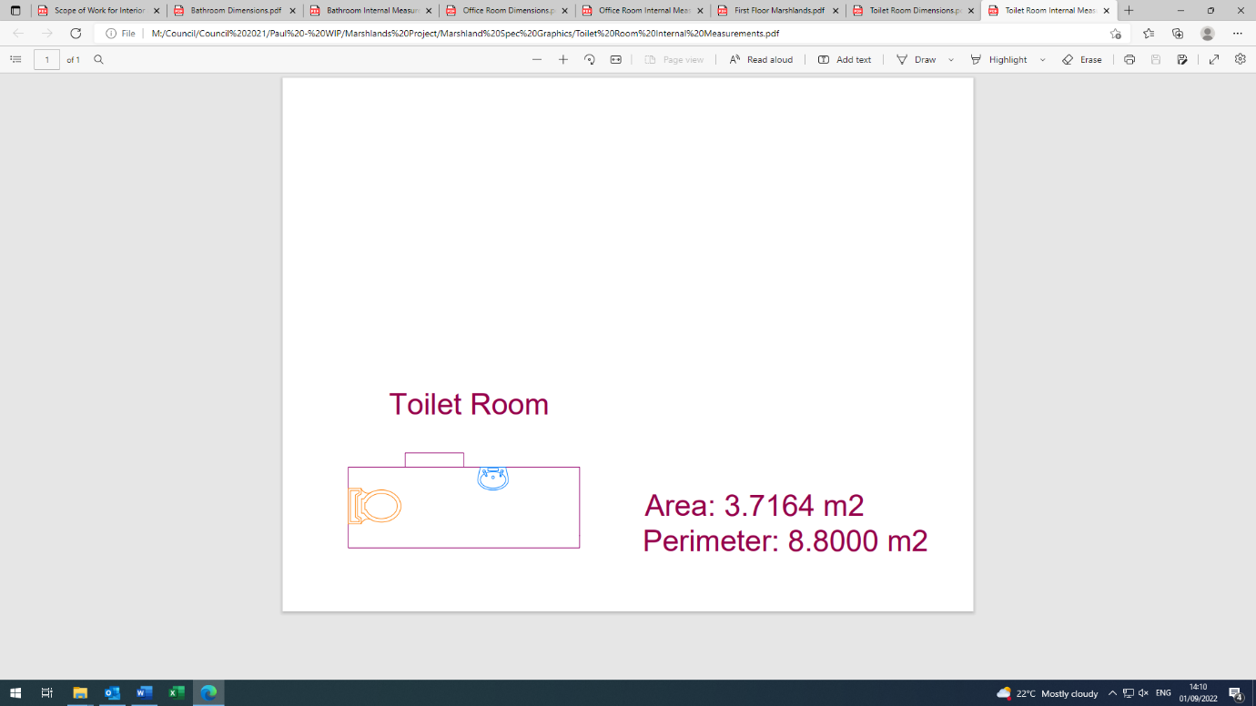

|  |
| --- |
|  |

1. **Type of finish**

|  |  |
| --- | --- |
|  | Ceiling |
|  | Wall |
|  | Door |
|  | Floor |
|  | Skirting board |
|  | Round LED lighting |
|  | Light and Emergency Light Switches |
|  | Double sockets and ethernet connections |
|  | Windows |

1. **General conditions and timeframe**

All works will be overseen by the Council’s Facilities & Projects Officer **but any contractor will primarily responsible for project managing the scheme.**

Contractors will be expected to provide along with their tender prices:

• copies of all relevant risk assessments

• certificates confirming qualifications

• evidence of public liability insurance certificate

• anticipated start and end date for works.

It is the duty of all contractors, their employees and sub-contractors, to be aware of their individual responsibilities under the Health & Safety at Work (etc.) Act 1974 to ensure, as is reasonable and practicable, that they provide and maintain safe and healthy working conditions, equipment and systems of work and to provide such information, training and supervision as they need for this purpose. Contractors should carry Public Liability Insurance of not less than £5,000,000 and understand that they accept responsibility for the health and safety of members of the public who may be affected by their activities.

In the event of any contractor failing to fulfil part of the contract, the Council reserves the right to have the outstanding work done at the charge of the contractor. All successful contractors will be expected to inform the Council of any damage they may observe within their area of contract. Contractors will be responsible for locking and securing any facilities/grounds for which they have been provided with a key, immediately on completion of all visits.

The Council reserves the right to terminate this agreement, should a contractor:

1. fail to comply with the terms and agreement of the contract.

2. become deemed unfit for work by a general practitioner.

3. be declared bankrupt or be convicted of a criminal offence.

1. **Conclusions**

Expressions of interest are invited from contractors to meet with the Council’s Facilities & Projects Officer with a view to providing a detailed quotation for the works set out in this specification.

Contact: Paul Johns

Email: [facilities@seaton.gov.uk](mailto:facilities@seaton.gov.uk)

Telephone: 01297 21388