Terms of Reference of the Camborne Town Deal Board

- Establishment
There shall be a Camborne Town Deal Board consisting of representatives from the public, private, voluntary and community sector organisations with an active interest in community regeneration in the Camborne Town Deal Board area shown in the map in Appendix 1. The Board is formed to seek funding and (if successful) oversee delivery of the Governments Towns Fund programme in this area.

The Parties acknowledge that the projects identified in the Common Objectives although separate are interdependent and are likely to be delivered on their own timescales dependent on funding, planning permission and other controls.

- Objectives and functions
In November 2019, The Ministry of Housing, Communities and Local Government (MCHLG) launched the £3.6bn Towns Fund, for 100 towns across the country each bidding for a share of up to £25 million. Of these for Cornwall, Camborne was selected for inclusion (the Towns Fund).

MCHLG published (Nov, ’19) the Towns Fund Prospectus, and in which there are explicit guidelines on the formation of the Town Deal Board, their role and function, who should sit on the board, and from where these members should be drawn.

The Prospectus instructs the Unitary Authority (Cornwall Council) hereto referred to as the Lead Council to develop the Town Deal Board, and from there draw up a Town Investment Plan. The Town Investment Plan shall be drawn up, and when consensus is achieved confirms that the content of the Town Investment Plan is of high enough quality for submission to MCHLG, it shall be done so by the Lead Council.

The proposed objectives include:

- The Towns Fund addresses growth constraints across the UK experienced by certain towns in certain areas.
- Successive governments have focussed on cities as drivers of economic growth. Towns have been overlooked and an objective of the Towns Fund is to level up that imbalance.

The Towns Fund will strengthen economies in towns that may not have the fundamental building blocks of a healthy localised economy. Without a strong economy amenities and leisure facilities, it is crucial to grow the economy of towns to facilitate the revival of these facilities and improve the standards of living in these areas.

The Towns fund will:
- focus on the individuality and assets of each town and build upon those assets providing the tools to design and deliver a growth strategy for that town.
- provide confidence in long-term investment for businesses in towns, capitalising on the natural environment for renewable energy creation, historic and cultural offering and access to infrastructure.
- work with local leaders to support the businesses to grow further and encourage a healthy supply chain.
- seek opportunities to reinvigorate a workforce with new skills and enable that workforce to pursue other job opportunities that may exist in a changing economic marketplace.
- work with Town Deal Boards to restore a spirit of pride that is often lost in ‘left-behind’ towns, through facilitation of project space for people to meet and deliver projects.
- assist Town Deal Boards in the creation of the Town Investment Plan (TIP) for the recognition, rationalisation, ongoing development, and future investment opportunities of a town.

This Agreement sets out a framework for co-operation and collaboration between the Parties in order to develop the Common Objectives.

- Representation / Membership
The Camborne Town Deal Board will be empowered to make all the necessary decisions relating to the Towns Fund. Representatives who serve on Camborne Town Deal Board in a voting capacity will be from named bodies, organisations and businesses with an interest in stimulating the economy and improving quality of life in the Camborne area.

The membership itself and the balance of members from different sectors (public/private/voluntary) will reflect the guidance contained in the Towns Fund Prospectus and no single sector will have more than 49% of the voting rights. Individuals can also join where agreed by the Town Deal Board where they contribute the relevant skills, experience or expertise required. It is anticipated that the total number of voting members will not number less than 12 but they will evolve to ensure there is democratic accountability across the area. The Voting members of the Camborne Town Deal Board can be found in Appendix 2.

Cornwall Councillors and Town and Parish Councillors who represent their authorities can only be members of the Board in this capacity and cannot represent private and/or community organisations in which they are involved.

The Town Deal Board members should be committed to implementing the objectives of the Towns Fund and to developing a fully evidenced based Town Investment Plan that will then be submitted to MHCLG in order to secure the funding required to deliver the Town Investment Plan. They should be prepared to act as a focal point for consultations, to oversee delivery across the area is undertaken in a co-ordinated way and to act as ambassadors for and actively promote the Towns Fund programme in a professional manner.

If a representative of an organisation resigns from that organisation, they resign from being the named representative on the Camborne Town Deal Board. The organisation will then be invited to nominate a new representative.

Membership will be kept under review and will be formally reviewed on an annual basis. In reviewing membership, the Camborne Town Deal Board will assess and take recognition of the involvement of its representatives in other related organisations and groups.
In addition, the Camborne Town Deal Board may co-opt additional representatives at any time during the year to further the interests of the work being undertaken. Normally these representatives would be non-voting. However, the Camborne Town Deal Board may decide in certain circumstances these individuals should have voting rights. The reasons for this decision should be clearly laid out in the minutes of the meeting.

Should any representative miss 3 consecutive meetings without sending comments the Camborne Town Deal Board will consider whether that representative should be asked for a written explanation, which will be formally reviewed by the Board and decision made as to whether a request is submitted to the organisation requesting alternative representation or a termination of the membership.

- Meetings
The Camborne Town Deal Board shall hold at least 4 meetings in every year for the transaction of general business and may hold such other meetings as they shall find necessary or convenient.

- Quoracy and decision making in meetings
For a meeting of the Camborne Town Deal Board to be quorate there must be present no less than 10 of the representatives entitled to vote and this can be in person or by tele/video conferencing. The requirement for no single sector having more than 49% of the voting rights is applicable at the point of a vote/decision.

Most decisions at a meeting of Camborne Town Deal Board shall be reached by a consensus rather than a voting procedure. Formal Voting (i.e. proposal, seconder and vote) will be needed on decisions that commit to financial matters (e.g. agreeing to contract with external suppliers (via the Lead Council) and agreeing to sign up to the “Town Deal” offered by Government in response to the submitted Town Investment Plan) and beyond that only in exceptional circumstances.

When voting takes place there will be an equality of votes amongst those representatives present and in the case of a tied vote on any matter, the person presiding at the meeting shall have a second or casting vote.

Members may bring supporting advisers to the meeting at the discretion of the Chair in addition to the current list of advisers as given in Appendix 2.

A full record of those present at the meeting and of the representatives sending in apologies of absence shall be recorded in the minutes. The minutes of every meeting of Camborne Town Deal Board shall be drawn up by the Economic Growth Service of Cornwall Council (as the Lead Council) and shall be approved by the Camborne Town Deal Board and when approved, signed by the Chair at the next meeting.

Each representative of Camborne Town Deal Board shall be permitted to: -

- Send to the Secretariat not less than 7 days prior to the date of the meeting a statement of any matter that they may wish to include in the agenda.
- Receive copies of the agenda and accompanying papers 5 days prior to the date of the meeting, unless there is some particular urgency when a lesser period may be given, which in any event shall not be less than 3 days.
- Items may be tabled for information purposes only; all should be written in plain English.
- Verbal reports other than those for information will only be accepted in exceptional circumstances and with the consent of the Chair.

Special Meetings
Any six representatives of Camborne Town Deal Board can call for a special meeting. Such requisition, made to the Secretariat, must set forth the nature of the matter requiring consideration and the notices summoning such meetings shall contain details of the matter to be discussed. The meeting must take place within 14 days of its notification.

- Written procedures
With the express consent of the Chair and the Lead Council decisions can be made by written procedures, such procedures to be agreed by the Camborne Town Deal Board but which reflect the principles of this constitution. In each case a deadline for response will be given, the decisions will be binding, and they will be reported to the next convened meeting of the Board

- Conflicts of Interest and Confidentiality
When accepting membership of Camborne Town Deal Board each representative must complete a register of interests and accept the membership code of conduct, which shall be kept by the Secretariat and be open to inspection by any representative of Camborne Town Deal Board. This register of interest must also be completed by any officer contributing to the work of the Camborne Town Deal Board.

In the spirit of openness, interests must be declared where appropriate. Those declaring an interest will be asked to leave the room and shall take no part in the discussion or the voting thereon. However, the Camborne Town Deal Board, if appropriate, can invite the interested party to provide factual information before the discussion begins. As a minimum the register must be updated annually, but each member should ensure that it is updated as necessary if any changes occur during the year.

All members should respect the confidential nature of some aspects of the activity undertaken by the Camborne Town Deal Board and must adhere to the membership code of conduct.

- Appointment of Chair and Vice Chair
The Camborne Town Deal Board shall appoint at its first formal meeting and thereafter annually a Chair and a Vice-Chair for the ensuing year. In line with the Towns Fund Prospectus guidance the chair should be from the private sector unless there are reasons why this cannot be the case.

The Chair and Vice Chair will act in the best interests of the Camborne Town Deal Board as a whole. The Chair shall conduct the meetings and perform other duties as determined by the Camborne Town Deal Board and formally agreed at a meeting. If the Chair is absent, the Vice Chair will take on the roles undertaken normally by the Chair. In the absence of both the Chair and Vice Chair, a meeting Chair will be elected for that meeting from the voting members present.

If the Chair resigns during the year, the Vice Chair will become Interim Chair and an interim Vice Chair will be nominated by the Camborne Town Deal Board until the formal elections are held.

If the Vice Chair indicates they do not wish to become the Interim Chair, then the Camborne Town Deal Board will nominate an interim Chair until the formal elections are held. If the Vice Chair resigns during the year, an interim Vice Chair will be nominated by the Camborne Town Deal Board until the formal elections are held.

Supporting arrangements
Provision is made to establish sub groups of the Camborne Town Deal Board to facilitate quick decision making and engagement of relevant specialists. The terms of reference, functions and membership of any such sub groups is to formally agree by the Camborne Town Deal Board prior to their creation. These details for each sub group established to date are attached to this constitution in Appendix 3.

Any groups established whilst having their own terms of reference are expected to operate within the remit of this constitution and shall have a majority of members from the voting representatives of the Camborne Town Deal Board.

Amendments to the Terms of Reference
The terms of reference shall be open to review at any time, but any amendment shall not be made unless agreed by a three quarters majority of representatives present that are entitled to vote. Notes of such proposed amendments shall be provided to representatives of Camborne Town Deal Board at least 14 days before the meeting.

Dissolution
The Group may be dissolved by a resolution passed by a simple two-thirds majority of those present and voting at a Special Meeting.

Terms of Reference agreed at the meeting of:

Signed:

Position: Chair of Camborne Town Deal Board

Date:

Signed:

Position: Representative of Cornwall Council as (Lead Council)

Date:

Appendix 1: Area covered by the Camborne Town Deal Board

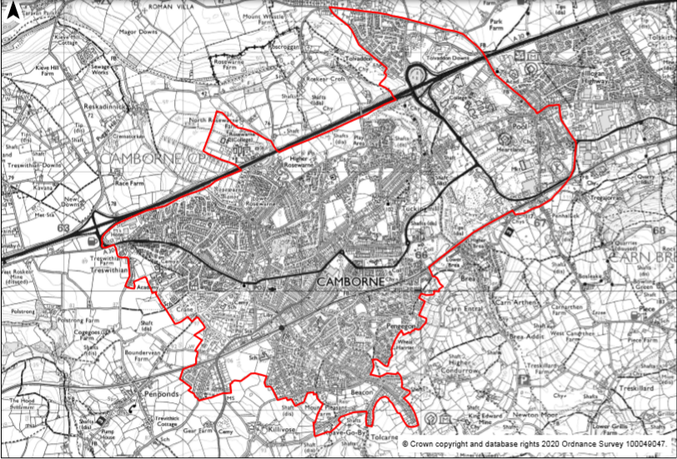

Appendix 2: List of voting members of the Camborne Town Deal Board

MEMBERSHIP OF the Camborne Town Deal Board

ORGANISATION | NAME
Public Sector x 9
Cornwall Council | Cllr D Biggs
Cornwall Council | Cllr P White
Cornwall Council | Cllr J Herd
Cornwall Council | Cllr D Atherford
Cornwall Council | Cllr P Desmonde
Camborne Town Council | Trevor Dalley
Camborne Town Council | Samantha Hughes
MP | George Eustice
Carn Brea Parish Council | TBC
Private/Community/Voluntary Sector x 8
Camborne BID | Anna Pascoe
Cornwall and IoS Local Enterprise Partnership | Simon Caklais
Private Sector | Justin Olusunde
Private Sector | Sue Bradbury
Private Sector | Rose Goodship
Anchor Institution | Lauren Burt
Community and Voluntary Sector | Val Dalley
Private sector | Tonia Lu
Voting Members
Quoracy 10

Ratification Officers
Cornwall Council (Lead Council) | Glenn Caplin
Non-Voting Officers
Cornwall Council | Chris Godolphin
Cornwall Council | Chloe Lorraine - Towns Fund Lead
Cornwall Council | David Rodda
Cornwall Council | Charlotte Caldwell
MHCLG | David Krohn

Appendix 3: Sub Group Terms of Reference if applicable

No sub group currently

