RM6187 Framework Schedule 6 (Order Form and Call-Off Schedules)

CALL-OFF REFERENCE: 707770450

THE BUYER: Strategic Command (UKStratCom) part of the
Ministry of Defence (MOD)

BUYER ADDRESS MoD Corsham,
B2, Building 405,
Westwells Road,
Corsham,
Wiltshire,
SN13 9NR

THE SUPPLIER: PA Consulting Services Limited
SUPPLIER ADDRESS: 10 Bressenden Place, London, SW1E 5DN
REGISTRATION NUMBER: 414220
DUNS NUMBER: 211000617
SID4GOV ID: 211000617

Applicable framework contract

This Order Form is for the provision of the Call-Off Deliverables and dated 17 July 2023.

It is issued under the Framework Contract with the reference number RM6187 for the provision of management consultancy services.

Call-off lot:

- Lot 6: Procurement and Supply Chain

Call-off incorporated terms
The following documents are incorporated into this Call-Off Contract.
Where schedules are missing, those schedules are not part of the agreement and can not be used. If the documents conflict, the following order of precedence applies:

- This Order Form includes the Call-Off Special Terms and Call-Off Special Schedules.
- Joint Schedule 1(Definitions and Interpretation) RM6187
- The following Schedules in equal order of precedence:

Joint Schedules for RM6187 Management Consultancy Framework Three

  - Joint Schedule 1 (Definitions)
  - Joint Schedule 2 (Variation Form)
  - Joint Schedule 3 (Insurance Requirements)
  - Joint Schedule 4 (Commercially Sensitive Information)
  - Joint Schedule 5 (Corporate Social Responsibility)
  - Joint Schedule 10 (Rectification Plan)
  - Joint Schedule 11 (Processing Data)

Call-Off Schedules

  - Call-Off Schedule 3 (Continuous Improvement)
  - Call Off Schedule 4 (Call Off Tender)
  - Call-Off Schedule 5 (Pricing Details)
  - Call-Off Schedule 7 (Key Supplier Staff)
  - Call-Off Schedule 8 (Business Continuity and Disaster Recovery)
  - Call-Off Schedule 9 (Security)
  - Call-Off Schedule 10 (Exit Management)
  - Call-Off Schedule 15 (Call-Off Contract Management)
  - Call-Off Schedule 16 (Benchmarking)
  - Call-Off Schedule 17 (MOD Terms)
- DEFCON 5J 18/11/16 – Unique Identifiers
- DEFCON 76 12/06 - Contractors Personnel At Government Establishments
- DEFCON 129J 18/11/16 – The use of the electronic business delivery form
- DECON 501 10/21 - Definitions and Interpretations
- DEFCON 503 07/21 – Formal Amendments to the contract
- DEFCON 513 07/21 – Value Added Tax
- DEFCON 514 08/15 – Material Breach
- DEFCON 515 06/21 – Bankruptcy and Insolvency
- DEFCON 516 04/12 - Equality 9
- DEFCON 518 02/17 – Transfer
- DEFCON 520 05/18 -Corrupt Gifts And Payments Of Commission
- DEFCON 522 11/17 - Payment And Recovery OF Sums Due
- DEFCON 526 08/02 – Notices
- DEFCON 527 09/97 – Waiver
- DEFCON 529 09/97 – Law (English)
- DEFCON 531 -11/14 Disclosure Of Information
- DEFCON 532B & DEFFORM 532 05/18 - Protection Of Personal Data
- DEFCON 534 09/21 – Sub-Contracting and Prompt Payment
- DEFCON 537 12/21 – Rights of Third Parties
- DEFCON 538 06/02 – Severability
- DEFCON 539 08/13 – Transparency
- DEFCON 540 05/23 - Conflict of Interest
- DEFCON 550 02/14 – Child Labour and Employment Law
- DEFCON 659A 02/17 - Security Measures
- DEFCON 566 10/20 – Change of Control of Contractor
- DEFCON 630 02/18 – Framework Agreements
- DEFCON 632 11/21 – Third Party Intellectual Property – Rights and Restrictions
- DEFCON 642 07/21 – Progress Meetings
- DEFCON 660 12/15 - Official Sensitive Security Requirement

  - Call-Off Schedule 18 (Background Checks)
  - Call-Off Schedule 20 (Call-Off Specification)

- CCS Core Terms
- Joint Schedule 5 (Corporate Social Responsibility)

Supplier terms are not part of the Call-Off Contract. That includes any terms written on the back of, added to this Order Form, or presented at the time of delivery.

Call-off special terms

The following Special Terms are incorporated into this Call-Off Contract:

Special Term 1 This Call Off Contract is viewed as a Tier 1 contract for the purposes of open book data reporting under the CSS Open Book Contract Management Guidance.

Special Term 2 Beyond contract information and delivery management information that must be kept for audit purposes no Government Data will be held on the Supplier’s corporate ICT systems. The Supplier will only access and / or create Government Data in the performance of this contract using Authority issued MODNET laptops. The requirement to erase all Government Data in Clauses 10.6.1(d), 14.8(d) of the Core Terms and in Call-Off Schedule 9 (Security) will be satisfied when the MOD laptops are returned to the Authority at the end of the contract.

Special Term 3. The Supplier only intends to access Government Data in the
performance of this contract using Authority issued MODNET laptops and there will not be a requirement to make its own back-ups of Government Data. Accordingly, the requirements of Clause 14.3 and 14.8(a) of the Core Terms are waived by the Buyer in respect of this Call-Off Contract.

Special Term 4 Both Parties agree that Call-Off Schedule 8 (Business Continuity and Disaster Recovery) shall be satisfied by the submission of the PA corporate Business Continuity and Disaster Recovery Plan within one (1) month of the call off commencement date. No further provisions of Call-Off Schedule 8 shall apply

Call-off start date: 25 July 2023

Call-off expiry date: 24 July 2024

Call-off initial period: Initial Period:
25 July 2023 – 24 July 2024

Extension options: 12 months
25 July 2023 – 24 July 2025

Call-off deliverables:

See details in Call-Off Schedule 20 (Call-Off Specification)

Security

Short form security requirements apply

Maximum liability

The limitation of liability for this Call-Off Contract is stated in Clause 11.2 of the Core Terms.

Call-off charges

See details in Call-Off Schedule 5 (Pricing Details)

All changes to the Charges must use procedures that are equivalent to those in Paragraphs 4, 5 and 6 (if used) in Framework Schedule 3 (Framework Prices)

The Charges will not be impacted by any change to the Framework Prices. The Charges can only be changed by agreement in writing between the Buyer and the Supplier because of:

- Specific Change in Law
- Benchmarking using Call-Off Schedule 16 (Benchmarking)

Reimbursable expenses

Recoverable as stated in Framework Schedule 3 (Framework Prices) paragraph 4.
Notwithstanding the provisions of Framework Schedule 3, the parties agree that Reimbursable Expenses are permitted for this Call-Off Contract, for travel to locations other than MOD Corsham if (i) requested by MOD or (ii) submitted in advance to the Authority for review and approval. All reimbursable expenses will be in accordance with the MOD corporate expense policy.

Payment method

Via MOD Contract Purchasing and Finance (CP&F)

Buyer’s invoice address

Amy Howard
UKStratCom DD-CM-MT-CO-42
Amy.Howard111@mod.gov.uk
DBS Finance, Walker House, Exchange Flags, Liverpool, L2 3YL

FINANCIAL TRANSPARENCY OBJECTIVES
The Financial Transparency Objectives do not apply to this Call-Off Contract.

Buyer’s authorised representative
Amy Howard
UKStratCom DD-CM-MT-CO-42
Amy.Howard111@mod.gov.uk
MoD Corsham, B2, Building 405, Westwells Road, Corsham, Wiltshire, SN13 9NR

Buyer’s security policy

Short form security requirement apply

Supplier’s authorised representative
Elaine Whyte
Member of PA’s Management Group
PA Consulting, 10 Bressenden Place, London, SW1E 5DN
Elaine.Whyte@paconsulting.com

Supplier’s contract manager
Alex Gormley
Principal Consultant
PA Consulting, 10 Bressenden Place, London, SW1E 5DN
Alex.Gormley@paconsulting.com

Progress report frequency

Provide a monthly report of activity and deliverables prior to invoicing, as per Call-Off Schedule 20 – Specification

Progress meeting frequency

Chair and minute a weekly review meeting with Buyer to report on team progress, as per Call-Off Schedule 20 – Specification

Key staff

N/A

Key subcontractor(s)

N/A

Commercially sensitive information
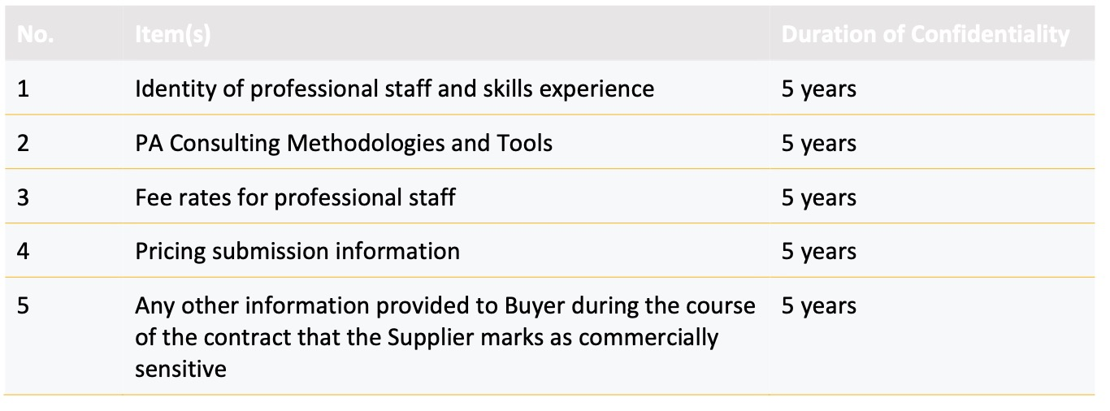

Service credits
Not applicable

Additional insurances
Not applicable

Guarantee
Not applicable

Buyer’s environmental and social value policy

Social value commitment
The Supplier agrees, in providing the Deliverables and performing its obligations under the Call-Off Contract, that it will comply with the social value commitments in Call-Off Schedule 4 (Call-Off Tender)]

Formation of call off contract
By signing and returning this Call-Off Order Form the Supplier agrees to enter a Call-Off Contract with the Buyer to provide the Services in accordance with the Call-Off Order Form and the Call-Off Terms.
The Parties hereby acknowledge and agree that they have read the Call-Off Order Form and the Call-Off Terms and by signing below agree to be bound by this Call-Off Contract.
For and on behalf of the Supplier:

Signature: Signed on the PDF

Name: Elaine Whyte

Role: A Member of PA’s Management Group

Date: 24th July 2023

For and on behalf of the Buyer:

Signature: oksdnd’sa

Name: dfkjdsf j ‘nkdsa’jd’

Role:

Date: 24th July 2023

