**Tennis Court – Fence Replacement**

**Takedown:** Take down and dispose, off site, existing fencing and gates Posts cut just below ground level. - Remove existing posts and mesh and dispose, off site - Break out post foundations from existing pitch fencing when required and remove from site Based on 164m.

**3.0m Fencing**: Corners / ends to above Supply and install 1.2m wide x 1.2m high single leaf spectator gate to spectator fence. Padlocks supplied by others. Finish: Galvanised & Polyester Powder Coated to RAL 6005 Moss Green Supply and install 3m high DualTech Rebound 868 fencing (Super rebound to lower 1.2m) (164m)

Corners/ends to above x 4

**Gates:** Supply and install 2.4m wide (or double width) x 1.2m high spectator gate to spectator fence. Padlock supplied by others (gate to be installed on the path side of the courts – see image 4 for reference).

Waterbeach Parish Council are based in Waterbeach, Cambridgeshire, and the tennis courts are on the recreation field, off of Cambridge Road.

When quoting for the job, we have been asked to also get the following information from potential contractors;

1. What timeframe can the work be completed within?
2. Confirm that the fencing is the actual Zaun fencing, if not, what?
3. What guarantee period do you offer?
4. Are you able to provide a reference from a previous customer?

Image 1 is the type of fencing we would like (ideally Zuan), images 2 and 3 are photos of the current tennis courts that need replacing.

**Image 1: Image 2:**

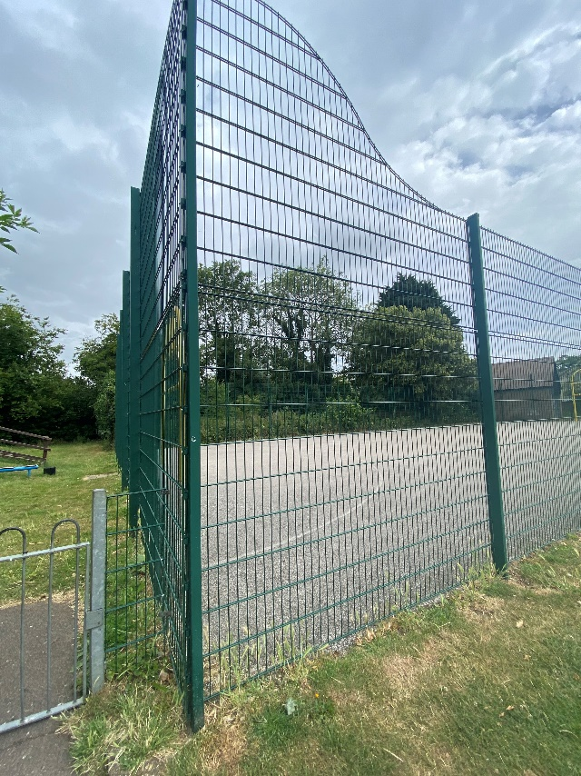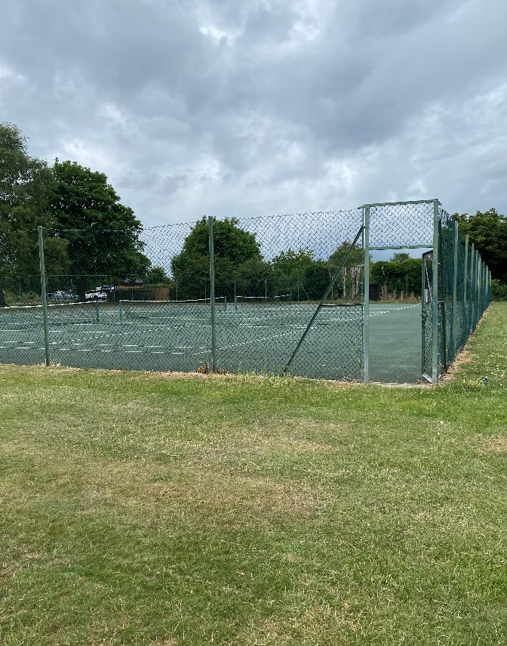

**Image 3:**

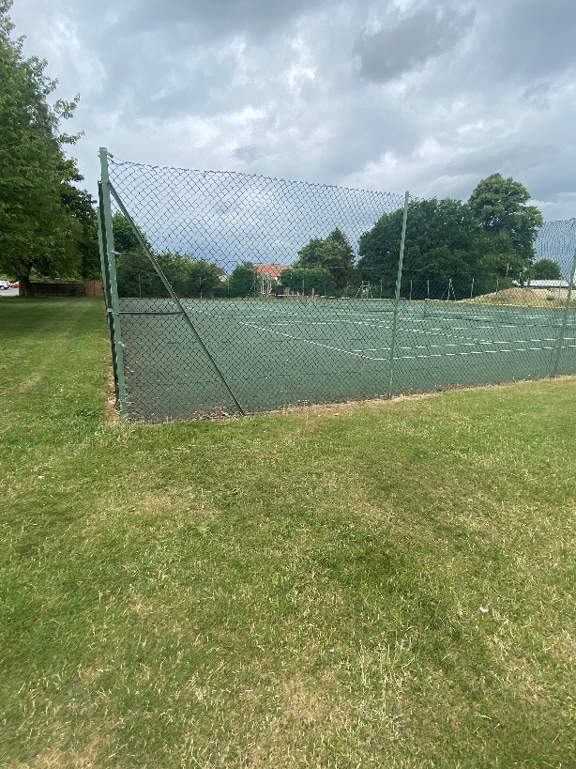

**Image 4: View of tennis courts:**

