Crew Mess utensils

Circular No.364, 28th April 1859 states “Mess utensils suitable for use on boards Her Majesty’s ships will hereafter be supplied gratuitously to each ship on being put in commission.”

The iron items available to crew messes are given by Circular No. 423, May 1860, which gives the cost regarding the loss of mess utensils:

“ Kettles 5 Gallons 10/-

Kettles 4 Gallons 8/-

Meat dish large 3/-

Meat dish small 2/10

Hook pots 1/4

Tin canisters 1/-

Pepper dredgers 0/6

Salt jars 1/6

Soup ladles 0/7

Drinking cups 0/7

Basins 0/7

Plates 0/7

Spoons 0/2

NB. A hook pot or pot hook in this instance means “ A pot fitted with a hook for hanging it to the bars of the galley range”, William Henry Smyth, The Sailor’s Wordbook,1867. Was this used to keep food warm for those on duty?

By the early 1870s the mess utensils in use for an average sized mess (I don’t know what that was on the ship concerned) were the following, from the Surgeon’s report HMS Lord Warden, 25 Sept 1870-31st Dec 1871, ADM 101/209:

“1 bread barge {Cochrane asks for large bread barges}

2 tin kettles - 1 for general use and one for grog

2 tin dishes – for cooking

2 large tubs - for washing

1 vinegar [??? ker] or 2 larger for general use {cleaning?}

1 pepper dredger

1 mustard canister (mustard pot privately purchased)

1 ladle – for soup

2 tin sconces - usually replaced with brass ones.

Basins –according to no. in mess.

Spoons –according to no. in mess.

Plates –according to no. in mess.

{the last three items} “ being made of Iron , these vessels are seldom drawn, but others of a better description often including knives and forks are privately purchased.”

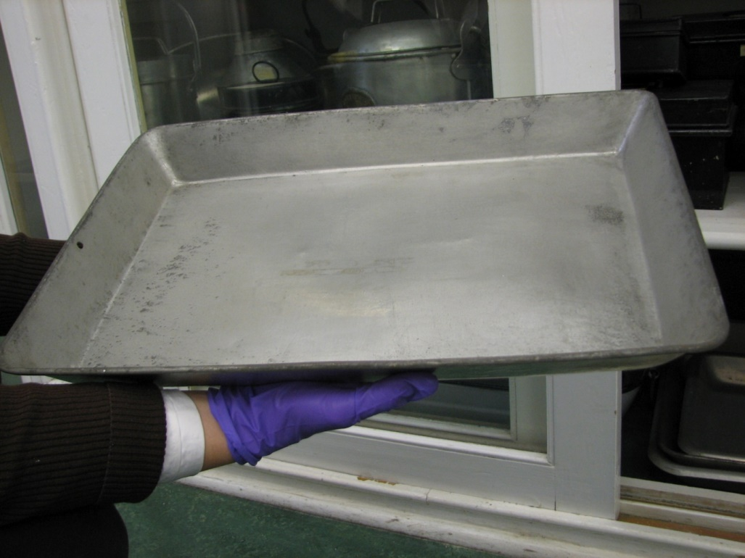Devonport collection large and small meat dishes c1910.

Dimensions tinned iron Small meat dish top 18 inches x 12 (bottom 16 inches x 9)

Dimensions tinned iron Large meat dish top 20 inches x 13 inches.

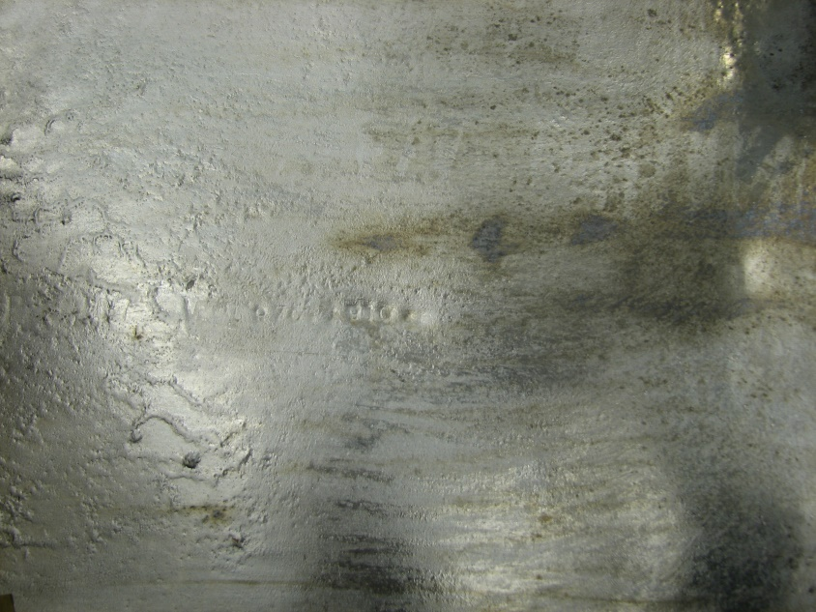

These items are heavily/thickly tinned. See photo above.

The stove on Warrior seems to have had a perforated shelf for inside the ovens to take the meat dishes so, both vertical (see 1906 photo below) or sloping sided dishes (c 1910 ones) could be used. I only looked in one of the large ovens but did not see this perforated shelf. Of course the right hand oven may currently have two inside. We will however, need these if we are to display the oven door open with meat dishes going inside.

Mess kettle below.

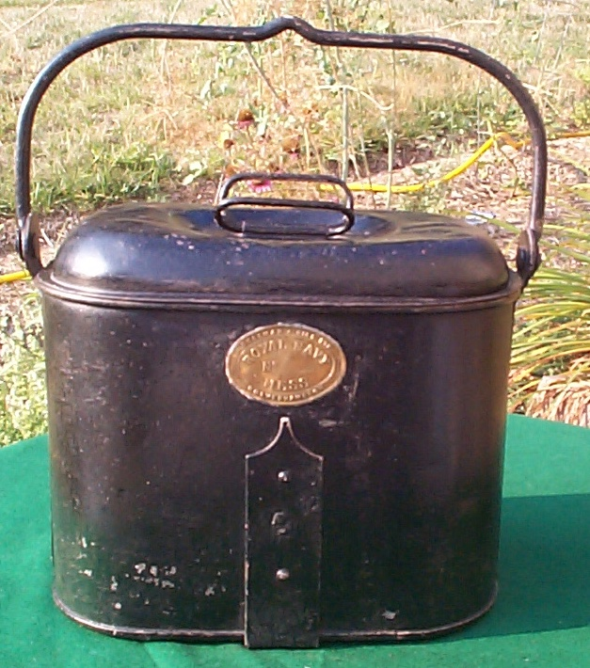mess kettle, 13w" x 10d" x 12h", http://www.thepirateslair.com/british-royal-navy-mess-dinnerware.html

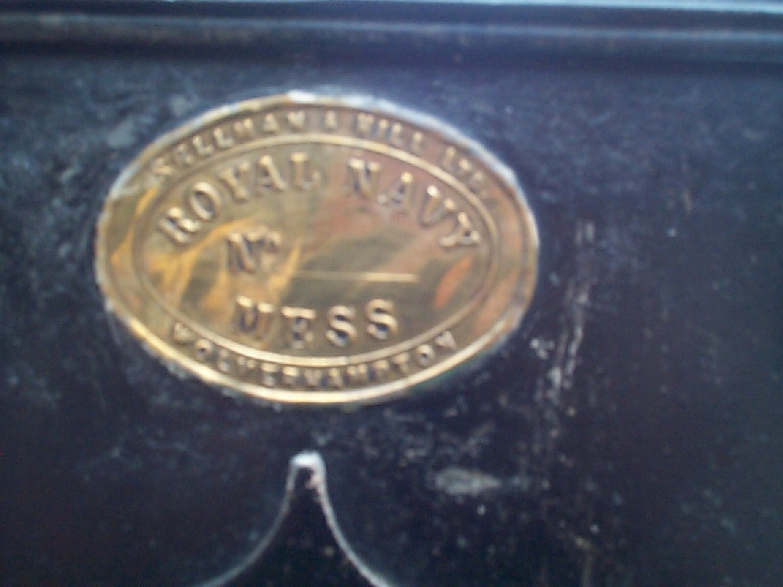

Most often seem to be plain tinned rather than japanned or painted black. See photo below c 1906.

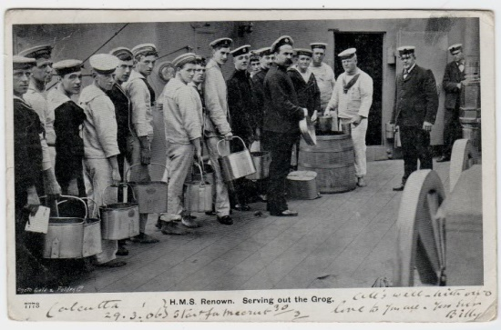

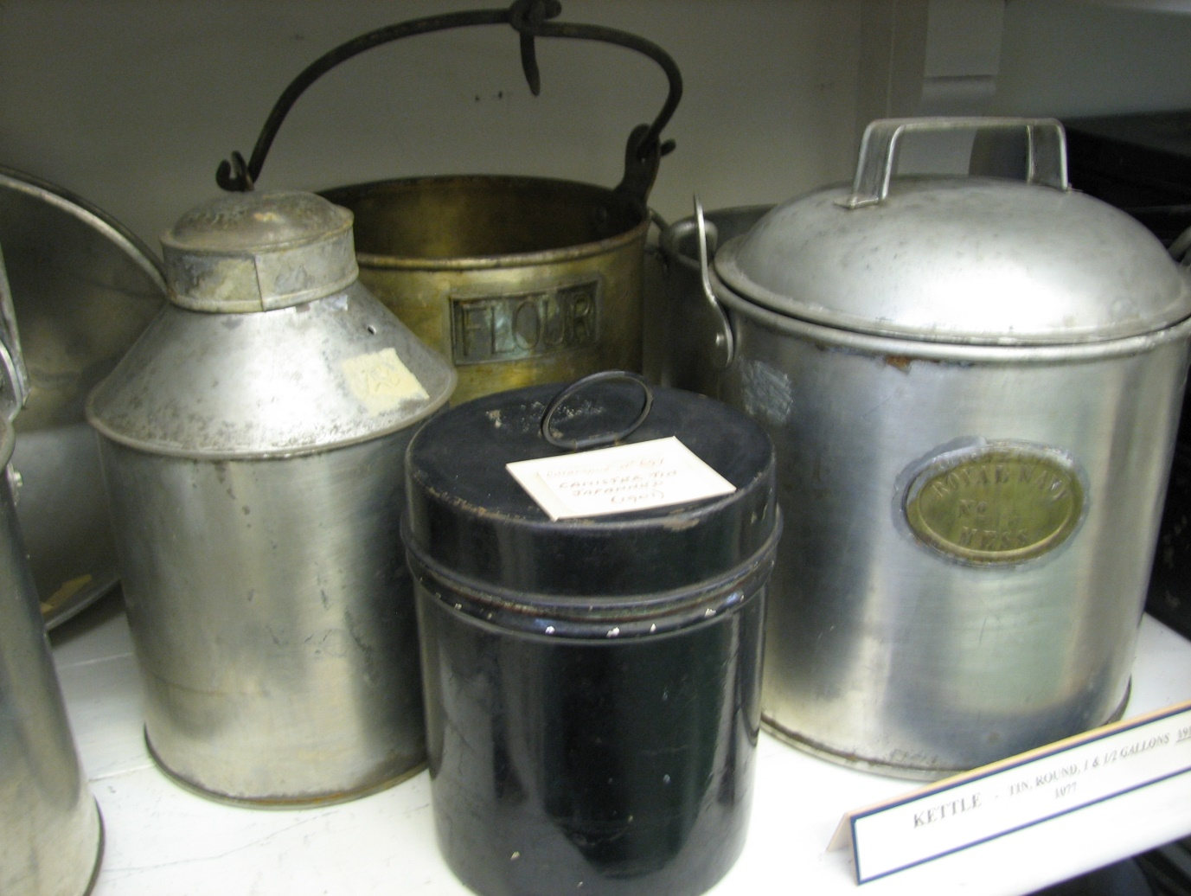Devonport collection.

In the foreground a small tinned Kettle with brass mess no. plaque, tinned canister and japanned canister c 1901-1913. Small tinned kettle - Body 8 inches tall, height overall 10.5 inches, diameter between the handle brackets 9.25 inches. Date made 1913.

Similar to those used in 1860.

