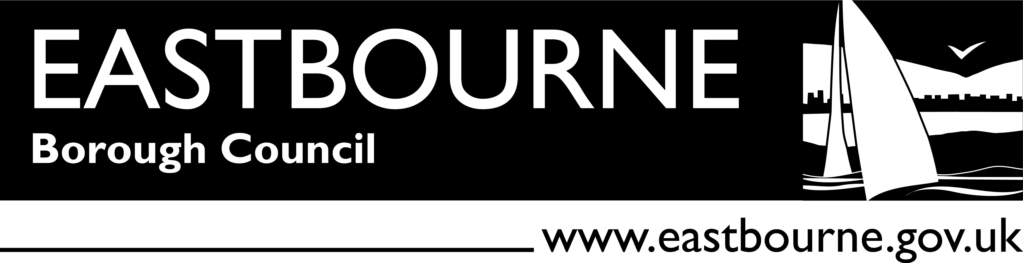

**Beachy Head Ice Cream Sales Licence**

Eastbourne Borough Council wishes to offer interested organisations the opportunity of taking a new five year licence to sell ice cream at its Beachy Head sites and is therefore seeking expressions of interest from external parties.

There are five possible pitches all located on the beautiful high Downs in the vicinity of Beachy Head within the South Downs National Park. Each is located within an existing car park and has a dedicated bay for an ice cream van. Two of the sites are at the main coach and car park at the summit of Beachy Head, as shown on the plans below and attached.

Offers exceeding £25,000 per annum will be considered. If your organisation wishes to apply please send details setting out briefly:

1. the history of the organisation,
2. organisation structure,
3. any additional value you can add to the service provided and
4. the last two years accounts

to –

Simon Hurt,

Specialist Advisor (Open Spaces)

Eastbourne Borough Council,

1 Grove Road,

Eastbourne,

East Sussex,

BN214TW

Email – [simon.hurt@eastbourne.gov.uk](mailto:simon.hurt@eastbourne.gov.uk)

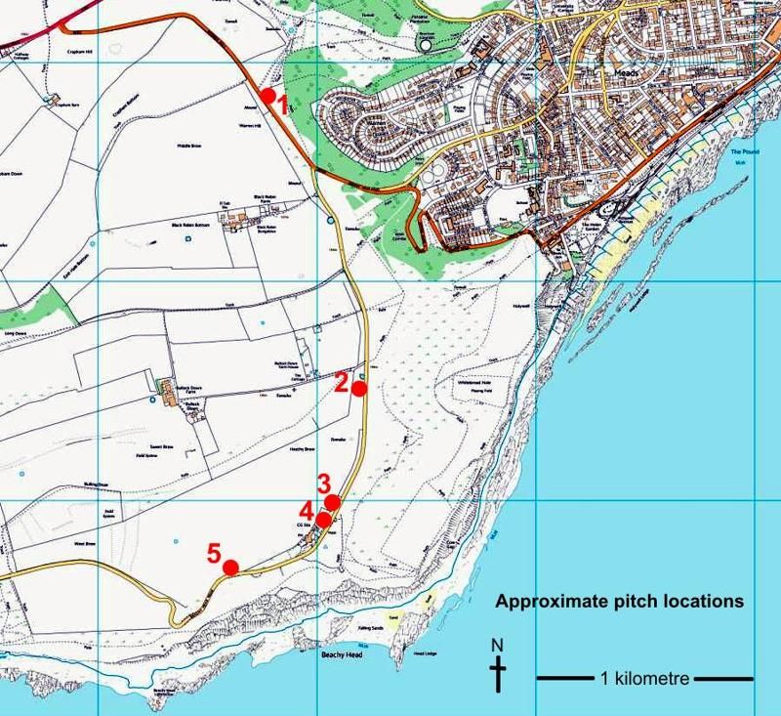by **3pm** **Tuesday 26th May 2015**