Queen Alexandra Hospital, Portsmouth – North Entrance Redevelopment
Information Pack

Introduction
Portsmouth Hospitals NHS Trust (the ‘Trust’) intends to seek tenders for the design, construction and finance of the redevelopment of the North Entrance at Queen Alexandra Hospital (QAH), Portsmouth (the ‘Project’). Optionally, the Project may include the sourcing of retail partners, the management of retail partners and ongoing maintenance of the redeveloped entrance.
QAH is a PFI Hospital with three public entrances (not including entrances to specific departments such as the Emergency Department etc). The Main Entrance is served by a Costa and Amigo store managed by the PFI partner. The East Entrance is mainly used by staff and has no retail facilities. The North Entrance is used by staff and public and although no quantitative review has taken place, it appears as though more people use the North Entrance than the Main Entrance. The North Entrance is served by a small Costa Cart managed by the PFI partner and a Charity Shop managed by the Trust. A Pharmacy for the public is a short walk along the corridor. Elsewhere, away from all entrances, is a staff and public restaurant, managed by the PFI partner. The PFI contract runs to 2040.
The QAH is on a slopping site with the North Entrance on Level A, the staff and public restaurant on Level B, and the East Entrance and Main Entrance on Level C. A site map is shown in Appendix 1.
It is anticipated that hard and soft facilities management for the common areas (not inside the retail units) in the redeveloped North Entrance, and if required external grounds maintenance, would be provided by the PFI partner. This would include provision of programmed maintenance, asset lifecycle replacement and reactive maintenance, helpdesk services, interface services, performance monitoring and reporting. Hard and soft facilities management within the retail units would be provided by or sourced by the retail units. However we are open to discussions on alternative models.
Vision
The Trust’s vision is for a modern, spacious, welcoming North Entrance with retail facilities covering:
- The dispensing of outpatient drugs and associated pharmaceutical retail sales (which will be sourced independently via a separate process);
- Café facilities serving tea, coffee, snacks etc;
- Other retail facilities likely to be attractive to staff and visitors.
The Trust’s expectation is that the redevelopment will involve building outwards from the current North Entrance onto the paved area outside (shown in Figure 1). Optionally, the redevelopment may include a second floor, connecting to the surgical outpatients waiting area above and possibly even a third floor. If the development includes a third and / or second floor, this may be used to create a dedicated research and innovation hub for commercial purposes. Also optionally, the Trust would be interested in exploring the addition of a deck on the car park outside of the North Entrance (shown in Figures 3 and 4), to further increase footfall through the entrance.
Any displaced existing outpatient check in terminals will need to be re-sited in the new North Entrance.
Retail Units
The Trust may source retail units itself but is open to discussions with potential North Entrance Redevelopment partners regarding any benefits associated with these being sourced and even managed by the development partner. However, the sourcing of a commercial pharmacy to supply outpatients with takeaway medicines (plus typical pharmacy retail sales) is likely to be pursued in advance of the Project. A commercial pharmacy may be placed into the current pharmacy area near the North Entrance, and subsequently moved into the redeveloped North Entrance, with the feasibility of this soon to be discussed with potential pharmacy providers.
Floor Plans
Floor plans for the North Entrance and surrounding areas are embedded below. The last file has a green line drawn around the area available for redevelopment. In addition, the redevelopment can extend out to the road shown on this diagram, or as close to it as practical. The contents of this file are pasted into Appendix 2 for ease of reference. Also embedded below is a dwg file at 1:1 scale for loading into CAD software.
Site Images
Below are a series of site images looking at the North Entrance and outwards from the North Entrance. There is currently a broken glass panel in the canopy above the North Entrance, hence the temporary barriers around the area directly underneath.
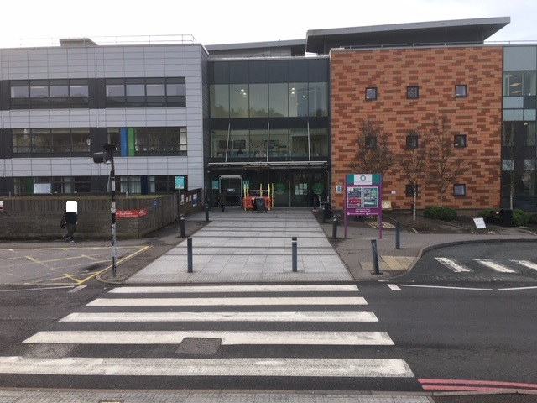
Figure 1 North Entrance
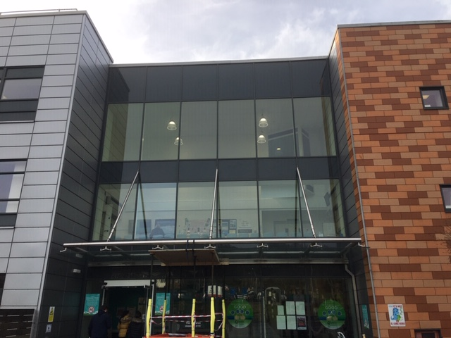
Figure 2 North Entrance, showing Surgical Outpatients Waiting Area above
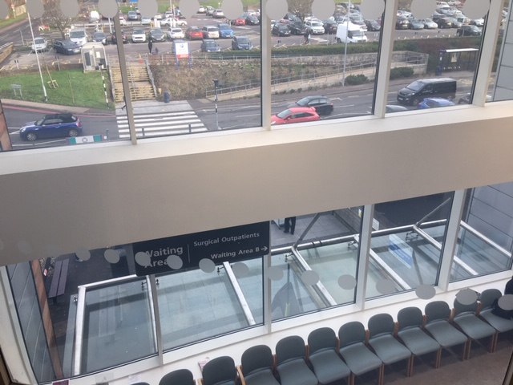
Figure 3 The view outwards from above Surgical Outpatients
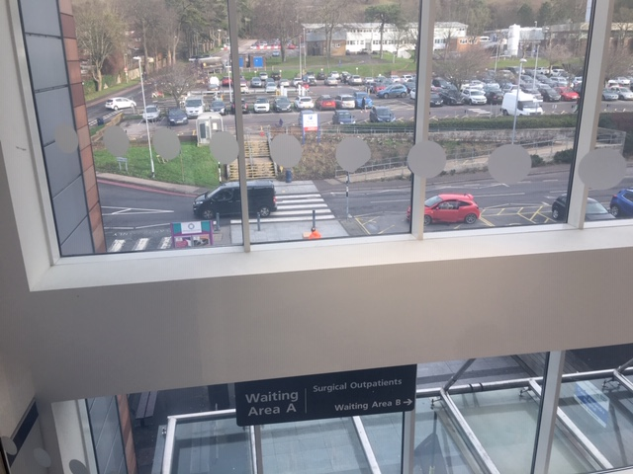
Figure 4 The view across the first car park from above Surgical Outpatients. There is another car park beyond the white building in the distance
Next Steps
The Trust will provide an opportunity in March 2020 for potential redevelopment partners to view the site and speak to Estate Management and PFI partner representatives to help develop their ideas. Please contact Mark Magrath, Interim Commercial Director via mark.magrath@porthosp.nhs.uk to schedule this.
Thereafter, a confidential meeting will be scheduled in April 2020 involving the Trust’s Chief Financial Officer, Director of Estates, Director of Procurement and Commercial Service, Commercial Director and PFI Partners. This meeting will be to discuss potential partners’ development ideas and to discuss the desired structure and key commercial principles for the Project, to make it attractive and viable for the Trust and potential redevelopment partners.

Mark Orchard
Chief Financial Officer
3 March 2020

Appendix 1 - Site Map
Staff Carpark
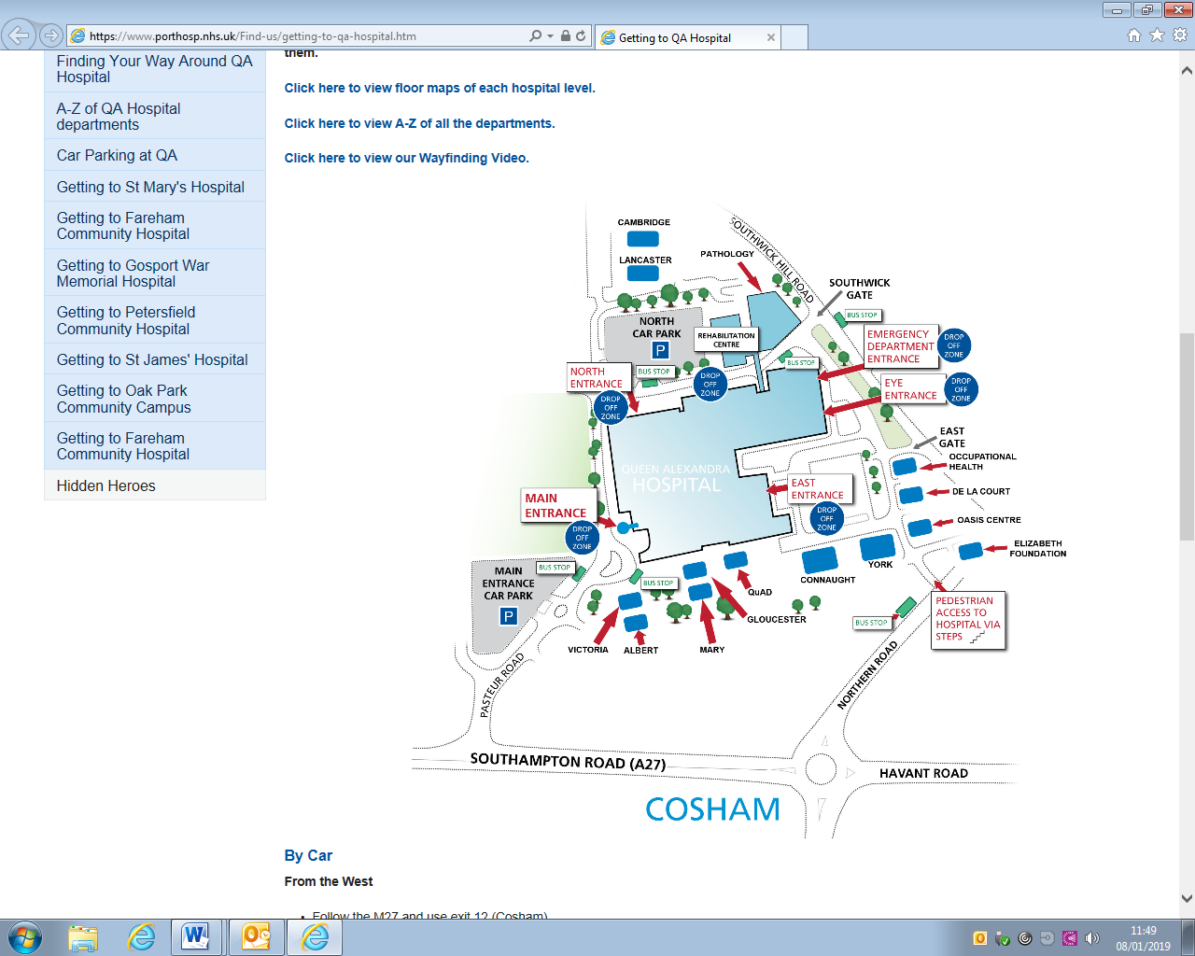
Public Carpark

Appendix 2 - North Entrance

