**Appendix B3: Description and Specification**

LOT 3

1. **Site identification**

|  |  |  |  |
| --- | --- | --- | --- |
| Site name | Edmunds Way/ Newbury Drive | | |
| Site reference | C4 | Site Postcode | SP4 7GH |
| What3Words location | ///bluff.procures.botanists | | |

Site photograph/s:

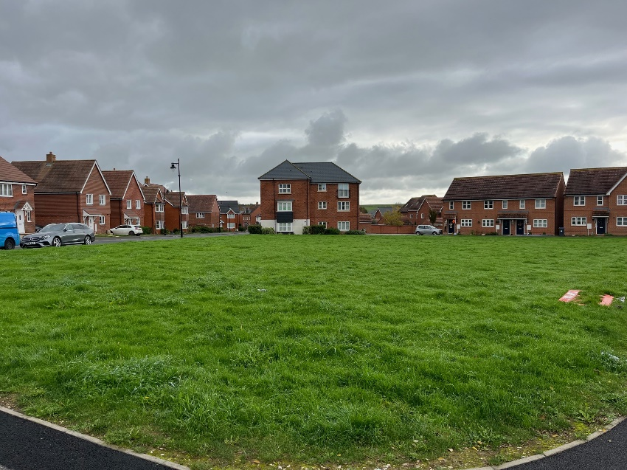

Site set-up:

Welfare (drinking water and a portable toilet) must be provided for the duration of the Works.

Heras Fencing must be established around the entire site for the duration of the Works, with sufficient CDM signage and double clipped.

Compound and Access Route: details on the tender submission should include any vehicle access route and contractor parking, proposed compound, and processes to mitigate any impact on the community such as vehicle movement, noise, or any other factors.

1. **Lot budget**

This Lot has an allocated maximum budget of £150,000.00

The full budget should be used but not exceeded.

All features included within the design must be included within the budget and quotation, there must be no ‘suggested’ additional works shown in the design outside the tendered price.

1. **Lot requirements & objectives**

This Lot is required to broadly meet the Fields In Trust definition for a large combined LAP/ LEAP. Key considerations are the appropriate provision of play equipment for the 0-12 age group.

The buffer zones set out in the definitions of a LEAP should be applied and noted on the design plans.

The design should consider creating a play space that is unique to this location and distinctive from other play areas within the Kings Gate development. This could be achieved with the style, design and general theme of the play area.

1. **Specification** 
   1. Play equipment

Play equipment construction should be predominately **steel for the Junior age zone**. Additional materials are acceptable for non-structural parts. Timber junior equipment is not acceptable at this area of the site.

Play equipment for the Toddler Zone may be **engineered or Robinia wood** construction with a specific theme or style unique to this site. Steel footings are required into ground foundations unless Robinia is the proposed material. Additional materials are acceptable for non-structural parts.



Siting of the equipment should be centralised within the available footprint to reduce potential risks posed by the surrounding roads, providing a buffer space between the play area and the surrounding streets. The Toddler zone should be located towards the lower part of the site, nearest to Newbury Drive odd numbers 1-27. Pathways should connect to the site as noted in Section 4.4 below.

Maximum height for equipment: 4.0 metres

Swings: Swings should have Anti-Wrap connectors where possible.

Equipment **not** suitable for this site: Zip Wires, ball sports

* 1. Safety Surfacing

Surfacing may be a combination of rubber wetpour and grass-matts. It is envisaged that items for young children are located on wetpour and items mainly used by older children are provided with grass mats.

Grass mats shall be fire retardant, cable tied, and have turf provided under where grass is not established. Also requires the installation of *Grass Mat Underlay Mesh.*

Wetpour sub-base works shall be excavated to the depth required for a flush finish with the surrounding area, back filled with 100mm depth of compacted MOT Type 1 stone laid beneath the rubber surface.

Edges should be trench cut into the surrounding grass or fully resin bonded to the pre-cast concrete (PCC) edging if adjoining a pathway.

Black wetpour shall have a minimum 30% colour fleck.

* 1. Landforms, mounds & landscaping

Soil excavations may remain on site and be formed into an interesting and playful landscape that enhances the play environment. Mounds, slopes and undulations should be finished with turf, watered until established and gradients designed to be maintained with a mechanical mower.

* 1. Pathways

Connecting pathways should be included in the design to link play zones to the existing footpaths serving the site and to provide a high level of accessibility for all throughout the year and in all weather conditions. Main connecting paths to gates and with wider recreation space must be a minimum 1.2 metres wide. Footpath widths should be clearly noted on your design plan.

Pathways should be constructed from a rubber/stone/ resin mix (such as ‘Conipave’/ ‘Enviro-Pave’ or similar). Pathway edging shall be pre-cast concrete (PCC).

* 1. Fencing & Gates

Fencing should be designed to surround the play space to reduce potential risks and hazards, mainly from the surrounding streets.

Fencing shall be steel bow-top style railings compliant with EN1176, 1.0m high, powder coated in black.

Gates shall be hydraulic (not sprung) self-closing with a flat top style, vertical bar in fill and powder coated in yellow to visually contrast from the fencing.

Vehicle access must be provided for locations with grass inside the fenced area. This may be a dedicated vehicle access gate or a combination gate and must be located in an appropriate position for access by mowing vehicles. .

* 1. Furniture

Seating should be: Glasdon ‘Pheonix’ seats with armrests and Glasdon ‘Clifton’ picnic tables with wheelchair access. Quantity at the discretion of the tenderer.

All seating should be on hardstanding and preferably connected to any new pathways.

Litter bins (x2) should be: Broxap ‘Derby’ Steel, 120 Litres in Black.

Cycle hoops (x4) should be: Broxap ‘Sheffield’ Stainless Steel.

* 1. Other

A post installation inspection by an independent RPii qualified inspector (i.e. Play Inspection Company, RoSPA or other similar provider) is required to sign off the completed installation. The contractor should allow for this cost within their tender price.

Signage (minimum A2 size) on gates should be provided to indicate: The site name, age the play area is intended for use by, telephone number to report any incident or damage, number to call in an emergency, Town Council logo.

Include graphics that demonstrate:

* children to be accompanied by adults
* dogs are excluded
* smoking is prohibited
* litter should be disposed of

Example sign (replace Wiltshire Council with Amesbury Town Council):

