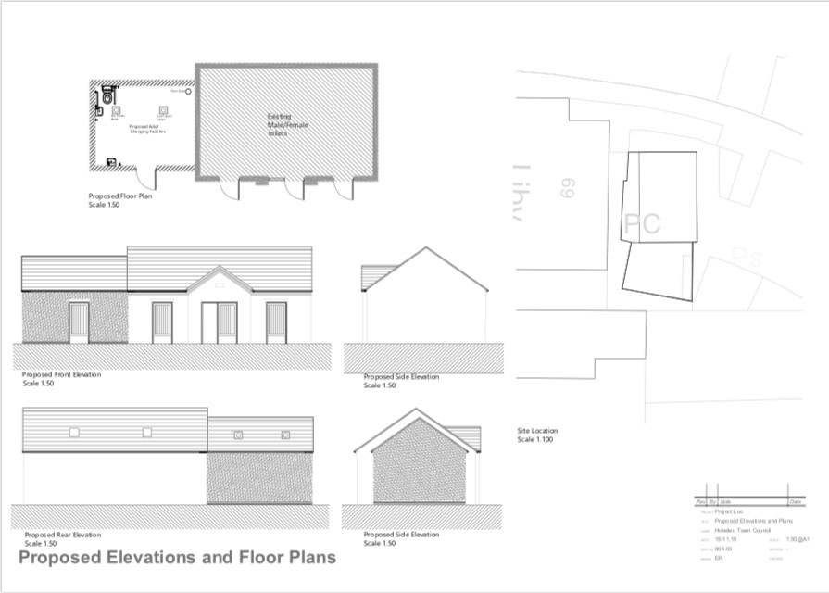

Design of the exterior of the building for the planning application

