3.2 | Reception
 | Image | Product Description | Qty | Unit Price | Total Price
3.2.1 | 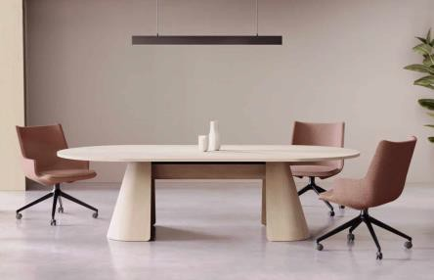 | 2400w x 1200d  Natural oak veneer base Natural oak veneer top  No power/cable management included  5 Year Warranty | 1 | £ | £
3.2.2 | 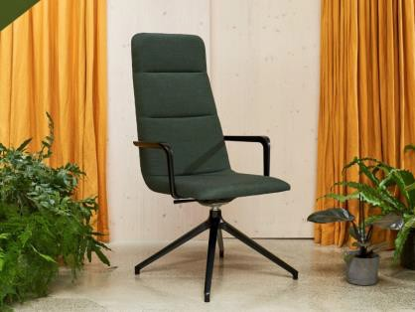 | - Upholstered in Remix 163 fabric  - Black 4 star phyramidal swivel base  - With tilt  - On glides  - With arms  - 5 Year Warranty | 1 | £ | £
3.2.3 | 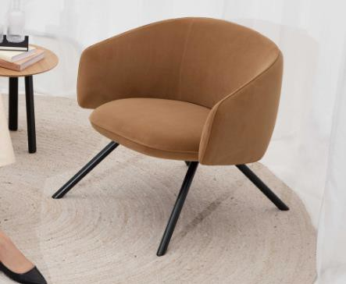 | Moulded foam construction  Fully upholstered in Re-Wool 718 fabric, with perimeter piping  Tubular steel black frame Single tone  Plastic glides  5 Year Warranty | 2 | £ | £
3.2.4 | 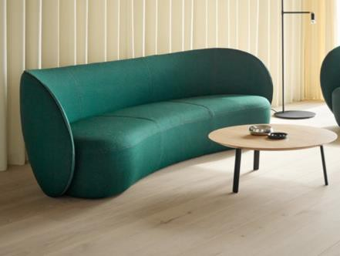 | - Moulded foam back rest  Cut foam seat carcass  - Fully upholstered in Sumi Chiba SUR08 fabric  - Single tone  - Plastic glides  5 Year Warranty | 2 | £ | £
3.2.5 | 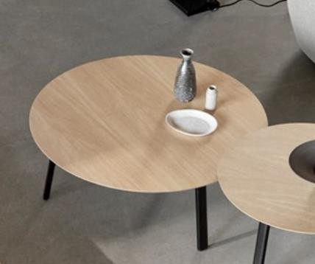 | - 1000dia  285h  - Top in clear oak  Base in black  5 Year Warranty | 1 | £ | £
3.2.6 | 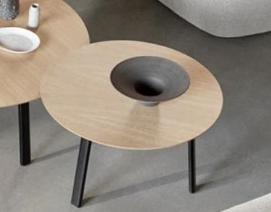 | - 800dia  - 315h  - Top in black  - Base in black  5 Year Warranty | 1 | £ | £
3.2.7 | 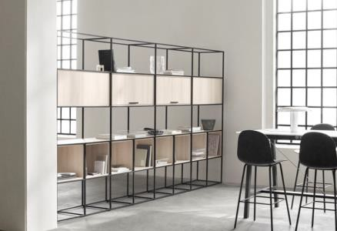 | 2660 total width  Shelves in clear oak  Frame in black  5 Year Warranty | 1 | £ | £
3.3 | Offices
 | Image | Product Description | Qty | Unit Price | Total Price
3.3.1 | 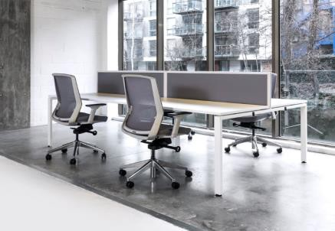 | - Accomodates 2 users  - 1200w x 1400d x 735h  - 700d tops with scallop edge  - MFC white top with ply edge  - Black metal legs  - With cable tray & frameless screen in  - Blazer Lite, Retreat LTH39 colour  5 Year Warranty | 8 | £ | £
3.3.2 | 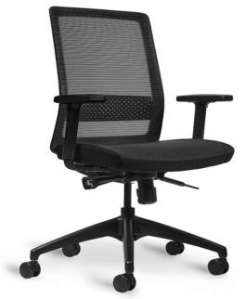 | Black mesh back  Black fabric seat pad  Height adjustable armrests  - Multi-locking synchronous mechanismwith tension adjustment  Adjustable lumbar support  Seat height & slide adjustment Black base & frame  5 Year Warranty | 16 | £ | £
3.3.3 | 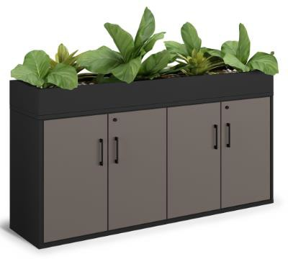 | - 4 door cupboard  - 2x adjustable shelves  - Black square handles  - Carcass in anthracite, doors in oak  - Including top planter box (liner & plant work not part of supply)  1600w x 500d x 890h 5 Year Warranty | 2 | £ | £
3.4 | Boardroom
 | Image | Product Description | Qty | Unit Price | Total Price
3.4.1 | 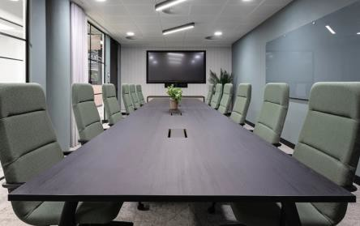 | 5400w x 1400d x 740h  3 Piece top, each with central grommet in white metal finish  Legs in black  - White MFC top with ply edge  - With cable tray  No power supplied  5 Year Warranty | 1 | £ | £
3.4.2 | 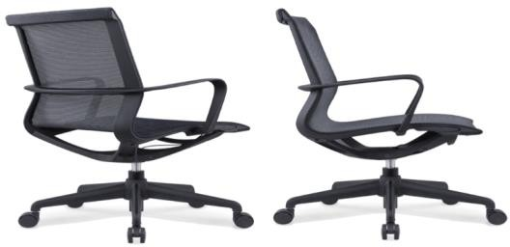 | Breathable black mesh upholstery Gas height adjustment  Black frame and base On castors  5 Year Warranty | 12 | £ | £
3.4.3 | 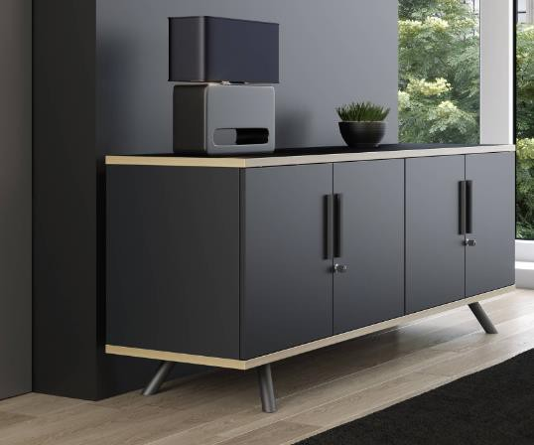 | 2000w x 500d x 740h  4x soft close doors, with 2x adjustable shelves  Lockable, includes 2x keys  In nanotech black, with ply edging on top and bottom panels  5 Year Warranty | 1 | £ | £
3.5 | Meeting Room 1
 | Image | Product Description | Qty | Unit Price | Total Price
3.5.1 | 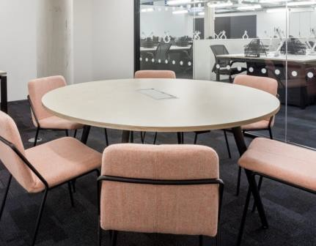 | 1400dia x 740h  With central grommet in white metal finish  Legs in black  MFC white top with ply edge With cable tray  No power supplied  5 Year Warranty | 1 | £ | £
3.5.2 | 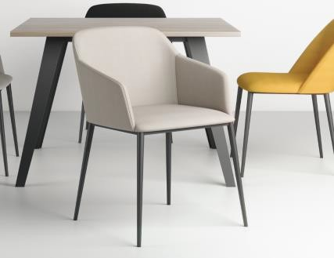 | With arms  QTY 2 upholstered in Warwick Plush Airforce colour  QTY 2 upholstered in Warwick Plush Fjord colour  Black metal 4 leg base  5 Year Warranty | 4 | £ | £

3.5.3 | 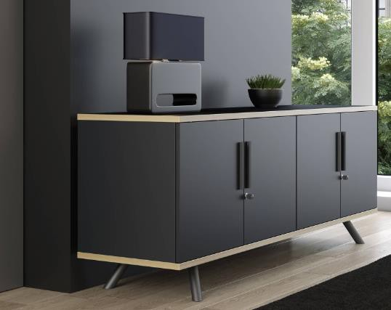 | 1500w x 500d x 740h  3x soft close doors, with 2x adjustable shelves  Lockable, includes 2x keys  In nanotech black, with ply edging on top and bottom panels  5 Year Warranty |  | 1 | £ | £
3.6 | Meeting Room 2
 | Image | Product Description |  | Qty | Unit Price | Total Price
3.6.1 | 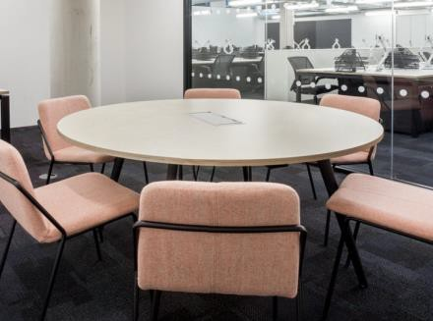 | 1400dia x 740h  With central grommet in white metal finish  Legs in black  MFC white top with ply edge With cable tray  No power supplied  5 Year Warranty |  | 1 | £ | £
3.6.2 | 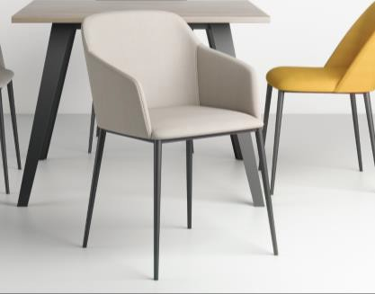 | With arms  QTY 2 upholstered in Warwick Plush Airforce colour  QTY 2 upholstered in Warwick Plush Fjord colour  Black metal 4 leg base  5 Year Warranty |  | 4 | £ | £
3.6.3 | 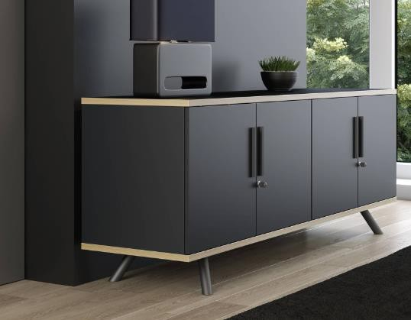 | 1500w x 500d x 740h  3x soft close doors, with 2x adjustable shelves  Lockable, includes 2x keys  In nanotech black, with ply edging on top and bottom panels  5 Year Warranty |  | 1 | £ | £
3.7 | Meeting Room 3
 | Image |  | Product Description | Qty | Unit Price | Total Price
3.7.1 | 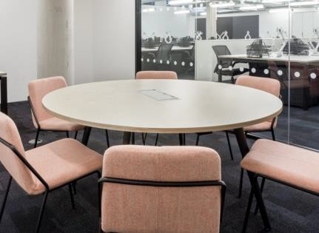 |  | 1400dia x 740h  With central grommet in white metal finish  Legs in black  White MFC top with ply edge  With cable tray  No power supplied  5 Year Warranty | 1 | £ | £
3.7.2 |  |  | With arms  QTY 2 upholstered in Warwick Plush Airforce colour  QTY 2 upholstered in Warwick Plush Fjord colour  Black metal 4 leg base  5 Year Warranty | 4 | £ | £
3.7.3 | 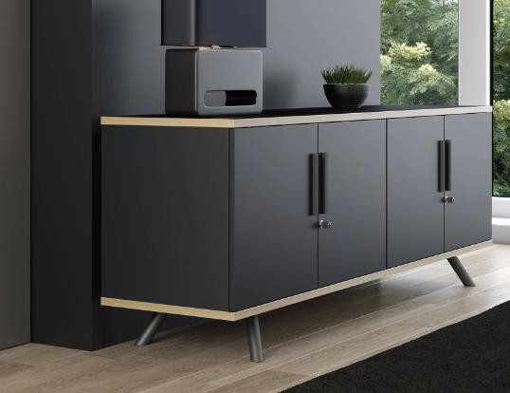 |  | 1500w x 500d x 740h  3x soft close doors, with 2x adjustable shelves  Lockable, includes 2x keys  In nanotech black, with ply edging on top and bottom panels  5 Year Warranty | 1 | £ | £
3.8 | Kitchen
 | Image |  | Product Description | Qty | Unit Price | Total Price
3.8.1 | 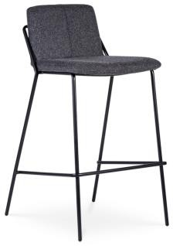 |  | 450w x 510d x 890h  Black powder coated wire frame Upholstered in Spradling Valencia  Chestnut colour Vinyl  5 Year Warranty | 4 | £ | £
3.8.2 | 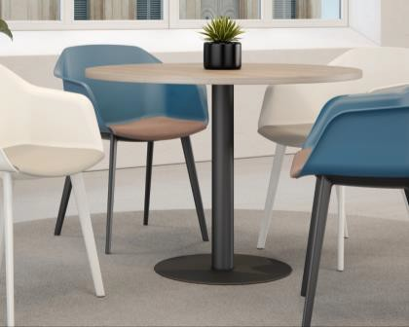 | 1000dia x 740h White MFC top With ply edge  Black graphite base  5 Year Warranty |  | 2 | £ | £
3.8.3 | 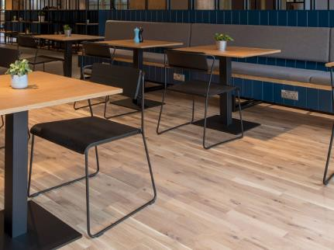 | Non upholstered  Seat and back in oak  Black powder coated wire frame Stackable up to 5  5 Year Warranty |  | 8 | £ | £
3.8.4 | 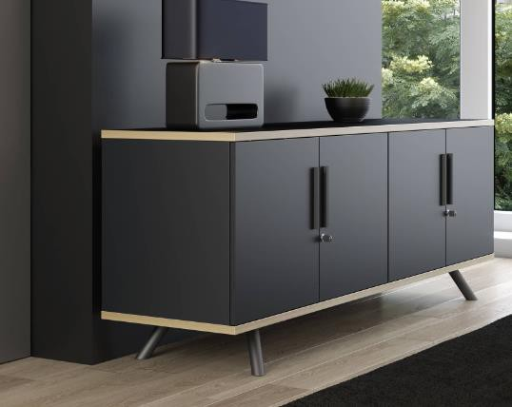 | 1500w x 500d x 740h  3x soft close doors, with 2x adjustable shelves  Lockable, includes 2x keys  In nanotech black, with ply edging on top and bottom panels  5 Year Warranty |  | 1 | £ | £
3.9 | Workspace
 | Image | Product Description |  | Qty | Unit Price | Total Price
3.9.1 | 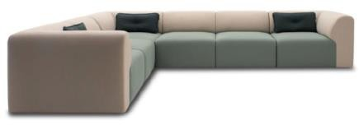 | Corner sofa - two toned Arm on both sides  Including linking brackets  Outer upholstered in Sumi Chiba SUR08  Inner upholstered in Remix 143 Scatter cushions not included 5 Year Warranty |  | 1 | £ | £
3.9.2 | 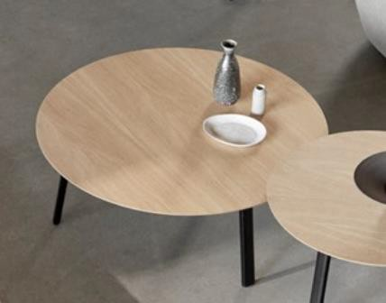 | 1000dia 285h  Clear oak top Black legs  5 Year Warranty |  | 1 | £ | £
3.9.3 | 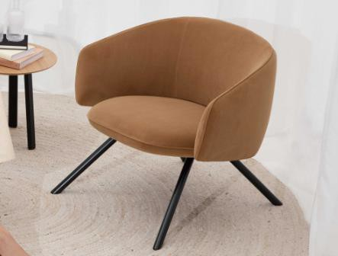 | Moulded foam construction  Fully upholstered in Kvadrat Re-Wool 718, with perimeter piping  Tubular steel black frame Single tone  Plastic glides  5 Year Warranty |  | 1 | £ | £
3.10 | Miscellaneous
 | Image |  | Product Description | Qty | Unit Price | Total Price
3.10.1 | 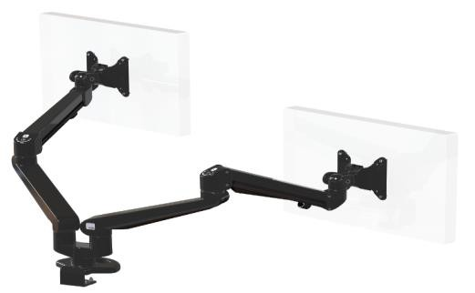 |  | In black, with baby-c fixing Dual screen application  Integral cable management  Maximum screen size 36"  Lockable quick release VESA function Each arm holds from 3-8kg | 16 | £ | £
 | Image | Product Description |  | Qty | Unit Price | Total Price
3.10.2 | 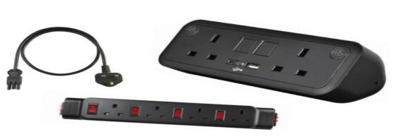 | UNO Power Bundle  1x Black UNO - 2 UK power & 2 USB A&C  1x Powerlink - 4 UK power  (Individually fused thermal rest switches)  1x 2m Starter lead  30W |  | 8 | £ | £
3.10.3 | 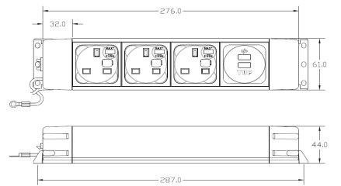 | Meeting Table Power  Matt black aluminium power box comprising: 3x UK sockets individually fused at 3.15A, 1x replaceable A+C twin fast charger (Max 5A), 250mm earth lead  With 3M starter cable to 13amp plug Power box to sit loose in table cable tray |  | 3 | £ | £
 | Delivery & Installation to our premises |  |  | 1 | £ | £
 | Provisional sum for plants, decorations and soft furnishings |  |  | 1 | £15,000.00 | £15,000.00
 | Provisional sum for ligting |  |  | 1 | £15,000.00 | £15,000.00
 | Total |  |  |  |  | £
 | VAT |  |  |  |  | £
 | Total Inclusive of VAT |  |  |  |  | £

