Remove Play area/seating leave area as grass
Remove car park leave area as grass
Keep picnic area
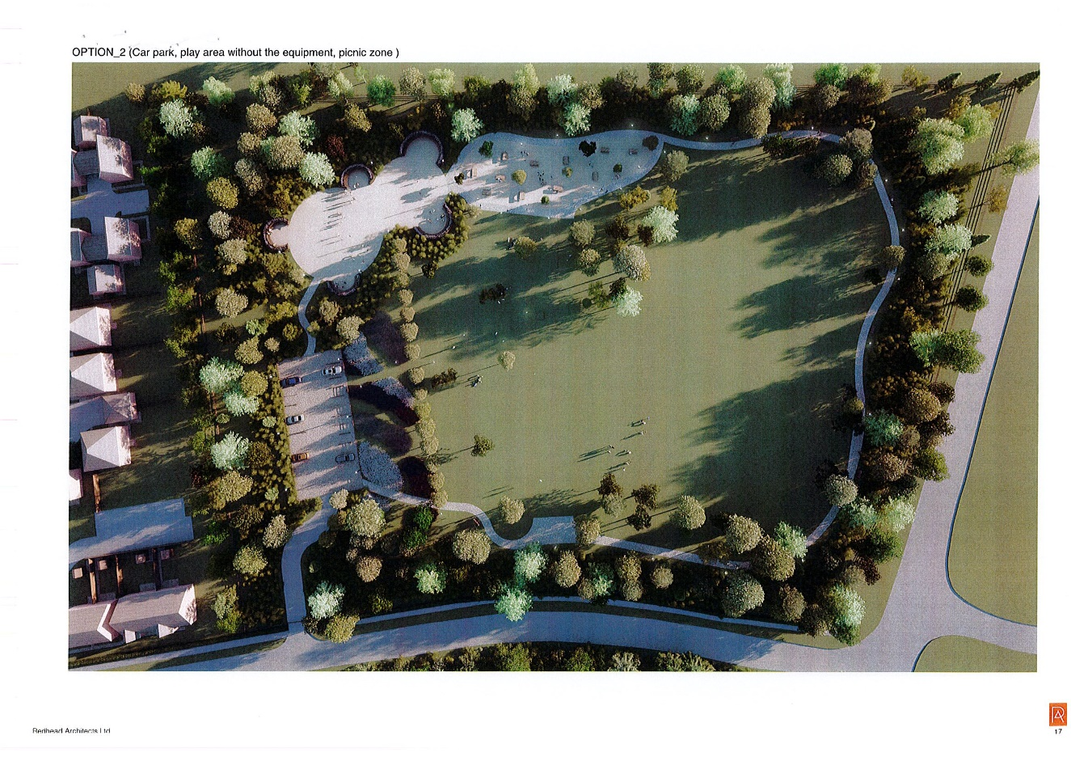
Keep entrance pathway
-Path around field to remain as per image wide enough for pushchairs and wheelchair users
-Trees/foliage wild flowers to be planted around edges.

