**Moss Side Farm**

**Peatland**

**Restoration**

**Works 2024 Fields**

**Specification**

**1.1 Site Background information**

Vets & Booths fields were formerly agricultural and sit within the Chat Moss peat extent.

There are a number of land drainage pipes within the fields resulting in the drawdown of the perched water table within the peat.

Other previous land usage has left the wider peat mass fragmented, meaning controlling the hydrology, presents significant problems. It is hoped that the remedial works outlined in this document will help address these issues.

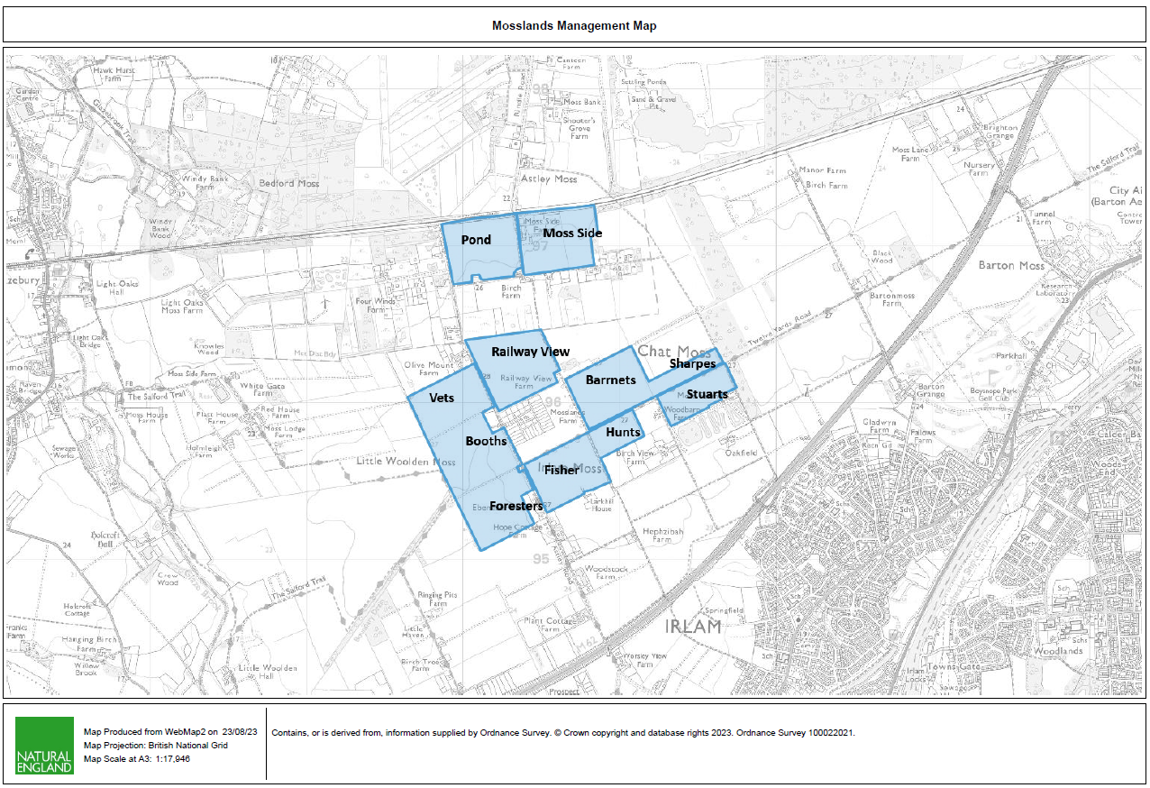

**1.2 Contractor Experience**

Contractors are invited to tender for this work, which will require not only skill and experience of this type of work but particularly on boggy, difficult to navigate peat soils. Successful Contractors must demonstrate knowledge of and have regard for the sensitive nature of wetland hydrology and ecology. It is not expected that this work will be sub-contracted out and must therefore be undertaken by the successful Contractor.

1.3 Nature of work

The work will include the following:

* The installation of 3253m of deep trench bunding
* The installation of 709m of ditches, around a section of the site boundary
* Installation of water control pipes x 7
* Installation of 50m of culvert with 300mm pipe

2.0 Contact Information

Project Manager

Chris Evans 07979 873504 [christopher.evans@naturalengland.org.uk](mailto:christopher.evans@naturalengland.org.uk)

**3.0 Access**

The site can be reached via access points off Astley Road (west off Liverpool Rd B5320 in Irlam). This road is in a dilapidated state but is wide enough and stable enough to allow access for large machinery. Each field can be accessed directly from this road.

Access to the site beyond the road is only on foot and by vehicles that are specially adapted to driving on peatland i.e. low ground pressure vehicles.

The centre of the site can be found at SJ 70247 95324.

A google maps pin for the car park area with one work field (Booths) to the north is <https://goo.gl/maps/4tXXzNAKP1Py6moG6>

4.0 Project Management

* Day-to-day management and supervision of all machines and operatives will be the responsibility of the Contractor.
* The Contractor will be required to liaise weekly with Natural England (NE) during the project and provide progress reports when required.

5.0 General Principles

5.1 Prevention of enrichment/pollution of the sites

It is vital to the management of the site that there is no nutrient enrichment or spillage of chemicals, of any kind, onto the site. The Contractor shall meet high environmental standards by providing (and using) spill kits for all equipment and using bio-fuels and bio-lubricants in all machines where possible.

5.2 Method of works

Due to the difficulty of transporting any weight around on the peat surface, the work will need to be planned such that access and/or movement of material is done solely on foot or by low ground pressure plant/vehicles.

5.3 Peat/mineral interface

The Contractor must be careful to avoid disturbing the peat/sand or peat/clay interface at all costs. Therefore, great care needs to be taken when excavating/scraping/moving any peat whilst creating the bunds. The client will need to be informed immediately of any occasion where the underlying mineral surface is accidentally exposed. At the north end of the area the peat depths are much shallower and bunding works are expected to encounter the underlaying clay. In areas with limited peat availability clay can be used to form the bunds.

6.0 Works to be carried out

6.1 Creation of deep trench bunds

6.1.1 Background

Bunding techniques for peatland restoration have developed over time and these works reflect current best practice for lowland raised bog restoration. Deep trench bunds will benefit the site by blocking the subsurface water movement.

6.1.2 Bunding required.

3253m of bunding on booths and vets to form sub-surface peat walls.

This will be achieved by digging to a depth of approx. 2m, turning over the peat and compacting this in place. This compaction is essential for sealing any pipes, cracks or voids in the peat and stopping water leaking.

The surface bunds’ main purpose is to slow the movement of surface water and provide some above ground water storage, which will further counter the effects of drier months.

The top bund must be made with wet putty peat and in line with the trench bunding underneath. It should be no more than 0.5m high and 1m wide at the base. It is then covered with loose vegetation, stripped from the surface when excavating the deep trench bund line.

To achieve the correct method of installation, this technique allows for a number of preliminary inspection digs to determine the required depth of the trench. Once determined, the installation must dig below the water loss depth and ensure good peat is compacted in the trench to seal against water loss. The bunds need to be constructed to at least 0.5m in height and 1m in width on level ground. However, ground levels within the field vary, so in higher areas the top level of the bund can be graded to ground level so that the bund is only a visible above ground in low lying areas.

The extra peat needed for building the bunds will be won by digging a series of shallow scrapes no deeper than 0.5m. Extra borrow pit locations will be discussed on site with NE staff through arrangement with the project manager.

No peat is to be won from within 2 metres of any bund feature or bund construction site. This is to ensure that the newly constructed bunds are not subjected to extra pressure from water pooling.

6.3 New ditch installation

6.3.1 Background

Due to the proximity of the surrounding properties and the liability of potential flooding, it is essential that we ensure that neighbouring properties are not at risk of flooding from the re-wetting works. To that end, boundary ditches will be installed to hold back water on site and channel it off where and when necessary.

6.3.2 Ditches required.

Ditches are to be dug to a depth of 0.5m and a width of 1m. These should carry water into the existing drainage ditches. Spoil created from this can be used in the construction of nearby bunds. The ditches can have wider areas along the length, to a maximum of 1.5m to create a varied and more nature friendly edge. The new ditches will be connected to the existing drainage ditches or outlet culverts, some profiling and excavation will be needed to facilitate this

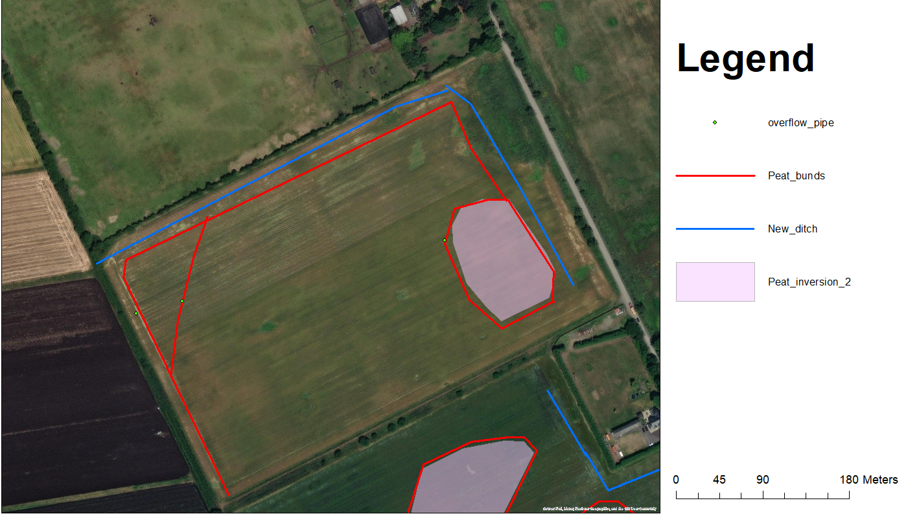

Plan for Vets

A

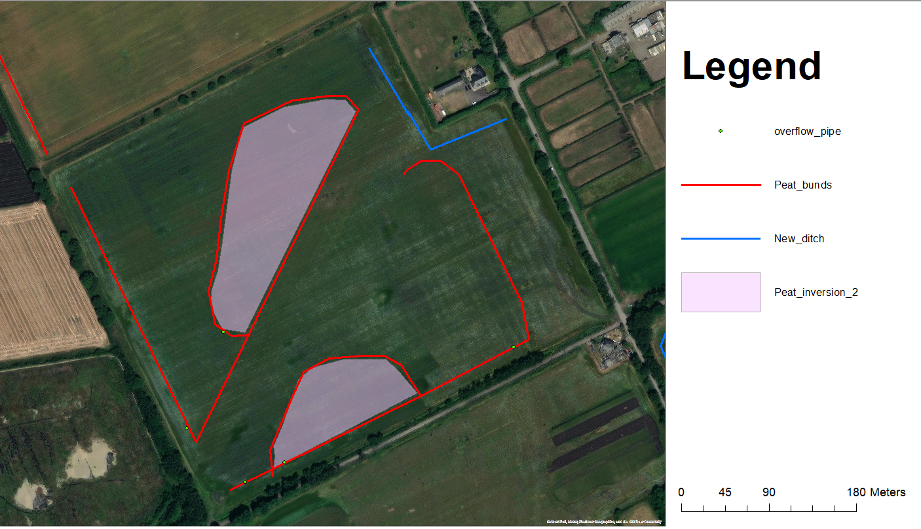

Plan for Booths

Figure 1 Re-wetting plan Vets & Booths,

6.4 Installation of Water Control Pipes and culverts

6.4.1 Background

The creation of a bunding network will result in water pooling in the ‘borrow pits’ where peat is won to build those bunds. Pooled water exerts higher hydraulic pressures on surrounding peat. Without any means of re-distributing this water and lowering that pressure, the bunds may suffer leakage, erosion caused by over-topping, wave action or a combination - compromising their structural integrity and ultimately resulting in their failure.

6.4.2 Control pipes required

Installation of 150mm diameter overflow pipes will be employed to maintain a degree of control of the site’s hydrology. Pipes will be fitted with an adjustable right angle ‘elbow’ piece, which can be adjusted dependent on the expected levels of rainfall. Pipes will be made of durable plastic and installed at appropriate locations that will be decided on site between land managers and contractors to ensure the most effective positioning.

A further 50m of 300mm pipe will be installed to allow the new ditch to cross the gas pipeline (at A on fig 1). Methods of working in this area will be agreed in advance by NE with the pipeline operator and the relevant permissions will be in place.

6.5 Soil burying and surface microtopographic forming.

6.5.1 Background

The presence of a soil layer on top of the peat is a significant obstacle to the restoration of lowland raised bog peat converted to farmland in the 1800s. This “night soil” and modified peat layer is restricted to the depth of historical ploughing, so tends to be between 50-60cm deep on chat moss but can be shallower in areas of pastureland (10-30cm). To restore an area of this type of farmed peatland directly back to bog, all the nutrients and lime within the night soil need to be removed to expose acidic nutrient poor peat to provide the correct conditions for sphagnum and cotton grass to grow.

6.5.1 Soil burying and surface microtopographic forming.

Inversion of the top 1.5 m of peat and night soil, to bury night soil below a layer of wet, nutrient poor & acid peat. The wet peat at the surface will then be compacted to form microtopographic pools across the surface (see fig 2). The area will then be enclosed by a deep trench bund to cut any drainage pipes flowing in or out of the area (note this is included as part of the overall bunding total). The result will be a mosaic of wet peat and bog pools ready for the establishment of bog habitat.

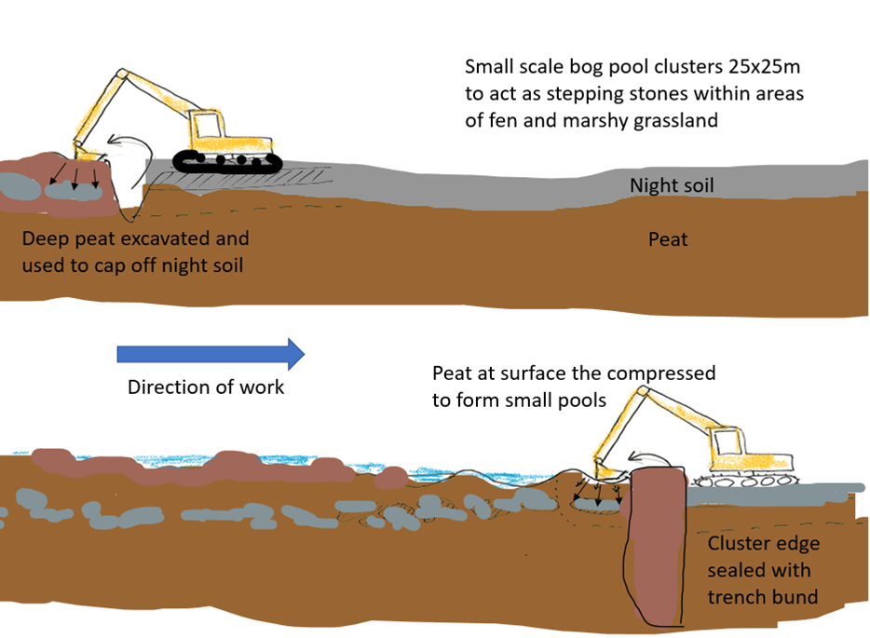

Fig 2. Envisioned working method Night soil burying and surface microtopographic forming

7.0 General work requirements

* All operatives will hold current, relevant certification for all machinery and the contractor will have appropriate public liability insurance cover. All certification, public liability insurance documents and a Health and Safety policy statement must be presented with the tender documents.
* All operators will be experienced of working on wet peatland sites undertaking restoration work of a similar kind.
* The contractor shall provide all equipment, all fuel and maintain all equipment required for the completion of the project, including all appropriate PPE.
* The contractor will be responsible for all first-aid within the contract work force, and a practising first-aider with current certification will be present at all times. The contractor will provide appropriate first aid equipment. Lone working will not take place under any circumstances. Welfare facilities can be provided at the close by Moss Side Farm if required.

7.1 Health and Safety

* A high-pressure gas pipeline runs through and adjacent to two fields.
* A permissive footpath runs to the north and west of the site. We can restrict public access when required for these works.
* The successful contractor will be expected to provide appropriate Risk Assessments and Method Statements.
* A Construction Phase Plan will be required with reference to welfare provided to operatives.
* Toilet facilities including warm water and a rest area can be made available at Moss Side Farm.
* Storage of plant can be provided at Moss Side Farm.
* Plant can be kept overnight next to the gardens of adjacent properties in the work fields.

8. Water Voles

Water voles have been recorded in the area historically. Operatives need to be mindful of the potential of voles in or close to drains. NE will undertake a survey before works begin and discuss mitigation measures with the contractor if required.

9. Timescale

The work is expected to be completed by mid-December 2024.

APPENDIX 1

|  |  |  |
| --- | --- | --- |
|  | | |
|  | PRELIMINARIES / GENERAL CONDITIONS |  |
|  | The successful contractor will: |  |
|  | Produce written risk assessments and method statements on all areas of operations. |  |
|  | Allow for production of Construction Phase Plan prior to the start of the works. |  |
|  | Maintain security, safety and protection of the site and works in accordance with HSE guidance and this specification. |  |

|  |  |  |  |
| --- | --- | --- | --- |
| Quantities | | | |
| ITEM | DESCRIPTION | QTY | UNIT OF WORK |
| 1.1 | The installation of deep trench bunding | 3253 | metres |
| 1.2 | The installation of ditches, around a section of the site boundary | 709 | metres |
| 1.3 | Installation of 300mm pipe culvert | 50 | metres |
| 1.4 | Installation of water control pipes | 7 | each |
| 1.5 | Peat inversion | 3.5 | ha |

B