|  |  |
| --- | --- |
| **Area Team & Project Name:** | Natural England West Midlands Area Team  Peat for the Planet – Ecohydrological Surveys and Landscape Restoration Plan |

|  |
| --- |
| **Peat for the Planet** |
| The West Midlands *Peat for the Planet* Project aims to drive and co-ordinate action across the county and into the surrounding areas, supported by site and landscape level plans that will establish a course for peatland restoration and management at a more detailed level.  Established in 2021, the project seeks to build partnerships, promote landowner engagement, and promote peatland restoration as a benefit for carbon sequestration, flood alleviation, water quality and biodiversity.  The project has identified a core project area in North Shropshire which has the highest concentration of lowland unprotected peat in the West Midlands (map below). The North Shropshire Peatscape project will use all existing and emerging tools available to promote peatlands, and encourage and facilitate restoration, including green finance, Biodiversity Net Gain, agri-environment schemes, and catchment sensitive farming. The area will act as a demonstration site for what can be achieved for peat which is scattered, fragmented and under multiple land ownerships.  As part of the initial stages of project development, further ecohydrological data and information is required to form a project baseline. This will inform project priorities, landowner engagement and a green finance model. |

|  |  |
| --- | --- |
| **Project Objective:** | To gain a greater understanding of the hydrological functioning of peatland across the north Shropshire project area (map included), highlighting opportunities for restoring and connecting peatland habitats, increasing carbon sequestration and storage, reducing flood risk and providing greater landscape resilience to climate change. |

|  |  |
| --- | --- |
| **Description:** | 1. Carry out a data collation and literature review of all existing information and data sets currently available within Natural England, Environment Agency, Shropshire Wildlife Trusts and partner organisations on peatland sites in the identified North Shropshire project area.  * Produce a preliminary report which: * Summarises existing evidence * Identify gaps in knowledge – geographically or technically – and the need for further study * Propose priorities for these re-surveys or new ecohydrological investigations.  1. Carry out ecohydrological studies to add to the above information collected. Efforts should be focussed on filling knowledge gaps across landscapes of peat: investigating hydrology, current peat condition and restoration potential.  * Add to the above report with: * details of the specific landscapes and areas re/surveyed * written summary of the new data collected * maps, identifying each hydrologically connected peatland across the project area.  1. The final output of this project will be a Landscape Restoration Plan with detailed maps, highlighting the most significant zones for peatland restoration. The plan should combine the existing knowledge gained from exercise 1 and the data collected in 2 and provide prioritised recommendations for capital restoration. Other constraints and opportunities such as landowner willingness should also be highlighted where possible. |

|  |  |
| --- | --- |
| **Aims:** | The evidence collected and presented in this Restoration Plan will help the Peat for the Planet project to continue to target landowner engagement and priority hydrological units of peat for capital restoration works.  This will feed into the development of a catalogue of opportunities which will form the basis of a green finance market for peatland restoration in north Shropshire.  The project will be carried out in a restricted project boundary in north Shropshire which contains the highest density of peat in the West Midlands. This project poses a demonstration site which can be repeated in other similar geographic areas with similar aims. |

|  |
| --- |
| 1. **Data Collation & Desk Studies** |
| * Prepare an eco-hydrological characterisation of the landscape following the Wetland Framework approach (Wheeler et al., 2009) * An initial analysis of existing information should be presented in a report which includes the following sections: * Site description (topographical context & wetland description) * Hydro-ecology (geology, water sources, surface water, groundwater) * Human modifications to peatland hydrology including drainage networks via the Enclosure Award drains and culverts * References, with a full catalogue of existing papers and research, detailing the most current and significant pieces of work first * Map with surface water catchments defined. * Establish what types of land use and existing habitats are present across the area. * Identify any implications of rewetting on these habitats. * Collate topographical data and produce a topographic map of the land using available data. Obtain available LIDAR data specific for the landscape where possible. * If existing data for any of the above is not sufficient for purpose, highlight as a knowledge gap and identify as a need for survey during the second part of this project. |
| 1. **Field Surveys** |
| * An ecohydrological assessment should focus on filling as many of the knowledge gaps identified in part 1 as possible. It may be appropriate to focus on specific catchments or landscapes of peat within the project area. * For the geographical and technical gaps identified, surveys should be carried out, and findings should be presented in a report which includes the following sections: * Hydro-ecology (geology, water sources, surface water, groundwater) * Water Supply Mechanisms * Peat depth, extent and condition * Human modifications to peatland hydrology including drainage networks via the Enclosure Award drains and culverts * Map with surface water catchments defined. This should include water sources and flow, its chemical and nutrient status. Information on locations of field drains in the catchment should be sought from land managers where appropriate and possible. * Topographical map with LIDAR data if this data was not already available and collated in part 1 of the project   Other aspects to the hydrological surveys may be:   * Identify any implications of rewetting certain areas, land uses and habitats. * Investigate pH/electrical conductivity of available water features particularly all above ground inflows (pH, conductivity and estimate flow rate) * Spot nutrient sampling of inflowing water (surface and groundwater, if possible) and available water in the site |
| 1. **Restoration Plan** |
| Based on the data collated in part 1 and collected during part 2, devise eco-hydrological restoration proposals centred on a naturalised state, so as to realise the landscapes full wetland potential and show how this could be practically achieved.  The restoration proposals should:   * Describe the different options for restoring natural hydrology in terms of nutrients, water supplies and water resources, and steps in the process to such a recovery. It is necessary to consider partial and more managed restoration scenarios and their likely outcomes. Present these in a hierarchy from the optimal to the sub-optimal depending on likeliness, potential ease, and benefits of restoration. * Describe how the restoring land should be managed sustainably. * Set out the risks, opportunities and benefits associated with each scenario – e.g. environmental (biodiversity, ecosystem services etc), social, cultural, historic landscape and economic. * Include a map showing ‘ideal’ restoration should be produced. This should show conditions in terms of likely vegetation and expected water levels. It should show the extent of land that would be likely to be affected by modified water levels. * Include a map showing practical changes required to achieve ‘ideal’ and more constrained/managed restoration e.g. location of ditches for blocking and in-filling, water control structures, changes in water level, fences, tree management, stock management.   The final plan should include an approximate costed schedule of works detailing operations required to address the threats facing the land and restore the peatlands to good condition. It should identify permissions from relevant statutory bodies that will be required to undertake the different scenarios. |

|  |  |
| --- | --- |
| **Timescales:** | Quotations should be received by **15th September 2022** so that the contract period for preparation of the project can commence as soon as possible thereafter.  **Project Deadlines**  A first draft report for section 1 should be completed and submitted by **16th November 2023**,final document submitted by **30th November 2022**.  A draft report for section 2 should then be completed and submitted by **17th January 2023** and final document submitted by **31st January 2023**.  Finally, a draft plan for section 3 should be completed and submitted by **17th March 2023** and the final document submitted by **31st March 2023**.  Regular progress meetings at appropriate and agreed intervals, between Natural England and consultant, should be organised by the consultant. |
| **Plan Formats:** | Maps, plans, illustrations, matrixes and photographs must be full colour where original material is in colour or where colour is essential to preparation of new, illustrative material.  The entire report and plan must be provided in electronic format with a hard copy in its final draft. |
| **Standards of Work:** | Consultants should note that unsatisfactory work which does not follow the brief (or any variation agreed with the client or Natural England) or which is not submitted according to the above timetable and/or output requirement may compromise the client’s eligibility for grant aid.  The client is responsible for monitoring the work of the consultant, in terms of time spent and cost incurred, to ensure that the plan is delivered on schedule and within budget.  Natural England must be alerted as soon as unforeseen cost or delays are predicted. |
| **Tender Documents:** | Tender documents are invited from independent, experienced consultants who have a wide and proven knowledge and experience of hydrogeological and ecohydrological assessment, as well as a very good understanding of wetland development, ecology and management.  To enable a full appraisal of the tenders, the following information is required from the consultant(s):   * Range of professional skills offered; * Evidence of successful completion of similar projects demonstrating the qualities listed above; * Names and CV’s of individuals who will carry out the work; * Details of any sub-contractors; * Total cost + VAT which should be broken down to show:  1. Day rates for each member of the consultant’s team; 2. Travel and related expenses; 3. A separate rate for additional meetings beyond those identified in the brief; 4. Other expenses; 5. Plan report production costs; 6. (Please note that day rates and expenses should be included in the total overall cost as there will be no allowance for adding in these costs later).   Where relevant, information should also be included on health and safety policy, risk assessments, professional indemnity insurance, public liability insurance and employer’s liability insurance. |

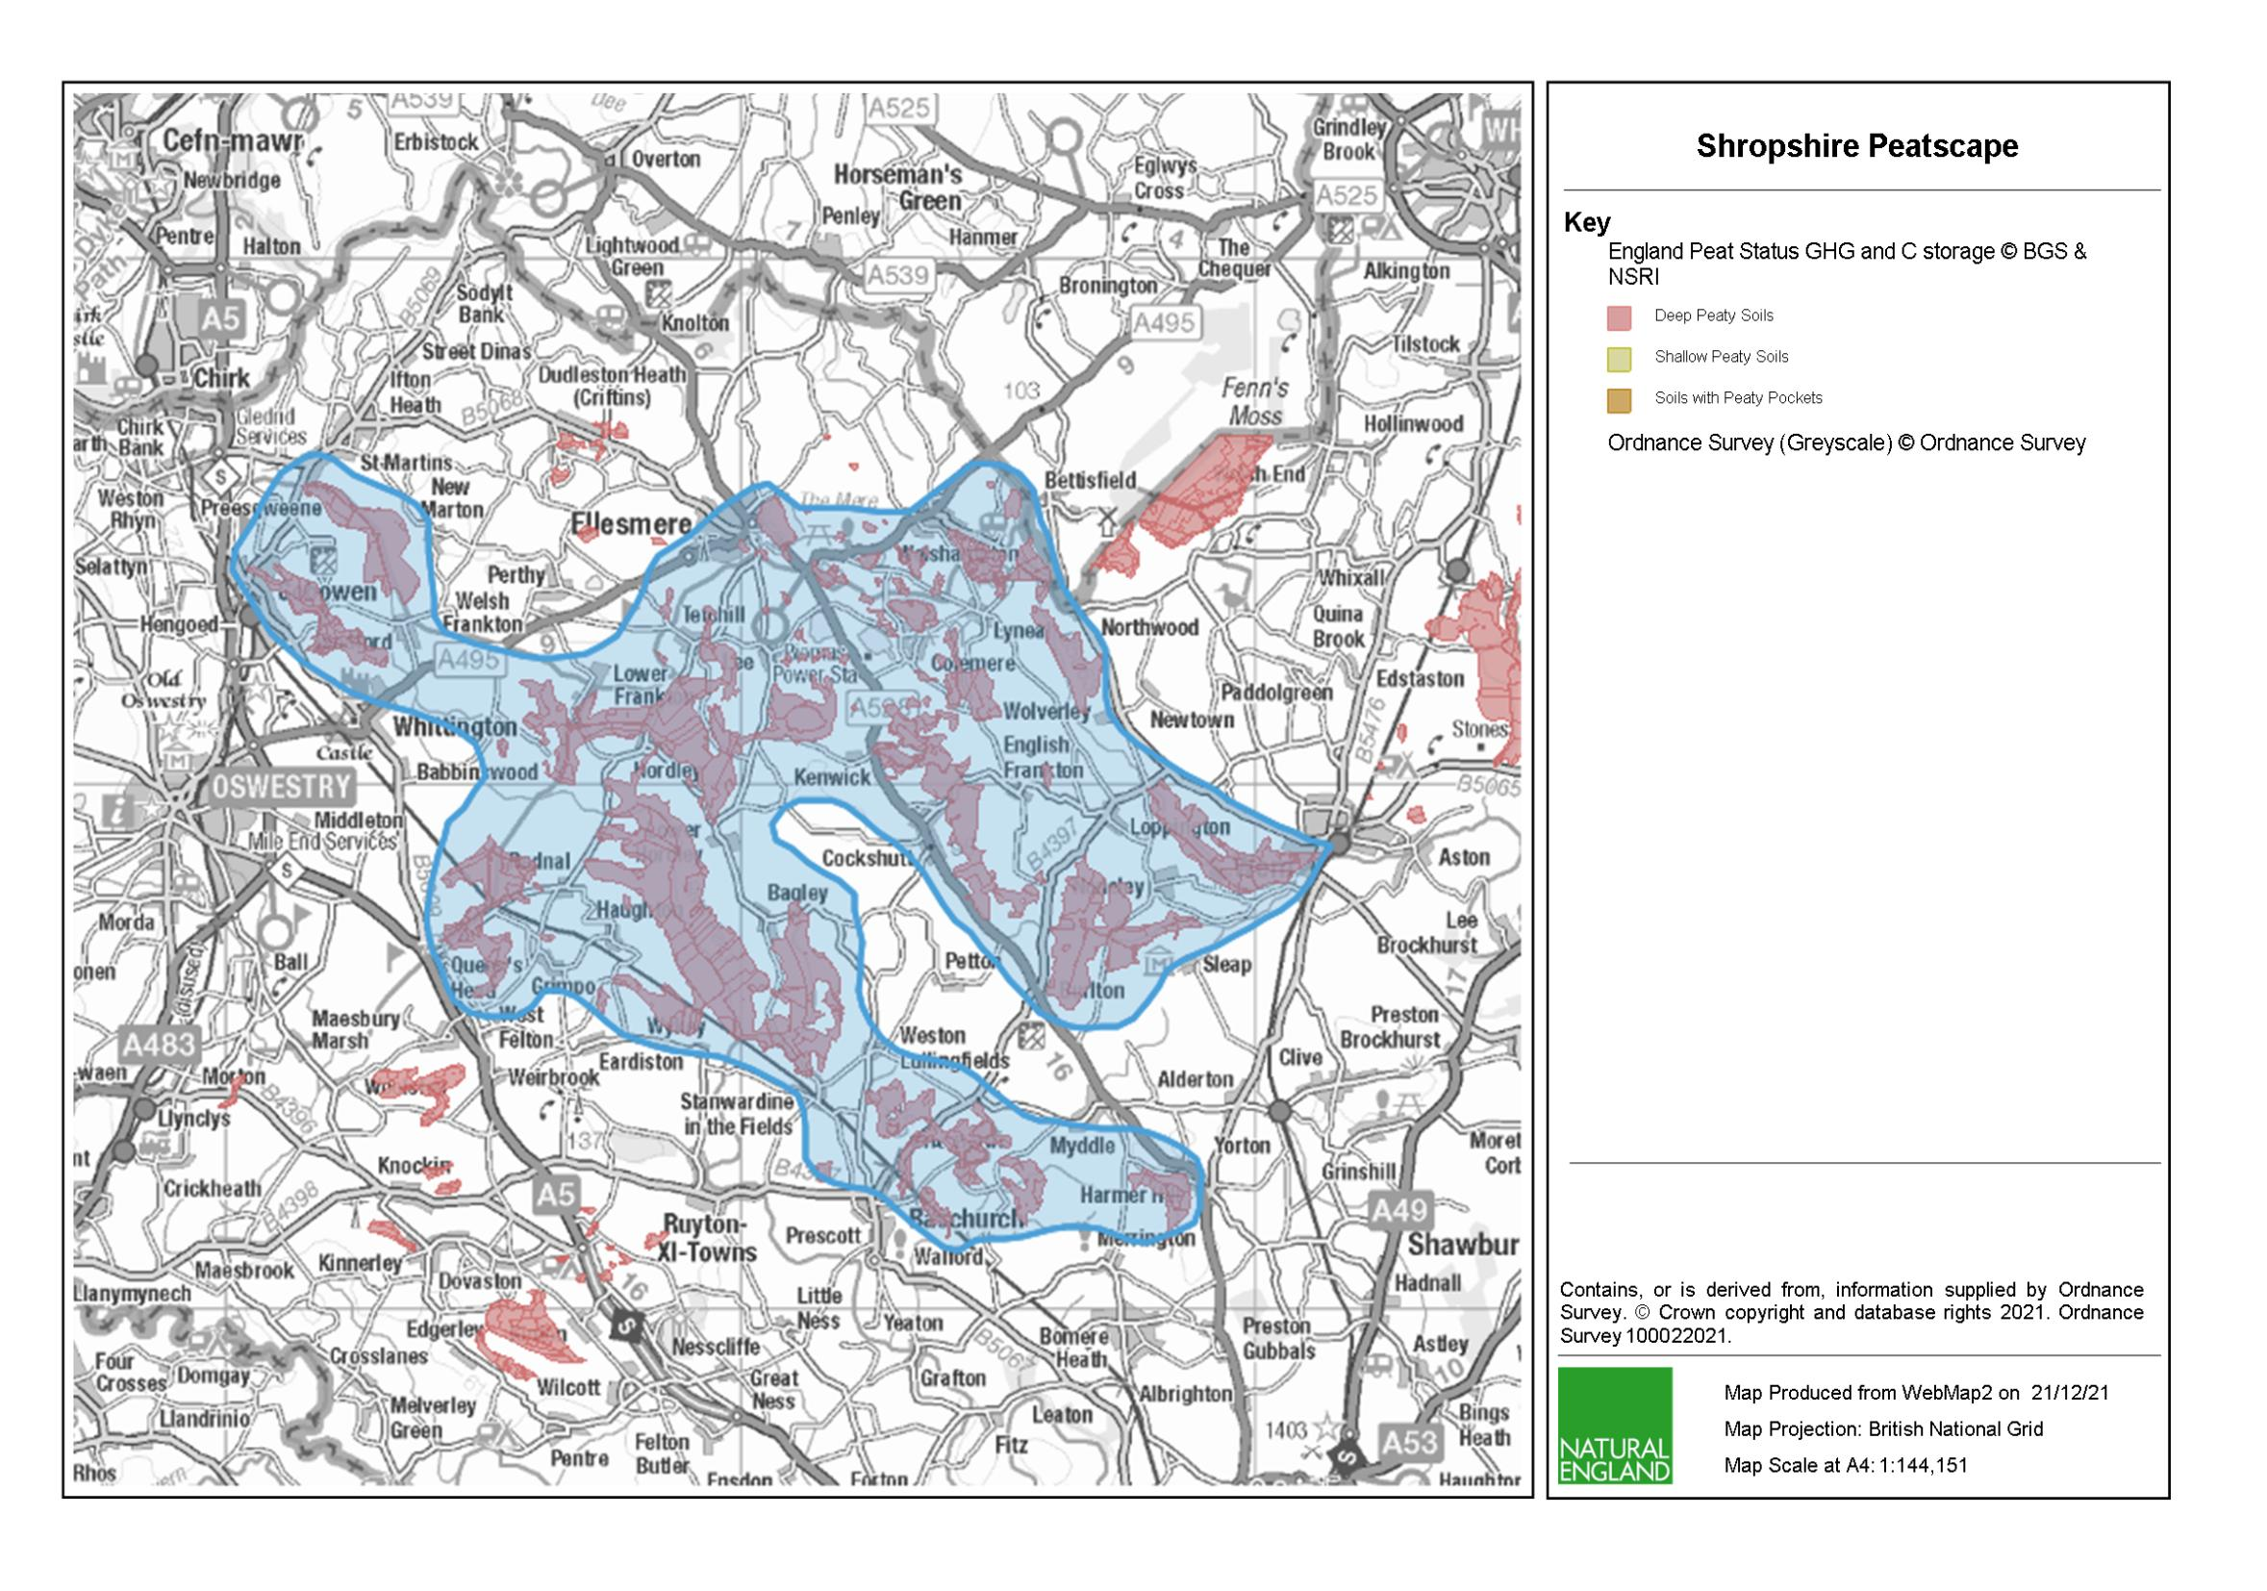**APPENDIX I - Peat for the Planet Project Area (highlighted in blue)**