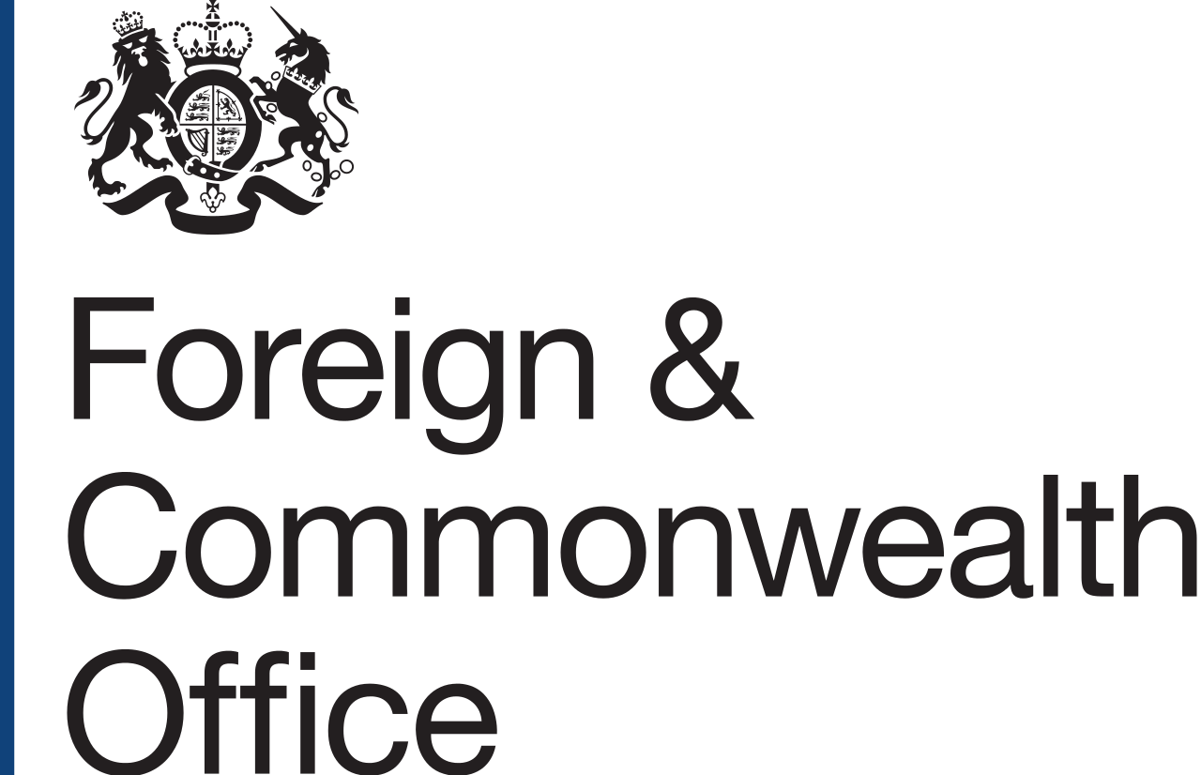

UK Prosperity Fund
South East Asia Low Carbon Energy Programme
Supplier Conference Call
27 November 2017

ATTENDEES
Cambridge Econometrics, Carbon Trust, CPI Climate Finance, Dragon Capital, Earth Security Group, Ecofys, EcoLtdGroup, Ecosphere Renewables, GiZ Asia, Global Green Growth Institute, Ordnance Survey, PA Consulting, Pact World, PwC, Ricardo, HKCCI – University of Edinburgh, Wood PLC, British High Commission Singapore: Camilla Fenning – Head of SE Asia Climate Change and Energy Network, Jane Ellaway – Head of Prosperity Programmes SE Asia, Aya Engracia – Regional Programme Officer, Prosperity Fund SE Asia

CONFERENCE CALL opened at 16:30H (GMT+8).

MEETING NOTES
UK Prosperity Fund and the South East Asia Low Carbon Energy Programme
The UK Prosperity Fund (PF) is a cross-government fund that aims to promote inclusive economic growth and development for partner countries and regions, as well as further enhancement of UK’s bilateral trade and investment.
There are a number of PF programmes happening in South East Asia (SEA) and low carbon energy has been identified as a key area of interest in the region for the PF.
The SEA Low Carbon Energy Programme is seeking £15m Prosperity Fund ODA allocation that will run to the end of March 2021. The initial scoping work presented two main challenges on low carbon energy in the region – Green Finance (GF) and Energy Efficiency (EE) – to which the UK has expertise and practical advantage to offer.
Other donors and stakeholders are operating in similar fields in the region, and the Programme will ensure that PF complement the existing work and shall identify particular areas of intervention where the UK can add value.
FCO is working closely with other government departments including the Department for Business, Energy & Industrial Strategy (BEIS) and Department for International Trade (DIT) in designing the programme and will be involved in measuring the secondary benefits and successes of the interventions.

The beneficiary countries
The target countries of the Programme are middle-income countries in SEA namely, Malaysia, Myanmar, Thailand, the Philippines, and Vietnam. Indonesia will only be involved in the GF intervention as it will have its own EE Programme.
Other SEA countries, e.g. Cambodia and Laos, have not been identified as priorities for PF at the moment, having taken into consideration the opportunities for economic growth and poverty reduction within the region and business comparative advantages within the target countries. Participation in workshops and activities can be opened up to countries other than the priority provided slots are available. However bulk of the interventions should be focused on the five targeted countries plus Indonesia.

Proposed key programme interventions
Green Finance and Energy Efficiency are the two proposed areas of intervention for PF work based on the initial scoping work and after consultations with governments in SEA. The governments have welcomed support from the UK in these two elements.
The Programme is looking for interventions which provide a coherent and holistic approach with a regional scope, at the same time recognising each individual country’s differing needs and stages of development.
On Green Finance, initially identified challenges in the region include the lack in capacity of financial institutions, insufficient understanding of GF and its instruments and the lack of standardised definition on green projects. There is also a disconnect between projects that are being developed and the finance that is becoming increasingly available.
The Programme’s aim is to support the region in having access to GF by being more aware of what is available, identifying existing barriers and suggesting pathways on how to address the barriers. Some of the planned interventions include provision of policy support, capacity building and technical assistance on the improvement of regulatory policy conditions.
The indicative areas of the Programme on Green Finance include:
- Analysis and harmonisation of GF standards
The aim is to address the lack of a clear definition of green standards across the target countries. The intention is not to create a new standard but to support the countries to have a harmonised and common understanding on GF. This should enable the creation of better GF projects and give greater risk assurance for companies and investors wanting to provide financing for the projects.
- Engagement and training of local financial institutions and trainers
The objective is to address the low level of understanding on GF, the lack of understanding on the scope of private financing available and proper access to this financing.
- Developing a pipeline of bankable projects
Potential implementers are expected to pave the path between those initiating and involved in the projects and the available funding.
The proposed projects need not end by 2021 despite the set timeline. It is hoped that successful introductions would have been made by the end of Prosperity funding between project developers and possible organisations that will be able to provide continued financing.
- Policy and regulatory support to improve the regional environment for GF

On Energy Efficiency, planned interventions revolve around harmonising EE standards across the region and supporting the improvement of regulatory environment of countries to fulfil their respective EE measures.
The indicative areas of the Programme on Energy Efficiency include:
- Establishing/embedding harmonised Minimum or Higher Energy Performance Standards (MEPs/HEPs)
The aim is to bring standards across the region to a defined level to encourage similar pace of economic growth amongst countries and create a better business environment for exporters operating in SE Asia.
- Policy and regulatory support to improve regional environment for EE practices
- Business support for EE standards in an industry sector
- Capacity building for suppliers, regulators, ESCOs, officials and established EE expert working group sharing best practice
- Developing a pipeline of bankable large-scale EE projects
This area shows the link between both components of the programme wherein benefit from GF can be realised through the UK’s strong expertise in pushing together EE projects.
Throughout the Programme, being ambitious at the same time realistic is key. It is integral to recognise how best to leverage resources across the region, build on what is happening and generate impact. Likewise, a regional point of view is to be considered rather than a per country approach.
These proposed interventions and expected outcomes are not set in stone. It is envisaged that the lead implementer will be required to conduct a market assessment to have full knowledge on the situation of GF and EE on the target countries, understand the company’s position and provide expertise alongside the identified target areas to achieve impact. This will ensure that the proposed interventions, once rolled out, are up-to-speed given the fast-moving field and GF and EE.
It is important to identify the barriers at the inception phase and how these can be overcome. One of the early parts of the programme being envisaged is a Wilton Park Conference. The intention is to convene project developers, regulators, and government officials together in the UK and hammer out the barriers to progress and find ways to address these. The final design of the programme will be done in consultation with the lead implementer which will consider the situation on the ground, take in the existing work of other donors that can either support or be in parallel or complementary with what is currently done, and the key interventions that can make impact.

Procurement
The Programme will be procured through the Prosperity Fund Procurement Framework. The lead implementer would be identified from this Framework and the list of preferred suppliers will be divided into lots e.g. Energy. The lead implementer will bring the expertise as needed. The bidding has now closed to participate as lead implementer. Should potential implementers wish to combine expertise and resources, lead bidders may form supply chains and network; this will be done at a bidder’s behest and must be organized amongst themselves. There is no deadline for joining up to work with a lead implementer once it has already been appointed. The Terms of Reference of this programme will be issued. It is important to note that there is no exclusivity requirement on subcontractors. Subcontractors can appear in several bids and are therefore not required to pick just one lead implementer to go with.
The Programme will not prescribe where the potential implementer and/or subcontractors will be based. Bids will be assessed considering the robust governance structure that will be followed and will take into account the in-country delivery structure of bids. The Programme team will reflect on the possibility of potential shift in scope after the conduct of the market assessment and will include further details on the Terms of Reference.
The Procurement Framework is expected to go live by early next year likewise anticipating that the list of prequalified suppliers will be publicly released. The bids from lead implementers will be assessed in accordance with the Terms of Reference and the evaluation criteria that were part of the Invitation to Tender.

AOB
The names and contact details of participants in the call will be circulated, unless participants indicated up to 48 hours after the call that they did not wish to be included.
Another supplier day will be held early next year to continue engaging with the market and provide opportunities to build relationships between potential lead implementers and sub-implementers. Further details will be provided once the timings are confirmed.

CONFERENCE CALL ended at 17:32H (GMT+8).

