
Terms and Conditions

The purpose of the agreement is to set out the basis on which Apprenticeship Learning Solutions Ltd T/A ALS Training (ALS) acting as the Training Provider will provide appropriate support to by the Employer to enable achievement of Apprenticeships or other funded vocational programmes (the “Training”).

Company Name: Driver & Vehicle Standards Agency Company Address: Berkeley House, Croydon St, Bristol
Post Code: BS5 0SA
L3 IT Infrastructure
Terms of this Agreement
This agreement shall commence –06/10/2025- and remain in force from the start date of the Training “the Commencement Date” and thereafter until all Learner(s) complete their Training or if terminated by either party giving to the other not less than 3 months’ notice in writing. ALS is the data controller as required as part of the funding contract held with the Welsh Government and will control all appropriate data in line with the Data Protection Act, GDPR and registration with the ICO
Obligations of the parties
- The Employer shall ensure that the Learner(s) receive(s) work experience, which is appropriate for the Training being undertaken.
- The Employer shall pay the Learner(s) a wage at a rate, which shall not be less than the statutory minimum wage as set by Government legislation.
- The Employer shall account for PAYE, National Insurance and other statutory deductions in respect of payment to the Learner(s), as required by its local tax office and Government legislation.
- To facilitate the monitoring and assessment of the Learner(s) as part of the Training being provided, the Employer shall permit access on to its premises by a representative of ALS and, where appropriate, by the Awarding Organisation (Quality Control) and the funding body which is providing funding for the Training, such access shall not be unreasonably withheld. The Employer shall use its best endeavours to provide a private area on its premises for this purpose.
- The Employer undertakes to ensure that no concurrent funding under a Government funded programme is received in respect of any Learner(s).
- The Employer shall, if so requested, make available to ALS all accounting, financial and other records relating to the period of the Training for the Learner(s).
- The Employer and ALS shall ensure that proper provision is made for the health, safety and welfare of Learner(s) and training advisors and that it complies with the Health and Safety at Work Act 1974 and all other relevant legislation (including the Codes of Practice and Guidance Notes issued from time to time by the Health and Safety Executive). This shall include, without being limited to, compliance with the items listed on the Health & Safety Induction Record, which ALS shall attach to this agreement where it has a contractual obligation to do so.
- The Employer shall ensure that there is provision for a safe and healthy working/learning environment, safe use of equipment and materials, safe systems of work, adequate welfare facilities, emergency arrangements and competent persons in place with responsibilities for health and safety.
- The Employer shall permit an ALS representative to visit its premises by appointment during the term of this agreement to undertake an assessment of the extent which the Employer’s premises, systems and procedures comply with health and safety standards. This assessment will include the appraisal and inspection with copies of relevant documents. The Employer will ensure that the Learner(s) attend(s) an induction which will include reference to Health and Safety as in the ALS Employer Handbook. Both parties acknowledge that the ALS Work Placement Health and Safety Appraisal shall be properly completed before the Learner(s) commence(s) their Training. Acceptance of the Learner(s) onto the Training is conditional on compliance of this checklist to the satisfaction of both parties.
- The Employer will ensure that the Learner(s) complete(s) the company induction which will include health and safety.
- The Employer will ensure that provision of any PPE required is in place and is provided free of charge, used and stored correctly and that training is provided for the Learner(s) in its correct use.
- The Employer shall ensure that there is a Health and Safety Policy in place and risk assessments completed as required by law.
- The Employer shall ensure that any prohibitions and restrictions in place are agreed and understood by all relevant persons, including the Learner(s), representatives of ALS and any other external visitors in relation to the Training.
- The Employer shall ensure that the Learner(s) is / are treated equally regardless of age, race, religion, sex, marital status and disability and shall comply with legislation relating to the rehabilitation of ex-offenders.
- The Employer shall notify ALS on the same day, if the Learner(s) is / are involved in an accident, work related illness or other dangerous occurrence. The Employer shall investigate with ALS all accidents and dangerous occurrence in which the Learner(s) is / are involved.
- The Employer shall maintain in force, with a reputable insurance company, policies of insurance in respect of Employer’s Liability, Public Liability and any other relevant insurance. The Employer shall, if so requested, provide ALS with copies of its current certificates in respect of such insurance.
- The Employer shall indemnify ALS against any Direct injury, loss or damage which may result from any act, error or omission by the Learner(s) for which the Employer is also liable in law, except to the extent that any such injury, loss or damage is caused by the negligence of ALS staff. Conversely this will also apply to ALS and the employer
- Where the Employer is claiming a wage subsidy via ALS for the Learner(s)’Training the Employer shall provide evidence to support the claim, e.g., payslips/timesheets in the form and manner prescribed by ALS and shall provide any other information relating to the Learner(s)’Training, which may reasonably be requested by ALS.
- The Employer agrees to release the Learner(s) for attendance at ‘Off the Job’ training sessions or specific testing sessions for the Training where applicable. ALS will agree in advance with the Employer any ‘Off the Job’ requirements in order to ensure minimum disruption to productivity.
- The Employer shall provide ALS in writing, the intention to terminate Training for the Learner(s) within the appropriate Employer notice period.
- The Employer undertakes that the Learner(s) who commence(s) the Training will be allowed to complete the Training. In the event that the Learner(s) is / are prevented by the Employer from completing the Training, the Employer shall indemnify ALS against any consequent loss of revenue, which ALS may suffer.
- ALS will provide monthly MI to provide DVSA with progress updates and raise any causes for concert
- Breach of the ‘Obligations of Parties’- either party will have 7 days to make good any breach, failure to do so could result in the termination of the agreement in line with the terms indicated in this document.
I have read the terms and conditions above and agree to be bound by them.

Signed on behalf of ALS Training Ltd:
Name: Signature:
Date:
Job Title: XXXXXX redacted under FOIA section 40

Signed on behalf of Company:
Name: XXXXXX redacted under FOIA section 40
Signature: XXXXXX redacted under FOIA section 40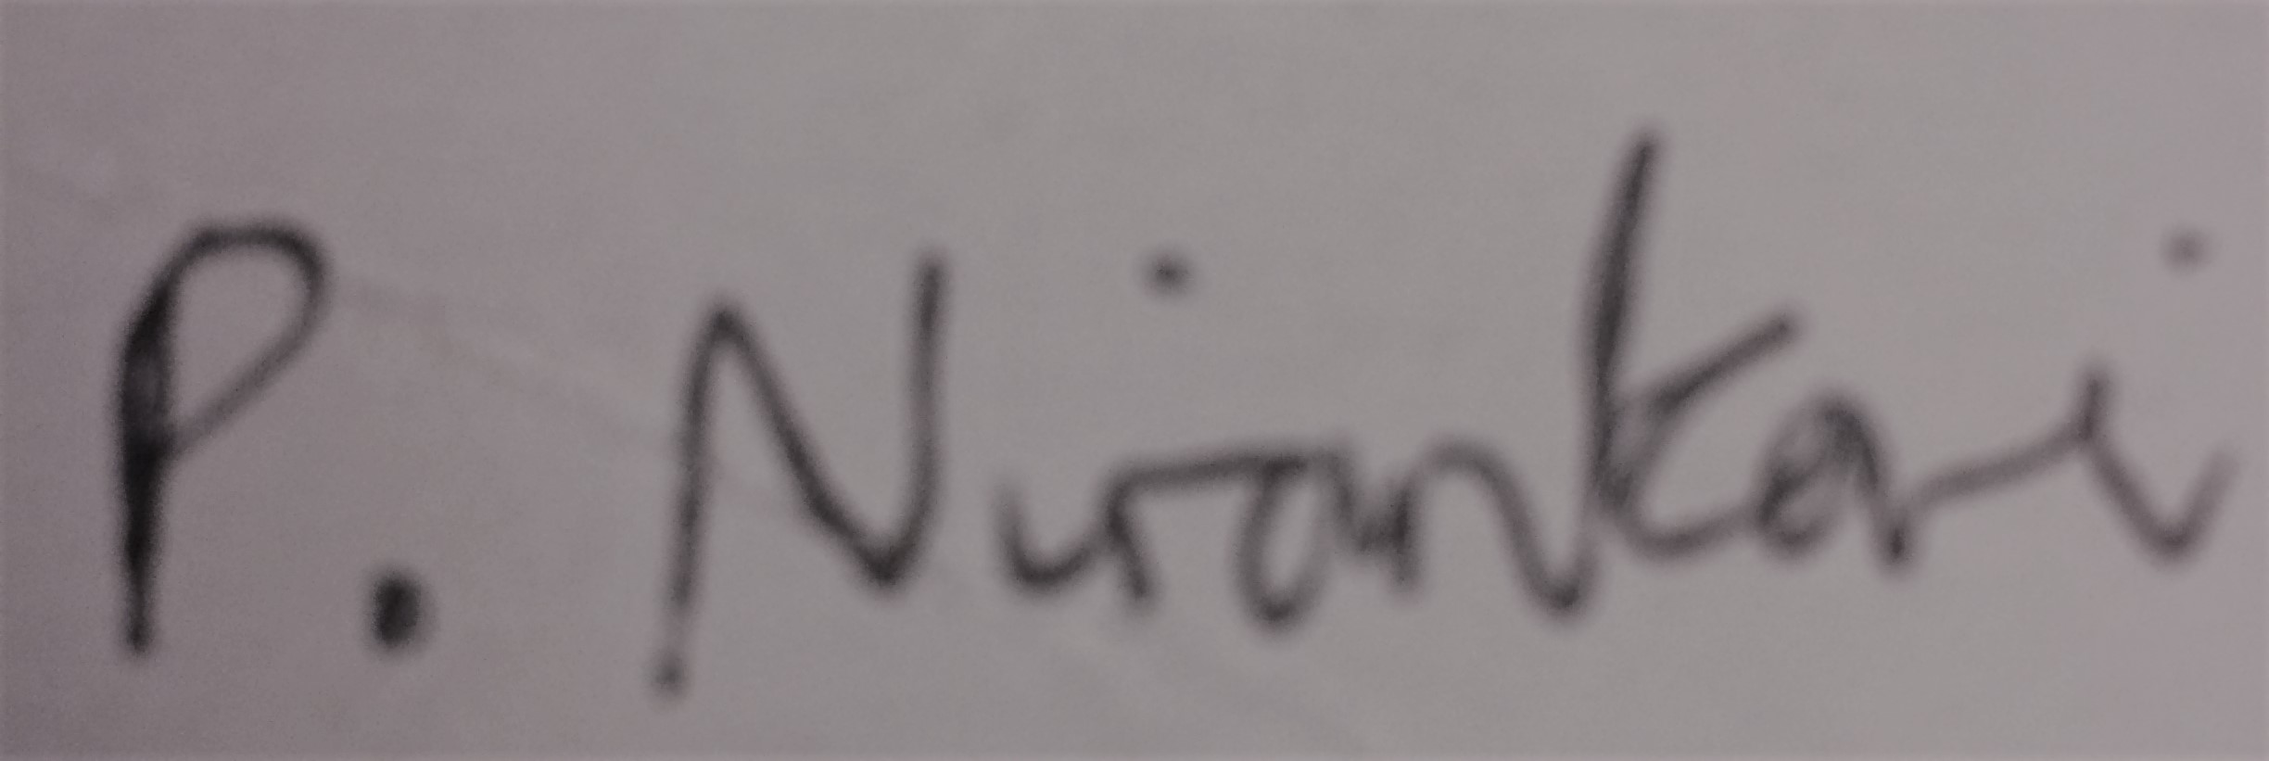
Date: 24/9/2025
Job Title: XXXXXX redacted under FOIA section 40
ALS, Ocean Park House, East Tyndall Street, Cardiff, CF24 5ET

3300-13 22/02/18

