INDEX

A10 Project Particulars

A11 Tender and Contract Information

A12 The Site/ Existing Buildings

A13 Description of the Works

A14 JCT Design and Build Contract

A15 Fees

A16 Performance Bond

A17 Subletting/ Supply

A18 Provision, Content and use of Documents

A19 Management of the Works

A20 Quality Standards/ Control

A21 Security/ Safety/ Protection

A22 Provisional Sums

A23 Document Hierarchy
A10 PROJECT PARTICULARS

100 THE PROJECT
Name: Westbury Town Council Public Toilet Refurbishment
Nature: Refurbishment of Existing Public Toilets

110 EMPLOYER (CLIENT)
Westbury Town Council
The Laverton
Bratton Road
Westbury
BA13 3EN

120 PRINCIPAL CONTRACTOR
To be determined by the tender.

130 EMPLOYERS AGENT & PROJECT MANAGER (EA)
South West Project Management
Grantchester
69 East Street
Warminster
Wiltshire
BA12 9BZ

140 CDM PRINCIPAL DESIGNER & BR PRINCIPAL DESIGNER
South West Project Management
Grantchester
69 East Street
Warminster
Wiltshire
BA12 9BZ

A11 TENDER & CONTRACT INFORMATION

100 EMPLOYER’S REQUIREMENTS INFORMATION

The Photos below are general images showing the general existing condition of the two existing public toilet sites to be stripped out and refurbished at Warminster Road & High Street, Westbury taken in September 2025.

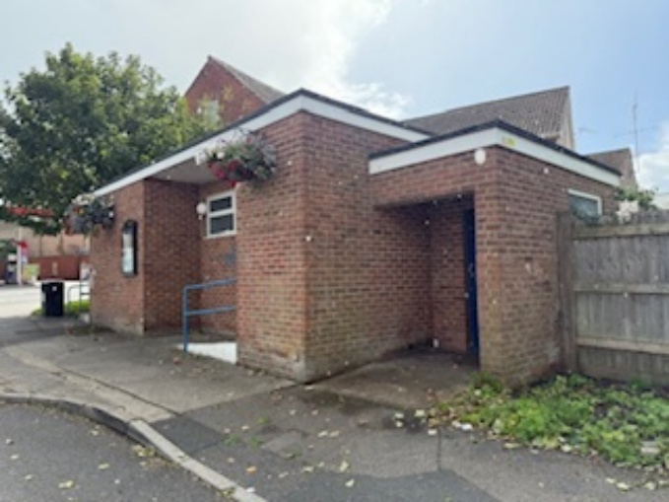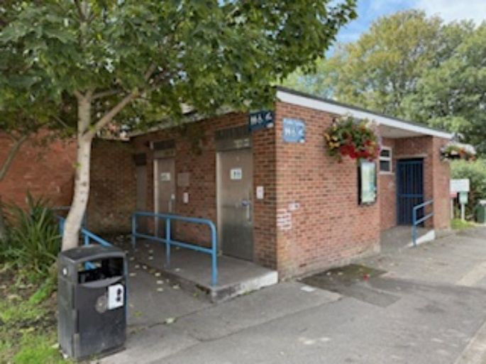
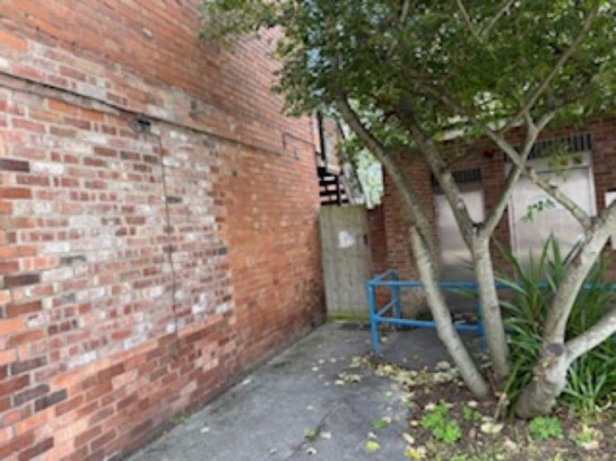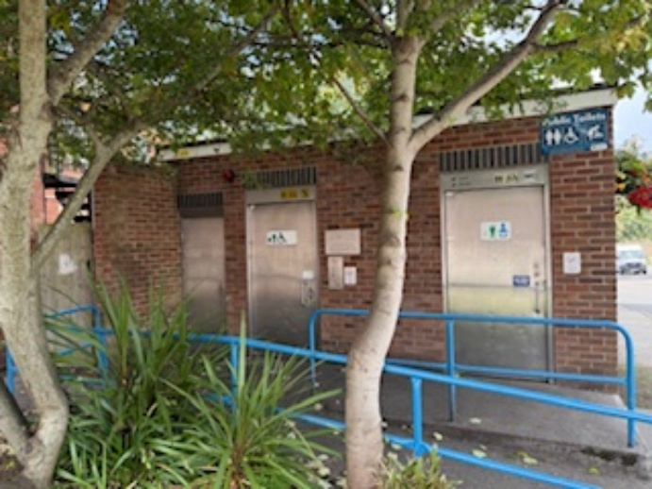

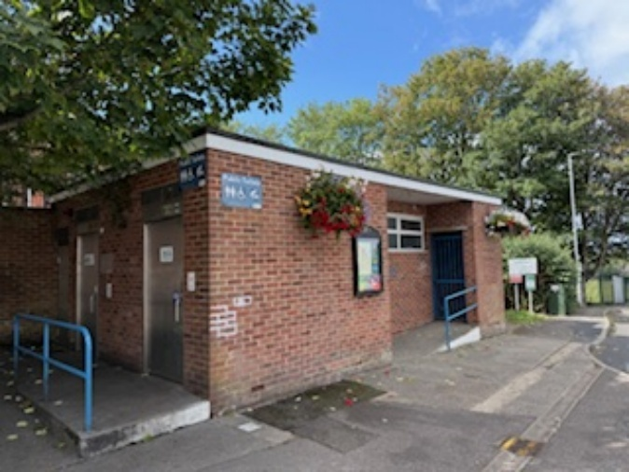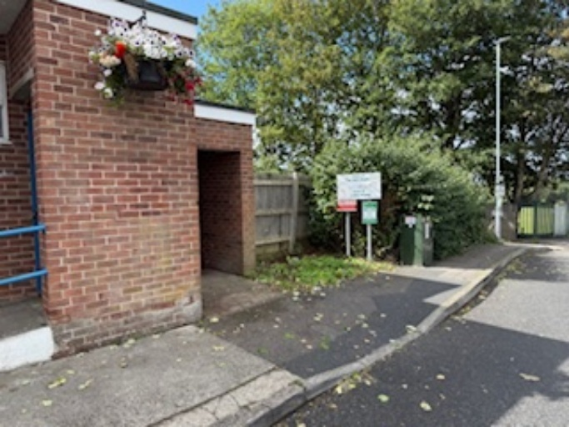
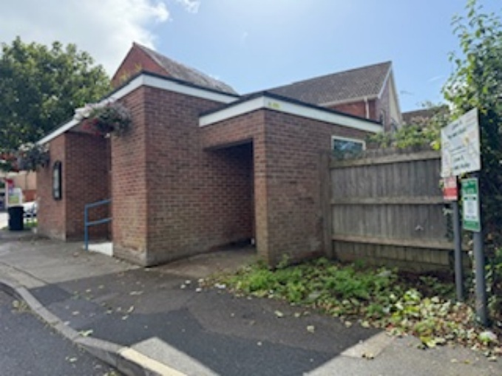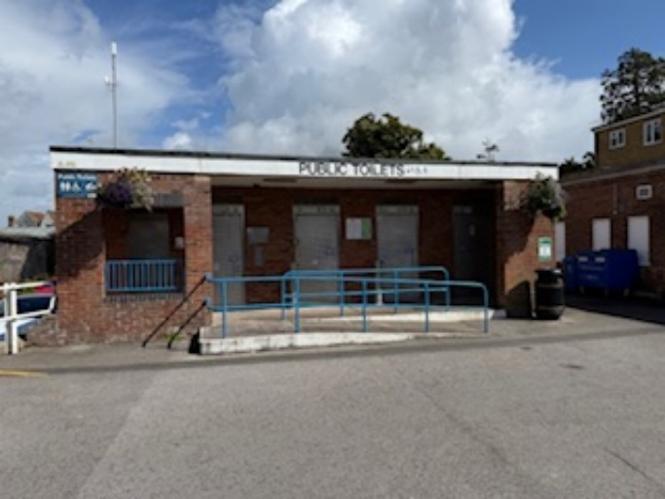

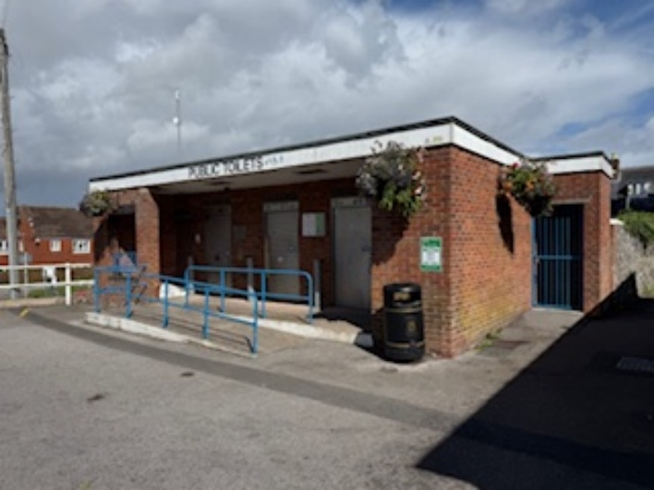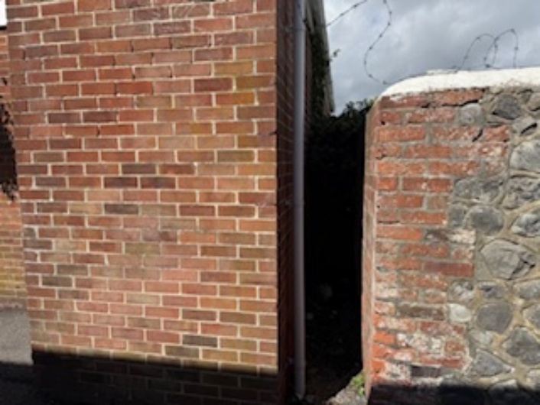
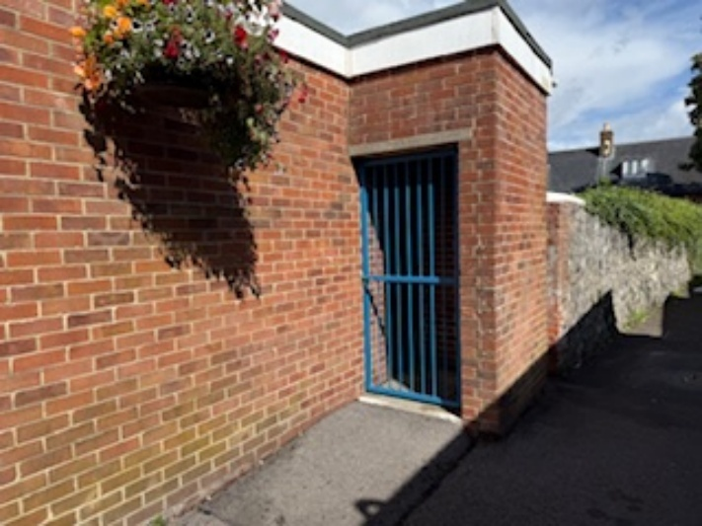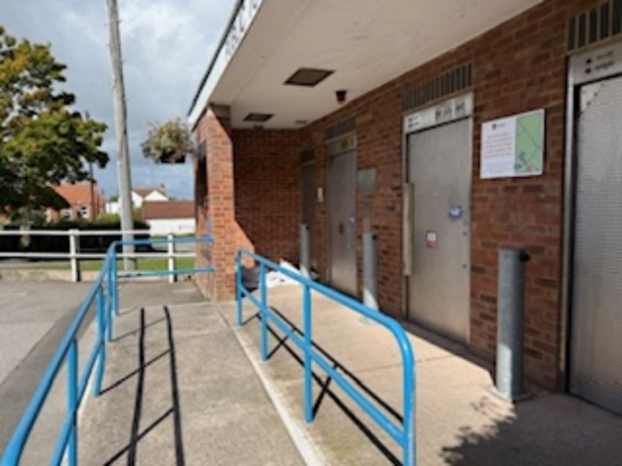

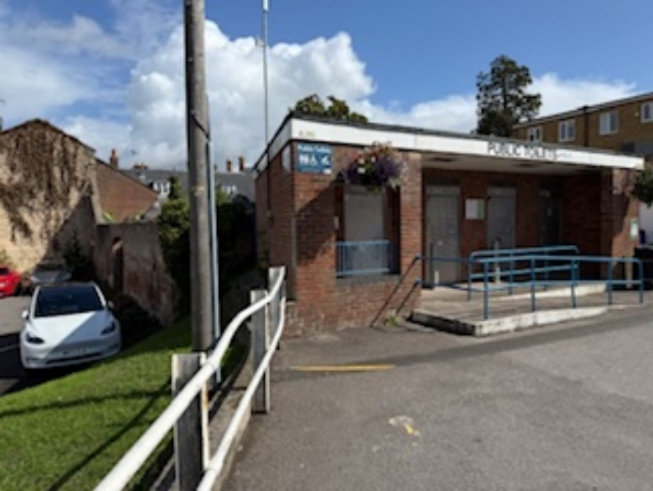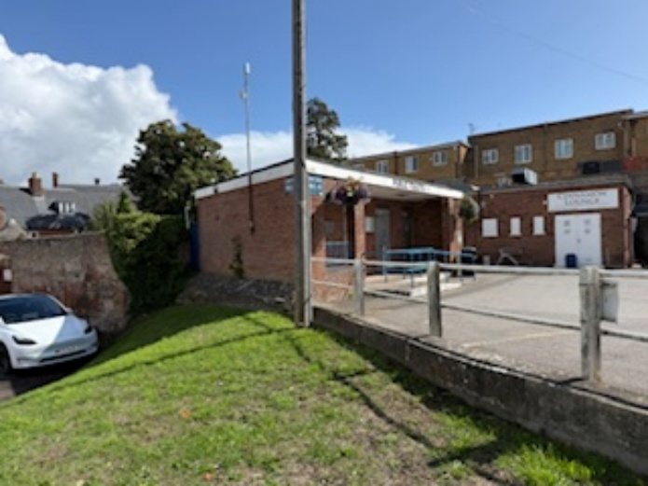
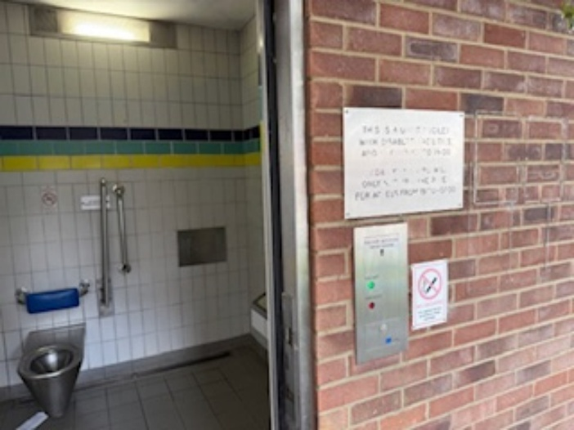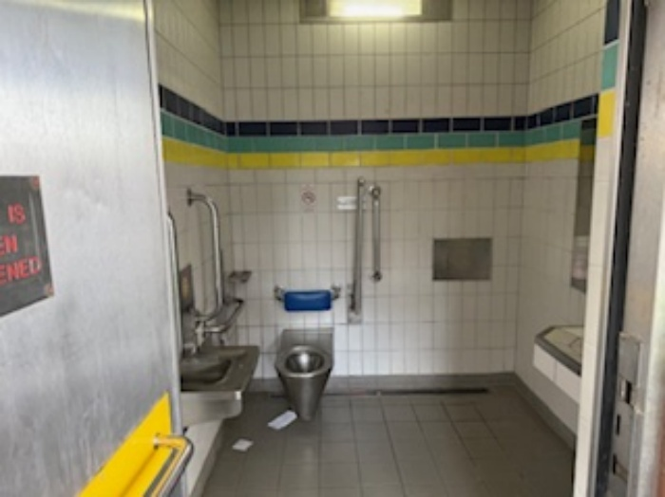

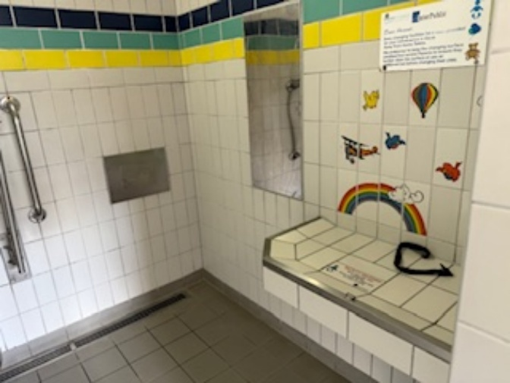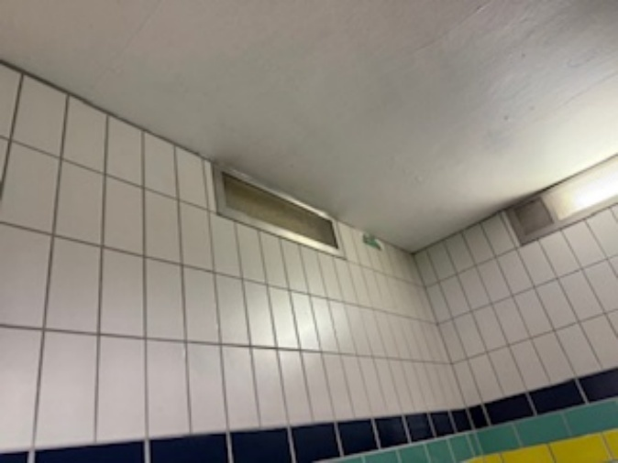
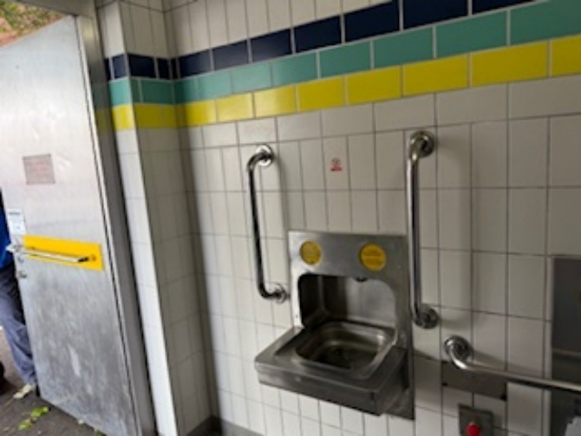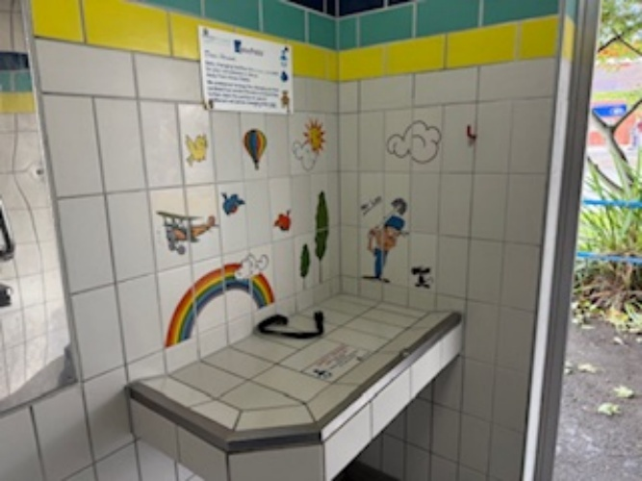

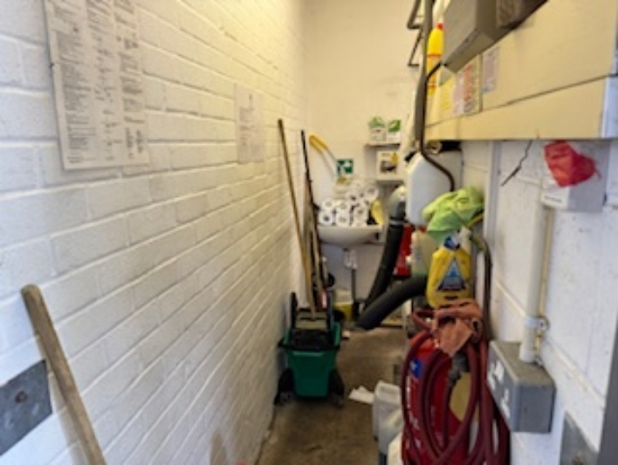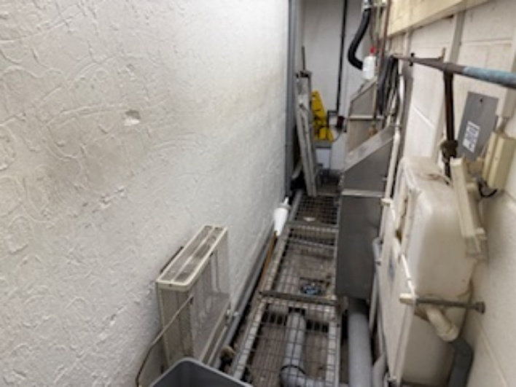
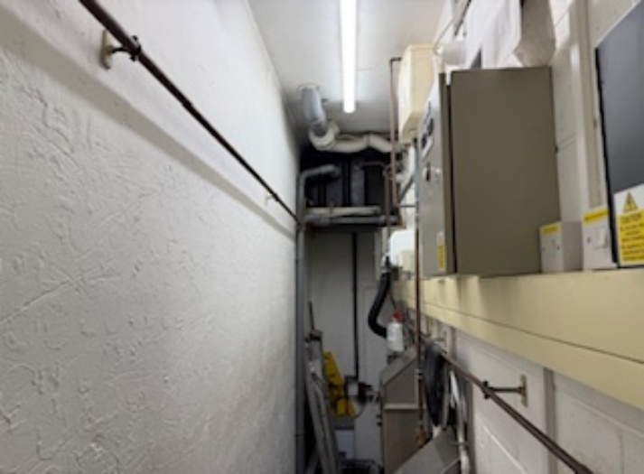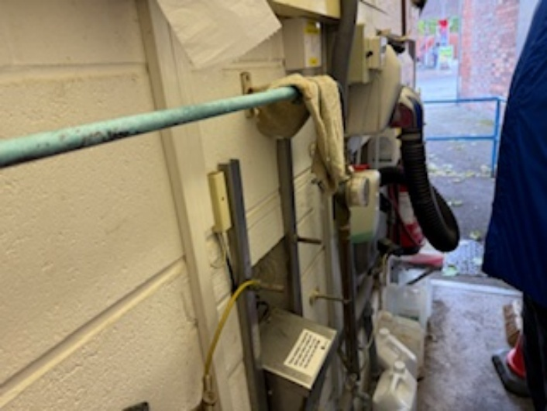

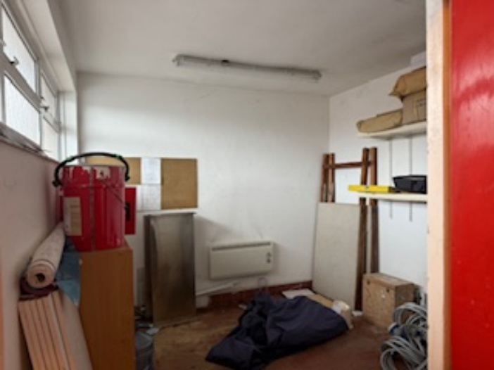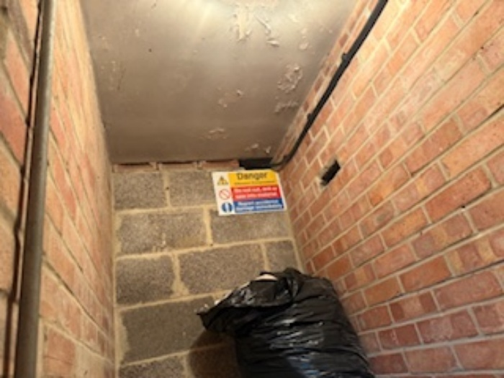
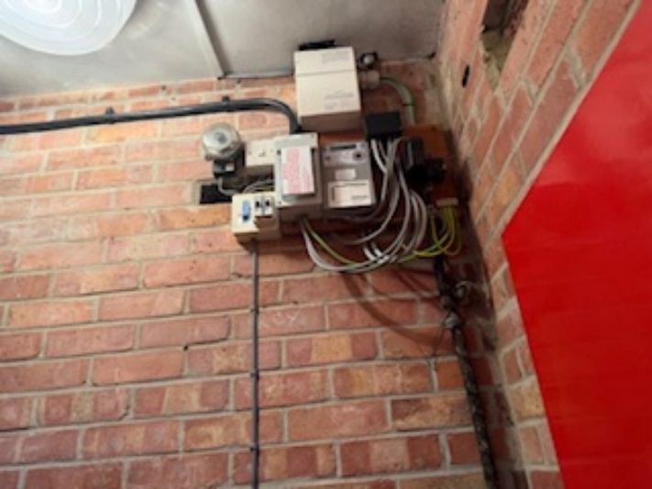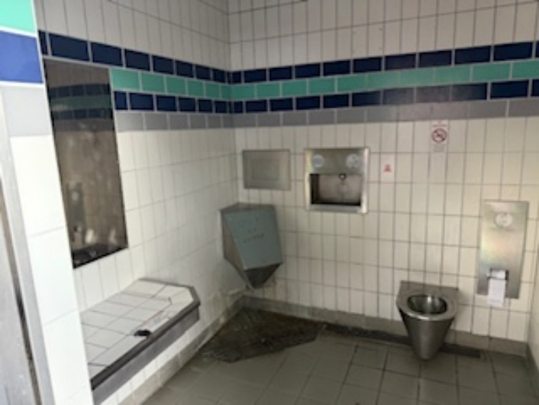

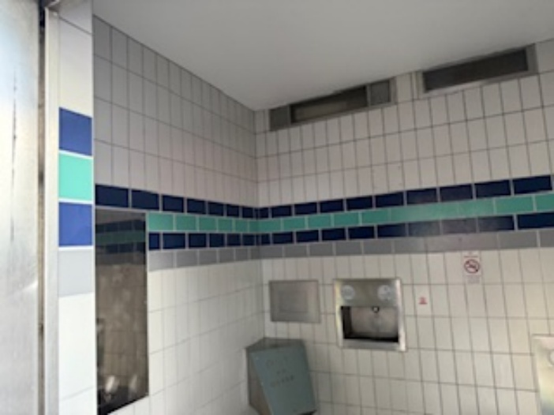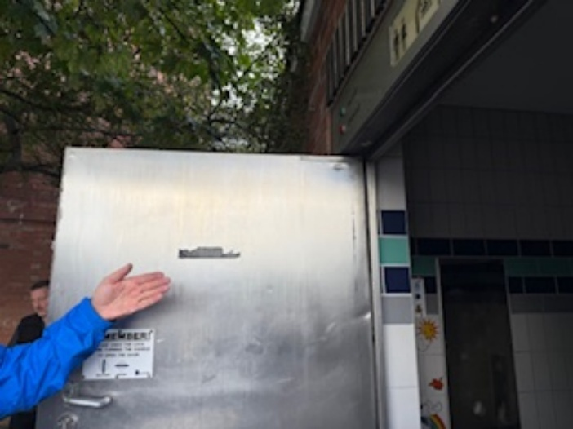
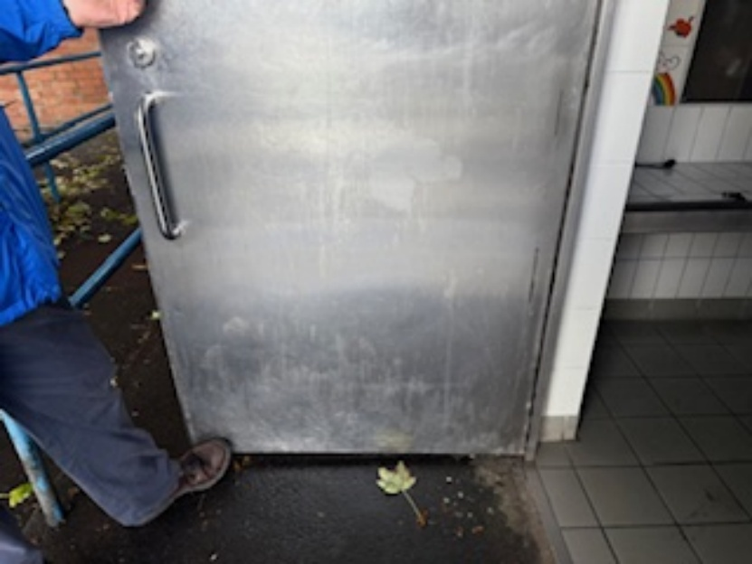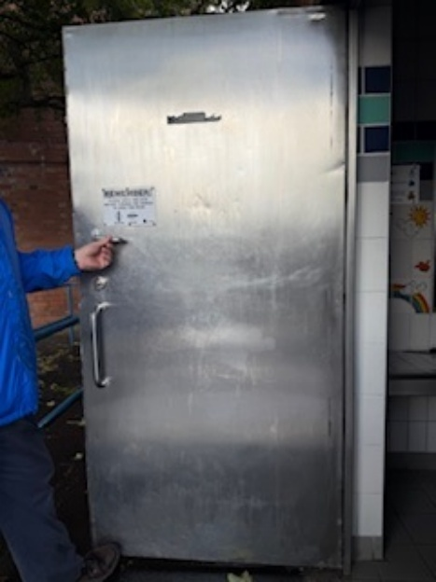

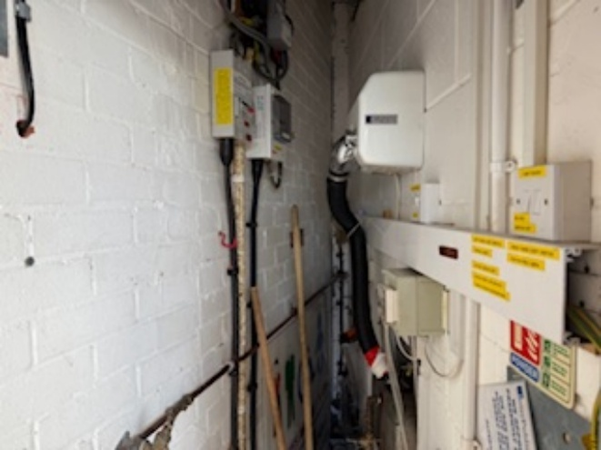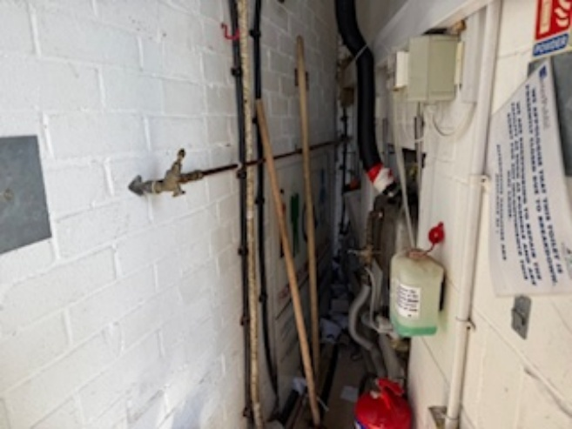
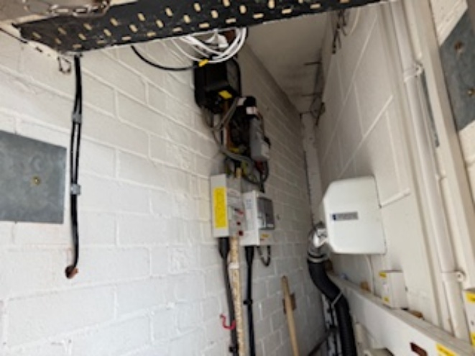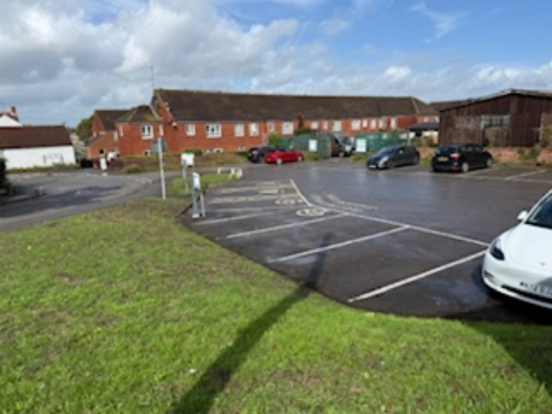

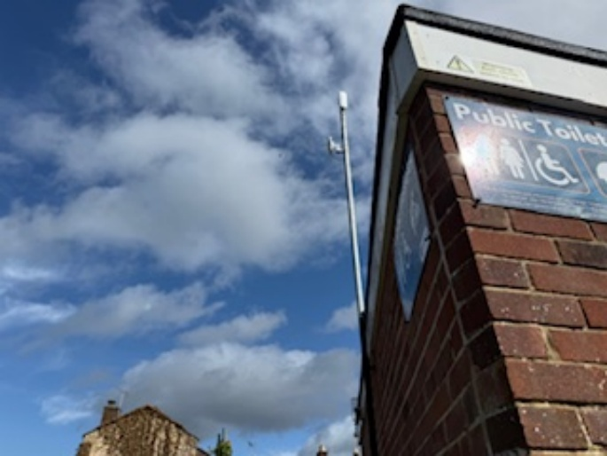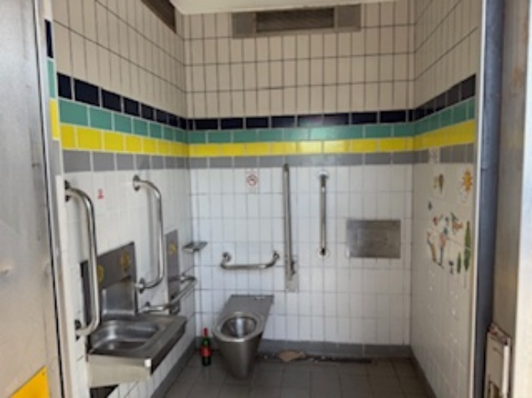
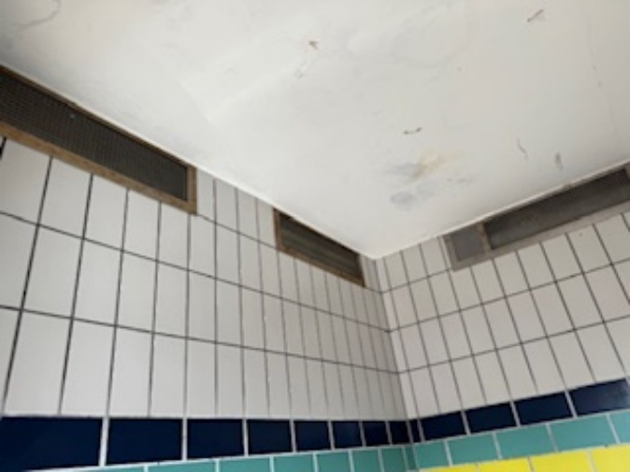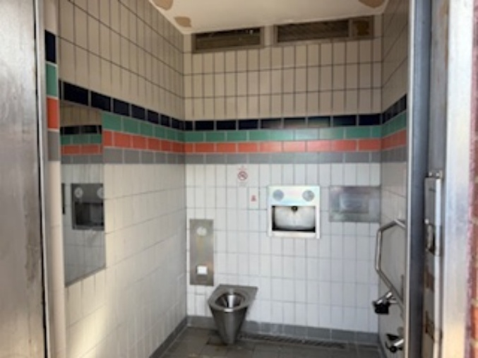

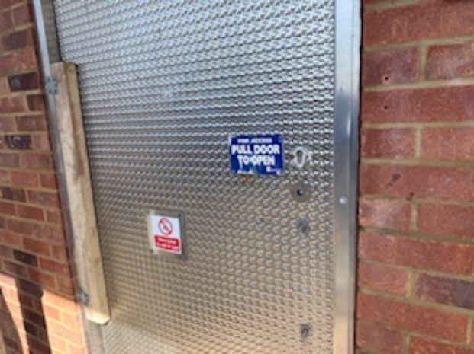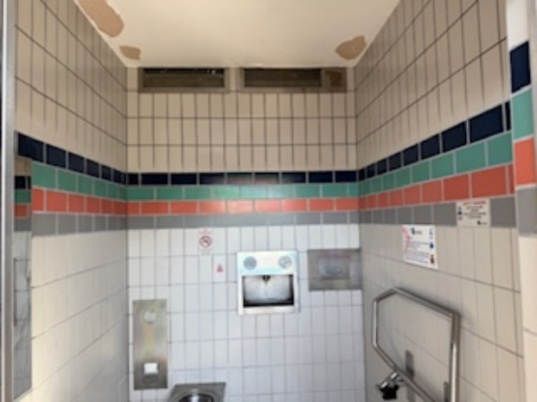
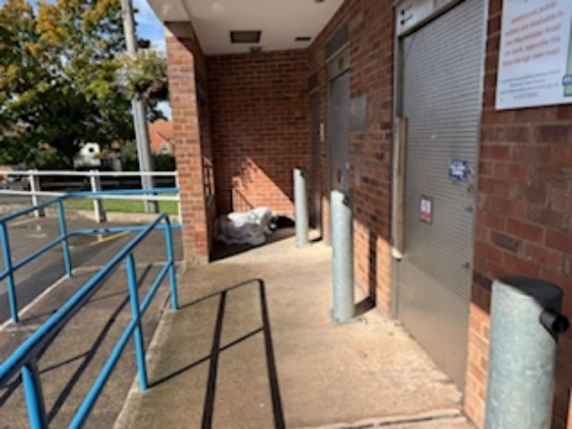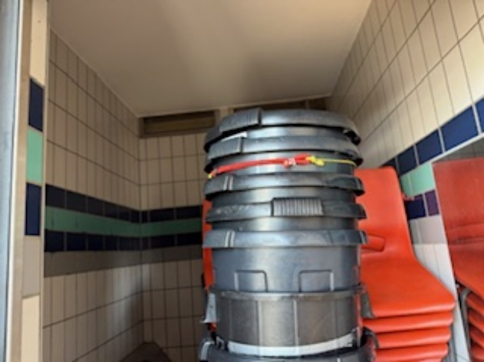

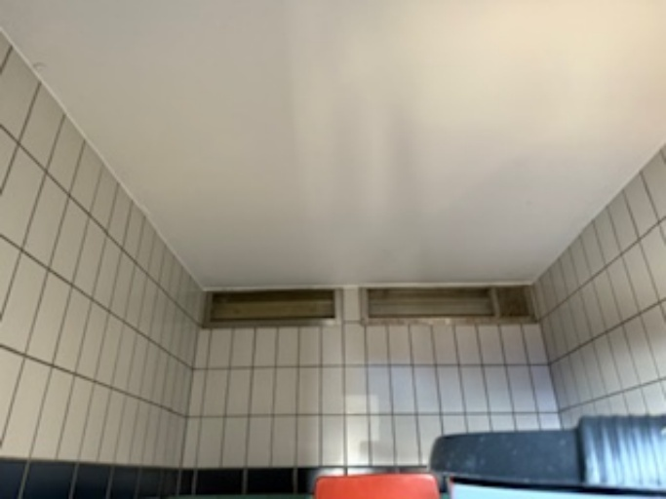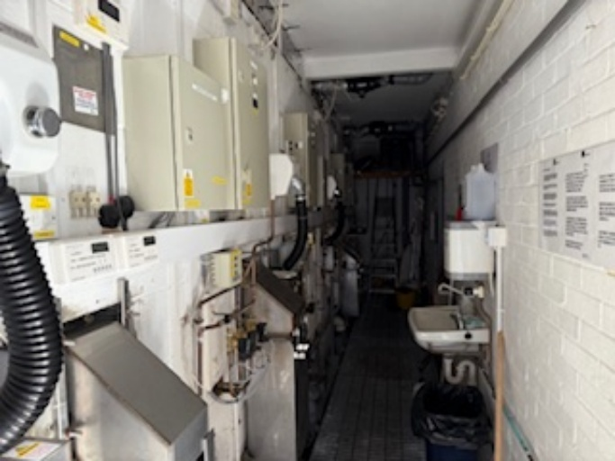
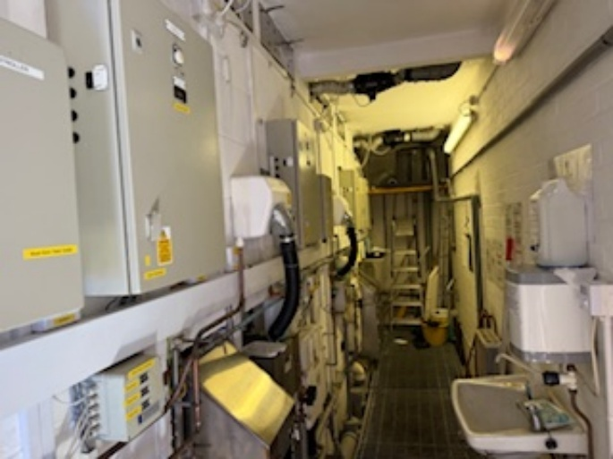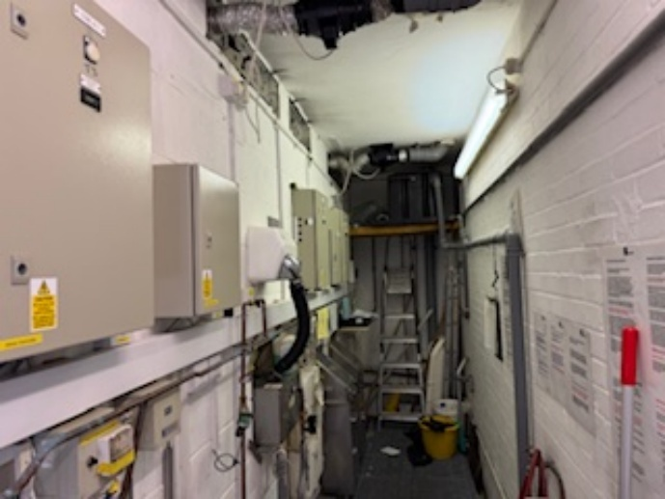

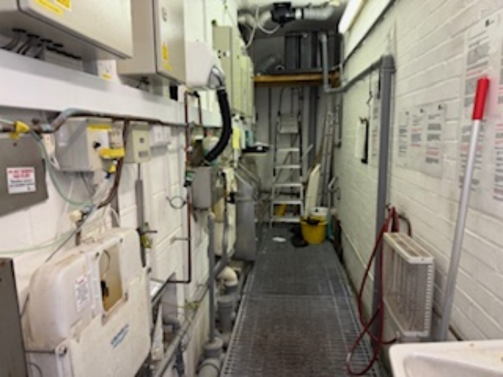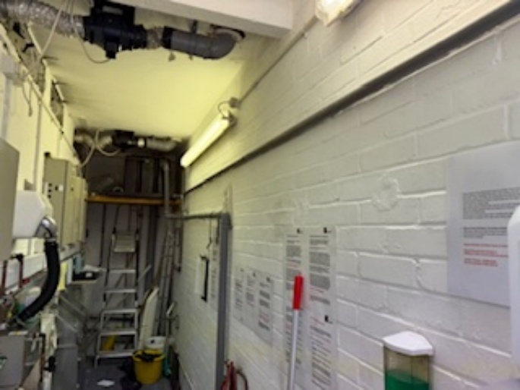
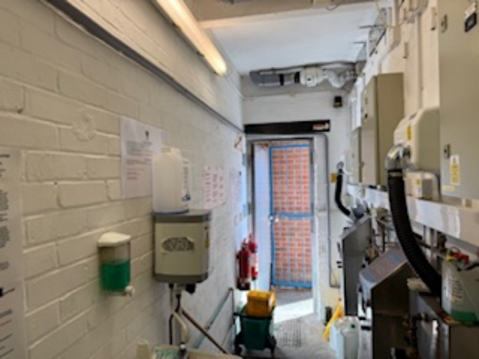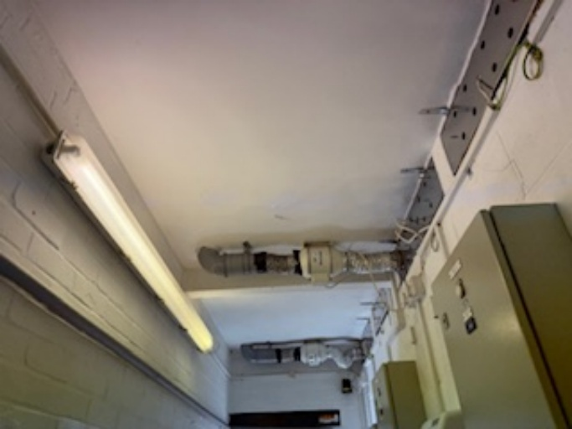

110 DRAWING, INFORMATION & DESIGN: The Contractor shall (via email to tim.goodman@swestpm.com in PDF format) provide the following drawings for both sites to the EA

- Following appointment and prior to the start of the construction phase - Contract Drawings comprising GA’s, Proposed specification & M&E - 3 sets
- On completion - Final "As Built" drawing comprising GA’s, Specification & Mechanical & Electrical - 3 sets.
- On Completion – Building O&M Manual. Health & Safety File – 3 sets

120 EMPLOYERS REQUIREMENTS

Are comprised of information provided within this document and the terms and conditions set out in the JCT Design and Build Minor Works contract 2024.

A12 THE SITE/ EXISTING BUILDINGS

100 THE SITE

The two sites currently accommodate existing public toilets, which are currently closed. The current layout for both the Warminster Road and High Street sites is shown below:

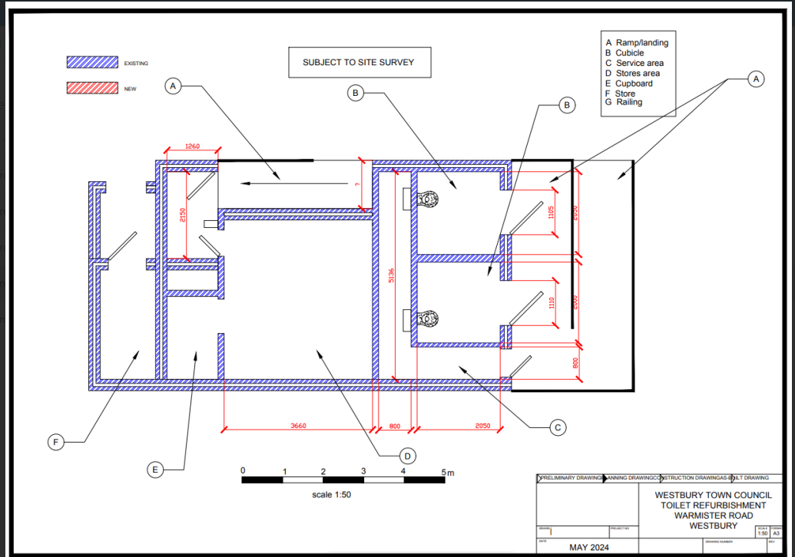

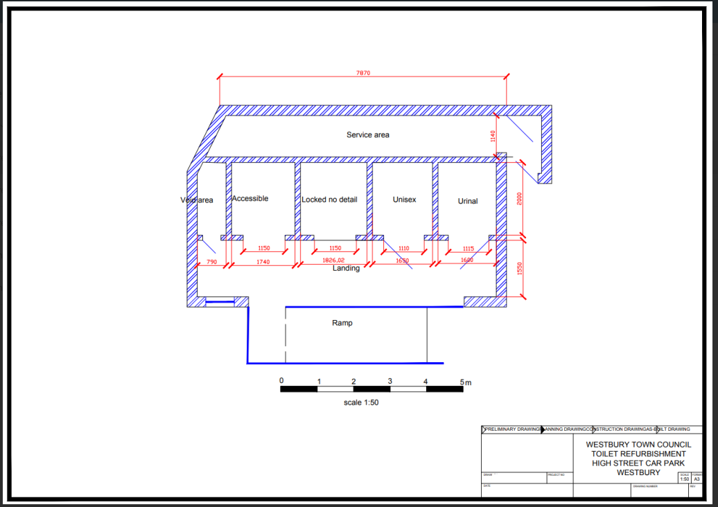

The facilities at both sites are in a very poor condition (see photographs) and currently closed to the public. The project requires a total strip out of all existing services, ceiling, wall and floor finishes, fixture, fittings and all existing sanitaryware, back to a shell, followed by a total refurbishment. It is anticipated that the existing external doors can be retained and refurbished. The current intention is for the internal layout to remain as is, though WTC are open to suggestions from the contractor that may improve this. The toilets will all be unisex with one disabled / accessible facility with baby changing facilities at both locations. A site visit has been arranged for 31 October 2025 at 11.00 a.m, for contractors to familiarise themselves with both sites.

110 LAND OUTSIDE THE PROJECT

Any arrangements which the Contractor may make for use of land outside the working area of the public toilets must be made outside the Contract, and the interests, rights and liability of the Employer must be fully protected and indemnified.

120 SITE BOUNDARIES

The Contractor will be responsible for setting out the site boundaries at both sites and providing safe separation of the works being undertaken, from the public. If in doubt the Contractor shall arrange for the Employer and EA to be present to agree the boundaries.

130 EXISTING BUILDINGS ON/ ADJACENT TO THE SITE

Description: The Contractor shall be held fully responsible for upholding and maintaining the structural stability of all adjacent and neighbouring properties/structures. The Contractor shall allow for complying with the provisions of the Party Wall Act 1996, and where necessary acting as Client’s Agent, issuing relevant notices on their behalf.

The Contractor shall not inconvenience, impede, or restrict the occupants of any of the adjacent buildings. The Contractor’s shall endeavour to not make unnecessary noise that disturbs neighbours and always keep the site neat and tidy.

140 CONDITIONS SURVEY

The Contractor will be required to record the condition of the existing buildings, boundaries, footpaths, and carriageways adjacent to the site before construction commences and any reinstatement necessary at the completion of the project will be the responsibility of the Contractor. A copy of the report including any photographs are to be supplied to the EA.

The Contractor should always ensure that he allows for protecting the public and adjacent property from any damage and disturbance caused by the carrying out of the Works and that adjacent access roads are kept free from mud and debris.

150 RETAINING STRUCTURES/HIGHWAYS STRUCTURES

If necessary, it is the Contractor’s responsibility to obtain any Highway, Council, and the Local Authorities approval of structures adjacent, under and over the Highways i.e., retaining walls etc if applicable. No Highway Works can commence until said approvals have been gained and the Contractor shall make an allowance for this.

160 EXISTING MAINS AND SERVICES

It is the Contractor's responsibility for determining the location and layout of any existing services/drains and for carrying out any work in connection with lowering or diverting or altering or maintaining such services/drains as necessary for the execution of the Works under this Contract. No claims for failure to determine the location or layout of services/drains or any costs associated therewith will be admitted.

The Contractor is to ascertain from the Local Authority the routes of all services/drains on, under, over and around the site and must satisfy themselves as to the full extent of services/drains. The Contractor shall maintain all services/drains on, under, over and around the site where required by the relevant authority. It is the responsibility of the Contractor to obtain information from the relevant authorities regarding services/drains to which temporary connections may be made.

The Contractor will be required to indemnify the Employer for all costs arising from the interruption or damage to any services/drains by their action.

170 DIVERSION OF FOOTPATHS

No diversions of footpaths are anticipated as being required

180 ARCHAEOLOGICAL EVALUATION

No Archaeological investigations are anticipated during the project.

190 EXISTING STREET FURNITURE

No existing street furniture is affected.

200 SITE / GROUND INVESTIGATION

No ground investigations are required / anticipated.

210 GROUND CONDITIONS

Any issues arising from existing ground conditions are the responsibility of the Contractor. The Contractor is to notify the EA / Employer of any issues arising from the existing ground such as land gases, subsidence etc.

220 METER READINGS

The Contractor must record all meter readings or utilities before commencing works.

230 TREES

The Contractor will be responsible for maintaining and protecting any trees on, or adjacent to the sites.

240 JAPANESE KNOTWEED

The Contractor is responsible for ascertaining the presence of Japanese Knotweed within the site boundary. If present the Contractor must inform the EA / Employer immediately, and pay any costs associated with its removal.

250 ACCESS TO THE SITE, WELFARE & PPE

Access to the sites will be gained by vehicle and pedestrian access/egress to the site from the adjacent car parks via designated, safe routes identified and marked out by the contractor.

Limitations: The Contractor must ascertain details of any restrictions which may be imposed by the Police or Local Authority and take all necessary precautions to prevent nuisance from excess traffic

The Contractor is to provide suitable welfare arrangements for their workers during the construction phase. Appropriate welfare units, such as an ‘Oasis’ may be placed in the adjacent car parks, subject to agreement with the Town Council and payment of any appropriate costs to Wiltshire Council.

Contractors & Visitors to site MUST follow the guidance for PPE as stipulated by the HSE: details: https://www.hse.gov.uk/ppe The site manager is responsible for managing adherence to this policy and manging overall safety on site.

260 PARKING

The Contractor will be responsible for the parking of its own, subcontractors’ and employees’ vehicles and the parking of such vehicles should not impede or restrict local traffic. Contractors are liable for all parking charges and PCN’s that may arise from the parking of vehicles.

270 USE OF THE SITE

General: The site is not to be used for any other purpose other than carrying out the Works.

280 SURROUNDING LAND/ BUILDING USES

General: Adjacent or nearby uses or activities are as follows:

- Residential
- School
- Offices
- Retail / Restaurants

290 HEALTH AND SAFETY HAZARDS

General: The nature and condition of the site cannot be fully and certainly ascertained before work commences. However, the following hazards may be present:

- Existing services (utilities)
- Ground conditions
- Demolition Works
- Asbestos
- Contaminated land

Information: The accuracy and sufficiency of this information is not guaranteed by the Employer or the Employer's representative. The Contractor is to ascertain if any additional information is required to ensure the safety of all persons and the Works and draw to the attention of all personnel working on the site, the nature of any possible contamination and the need to take appropriate precautionary measures.

300 COVID

The Contractor shall comply with all UK Government and HSE guidelines and advice relating to the construction industry and its working practices for COVID.

310 SITE VISIT

An open day for contractors to ascertain the nature of the site, access thereto and all local conditions and restrictions likely to affect the execution of the Works will be arranged by the EA for 11.00 a.m. on Wednesday 31 October 2025

320 SITE HANDOVER

The Handover date for the project must be agreed with the EA / Employer

A13 DESCRIPTION OF THE WORKS

100 THE WORKS

Description: The Employer is seeking proposals from Contractor’s to design and refurbish the two existing toilet blocks to a good standard, in line with the principles set out in the Government guidance document ‘Toilet accommodation – Approved Document T 2024’ A copy of this guidance is provided within the tender information. All proposals submitted must adhere to current building regulations as stipulated in Approved Documents - GOV.UK

This project requires a full strip out of both sites including the removal and replacement of existing mechanical & electrical services, ceiling, wall and floor finishes, fixtures, fittings and sanitaryware. It is anticipated that all the external doors can be refurbished and reused. The layout of the toilets is to remain as per the existing configuration and equipment supplied new on a like for like basis.

WTC has commissioned detailed Mechanical & Electrical surveys for both sites which are included in the tender information.

The intention is to provide facilities to the public which are accessible, functional, durable and easy to maintain.

A key element of the project will be access control. This will require a timed locking mechanism on all doors to be set to open at 7am and close at 7pm, have separate disabled key access and a debit card entry mechanism. The toilets will all be unisex with one disabled / accessible facility with baby changing facilities at both locations. All new fixtures, fittings and sanitaryware need to be vandal proof, easy to maintain with readily available spare parts.

Following their appointment, and before construction starts, the contractor will be invited to attend regular design team meetings with the Employer / EA to agree and finalise the specification for fixtures, fittings, sanitaryware and materials to be used. The contractor will be required to produce a final schedule and finishes board for approval by the EA before staring work on site.

SCOPE

Activity / Item | Action
Design | Submit to the EA / Employer for approval a full schedule of design to RIBA Stage 4 detailing all fixtures, fittings, sanitaryware and materials to be used, including the proposed mechanical and electrical specification, door entry system, fire safety measures (FRA) and CCTV
Strip out | Disconnection of, and removal and disposal of all existing mechanical and electrical services including distribution boards, trunking, electrical & data cabling telecoms, sockets, lighting fixtures, pipework, ventilation grilles wall heaters and hand dryers  Removal and disposal of all Non-Structural elements including paint, wall tiles, flooring tiles, grab rails, mirrors, toilet paper holders, soap dispensers, wash basins, taps, toilets and furniture.  Review asbestos report and remove any asbestos related material.  Doors
Making good | Ensure that all walls, ceilings and floors are stripped back and made good, suitable for accepting new finishes
Supply and install new ceiling finishes | Paint - Crown easy clean Bathroom Mid Sheen Emulsion with MOULDGUARD+ technology
Supply and install new wall finishes | Cladding (toilet areas) – Altro Whiterock. Satins  Paint - Crown easy clean Bathroom Mid Sheen Emulsion with MOULDGUARD+ technology
Flooring | Altro Aquarius – Nonslip vinyl floor – ‘Blue Penguin’ Must provide colour contrast to walls for visually impaired. Thresholds should be stainless steel and flush with the floor.
Sanitaryware, soap dispensers and toilets | Armitage Shanks – Public Area Bathroom & Sanitaryware range. Toilets and handbasins must be floor mounted not wall hung with sensors for flush & tap supply. Toilet roll holders should be recessed into the wall. No seats to be installed to toilets.
Hand dryers | Xlerator Excel Eco hand drier White polymer
Mechanical | Design, supply and install a new domestic hot water system to provide hot water to each wash hand basin. From new stub stacks, design, supply and install new above ground drainage to serve WC’s and wash hand basins.  Design, supply and install a new ventilation and heating system to the existing space, compliant with part L. Heating to be controlled remotely from plant room area on a timer switch. The toilets shall be well-ventilated by natural or mechanical means to remove odours and to keep floors dry. Access to all new services needs to be maintained to allow for servicing and repair.  Contractors should refer to recommendations made in the mechanical survey provided.
Electrical | From existing mains electric intake position, design, supply and install a new metal cased main electrical distribution board, complete with isolator and tails to existing electricity meter.  Design, supply and install new LED light fittings with PIR sensors and emergency lighting where required. The minimum lighting level shall be 200 lux to ensure that the space is sufficiently illuminated.  Install smoke detectors in all rooms.  Design, supply and install new small power installation comprising socket outlets and spurs. All face plates to comprise flush mounted brushed stainless steel.  Allow for the installation of 2 x new CCTV cameras at each site.  Allow for external lighting at entrances to both buildings at 150 Lux.  Contractors should refer to recommendations made in the electrical survey provided.  Upon completion of electrical installation, provide NICEIC Electrical Test and Completion Certificate and Emergency Lighting Completion Certificate.
External doors | Existing external steel doors, including frames to be overhauled and repainted in RAL 5019  All doors are to be fitted with a timed locking mechanism to be set to open at 7am and close at 7pm, and to have a debit card entry mechanism capable of accepting contactless payment by credit/debit card.
External areas | Make good all external areas to the buildings, ensuring the buildings are watertight. Repair existing access ramps, roof, guttering and clean external brickwork. Repaint external railings and remove any vegetation.
Waste | Any waste arising from the project is to be correctly disposed of and recycled where possible. Skips can be left in the adjacent car parks subject to appropriate arrangements being made.
Solar Panels | WTC would like to explore the option of installing 4 solar panels to the roofs of both buildings. The panels should be approx. 300W with a battery for energy storage, a charge controller to manage power, and an efficient inverter to convert DC power to AC – Provisional Sum
Grey Water System | WTC would like to explore the option of installing grey water systems at both sites – Provisional Sum

All the building works shall be designed and constructed where applicable, to incorporate, and in accordance with, the latest relevant, current requirements and codes of practice of the following:

- Local planning authority – Wiltshire Council
- Building Regulations
- Building Safety Bill
- British Standards
- Principles of Secured by Design
- Fire Officer
- Health and Safety at Work Act 1974/CDM Regulations 2015
- RoSPA guidelines
- All Utilities (Gas, Electricity & Water)
- Telecoms (British Telecom & Virgin Media)
- Satellite & Cable Operators
- Environmental Agency
- SMART CCTV and security

The Contractor shall confirm in his proposals that their design meets with these requirements. The Contractor shall comply with all local authority and other statutory requirements for these works by obtaining and paying all fees and charges in connection with all necessary licences and permissions for working in areas which are not in the Employer’s ownership, including Statutory Services and drainage.

The Contractor shall be entirely responsible for the full design and construction of the Works and is deemed to have included for all items necessary to complete the whole of the Works within his Contract Sum.

110 THE WORKS

The Contractor shall be responsible for obtaining all necessary approvals to progress and finish the works, including but not limited to Building Regulations, Environmental Health approval, etc and shall include for all charges, fees, and associated costs in complying with these and other Statutory Requirements. Building Regulations shall be those current at the time the works commence on site. On receipt of the approval documentation the Contractor shall pass the original Notice of Approval together with any supporting documents to the Employer.

120 THE WORKS

There are no known planning conditions attached to this proposal. The Contractor shall ensure that all works comply with Codes of Practice, British Standards, Building Regulations, and other Statutory Regulations currently in force on the date of appointment.

The Contractor shall be responsible for identifying, meeting, and complying with any requirements from the Local or Statutory Authorities. All costs in carrying out such works are included within the Contract Sum and no claims for failure to determine such requirements or any costs associated therein will be admitted.

Where applicable, contractors should include for providing roads, sewers, site services and external works of sufficient size and capacity to service the site and provide additional mains, ducts, pipes, manholes and chambers to facilitate connection thereto, avoiding disruption to new paved areas wherever possible, and for obtaining approval from relevant Statutory Authorities for the size and location of these additional site services and external works.

130 ADOPTIONS

Where applicable, any footpaths, service reservation strips, footpath crossings, roads, street lighting, drainage, and public open space to be adopted by the Local Authority are to be constructed to the specification and standard laid down by the Local Authority. The Contractor is required to negotiate and enter into the relevant Section Agreement(s) as a Developer with the Local Authority and Employer under a tri-party agreement. The Contractor will be responsible for paying all costs in connection including all supervision, legal fees, and bonds. The Employer will enter into any agreements with the Local Authority as Landowner/Client only.

A14 JCT DESIGN AND BUILD CONTRACT

100 The Works will be carried out under the Joint Contracts Tribunal Design and Build Minor Works Contract 2024 with Westbury Town Council bespoke contract amendments.

A15 FEES

110 LIABILITY FOR FEES AND CHARGES is as follows:

a) To be paid by the Employer

(i) Fees for the preparation of these Employer's Requirements

(ii) Legal Fees in connection with Statutory Agreements

- Fees for the Employers Agent (EA)

- Fees for the Quantity Surveyor (QS)

- Fees for the Principal Designer (PD)

- CCTV Installation

b) To be paid by the Contractor (where applicable)

- Fees for Planning Permission for any changes to existing planning status brought about by the Contractor's Proposals.

- Building Regulation Fees.

- All Design fees associated with the preparation of the Contractor's Proposals including all drawings, quantities, etc.

- Fees for all additional site surveys and structural surveys undertaken by the Contractor and not issued as part of the Employer's Requirements documentation.

- All fees, charges and capital contributions levied by all Statutory Authorities including any commuted sums.

- Fees payable to the design team including the Architect, M&E Designer, Structural Engineer, etc and any other design consultants employed by or novated to the Contractor.

- All fees, bonds, legal costs, and charges etc. in respect of Section Agreements, including Section 38, 41, 104, 106, 278 Agreements, excluding the Employer’s legal fees

- Demolition and any asbestos/toxic fungus and Japanese Knotweed removal.

- Carbon Index energy rating (Energy Performance Certificate) for the building.

- Acoustic / sound tests, ecology survey, daylighting, feasibility for renewable sources of energy, survey fees etc.

- Air permeability test

- Fees for Considerate Constructors

- Fees for landscape architect

- Any fees payable not being listed as the Employer's responsibility.

A16 PERFORMANCE BOND

100 No Performance Bond is required.

A17 SUBLETTING/ SUPPLY

MAIN CONTRACT

100 CONTRACTORS GUARENTEE / SUB-CONTRACTORS/SUPPLIERS

In addition to the 12-month defects liability period defined in the JCT contract, the Contractor is to guarantee all products and materials supplied for a minimum of 2 years from the date of practical completion.

110 CONTRACTOR'S DESIGN

Where relevant, the Contractor will undertake full responsibility for the design of the following parts of the Works:

Architectural

- Detailed design and detailing of the windows and external doors including refurbishment
- Detailed design and detailing of the internal layout
- Detailed design of the flooring & walls
- Detailed design of sanitaryware, fixtures and fixings
- Recommendation and specification for materials, sanitaryware, fixtures and fixings
- Recommended repairs to the building

Mechanical and Electrical

- Mechanical controls and building ventilation systems
- Lighting & emergency lighting
- Fire detection and alarm system
- Security, CCTV and door entry system
- All Electrical installation, sockets, switches and distribution boards
- Earthing and bonding
- Building lightning protection
- Solar photovoltaics (PV’s)
- All pipework & cabling
- Fire stopping, sealing and protection
- Smoke and fire damper systems
- Acoustic systems

Selected sub-contractors: Prior to construction starting the main contractor is required to name all subcontractors and suppliers they intend to instruct for the project.

120 EMPLOYER’S REQUIREMENTS

This document sets out the criteria which will have to be fulfilled during the design and construction, of the works together with the basis upon which the Employer and the Contractor have entered into contract.

The Contractor is deemed to have included for all work shown or described in the contract documents as a whole or clearly apparent as being necessary for the complete and proper execution of the Works. Any questions may be raised through the clarification process described in the ITT.

130 PRICING OF THE EMPLOYER’S REQUIREMENTS

Alterations and qualifications to the Employer’s Requirements must not be made without the written consent of the EA. Costs relating to items in the Employer’s Requirements which are not priced will be deemed to be included elsewhere in the Contract Sum.

140 PROGRAMME

Programme of work: The Contractor is to prepare and maintain a project programme, showing the sequencing and timing of the Works including the Critical Path. This is to be presented as part of the monthly report and submitted within one week of any request by the EA.

150 PROPOSED PRODUCTS

All materials, layouts and specifications must be agreed with the employer prior to installation.

160 QUALITY ASSURANCE

If requested by the EA the contractor must submit details of their quality assurance process.

170 HEALTH AND SAFETY INFORMATION

The contractor will provide if requested:

- A copy of their health and safety policy document, including risk assessment procedures.
- Accident and sickness records for the past five years.
- Records of any previous Health and Safety Executive enforcement action.
- Records of training and training policy and the number / type of staff responsible for H&S on this project with details of their qualifications and duties.
- Method statements on how risks from hazards identified in the pre-tender health and safety plan and other hazards identified by the contractor will be addressed.
- Details of the management structure and responsibilities. Arrangements for issuing health and safety directions.
- Procedures for informing other contractors and employees of health and safety hazards.
- Selection procedures for ensuring competency of other contractors, the self-employed and designers.
- Procedures for communications between the project team, other contractors, and site operatives.
- Arrangements for cooperation and coordination between contractors and procedures for carrying out risk assessment and for managing and controlling the risk.
- Emergency procedures including those for fire prevention and escape.
- Arrangements for ensuring that all accidents, illness, and dangerous occurrences are recorded.
- Arrangements for welfare facilities.
- Procedures for ensuring that all persons on site have received relevant health and safety information and training.
- Arrangements for preparing site rules and drawing them to the attention of those affected and
ensuring their compliance.
- Monitoring procedures to ensure compliance with site rules, selection and management procedures, health and safety standards and statutory requirements.
- Review procedures to obtain feedback.
- Contractor to provide evidence of sexual harassment policy, background checks and whistleblowing

180 ENVIRONMENTAL IMPACT

The Employer’s aim is to minimize any adverse impact that construction has on the environment. Contractors and their supply chain will therefore be requested to:

- Implement a Site Waste Management Plans that not only meets minimum regulatory requirements, but exceed these requirements by meeting project specific targets for waste reduction and recovery and measuring performance
- Measure and report progress against the corporate KPIs for waste and waste to landfill
- Recover a minimum of 85% of construction materials, and aim to exceed 90%
- Recover a minimum of 90% of demolition and strip-out materials (where applicable), and aim to exceed 95%
- Ensure that at least 20% of total material value derives from reused and recycled content in new build,
- Select the best opportunities to exceed this figure without increasing the cost of materials and report actual performance.
- Share relevant policies

190 SITE WASTE MANAGEMENT PLAN

Person responsible for drafting the plan: The Contractor.

Content: Include details of:

- Principal Contractor for the purposes of the regulations.
- Location of the site.
- Description of the project.
- Estimated project cost.
- Types and quantities or waster that will be generated.
- Resource management options for these wastes including proposals for minimisation / reuse / recycling.
- The use of appropriate and licence waste management contractors.
- Waste auditing protocols
- Record keeping procedures.

200 DOMESTIC SUBCONTRACTS

General: Comply with the Construction Industry Board 'Code of Practice for the selection of subcontractors'.

210 EQUAL OPPORTUNITIES:

The Contractor is reminded of their obligations under legislation not to unlawfully discriminate. To this end Contractors must promote equal opportunities in employment regardless of an employee's gender, religion, disability, marital status, creed, colour, race or ethnic origin in respect of all conditions

of employment and shall ensure that any sub-contractor acts similarly. The aim of this requirement is to ensure fair employment conditions for all workers with a direct or indirect relationship with the Employer and to promote the employment of local people on a non-discriminatory basis.

220 SOCIAL VALUE

The Contractor should consider how to improve the economic, social, and environmental well-being of the area served by them through the delivery of the project and how to undertake the process of procurement with a view to securing that improvement.

A18 PROVISION, CONTENT AND USE OF DOCUMENTS

100 CLERK OF WORKS

The right is reserved for a Clerk of Works to be engaged by Westbury Town Council who may make periodic inspections of the Works, for the purpose of ensuring that the standards of design and construction (including materials and workmanship) are in accordance with these Employer's Requirements and any other parameters laid down by the Employer.

The Clerk of Works may, from time to time, issue instructions in respect of opening up for testing of work, or for removal of items.

110 PRODUCTS

Definition: Materials, both manufactured and naturally occurring, and goods, including components, equipment, and accessories, intended for the permanent incorporation in the Works. Includes: Goods, plant, materials, site materials and things for incorporation into the Works.

120 SITE EQUIPMENT

Definition: All appliances or things of whatsoever nature required in or about the construction for completion of the Works but not materials or other things intended to form or forming part of the Permanent Works.

Includes: Construction appliances, vehicles, consumables, tools, temporary works, scaffolding, cabins, and other site facilities.

130 APPROVAL

Definition: Means the approval in writing of the EA unless specified otherwise.

140 SUBMIT

Definition: Means to the EA unless instructed otherwise.

150 TERMS USED IN SPECIFICATION

Remove: Disconnect, dismantle as necessary and take out the designated products or work and associated accessories, fixings, supports, linings, and bedding materials. Dispose of unwanted materials. Excludes taking out and disposing of associated pipework, wiring, ductwork, or other services.

Fix: Unload, handle, store, place and fasten in position including all labours and use of site equipment.

Supply and fix: Includes all labour and site equipment for unloading, handling, storing and execution. All products to be supplied and fixed unless stated otherwise.

Keep for reuse: Do not damage designated products or work. Clean off bedding and jointing materials. Stack neatly, adequately protect and store until required by the Employer or for use in the Works as instructed.

Make good: Execute local remedial work to designated work. Make secure, sound, and neat. Excludes redecoration and/ or replacement.

Replace: Supply and fix new products matching those removed. Execute work to match original new state of that removed.

Repair: Execute remedial work to designated products. Make secure, sound, and neat. Excludes redecoration and/ or replacement.

Refix: Fix removed products.

Ease: Adjust moving parts of designated products or work to achieve free movement and good fit in open and closed positions.

Match existing: Provide products and work of the same appearance and features as the original, excluding ageing and weathering. Make joints between existing and new work as inconspicuous as possible.

System: Equipment, accessories, controls, supports and ancillary items, including installation, necessary for that section of the work to function.

160 MANUFACTURER AND PRODUCT REFERENCE

Definition: When used in this combination:

- Manufacturer: The firm under whose name the product is marketed.

- Product reference: The proprietary brand name and/ or reference by which the product is identified.

Currency: References are to the product as specified in the manufacturer's technical literature current on the date of the invitation to tender.

170 BRITISH STANDARD PRODUCTS

Where any product is specified to comply with a British Standard for which there is no equivalent European Standard it may be substituted by a product complying with a grade or category within a national standard of another Member State of the European Community or an international standard recognised in the UK specifying equivalent requirements and assurances in respect of material, safety, reliability, fitness for purpose, compatibility with adjacent construction, availability of compatible accessories and, where relevant, appearance. In advance of ordering notify the EA of all such substitutions and, when requested, submit for approval documentary evidence confirming that the products comply with the specified requirements. Any submitted foreign language documents must be accompanied by certified translations into English.

180 SUBSTITUTION OF PRODUCTS

Products: If an option of an alternative product to that specified is proposed, obtain approval before ordering the product.

Reasons: Submit reasons for the proposed substitution.
Documentation: Submit relevant information, including:

- Manufacturer and product reference.
- Cost.
- Availability.
- Relevant standards.
- Performance & Function.
- Compatibility of accessories.
- Proposed revisions to drawings and specification.
- Compatibility with adjacent work.
- Appearance.
- Copy of warranty/ guarantee.

Alterations to adjacent work: If needed, advise scope, nature, and cost. Manufacturers' guarantees: If substitution is accepted, submit before ordering products.

190 DISCLAIMER

This document and its contents have been prepared and are intended solely for Westbury Town Council. Westbury Town Council assumes no responsibility to any other party in respect of or arising out of or in connection with this document and/or its contents.

200 AS BUILT DRAWINGS AND INFORMATION

The works shall be carried out to the entire satisfaction of the Employer, and the Contractor shall supply the Employer with 3 copies of the As Built manuals. Prepare manuals and handover to the EA not less than 2 weeks before completion of the works. This must include:

- As built drawings incorporating all changes / variations
- Sub-contractors drawings and specifications.
- Schedule of all finishes and fittings, including internal finishes, roof tile types, sanitary fittings, kitchen units, paint, stain etc.
- Names and address of sub-contractors and suppliers.
- Contacts for emergency repairs. This is of particular importance where handover is, by necessity, immediately prior to a holiday period.
- Manufacturers and installers guarantee.
- Manufacturers operating, cleaning and maintenance instructions, including recommended maintenance and cleaning cycles.
- Details of heating installation, hot and cold-water supply, electrical installations and lift installations.
- Landscape plan showing all adopted roads, footpaths and adopted areas.
- Floor layout plans indicating service runs.
- Completed Appendix 3.7 – M&E Handover Equipment Schedule.

Note these may be included in operating and maintenance manual also.
Submit: 2 weeks prior to final handovers

210 TECHNICAL LITERATURE

Information: Keep on site for reference by all supervisory personnel:

- Manufacturers' current literature relating to all products to be used in the Works.
- Relevant British Standards.
- A copy of up-to-date working drawings.
- Parts of BS8000 ‘Workmanship on Building Sites’ which are involved in the specification.
- BSI Handbook No. 3, with all current revision sheets included and superseded sheets involved.

220 MAINTENANCE INSTRUCTION AND GUARANTEES

Components and equipment: Obtain or retain copies, register with manufacturer and hand over on or before completion of the Works.

Emergency call out services: Provide telephone numbers for use after completion. Extent of cover: 24 hours.

230 ENERGY RATING CALCULATION

- EPC certificate to be submitted to EA on completion of works

240 RECORD DRAWINGS

On completion of the works the Contractor shall supply to the EA such copies of 'As Built' manuals together with copies of all maintenance and operation manuals for all services installed as requested elsewhere in these documents.
Submit: At least two weeks before the Date of Completion.

250 REQUIREMENTS AT HANDOVER: THE WORKS:

The building shall be completed in accordance with the completion schedule and will require the following:

- The building is watertight and dry
- All utility meters are installed and operational.
- All mechanical and electrical equipment, door entry/fire alarm/lift systems shall be tested, fully commissioned and all certificates and operating manuals passed to the EA.
- Training provided to Employer with regards to the operation of the building, and M&E systems and installations.
- All works concerning fencing, walls, roads and footpaths are to be completed with safe and clear access to the building.
- All parking areas must be completed with safe and clear access and EV charging points installed, tested, and commissioned.
- All refuse facilities, drying areas etc, and external lighting must be fully complete and operational.
- All drainage is to be fully cleaned and rodded to the satisfaction of the EA.
- The building is to be cleaned, both inside and outside with all splashes and deposits of rubbish and surplus material removed.
- All temporary markings, coverings and protective wrapping removed unless otherwise instructed.
- Painted surfaces to be clear of faults and blemishes and touching up to have been carried out carefully and to the satisfaction of the EA with matching colour.
- Moving parts to be lubricated and adjusted to ensure their smooth and efficient operation.
- All glass must be clean inside and outside.
- All baths, sinks, w/c and kitchen must be fully cleaned.
- The Contractor shall also note that cleaning materials must be used correctly and in accordance with manufacturer’s instructions.
- The site compound, all fencing, plant and associated materials are to be cleared from site within two weeks of handover.

260 REQUIREMENTS AT HANDOVER: PROVISION OF KEYS, MANUALS AND CERTIFICATES:

The following should be passed to the Employer 2 week’s prior to the handover meeting:

- Local Authority Building Control approval and certification.
- 3 sets of a hard copy and an electronic copy of the As Built drawings, O&M manuals and completed Health & Safety File.
- Evidence of adherence to Building Safety Bill requirements
- Updated condition survey
- PV and invertor commissioning certification
- L8 chlorination certification
- Emergency lighting commissioning certification
- Fire alarm commissioning certification (including external ARC monitoring).
- Affray alarm commissioning certification (including external ARC monitoring).
- CCTV commissioning certification
- Access Control commissioning certification
- Lift commissioning certification
- HVAC and air conditioning commissioning certification
- Security arm barrier commissioning certification
- Automated door gear commissioning certification
- All Electrical Test Certificates.
- Health and Safety File/Building manual including all as-built drawings.
- Confirmation of the full and final discharge of any Planning Conditions from the Local Authority.

The following should be passed to the Employer at the handover meeting:

- Three sets of labelled and identified keys on metal tags for all lockable windows, doors, and cabinets both internally and externally.
- Please note that the Employer will not usually accept handover of the building without the keys, manuals and certificates listed above being in place.

A19 MANAGEMENT OF THE WORKS

GENERALLY

100 SUPERVISION

Site Manager: The contractor is to nominate a site manager as the sole point of contact on site for the duration of the works. The EA shall meet with the proposed site foreman prior to Works commencing and shall retain the right to interview alternative foremen should it be deemed necessary. The EA is to be kept informed of any period(s) when the site foreman is likely to be absent from the site for whatever reason.

General: Accept responsibility for the coordination, supervision, and administration of the Works, including all subcontracts.

Coordination: Arrange and monitor a programme with each subcontractor, supplier, local authority, and statutory undertaker, and obtain and supply information as necessary for coordination of the work.

Site Tidiness: The Contractor shall keep the site and access to the site and surrounding area clean and tidy at all times. Should the site or access thereto, in the EA’s opinion become untidy and unsightly, the contractor will be notified to rectify the situation in a reasonable period. Should the contractor fail to carry out such a request, the Employer reserves the right to employ a third party to complete the clean-up and deduct the costs from the contractor accordingly.

Fire Safety: The contractor is to adhere to the Regulatory Reform (Fire Safety) Order 2005 which sets out the law relating to fire safety on construction sites. This should include, in consultation with Local Fire Officer, an allowance for establishing a fire safety plan for the site, including the maintenance of adequate fire escape routes and suitable assembly points at all times during the course of the Works.

110 INSURANCES

The Contractor shall be CHAS registered, or similarly accredited and carry the following insurances:

- Professional Indemnity insurance (£2M, each and every claim)

- Contractors All Risks (£5M, each and every claim)

- Public Liability insurance (£10M, each and every claim)

Before starting work on site submit details, and/ or policies and receipts for the insurances required by the Conditions of Contract.

120 INSURANCE CLAIMS

Notice: If any event occurs which may give rise to any claim or proceeding in respect of loss or damage to the Works or injury or damage to persons or property arising out of the Works, immediately give notice to the Employer, the person named in clause A10/130 and the Insurers. Failure to notify: Indemnify the Employer against any loss, which may be caused by failure to give such notice.

130 WEATHER CONDITIONS

The Contractor shall pay full regard to the weather conditions likely to affect works at the site and report any concerns to the EA.

PROGRAMME/ PROGRESS

140 PROGRAMME

When requested and before starting work on site, submit in MS Excel an indicative programme for the Works, which must include details of:

- Planning and mobilisation date to site by the Contractor.
- Earliest and latest start and finish dates for each activity and identification of all critical activities.

The programme must show the earliest and latest start and finish dates for each activity and identify all critical activities.

150 COMMENCEMENT OF WORK

Notice: Before the proposed date for commencement of work on site give minimum notice of 7 working days.

160 SITE MEETINGS

General: Site meetings will be held to review progress and other matters arising from administration of the Contract.

- Frequency: Wednesday, every 2 weeks
- Location: On site (or via video conferencing as required).
- Accommodation: Ensure availability at the time of such meetings.
- Attendees: Attend meetings and inform subcontractors and suppliers when their presence is required.
- Chairperson (who will also take and distribute minutes): EA.

170 CONTRACTOR'S PROGRESS REPORT

General: Submit a progress report at least 3 working days before the site meeting.
Content: Notwithstanding the Contractor's obligations under the Contract the report must include:

- Date, period covered and number.
- Relevant dates, including Possession Date, Enabling Works start date, Main Contract Works start date, Contract Completion Date
- Contract Period and current week number out of Contract Period/Programme
- Progress update: current position compared to indicative programme (updated programme) and work in progress including any adjustments to completion dates or potential implications (early/late)
- Details of any matters materially affecting the regular progress of the Works, including Extension of time requested, extension of time granted, list any actual delays, list any potential delays
- Schedule of requests for information: further drawings or details or instructions requested and answered/outstanding
- Health and Safety Report, including: F10, Construction Phase Plan, construction issues, risk assessments, method statements, H&S audit report, incidents, accidents, HSE visits
- Planning Tracker, detailing the status of discharge of any outstanding conditions
- Building Regulation Tracker
- Update on Considerate Constructors Scheme
- Security Issues
- Weather log including time lost due to inclement weather, total to date, total in month
- Progress Photographs
- Progress with Statutory Utilities
- Works carried out in the current month and a forecast of work for the next month
- Any requirements for further details or instructions.

180 CONTRACTOR'S SITE MEETINGS

General: Hold meetings with appropriate subcontractors and suppliers shortly before main site meetings to facilitate accurate reporting of progress.

190 PHOTOGRAPHS

Number of locations: One
Frequency of intervals: Every 2 weeks.
Image format: jpeg, tif, gif.
Number of images from each location: one.
Distribution: Attach to Contractor’s Progress report.

200 NOTICE OF COMPLETION

Requirement: Give notice of the anticipated dates of completion of the whole or parts of the Works.
Associated works: Ensure necessary access, services and facilities are complete.
Period of notice (minimum): 4 weeks firm notice. Failure to achieve completion by this date will lead to costs for administration and attendance from the Employer being charged against the Contractor’s Contract Sum.

210 ADVERSE WEATHER

Use all reasonable and suitable building aids and methods to prevent or minimise delays during adverse weather conditions. Such protection to include for draining down and later refilling heating systems during cold weather

220 Adjustment of Completion date/ EXTENSIONS OF TIME

Notice: When a notice of the cause of any delay or likely delay in the progress of the Works is given under the conditions of contract, written notice must also be given of all other causes which apply concurrently.

Details: As soon as possible submit:

- Relevant particulars of the expected effects, if appropriate, related to the concurrent causes.
- An estimate of the extent, if any, of the expected delay in the completion of the Works beyond the date for completion.
- All other relevant information required.

CONTROL OF COST

230 CASH FLOW FORECAST

Submission: Before starting work on site, submit a forecast showing the gross valuation of the Works at the date of each Interim Certificate throughout the Contract period. Base on the programme for the Works. This forecast shall be updated monthly and submitted alongside the Application for Payment to the Quantity Surveyor for certification and approval.

240 VAT

Before signing of the Contract, the Contractor will be required to submit a detailed priced list describing the items, which, in the contractor's view, will attract positive rated value added tax. A statement of value added tax being claimed is to accompany each application for payment.

250 RETENSION RELEASE

Notwithstanding other terms and conditions imposed by the JCT contract conditions, the first half of retention will not be released until the Requirements set out in the requirements for Handover Documentation are satisfied. Subject to following the correct procedures, this involves early delivery of the O&M Manuals followed by a witnessing of the commissioning of the M&E systems in accordance with the ‘M&E Witnessing Procedure’ to an acceptable standard.

Final retention release will not occur until the Employer is in receipt of all 'as built' drawings, manuals, Statutory Approval documents and all necessary adoptions have been formally confirmed in writing by the necessary organisation or authority as having taken place.

260 PROPOSED INSTRUCTIONS

Estimates: If a proposed instruction requests an estimate of cost, submit without delay and in any case within seven days.

Include:

- A detailed breakdown of the cost, including any allowance for direct loss and expense.
- Details of any additional resources required.
- Details of any adjustments to be made to the programme for the Works.
- Any other information as is reasonably necessary to fully assess the implications of issuing such an instruction.

Inability to comply: Inform immediately if it is not possible to comply with any of the above requirements.

270 MEASUREMENT

Covered work: Give notice before covering work required to be measured.

280 INTERIM VALUATIONS

Applications: Include details of amounts due under the Contract together with all necessary supporting information.

290 PRODUCTS NOT INCORPORATED INTO THE WORKS

Ownership: At the time of each valuation, supply details of those products not incorporated into the Works which are subject to any reservation of title inconsistent with passing of property as required by the Conditions of Contract, together with their respective values.
Evidence: When requested, provide evidence of freedom of reservation of title.

300 LISTED PRODUCTS STORED OFF SITE

Evidence of Title: Submit reasonable proof that the property in 'listed items' is vested in the Contractor.

Include for products purchased from a supplier:

- A copy of the contract of sale and a written statement from the supplier that any conditions of the sale relating to the passing of property have been fulfilled and the products are not subject to any encumbrance or charge.

Include for products purchased from a supplier by a subcontractor or manufactured or assembled by any subcontractor:

- Copies of the subcontract with the subcontractor and a written statement from the subcontractor that any conditions relating to the passing of property have been fulfilled.

310 LABOUR AND EQUIPMENT RETURNS

Daily records: Provide at the beginning of each week in respect of each of the previous seven days for verification.

Records must show:

- The number and description of craftsmen, labourers and other persons employed on or in connection with the Works, including those employed by subcontractors.
- The number, type and capacity of all mechanical and power-operated equipment employed in constructing the Works or Services.

A20 QUALITY STANDARDS/ CONTROL

STANDARDS OF PRODUCTS AND EXECUTIONS

100 INCOMPLETE DOCUMENTATION

General: Where and to the extent that products or work are not fully documented, they are to be:

- Of a kind and standard appropriate to the nature and character of that part of the Works where they will be used.
- Suitable for the purposes stated or reasonably to be inferred from the project documents.
- Contract documents: Omissions or errors in description and/ or quantity shall not vitiate the Contract nor release the Contractor from any obligations or liabilities under the Contract.

110 WORKMANSHIP SKILLS

Operatives: Appropriately skilled and experienced for the type and quality of work.

Registration: With Construction Skills Certification Scheme.

Evidence: Operatives must produce evidence of skills/ qualifications when requested.

120 QUALITY OF PRODUCTS

Generally: New. (Proposals for recycled products may be considered).

Supply of each product: From the same source or manufacturer.

Whole quantity of each product required to complete the Works: Consistent in kind, size, quality and overall appearance.

Tolerances: Where critical, measure a sufficient quantity to determine compliance.

Deterioration: Prevent. Order in suitable quantities to a programme and use in appropriate sequence.

130 PROPRIETARY PRODUCTS

Handle, store, prepare and use or fix each product in accordance with its manufacturer's current printed or written recommendations/instructions. Inform EA if these conflict with any other specified requirement. Submit copies to EA when requested.

The Contract Sum will be deemed to be based on the products specified and recommendations on their use as described in the manufacturer's literature current at ten working days before the date of tender.

Obtain confirmation from manufacturers that the products specified and recommendations on their use have not been changed since that time. Where such change has occurred, inform EA and do not place orders for or use the affected products without further instructions.

Where British Board of Agrément certified products are used, comply with the limitations, recommendations, and requirements of the relevant valid certificates.

Ancillary products and accessories to be of a type recommended by the main product manufacturer unless otherwise specified.

140 QUALITY OF EXECUTION

Generally: Fix, apply, install, or lay products securely, accurately, plumb, neatly and in alignment.
Colour batching: Do not use different colour batches where they can be seen together.

Dimensions: Check on-site dimensions.

Finished work: Not defective, e.g., not damaged, disfigured, dirty, faulty, or out of tolerance.

Location and fixing of products: Adjust joints open to view so they are even and regular.

150 COMPLIANCE

Compliance with proprietary specifications: Retain on site evidence that the proprietary product specified has been supplied.
Compliance with performance specifications: Submit evidence of compliance, including test reports indicating:

- Properties tested.
- Pass/ fail criteria.
- Test methods and procedures.
- Test results.
- Identity of testing agency.
- Test dates and times.
- Identities of witnesses.
- Analysis of results.

160 INSPECTIONS

Products and executions: Inspection or any other action must not be taken as approval unless confirmed in writing referring to:

- Date of inspection.
- Part of the work inspected.
- Respects or characteristics which are approved.
- Extent and purpose of the approval.
- Any associated conditions.

170 PROTECTION OF PRODUCTS

Prevent over-stressing, distortion, and any other type of physical damage.
Keep clean and free from contamination. Prevent staining, chipping, scratching or other disfigurement, particularly of products exposed to view in the finished work.

Keep dry and in a suitably low humidity atmosphere to prevent premature setting, moisture movement and similar defects. Where appropriate store off the ground and allow free air movement around and between stored products.

Prevent excessively high or low temperatures and rapid changes of temperature in the products.
Protect adequately from rain, damp, frost, sun and other elements as appropriate. Ensure that products are at a suitable temperature and moisture content at time of use.

Ensure that sheds and covers are of ample size, in good weatherproof condition and well secured.
Keep different types and grades of products separately and adequately identified.

So far as possible keep products in their original wrappings, packings, or containers, until immediately before they are used.

Wherever possible retain protective wrappings after fixing and until shortly before Practical Completion.

Ensure that protective measures are fully compatible with and not prejudicial to the products/materials.

180 RELATED WORK

Details: Provide all trades with necessary details of related types of work. Before starting each new type or section of work ensure previous related work is:

- Appropriately complete.
- In accordance with the project documents.
- To a suitable standard.
- In a suitable condition to receive the new work.

Preparatory work: Ensure all necessary preparatory work has been carried out, including provision for services, openings, supports, fixings, damp proofing, priming and sealing.

Ensure that the environmental conditions are suitable, particularly that the building is suitably weathertight when internal components, services and finishes are installed.

190 GENERAL QUALITY OF WORKMANSHIP

- Operatives must be appropriately skilled and experienced for the type and quality of work
- Take all necessary precautions to prevent damage to the work from frost, rain and other hazards.
- Inspect components and products carefully before fixing or using and reject any which are defective.
- Fix or lay securely, accurately and in alignment.
- Fastenings to comply with relevant British Standards.
- Provide suitable, tight packings at screwed and bolted fixing points to take up tolerances and prevent distortion. Do not overtighten fixings.
- Adjust location and fixing of components and products so that joints which are to be finished with mortar or sealant or otherwise left open to view are even and regular.
- Ensure that all moving parts operate properly and freely. Do not cut, grind or plane prefinished components and products to remedy binding or poor fit without approval.

200 BS 8000: BASIC WORKMANSHIP:

Where compliance with BS 8000 is specified, this is only to the extent that the recommendations therein define the quality of the finished work.

Where BS 8000 gives recommendations on working methods or other matters which are properly within the province and responsibility of the Contractor, compliance therewith will be deemed to be a matter of general industry good practice and not a specific requirement of the EA under the Contract.

If there is any conflict or discrepancy between the recommendations of BS 8000 on the one hand and the project documents on the other, the latter will prevail.

210 MANUFACTURER'S RECOMMENDATIONS/ INSTRUCTIONS

General: Comply with manufacturer's printed recommendations and instructions current on the date of the Invitation to Tender.

Changes to recommendations or instructions: Submit details.
Ancillary products and accessories: Use those supplied or recommended by main product manufacturer.

220 WATER FOR THE WORKS

Mains supply: Clean and uncontaminated.

Other: Do not use until:

- Evidence of suitability is provided.
- Tested to BS EN 1008 if instructed.

SAMPLES/ APPROVALS

230 SAMPLES AND TESTING

The net cost of samples and testing including concrete test cubes and external materials for planning condition discharge, is deemed to be included in the Contract Sum.

The cost of testing and commissioning the heating, security and electrical installations is deemed to be included in the Contract sum and the Contractor must have included for all necessary attendances, fuel and power.

Products or executions: Comply with all other specification requirements and in respect of the stated or implied characteristics either:

- To an express approval.
- To match a sample expressly approved as a standard for the purpose.

Where samples of finished work are specified obtain approval of stated characteristic(s) before proceeding with the Works. Retain approved samples in good, clean condition on site for comparison with the Works. Remove samples which are not part of the finished Works when no longer required.

240 APPROVAL OF PRODUCTS

Submissions, samples, inspections, and tests: Undertake or arrange to suit the Works programme.
Approval: Relates to a sample of the product and not to the product as used in the Works. Do not confirm orders or use the product until approval of the sample has been obtained.
Complying sample: Retain in good, clean condition on site. Remove when no longer required.

250 APPROVAL OF EXECUTION

Submissions, samples, inspections, and tests: Undertake or arrange to suit the Works programme.

Approval: Relates to the stated characteristics of the sample. (If approval of the finished work is required this is specified separately). Do not conceal or proceed with affected work until compliance with requirements is confirmed.

Complying sample: Retain in good, clean condition on site. Remove when no longer required.

260 ACCURACY OF INSTRUMENTS

Accuracy in measurement: Use instruments and methods described in BS 5606, Appendix A:

- Linear dimensions: + or - 10mm for over 5m up to 25m.
- Angular dimensions: + or - 10mm for up to 50m.
- Verticality: + or - 5mm up to 30m.
- Levels: + or - 5mm.

270 SETTING OUT

General: Submit details of methods and equipment to be used in setting out the Works.

Levels and dimensions: Check and record the results on a copy of drawings. Notify discrepancies and obtain instructions before proceeding.

Inform: When complete and before commencing construction.

Note: Before commencing works on Site the Contractor must liaise with the Employer to set out the boundaries of the site. The undefined boundaries shall be marked with temporary markers consisting of 50 x 50 x 600 mm timber posts set in concrete bases and they shall be placed at all changes in direction of the boundary and at sufficient intervals on straight runs to allow the line to be clearly determined. They shall be maintained in position throughout the contract and removed on completion when instructed.

280 APPEARANCE AND FIT

Tolerances and dimensions: If likely to be critical to execution or difficult to achieve, as early as possible either:

- Submit proposals; or
- Arrange for inspection of appearance of relevant aspects of partially finished work.

General tolerances (maximum): To BS 5606, tables 1 and 2.

290 CRITICAL DIMENSIONS

Critical dimensions: Set out and construct the Works to ensure compliance with the tolerances stated.

300 LEVELS OF STRUCTURAL FLOORS

Maximum tolerances for designed levels to be:

- Floors to be self-finished, and floors to receive sheet or tile finishes directly bedded in
adhesive: +/- 10 mm.
- Floors to receive dry board/ panel construction with little or no tolerance on thickness: +/- 10
mm.
- Floors to receive mastic asphalt flooring/ underlays directly: +/- 10 mm.
- Floors to receive mastic asphalt flooring/ underlays laid on mastic asphalt levelling coat(s): +/-
15 mm.
- Floors to receive fully bonded screeds/ toppings/ beds: +/- 15 mm.
- Floors to receive unbonded or floating screeds/ beds: +/- 20 mm.

310 RECORD DRAWINGS

Site setting out drawing: Record details of all grid lines, setting-out stations, benchmarks and profiles. Retain on site throughout the contract and hand over on completion.

SERVICES GENERALLY

320 SERVICES REGULATIONS

New or existing services: Comply with the Byelaws or Regulations of the relevant Statutory Authority.

330 WATER REGULATIONS/ BYELAWS NOTIFICATION

Requirements: Notify Water Undertaker of any work carried out to or which affects new or existing services and submit any required plans, diagrams and details.

Consent: Allow adequate time to receive Undertaker's consent before starting work. Inform immediately if consent is withheld or is granted subject to significant conditions.

340 WATER REGULATIONS/ BYELAWS CONTRACTOR'S CERTIFICATE

On completion of the work: Submit (copy where also required to the Water Undertaker) a certificate including:

- The address of the premises.
- A brief description of the new installation and/ or work carried out to an existing installation.
- The Contractor's name and address.
- A statement that the installation complies with the relevant Water Regulations or Byelaws.
- The name and signature of the individual responsible for checking compliance.
- The date on which the installation was checked.

350 ELECTRICAL INSTALLATIONS CERTIFICATE

Issue – When work is complete

Original Certificate: to be included in the Health and Safety File ensuring the certificate specifies a minimum 5-year re-inspection.

360 MECHANICAL AND ELECTRICAL SERVICES

Final tests and commissioning: Carry out so that services are in full working order at completion of the Works.

Building Regulations notice: Health & Safety File.

SUPERVISION/ INSPECTION/ DEFECTIVE WORK

370 SUPERVISION

General: In addition to the constant management and supervision of the Works provided by the Contractor's person in charge, all significant types of work must be under the close control of competent trade supervisors to ensure maintenance of satisfactory quality and progress.

Replacement: Give maximum possible notice before changing person in charge or site agent.

380 COORDINATION OF ENGINEERING SERVICES

Suitability: Site organisation staff must include one or more persons with appropriate knowledge and experience of mechanical and electrical engineering services to ensure compatibility between engineering and the Works generally.
Evidence: Submit when requested CVs or other documentary evidence relating to the staff concerned.

390 OVERTIME WORKING

Notice: Prior to overtime being worked, submit details of times, types and locations of work to be done.

Minimum period of notice: 2 days.

Concealed work: If executed during overtime for which notice has not been given, it may be required to be opened up for inspection and reinstated at the Contractor's expense.

400 DEFECTS IN EXISTING WORK

Undocumented defects: When discovered, immediately give notice. Do not proceed with affected related work until response has been received.

Documented remedial work: Do not execute work which may:

- Hinder access to defective products or work; or
- Be rendered abortive by remedial work.

410 ACCESS FOR INSPECTION

Removal: Before removing scaffolding or other facilities for access, give notice of not less than 2 days.

420 COVERING UP

Give not less than 3 working days’ notice to the EA, Technical Advisor and Clerk of Works or Contracts Manager/Technical Officer before covering up any works.

430 ACCESS FOR EA AND LOCAL AUTHORITY REPRESENTATIVES

Provide during the Works and Defects Liability Period all proper means of access, ladders, gangways and necessary attendance for inspection or measurement by the EA, Contracts Manager/Technical Officer or their appointed representatives or Local Authority Representatives.

440 TESTS AND INSPECTIONS

Timing: Agree and record dates and times of tests and inspections to enable all affected parties to be represented.

Confirmation: One working day prior to each such test or inspection. If sample or test is not ready, agree a new date and time.

Records: Submit a copy of test certificates as soon as practicable and retain copies on site.

450 AIR PERMEABILITY

Method: Pressure test in accordance with ATTMA publication: TS1: Measuring Air Permeability of Building Envelopes.

Requirement: Air leakage not to exceed 10m³/hour.m² at an internal to external pressure difference of 50 Pascals.

Results: Submit test results. Copy to be lodged in Health and Safety file

460 CONTINUITY OF THERMAL INSULATION

Record and report: Confirm that work to new, renovated or upgraded thermal elements has been carried out to conform to specification. Include:

- The address of the premises.
- The Contractor's name and address.
- The name, qualification, and signature of the competent person responsible for checking
compliance.
- The date on which the installation was checked.

Submit: Before completion of the Works.

Copy: To be lodged in the Health and Safety file

470 RESISTANCE TO PASSAGE OF SOUND

Method: Construct in accordance with latest version of the Building Regulations Approved Document E.

Compliance: Submit sound test results, copies to be incorporated in the Health and Safety file.

480 ENERGY PERFORMANCE CERTIFICATE

EPC certificate to be submitted on completion of works

490 PROPOSALS FOR RECTIFICATION OF DEFECTIVE PRODUCTS/ EXECUTIONS

Proposals: Immediately any execution or product is known, or appears, to be not in accordance with the Contract, submit proposals for opening up, inspection, testing, making good, adjustment of the Contract Sum, or removal and re-execution.

Acceptability: Such proposals may be unacceptable, and contrary instructions may be issued.

500 MEASURES TO ESTABLISH ACCEPTABILITY

General: Wherever inspection or testing shows that the work, materials, or goods are not in accordance with the contract and measures (e.g., testing, opening up, experimental making good) are taken to help in establishing whether or not the work is acceptable, such measures:

- Will be at the expense of the Contractor.
- Will not be considered as grounds for extension of time.

510 QUALITY CONTROL

Procedures: Establish and maintain to ensure that the Works, including the work of subcontractors, comply with specified requirements.
Records: Maintain full records, keep copies on site for inspection, and submit copies on request.
Content of records:

- Identification of the element, item, batch, or lot including location in the Works.
- Nature and dates of inspections, tests, and approvals.
- Nature and extent of nonconforming work found.
- Details of corrective action.

520 FUEL, EQUIPMENT AND ATTENDANCE

Provide everything necessary for drying and controlling the humidity of the Works and pay all costs in connection therewith.

Control the drying and humidity of the Works and the application of heat to prevent:

- Blistering and failure of adhesion.
- Damage due to trapped moisture.
- Excessive movement.

530 WORK BEFORE COMPLETION

General: Make good all damage consequent upon the Works.

Temporary markings, coverings, and protective wrappings: Remove unless otherwise instructed.
Cleaning: Clean the Works thoroughly inside and out, including all accessible ducts and voids. Remove all splashes, deposits, efflorescence, rubbish, and surplus materials.

Cleaning materials and methods: As recommended by manufacturers of products being cleaned and must not damage or disfigure other materials or construction.

COSHH dated data sheets: Obtain for all materials used for cleaning and ensure they are used only as recommended by their manufacturers.

Minor faults: Touch up in newly painted work, carefully matching colour and brushing out edges. Repaint badly marked areas back to suitable breaks or junctions.

Moving parts of new work: Adjust, ease, and lubricate as necessary to ensure easy and efficient operation, including doors, windows, drawers, ironmongery, appliances, valves and controls.

540 SECURITY AT COMPLETION

General: Leave the Works secure with, where appropriate, all accesses closed and locked.

Keys: Account for and adequately label all keys and hand over to Employer with itemised schedule, retaining duplicate schedule signed by Employer as a receipt.

550 MAKING GOOD DEFECTS

Remedial work: Arrange access with Employer.
Rectification: Give reasonable notice for access to the various parts of the Works.
Completion: Notify when remedial works have been completed.
General: The Contractor should note that it may be required to carry out remedial works at any time during the Rectification Period as instructed by the Employer.
The Contractor shall note the requirements of the Employer as follows:

- The customer expects defects to be treated in the same way as all other repairs and the guidance below is the Employer’s standard to be applied to all building contracts.
- Items within the Schedule of Defects will be classified as detailed below and the Contractor must act as stipulated

560 MAKING GOOD DEFECTS

Notification may be by telephone, subsequently confirmed in writing. A note of the time, date and person accepting the message will be taken and the time of the telephone message. Should the Contractor fail to rectify the defects within the period stated, the Employer reserves the right to instruct a selected Contractor to immediately correct the defects and to deduct any costs incurred from any sums due or to become due to the Contractor.

In respect of defects, the Employer will make every reasonable effort to notify the Contractor, but in the event of such contact not being practical within half a working day, reserves the right to pass the repair to others to enable rectification in the same working day as the occurrence of the defect.

Inform EA when remedial works to the various parts of the Works are completed.

570 DEFECTS LIABILITY INSPECTIONS

Should be carried out prior to the expiry of the relevant period. The Clerk of Works or another representative of the Employer will normally attend.

The Clerk of Works will prepare a list of all items identified and the EA shall send copies to the Contractor and Employer.

If the Contractor fails to present a programme of defects as he is required to under the Contract, the EA will serve an enforcement programme. If the work is not carried out in accordance with the agreed or enforced programme, a third party will be called in to carry out the works and the cost deducted from the retention monies.

580 EMERGENCY PROCEDURES

Before completion of the building, provide comprehensive contact details (name, address, telephone / mobile / fax numbers and email address) for

- Defects reporting during working hours, and
- 24-hour emergency call outs (from the main Contractor and Mechanical and Electrical Services Sub-Contractors) during the Rectification Period.

These contact details must be updated as and when required.

590 HIGHWAY/ SEWER ADOPTION

Where applicable, work to be adopted under the Highways Act, Section 38, or the Water Industry Act, Section 104:

Description: Roads, Footpaths, Sewers, Street Lighting.

Work for adoption must be:

- Completed by the Contractor to the satisfaction of the Highway / Sewer Authorities before the certificate stating the Works are complete is issued.
- Subject to a Defects Liability / Rectification Period of 24 months
- Maintained during the Defects Liability / Rectification Period, including making good of damage due to reasonable wear and tear occurring during the Period and cleaning at the end of the Period, all to the satisfaction of the Highway / Sewer Authorities.

Notwithstanding the Contractor's responsibility as agents to procure the necessary Agreements the Employer (as land owners) shall complete the agreement jointly with the Local Authority, Contractor (as developer) and any required surety, under a tri-party agreement.

All costs, including those relating to the preparation of agreements, any bond, supervision fees etc, in connection with the adoption works shall be borne by the Contractor.

Final retention release will not occur until the Employer is in receipt of all necessary adoption agreements and have been confirmed as being fully engrossed and bonded.

The Employer will not accept handover of the building without the Agreement being in place.

600 ADOPTED WORKS OUTSIDE THE SITE BOUNDARY: Works required outside the site boundary whether under Section 278 of the Highways Act 1980 or otherwise including

- Roads and Footpaths
- Street lighting
- Sewers
- Road improvements/traffic calming shall be carried out by the Contractor including associated costs

Work for adoption must be:

- Completed by the Contractor to the satisfaction of the relevant Authorities before the certificate stating the Works are complete is issued.
- Subject to a Defects Liability / Rectification Period of 24 months (see Contract Conditions / Contract Particulars).
- Maintained during the Defects Liability / Rectification Period, including making good of damage due to reasonable wear and tear occurring during the Period and cleaning at the end of the Period, all to the satisfaction of the relevant Authorities.

Notwithstanding the Contractor's responsibility as agents to procure the necessary Agreements the Employer (as proprietors / land owners) shall complete the agreement jointly with the Local Authority, Contractor (as developer) and any required surety, under a tri-party agreement.

All costs, including those relating to the preparation of agreements, any bond, supervision fees etc, in connection with the adoption of the roads and footpaths together with associated lighting and drainage, shall be borne by the Contractor.

Final retention release will not occur until the Employer is in receipt of all necessary adoption agreements and have been confirmed as being fully engrossed and bonded.

610 LANDSCAPE ESTABLISHMENT:

General: All grassed areas, plants and trees failing to establish within twelve months from the date of Practical Completion, or such other period as may be stated in the Planning Permission (whichever is the longer) shall be replaced by the Contractor at no cost to the Employer.

A21 SECURITY/ SAFETY/ PROTECTION

SECURITY, HEALTH AND SAFETY

100 EXECUTION HAZARDS

Common hazards: Not listed. Control by good management and site practice. Significant hazards:
Please note that this is not an exhaustive list. The Principal Contractor is advised to refer to the Principal Designer’s Pre-Construction Information.

110 HSE APPROVED CODES OF PRACTICE: Comply with the following:

Management of health and safety at work.
Managing construction for health and safety.
CDM Regulations

120 PRODUCT HAZARDS

Hazardous substances: Site personnel levels must not exceed occupational exposure standards and maximum exposure limits stated in the current version of HSE document EH40: Workplace Exposure Limits.

Common hazards: Not listed. Control by good management and site practice.

130 CONSTRUCTION PHASE HEALTH AND SAFETY PLAN

Submission: Present to the Employer/ CDM Principal Designer.

Confirmation: Do not start construction work until the Employer has confirmed in writing that the Construction Phase Health and Safety Plan includes the procedures and arrangements required by CDM Regulation.

Content: Develop the plan from and draw on the Outline Construction Phase Health and Safety Plan, and the Pre-Construction Information Pack.

140 RISKS TO HEALTH AND SAFETY

In addition to complying with statutory requirements use products, methods of work and protective measures which will minimise health and safety hazards.

Inform the EA in advance of all safety provisions and procedures (including those relating to materials which may be deleterious) which will require the compliance of the Employer or his representatives when visiting the site. Provide protective clothing and/or equipment for the Employer and his representatives as appropriate.

Provide the EA and Principal Designer with copies of all Method Statements submitted to the Health and Safety Executive.

150 TRAFFIC REGULATIONS

Allow all measures necessary to ensure compliance.

160 HAZARDOUS SUBSTANCES AND BOTTLED GASES

The Contractor must provide the EA with a list of hazardous substances or bottled gases he intends to be brought onto the site.

The Contractor must devise an assessment of the risk associated with the hazardous substances he intends to use and the steps he intends to take control or eliminate that risk. In particular, he must demonstrate to the EA the steps he intends to take to ensure that the Employers employees and members of the public are not exposed to risk.

The Contractor must decide for the safe handling, storage and disposal of the hazardous substances and bottled gases that he brings onto site. These arrangements must be agreed with the EA before starting work.

The Contractor must ensure that sub-contractors safely control the use of hazardous substances and bottled gases and that the arrangements for the site handling, use, storage and disposal of such materials are agreed with the EA before work is started.

170 SECURITY

Protection: Safeguard the site, the Works, products, materials, and any existing buildings affected by the Works from damage and theft.

Access: Take all reasonable precautions to prevent unauthorized access to the site, the Works and adjoining property.

180 SAFEGUARD THE WORKS

Special requirements: Provide any necessary watching and lighting for security of the works and protection of the Public. Provide shelter, fuel and equipment for any watchmen as required, liaise with the local Police for protection of the site, particularly against vandalism and include for all necessary fencing and compounds.

190 SITE VEHICLES

The Contractor shall ensure that all vans used by the contractor and his subcontractors / suppliers shall bear their company logo. No unmarked vans shall be used to reduce theft on site and in the adjacent area.

200 STABILITY

Responsibility: Maintain the stability and structural integrity of the Works and adjacent structures during the Contract.

Design loads: Obtain details, support as necessary and prevent overloading.

210 MOBILE TELEPHONES

Use: Only permitted in the following areas:

- Inside site accommodation.
- Designated external areas

220 EMPLOYER'S REPRESENTATIVES SITE VISITS

Safety: Submit details in advance, to the Employer, of safety provisions and procedures (including those relating to materials, which may be deleterious), which will require their compliance when visiting the site.

Protective clothing and/ or equipment: Provide and maintain on site for the Employer and the person stated in clause A10/130 and other visitors to the site.

PROTECT AGAINST THE FOLLOWING

230 EXPLOSIVES

Use: Not permitted.

240 NOISE CONTROL

Standard: Comply generally with the recommendations of BS 5228-1, clause 7.3 to minimize noise levels during the execution of the Works.

Noise levels from the Works: Maximum level as stated in the Building Regulations.

Equipment: Fit compressors, percussion tools and vehicles with effective silencers of a type recommended by manufacturers of the compressors, tools or vehicles.

Restrictions: Do not use:

- Pneumatic drills and other noisy appliances without consent.

- Radios or other audio equipment or permit employees to use in ways or at times that may
cause nuisance.

250 POLLUTION

Prevention: Protect the site, the Works and the general environment including streams and waterways against pollution.
Contamination: If pollution occurs inform immediately, including to the appropriate Authorities and provide relevant information.

260 PESTICIDES

Use: Only where specified or approved, and then only suitable products listed on www.pesticides.gov.uk.

Restrictions: Work near water, drainage ditches or land drains must comply with the 'Guidelines for the use of herbicides on weeds in or near watercourses and lakes'.

Containers: Comply with manufacturer's disposal recommendations. Remove from site immediately empty or no longer required.

Competence: Operatives must hold a BASIS Certificate of Competence or work under supervision of a Certificate holder.

270 NUISANCE

Duty: Prevent nuisance from smoke, dust, rubbish, vermin, and other causes.

Surface water: Prevent hazardous build-up on site, in excavations and to surrounding areas and roads.

280 POLICE AND LOCAL AUTHORITY HIGHWAYS REGULATIONS

Ascertain and comply with Police and Highway Regulations affecting the execution of the Works and liaise with the Police should any off-site parking of site delivery or operatives vehicles be proposed.

290 ASBESTOS CONTAINING MATERIALS

Duty: Report immediately any suspected materials discovered during execution of the Works.
Do not disturb.

Agree methods for safe removal or encapsulation as part of ground remediation works

300 ANTIQUITIES

Duty: Report immediately any fossils, antiquities and other objects of interest or value discovered during execution of the works.

Preservation: Keep objects in the exact position and condition in which they were found.

310 FIRE PREVENTION

Duty: Prevent personal injury or death, and damage to the Works or other property from fire.

Standard: Comply with Joint Code of Practice 'Fire Prevention on Construction Sites', published by the Construction Confederation and The Fire Protection Association (The 'Joint Fire Code').

320 SMOKING ON SITE

Smoking on site: Not permitted.

330 BURNING ON SITE

Burning on site: Not permitted.

340 MOISTURE

Wetness or dampness: Prevent, where this may cause damage to the Works.

Drying out: Control humidity and the application of heat to prevent:

- Blistering and failure of adhesion.
- Damage due to trapped moisture.
- Excessive movement.

350 WORK IN ALL SECTIONS:

Adequately protect all types of work and all parts of the Works, including work carried out by others, throughout the Contract. Wherever work is of an especially vulnerable nature or is exposed to abnormal risks provide special protection to ensure that damage does not occur.

360 PROTECT THE WORKS

Protect the works and materials from damage by inclement weather and use all reasonable and approved building aids and methods to prevent or minimise delays during cold and inclement weather.

370 INFECTED TIMBER

Removal: Where instructed to remove timber affected by fungal/ insect attack from the building, minimize the risk of infecting other parts of the building.
Testing: Carry out and keep records of appropriate tests to demonstrate that hazards presented by concentrations of airborne particles, toxins and other micro-organisms are within acceptable levels.

380 WASTE

Includes: Rubbish, debris, spoil, containers, and surplus material.
Minimize: Keep the site and Works clean and tidy.

Remove: Frequently and dispose off site in a safe and competent manner:

- Non-hazardous material: In a manner approved by the Waste Regulation Authority.
- Hazardous material: As directed by the Waste Regulation Authority and in accordance with relevant regulations.

Voids and cavities in the construction: Remove rubbish, dirt and residues before closing in.
Waste transfer documentation: Retain on site.

390 WASTE DISPOSAL:

The Contractor shall ensure that excavated spoil, rubbish, surplus materials and the like arising from the Works are removed from site and are not deposited on an area other than a public or private tip controlled or recognised by the Local Authority and shall comply with the CIVIC AMENITIES ACT 1967 and other legislation governing the controlled tipping of refuse.

No materials of whatever nature arising from the Works shall be burned or otherwise destroyed or disposed of on the site without the approval of the EA.

The Contractor shall include for all costs associated with the above Waste Disposal requirements including all landfill taxes applicable.

400 ELECTROMAGNETIC INTERFERENCE

Duty: Prevent excessive electromagnetic disturbance to apparatus outside the site.

410 LASER EQUIPMENT

Construction laser equipment: Install, use and store in accordance with BS EN 60825-1 and the manufacturer's instructions.

Class 1 or Class 2 laser equipment: Ensure laser beam is not set at eye level and is terminated at the end of its useful path.

Class 3A and Class 3B laser equipment: Do not use without approval and subject to submission of a method statement on its safe use.

420 POWER ACTUATED FIXING SYSTEMS

Use: Not permitted.

430 EXISTING SERVICES

Confirmation: Notify all service authorities, statutory undertakers and/ or adjacent owners of proposed works not less than one week before commencing site operations.
Identification: Before starting work, check and mark positions of mains/ services. Where positions are not shown on drawings obtain relevant details from service authorities, statutory undertakers, or other owners.

Work adjacent to services:

- Comply with service authority's/ statutory undertaker's recommendations.
- Adequately protect and prevent damage to services: Do not interfere with their operation without
consent of service authorities/ statutory undertakers or other owners.

Identifying services:

- Below ground: Use signboards, giving type and depth;
- Overhead: Use headroom markers.

Damage to services: If any results from execution of the Works:

- Immediately give notice and notify appropriate service authority/ statutory undertaker.
- Decide for the work to be made good without delay to the satisfaction of service
authority/ statutory undertaker or another owner as appropriate.
- Any measures taken to deal with an emergency will not affect the extent of the Contractor's liability.

Marker tapes or protective covers: Replace, if disturbed during site operations, to service authority's/ statutory undertaker's recommendations.

440 ROADS AND FOOTPATHS

Duty: Maintain roads and footpaths within and adjacent to the site and keep clear of mud and debris. Drivers leaving the site must ensure that their vehicles are in a condition which will not deposit soil and debris on the highway

Damage caused by site traffic or otherwise consequent upon the Works: Make good to the satisfaction of the Employer, Local Authority, or other owner.

Keep approaches to the site clear of mud and debris. Driver leaving the site must ensure that their vehicles are in a condition which will not deposit soil debris on the highway

450 EXISTING TOPSOIL/ SUBSOIL

Duty: Prevent over compaction of existing topsoil and subsoil in those areas which may be damaged by construction traffic, parking of vehicles, temporary site accommodation or storage of materials and which will require reinstatement prior to completion of the Works.
Protection: Before starting work submit proposals for protective measures.

460 RETAINED TREES/ SHRUBS/ GRASSED AREAS

Protection: Preserve and prevent damage, except those not required.

Replacement: Mature trees and shrubs if uprooted, destroyed, or damaged beyond reasonable chance of survival in their original shape, as a consequence of the Contractor's negligence, must be replaced with those of a similar type and age at the Contractor's expense.

470 RETAINED TREES

Protected area: Unless agreed otherwise do not:

- Dump spoil or rubbish, excavate or disturb topsoil, park vehicles or plant, store materials or
place temporary accommodation within an area which is the larger of the branch spread of the tree or an area with a radius of half the tree's height, measured from the trunk.

- Sever roots exceeding 25 mm in diameter. If unintentionally severed give notice and seek
advice.

- Change level of ground within an area 3 m beyond branch spread.

480 EXISTING FEATURES

Protection: Prevent damage to existing buildings, fences, gates, walls, roads, paved areas, and other site features, which are to remain in position during execution of the Works.

490 BUILDING INTERIORS

Protection: Prevent damage from exposure to the environment, including weather, flora, fauna, and other causes of material degradation during course of work

500 ADJOINING PROPERTY

Permission: Obtain as necessary from owners if requiring erecting scaffolding on or otherwise using adjoining property.

510 ADJOINING PROPERTY RESTRICTIONS

Precautions:

- Prevent trespass of workpeople and take precautions to prevent damage to adjoining property.

- Pay all charges.

- Remove and make good on completion or when directed.

Damage: Bear cost of repairing damage arising from execution of the Works.

520 EXISTING STRUCTURES

Duty: Check proposed methods of work for effects on adjacent structures inside and outside the site boundary.

Supports: During execution of the Works:

- Provide and maintain all incidental shoring, strutting, needling and other supports as may be
necessary to preserve stability of existing structures on the site or adjoining that may be
endangered or affected by the Works.

- Do not remove until new work is strong enough to support existing structure.

- Prevent overstressing of completed work when removing supports.

Adjacent structures: Monitor and immediately report excessive movement.

Standard: Comply with BS 5975 and BS EN 12812.

530 MATERIALS FOR RECYCLING/ REUSE

Duty: Sort and prevent damage to stated products or materials, clean off bedding and jointing materials and other contaminants.

Storage: Stack neatly and protect until required by the Employer or for use in the Works as instructed.

540 PROHIBITED PRODUCTS

The Contractor shall not employ on, or incorporate into the Works the Prohibited Materials listed below:

- Asbestos and Asbestos Containing Materials (ACM). Asbestos is often found in products such as cement fibre boards and roofing and sprayed as fireproofing or insulation. There are strict regulations controlling its removal and disposal (see Asbestos for more information).

- Brick slips. There is a risk of poor adhesion, and the lack of "soft joints" can transfer loads to slips and cause delamination.

- Cadmium products.

- Chlorides. Calcium chloride and sodium chloride.

- Chlorofluorocarbons (CFC's) Hydro chlorofluorocarbons (HCFC's) and Hydrofluorocarbons (HFC's) are considered to be 'greenhouse' gasses.

- Coal tar.

- Lead and Lead Containing Materials (LCM) are hazardous materials which are neuro-toxic. Lead in paint is far more widespread than is realised. HSE guidance states "if preparing paintwork, lead surveys" are a requirement for pre-construction information. Residual leaded exhaust particle contamination can also be found in floor, ceiling and roof voids. Working with LCMs creates a 'significant' exposure risk, from inhalation and ingestion, as defined by lead regulations.

- Hair plaster

- High alumina cement. Used as an accelerator for quick setting of concrete.

- Urea formaldehyde. Used in furniture and foam products or contained in adhesives.

- Urea formaldehyde foam. Used in cavity wall insulation and some insulation boards, however this is not very common in the UK.

- Polychlorinated Biphenyls (PCB's).

- Polyisocyanurate or polyurethane foam.

- Marine sea dredged aggregates (not in compliance with BS EN 1260). Such aggregates may contain salts, such as sodium chloride. If the salts are not washed out there is a risk of corrosion of concrete reinforcement.

- Mercury, which can now be found in Compact Fluorescent Lamps (CFL's)

- Machine Made Mineral Fibres (MMMF). If the fibres have a diameter of 3 microns or less or a length of 200 microns or less.

- Pentachlorophenol. Most commonly found in paint and wood preservatives.

- Silica dust. Stone, brick, tile and concrete contain silica. Silica dust (known as Respirable Crystalline Silica (RCS)) can be inhaled and can lead to silicosis, a lung disease that causes permanent disablement and early death. See HSE: Control of Substances Hazardous to Health (COSHH) for more information.

- Vermiculite, unless fibre free. Vermiculite can be found in light-weight concrete, fire protection materials, paints and other coatings.

Volatile organic compounds found in paints and protective coatings.

Confirmation: Written confirmation that none of the Prohibited Materials have been incorporated within the project is required from the Contractor, prior to Practical Completion.
Notification: In the event of any such products being specified by or on behalf of the EA, the Contractor shall immediately draw the attention of the EA to this fact and require him to issue alternative instructions in regard to thereto.

A22 PROVISIONAL SUMS

100 Please provide details of any defined or undefined provisional sums allowed within the tender sum and ensure that these are clearly identified.

A23 DOCUMENT HIERARCHY

100 JCT Design & Build Minor works contract & Employers Requirements take precedence.

