Draft Contract Notice seeking a Voluntary, Community and Social Enterprise (VCSE) Development Partner

1 September 2016
Communities and Organisational Development

Customers and Communities

Contents

1. Definitions 3

2. Introduction 5

3. Background 5

4. Service conditions 8

5. Statement of requirements 8

6. Quality requirements 11

7. Contract management and KPIs 11

8. Technology systems and management techniques 12

9. Security 12

10. Safeguarding 12

11. Environmental sustainability and carbon management 12

12. Training 12

13. Implementation timetable 12

Appendix 1: Cornwall Transformation Challenge Award ‘Theory of Change’ 13

Appendix 2: Place based pilots for collective impact 17

Definitions

Commissioning
Means how the public sector deploys resources to improve outcomes. This typically involves a cycle of analysis, planning, securing services and review.

Comprehensive impact assessment
Means a tool used by the Council to think carefully about the likely impact any policies, strategies, decisions etc. may have on our customers. They assess and record the actual, potential and likely impacts of change. A legal responsibility sits behind this.

Contract
Means the contract for the provision of the Services which will be awarded to a successful Supplier.

Council
Means Cornwall Council, County Hall, Treyew Road, Truro, Cornwall TR1 3AY.

Demand reduction
Means reducing demand for publicly funded services. Given the pressure on Council budgets, particularly pertinent examples include services such as domiciliary and residential care, diabetes services, reducing hospital admissions and welfare benefits. Demand reduction can be absolute or relative (for example a reduction in the rate by which demand is increasing).

Funding partner
Means organisations that have agreed to provide some funding for the Development Partner.

Local councils
Means Town and Parish Councils in Cornwall.

Outcomes
Means the results the Council aims to achieve by working with our Development Partner. Our Contract Notice sets out these outcomes.

People services
Means services that support individuals and/or communities of interest/place

Public sector partner
Means publicly funded partners of the Council. These include DWP, NHS Kernow, RCHT, Cornwall Partnership Foundation Trust, Devon and Cornwall Police and Crime Commissioner, Devon and Cornwall Police, Registered Housing Providers etc.

Services
Means the provision of services by the VSCE Development Partner as described in this Specification.

Social Action
Means people coming together to help improve their lives and solve the problems that are important in their communities. It can include volunteering, the giving of money, community action or simple neighbourly acts.

Statutory services
Means a service that is underpinned by a statutory or other legislative requirement.

Supplier/Provider
Means any person or persons, firm or firms or company or companies applying to tender for the Services, Supplies or Works, or, where there is more than one organisation applying, the lead organisation.

The Council’s Contract Manager
Means the representative of Cornwall Council responsible for arranging and leading Contract Review Meetings.

The Supplier’s Contract Manager
Means the representative of the Provider/Supplier responsible for attending Contract Review Meetings and actioning any changes required.

Social Value
Means the benefit to the community following a commissioning/procurement process over and above the direct purchasing of goods, services and outcomes.

Timebanking
Means linking people or organisations to share time and skills.

Voluntary, community and social enterprise (VCSE) sector
Means non-governmental organisations that are value-driven and which principally reinvest their surpluses to further social, environmental or cultural objectives.

Consider defining any of the following:
Community Capacity
Individual resilience
Community resilience,
Community engagement

Introduction

The VCSE in Cornwall is large in size, diversity and strength. Cornwall Council wants to appoint a single ‘convening’ organisation – or consortium – to work as its ‘VCSE Development Partner’ for up to five years. This will help us deliver not only our strategy of closing the gaps in relation to Cornwall’s economy, equality, funding and health, but we also expect the Development Partner to work with us to help create the right conditions to build greater self-reliance in individuals and communities. Therefore, by intervening earlier and helping in issues affecting people’s quality of life and wellbeing, we would expect to see demand being reduced on statutory services.

We have developed with VCSE partners an emerging ‘theory of change’ model -which is set out in Appendix 1 to help us achieve this reduction in demand. The Development Partner will work with us to develop and promote the behaviours and interventions which would be required to achieve the goals and outcomes that are set out in this specification. This approach will help support the implementation of Cornwall Council’s Strategy, Cornwall’s Health and Wellbeing Strategy, Cornwall’s Strategic Economic Plan and Cornwall’s developing Sustainability and Transformation Plan. Below are links to the documents which set the strategic context for Cornwall:
Council strategy
Council health and wellbeing strategy
Strategic Economic Plan
We are seeking a VCSE Development Partner to work effectively with ourselves, the VCSE, local Town and Parish Councils and the private sector to support the development of social action in all our communities. It is anticipated that the successful bidder/provider could either be a single organisation or a consortium with a lead partner. The specific outcomes we want to achieve with the Development Partner are set out in Section 4.

Our requirements are complicated and therefore do require a close working relationship with the Development Partner.

We expect to work with our Development Partner for at least three years and there will be an option to extend by a further two years. We intend to make a total of £950,000 available over five years. £875,000 of this will be revenue funding and there will be a capital provision of up to £75,000 to purchase/develop relevant digital tools. It should be noted that this funding is subject to confirmation by Full Council when it meets in March 2017.

Background

Cornwall is faced with four fundamental challenges:

- Our population is changing and growing
- Our economy is still underperforming in some areas
- Cornwall’s unique geography and settlement pattern places strain on the public purse
- The cost of living is increasing inequality

Cornwall’s Gross Domestic Product is less than 75% of the national average, with a significant proportion of employment being low paid and seasonal. In addition, Cornwall’s economy is held back by underemployment and higher than average economic inactivity.

As part of Cornwall’s Transformation Challenge Award (TCA) programme we have been looking at how the Council and the Voluntary, Community and Social Enterprise sector can work better together. Our objectives were to improve outcomes, improve commissioning and strengthen the sector. More information about the work we have done in partnership with the sector is available at:

www.cornwall.gov.uk/cornwalltca

The TCA team over the last year have been working with over 50 VCSE stakeholders along with public sector partners and commissioners to find out what are the challenges and areas for development that Cornwall and the sector face over the next three years. This was achieved through workshops, surveys and meetings in which the TCA team has supported a sector support work stream to develop ideas and services. Some of these ideas have been further developed and incorporated into this specification for the Development Partner.

Survey of VCSE organisations in Cornwall by Transform Research
VCSE local evidence base summary

The VCSE Development Partner and its relationship with the Council will be a key part of the TCA programme’s legacy.

Cornwall Council and its public sector partners are under significant pressure to meet rising levels of demand for services with less resources. This requires the Council and partners to work in a different way to meet these challenges. One of the key challenges is increasing the self-reliance of individuals and the strength of communities to support this self-reliance.

Within the health area, the draft Cornwall and Isles of Scilly Sustainability and Transformation Plan which we have been developing with our health partners; proposes a number of areas of transformation including the following which have the most relevance for the Development Partner:

- ‘Developing integrated prevention, care and support communities.’
- ‘Redesigning pathways and provider and commissioner reform’.

Both of these areas support the national agenda of bringing health and social care closer together and also aligns to development areas in the TCA project and the Council’s strategy. The detailed implementation plan for the Sustainability and Transformation Plan has not yet been developed.

The other key policy agendas for the Council are economic growth and ‘Devolution’. Devolution concerns both the transfer of powers and responsibilities from Whitehall to Cornwall, but also the transfer of responsibilities from County Hall to local Town and Parish Councils, the local Voluntary, Community and Social Enterprise sector and local communities.

The VCSE sector in Cornwall is large and diverse and works all over Cornwall. It is involved all aspects of Cornish life. Levels of volunteering in Cornwall are high compared with the rest of the country, with 36% of the population regularly volunteering. In 2013, there were an estimated 6,000 VCSE organisations. Over 4,500 of these were formally constituted. The turnover of the sector was approximately £580m. This figure excluded the value of volunteering which counted for a further £490m if valued using the minimum wage. This represents about 13% of the local economy.

Cornwall Council is a significant funder of the sector. It made payments of £77m to over 700 VCSE organisations in 2015/16. £14m of this was in the form of direct grants. The VCSE has come under direct pressure in recent years as reductions in public sector spending bite, with the sector in Cornwall contracting about 20% in size over the last five years. This is in line with national trends. The VCSE in Cornwall will also lose significant funding opportunities when the European Growth Programme ends as a consequence of the UK leaving the European Union - unless the UK government implements a ‘like-for-like’ investment programme.

For the last four years Cornwall Council has provided grants to four organisations to help support the VCSE sector in Cornwall. These grants ended in September 2016. An impact assessment was conducted in the autumn of 2015 into the gaps and impact the ending of this funding might have on Cornish Communities.
The impact assessment of withdrawing these arrangements can be found here:

Impact assessment on the ending of the infrastructure agreement

This assessment concluded that ‘The new policy context makes the work on… a ‘new model’ for how the Council (and NHS Kernow) are going to work together, and with the VCSE in order to improve commissioning, outcomes and the strength of the VCSE particularly important.’

In response to the impact assessment, the proposal for a Development Partner has been developed to act as a catalyst and innovator in order to develop improved partnership working and support, and to help communities, the VCSE and the public sector work better together to improve wellbeing and life chances in Cornwall.

We know that across VCSE organisations there are examples of duplication of functions and associated costs: For example the majority of VCSE organisations pay for insurance, payroll and accountancy services and other overheads. There is the potential for greater rationalisation of back-office functions, shared premises through merger or collaboration between organisations which could generate substantial efficiency and cost savings which in turn could reduce the demand for support services. The sector previously has not been adept at negotiating mergers and acquisitions or adopting new technology. There is a role for the Development Partner to support these activities with organisations

There is also a growing requirement for many VCSE organisations that trade just like SMEs, to become more skilled in business planning and income diversification. This often means moving away from philanthropic donations, grants and contract income, and moving towards a higher proportion of their earned income from trading in the open market. There are limited European Social Fund programmes to support these developments and the Development Partner will need to work closely with those organisations who will be delivering these programmes.

Service conditions

The great majority of work by the Development Partner will be delivered in Cornwall. However, there will be some work with regional and national bodies. We also expect the partner to have an understanding of emerging national and international issues, policy and practice.

The successful bidder must ensure that work is delivered by staff or volunteers who are appropriately trained and have the skills and expertise working with a wide range of VCSE organisations and people undertaking social action.

The successful bidder must also be able to work effectively and have credibility with other VCSE sector support organisations, the private sector, funders, Cornwall Council and our public sector partners.

Cornwall Council operates in a dynamic and political environment. Whilst there will be a close relationship with the corporate, political and service leadership teams of Cornwall Council, the Development Partner must be flexible and be able to respond to these needs whilst remaining politically neutral.

The Council will require the Development Partner to produce an annual plan. This plan will form part of the contractual terms and conditions between the Development Partner and Cornwall Council. The same annual planning process will take in each subsequent year and the Council (and its partners) will have the right to specify two priorities each year.

Statement of requirements

The outcomes have been developed based on evidence, research and best practice across the country. This has been combined with interviews and workshops with commissioners and stakeholders across our partners and with over fifty VCSE organisations of all shapes and sizes.

The following table sets out the ‘outcomes’ we seek to achieve with our Development Partner. We are using an outcome based approach because we want to encourage innovation and a constructive and effective dialogue about possible solutions and how we can all best work together. We have also listed ‘potential contractual requirements’ where inputs, or outputs, will become non-negotiable. Through dialogue, we will also discuss and agree measures of success which will be used to monitor progress through the contract. Some proposed measures of success have been listed.

Ref | Outcome | Potential Contractual requirements | Proposed measures of success
 | The Development Partner is seen as a leading VCSE organisation in Cornwall and is accountable to its stakeholders and partners. | - Develop an Annual work plan with effective measure of success  - Attend quarterly Contract Management Board meetings to discuss progress against the Annual Plan and agree any changes.  - Review, update and promote the Cornwall Compact.  - Broker and co-ordinate mediation in relation to the Cornwall Compact.  - Engage in effective dialogue with the Council and the sector and vice versa. | - Results of survey of VCSE organisations  - Views of stakeholders and partners  - Become a Big Lottery ‘Big Potential’ approved supplier for Cornwall  - Performance of compact
 | The Development Partner facilitates change by aiding and equipping the VCSE to become more asset-based, prevention-facing, innovative, impact-focused and sustainable. | - Maintain a range of digital platforms and tools to help VCSE organisations – and people taking social action – access information, tools, people and other resources to support their work and development.*  - Promote and share best practice and share collective evidence and intelligence (see Outcome 5). | - Uptake of and feedback on services.  - The amount of Funding awarded to Cornwall.  - Collaborations, mergers and acquisitions within the VCSE.  - Access/ enquiries to evidence and intelligence via website or telephone
 | There are plans in place, and actions underway, to involve the VCSE and harness social action to help Cornwall Council meet its priorities. | - Work with appropriate VCSE representatives to input into key strategic fora and discussions. These currently include Cornwall Executive Group, Health and Wellbeing Board, Children’s Trust, Local Nature Partnership, Safer Cornwall Partnership and Local Enterprise Partnership (this is not an exhaustive list). | - Feedback from Chairs of Boards
 | Individual self-reliance and community resilience is systematically being strengthened. This results in a reduction in demand for statutory services. | - Support co-production in commissioning and understanding of outcome-based commissioning based on customer insight and shared knowledge.  - Champion moves towards asset-based approaches, greater use and knowledge of social value evaluation criteria, systems leadership and collaboration.  - Support community right to ‘challenge’, ‘bid’ and ‘build’ set out in the Localism Act, 2012. | - Reduction in level of demand for priority services (see first year 1 priority, below)  - Case studies  - Number of assets/services in community ownership
 | The VCSE sector - and people taking social action - are making good use of information and tools to help themselves and to seek and provide peer- support. | - Launch, evaluate and develop tools to promote and support VCSE peer support, social action, work with Local Councils and sharing of good practice.* | - Annual survey  - Uptake of tools  - User feedback
 | The Development Partner is the organisation that Council officers seek help from when they want support re-designing people services. | - Convene the right VCSE organisations - and groups of residents and service users - to support re-design particularly for ‘hard to reach’ groups.  - Convene support/advice on the production of Comprehensive Impact Assessments (subject to agreement with CC Equality team). | - Number of requests for support from the Development Partner  - Customer feedback on support  -Annual satisfaction survey
 | There are effective and well-used routes for the exchange of information between the Council and the VCSE and for the use of information, intelligence and insight from the VCSE. | - Communicate effectively and regularly with and across the VCSE in Cornwall.  - Channel information into and out from the Council so it can inform decision-making.  - Establish and demonstrate an effective working relationship with key VCSE partners including other providers of VCSE sector support and the successful bidders for the European Social Fund particularly in relation to ‘Upskilling the VCSE’ and ‘Building the VCSE’. | - Uptake  - Feedback; web statistics and enquiry stats  - Views of Council staff including Commissioning Officers, Community Link Officers and Public Health Information Team
 | Social Action is supported and well-developed in communities across Cornwall. | - Support the maintenance of an up-to-date and comprehensive directory of VCSE services.*  - Support the development of local networks including links to Cornwall Councillors and Local Councils.  .  More information is at Appendix 2 on the place based pilots | - Maintenance of directory  - Uptake of directory  - Feedback on directory  - Feedback and evaluation of the Active Learning Partner (CR18)
 | Assets and resources are effectively used and shared across the sector and in local communities. | - Implement, support and promote individual and organisational time-banking.*  - Identify and agree with the VCSE and other local partners areas where efficiencies can be made along with potential solutions which may include pool services, mergers and affiliations e.g. back office functions, access to framework contracts for services, premises sharing. | - Uptake of time banking  - Feedback on tools  - Case studies of collaboration and sharing including with Local Councils  - Annual review of measures and activities undertaken with partners

* These are areas where we anticipate there may be a need for capital investment either in the purchase or development of Information Technology infrastructure, software or applications. Cornwall Council is seeking to make up to £75,000 of capital funding available to support this investment, if required. Proposals for investment will need to be approved by a capital investment group. Cornwall Council will retain the right to transfer use of any software or applications to another party if the contract is terminated within the first three years or the option to extend the contract is not exercised.

In addition to working with Cornwall Council to achieve the above outcomes, we also require out Development Partner to support our year one priorities. These are set out below:

Priority and summary of requirement | Possible measure of success
CR19. Support the work of the ‘Improving outcomes for people who require homecare’ Steering Group by advising on the establishment of community-based solutions that reduce demand for non-regulated aspects of domiciliary care such as assisting with the production and provision of meals. | - Reduction in cost of domiciliary care for individuals attributable to the introduction of community based solutions.  - Level of support/uptake for community based solutions.
CR20. DWP have decided to join as a co-funder. Milestones and outcomes will be finalised by end of September 2016 for inclusion in the final tender documentation | TBC

Quality requirements

Social and Added value requirements will be refined with the Development Partner, but ideas, detailed understanding and activity must be referenced in any provider’s bid

Contract management and KPIs

This is currently covered under the statement of requirements and will be subject to further negotiation and development.

Technology systems and management techniques

To be included in the final tender documentation

Security

We would expect the Development Partner to follow best practice and not publish any data without informed and written consent. Where appropriate we would expect the Development Partner to use Open Data Standards.

Safeguarding

Irrespective of the level of risk, safeguarding contract clauses will be included in this contract. Safeguarding will form a constituent part of selection and award criteria as appropriate, in addition extended contract clauses will apply. There will be specific work in relation to vulnerable people which is outlined in the statement of requirements.

Environmental sustainability and carbon management

Not applicable

Implementation timetable

Target commencement date will be: 3 April 2017.
There is a Proposed 3-year contract with an option for a 2-year extension.

Appendix 1: Cornwall Transformation Challenge Award ‘Theory of Change’

The core vision of the Cornwall Transformation Challenge Award programme revolves around:

Empowering and mobilising people, communities and organisations for good

This is within the context of developing resilient individuals and communities, significantly reduced public finances and the impact this is having on the availability of support services.

The ultimate goal for change is therefore about individuals being able to do more for themselves and for others, within communities that are strong, supportive, thriving and self-reliant.

This will mean that demand for services is reduced, but more importantly people will be healthier, more capable and in control of their own destinies, within communities that are more cooperative and caring.

It is acknowledged that this goal cannot be achieved overnight, but is instead a long-term ambition. We have set an initial five-year timeline, with progress monitored on an incremental basis.

‘Ladders’ of change
The following diagrams show the steps required to achieve this change for different audiences. They broadly follow the Results Oriented Management and Accountability (ROMA) model, which provides a framework for benchmarking and reporting on progress.

Benchmark | Description
Thriving (self-sufficient) | The ability to meet family basic needs without assistance, and to have sufficient discretionary income for savings and emergency expenses.
Safe | The ability to meet family basic needs without public assistance.
Stable | The ability to meet family basic needs.
-------------------- Prevention line --------------------
Vulnerable | The inability to meet all of the family basic needs.
In crisis | The inability to meet all of the family basic needs, with some needs in a critical state (eviction notice expired or homeless, no food in the house, utilities shut off).
People who need services
In thinking about the 'ladder of change' (e.g. the ‘outcomes star’ from Triangle Consulting shown below) that leads to that ultimate goal or impact, people who are in crisis or stuck in challenging circumstances need to accept help, begin to build confidence and self-belief, and learn how to change things to improve their lives. This will result in strengthened self-reliance. This embodies a 'psychology of change', where individuals modify their mind-sets and adopt new behaviours.

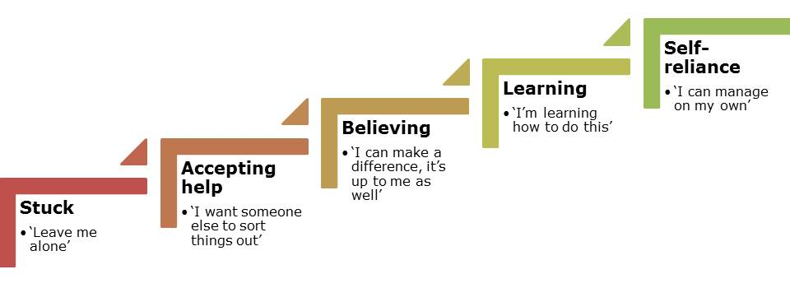

The ladder of change towards self-reliance encompasses the full range of individual needs (employment, housing, health etc.). These aspects could be described as different 'outcome domains'.

It is recognised that individuals will start and end at different stages of this ladder of change, dependent on their life circumstances, but all can make progress.

People who don’t need services
Those individuals who are already doing well will be encouraged to become net contributors to their communities. Their respective ladder of change starts with becoming aware of the community's needs and recognising the contribution they can make to meeting those needs. They then begin to give time, knowledge, skills and resources, and subsequently sustain that input.

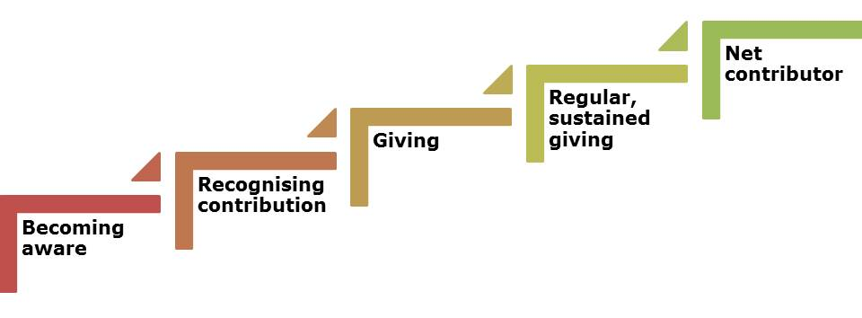

Voluntary, community and social enterprise sector
VCSE organisations, working collaboratively with the public sector, have a key role to play in driving the change agenda; acquiring relevant skills and knowledge, becoming asset-based, shifting towards prevention and early intervention, trialling innovative approaches and becoming focused on the impact they can generate.

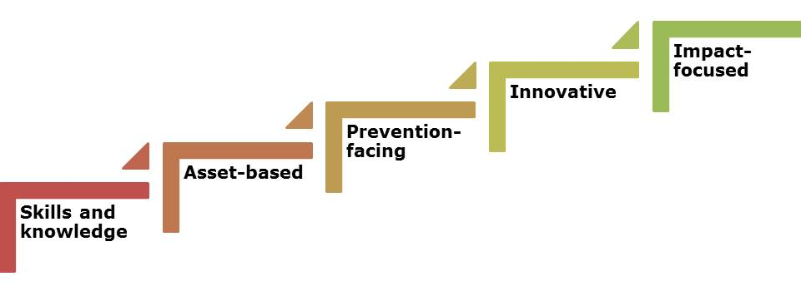

Public sector
Similarly, the Council and the wider public sector needs to change itself in order to realise this vision of developing stronger individuals and communities. This will require removing blockages/overcoming the fear of change, integrated working practices, system leadership, an enlightened approach to risk and reward, and a stronger focus on collaboration.

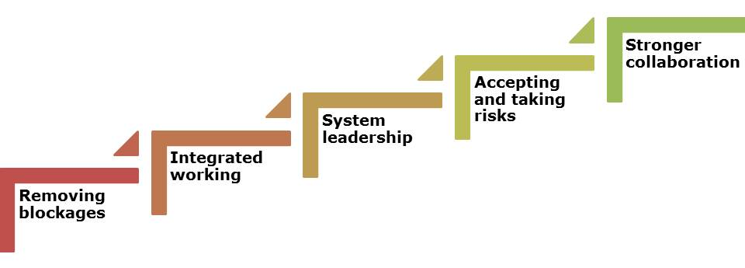

Key to delivering this Theory of Change are a number of interventions. These include:

- Community-led conversations: where individuals, groups and organisations meet on equal terms to co-design plans for change at a local community level
- Rewards for people taking action: e.g. social convections, wellbeing, time banking and Local Exchange & Transfer Schemes (LETS)
- Innovations within public sector commissioning including:
  - Outcomes-based commissioning
  - More strategic use of social value criteria
  - Collaborative/shared risk and reward approaches
  - Multiple outcomes
- Cross-sector partnerships: with increased working across traditional boundaries
  - Whole-system approach

Theory of Change diagram
The following diagram summarises our Theory of Change, where individuals themselves work towards increased self-reliance within strong, thriving communities, supported by the public and VCSE sectors working collaboratively for greater impact.

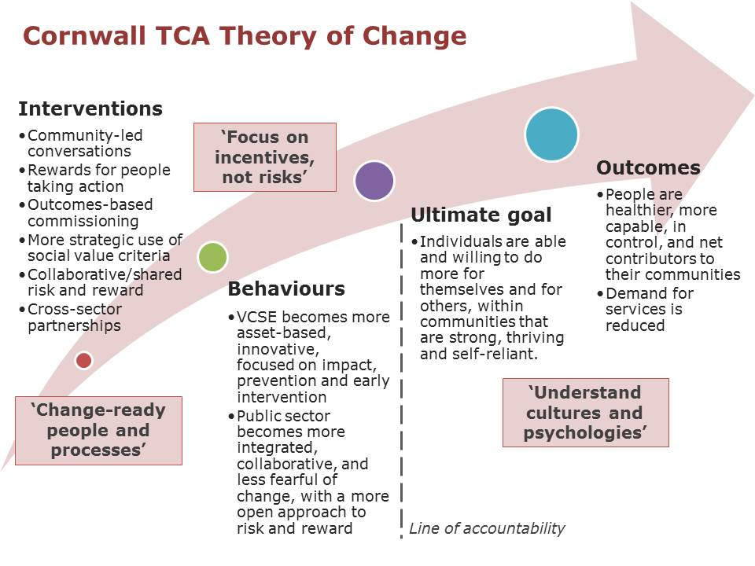

Appendix 2: Place based pilots for collective impact

These pilots will be taking place focused on agreed neighbourhoods in the West Penwith and Bude Community Network Areas.

We have committed to run these pilots for at least 2 years from October 2016. For more details on these place based pilots, will be included in the final tender documentation.

More information on collective impact approach can be found at:
https://en.wikipedia.org/wiki/Collective_impact

Prepared by:
Donna Peverley & Denbigh Cowley
VCSE Specialist & Programme Manager
Communities and Organisational Development
1 September 2016

If you would like this information
in another format please contact:
Cornwall Council
County Hall
Treyew Road
Truro TR1 3AY
Telephone: 0300 1234 100
Email: enquiries@cornwall.gov.uk
www.cornwall.gov.uk

