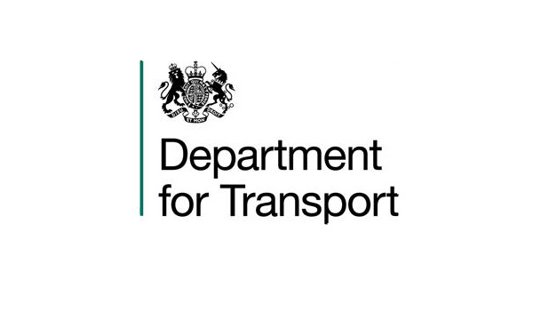

VARIATION TO CONTRACT FORM

Contract Name: The Provision of Legal Advice Regarding [REDACTED]

CONTRACT REF: CCLL17A32-02

Current CCS ref: CCLL17A32

Variation Number: 2

Effective from: 24th April 2018

Between:

The Department for Transport (hereinafter called “the Client”) and Eversheds-Sutherland (hereinafter called “the Contractor”)

The Contract is extended as follows:

- This is a variation to the contract between the Client and the Contractor.

The original contract term was for four months 24th October 2017 – 23rd February 2018 and was extended by two months until 23rd April 2018 a permitted by the original Contract.

The Contract shall be extended by a further 12 months from 24th April 2018 until 24th April 2019 and the value shall be increased by 50% to a total value of £100,000 (ex VAT).

The Terms and Conditions of Contract as previously agreed and amended between the Client and the Contractor will still apply.

2. Words and expressions in this Variation shall have the meanings given to them in the Contract.

3. The Contract shall remain effective and unaltered except as amended by this Variation.

SIGNED

For the Client: [REDACTED] For the Contractor: [REDACTED]

Full Name: [REDACTED] Full Name: [REDACTED]

Title: [REDACTED] Title: [REDACTED]
Date: 03/03/2018 Date: 03/03/2018

