Service Specification for: Adult Mental Health and Wellbeing Specialist Service

- Brief Summary of Service
In order to embed a whole family approach Children’s Services are developing a model of multi disciplinary working (MDW), whereby specialist workers are co-located within Children’s Social Care teams. The aim of this is to keep families together and to ensure children are able to remain safely at home. To date the specialisms include Domestic Abuse – Victim and Perpetrator Support, Substance Misuse and CAMHS.

We are seeking a Service Provider who will employ staff to introduce an Adult Mental Health and Wellbeing (AMHW) specialist service. The Service Provider will be required to input into Children’s Services Department (CSD) monitoring and evaluation

The Service will work with CSD staff and other specialists to develop and embed MDW.

AMHW specialist workers will deliver:

- One to one or group interventions with families.
- Consultations with CSD staff on an individual case basis.
- Staff awareness sessions to increase CSD staff awareness and understanding of AMHW and interventions.

This Hampshire Approach is being introduced to be adopted by all who are working with families and is underpinned by a strengths based resilience methodology.

The AMHW Service will provide support to families of children open to Childrens Social Care.
Multi disciplinary working is being rolled out across Hampshire, therefore, the service is required to cover the whole county.

- Background and Context
Research and experience tells us:
- One of the key drivers for keeping families safely together is having access to intensive and specialist support that allows families to deal with any underlying challenges that result in risks for their children.
- Outcomes are more positive when we can engage, build trust and motivate families to complete interventions, through that access to specialist support.

The Council has received funding for the Service for a period of 24 months. Financial sustainability will be developed in light of outcomes achieved and available funding. The Service will sit within Children’s Services’ multi disciplinary hubs alongside other specialist workers to embed the knowledge and skills of all specialist services within the CSD umbrella.

- Specific Aims, Objectives and Expected Outcomes of the Service
3a. Aims
- To provide interventions to parents where children and young people have been identified by their case holding Social Worker as being within a Priority Cohort (as defined under 6a below) of families who will receive intensive and specialist support.
- To increase the knowledge and skill of CSD staff to better enable them to identify and intervene in Adult Mental Health and Wellbeing issues which impact upon family life.

3b. Objectives
- Parents/carers will receive appropriate and timely support with their mental health and wellbeing. The timeliness of the intervention will be discussed and determined by a case allocation process lead by Children’s Services. However, it is recognised that the earlier the opportunity to intervene, the greater the potential to reduce risk factors and the speed of their escalation.
- Through these interventions, there is the expectation that the need for higher tier AMH and Wellbeing intervention will reduce.
- Through co-location, mechanisms for learning and case discussion between the Service Provider’s and CSD staff, there is the expectation that Social Care staff will be better able to identify the most appropriate resource to support a parent’s/carer’s mental health and well being.
3c. Expected Outcomes
- More parents and carers will be supported with their mental health and well being leading to improved outcomes for them and their families. This will be evidenced through fewer families being re-referred into social care and more children being able to remain safely at home.

- Service Model
Cases will be open to a CSD Social Worker.

If a case is identified as being within one of the priority cohorts, the case holding Social Worker can request an Intensive Worker to work with the family.

Intensive Workers are employed by CSD and will work with up to 8 families at a time, enabling them to provide a higher level of intervention and support.

Where a need for specialist service is identified, the Intensive Worker will request specialist support.

Requests for intensive or specialist support will be managed by a County Coordinator employed by Hampshire Children’s Services. The Coordinator will: monitor resource and outcomes and undertake a partnership role between CSD and the Service Provider, to monitor contract delivery.
Figure 1
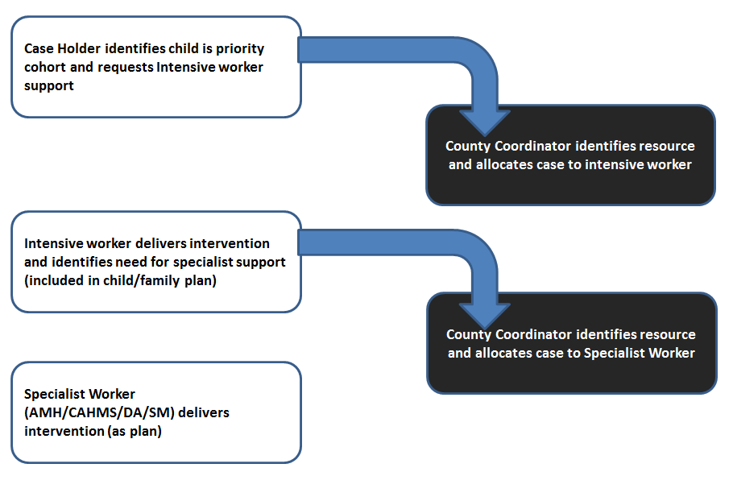

The AMHW Specialist Workers will deliver interventions to families identified and allocated through CSD. The Service Provider will employ the AMHW Specialist Workers and will provide clinical supervision on a monthly basis. CSD will provide daily oversight and coordination.

Overall this service will be delivered to priority cohort families. This multi-disciplinary working model will be delivered through multi- disciplinary hubs which are based on a defined geographical area (see Figure 2)

The AMHW Specialist Workers and other practitioners (Social Worker/Intensive Worker/other specialists) who deliver this service are working together to test out the impact that such a multi-disciplinary model can have on improving the outcomes for children and young people.

The Service Provider’s staff must :
- Be responsible for adult mental health assessments and resulting packages of evidenced based intervention, to be delivered on a 1:1 or group work basis.
- Be responsible for providing a programme of regular, planned consultation to CSD teams. There will be a formal process created by which CS staff will book a consultation slot with AMHW specialist worker. Consultation will be accessible for all cases, not just those in a priority cohort.
- Ensure parents/ carers/significant others are included in planning implementation, delivery and evaluation of the intervention.
- Increase CSD knowledge and skills in identification and intervention of Adult Mental Heath and Wellbeing which impacts on family life.

Through increased engagement of parents affected by mental health/well being issues the Service should achieve the following impact:
- Positive change is sustained following support
- Increased family resilience and ability to identify and manage own mental health and wellbeing
- Prevention of escalation of issues
- Parents more aware of their Adverse Childhood Experiences (ACE) and trauma and how this affects their parenting
- Increase in parents’ self esteem and mental wellbeing
- Reduced risk to children in household
- Increased number of children able to stay safely within the family home
- Improved communication, understanding and partnership working between AMHW services and CSD
- Increased CSD staff confidence, expertise and working practice with families with mental health needs.

- The Service to be Delivered
The Service Provider will:
- Recruit and employ AMHW Specialist Workers with the relevant experience and training.
- Deliver HR and continuous professional development management.
- Provide monthly clinical supervision.
- Provide travel and required equipment.
- Meet regularly with the County Coordinator to monitor and review performance.

The Service will be provided to families in the CSD identified priority cohorts.
Interventions and programmes will be strength based and aim to build resilience and emotional coping strategies in families.

The Service Provider and its staff will:

- Assess levels of presenting risk and support the management of risk by escalating cases appropriately according to protocols.
- Signpost and make onward referrals as appropriate and required to meet an individual’s needs.
- Deliver one awareness raising session per quarter in each Children’s Services district to support the building of knowledge and confidence across the social care workforce –Topics to include identification of recognised mental health and well being conditions and illness, strategies social care staff can use to support adults with their mental health, overview of wider AMHW service including services available, referral criteria and referral process. Sessions to be 2 hours in duration.
- Attend and contribute to a range of meetings as appropriate that support the planning process for a family and meeting of a child’s needs i.e. child protection case conference, core group meetings relevant to an adult/parent they are with.
- Record interventions into CSD electronic care recording system.
- Provide consultation to social care staff, to discuss case concerns and advise of appropriate course of action/intervention.

- Priority Cohorts, Geographical Scope, Location and Availability
6a. Priority Cohorts
Priority cohorts are those cohorts where the Council believes it can have the biggest impact in enabling more children and young people to stay safely at home.

Priority cohort definitions are based on research from external sources and discussions with staff across the organisation.

Priority cohort definitions:
• Parents of children aged 11-15 (from 7 years for children with disabilities) at risk of
entry to care
• Pregnant mothers with an unborn child at risk of removal
• Mothers with previous child/ren removed
• Care leavers at risk of pregnancy with associated safeguarding concerns
• Children in care who could be reunified home.

6b. Geographical Scope
The Service will be delivered throughout the Hampshire County Council area and will work across all eight of the CSD districts in Hampshire.

The districts and work locations are:
- Havant – Public Services Plaza
- Fareham & Gosport – Kent Road Family Centre (Gosport)
- New Forest – Totton Hub
- Test Valley – Beech Hurst (Andover)
- Hart & Rushmoor – Farnborough Council Office
- East Hants – Park House (Alton)
- Basingstoke – Dame Mary Fagan House
- Winchester & Eastleigh – Hampshire House (Eastleigh)

The CSD Districts are split into 4 MDW areas (see figure 2).

Figure 2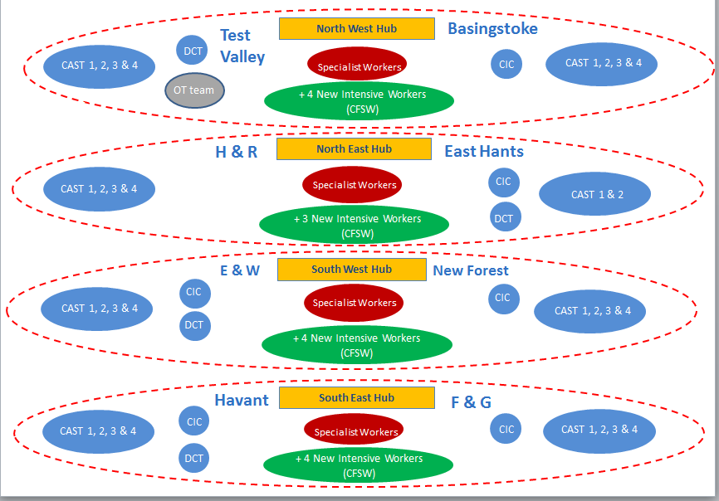
6c. Location
The service will be delivered in Children’s Services office bases and within a child /young person’s home, foster home or other agreed and appropriate venues. The AMHW Specialists Workers will be expected to work across districts as need requires. The MDW approach requires elements of co-location of workers from varying disciplines. The AMHW Specialist Workers will be required to spend time in each of the district locations where desk space and IT access can be accessed. If required, one of the district locations can be provided as a base for the AMHW Specialist Worker.

6d. Availability
The Service will need to be available during the week and core hours.

However, in order to support multi-disciplinary working and a family friendly approach a level of flexibility may be required on occasions.

Working time outside of the hours stated above will be agreed between the AMHW worker and the Children’s Services Team Manager.

