

Price Model and Evaluation Guidance

Estate Professional Services

Reference Number

RM 3816

Attachment 11

These instructions are to read as part of the rest of the ITT documents and set out as follows:

- Introduction to charging structure workbooks
- Instructions for completion – charging structure
- Price evaluation process

These instructions are applicable for all 4 (four) Lots (including the 8 (eight) Regional Panels in Lot 2) for the Estate Professional Services (EPS) Framework.

Potential Providers responding to this Tender shall read and fully understand how the charging structure workbook is completed, and to adhere to these instructions on how to complete Attachment 12 Charging Structure and how it will be evaluated.

These instructions apply to Potential Providers submitting a Tender for one or more Lots (including the 8 (eight) Regional Panels in Lot 2) either in their own name or as the Lead Contact of a Group of Economic Operators (see paragraph 6.6.3 of Attachment 1 Invitation To Tender (ITT).

Introduction to Charging Structure workbooks

- Introduction

  - These instructions are provided to assist Potential Providers in the completion of Attachment 12 charging structure workbooks. Potential Providers shall also ensure that they comply with any instruction contained within the individual charging structure workbook.

- Overall Approach

  - Potential Providers are required to submit pricing for hourly fee, percentage service fees, time charge fees and fixed fees for each Lot and for any of the Regional Panels (Lot 2) for which they are submitting a Tender.

  - The fees shall represent the maximum charge for the Services provided by the Potential Provider and shall be based on national office rates for Property and shall exclude VAT at the prevailing rate.

  - The fees represented in the Framework will be the maximum fee charged at Call Off and Potential Providers shall offer discount at Call Off to deliver the most economically advantageous Tender at Further Competition.

  - The Charging Structure allows price adjustments per Lot for the type of Property (Industrial, Retail, Residential and Land) and Services provided to a Property located in London (London is defined as any property situated within the M25 or London Orbital Motorway). For clarity the London variation will be determined on the location of the property and it is not based on the location of the Potential Providers office or where their staff are based.

  - All fees to exclude the Management Charge.

  - Disbursements means any sum spent or to be spent by the Potential Provider on behalf of the Contracting Authority (including any VAT element), for the avoidance of doubt excluding expenses and should be clearly identified at Call Off.

  - All Estates Professional Services will be the subject of tendered fees and Charges as set out within this document or on other fee arrangements based on these Framework rates as agreed with the Contracting Authority. Contracting Authority’s for example, at the time of appointment on individual Orders placed on General Hourly rates can ask Potential Providers to provide a maximum lump sum bid for the work required. This lump sum will be based on the fee structure set out in this document and agreed methodologies, resources, outputs and deliverables.

  - The Potential Provider shall complete ALL necessary cells in the workbooks for each of the service disciplines applicable to that Lot or Regional Panel for which it is submitting a Tender. Any Potential Provider who fails to fully complete each of the Charging Structure for each applicable Lot or Regional Panel, for which it is submitting a Tender, may excluded from further participation in this Procurement.

  - The table below sets out the Lots, number of awards and charging structure worksheet to be completed:

RM 3816 | Number of Awards available* | Charging Structure Worksheet
Lot 1 National | 10 | 1
Lot 2 Regional Panel 2A - East Anglia | 5 | 2
Lot 2 Regional Panel 2B - East & West Midlands | 5 | 3
Lot 2 Regional Panel 2C - London & South East England | 5 | 4
Lot 2 Regional Panel 2D - North East England | 5 | 5
Lot 2 Regional Panel 2E - North West England & North Wales | 5 | 6
Lot 2 Regional Panel 2F - Northern Ireland | 5 | 7
Lot 2 Regional Panel 2G - Scotland | 5 | 8
Lot 2 Regional Panel 2H - South Wales & South West England | 5 | 9
Lot 3 Vertical Real Estate | 5 | 10
Lot 4 Procurement Managed Service (FM & Property Services) | 5 | 11
Evaluation summary | NA | 12
*See Attachment 1 paragraphs 3.3 & 3.4 of the ITT on Lot 1 and Lot 2 Awards.

  - Potential Providers within the charging structure worksheets will indicate the Lot’s and / or Regional Panels for which they are bidding. The Potential Provider may bid for all or any combination Lots (1, 2, 3 and 4) and all eight Regional Panels (Lot 2).

- Charging Structure Workbook

3.1. A single charging structure workbook is provided for the Framework Agreement and relates to the Scope of Services in Schedule 2 Part A Services

3.2. The Potential Provider shall refer to the table in paragraph 2.11 above to determine the relevant charging structure worksheet(s) applicable to the Lot and/ or Regional Panel for which it is submitting a Tender.

3.3. The Potential Provider must complete each applicable charging structure worksheet for the Lots for which they are submitting a Tender. Please enter Yes or No in the first available cell of the Lots / Regional Panels that you are not bidding for.

3.4 The prices in the charging structure worksheet(s) should include the following:
- Expenses
- The provision of technical staff and staff engaged in secretarial, accountancy, administrative or other supporting duties.
- Overheads and profits, office expenses.
- Postage, delivery of documents, telephone calls and similar incidentals.

- Instructions for Completion Charging Structure Workbook

  - A single charging structure workbook is provided for the Framework Agreement, each Lot or Regional Panel has a separate worksheet and relates to the Scope of Services in Framework Schedule 2.

  - The Charging Structure includes a number of coloured cells and the Potential Provider shall note that within the individual worksheets the following guidance applies:

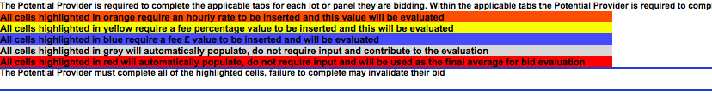

  - Potential Providers shall insert a percentage fee (up to 2 decimal points only) where a value is required. If the Potential Provider inserts a value with more than 2 decimal places this will be rounded down to 2 decimal points.

  - Potential Providers are required to complete all the relevant highlighted cells within each worksheet they are tendering, any omissions or errors will be highlighted with the following example message ‘ERROR - Cells must not be left blank’. Any error messages remaining on the submission of the Tender may invalidate the Tender as per section 2.8 above.

  - The single charging structure workbook is split out into the following worksheets listed below:

- Lot 1 National (Worksheet 1)

  - The workbook contains one worksheet for Lot 1 National Services, the Potential Provider shall complete for the mandatory Services, including but not limited to professional management, workplace planning and space optimisation including but not limited to demand assessment and capacity testing; advice, guidance, negotiation and assistance on property and estates issues, on a national basis. International services shall be provided as an optional Service at Call Off.

  - Within the Lot 1 worksheet the Potential Provider shall complete the following boxes:

    - Company bidding for the lot
    - Company Name
    - Model populated (Potential Provider contact point for the charging structure)

  - Within the Lot 1 worksheet the Potential provider shall complete the following tables
- Price Adjustment London
The Potential Provider has the ability to input a price adjustment (+/-) for the provision of Services as per paragraph 2.4. For the avoidance of doubt the Potential Provider may decide to offer no adjustment, in which case the Potential Provider should insert zero (0).

- Price Adjustment Property Type
The Potential Provider has the ability to input a price adjustment (+/-) for the provision of Services as per paragraph 2.4. For the avoidance of doubt the Potential Provider may decide to offer no adjustment, in which case the Potential Provider should insert zero (0).

- Table 1
The Potential Provider shall complete the cells highlighted in orange with an Hourly rate for delivering the Services identified and as detailed in Framework Schedule 2 Scope of Services. For avoidance of doubt the Potential Provider shall input a value for each role, where the Potential Provider does not provide that role they should include a cost to Sub - Contract that role.

- Table 2 to 12
The Potential Provider shall complete the cells highlighted in blue with their minimum and maximum fee for delivering the Services identified and as detailed in Framework Schedule 2 Scope of Services.

The Potential Provider shall complete the cells highlighted in yellow with their percentage fee for delivering the Services identified and as detailed in Framework Schedule 2 Scope of Services for each individual stage.

- Table 13
The Potential Provider shall complete the blue cell with a £ fixed fee for the delivering the Services identified and as detailed in Framework Schedule 2 Scope of Services

- Table 14
The Potential Provider shall complete the cells highlighted in blue with their maximum fee for delivering the Services identified and as detailed in Framework Schedule 2 Scope of Services

The Potential Provider shall complete the cells highlighted in yellow with their percentage fee for delivering the Services identified and as detailed in Framework Schedule 2 Scope of Services for each individual stage.

- Table 15
The Potential Provider shall complete the blue cell with a £ fixed fee for the delivering the Services identified and as detailed in Framework Schedule 2 Scope of Services

- Table 16 and 17
The Potential Provider shall complete the cells highlighted in blue with their initial consultation fee for delivering the Services identified and as detailed in Framework Schedule 2 Scope of Services

The Potential Provider shall complete the cells highlighted in yellow with their percentage fee for delivering the Services identified and as detailed in Framework Schedule 2 Scope of Services for each individual stage.

The Potential Provider shall complete the cells highlighted in blue with their maximum fee for delivering the Services identified and as detailed in Framework Schedule 2 Scope of Services

- Table 18

The potential Provider shall complete the cells highlighted in yellow with their percentage fee for delivering the Services identified and as detailed in Framework Schedule 2 Scope of Services for each individual stage.

The Potential Provider shall complete the cells highlighted in blue with their maximum fee for delivering the Services identified and as detailed in Framework Schedule 2 Scope of Services

  - The Potential Provider shall note that the percentage fees for cells highlighted in yellow are not cumulative across the stages and therefore the final fee percentage chargeable relates only to that stage if a minimum or maximum rate does not apply.

  - The Potential Provider shall note that the adjustment for London and Property Type will not be applied to the minimum or maximum fee rates.

- Lot 2 Regional Panels (Worksheets 2 to 9)

  - The workbook contains 8 worksheets for each of the Regional Panels, the Potential Provider should complete each individual worksheet for the Regional Panels that it is tendering Services for, noting paragraphs 3.3 and 3.4 above.

  - The Lot 2 worksheets contains mandatory or optional Services including but not limited to professional management, advice, guidance, negotiation and assistance on property and estates issues, on a regional basis.

  - Within the Lot 2 worksheet the Potential Provider shall complete the following boxes:
    - Company bidding for lot
    - Company Name
    - Model populated

Within the Lot 2 worksheet the Potential Provider shall complete the following tables:

- Price Adjustment London
The Potential Provider has the ability to input a price adjustment (+/-) for the provision of Services as per paragraph 2.4. For the avoidance of doubt the Potential Provider may decide to offer no adjustment, in which case the Potential Provider should insert zero (0).

- Price Adjustment Property Type
The Potential Provider has the ability to input a price adjustment (+/-) for the provision of Services as per paragraph 2.4. For the avoidance of doubt the Potential Provider may decide to offer no adjustment, in which case the Potential Provider should insert zero (0).

- Table 1
The Potential Provider shall complete the cells highlighted in orange with an Hourly rate for delivering the Services identified and as detailed in Framework Schedule 2 Scope of Services. For avoidance of doubt the Potential Provider shall input a value for each role, where the Potential Provider does not provide that role they should include a cost to Sub-Contract that role.

- Table 2 to 12
The Potential Provider shall complete the cells highlighted in blue with their minimum and maximum fee for delivering the Services identified and as detailed in Framework Schedule 2 Scope of Services.

The Potential Provider shall complete the cells highlighted in yellow with their percentage fee for delivering the Services identified and as detailed in Framework Schedule 2 Scope of Services for each individual stage.

- Table 13
The Potential Provider shall complete the blue cell with a £ fixed fee for the delivering the Services identified and as detailed in Framework Schedule 2 Scope of Services

- Table 14
The Potential Provider shall indicate whether they are delivering the optional Services identified and as detailed in Framework Schedule 2 Scope of Services by completing the indication box.

If the Potential Provider is not tendering for the Services identified in table 14, they will need to indicate this in the check box and shall not input any values into the tables.

The Potential Provider shall complete the cells highlighted in blue with their maximum fee for delivering the Services identified and as detailed in Framework Schedule 2 Scope of Services

The Potential Provider shall complete the cells highlighted in yellow with their percentage fee for delivering the Services identified and as detailed in Framework Schedule 2 Scope of Services for each individual stage.

- Table 15
The Potential Provider shall complete the blue cell with a £ fixed fee for the delivering the Services identified and as detailed in Framework Schedule 2 Scope of Services

- Table 16 and 17
The Potential provider shall indicate whether they are delivering the optional Services identified and as detailed in Framework Schedule 2 Scope of Services by completing the indication box.

If the Potential provider is not tendering for the Services identified in table 14, they will need to indicate this in the check box and shall not input any values into the tables.

The Potential Provider shall complete the cells highlighted in blue with their initial consultation fee for delivering the Services identified and as detailed in Framework Schedule 2 Scope of Services

The Potential Provider shall complete the cells highlighted in yellow with their percentage fee for delivering the Services identified and as detailed in Framework Schedule 2 Scope of Services for each individual stage.

The Potential Provider shall complete the cells highlighted in blue with their maximum fee for delivering the Services identified and as detailed in Framework Schedule 2 Scope of Services

i) Table 18
The Potential Provider shall complete the cells highlighted in yellow with their percentage fee for delivering the services identified and as detailed in Framework Schedule 2 Scope of Services for each individual stage.

The Potential Provider shall complete the cells highlighted in blue with their maximum fee for delivering the services identified and as detailed in Framework Schedule 2 Scope of Services

  - The Potential provider should note that the percentage fees for cells highlighted in yellow are not cumulative across the stages and therefore the final fee percentage chargeable relates only to that stage if a minimum or maximum rate does not apply.

  - The Potential Provider should note that the adjustment for London and Property Type shall not be applied to the auto calculate cells for minimum or maximum fee rates.

- Lot 3 Vertical Real Estate (Worksheet 10)

  - The workbook contains one worksheet for Lot 3 Vertical Real Estate (VRE), the Potential Provider shall complete for the mandatory services including but not limited to administration of the VRE projects, supporting the Digital Strategy, on a national basis.

  - Within the Lot 3 worksheet the potential Provider shall complete the following boxes:
a. Company Name
b. Model populated

  - Within the Lot 3 worksheet the Potential Provider shall complete the following tables:

- Price Adjustment London
The Potential Provider has the ability to input a price adjustment (+/-) for the provision of Services as per paragraph 2.4. For the avoidance of doubt the Potential Provider may decide to offer no adjustment, in which case the Potential Provider should insert zero (0).

- Price Adjustment Property Type
The Potential Provider has the ability to input a price adjustment (+/-) for the provision of Services as per paragraph 2.4. For the avoidance of doubt the Potential Provider may decide to offer no adjustment, in which case the Potential Provider should insert zero (0).

- Table 1
The Potential Provider shall complete the cells highlighted in orange with an Hourly rate for delivering the Services identified and as detailed in Framework Schedule 2 Scope of Services. For avoidance of doubt the Potential Provider shall input a value for each role, where the Potential Provider does not provide that role they should include a cost to Sub- Contract that role.

- Table 2
The Potential Provider shall complete the cells highlighted in blue with their minimum and maximum fee for delivering the Services identified and as detailed in Framework Schedule 2 Scope of Services.

The Potential Provider shall complete the cells highlighted in yellow with their percentage fee for delivering the Services identified and as detailed in Framework Schedule 2 Scope of Services for each individual stage.

For the avoidance of doubt the Potential Provider within table 2 is tendering for an end-to-end service on a guidance, assurance or management role.

- Table 3 to 5
The Potential Provider shall complete the cells highlighted in blue with their minimum and maximum fee for delivering the Services identified and as detailed in Framework Schedule 2 Scope of Services.

The Potential Provider shall complete the cells highlighted in yellow with their percentage fee for delivering the Services identified and as detailed in Framework Schedule 2 Scope of Services for each individual stage.

  - The Potential provider should note that the percentage fees for cells highlighted in yellow are not cumulative across the stages and therefore the final fee percentage chargeable relates only to that stage if a minimum or maximum rate does not apply.

  - The Potential Provider should note that the adjustment for London and Property Type shall not be applied to the auto calculate cells for minimum or maximum fee rates.

- Lot 4 Procurement Managed Service (Worksheet 11)

  - The workbook contains one worksheet for Lot 4 Procurement Managed Service, the Potential Provider shall complete for all mandatory Services.

  - Within the Lot 4 worksheet the Potential Provider shall complete the following boxes:
    - Company Name
    - Model populated

  - Within the Lot 4 worksheet the Potential Provider shall complete the following tables:

- Price Adjustment London
The Potential Provider has the ability to input a price adjustment (+/-) for the provision of Services as per paragraph 2.4. For the avoidance of doubt the Potential Provider may decide to offer no adjustment, in which case the Potential Provider should insert zero (0).

- Table 1
The Potential Provider shall complete the cells highlighted in orange with an Hourly rate for delivering the Services identified and as detailed in Framework Schedule 2 Scope of Services. For avoidance of doubt the Potential Provider shall input a value for each role, where the Potential Provider does not provide that role they should include a cost to subcontract that role.

- Table 2
The Potential Provider shall complete the cells highlighted in blue with their minimum and maximum fee for delivering the Services identified and as detailed in Framework Schedule 2 Scope of Services.

The Potential Provider shall complete the cells highlighted in yellow with their percentage fee for delivering the Services identified and as detailed in Framework Schedule 2 Scope of Services for each individual stage.

For the avoidance of doubt the Potential Provider within table 2 is tendering for an end-to-end procurement service of varying complexities.

  - The Potential Provider should note that the percentage fees for cells highlighted in yellow are not cumulative across the stages and therefore the final fee percentage chargeable relates only to that stage if a minimum or maximum rate does not apply.

  - The Potential Provider should note that the adjustment for London and Property Type shall not be applied to the auto calculate cells for minimum or maximum fee rates.

- Evaluation Summary (Worksheet 12)

  - The workbook contains one worksheet that provides a summary of the data contained within the automatically populated ‘average final fee’ highlighted red cells from each Lot or Regional Panel worksheet the Potential Provider has tendered and will be exported to the tender evaluation template as the ‘average fee final’ for the Potential Provider for each service.

- Price Evaluation

  - Please see Attachment 1 section 11 Award Stage Evaluation which includes a description of how the Potential Providers price submission will be evaluated

  - Each Lot or Regional Panel follows the same evaluation principle for the Services tendered and this is set out below.

  - Each of the worksheets contains an automatically populated ‘average fee final’ (highlighted red cell) for each service table which populates the tables in the Bidder Summary tab. The ‘average fee final’ is extracted into the ‘Submission’ cell in the evaluation template from the tables in the Bidders Summary tab and will be used to evaluate the Potential Providers tender.

  - The ‘average fee final’ and is calculated as follows for the different fee types/tables:

  - Hourly Rate
The ‘average final fee’ in table 1 throughout the worksheets is calculated by taking an average of the orange (Potential Providers inputted data) and grey highlighted (automated data taking into account any London or property adjustments) for the following tables as per the example below:
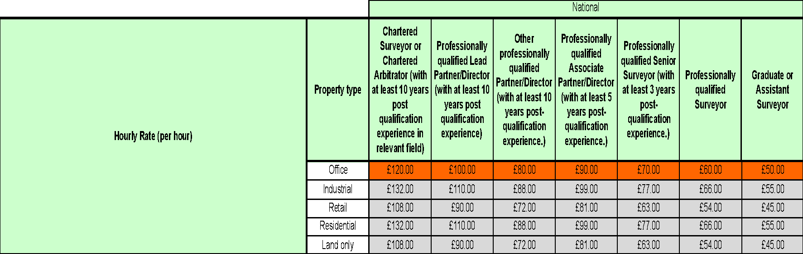

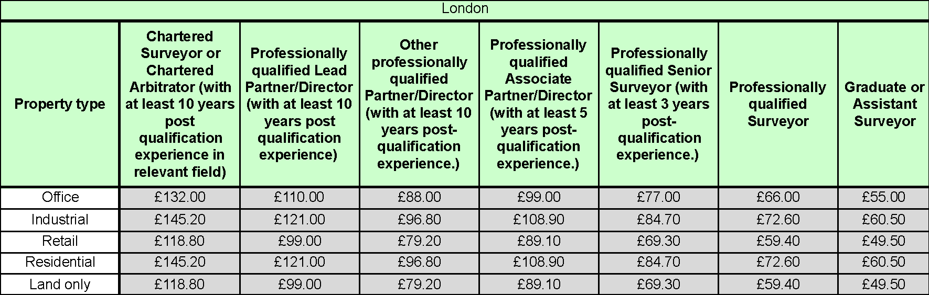
The average of the tables calculate the average final fee to the right hand of the worksheet as the example below:



  - The ‘average final fee’ in Tables 2- 12 and 18 throughout the worksheets is calculated by taking the individual average of each stage of the yellow (Potential Providers inputted data) and grey highlighted (automated data taking into account any London or property adjustments). The following tables provide a staged example:

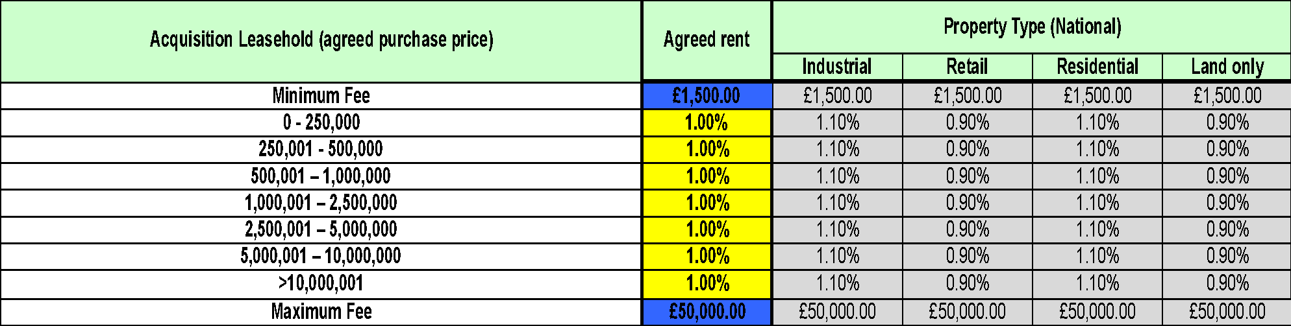

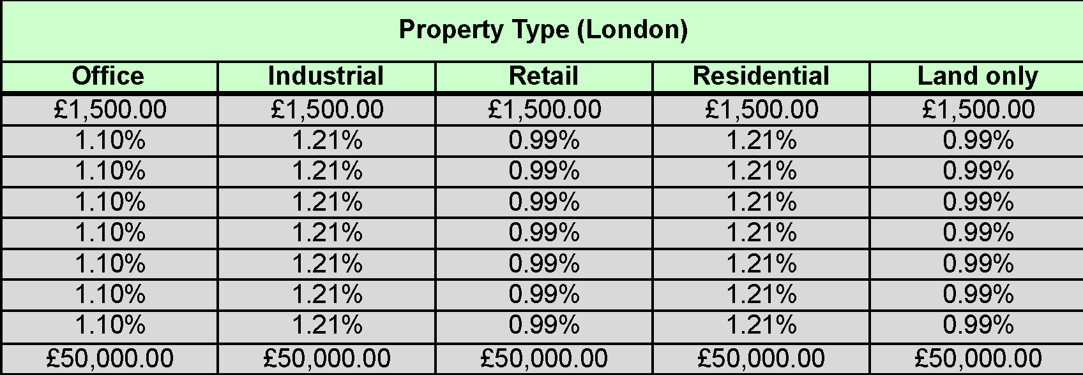

The average percentages are automatically populated to the next table, example below and applied to a scenario within the worksheets:

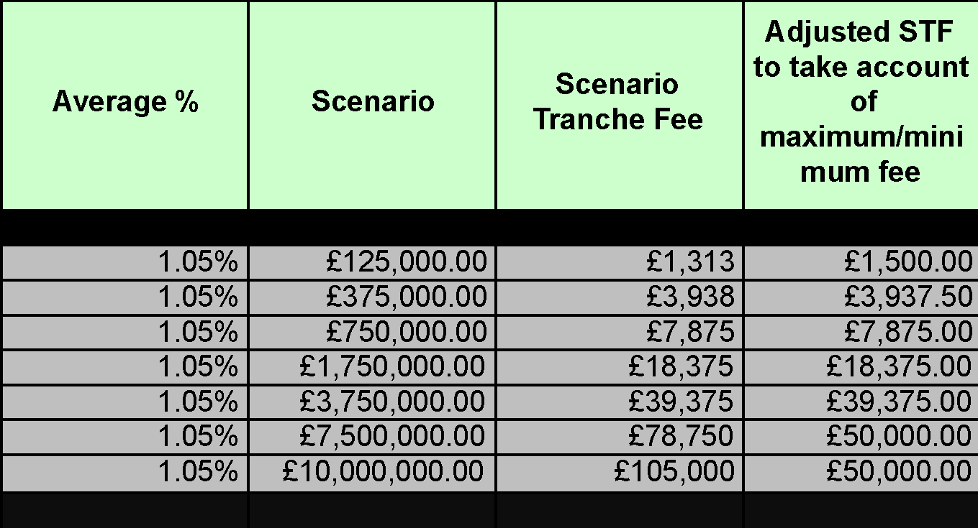

  - The average % is applied to a scenario fee (£), which is approximately the midpoint of each stage value.

The average % and the scenario fee are multiplied to calculate the scenario tranche fee.

The scenario tranche fee is applied to the adjusted scenario tranche fee and this takes into account the Potential Providers minimum and maximum fee values, applying the blue cell maximum or minimum if the fee charge is below or above this figure.

The ‘average final fee’ is calculated as the average of the Adjusted Scenario Tranche Fee (STF) cells.

The average annual fee is calculated to the right hand side of the worksheet as per the example below:


  - Fixed fee
The ‘average final fee’ in Tables 13 and 15 through-out the worksheets is calculated by taking the individual average of the blue (Potential Providers inputted data) and grey highlighted (automated data taking into account any London or property adjustments). The following tables provide a staged example:



The average of the tables calculate the average final fee to the right hand of the worksheet as the example below:



  - Initial consultation, percentage (%) and maximum fee:

The ‘average final fee’ in Tables 16, and 17 through-out the worksheets follows the process as per example 10.6. with the initial consultation fee added to the adjusted scenario tranche fee. For the avoidance doubt it should be noted that the maximum fee is exclusive of the initial consultation fee.

  - For the avoidance of doubt all figures included within the tables above are purely for illustration purposes to demonstrate the process and are not be interpreted as indicative returns by the Potential Provider.

  - As described above the ‘average final fee’ for each service type will be extracted by the Authority into the evaluation template. The evaluation template has not been shared with Potential Providers and an overview is provided below at paragraph 10.20.

  - Each individual Lot or Regional Panel will be evaluated ‘like for like’, therefore the Authority will extract the ‘average final fee; for each service into the relevant templates for each Lot or Regional Panel.

  - The evaluation template will review the Potential Providers price and rank them using the following process:

  - The individual average final fee for each service is extracted from the evaluation worksheet into the evaluation template and into the submission cell for that service. As per the example below:

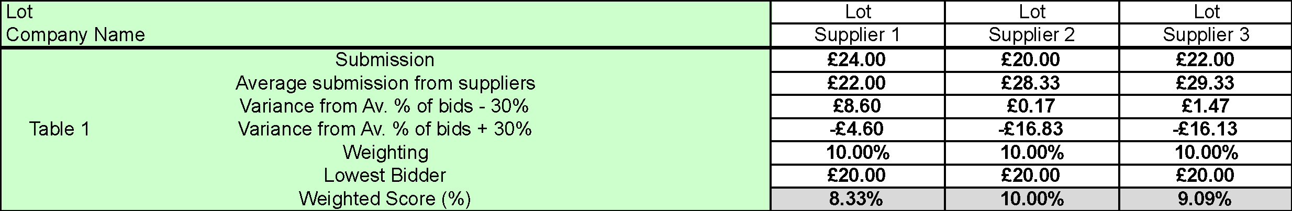

  - The above example is duplicated for each service table within the Lot or Regional Panel. The evaluation table consists of all Potential Providers bids, for all the Services within the Lot or Regional Panel and each Potential Provider will be evaluated against all compliant bids Service by Service.

  - The Potential Providers Price Score used to calculate the Final Score as per Attachment 1 – ITT , paragraph 11.8

