Appendix 4 a-Todmorden Festive Decoration Register (DWG: 29.Todmorden Festive Dec Drawing 2019 )
Festive Deceration UID | Lighting Column ID | Street Name | Description | Installation Arrangement | Festive Decoration Weight | Wind loading | Fixing type | Image
Column Mounted
CFD0101 | 4 | Rochdale Road | Santa on Motorbike | Column Mounted | 5kg | 20% | Tespa Banded | 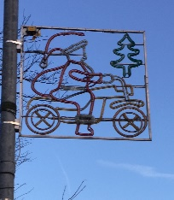
CFD0102 | 5 | Rochdale Road | Santa's Head | Column Mounted | 5kg | 20% | Tespa Banded | 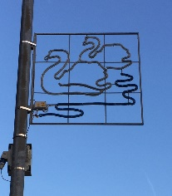  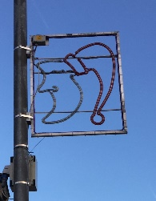
CFD0103 | 6 | Rochdale Road | 2 no. Swans | Column Mounted | 5kg | 20% | Tespa Banded
CFD0104 | 7 | Rochdale Road | Santa | Column Mounted | 5kg | 20% | Tespa Banded | 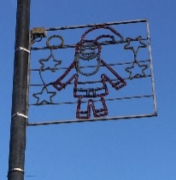
CFD0105 | 8 | Rochdale Road | Penguin | Column Mounted | 5kg | 20% | Tespa Banded | 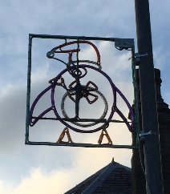
CFD0106 | 427 | Burnley Road | Santa Coming and Clock | Column Mounted | 7kg | 20% | Tespa Banded | 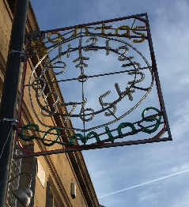
CFD0107 | 428 | Burnley Road | Christmas Pudding | Column Mounted | 5kg | 20% | Tespa Banded | 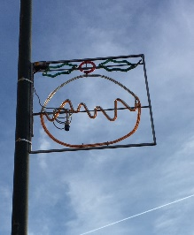
CFD0108 | 429 | Burnley Road | Santa in Chimney | Column Mounted | 5kg | 20% | Tespa Banded | 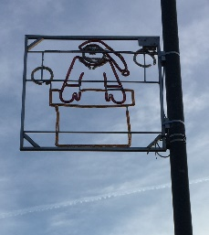
CFD0109 | 430 | Burnley Road | Shooting Star | Column Mounted | 5kg | 20% | Tespa Banded | 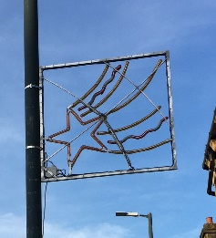
CFD0110 | 431 | Burnley Road | Red, Blue, Yellow | Column Mounted | 5kg | 20% | Tespa Banded | 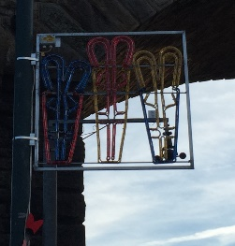
CFD0111 | 432 | Burnley Road | Holly Leaf | Column Mounted | 5kg | 20% | Tespa Banded | 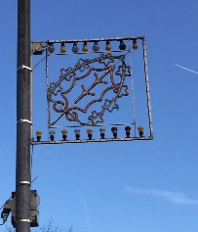
CFD0112 | 433 | Burnley Road | Christmas Tree | Column Mounted | 8kg | 20% | Tespa Banded | 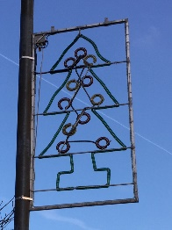
CFD0113 | 434 | Burnley Road | 3 Kings | Column Mounted | 8kg | 20% | Tespa Banded | 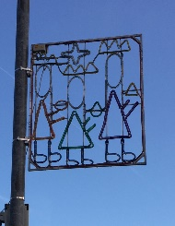
CFD0114 | 435 | Burnley Road | Stocking | Column Mounted | 5kg | 20% | Tespa Banded | 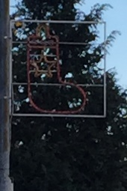  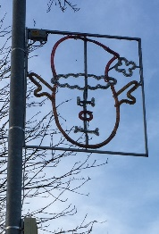
CFD0115 | 436 | Burnley Road | Santa | Column Mounted | 9kg | 20% | Tespa Banded
CFD0116 | 4 | Halifax Road | Baubles | Column Mounted | 8kg | 20% | 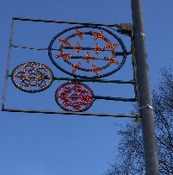  Tespa Banded
CFD0117 | 5 | Halifax Road | Mistletoe | Column Mounted | 8kg | 20% | Tespa Banded | 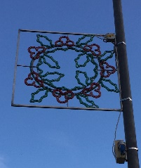
CFD0118 | 6 | Halifax Road | Candle & Snowflake | Column Mounted | 8kg | 20% | Tespa Banded | 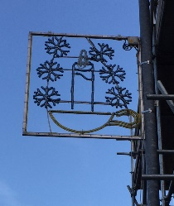
CFD0119 | 7 | Halifax Road | Bird | Column Mounted | 8kg | 20% | Tespa Banded | 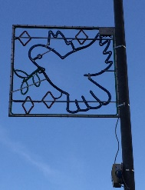
CFD0120 | 8 | Halifax Road | Bells | Column Mounted | 8kg | 20% | 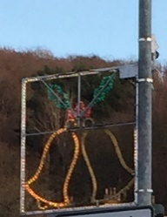  Tespa Banded
CFD0121 | 10 | Halifax Road | Snowman | Column Mounted | 5kg | 20% | Tespa Banded | 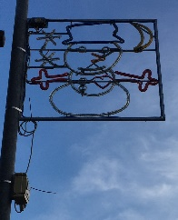
CFD0122 | 11 | Halifax Road | Candle Lantern | Column Mounted | 3kg | 20% | Tespa Banded | 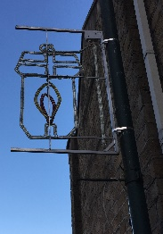  
CFD0123 | 12 | Halifax Road | Santa In Car | Column Mounted | 5kg | 20% | Tespa Banded
Christmas Trees
CFD0124 |  | Rochdale Road | Christmas Tree Lights |  |  |  | Wrapped around tree | 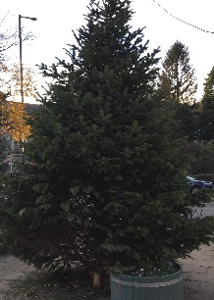  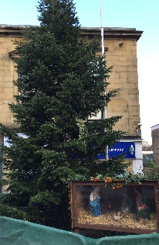
CFD0125 |  | Burnley Road | Christmas Tree Lights |  |  |  | Wrapped around tree
Catenary Lighting - outside St Mary's Church
CFD0126 | Support Column 11 | Rochdale Road |  | Catenary |  |  | Tespa Banded
 | Support Column 12 | Rochdale Road |  | Catenary |  |  | Tespa Banded
 | Support Column 13 | Rochdale Road |  | Catenary |  |  | Tespa Banded

Appendix 4b Walsden Festive Decoration Register (DWG: 6.Walsden Festive Dec Drawing 2019 )
Festive Decoration UID | Lighting Column ID | Street Name | Description | Installation Arrangement | Festive Deceration Weight | Wind loading | Fixing UID | Fixing type | Image
Column Mounted
CFD0136 | 76 | Rochdale Road | Warm White | Column Mounted | 4kg | 20% |  | Tespa Banded | 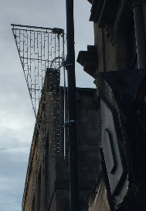
CFD0137 | 77 | Rochdale Road | Warm White | Column Mounted | 4kg | 20% |  | Tespa Banded
CFD0138 | 78 | Rochdale Road | Warm White | Column Mounted | 4kg | 20% |  | Tespa Banded
CFD0139 | 79 | Rochdale Road | Warm White | Column Mounted | 4kg | 20% |  | Tespa Banded
CFD0140 | 80 | Rochdale Road | Warm White | Column Mounted | 4kg | 20% |  | Tespa Banded
CFD0141 | 81 | Rochdale Road | Warm White | Column Mounted | 4kg | 20% |  | Tespa Banded
CFD0142 | 82 | Rochdale Road | Warm White | Column Mounted | 4kg | 20% |  | Tespa Banded
CFD0143 | 83 | Rochdale Road | Warm White | Column Mounted | 4kg | 20% |  | Tespa Banded
CFD0144 | 1 | Inchfield Road | Warm White | Column Mounted | 4kg | 20% |  | Tespa Banded

Appendix 4 c Cornholme Festive Decoration Register (DWG: 6.Cornholme Festive Dec Drawing 2019 )
Festive Deceration UID | Lighting Column ID | Street Name | Description | Installation Arrangement | Festive Deceration Weight | Wind loading | Fixing type | Image
Column Mounted
CFD0127 | 326 | Burnley Road | Warm White | Column Mounted | 4kg | 20% | Tespa Banded
CFD0128 | 327 | Burnley Road | Warm White | Column Mounted | 4kg | 20% | Tespa Banded
CFD0129 | 328 | Burnley Road | Warm White | Column Mounted | 4kg | 20% | Tespa Banded
CFD0130 | 329 | Burnley Road | Warm White | Column Mounted | 4kg | 20% | Tespa Banded
CFD0131 | 330 | Burnley Road | Warm White | Column Mounted | 4kg | 20% | Tespa Banded
CFD0132 | 331 | Burnley Road | Warm White | Column Mounted | 4kg | 20% | Tespa Banded
CFD0133 | 332 | Burnley Road | Warm White | Column Mounted | 4kg | 20% | Tespa Banded
CFD0134 | 333 | Burnley Road | Warm White | Column Mounted | 4kg | 20% | Tespa Banded
CFD0135 | 334 | Burnley Road | N/A | N/A | N/A | N/A | Tespa Banded

